New Ethernet Applications

Industry Connections Activity Initiation Document (ICAID)

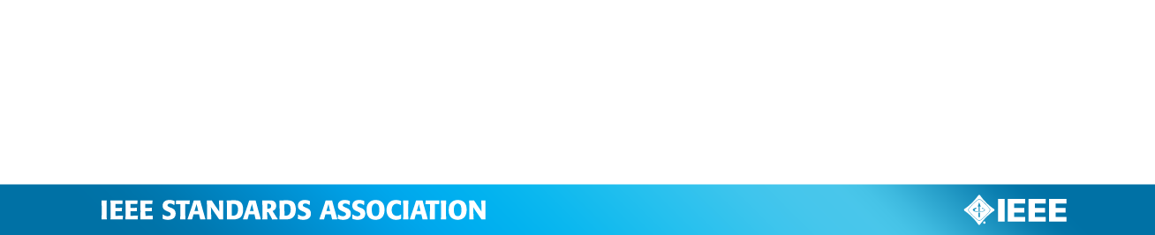
Version: 1.0, 07-Sep-2016

Instructions
- Instructions on how to fill out this form are shown in red. It is recommended to leave the instructions in the final document and simply add the requested information where indicated.
- Shaded Text indicates a placeholder that should be replaced with information specific to this ICAID, and the shading removed.
- Completed forms, in Word format, or any questions should be sent to the IEEE Standards Association (IEEE-SA) Industry Connections Committee (ICCom) Administrator at the following address: industryconnections@ieee.org.
- The version number above, along with the date, may be used by the submitter to distinguish successive updates of this document. A separate, unique Industry Connections (IC) Activity Number will be assigned when the document is submitted to the ICCom Administrator.

- Contact
Provide the name and contact information of the primary contact person for this IC activity. Affiliation is any entity that provides the person financial or other substantive support, for which the person may feel an obligation. If necessary, a second/alternate contact person’s information may also be provided.

Name:
Email Address:
Phone:
Employer:
Affiliation:

- Participation and Voting Model
Specify whether this activity will be entity-based (participants are entities, which may have multiple representatives, one-entity-one-vote), or individual-based (participants represent themselves, one-person-one-vote).

Individual-Based

- Purpose

  - Motivation and Goal
Briefly explain the context and motivation for starting this IC activity, and the overall purpose or goal to be accomplished.

The mobile industry is currently pursuing the development of the next generation mobile communication networks fulfilling the requirements for extreme mobile broadband, massive machine-type communication, and ultra-reliable and low latency communications as specified in ITU-R M.2083 for IMT-2020.
Many of the observed trends and use case scenarios described in ITU-R M.2083 for the evolution of International Mobile Telecommunications apply as well to communication infrastructures which do not belong to the IMT domain. IEEE 802 technologies are mainly deployed in communication infrastructures outside of the IMT domain, and may require enhancements to cope with the emerging requirements of future communications.

The goal of this activity is to assess emerging requirements for IEEE 802-based communication infrastructures, identify commonalities and gaps not currently addressed by IEEE 802 standardization, and facilitate building industry consensus towards proposals to initiate new standards development efforts.

  - Related Work
Provide a brief comparison of this activity to existing, related efforts or standards of which you are aware (industry associations, consortia, standardization activities, etc.).

There are no known open standards / IEEE 802 based activity to compare against this Industry Connections activity proposal.

  - Previously Published Material
Provide a list of any known previously published material intended for inclusion in the proposed deliverables of this activity.

None

  - Potential Markets Served
Indicate the main beneficiaries of this work, and what the potential impact might be.

IEEE 802 technologies are deployed in a huge number of market applications, which are exhibiting a growing diversity in terms of the features needed. Solutions spanning these different application spaces and feature requirements will be best addressed by leveraging common technology approaches. This activity will enable industry consensus building on the market/application requirements and identify gaps not currently addressed by IEEE 802 standardization of new solutions, which will help to foster industry interest in new study groups.

- Estimated Timeframe
Indicate approximately how long you expect this activity to operate to achieve its proposed results (e.g., time to completion of all deliverables).

Expected Completion Date: ??/2018

IC activities are chartered for two years at a time. Activities are eligible for extension upon request and review by ICCom and the IEEE-SA Standards Board. Should an extension be required, please notify the ICCom Administrator prior to the two-year mark.

- Proposed Deliverables
Outline the anticipated deliverables and output from this IC activity, such as documents (e.g., white papers, reports), proposals for standards, conferences and workshops, databases, computer code, etc., and indicate the expected timeframe for each.

There will be multiple types of deliverables. The first type of deliverable will be the records of the meetings, including minutes and supporting presentations. The second type of output may be the creation of white papers documenting the findings of the IC activity. A third possible type of deliverable may be the creation, as appropriate, of one or more consensus presentations that are used as the basis for one or more study groups to develop PAR proposals for new standardization.

- Funding Requirements
Outline any contracted services or other expenses that are currently anticipated, beyond the basic support services provided to all IC activities. Indicate how those funds are expected to be obtained (e.g., through participant fees, sponsorships, government or other grants, etc.). Activities needing substantial funding may require additional reviews and approvals beyond ICCom.

None.

- Management and Procedures

  - IEEE Sponsoring Committee
Indicate whether an IEEE sponsoring committee of some form (e.g., an IEEE Standards Sponsor) has agreed to oversee this activity and its procedures.

Has an IEEE sponsoring committee agreed to oversee this activity?: Yes

If yes, indicate the sponsoring committee’s name and its chair’s contact information.

Sponsoring Committee Name: IEEE 802 LAN/MAN Standards Committee
Chair’s Name: Paul Nikolich
Chair’s Email Address: p.nikolich@ieee.org
Chair’s Phone: + 857 205 0050

  - Activity Management
If no IEEE sponsoring committee has been identified in 7.1 above, indicate how this activity will manage itself on a day-to-day basis (e.g., executive committee, officers, etc).

N/A

  - Procedures
Indicate what documented procedures will be used to guide the operations of this activity; either a) modified baseline Industry Connections Activity Policies and Procedures, or b) Sponsor or Working Group policies and procedures accepted by the IEEE-SA Standards Board. The chosen policies and procedures must be reviewed by ICCom

IEEE 802 LMSC Operations Manual, IEEE 802 P&P

- Participants

  - Stakeholder Communities
Indicate the stakeholder communities (the types of companies or other entities, or the different groups of individuals) that are expected to be interested in this IC activity, and will be invited to participate.

Stakeholders identified to date includes but are not limited to: users and producers of systems and components for servers, network storage, networking systems, data centers, high performance computing, telecommunications carriers, automotive, and industrial applications.

  - Expected Number of Participants
Indicate the approximate number of entities (if entity-based) or individuals (if individual-based) expected to be actively involved in this activity.

50 individuals

  - Initial Participants
Provide a list of the entities or individuals that will be participating from the outset. It is recommended there be at least three initial participants for an entity-based activity, or five initial participants (each with a different affiliation) for an individual-based activity.

Use the following table for an entity-based activity:
Entity | Primary Contact | Additional Representatives
Entity Name | Contact Name  Email Address  Phone Number | Name, Email Address  Name, Email Address

Use the following table for an individual-based activity:
Individual | Contact Information | Employer | Affiliation
Max Riegel | maximilian.riegel@nokia.com  +49 173 293 8240 | NSN | Nokia

Supporters to be confirmed

