Document Title: Minutes of the 9th IEEE DySPAN-SC Meeting in December 2013 in Yokosuka, Japan.

Document Date: January 28, 2014

Document No: DCN sc-14-0002-00-MINS

Author’s Name | Company | Address | Phone | email
Ha Nguyen Tran | NICT |  |  | haguen@ieee.org

Notice: This document has been prepared to assist IEEE DySPAN-SC and its Working Groups. It is offered as a basis for discussion and is not binding on the contributing individual(s) or organization(s). The material in this document is subject to change in form and content after further study. The contributor(s) reserve(s) the right to add, amend or withdraw material contained herein.

Release: The contributor grants a free, irrevocable license to the IEEE to incorporate material contained in this contribution, and any modifications thereof, in the creation of an IEEE Standards publication; to copyright in the IEEE’s name any IEEE Standards publication even though it may include portions of this contribution; and at the IEEE’s sole discretion to permit others to reproduce in whole or in part the resulting IEEE Standards publication. The contributor also acknowledges and accepts that this contribution may be made public by IEEE DySPAN-SC.

Patent Policy and Procedures: The contributor is familiar with the IEEE Patent Policy and Procedures including the statement "IEEE standards may include the known use of patent(s), including patent applications, provided the IEEE receives assurance from the patent holder or applicant with respect to patents essential for compliance with both mandatory and optional portions of the standard." Early disclosure to IEEE DySPAN-SC and its Working Groups of patent information that might be relevant to the standard is essential to reduce the possibility for delays in the development process and increase the likelihood that the draft publication will be approved for publication. Please notify the Chair as early as possible, in written or electronic form, if patented technology (or technology under patent application) might be incorporated into a draft standard being developed within the IEEE DySPAN-SC.
If you have questions, contact the IEEE Patent Committee Administrator at <patcom@ieee.org>.

Minutes of The IEEE DySPAN Standards Committee Meeting
YRP, Yokosuka, Japan, December 2 — 5, 2013

 | Name | Affiliation | Email
Chair | Hiroshi Harada | NICT | harada@nict.go.jp
Treasurer | Oliver Holland | Kings College London | oliver.holland@kcl.ac.uk
Secretary | Ha Nguyen Tran | NICT | haguen@ieee.org

Meeting participants: See Appendix A

Tuesday, December 2, 2013
Item 1: Opening business
- Chair of the DySPAN-SC (Hiroshi Harada) called the meeting to order at 15:20 local time.
- The Chair made a brief introduction about the meeting. Then, the Chair made call for Potentially Essential Patents and indicated patent related links for further information.
- Attendance of the participants was taken (See Appendix A). 15 participants attended the meeting, 12 have voting rights. The total number of voting members is 13.
The quorum to start the meeting has been established.
- The Chair presented the document sc-13-0047-02-MTNG about the meeting agenda.
- Motion #1: Approve the agenda of the 9th general meeting of IEEE DySPAN-SC as shown in the document DCN sc-13-0047-02-MTNG.
  - Moved by Stanislav Filin.
  - Seconded by Dominique Noguet.
  - Discussion: None.
  - Voting result: No: 0; Abstain: 0.
  - Motion passed by unanimous consent.
- The Chair informed that the minutes of the previous meeting are available in the mentor.
- Motion #2: Approve the minutes of the 8th general meeting of IEEE DySPAN-SC (DCN sc-13-0042-00-MINS) held in Arlington USA in August 2013.
- Moved by Michael Gundlach.
- Seconded by Stanislav Filin.
- Discussion on the motion: None.
- Voting result: No: 0; Abstain: 0.
- Motion passed by unanimous consent.
Item 2: Reports of officers
2.1 Report from DySPAN-SC Chair
- The Chair reported about the following items. The details are in the slides from number 16 to number 25 of the document sc-13-0051-00-MTNG.
  - Current structure of the IEEE DySPAN-SC.
  - Standards published by the WGs of DySPAN-SC.
  - On-going projects of DySPAN-SC.
  - The meetings in 2013 and the host of those meetings. The Chair stated that the DySPAN-SC leadership would like to express their special thanks to KCL, MITRE, and NICT for hosting DySPAN-SC’s meetings for the year 2013.
2.2 Current officers, membership, and standard development tools of the DySPAN-SC
- The Chair reported about current officers, membership and tools for the standards development. The details are in the slides from number 26 to number 28 of the document sc-13-0051-00-MTNG.
2.3 Treasurer’s report
- The Treasurer reported about financial status of the DySPAN-SC. The details are in document sc-13-0050-00-MTNG.
- The Treasurer emphasized that WGs and meeting hosts should coordinate with the Treasurer before holding meetings—Treasurer/leadership have no issue with losses for a good cause, but they should be planned.
- The Treasurer suggested DySPAN-SC members to consider how to spend DySPAN-SC’s money to the benefit of DySPAN-SC and the 1900 working groups.
- The Chair expressed appreciated the healthy financial status of the committee. The Chair suggested WG members propose ideas to utilize the available finance to support the standards development.
Item 3: Progress reports of WGs
  - Status report of 1900.1 WG
- The 1900.1 WG Chair (Oliver Holland) presented the status of 1900.1 WG activities. The report document is DCN sc-13-0049-00-MTNG in the Mentor.
https://mentor.ieee.org/dyspan-sc/documents
3.2 Status report of 1900.4 WG
- There was no report from the 1900.4 WG.
3.3 Status report of 1900.5 WG
- The 1900.5 WG Chair (Matthew Sherman) presented the status of 1900.5 WG activities. The report document is DCN 5-13-0078-00-mmat.
https://mentor.ieee.org/1900.5/documents
- question regarding additional online meeting (GoToMeeting) license: Matthew Sherman will contact Oliver Holland to purchase a new license, which is the third of DySPAN-SC.
- Question regarding the DySPAN P&P: Hiroshi Harada informed that the draft P&P has been submitted to AudCom. It is included in the agenda of AudCom’s December 2013 meeting.
- Regarding the Piscataway meeting proposal: the Chair welcomed Matthew’s proposal.
- Regarding the comments from 1900.5 WG to FCC (COMMENTS OF IEEE DYNAMIC SPECTRUM ACCESS NETWORKS STANDARDS COMMITTEE (DYSPAN-SC) ON LICENSIGN MODELS AND TECHNICAL REQUIREMENTS IN THE 3550-3650 MHZ BAND):
  - Hiroshi Harada asked other WG Chairs to review the document.
3.4 Status report of 1900.6 WG
- The 1900.6 WG Chair (Michael Gundlach) presented the status of 1900.6 WG activities. The report document is DCN sc-13-0048-00-MTNG.
- Michael informed that he will resign after this December meeting. The WG Chair position will be open.
3.5 Status report of 1900.7 WG
- The 1900.7 WG Chair (Stanislav Filin) presented the status of the 1900.7 WG activities. The report document is DCN 7-13-0066-00-REPT.
Item 4: Administrative items
  - Policies and procedures (P&P)
- The Chair informed about the status of DySPAN-SC draft P&P
  - the draft P&P is available on the Mentor, DCN sc-13-0031-02-PnPs
  - the draft P&P has been submitted to the AudCom, it is included in the agenda of the AudCom meeting in December 2013.
Item 5: Meeting planning
- Hiroshi Harada informed that 2 proposals have been received: the proposal to host the April meeting by Dominique Noguet in Grenoble, France, and the proposal to host the August meeting by Matthew Sherman in Piscataway, NJ, USA.
- Hiroshi Harada asked the members if they have any other proposals. None heard.
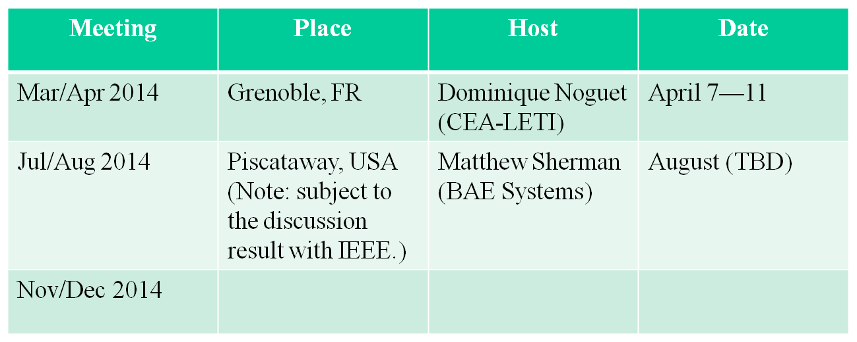
Motion No.3: To approve the above meeting plan (in slide No 35 of the document sc-13-0051-01-MTNG).
Moved by: Dominique Noguet
Seconded by: Vinh Dien Hoang
Discussion on the motion: None
Objection: 0, Abstention:0. Motion passed by unanimous consent.
The meeting was recessed at 17:00 local time.
Wednesday, December 4th, 2013 15:20
Item 6: Wrap-up reports
6.1 Wrap-up report of 1900.1 WG
- The 1900.1 WG Chair (Oliver Holland) presented the wrap-up report of 1900.1 WG activities during this meeting. The report is available as DCN sc-13-0053-00-MTNG in the mentor
https://mentor.ieee.org/dyspan-sc/documents
6.2 Status report of 1900.5 WG
- The 1900.5 WG Chair (Matthew Sherman) presented the wrap-up report of 1900.5 WG activities. The report document is DCN 5-13-0082-00-mmat.
- Regarding the comment to FCC (sc-13-0054-00-MTNG), Hiroshi Harada asked each WG Chair to present their opinion.
- After hearing all comments from the WG Chairs, Hiroshi Harada asked Matthew Sherman to resolve the comments, update the draft and send to Hiroshi Harada for confirmation before submit to the FCC.
6.3 Status report of 1900.6 WG
- The 1900.6 WG Chair (Michael Gundlach) presented the wrap-up report of 1900.6 WG activities. The report document is DCN sc-13-0051-01-MTNG.
- Michael recommended the DySPAN-SC Chair to appoint Oliver Holland as Acting Chair of the WG.
- Hiroshi Harada appointed Oliver Holland as Acting Chair of the WG.
- Hiroshi Harada appointed Ha Nguyen Tran as the election processor for the election of the 1900.6 WG Chair.
6.4 Status report of 1900.7 WG
- The 1900.7 WG Chair (Stanislav Filin) presented the wrap-up report of 1900.7 WG activities. The report document is DCN 7-13-0071-00-REPT.

Meeting schedule update
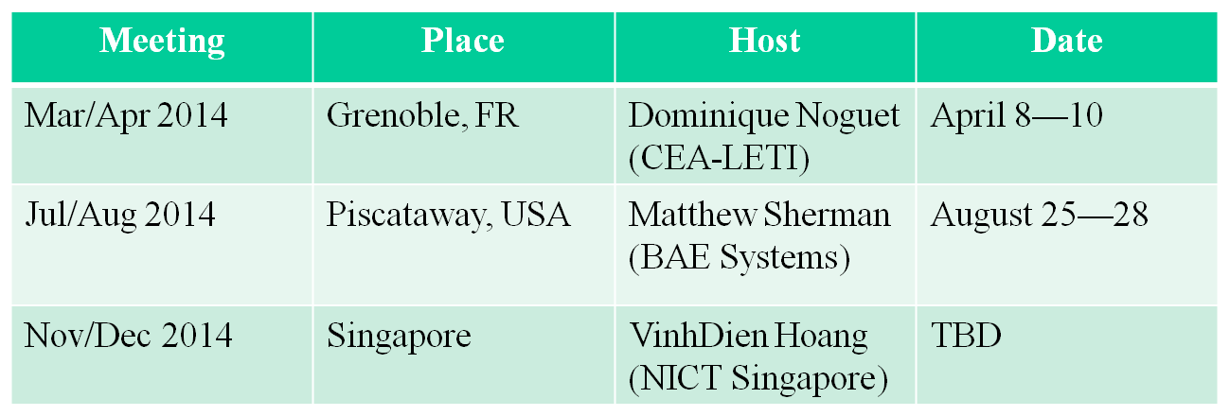
Motion No4: To approve the above meeting plan.
Moved by: Dominique Noguet
Seconded by: Vinh Dien Hoang
Discussion on the motion: None
Objection: 0, Abstention: 0. Motion passed by unanimous consent.
Item 8: AoB
- None.

The meeting was adjourned at 16:30 local time.
Appendix A
List of Participants
 | Last name | First name | Employer | Affiliation | Opening session | Closing session
1 | Filin | Stanislav | NICT | NICT | X | X
2 | Harada | Hiroshi | NICT | NICT | X | X
3 | Holland | Oliver | King’s College London | King’s College London | X | X
4 | Ishizu | Kentaro | NICT | NICT | X | X
5 | Tran | Ha Nguyen | NICT | NICT | X | X
6 | Noguet | Dominique | CEA | CEA | X | X
7 | Swain | Darcy | MITRE | US DoD | X | X
8 | Lu | Liru | NICT Singapore | NICT | X | X
9 | Gundlach | Michael | NSN | NSN | X | X
10 | Hoang | Vinh Dien | NICT Singapore | NICT | X | X
11 | Prasad | Venkatesha | TU Delf | TU Delf | X | X
12 | Zhang | Xin | NICT Singapore | NICT | X | X
13 | Sherman | Matthew | BAE Systems | BAE Systems | X | X
14 | Muhammad | Aljuaid | Saudi Aramco | Saudi Aramco | X
15 | Bochow | Bernd | FOKUS | Self/IEEE member | X | X

