**IEEE P802.24**

**Vertical Applications Technical Advisory Group**

|  |  |  |
| --- | --- | --- |
| Project | IEEE P802.24 Vertical Applications Technical Advisory Group | |
| Title | **Proposed Text for adding WBMS (Wireless Battery Management System) in Clause 3.5 of the AFV White Paper (Doc. 24-23-0007-05-0000)** | |
| Date Submitted | 2024-07-06 | |
| Source | Hyeong Ho Lee (Seoul National University of Science & Technology/Netvision Telecom Inc.) and Jin Seek Choi (Hanyang University) |  |
| Re: | Additional content | |
| Abstract | This contribution proposes Texts and Figures of WBMS (Wireless Battery Management System) for Clause 3.5 of the AFV White Paper (Doc. 24-23-0007-05-0000). | |
| Purpose | To be added in Clause 3.5 of the AFV draft (Doc. 24-23-0007-05-0000). | |
| Notice | This document has been prepared to assist the IEEE P802.24. It is offered as a basis for discussion and is not binding on the contributing individual(s) or organization(s). The material in this document is subject to change in form and content after further study. The contributor(s) reserve(s) the right to add, amend or withdraw material contained herein. | |
| Release | The contributor acknowledges and accepts that this contribution becomes the property of IEEE and may be made publicly available by P802.24. | |

# AFV Fueling Use Cases

## Wireless Communication for EV Battery Management (WBMS)

Lithium-Ion-based Batteries (LIBs) are extensively used as a primary battery energy storage system in high power battery packs typically used in Electric Vehicles (EVs) and stationary grid-tied energy storage stations. However, the narrow safe operating area necessitates an effective Battery Management System (BMS) for almost all practical purposes [3.5-1]. The functionalities of a BMS includes State Of Charge (SOC) estimation and State Of Health (SOH) estimation, State Of Power (SOP) estimation, Remaining Useful Life (RUL) prediction, temperature measurement/estimation, cell balancing, fault detection/diagnosis and thermal management.

A BMS consists of several hardware components such as sensors, microcontrollers and software to perform all these functionalities. Therefore, a suitable communication architecture is essential for establishing data communication inside the BMS among internal sensors and controllers alongside communication with external devices for data storage, display and external control. Traditionally, communication between the hardware components of the BMS has been over wires. For example, wired BMS has been widely used in battery-powered systems, where Controller Area Network (CAN)-bus and I2C/SPI communication protocols are commonly used. However, CAN-bus communication requires a large wired mesh network to collect sensor data and transmit it to the BMS’s master controller, making implementation cost, weight, and design complexity very high. Clearly, the use of wired networks in BMS increases the complexity of certain issues, including manufacturing difficulties, increased wiring costs, and complex design procedures for battery packets due to isolation issues. Therefore, research on Wireless Battery Management System (WBMS) is underway to minimize the BMS wiring complexity.

The advantages of WBMS over wired BMS are explained and listed in detail as follows.

● The WBMS offers improved system reliability, lower weight and cost due to reduced wiring complexity, elimination of the requirement of galvanic isolations and physical connectors, especially for high capacity multicell battery packs. WBMS also increases the flexibility of sensor placement inside the BMS and the placement of the BMS module itself inside the powertrain. The WBMS has high fault tolerance and adequate scalability when compared to conventional modularized BMS. Moreover, WBMS also enables the replacement of individual components without reconstructing the entire system.

● The WBMS not only minimizes the wiring complexity but also supports location positioning for battery modules. IoT can provide a reliable solution to the BMS problem. IoT devices containing a communication component and a system-on-chip Integrated Circuit (IC) form the central element of a WBMS. The communication subsystem uses IoT protocols and IoT gateways to communicate with external systems, such as the converter and the internal modules.

● The WBMS can minimize the massive wiring harness, space requirement and physical connection failure, while simultaneously eliminating complex rewiring for each new vehicle and rewiring in the event of a single cell failure. Thereby, WBMS can enhance the scalability of a battery pack with little additional investment.

The basic architecture of a WBMS is almost similar to a traditional wired BMS. All features are also common in both architectures. The only major difference lies in the internal and external communication channels. Information from each cell, such as voltage, current, and temperature, is required to estimate various states and realize control and management operations by the centralized master controller of the BMS. Now, in the case of WBMS, all these information exchange between each sensor node, master controller, on-board display device, data storage device and other control and management devices is implemented through wireless communication channel rather than wired communication as in the case of wired BMS. Recently developed cloud-based BMSs also use wireless internet communication for two-way communication between the onboard BMS and cloud BMS. The schematic layout of a typical WBMS is shown in Figure 3.5-1.

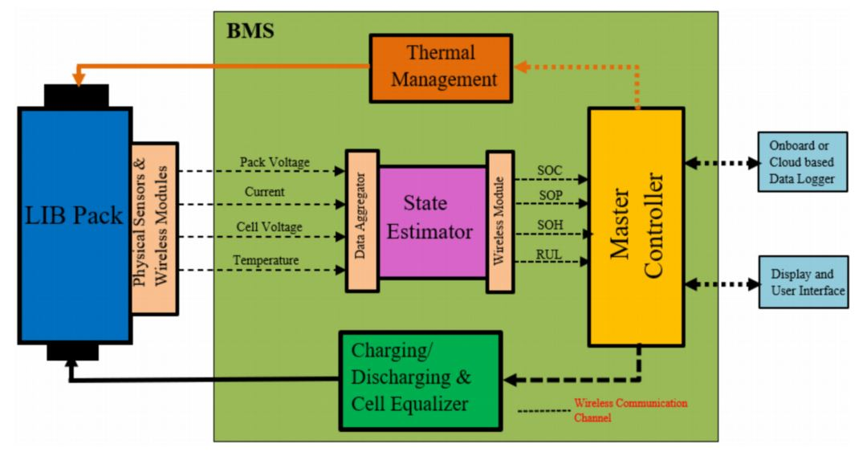

Figure 3.5-1. Schematic layout of a typical WBMS [3.5-1].

Figure 3.5-2 shows an example of the overall system architecture of a distributed and decentralized WBMS, and Figure 3.5-3 shows an example of the system architecture and components of a cloud-based WBMS. In cloud-based WBMS shown in Figure 3.5-3, IoT sensor of the wireless Module Management System (MMS) measures the current, voltage, and temperature of the battery at a given time. Since the nodes (or EVs) cannot store large amounts of data, the data is sent to the cloud server using TCP/IP protocol through the IoT gateway, where it is stored in the cloud data storage. On the other hand, MMS receives health monitoring process results from the Cloud Battery Management Platform (CBMP). The CBMP is used to support battery health monitoring system to detect defects in battery cells.

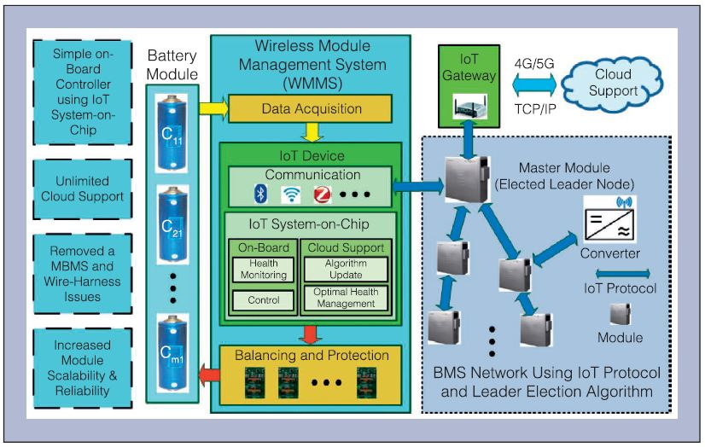

Figure 3.5-2. Example of overall system architecture of a distributed WBMS [3.5-2, 3.5-3].

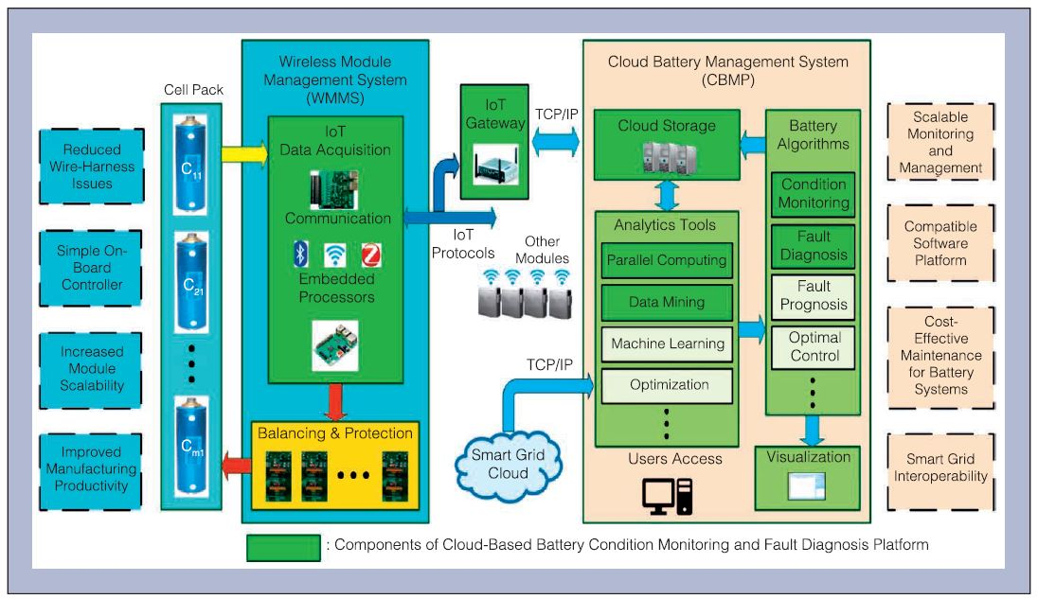

Figure 3.5-3. Example of the system architecture and components of a cloud-based WBMS [3.5-4, 3.5-5].

WBMS has been an active research topic since the early 2010s. Many authors have proposed various ways to implement this in stationary and automotive applications. Key questions concern which wireless protocol and network topologies are best suited for these critical applications. Several studies on wireless communication of WBMS are reviewed as follows [3.5-1, 3.5-6].

● Jamaluddin et al. proposed a wireless battery monitoring system based on Bluetooth Basic Rate (BBR) that uses a Bluetooth module to share battery data with a computer in stationary applications [3.5-7]. Shell et al. presented a BBR WBMS system designed and implemented for racing go-kart to reduce mechanical failures of wired BMS [3.5-8]. In both works, the proposal used only one slave and one master. None of them provided data on latency, reliability, or energy consumption. Although BBR consumes much less power than Wi-Fi, it is still higher for WBMS and cannot guarantee deterministic latency, which is important in critical applications [3.5-9].

● Le Gall proposed a wireless network for reliable electric vehicle BMS based on IEEE Std. 802.15.4-2015 Time Slotted Channel Hopping (TSCH) [3.5-10]. The wireless network was implemented and tested in a Renault Fluence battery pack environment using the IEEE Std. 802.15.4 TSCH physical and link layers. Final tests showed that wireless communication for WBMS is feasible as the network can adjust its topology depending on the link quality. However, there are still several important aspects that need to be considered before implementation in real EVs, such as security issues, BMS power saving modes, cost benefits, power consumption, and topology definition.

● Kunitachi et al. presented reliable wireless communication for WBMS based on TSCH network [3.5-11]. They proposed using overhear techniques to establish a highly reliable link between the nodes and the master. With this protocol, when a source node sends a packet to its destination, its neighbor nodes will listen to the packet. If the destination does not receive the packet, the neighbor nodes retransmit using CSMA to check if the channel is available. The network simulation results show that up to 100 % reliability can be achieved. Although the article does not present energy consumption results, the overhear technology requires high radio utilization, which increases the power consumption of the nodes.

● Wu et al. proposed a WBMS implementation based on the Zigbee protocol [3.5-12]. They monitored a 50Ah battery pack composed of 108 Li-cells with a sampling period of 200ms. The authors confirm that the maximum current consumption of the devices is 28mA. However, there are no network performance results in the analysis. Although Zigbee is a standardized, low-cost, low-power wireless protocol, it has some limitations for critical applications such as WBMS. It is not designed to guarantee deterministic latency or high reliability [3.5-1].

● Huang et al. proposed a Wireless Smart Battery Management System (WSBMS) [3.5-13], that uses Wi-Fi connections between the master and slaves. It can also calculate the SOC and SOH to keep the battery cells balanced. This work does not provide details about the network performance (reliability) or the power consumption. It is well-known that Wi-Fi networks are designed for high throughput without special consideration for limited latency.

● M. Lee et al. proposed a WBMS based on a proprietary protocol called Wireless Battery Area Network (WiBaAN) [3.5-14]. This protocol uses FSK modulation in the 900MHz ISM band with the data rate up to 1Mbps. It does not use channel hopping because they prefer to use channel diversity to allow multiple WBMS networks in the same space. The authors confirmed the achievement of a reliable network, but no data from simulations or experiments were presented.

Recently some vendors, such as Analog Devices (ADI) and Texas Instrument (TI), have announced and are offering commercial WBMS solutions for the EV automotive markets. They all claim that their breakthrough technology reduces the battery pack assembly and design complexity. A summary of ADI’s activities related to WBMS solutions is as follows.

● ADI recognizes the industry’s need to implement robust wireless communications inside battery packs, and proposes a WBMS system based on a modified version of the proven SmartMesh IP technology. ADI’s SmartMesh IP products are wireless chips and pre-certified PCB modules with ready-to-deploy wireless mesh networking software. They are built for IP compatibility and based on the 6LoWPAN and 802.15.4e standards. The SmartMesh IP, ADI’s commercial TSCH solution, enables low power consumption and 99.999% data reliability, even in harsh and dynamically changing RF environment [3.5-15]. The manufacturer created a microcontroller with a hardware MAC engine to execute MAC-related operations with lower power consumption than using a microcontroller [3.5-16].

● The first ADI WBMS concept was implemented in the BMW i3, where the main motivation was to improve system reliability and reduce the cost and wiring complexity of the battery pack. ADI notes that the timing synchronization characteristics of a TSCH network helps the BMS algorithms to compute the SOC and SOH more accurately. They also foresee that with the additional local processing at each module there is a potential to enable the concept of smart battery modules [3.5-17].

● In December 2021, General Motors (GM) launched the Hummer EV, the first commercial EV equipped with ADI’s WBMS. ADI claims that its WBMS system facilitates diagnosis of malfunctioning modules, replacement and integration into new Second Life applications [3.5-18]. The system has achieved the ISO/SAE 21434 certification, which is an assessed automotive cybersecurity certificate [3.5-19].

Texas Instruments (TI) confirms that cable failures to BMS are costly, with the largest failures occurring in connectors and wiring harnesses. They argue that implementing wireless connectivity reduces weight, reduces costs, and avoids the isolation problems typical of traditional wired BMS [3.5-20]. The following summarizes TI’s activities related to WBMS solutions.

● TI developed a commercial implementation of WBMS based on the Simplelink MCU platform, a well-known low-power wireless connectivity solution for IoT [3.5-21]. They have developed a proprietary protocol for a WBMS solution using frequency hopping technique and the 2.4 GHz band with a data rate of 2 Mbps. The vendor confirms that its system achieved 99.999 % of reliability [3.5-22].

● TI launched the first WBMS TUV SUD assessed for enabling ASIL D functional safety systems [101]. To achieve this, TI uses the black channel concept. There are two possible architectures for safety-related data transmission: White channel and black channel. In the first, all hardware and software components are developed and validated according to functional safety standards. On the other hand, the black channel concept means that the end devices (BMS controller and ASIC BMS) must be safety compliant but it is not necessary for the components of the communication channel, which is the case of the wireless MCU used in the system [3.5-23].

● TI WBMS system features CRC-32 to detect data corruption and 4-byte MAC (Message Authentication Code) to ensure authenticity and integrity. The wireless protocol encapsulates the BMS ASIC commands and responses without modifying the data. In this way, the system can detect errors in the communication channel without interfering with the safe communication protocol between the BMS controller and the ASIC BMS [3.5-23].

In addition to ADI and TI, several venders have disclosed their activities on WBMS. Renesas proposed a BLE-based solution using SmartBond TINY, which it claims is the world’s smallest and lowest-power BLE SoC [3.5-24]. Visteon announced that General Motors will use Visteon wireless BMS technology, called wireless smartBMS, in all planned EV models powered by Ultium batteries [3.5-25]. Marelli announced its WBMS, which can reduce wiring harness up to 90%, increasing flexibility, efficiency, reliability and reducing costs in electric vehicles [3.5-26].

Acronyms

ADI Analog Devices

ASIC Application-Specific Integrated Circuit.

ASIL Automotive Safety Integrity Level.

BBR Bluetooth Basic Rate

BLE Bluetooth Low Energy

BMS Battery Management System

CAN Controller Area Network

CBMP Cloud Battery Management Platform

CRC Cyclic Redundancy Check

CSMA Carrier Sense Multiple Access

EV Electric Vehicle

GM General Motors

I2C/SPI Inter-Integrated Circuit / Serial Peripheral Interface

IC Integrated Circuit

IoT Internet of Things

ISM Industrial, Scientific and Medical

LIB Lithium-Ion-based Batteries

MAC Medium Access Control

MAC Message Authentication Code

MCU Micro Controller Unit

MMS Module Management System

RF Radio Frequency

RUL Remaining Useful Life

SoC System on Chip

SOC State Of Charge

SOH State Of Health

SOP State Of Power

TI Texas Instrument

TSCH Time Slotted Channel Hopping

WBMS Wireless Battery Management System

WiBaAN Wireless Battery Area Network

References

[3.5-1] Akash Samanta and Sheldon S. Williamson, “A Survey of Wireless Battery Management System: Topology, Emerging Trends, and Challenges,” Electronics 2021, 10, 2193. https://doi.org/10.3390/electronics10182193

[3.5-2] T. Faika, T. Kim, and M. Khan, “An Internet of Things (IoT)-based network for dispersed and decentralized wireless battery management systems,” Proc. 2018 IEEE Transportation Electrification Conf. Expo, Jun. 2018.

[3.5-3] Fazel Mohammadi, and Rashid Rashidzadeh, “An Overview of IoT-Enabled Monitoring and Control Systems for Electric Vehicles,” IEEE Instrumentation & Measurement Magazine, pp.91~97, May 2021.

[3.5-4] A. Adhikaree, T. Kim, J. Vagdoda, A. Ochoa, P. J. Hernandez, and Y. Lee, “Cloud-Based Battery Condition Monitoring Platform for Large-Scale Lithium-Ion Battery Energy Storage Systems Using Internet-of-Things (IoT),” 2017 IEEE Energy Conversion Congress and Exposition (ECCE), 2017.

[3.5-5] T. Kim, D. Makwana, A. Adhikaree, J. S. Vagdoda, and Y. Lee, “Cloud-based battery Condition monitoring and fault diagnosis platform for large-scale Lithium-Ion battery energy storage systems,” Energies, vol. 11, no. 1, Jan. 2018.

[3.5-6] Fabian Rincon Vija. “Enabling robust wireless communication for battery management systems in electric vehicles,” PhD thesis, Ecole nationale supérieure Mines-Télécom Atlantique, 2022.

[3.5-7] Anif Jamaluddin et al., “Development of Wireless Battery Monitoring for electric vehicle,” 2014 International Conference on Electrical Engineering and Computer Science (ICEECS), IEEE, pp. 147–151.

[3.5-8] Cody Shell et al., “Implementation of a wireless battery management system (WBMS),” 2015 IEEE International Instrumentation and Measurement Technology Conference (I2MTC) Proceedings, IEEE, pp. 1954–1959.

[3.5-9] Akash Samanta and Sheldon S Williamson, “A Survey of Wireless Battery Management System: Topology, Emerging Trends, and Challenges,” Electronics 10.18 (2021), p. 2193.

[3.5-10] Guillaume Le Gall, “Wireless network for reliable electric vehicle battery management,” PhD thesis, Ecole nationale supérieure Mines-Télécom Atlantique, 2021.

[3.5-11] Tadahide Kumtachi, Kazuhiko Kinoshita, and Takashi Watanabe, “Reliable wireless communications in battery management system of electric vehicles,” 2017 Tenth International Conference on Mobile Computing and Ubiquitous Network (ICMU), IEEE, pp. 1–6.

[3.5-12] Yun Wu et al., “A Battery Management System for electric vehicle based on Zigbee and CAN,” 2011 4th International Congress on Image and Signal Processing, vol. 5, IEEE, pp. 2517–2521.

[3.5-13] Xinrong Huang et al., “Wireless smart battery management system for electric vehicles,” 2020 IEEE Energy Conversion Congress and Exposition (ECCE), IEEE, pp. 5620–5625.

[3.5-14] Minkyu Lee et al., “Wireless battery management system,” 2013 World Electric Vehicle Symposium and Exhibition (EVS27), IEEE, pp. 1–5.

[3.5-15] Fabian Rincon, Yasuyuki Tanaka, and Thomas Watteyne, “On the impact of WiFi on 2.4 GHz industrial IoT networks,” 2018 IEEE International Conference on Industrial Internet (ICII), IEEE, pp. 33–39.

[3.5-16] Thomas Watteyne et al., “Technical overview of SmartMesh IP,” 2013 Seventh International Conference on Innovative Mobile and Internet Services in Ubiquitous Computing, IEEE, pp. 547–551.

[3.5-17] Greg Zimmer et al., “Wireless Battery Management Systems Highlight Industry’s Drive for Higher Reliability,” Linear Technology, February 2017, url: https://www.analog.com/media/en/technical-documentation/technical-articles/s65-wireless_bms_en.pdf

[3.5-18] Norbert Bieler and Paul Hartanto-Doeser, “wBMS Technology: The New Competitive Edge for EV Manufacturers,” Analog Devices, 2022, url: https://www.analog.com/en/signals/thought-leadership/wbms-tech-competitive-edge.html

[3.5-19] Analog Devices, “Wireless Battery Management Systems (wBMS),” url: https://www.analog.com/en/product-category/wireless-battery-managementsystems.html

[3.5-20] Mark Ng, Texas Instruments, “How Innovation in Battery Management Systems is Increasing EV Adoption,” 2022, url: https://www.ti.com/lit/wp/slyy218/slyy218.pdf

[3.5-21] Texas Instruments, “SimpleLink™ Microcontroller Platform,” 2018, url: https://www.ti.com/lit/ml/swat002b/swat002b.pdf

[3.5-22] David Lara and Danovan Porter, “Cable replacement using wireless technologies in automotive,” 2020, url: https://www.ti.com/lit/ml/slyp670/slyp670.pdf

[3.5-23] Tomas Urban, « Functional Safety-Relevant Wireless Communication in Automotive Battery Management Systems,” 2021, https://www.ti.com/lit/fs/sluucf5/sluucf5.pdf

[3.5-24] Renesas, “Wireless EV Battery Management System,” url: https://www.renesas.com/us/en/applications/automotive/ev-hev-vehicles/wireless-ev-battery-management-system

[3.5-25] Visteon, “Visteon Complements Industry-First Smart Wireless Battery Management System with Additional Electrification Technology,” 2022, url: https://www.visteon.com/newsroom/visteon-complements-industry-first-smart-wireless-battery-management-system-with-additional-electrification-technology

[3.5-26] Marelli, “Marelli launches its Wireless Distributed Battery Management System,” 2022, https://www.marelli.com/en/news/marelli-launches-wireless-distributed-battery-management-system-wbms.html