**IEEE P802.24**

**Vertical Applications Technical Advisory Group**

|  |  |  |
| --- | --- | --- |
| Project | IEEE P802.24 Vertical Applications Technical Advisory Group | |
| Title | **White Paper: IEEE 802 Networks for next-generation Electric Vehicle Charging Infrastructure and use cases** | |
| Date Submitted | 2022-07-16 | |
| Source | Craig Rodine, Adedamola Adesokan, Sheryl Drake, Jin Seek Choi, Hyeong Ho Lee, Young Kyu Ko, |  |
| Re: | Draft with additional content | |
| Abstract | This white paper describes how IEEE 802 standards and technologies can help to enhance the features, performance, security, and convenience of Electric Vehicle charging infrastructure. It provides examples of emerging, advanced use cases and the networked integration of EV charging with other platforms and capabilities at the ‘energy edge’. | |
| Purpose | To encourage innovative thinking and proof-of-concept experiments using IEEE 802 standards and technologies to integrate the control and management of next-generation distributed power systems. | |
| Notice | This document has been prepared to assist the IEEE P802.24. It is offered as a basis for discussion and is not binding on the contributing individual(s) or organization(s). The material in this document is subject to change in form and content after further study. The contributor(s) reserve(s) the right to add, amend or withdraw material contained herein. | |
| Release | The contributor acknowledges and accepts that this contribution becomes the property of IEEE and may be made publicly available by P802.24. | |

# Introduction

The growing adoption of vehicles powered by electricity and hydrogen, instead of traditional fossil fuels like gasoline and diesel, creates the opportunity and need to re-consider fueling processes and infrastructure. The ‘user experience’ of fueling a traditional Internal Combustion Engine (ICE) vehicle is familiar throughout the world. Everything from station locations and hours of operation, to safety precautions and ergonomics; the resources (time and money) required; how to use the dispenser; the units of measure and method of sale, including financial transaction and receipt; are well-known and effectively taken for granted by the driving public. However, many aspects of the fueling experience can and will likely be quite different for the new, non-ICE Alternative Fuel Vehicles.

In this white paper, the term Alternative Fuel Vehicle (abbreviated AFV) designates Electric Vehicles (EVs) and Hydrogen Surface Vehicles (HSVs), the two leading types of AFVs coming into use. Since the vast majority of AFVs in use are pure battery electric vehicles, our focus in this whitepaper is almost exclusively on EVs and their charging infrastructure.

One significant difference is that AFV vehicles connect to their fueling infrastructure via a coupler that enables analog signaling and/or digital communication between the devices. (Currently, by way of wires in cables used for EV charging or an infrared link for HSV fueling.) This capability supports control protocols that manage the transfer of electrical energy or gaseous hydrogen; in principle, it could be used for other communications as well.

This whitepaper presents some use cases, requirements, and integration oppor­tunities for AFV fueling that take advantage of mainstream IEEE 802 communications technologies and standards across a range of scenarios and sites.

# Overview of AFV Fueling

This section describes common aspects and characteristics of AFV fueling processes as background and orientation to the use cases presented in Section 3.

## AFV – Fuel Dispenser Mechanical Connection

Every fueling process requires a means for fuel (liquid gas/petrol, electricity, liquid or gaseous hydrogen) to flow between the dispenser and the vehicle. It’s helpful to refer to this mechanism as a *coupler* with two mating components, an *inlet* (on the vehicle) and a *connector* or *nozzle* (on the dispenser).

The familiar “gas pump handle” used to fuel an ICE is a simple coupler whose critical mating feature is the diameter of the nozzle spout and fuel filler neck. This “physical coding” prevents a diesel fuel nozzle from being inserted into a petrol inlet, or leaded petrol from being pumped into an ICE that requires unleaded fuel. An ICE coupler’s control and safety features are all mechanical: fuel-tank shutoff, attitude shut-off, a no-pressure-no-flow device, etc. There is no explicit signaling or communication between ICE fueling infrastructure and vehicles.

A gaseous hydrogen fuel coupler is similar to the ICE design but more complex, requiring a mating collar with magnet for dispenser activation and a sealing/locking feature for safety, since the gaseous fuel is under pressure. The HSV specifies its fueling pressure (H35 or H70 service) via one-way infrared communication and can send an ‘emergency stop’ message if the vehicle detects an unsafe condition. (The dispenser can also detect an anomaly and shut down, but it can’t communicate the condition or its cause to the vehicle.)

For *conductive* charging of EVs, there are multiple standards-based couplers designed for manual, ergonomic insertion; they use mating pin-and-sleeve (contact-tube) electrical contacts like other standards for high-voltage electrical plugs and sockets (e.g. the IEC 60309 series). All DC couplers support mechanical or magnetic locking to prevent arc flash on separation of connector from inlet with high voltage on the contacts. Some AC coupler designs include a locking feature, primarily for physical security (to prevent a charging cord from being stolen) and only secondarily for electrical safety.

EVs can also be charged in a “wireless” manner via induction. For inductive charging, electrical energy is passed over an air gap between coils in the infrastructure and the vehicle. In a typical prototype implementation, the dispenser coil is embedded in the floor or in a moveable pad or platform, and the mating coil is mounted on the underside of the E as shown in Figure X1 [s1]. Charging is done by positioning the vehicle over the pad for optimal energy flow between the coils; this could be accomplished with automatic vehicle control (e.g. EV autonomous driving capabilities). Naturally, the communications used to control inductive charging is also wireless. One system sends control signals on the energy transfer frequency (~25 kHz or 85 kHz), while one prototype used JSON messages over IEEE 802.11/Wi-Fi® for coil compatibility and positioning.

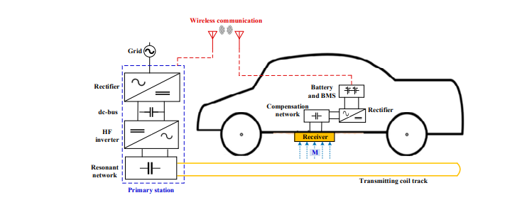

Figure X. EV Inductive Power Transfer Components

Finally, there are standards for robotic control of EV-infrastructure charging using pantograph mechanisms to connect rails or other, multi-pole contact systems to charge electrically powered buses as shown in Figure X2 [s2] Such a system can deliver power at high levels, up to 1 MW for 30 seconds or 400 kW for 15 minutes. Wireless communications, including IEEE 802.11n, is designated as the means for operating the pantograph, performing connectivity and safety checks, and controlling energy flow.

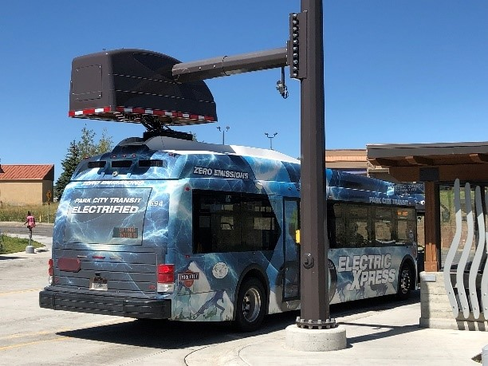

Figure X2. Pantograph charging.

## Energy Requirements and Supply

For conductive charging, AC systems use ubiquitous utility service to charge the EV traction battery via AC-DC converters (power electronics-based rectifiers) situated on board the EV. In North America, utility service is nominally 117-120 VAC and 208-240 VAC, both single phase; these are called Level 1 (L1) and Level 2 (L2) AC charging levels, respectively. In Europe the coupler has five pins for power, enabling it to support three-phase as well as single-phase AC charging; nominal service voltage is 230 VAC per phase.

DC “Fast Charging” (DCFC, Level 3) stations are typically powered by three-phase AC power from the utility at 400-480 VAC, the typical service voltage for commercial and industrial sites. AC input power is converted to DC through multiple steps including AC-to-DC conversion, DC power smoothing, and providing the DC voltage and current required by the EV. DCFC stations conforming to established IEC and SAE standards can deliver between 50-350 kW to the EV. In addition, the emerging Megawatt Charging System (MCS), defined in the IEC 63379 and SAE 3271 standards, supports charging voltage up to 1,250 VDC and currents up to 3000 A, potentially supporting EV charging at “multi-megawatt” levels. At charging rates above 150 kW significant heat is generated in energy conversion and transfer. Temperature sensors in the DC coupler (connector and inlet) and liquid cooled cables (in the charging station and EV) are used for thermal management: coolant is circulated through dedicated coolant channels integrated within the cables and pin housings and recycled though a heat exchanger to remove thermal energy from the system.

To avoid AC-DC power conversion losses, there is growing interest in using DC power as EV charging system input. Sources that generate DC power natively include photovoltaic (PV, solar panel) arrays and stationery (fuel cell and battery based) energy storage systems. In such a “DC microgrid” environment, an IEEE 802 network could provide a secure, flexible, and extensible communications fabric for the integration, coordination, and control of ‘energy edge’ systems supporting AFV fueling.

## Fueling Session Frequency and Duration

The charging level used impacts the “dwell time” (charging session duration) needed to reach a desired battery charge. Higher-powered (Level 3) DC Fast Charging enables shorter dwell times, while Level 2 AC charging requires longer charging sessions for the same energy charge. AC charge time is determined primarily by the charging voltage, for example to fill a mid-sized EV battery (40 kWh) from 10-80% charge with a Level 1 charger (120V delivering 1kW) would take approximately 28 hours, but only 1.5-4 hours using a Level 2 charger (240V at 7-19 kW). Charging time using DC chargers (400-900 V delivering 50-350kW) is much shorter, with the same EV charging scenario requiring approximately 5-33 minutes. to an hour, again based on starting charge, battery capacity, temperature, etc.

Use cases and business considerations strongly shape the vehicle charging facilities on offer. Maintenance costs are also a factor: some EV charging equipment is lightly used, delivering one or two charging sessions per day, e.g. an AC charging station in a residence or workplace. Others are used with higher frequency, perhaps as many as 24 sessions per day at a popular, publicly available charging station or highway-side heavy-duty vehicle charging site.

## Charging Infrastructure Environments

With the refinement of EV technology and the associated proliferation of EV vehicles in commercial, industrials and consumer areas, there is a variety of EV charging system architectures based upon the specific application requirements. When evaluating network architecture and design for an EV charging implementation, care to numerous factors such as the number and type of chargers needed with the associated power system connectivity and density requirements, as well as, deploying a physical and logical architecture which is robust, secure and scalable. Site assessments include determining site accessibility, physical security, greenfield (new) or brownfield (integrating legacy infrastructure with new charging infrastructure) installation characteristics.

While there are numerous implementation architectures, some common scenarios include:

* Single and multi-family residences with Level 2 AC stations
  + 1 to 10 chargers with Power level 3-11 kW (240V) each
  + Typical cable length 5 ± 2 m;
  + Medium physical security;
  + Mostly retrofit, but with some greenfield;
  + Wireless access spans would be covered by a single Wi-Fi AP.
* Workplaces and other long-dwell, high-user-density Charging sites
* Tens to a thousand L2 AC stations, power level 6-22 kW (208-240V) each, currently almost all 6.6-7.6 kW AC
* Typical cable length 5 ± 1 m;
* Wireless access spans would require one to many Wi-Fi APs
* Some workplace sites will resemble large public parking facilities, e.g. municipal or airport parking lots.
* Future - DC stations (same input voltage as AC but higher power level e.g. 11 kW);
* Publicly accessible facilities for short-dwell, high-power-delivery “fast charging”, such as urban and suburban dedicated fueling stations, parking structures, and highway rest stops;
  + DC Charging, multiple charging stations, short dwell
* Fleet vehicle depots, including privately owned (goods delivery, taxi pools) and publicly owned facilities (school districts, postal services, etc.)
  + Long-dwell L2 AC charging for overnight services (fleet, postal, school district)
  + Short-dwell DC charging for taxi pools, etc.
  + Higher physical and logical security requirements
* Highway-side fueling facilities for extremely-high-power-delivery long-haul truck re-fueling (“truck stops”)
  + High capacity, High-voltage DC Charging for heavy duty vehicles

## EV Charging Infrastructure Communications

Initiating a charging cycle from an EV to a charging station involves the exchange of information between multiple car systems components and the charging infrastructure to provide both the monitoring and control of the charging session and the authentication and billing for the charging service provided. During a charging cycle, once an EV is connected to a charge cable or is in physical proximity to an inductive charger, several authentication steps must be performed prior to the transfer of electric energy to the car. For public charging, the station may require authentication of the EV vehicle and/or driver to process payments and allow for the charging service to commence. Once authorization has been approved, the communications and handshaking begin between both the EV and the charging station to negotiate the charging level based upon both the capabilities of them both. After the session and power negotiations are complete, the charging of the EV batteries can begin where an on-board converter within the EV converts the charging station from AC (L1/L2) power to DC power which is required for battery energy storage. In the case of L3, or fast charging, the DC power supplied by the charging station can be directly stored in the battery without conversion. Throughout the charging session, charging status, battery health and energy usage are monitored and when the charging is complete, final handshaking between the EV and the charging station is completed regarding the session with billing and payment information shared between the customer and the charging system operator if applicable.

To accommodate this process there are several communications protocols which control various aspects of each of the charging session stages. Within the EV itself there are several communications system in place which control the powertrain and charging systems with many manufacturers using the CAN bus (Controller Area Network) protocol or vendor specific variations for communication between these various electronic control systems. Upon connection from the EV to the charging station, the IEC 61851 protocol is used to exchange data regarding charger and EV capabilities, the authentication and authorization processes, power negotiation and charging control. ISO 15118 provides similar functions including the frameworks for plug-and-charge (PnG) functionality and billing data communications. From the EV charger station to the charging operator and management system, Open Charge Point Protocol (OCPP) gives an interoperability standard used to manage and monitory the charging session including user identification, authorization and billing information. The various protocols required to manage the charging sessions rely upon a reliable layer 2/3 transport utilizing IEEE 802.3, 802.11 and 802.15 protocols to communicate data dependent upon the specific implementation. Additionally, 802.1X can be used to augment the security aspects of IEC 61851 and ISO 15118, providing an additional layer of user authentication control.

Historically, EV charging communications methods were created by auto and electrical infrastructure engineers to be ad-hoc ‘point’ solutions without knowledge of or regard for communications/network orientation or expertise. Typically, EV-EVSE interactions are not inherently communications intensive and could remain isolated however, many additional e-mobility service applications would require a more robust communication infrastructure.

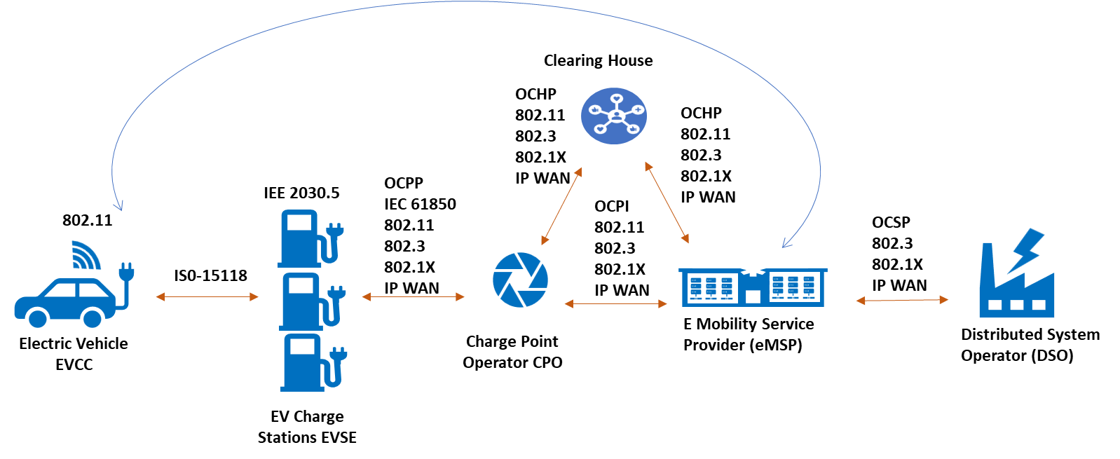

Figure X. EV Fueling Communications

# AFV Fueling Use Cases

With the increasing adoption of EVs, there will be many opportunities to leverage technological innovations to enhance charging session options and user satisfaction. This Section presents use cases that showcase potential improvements to EV charging in consumer and commercial settings. They illustrate how IEEE 802 standards can deliver the connectivity and communications that these novel use cases require.

## Public/Workplace Parking with Advanced Charging Services

*< Describe the use case ref. 24-22-0020-01-0000-afv-fueling-vertical-update.pptx, #5 >*

< Motivation – describe the currently supported scenario: driver has to locate a charging station, depending on signage that might not be clear, or perhaps by using an app but cellular coverage can be weak; then use different account credentials for charging and for parking. The site owner has no way to offer differentiated services, for example discounts for frequent customers (a loyalty program) or for charging at a lower power level so the site doesn’t exceed its load limit (“smart charging”), which limit might be dynamically controlled by the supplying utility. While some of these features might be possible using a charging service provider smartphone app, they’re not integrated with the EV nor the site/parking payment system. >

EV charging in public or workplace parking facilities could become more energy-efficient and driver-friendly with the introduction of advanced services such as managed or “smart” charging, automatic payment, real-time station availability information, charging session reservations and “waitlisting”, and charging mode selection (e.g. high-power, long-dwell, conductive/inductive). As always in a public or workplace setting, such enhanced services must be delivered reliably and in a secure manner.

To enable these capabilities, an EV could be equipped with an IEEE 802.11 Station (STA) that’s dedicated to communicating with infrastructure sites and services. When within range, the EV would scan for and connect with the site’s session initiation service available on their Wi-Fi® network (e.g. using an established SSID and URL similar to in-flight Wi-Fi/Internet services on planes). The session would be secured using IEEE 802.1X with the site’s infrastructure Access Point (AP) so service parameters, including access credentials, can be safely exchanged. Security should be Enterprise Grade, e.g. WPA-3 with certificate-based mutual device authentication and message encryption. Client certificates on EVs could be installed during service account creation, perhaps under the EV charging ecosystem PKI. (Notably, the SAE ITC EVPKI trust model has been designed to be extensible in order to support such emerging ancillary services throughout the ecosystem.) The Authentication Server could be site-based, or hosted in the cloud to facilitate centralized, integrated authentication and payment services for parking and EV charging across a parking provider’s or enterprise’s multiple sites.

Integrated parking and energy services

Following the establishment of a secure connection, the EV and EVSP would negotiate charging service/session parameters. This should begin as soon as possible to provide directions to a suitable parking spot and charging station. Matching driver needs to site resources would be based on the type of charging service needed (conductive or inductive, lower or higher power, etc.) and other parameters like the desired amount of energy in kilowatt-hours (kWh) or additional range (in miles or kilometers); the acceptable duration of the charging session; and pricing terms acceptable to the driver, based on dynamic pricing models, subscription plans, or fixed site rates. This information exchange would tailor the charging service to the needs of the EV and its driver and help allocate the energy supply available at the site to meet the overall EV charging demand.

The EVSP would then process this information and make the best match between the EV's request and the capabilities of the Electric Vehicle Charging Infrastructure (EVCI) available at the parking structure. This determination involves several key considerations:

* Account Verification: The EVSP checks if the driver has an existing account or subscription with the service, usually through a query to a Charging Station/Services Management Server (CSMS).
* Charging Station Availability: The EVSP assesses the availability of a charging station that can deliver the power level needed to provide the requested amount of energy or range within the desired session duration. This involves checking the current occupancy and operational status of the charging stations.
* Other Considerations: Additional factors such as compatibility with the EV's charging system, current grid conditions, and any special requirements or preferences set by the driver may also be considered.

< TODO: Insert a network architecture diagram >

Network architecture and segmentation considerations:

* Public Wi-Fi Network for Users
* EV Charging Infrastructure Network
* Operational and Administrative Network
* Payment Processing Network/overlay
* IoT and Surveillance Network/overlay

<TODO: Brief consideration of 802.11 for Hydrogen Surface Vehicle (HSV) Fueling

* + Describe current one-way IR link, need for two-way, ISO and SAE standards WG interest in using secure [enterprise] Wi-Fi (e.g. perhaps extending EV PKI for this case, too)

Automated Valet charging service using ADAS

Similarly, the use of an Automated Valet feature for EV Parking could be used to increase charger utilization efficiency and improve the customer experience. Utilizing autonomous driving capabilities, vehicles could independently navigate to designated charging stations within parking facilities, ensuring a seamless integration of charging services into the parking process.

Here, an Electric Vehicle (EV) could utilize the IEEE 802.11bd standard for secure, high-bandwidth vehicle-to-infrastructure communication to enable automated valet parking and efficient charging within a parking structure, leveraging autonomous navigation and smart charging technologies. Upon approaching the parking structure, the EV initiates communication using IEEE 802.11bd standard. This protocol is part of the enhanced Wireless Access in Vehicular Environments (WAVE) suite, specifically designed to facilitate direct vehicle-to-infrastructure (V2I), vehicle -to-vehicle (V2V) and other V2X communications, allowing the EV to securely connect to the parking structure’s communication network. The adoption of IEEE 802.11bd ensures enhanced reliability, lower latency, and increased bandwidth across these diverse communication channels, significantly improving the support for complex vehicular communications. Leveraging IEEE 802.1X for authentication, the EV establishes a secure communication link with the parking structure’s network, ensuring encrypted data exchange. Through this secure link, the EV communicates with the Electric Vehicle charging services platform (EVSP) to negotiate charging service parameters, as in the case above.

Once the charging service parameters are agreed upon, including type of charging, energy requirements, and session duration, the parking structure's management system activates the automated valet service for the EV. The EV could utilize standards under the IEEE P2040 family, which are related to road vehicle automation, to safely navigate within the parking structure. This involves real-time data exchange between the EV and infrastructure to guide the vehicle to the designated parking spot with the appropriate charging station. The EV's Advanced Driver-Assistance Systems (ADAS), enhanced for autonomous navigation in confined spaces then takes control. Using a combination of onboard sensors, cameras, and V2I communication, the EV autonomously navigates to the assigned parking spot, avoiding obstacles and adhering to the parking structure's traffic flow guidelines.

Upon reaching the designated parking spot, the EV aligns itself with the charging station and depending on the charging technology (conductive or inductive), the vehicle either automatically connects to the charging station through a robotic arm mechanism (for conductive charging) or positions itself accurately over an inductive charging pad. This process is facilitated by the Automatic Connection Device (ACD) feature set included in ISO 15118-20, which specifies advanced communication protocols for automated charging, ensuring a seamless and efficient connection between the EV and the charging infrastructure. With the physical connection established, the EV and the charging station commence the charging session based on the pre-negotiated parameters, ensuring the charging only begins after automatic authentication and authorization have been successfully completed. The EVSP monitors the session, adjusting as necessary to ensure optimal charging.

Throughout the charging session, the EV maintains a conductive or wireless communication link with the EVSP, providing updates on charging progress and any adjustments required due to changes in the EV's energy needs or the parking structure's power availability. Once the charging session is complete, or if the vehicle needs to be moved (e.g., to optimize parking space usage or for load balancing on the power grid), the EV can be autonomously navigated to a different spot or made ready for the driver to take over.

Similarly, for Hydrogen Surface Fueling processes, there is a growing interest to apply comparable secure wireless technologies. Currently, HSV fueling often relies on a one-way infrared (IR) communication link, which, while functional for basic data transmission, lacks the interactivity and security afforded by more advanced communication methods. Recognizing this limitation, there could be a clear need for transitioning to a two-way communication system, which would significantly enhance the fueling process by enabling dynamic data exchange between the vehicle and the fueling station.

The potential shift towards utilizing secure, enterprise-level Wi-Fi, possibly by extending the existing Public Key Infrastructure (PKI) used in EV scenarios could be closely examined to push for a more robust and flexible communication infrastructure that can support not only the current needs but also the future developments in HSV fueling technology. By adopting a two-way communication protocol, based on secure Wi-Fi technologies, HSVs could engage in a secure authentication process with the fueling station's infrastructure, like the IEEE 802.1X network access control used in EV charging. This would facilitate many advanced functionalities, such as real-time negotiation of fueling parameters, secure transaction processing, and enhanced compatibility checks, thereby ensuring a safe, efficient, and user-friendly fueling experience. Additionally, this approach would allow for the integration of smart grid capabilities, optimizing energy usage and contributing to overall grid stability.

## Low-power, long-dwell EV Fleet Charging

< Describe the use case ref. 24-22-0020-01-0000-afv-fueling-vertical-update.pptx, #4 >

- For a number of use cases, communications beween AC charging stations and a site-based or remote Charging Service Management System (CSMS) is required. Examples include vehicle and/or driver authentication; matching E-Van energy needs to charging station capabilities and availability; tracking and managing energy supply among charging stations; and providing firmware upgrade services to EV charging stations.

- Looking at the second example above in more detail: the main fleet use case is for overnight E-Van charging, but there might also be a need to charge vans between delivery runs. E-Van range with a full battery pack is typically 125 to 160 miles; charging requires the delivery of 68 kWh (Ford E-Transit) to 135 kWh (Rivian EDV/ECV). Depending on the initial state of charge (SoC, how much energy is in the battery when charging starts); and station power (7.6 kW to 22 kW), charging time to fully charge the E-Van battery can range between 3-18 hours. Fleets will have mix of shorter- and longer-range E-Vans; if every charging station must be able to charge any van overnight (say, between midnight and 6am) there will also be a mix of lower and high-power stations. To match stations to charging requirements, an E-Van could connect to a secure site Wi-Fi service when entering the depot and report its energy needs to the CSMS, which would make the match with an appropriate parking/charging bay. (Using the same process described in the Public Parking use case, Section 3.1, with perhaps additional service parameters exchanged in support of fleet logistics – see below.)

As more organizations electrify their fleet vehicles, the need for secure communications to support evolving EV charging technology. For EV fleet vehicles, maintaining a reliable and secure charging session is essential for both business needs and to protect sensitive organizational data. With the use of wireless technologies and other communication connectivity through the EV charging port, there is opportunities to leverage information gathered by the vehicle to optimize charging and other telematic logistical data within the fleet. Additionally, other opportunities though an 802 connected interface will allow for vehicle firmware updates for various systems such the Battery Management System (BMS), the Vehicle Control Unit (VCU), telematic and logistics management software or any required system security upgrades.

Since EV fleet vehicles are typically used in a time-bound manner allowing for overnight charging (long-dwell) sessions in depot settings the availability of numerous of medium-power L2 AC charging stations is required. AC charging can be simple, using only analog controls (see Appendix 1), and thus less expensive to deploy, with first-generation fleet vehicles charging stations being “standalone”, with minimal or no integration requirements, or external communications interfaces beyond RFID readers and Bluetooth capabilities for configuration. However, more advanced communications infrastructure would be required to support future applications in this area such as the integration of advanced technology and smart management to address the specific needs of electric vehicle (EV) fleets such as the optimization of charging based on operational patterns and predictive analysis, grid load balancing, and dynamic charging based upon time-of-day charging rates, grid condition and energy supply.

To illustrate, consider a package distribution or postal service operator employing electrified vans (E-Vans) within its fleet, multiple medium-power (Level 2, L2) AC charging stations would need to be installed at the operator’s depot. Upon arrival at the depot, each E-Van automatically initiates a secure wireless connection to the facility's network via its onboard IEEE 802.11 Station (STA) capability. This process involves the vehicle scanning for and establishing a connection with an infrastructure Access Point (AP), subsequently undergoing an authentication process managed by a back-end Authentication Server. This server is an integral component of the Charging Station/Services Management Server (CSMS), which leverages cloud technology for enhanced scalability and reliability, overseeing the authentication, monitoring, and management of EV charging sessions across the fleet.

Prior to the initiation of a specific charging session, authentication of the E-Van or driver could be implemented as exchanges over the secure Wi-Fi network. Here, When the E-Van arrives at the designated parking/charging bay, an EVSE with cable and connector (conductive charging service) might be plugged in to the EV by a robot arm that uses a camera and positioning sensors that all communicate via Wi-Fi. If the EVSE charges wirelessly, using inductive power transfer, Wi-Fi could be used to align the coil on the E-Van with the charging station coil embedded in the floor or mounted on a pillar. In both inductive and conductive charging cases, energy transfer can be managed by Wi-Fi messages between the EV and the charging station.

As part of the EV fleet charging infrastructure, the Charging Management System (CMS) can utilize advanced intelligence to schedule charging for each vehicle based on several factors such as the vehicle's current battery level, its anticipated energy needs for the upcoming day, and the depot's total energy capacity. This scheduling is dynamically adjusted in real-time to take advantage of fluctuating electricity prices, ensuring charging occurs during off-peak hours to maximize cost efficiency. Additionally, the system manages the depot's energy demand meticulously to prevent exceeding capacity limits. A pivotal feature of this system is the incorporation of Vehicle-to-Grid (V2G) capabilities, enabling not only the charging of the EVs but also allowing these vehicles to supply energy back to the grid during peak demand times. This bi-directional energy exchange is not just a potential source of additional revenue but also contributes to significant cost savings and promotes sustainable energy utilization.

*< We need to work out network configurations: whether these Wi-Fi services are infrastructure/ AP-based, over an ad-hoc network, over a point-to-point link, etc. based on site and use case requirements for coverage, performance, etc. >*

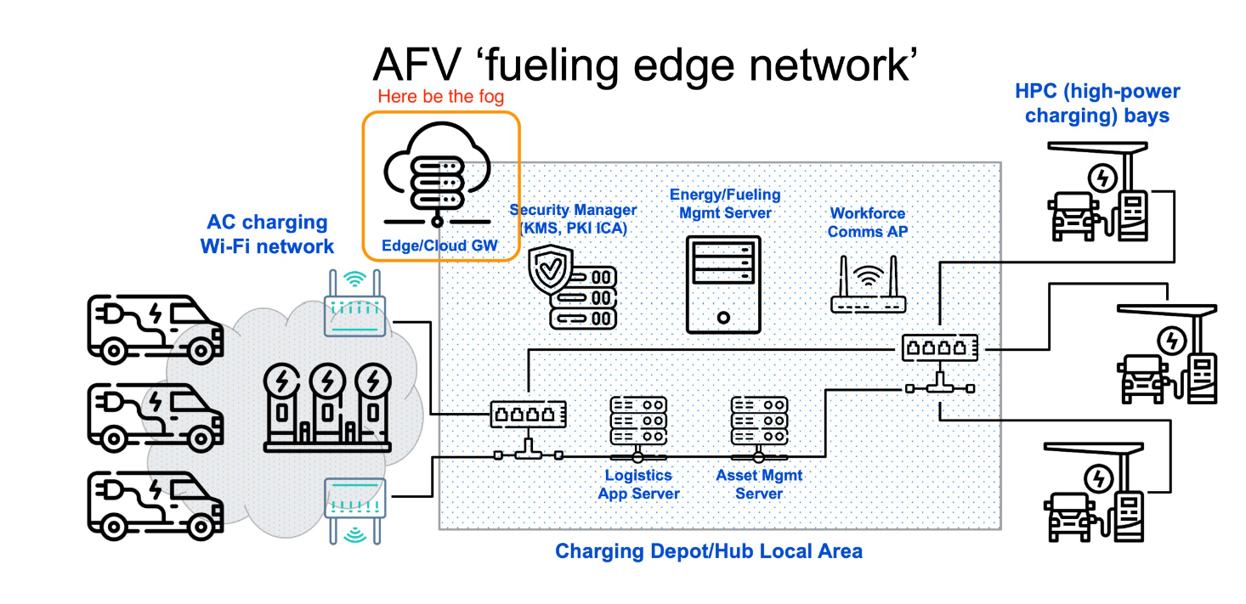

## High-power Medium/Heavy-duty Vehicle Charging

< Describe the use case ref. 24-22-0016-01-0000-ev-charging-vertical-overview.pptx, #8 >

Narrative:

1. Next-generation couplers for high-power EV charging (ChaoJi/CHAdeMO 3.0, SAE J3271 Megawatt Charging System [“MCS”]) include two pins for EV-charging station communications. Mechanical aspects (size, spacing, contact, etc.) were chosen to meet the high mating cycle requirements of the automotive industry (10,000). Signaling over the pins and conductors of these cable systems is still being defined, and there is interest in using IEEE 802.3 PHYs, specifically Single Pair Ethernet e.g. MultiGBase-T1 (IEEE 802.3ch), 1000Base-T1 (IEEE 802.3bp), 100Base-T1 (IEEE 802.3bw), 10Base-T1S (IEEE 802.cg), and 10Base-T1L (IEEE802.3cg) 802.3.
2. Incorporating EVs as peer stations on an Ethernet LAN has several advantages.  
   - best in class digital trust and cybersecurity  
   - trusted metering and energy management for uni- and bi-directional power flows  
   - fine-grained data on EV traction battery health (e.g. from/to BMS)  
   - capacity (bitrate, bandwidth) for EV services, e.g. diagnostics, FW/SW updates  
   - high-volume/critical data transfer, e.g. map updates, fleet ops, payload tracking
3. Drill down on security aspects  
   - endpoint authentication using IEEE 802.1X  
   - other L2 security features (e.g. MACSEC)  
   - security for BPT transactions, e.g. trusted pricing, metering; non-repudiation  
   - support for higher-layer application security - (app/user authentication, MFA, ZTA)  
   - potential for using ML to track normal and anomalous EV charging behaviors
4. Drill down on energy management aspects  
   - waveforms for power transfers e.g. BPT and integration with on-site battery storage  
   - proof of conformance/performance to managed energy programs/signals  
   - backhaul for wireless WBMS

## Wireless Communication for EV Battery Management (WBMS)

< use case introduced in the March 2024 802 Plenary Session by Hyeong Hon LEE and Jin Seek CHOI, DCN 24-24-0005-00-0000) >

Lithium-Ion-based Batteries (LIBs) are extensively used as a primary battery energy storage system in high power battery packs typically used in Electric Vehicles (EVs) and stationary grid-tied energy storage stations. However, the narrow safe operating area necessitates an effective Battery Management System (BMS) for almost all practical purposes [3.5-1]. The functionalities of a BMS includes State Of Charge (SOC) estimation and State Of Health (SOH) estimation, State Of Power (SOP) estimation, Remaining Useful Life (RUL) prediction, temperature measurement/estimation, cell balancing, fault detection/diagnosis and thermal management.

A BMS consists of several hardware components such as sensors, microcontrollers and software to perform all these functionalities. Therefore, a suitable communication architecture is essential for establishing data communication inside the BMS among internal sensors and controllers alongside communication with external devices for data storage, display and external control. Traditionally, communication between the hardware components of the BMS has been over wires. For example, wired BMS has been widely used in battery-powered systems, where Controller Area Network (CAN)-bus and I2C/SPI communication protocols are commonly used. However, CAN-bus communication requires a large wired mesh network to collect sensor data and transmit it to the BMS’s master controller, making implementation cost, weight, and design complexity very high. Clearly, the use of wired networks in BMS increases the complexity of certain issues, including manufacturing difficulties, increased wiring costs, and complex design procedures for battery packets due to isolation issues. Therefore, research on Wireless Battery Management System (WBMS) is underway to minimize the BMS wiring complexity.

The advantages of WBMS over wired BMS are explained and listed in detail as follows.

● The WBMS offers improved system reliability, lower weight and cost due to reduced wiring complexity, elimination of the requirement of galvanic isolations and physical connectors, especially for high capacity multicell battery packs. WBMS also increases the flexibility of sensor placement inside the BMS and the placement of the BMS module itself inside the powertrain. The WBMS has high fault tolerance and adequate scalability when compared to conventional modularized BMS. Moreover, WBMS also enables the replacement of individual components without reconstructing the entire system.

● The WBMS not only minimizes the wiring complexity but also supports location positioning for battery modules. IoT can provide a reliable solution to the BMS problem. IoT devices containing a communication component and a system-on-chip Integrated Circuit (IC) form the central element of a WBMS. The communication subsystem uses IoT protocols and IoT gateways to communicate with external systems, such as the converter and the internal modules.

● The WBMS can minimize the massive wiring harness, space requirement and physical connection failure, while simultaneously eliminating complex rewiring for each new vehicle and rewiring in the event of a single cell failure. Thereby, WBMS can enhance the scalability of a battery pack with little additional investment.

The basic architecture of a WBMS is almost similar to a traditional wired BMS. All features are also common in both architectures. The only major difference lies in the internal and external communication channels. Information from each cell, such as voltage, current, and temperature, is required to estimate various states and realize control and management operations by the centralized master controller of the BMS. Now, in the case of WBMS, all these information exchange between each sensor node, master controller, on-board display device, data storage device and other control and management devices is implemented through wireless communication channel rather than wired communication as in the case of wired BMS. Recently developed cloud-based BMSs also use wireless internet communication for two-way communication between the onboard BMS and cloud BMS. The schematic layout of a typical WBMS is shown in Figure 3.5-1.

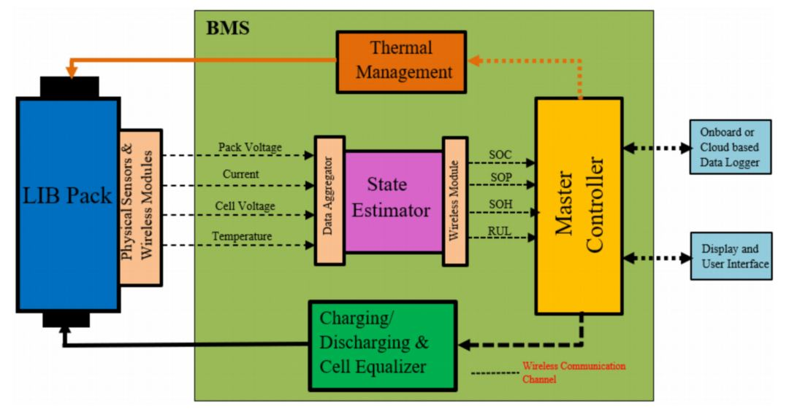

Figure 3.5-1. Schematic layout of a typical WBMS [3.5-1].

Figure 3.5-2 shows an example of the overall system architecture of a distributed and decentralized WBMS, and Figure 3.5-3 shows an example of the system architecture and components of a cloud-based WBMS. In cloud-based WBMS shown in Figure 3.5-3, IoT sensor of the wireless Module Management System (MMS) measures the current, voltage, and temperature of the battery at a given time. Since the nodes (or EVs) cannot store large amounts of data, the data is sent to the cloud server using TCP/IP protocol through the IoT gateway, where it is stored in the cloud data storage. On the other hand, MMS receives health monitoring process results from the Cloud Battery Management Platform (CBMP). The CBMP is used to support battery health monitoring system to detect defects in battery cells.

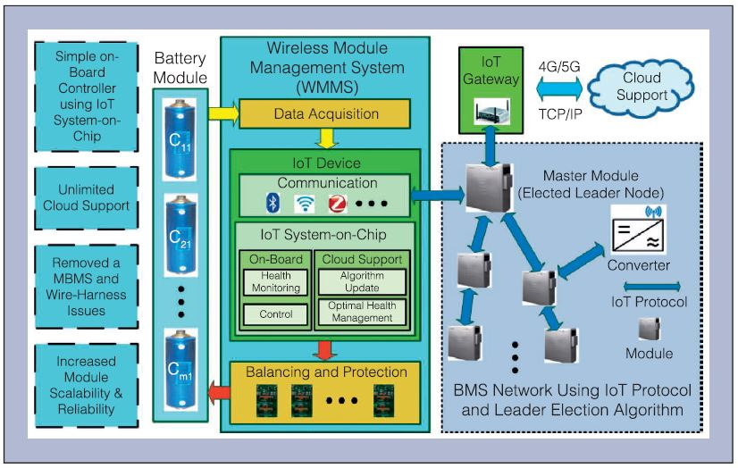

Figure 3.5-2. Example of overall system architecture of a distributed WBMS [3.5-2, 3.5-3].

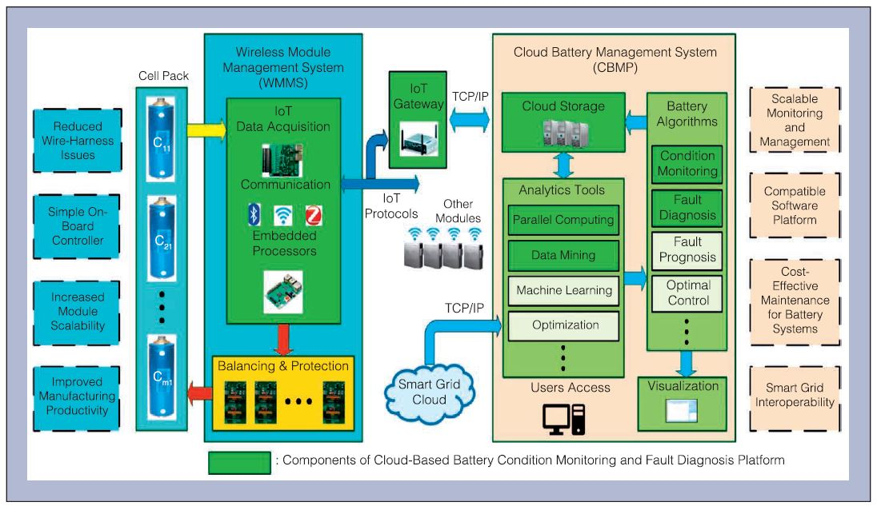

Figure 3.5-3. Example of the system architecture and components of a cloud-based WBMS [3.5-4, 3.5-5].

WBMS has been an active research topic since the early 2010s. Many authors have proposed various ways to implement this in stationary and automotive applications. Key questions concern which wireless protocol and network topologies are best suited for these critical applications. Several studies on wireless communication of WBMS are reviewed as follows [3.5-1, 3.5-6].

● Jamaluddin et al. proposed a wireless battery monitoring system based on Bluetooth Basic Rate (BBR) that uses a Bluetooth module to share battery data with a computer in stationary applications [3.5-7]. Shell et al. presented a BBR WBMS system designed and implemented for racing go-kart to reduce mechanical failures of wired BMS [3.5-8]. In both works, the proposal used only one slave and one master. None of them provided data on latency, reliability, or energy consumption. Although BBR consumes much less power than Wi-Fi, it is still higher for WBMS and cannot guarantee deterministic latency, which is important in critical applications [3.5-9].

● Le Gall proposed a wireless network for reliable electric vehicle BMS based on IEEE Std. 802.15.4-2015 Time Slotted Channel Hopping (TSCH) [3.5-10]. The wireless network was implemented and tested in a Renault Fluence battery pack environment using the IEEE Std. 802.15.4 TSCH physical and link layers. Final tests showed that wireless communication for WBMS is feasible as the network can adjust its topology depending on the link quality. However, there are still several important aspects that need to be considered before implementation in real EVs, such as security issues, BMS power saving modes, cost benefits, power consumption, and topology definition.

● Kunitachi et al. presented reliable wireless communication for WBMS based on TSCH network [3.5-11]. They proposed using overhear techniques to establish a highly reliable link between the nodes and the master. With this protocol, when a source node sends a packet to its destination, its neighbor nodes will listen to the packet. If the destination does not receive the packet, the neighbor nodes retransmit using CSMA to check if the channel is available. The network simulation results show that up to 100 % reliability can be achieved. Although the article does not present energy consumption results, the overhear technology requires high radio utilization, which increases the power consumption of the nodes.

● Wu et al. proposed a WBMS implementation based on the Zigbee protocol [3.5-12]. They monitored a 50Ah battery pack composed of 108 Li-cells with a sampling period of 200ms. The authors confirm that the maximum current consumption of the devices is 28mA. However, there are no network performance results in the analysis. Although Zigbee is a standardized, low-cost, low-power wireless protocol, it has some limitations for critical applications such as WBMS. It is not designed to guarantee deterministic latency or high reliability [3.5-1].

● Huang et al. proposed a Wireless Smart Battery Management System (WSBMS) [3.5-13], that uses Wi-Fi connections between the master and slaves. It can also calculate the SOC and SOH to keep the battery cells balanced. This work does not provide details about the network performance (reliability) or the power consumption. It is well-known that Wi-Fi networks are designed for high throughput without special consideration for limited latency.

● M. Lee et al. proposed a WBMS based on a proprietary protocol called Wireless Battery Area Network (WiBaAN) [3.5-14]. This protocol uses FSK modulation in the 900MHz ISM band with the data rate up to 1Mbps. It does not use channel hopping because they prefer to use channel diversity to allow multiple WBMS networks in the same space. The authors confirmed the achievement of a reliable network, but no data from simulations or experiments were presented.

Recently some vendors, such as Analog Devices (ADI) and Texas Instrument (TI), have announced and are offering commercial WBMS solutions for the EV automotive markets. They all claim that their breakthrough technology reduces the battery pack assembly and design complexity. A summary of ADI’s activities related to WBMS solutions is as follows.

● ADI recognizes the industry’s need to implement robust wireless communications inside battery packs, and proposes a WBMS system based on a modified version of the proven SmartMesh IP technology. ADI’s SmartMesh IP products are wireless chips and pre-certified PCB modules with ready-to-deploy wireless mesh networking software. They are built for IP compatibility and based on the 6LoWPAN and 802.15.4e standards. The SmartMesh IP, ADI’s commercial TSCH solution, enables low power consumption and 99.999% data reliability, even in harsh and dynamically changing RF environment [3.5-15]. The manufacturer created a microcontroller with a hardware MAC engine to execute MAC-related operations with lower power consumption than using a microcontroller [3.5-16].

● The first ADI WBMS concept was implemented in the BMW i3, where the main motivation was to improve system reliability and reduce the cost and wiring complexity of the battery pack. ADI notes that the timing synchronization characteristics of a TSCH network helps the BMS algorithms to compute the SOC and SOH more accurately. They also foresee that with the additional local processing at each module there is a potential to enable the concept of smart battery modules [3.5-17].

● In December 2021, General Motors (GM) launched the Hummer EV, the first commercial EV equipped with ADI’s WBMS. ADI claims that its WBMS system facilitates diagnosis of malfunctioning modules, replacement and integration into new Second Life applications [3.5-18]. The system has achieved the ISO/SAE 21434 certification, which is an assessed automotive cybersecurity certificate [3.5-19].

Texas Instruments (TI) confirms that cable failures to BMS are costly, with the largest failures occurring in connectors and wiring harnesses. They argue that implementing wireless connectivity reduces weight, reduces costs, and avoids the isolation problems typical of traditional wired BMS [3.5-20]. The following summarizes TI’s activities related to WBMS solutions.

● TI developed a commercial implementation of WBMS based on the Simplelink MCU platform, a well-known low-power wireless connectivity solution for IoT [3.5-21]. They have developed a proprietary protocol for a WBMS solution using frequency hopping technique and the 2.4 GHz band with a data rate of 2 Mbps. The vendor confirms that its system achieved 99.999 % of reliability [3.5-22].

● TI launched the first WBMS TUV SUD assessed for enabling ASIL D functional safety systems [101]. To achieve this, TI uses the black channel concept. There are two possible architectures for safety-related data transmission: White channel and black channel. In the first, all hardware and software components are developed and validated according to functional safety standards. On the other hand, the black channel concept means that the end devices (BMS controller and ASIC BMS) must be safety compliant but it is not necessary for the components of the communication channel, which is the case of the wireless MCU used in the system [3.5-23].

● TI WBMS system features CRC-32 to detect data corruption and 4-byte MAC (Message Authentication Code) to ensure authenticity and integrity. The wireless protocol encapsulates the BMS ASIC commands and responses without modifying the data. In this way, the system can detect errors in the communication channel without interfering with the safe communication protocol between the BMS controller and the ASIC BMS [3.5-23].

In addition to ADI and TI, several venders have disclosed their activities on WBMS. Renesas proposed a BLE-based solution using SmartBond TINY, which it claims is the world’s smallest and lowest-power BLE SoC [3.5-24]. Visteon announced that General Motors will use Visteon wireless BMS technology, called wireless smartBMS, in all planned EV models powered by Ultium batteries [3.5-25]. Marelli announced its WBMS, which can reduce wiring harness up to 90%, increasing flexibility, efficiency, reliability and reducing costs in electric vehicles [3.5-26].

Acronyms

ADI Analog Devices

ASIC Application-Specific Integrated Circuit.

ASIL Automotive Safety Integrity Level.

BBR Bluetooth Basic Rate

BLE Bluetooth Low Energy

BMS Battery Management System

CAN Controller Area Network

CBMP Cloud Battery Management Platform

CRC Cyclic Redundancy Check

CSMA Carrier Sense Multiple Access

EV Electric Vehicle

GM General Motors

I2C/SPI Inter-Integrated Circuit / Serial Peripheral Interface

IC Integrated Circuit

IoT Internet of Things

ISM Industrial, Scientific and Medical

LIB Lithium-Ion-based Batteries

MAC Medium Access Control

MAC Message Authentication Code

MCU Micro Controller Unit

MMS Module Management System

RF Radio Frequency

RUL Remaining Useful Life

SoC System on Chip

SOC State Of Charge

SOH State Of Health

SOP State Of Power

TI Texas Instrument

TSCH Time Slotted Channel Hopping

WBMS Wireless Battery Management System

WiBaAN Wireless Battery Area Network

References

[3.5-1] Akash Samanta and Sheldon S. Williamson, “A Survey of Wireless Battery Management System: Topology, Emerging Trends, and Challenges,” Electronics 2021, 10, 2193. https://doi.org/10.3390/electronics10182193

[3.5-2] T. Faika, T. Kim, and M. Khan, “An Internet of Things (IoT)-based network for dispersed and decentralized wireless battery management systems,” Proc. 2018 IEEE Transportation Electrification Conf. Expo, Jun. 2018.

[3.5-3] Fazel Mohammadi, and Rashid Rashidzadeh, “An Overview of IoT-Enabled Monitoring and Control Systems for Electric Vehicles,” IEEE Instrumentation & Measurement Magazine, pp.91~97, May 2021.

[3.5-4] A. Adhikaree, T. Kim, J. Vagdoda, A. Ochoa, P. J. Hernandez, and Y. Lee, “Cloud-Based Battery Condition Monitoring Platform for Large-Scale Lithium-Ion Battery Energy Storage Systems Using Internet-of-Things (IoT),” 2017 IEEE Energy Conversion Congress and Exposition (ECCE), 2017.

[3.5-5] T. Kim, D. Makwana, A. Adhikaree, J. S. Vagdoda, and Y. Lee, “Cloud-based battery Condition monitoring and fault diagnosis platform for large-scale Lithium-Ion battery energy storage systems,” Energies, vol. 11, no. 1, Jan. 2018.

[3.5-6] Fabian Rincon Vija. “Enabling robust wireless communication for battery management systems in electric vehicles,” PhD thesis, Ecole nationale supérieure Mines-Télécom Atlantique, 2022.

[3.5-7] Anif Jamaluddin et al., “Development of Wireless Battery Monitoring for electric vehicle,” 2014 International Conference on Electrical Engineering and Computer Science (ICEECS), IEEE, pp. 147–151.

[3.5-8] Cody Shell et al., “Implementation of a wireless battery management system (WBMS),” 2015 IEEE International Instrumentation and Measurement Technology Conference (I2MTC) Proceedings, IEEE, pp. 1954–1959.

[3.5-9] Akash Samanta and Sheldon S Williamson, “A Survey of Wireless Battery Management System: Topology, Emerging Trends, and Challenges,” Electronics 10.18 (2021), p. 2193.

[3.5-10] Guillaume Le Gall, “Wireless network for reliable electric vehicle battery management,” PhD thesis, Ecole nationale supérieure Mines-Télécom Atlantique, 2021.

[3.5-11] Tadahide Kumtachi, Kazuhiko Kinoshita, and Takashi Watanabe, “Reliable wireless communications in battery management system of electric vehicles,” 2017 Tenth International Conference on Mobile Computing and Ubiquitous Network (ICMU), IEEE, pp. 1–6.

[3.5-12] Yun Wu et al., “A Battery Management System for electric vehicle based on Zigbee and CAN,” 2011 4th International Congress on Image and Signal Processing, vol. 5, IEEE, pp. 2517–2521.

[3.5-13] Xinrong Huang et al., “Wireless smart battery management system for electric vehicles,” 2020 IEEE Energy Conversion Congress and Exposition (ECCE), IEEE, pp. 5620–5625.

[3.5-14] Minkyu Lee et al., “Wireless battery management system,” 2013 World Electric Vehicle Symposium and Exhibition (EVS27), IEEE, pp. 1–5.

[3.5-15] Fabian Rincon, Yasuyuki Tanaka, and Thomas Watteyne, “On the impact of WiFi on 2.4 GHz industrial IoT networks,” 2018 IEEE International Conference on Industrial Internet (ICII), IEEE, pp. 33–39.

[3.5-16] Thomas Watteyne et al., “Technical overview of SmartMesh IP,” 2013 Seventh International Conference on Innovative Mobile and Internet Services in Ubiquitous Computing, IEEE, pp. 547–551.

[3.5-17] Greg Zimmer et al., “Wireless Battery Management Systems Highlight Industry’s Drive for Higher Reliability,” Linear Technology, February 2017, url: https://www.analog.com/media/en/technical-documentation/technical-articles/s65-wireless_bms_en.pdf

[3.5-18] Norbert Bieler and Paul Hartanto-Doeser, “wBMS Technology: The New Competitive Edge for EV Manufacturers,” Analog Devices, 2022, url: https://www.analog.com/en/signals/thought-leadership/wbms-tech-competitive-edge.html

[3.5-19] Analog Devices, “Wireless Battery Management Systems (wBMS),” url: https://www.analog.com/en/product-category/wireless-battery-managementsystems.html

[3.5-20] Mark Ng, Texas Instruments, “How Innovation in Battery Management Systems is Increasing EV Adoption,” 2022, url: https://www.ti.com/lit/wp/slyy218/slyy218.pdf

[3.5-21] Texas Instruments, “SimpleLink™ Microcontroller Platform,” 2018, url: https://www.ti.com/lit/ml/swat002b/swat002b.pdf

[3.5-22] David Lara and Danovan Porter, “Cable replacement using wireless technologies in automotive,” 2020, url: https://www.ti.com/lit/ml/slyp670/slyp670.pdf

[3.5-23] Tomas Urban, « Functional Safety-Relevant Wireless Communication in Automotive Battery Management Systems,” 2021, https://www.ti.com/lit/fs/sluucf5/sluucf5.pdf

[3.5-24] Renesas, “Wireless EV Battery Management System,” url: https://www.renesas.com/us/en/applications/automotive/ev-hev-vehicles/wireless-ev-battery-management-system

[3.5-25] Visteon, “Visteon Complements Industry-First Smart Wireless Battery Management System with Additional Electrification Technology,” 2022, url: https://www.visteon.com/newsroom/visteon-complements-industry-first-smart-wireless-battery-management-system-with-additional-electrification-technology

[3.5-26] Marelli, “Marelli launches its Wireless Distributed Battery Management System,” 2022, https://www.marelli.com/en/news/marelli-launches-wireless-distributed-battery-management-system-wbms.html

## 3.5 Charging in Cooperative Energy and Smart Home Management

EV users who frequently commute between their workplace and home rely on an accessible charging infrastructure at both locations. Often employees work in small to medium-sized office buildings, while their residence could be a small multi-family residence or a single-family dwelling, both needing EV charging connections. As these vehicles can remain parked for several hours, L2 AC charging systems are most often used. At the most basic level, L2 AC charging is controlled by analog circuits within the charging device, operating standalone, with limited communications interface necessary apart from the vehicle battery management system negotiation for the charging session.

However, the integration of business power management with EV charging requirements is beneficial for small commercial building managers to maximize the utilization of charging resources, Similarly, homes or small multi-family dwellings with multiple charging stations can find a comprehensive approach to energy management to be advantageous, As such,

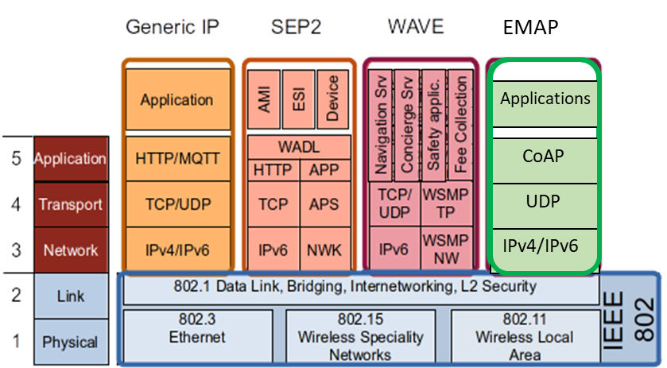

*Figure N: Examples of Smart Home platforms that can be deployed on IEEE 802 networks*

# Distributed Energy System Support for EV Charging

*<Introduce and expand on the concept of ‘energy edge’ and its convergence with LAN/MAN (the Internet and content edge) and edge computing (the data/ML edge).>*

EV charging systems rely on a complex and robust systems to generate, deliver and manage the charging processes. Energy generation edge devices can include renewable energy sources such as photovoltaic (PV) panels, wind storage system or other edge systems such as microgrids. Complimenting the energy generation processes, energy management systems rely upon smart meters and sensors to enable localized data processing, analysis, and decision-making at the energy edge, allowing for real-time optimization, predictive maintenance, and intelligent energy management.

As vehicle fleet operators, such as mail/package delivery services and long-haul freight carriers, embrace electrification depots and fueling facilities will have to deliver high levels of electrical power and energy. Some sites may be adequately served by an electric utility, while others might be constrained by utility limitations regarding energy supply capacity or reliability, engineering project timelines, capital or operating costs, or other factors. Site- or region-scale solutions for energy generation, storage, management, and distribution – collectively, Distributed Energy Resources (DERs)– might become attractive alternatives.

We propose the term ‘energy edge’ to describe the use of DERs to manage energy production, distribution, and delivery close to electrical loads and to manage energy flows to and from ‘core’ electrical energy systems, e.g. the traditional electric utility. ‘Energy edge’ is thus a concept analogous to the ‘network edge’ and ‘edge computing’ in the IT world. We would qualify *microgrids* as exemplary but elementary or basic energy edge systems, due to their limited communications, control, and computing capabilities and the resulting ‘loose coupling’ so far between microgrids and the larger utility grid.

Indeed, microgrids were initially designed to work independently and separately from the utility grid. They were ‘energy islands’ by design for safety reasons: power generated by DERs might energize a segment of the grid that the utility had de-energized, thereby putting personnel at potential risk of electrocution. There was no way to integrate early DERs with the utility’s distribution system to ensure safety. Within a microgrid, each element relied on a self-contained controller and sensors to maintain its operation within acceptable bounds – there were no communications interfaces or networks connecting DERs.

As DERs and microgrids evolved, a degree of coordination enabling auto-islanding (disconnection) and reconnection of microgrids, was introduced based on a combination of energy sensing and some basic digital communications capabilities, which were introduced primarily to support remote monitoring and configuration – effectively, energy system ‘management plane’ functionality. That is, communications within currently deployed microgrids are not designed to support fine-grained coordination of energy flows, which still relies on ‘local’ (to the DER) sensing and control.

We use the term ‘converged energy edge’ to designate distributed energy systems, including microgrids, that embrace the aggressive, forward-looking use of digital communications to manage and control energy flows, safety, cybersecurity, reliability, efficiency, and all aspects of the energy edge. The capabilities of modern LAN/MAN standards and technologies have not yet been leveraged for energy edge applications. We believe that IEEE 802 standards and technologies can provide a coherent, secure, and extensible platform supporting next-generation, fine-grained sensing and control of EV charging stations, DERs, and microgrids. Along with edge computing, IEEE 802 networking will enable more reliable, resilient, and secure microgrid systems, including and especially those supporting electrified and other alternative vehicle fueling.

We can illustrate this by sketching a few integration scenarios based on high-level requirements.

1. Site-based energy storage: *<e.g. for energy security through utility supply outages; optimizing energy costs; fine-grained management of V2B. Mostly site-contained LAN-based communications, local edge computing for energy modeling and optimization, potential connection to cloud e.g. a centralize enterprise-wise asset/operations management system. >*

2. Connecting a fleet operator’s depots in a metropolitan area: *<e.g. regional network connections between US Post Office or Amazon depots; the analogy is with data CDNs. >*

3. Integration with offsite DERs*: < e.g. communication with a local or regional wind generation site. LAN-based or (more likely?) MAN-based communications, depending on distance and data comms requirements; tighter integration possible for fleet-owned DERs. >*

4. Integration with the serving utility’s distribution system: *< e.g. connection with the serving substation for the exchange of control signals, analytical data, energy management e.g. DR Program signasl, etc. >*

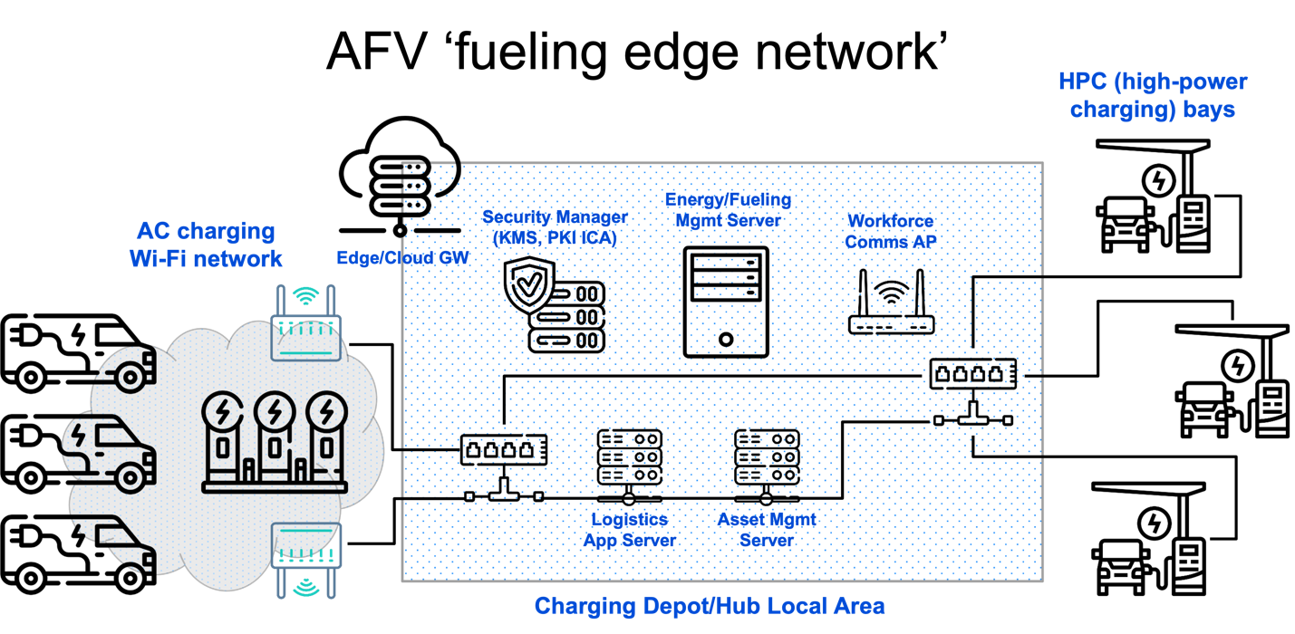

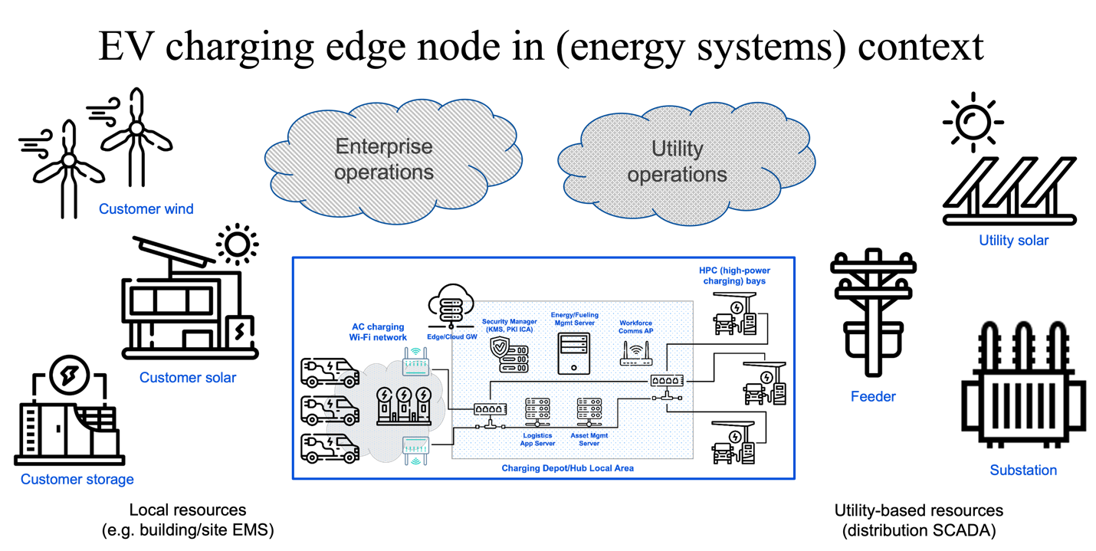

# Communications and Networks supporting AFV Fueling

*< Indicate that this is the technical essence of our whitepaper, providing details on the topics in the subsections below.>*

## Communications Requirements

*< Speeds and feeds, both minimal and aspirational. This can be the kind of table shown in other 802.24 whitepapers, with use cases/scenarios as rows and metrics as columns. This is a common way to show ‘speeds and feeds’ requirements over common span distances / in or across network domains; I’ll try to find some other examples. >*

## Network Architectures

*< Expanding on the diagrams above from 24-23-0007-00-0000-draft-afv-whitepaper.docx. At a basic level, perhaps show the next level of detail for the first diagram above: clarify the wireless and wired LAN endpoints, add access points, switches and routers, 802.1X AAA servers, etc. Then, supplement this LAN-only architecture (with a site-level connection to enterprise network or cloud) with a depiction of LANs connected via MAN interfaces, and other MAN nodes: ‘sister’ depots, energy supply partner sites, utility sites e.g. a substation. >*

## Device and Network Cybersecurity and Management * EV Charging System Cybersecurity and Management?

*< Survey the applicable IEEE 802 standards relevant and applicable to this concern.*

*I think the approach here would be to describe what kinds and levels of cybersecurity provisions would be required on various, well-chosen links, e.g. between AC EVs using Wi-Fi and APs; between APs and network management elements [authentication server]; between LAN switches and routers; etc. We should draw on and reference well-established practices and guidelines for configuring ‘enterprise-grade security for wireless and wired LANs’ – Damola has been researching these – keep it short and sweet, since we presume our reading audience is familiar with common 802 networking knowledge.*

*Let’s review what the draft IEC/IEEE 60802 Industrial Automation and Control standard has in this regard – for example, it calls out cipher suites for device authentication and might require the use of mTLS (if memory serves, need to verify). We could note that the ICS (industrial control systems) community, which has traditionally relied on physical security and minimized cybersecurity provisions to keep costs and operational complexity low, are now stipulating more stringent cybersecurity requirements. This might be seen as setting a new ‘floor’ for cyber requirements for cost-constrained devices – we can draw some conclusions for energy edge and EV charging, etc. >*

# IEEE 802 Standards and Technologies supporting AFV Fueling and the Energy Edge

<A survey of specific IEEE 802 Standards/Clauses and Amendments that would comprise a secure communications fabric/foundation for the ‘energy edge’.>

IEEE 802 protocols provide an OSI Layer 2 transport network supporting pure L2, IPv4 and IPv6 communications, which enable flexible, real-time capabilities necessary to facilitate the communications of industry specific higher-level protocols necessary to manage various EV charging scenarios. While the 802 standards have a rich protocol suite which can be used in a variety of purposes to foster robust, reliable and timely communications, the most relevant protocols for consideration within the AFV fueling environment include 802.1, 802.3, 802.11 and 802.15.

## IEEE 802.1 for AVF Bridging and Management Applications

While the 802.1 protocols themselves are not directly used for EV charging, they play a crucial role in providing network infrastructure and management capabilities that support EV charging systems. Here are a few ways in which the 802.1 protocols can be most applicable in EV charging:

* 802.1AB-802.1AB-2016 - IEEE Standard for Local and metropolitan area networks - Station and Media Access Control Connectivity Discovery
  + Link Layer Discovery Protocol (LLDP) can be used for discovering and advertising network device information enabling EVs to discover and identify charging stations and for charging systems to be identified for integration into network management systems.
* 802.1AC-802.1AC-2016/Cor 1-2018 - IEEE Standard for Local and Metropolitan Area Networks--Media Access Control (MAC) Service Definition - Corrigendum 1: Logical Link Control (LLC) Encapsulation EtherType
  + - Ethernet encapsulation could be used in networks to transport other protocol data necessary to enable the charging process.
* 2018 - IEEE Standard for Local and metropolitan area networks -- Time-Sensitive Networking for Fronthaul 802.1CS-2020 - IEEE Standard for Local and Metropolitan Area Networks--Link-local Registration Protocol
  + - Time sensitive Networking (TSN) can be relevant in EV charging systems that require precise timing and synchronization, such as for Vehicle-to-Grid (V2G) applications or coordination with grid management systems.
* 802.1Q-2018 - IEEE Standard for Local and Metropolitan Area Network--Bridges and Bridged Networks
  + - Virtual LAN (VLAN) tagging can be used to allow for the segmentation of network traffic into different virtual networks enabling the separation and prioritization of charging-related traffic, ensuring efficient and secure communication between charging stations, management systems, and other network components.
* 802.1X-2020 - IEEE Standard for Local and Metropolitan Area Networks--Port-Based Network Access Control –
  + - Could be used within EV charging systems to authenticate and authorize EV access to charging infrastructure.

## IEEE 802.3 for AVF Ethernet Applications

Similar to 802.1 protocols, the IEEE 802.3 protocol suite provides necessary elements to a robust and reliable L2 transport. Again, IEEE 802.3 is a comprehensive suite of protocols which could be used to support various requirements of a AFV fuelling. These protocols are relevant to EV charging either due to their power delivery capabilities, speed characteristics or use within an automotive application. 802.3-2018 - IEEE Standard for Ethernet

* 802.3ch-2020 - IEEE Standard for Ethernet--Amendment 8: Physical Layer Specifications and Management Parameters for 2.5 Gb/s, 5 Gb/s, and 10 Gb/s Automotive Electrical Ethernet
  + - As this protocol addresses connectivity in automotive applications, it could be relevant to AFV fueling, although not directly used in EV charging.
* 802.3cg-802.3cg-2019 - IEEE Standard for Ethernet - Amendment 5: Physical Layer Specifications and Management Parameters for 10 Mb/s Operation and Associated Power Delivery over a Single Balanced Pair of Conductors
  + - The use of single pair ethernet could be advantageous in some scenarios within an AFV fueling system allowing for a both 10 Mb/s data and power to be transmitted over 2 physical wires.
* 802.3cd-2018 - IEEE Standard for Ethernet - Amendment 3: Media Access Control Parameters for 50 Gb/s and Physical Layers and Management Parameters for 50 Gb/s, 100 Gb/s, and 200 Gb/s Operation
  + - * 50 Gb/s, 100 Gb/s, and 200 Gb/s operation can be used within aspects of a charging system, or the backend systems required for authentication, billing and authorization of services.
* 802.3bt-802.3bt-2018 - IEEE Standard for Ethernet Amendment 2: Physical Layer and Management Parameters for Power over Ethernet over 4 pairs
* Power over Ethernet (PoE) can be used within the context of EV charging to enable the transmission of power with data for various components or auxiliary devices.

## IEEE 802.11 for AVF Wireless Applications

* 802.11-2020 - IEEE Standard for Information Technology--Telecommunications and Information Exchange between Systems - Local and Metropolitan Area Networks--Specific Requirements - Part 11: Wireless LAN Medium Access Control (MAC) and Physical Layer (PHY) Specifications
* 802.11ax-2021 - IEEE Standard for Information Technology--Telecommunications and Information Exchange between Systems Local and Metropolitan Area Networks--Specific Requirements Part 11: Wireless LAN Medium Access Control (MAC) and Physical Layer (PHY) Specifications Amendment 1: Enhancements for High-Efficiency WLAN
* 802.11ay-802.11ay-2021 - IEEE Standard for Information Technology--Telecommunications and Information Exchange between Systems Local and Metropolitan Area Networks--Specific Requirements Part 11: Wireless LAN Medium Access Control (MAC) and Physical Layer (PHY) Specifications Amendment 2: Enhanced Throughput for Operation in License-exempt Bands above 45 GHz
* 802.11ba-802.11ba-2021 - IEEE Standard for Information Technology--Telecommunications and Information Exchange between Systems Local and Metropolitan Area Networks--Specific Requirements Part 11: Wireless LAN Medium Access Control (MAC) and Physical Layer (PHY) Specifications Amendment 3: Wake-Up Radio Operation
* IEEE 802.11bd-2022 - IEEE Standard for Information Technology--Telecommunications and Information Exchange between Systems Local and Metropolitan Area Networks--Specific Requirements Part 11: Wireless LAN Medium Access Control (MAC) and Physical Layer (PHY) Specifications Amendment 5: Enhancements for Next Generation V2X. -

## IEEE 802.15 for AVF Specialty Applications

* 802.15.3-2016 - IEEE Standard for High Data Rate Wireless Multi-Media Networks
* 802.15.3f-2017 - IEEE Standard for High Data Rate Wireless Multi-Media Networks Amendment 3: Extending the Physical Layer (PHY) Specification for Millimeter Wave to Operate from 57.0 GHz to 71 GHz
* 802.15.3d-2017 - IEEE Standard for High Data Rate Wireless Multi-Media Networks--Amendment 2: 100 Gb/s Wireless Switched Point-to-Point Physical Layer
* 802.15.3e-2017 - IEEE Standard for High Data Rate Wireless Multi-Media Networks--Amendment 1: High-Rate Close Proximity Point-to-Point Communications
* 802.15.4-2020 - IEEE Standard for Low-Rate Wireless Networks
* 802.15.4y-802.15.4y-2021 - IEEE Standard for Low-Rate Wireless Networks Amendment 3: Advanced Encryption Standard (AES)-256 Encryption and Security Extensions
* 802.15.4w-802.15.4w-2020 - IEEE Standard for Low-Rate Wireless Networks--Amendment 2: Low Power Wide Area Network (LPWAN) Extension to the Low-Energy Critical Infrastructure Monitoring (LECIM) Physical Layer (PHY)
* 802.15.4z-2020 - IEEE Standard for Low-Rate Wireless Networks--Amendment 1: Enhanced Ultra Wideband (UWB) Physical Layers (PHYs) and Associated Ranging Techniques
* 802.15.6-802.15.6-2012 - IEEE Standard for Local and metropolitan area networks - Part 15.6: Wireless Body Area Networks
* 802.15.7-2018 - IEEE Standard for Local and metropolitan area networks--Part 15.7: Short-Range Optical Wireless Communications
* 802.15.8-2017 - IEEE Standard for Wireless Medium Access Control (MAC) and Physical Layer (PHY) Specifications for Peer Aware Communications (PAC)
* 802.15.9-2021 - IEEE Standard for Transport of Key Management Protocol (KMP) Datagrams
* 802.15.10-802.15.10-2017 - IEEE Recommended Practice for Routing Packets in IEEE 802.15.4 Dynamically Changing Wireless Networks
* 802.15.10a-802.15.10a-2019 - IEEE Recommended Practice for Routing Packets in IEEE 802.15.4(TM) Dynamically Changing Wireless Networks - Amendment 1: Fully Defined Use of Addressing and Route Information Currently in IEEE Std 802.15.10

# Conclusions and Recommendations

# References

1. J. S. Choi, "Energy management agent frameworks: Scalable, flexible, and efficient architectures for 5G vertical industries," IEEE Industrial Electronics Magazine, vol. 15, no. 1, pp. 62-73, March 2021
2. ISO/IEC 15067-3:2012, Information technology – Home Electronic System (HES) application model – Part 3: Model of a demand-response energy management system for HES
3. ISO/IEC 15067-3-3:2019, Information technology – Home Electronic System (HES) application model – Part 3-3: Model of a system of interacting energy management agents (EMAs) for demand response energy management
4. ISO/IEC 15067-30:FIDS, Information technology – Home Electronic System (HES) application model – Part 30: EMA functional requirements and interfaces
5. ISO/IEC 15067-3-31:FDIS, Information technology – Home Electronic System (HES) application model – Part 3-31: Protocol of energy management agents for demand response energy management and interactions among these agents
6. J. S. Choi, "A hierarchical distributed energy management agent framework for smart homes, grids, and cities," IEEE Communications Magazine, Vol. 57, No. 7, pp. 113-119, 2019
7. T. Shimizu, T. Ono, W. Hirohashi, K. Kumita, and Y. Hayashi, “Experimental demonstration of smart charging and vehicle-to-home technologies for plugin electric vehicles coordinated with home energy management systems for automated demand response,” SAE International Journal of Passenger Cars-Electronic and Electrical Systems, vol. 9, no. 2016-01-0160, pp. 286–293, 2016.
8. IETF RFC 7252, The Constrained Application Protocol (CoAP), edited by Z. Shelby et al., June 2014, available at: <https://tools.ietf.org/rfc/rfc7252.txt> [viewed 2023-05-31]
9. IETF RFC 7159, The JavaScript Object Notation (JSON) Data Interchange Format, edited by T. Bray, March 2014, available at: https://tools.ietf.org/rfc/rfc7159.txt [viewed 2023-05-31]

A. A. S. Mohamed, A. A. Shaier, H. Metwally, and S. I. Selem, “An Overview of Dynamic Inductive Charging for Electric Vehicles,” *Energies*, vol. 15, no. 15, p. 5613, Aug. 2022, doi: <https://doi.org/10.3390/en15155613>.

[1]

“ROADMAP OF STANDARDS AND CODES FOR ELECTRIC VEHICLES AT SCALE ANSI Electric Vehicles Standards Panel (EVSP),” 2023. Accessed: Apr. 20, 2024. [Online]. Available: https://share.ansi.org/evsp/ANSI_EVSP_Roadmap_June_2023.pdf

‌

[1]

T. Basso and R. Deblasio, “IEEE Smart Grid Series of Standards IEEE 2030 (Interoperability) and IEEE 1547 (Interconnection) Status Preprint,” 2011. Accessed: Mar. 29, 2024. [Online]. Available: https://www.nrel.gov/docs/fy12osti/53028.pdf

‌ [1]

C. Ruth, “IEEE Standards in Everyday Life: Summer Vacation,” *IEEE Standards Association*, Jun. 30, 2022. https://standards.ieee.org/beyond-standards/industry/technology-industry/ieee-standards-in-everyday-life-summer-vacation/ (accessed Mar. 29, 2024).

‌

**Appendix 1: Electrical Characteristics of Residential and Small Building Charging**

Currently, the most common type of EV charging used in these sites is a so-called “Level 2” (L2) AC charging device. Level 2 designates the capability to deliver 3-20 kW of power to recharge the EV battery; this is done by a control unit (in a “cordset” that plugs into a standard electrical socket, or a fixed-in-place “wallbox” with a receptacle or cable and connector) that manages energy flow to the on-vehicle converter and battery management system. The voltage level of L2 charging is 200-250 VAC; and the current level typically ranges from 12-80 Amps. L2 charging service is defined in three standards: SAE J1772 (used in North America and Japan); GB/T-XXXX (used in China); and IEC 68151-1 (used in Europe). While there are substantive difference between the three, they have much in common.

The SAE J1772 standard defines charging using a single-phase electrical connection; the connector it defines has three pins to support power transfer: two for power delivery and one for earth (ground). Two additional, smaller pins are used for control pilot (signaling) and proximity sensing (optional)SAE J1772 also defines “Level 1” charging, which uses 100-120 VAC. [need to check L1 current range] Most legacy North American EVs support L1 charging over a cable with a three-prong (grounded) household appliance plug on one end and a J1772-compliant connector on the other. Newer EVs, especially those with battery capacity of 30 kWh or more, might not support L1 charging due to long charging times at L1 power levels (see below).

The IEC 61851-1 standard defines charging using both single- and three-phase electrical connections; consequently, the associated connector (per IEC 62196-2) has five pins for power transfer: three for power delivery (one per phase; single-phase charging is supported on two designated pins) and one for earth (ground). Like the SAE standard, two additional pins are used for control pilot and proximity sensing / resistive coding.

The advantage of L2 charging over L1 is shorter EV charging times. For example, fully charging an EV with 30 kWh battery capacity would take more than 15.5 hours to charge at L1 (~2 kW: 120 VAC x 16 A) and fewer than 4 hours at a typical L2 level (~7.6 kW: 240 VAC x 32 A). Using four times the power, the EV can charge in 1/4 the time.

The amperage values above align with common circuit breaker values, and the North American electrical code requirement that installed breakers be rated to trip at 125% of the maximum expected current draw (appliance maximum current rating) on the circuit. If it is the only appliance being protected on the circuit, a charging device drawing up to16 A requires a 20 A circuit breaker; a 32 A device must be protected by a 40A breaker.

The main deterent to L2 charging is the potentially high cost of providing the electrical wiring and protection needed. The worst case is when the capacity of the site’s electrical service would be exceeded by the addition of an EV charging station; the cost of a utility service upgrade (say, from 100 to 200 A) can be prohibitive. Another consideration is whether existing wiring from the service delivery point (the circuit breaker box) to the installation location is adequate; if not, new wiring might need to be installed. Finally, the cost of the EV charging device adds to the overall impact, but this is often the least costly part of a project.

Appendix 2: Smart Home Overview

In order to meet these goals, the devices and systems in a home need to have some degree or information processing and communication capability. Modern media devices, which are highly configurable and connected, provide a good example of how any subsystem within the home can be automated and integrated with others. For example, meshed Wi-Fi nodes – originally meant primarily to provide consumer devices with wireless access to the Internet –now incorporate microphones and speakers, allowing for natural-language interaction from almost anywhere in the home; can retrieve or relay data such as music playlists or television viewing preferences and activate services accordingly; and can report the status or change the settings of environmental controllers such as thermostats, skylights, and window shades. One can imagine such nodes soon incorporating sensors to gauge environmental factors (e.g. air quality, human/pet motion/activity, light or noise levels) as well.

**Appendix 3: DER Overview**

DER energy sources (such as solar energy and wind energy) have become important alternative sources of energy in the smart home. EVs are also becoming popular, because of their fuel efficiency and economic benefit, as compared to the conventional fuel-based vehicles. Energy management is an early target for similar verticals such as healthcare, agriculture, manufacturing, automotive, public transportation, utilities and energy, environmental, smart cities, and more. In energy vertical, it is crucial to find solutions to manage the peak demand while supporting substation automation of renewable energy systems such as DERs and EVs.

Appendix 4: Smart Energy Environmental Management Systems

EMAs enable the allocation of energy among appliances and switching energy sources from grid to local generation or storage according to consumer preferences [1]. EMAs also enable automated demand-response (DR) services in a house, a residential community or a building consisting of multiple apartments for coordinating and allocating energy consumption and generation among multiple EMAs in different locations [6]. DR programs are being offered to residential consumers for energy conservation and for energy management to align demand for power with available supplies for appliance usage and budget constraints. The co-ordination among EMAs offers improved energy management and overall efficiency according to customer preferences.

Typical smart energy services can include integrated energy management for efficient energy usage. The coordinative energy management is a combination of DR services and distributed energy sharing and trading within the community, energy information sharing among multiple energy systems for more efficient energy usage, etc. These cooperative energy services offer benefits in electrical energy management in a house, a residential community or a building consisting of multiple apartments by energy sharing and trading among EMAs, EVs, DERs and home appliances [6].

EMA Protocol is a protocol to facilitate high-level communications among EMAs, EVs and DERs for cooperative energy management applications [5]. In this context, control of the energy systems will allow the management of energy flow generated from DERs and EVs for consumption or for storage in the collective EVs. The intent of EMAP is to accommodate flexible and efficient energy management systems according to the customer’s budget over a broad range of EMA deployments.

Appendix 5: Additional Use Cases:

An example of a service delivered to the charging device via Wi-Fi and the vendor’s cloud, is to allow the user to select their electricity pricing rate program from a list provided by the utility or utilities serving their location. Some utilities offer discounted rates for overnight consumption, encouraging EV charging at lower cost when electricity is not in high demand. If the user enrolls in such a program and selects that rate, their wallbox might be configured to block charging, or post a warning, if the EV is plugged in when rates are higher (e.g., during daytime). Given the rate program, the wallbox could calculate and display the cost of charging the EV. (Only after energy has been delivered, unless the EV’s battery capacity was set on the station and the EV sent its state of charge before charging, which is not currently possible using SAE and IEC L2 AC charging protocols).

A similar service that could be provided to EV drivers via the vendor cloud and Wi-Fi include charging power level regulation and/or incentive based on energy pricing or utility capacity constraints. Thus, an attempt to charge an SUV or pick-up truck with a 120 kWh battery pack at 14.4 kW (60 A) during hours of peak energy demand might result in the charging station being limited to delivering only 7.2 kW (30 A) and perhaps incentives – a price discount or confirmed reservation – to charge at a nearby public fast charging station that gets its energy from solar panels and energy storage, rather than the grid.