PvarDesignation™/DvarDraftNumber
DrafttxtTrialUsetxtGorRPorSTD for varTitlePAR
Sponsor

varCommittee
of the
IEEE varSociety

Approved varApprovedDate

IEEE-SA Standards Board

Copyright © varCRYear by The Institute of Electrical and Electronics Engineers, Inc.
Three Park Avenue
New York, New York 10016-5997, USA
All rights reserved.
This document is an unapproved draft of a proposed IEEE Standard. As such, this document is subject to change. USE AT YOUR OWN RISK! IEEE copyright statements SHALL NOT BE REMOVED from draft or approved IEEE standards, or modified in any way. Because this is an unapproved draft, this document must not be utilized for any conformance/compliance purposes. Permission is hereby granted for officers from each IEEE Standards Working Group or Committee to reproduce the draft document developed by that Working Group for purposes of international standardization consideration. IEEE Standards Department must be informed of the submission for consideration prior to any reproduction for international standardization consideration (stds.ipr@ieee.org). Prior to adoption of this document, in whole or in part, by another standards development organization, permission must first be obtained from the IEEE Standards Department (stds.ipr@ieee.org). When requesting permission, IEEE Standards Department will require a copy of the standard development organization's document highlighting the use of IEEE content. Other entities seeking permission to reproduce this document, in whole or in part, must also obtain permission from the IEEE Standards Department.
IEEE Standards Department
445 Hoes Lane
Piscataway, NJ 08854, USA

Abstract: This standard specifies the architecture, abstraction layers, interfaces and metadata requirements for Spectrum Characterization and Occupancy Sensing (SCOS) system, and defines performance parameters, units and measures. This SCOS system comprises one or more semi-autonomous Spectrum Sensing Devices which scan electromagnetic spectrum, digitize it and perform processing, transmitting the resultant data with appropriate metadata to a central storage and processing system, according to rules, policies or instructions imposed on the Spectrum Sensing Devices by a management system.

Keywords: Radio spectrum sensing, spectrum monitoring, signal characterization, cognitive radio, IEEE 802.22.3, WRAN standards

•Important Notices and Disclaimers Concerning IEEE Standards Documents
IEEE documents are made available for use subject to important notices and legal disclaimers. These notices and disclaimers, or a reference to this page, appear in all standards and may be found under the heading “Important Notices and Disclaimers Concerning IEEE Standards Documents.” They can also be obtained on request from IEEE or viewed at http://standards.ieee.org/IPR/disclaimers.html.
Notice and Disclaimer of Liability Concerning the Use of IEEE Standards Documents
IEEE Standards documents (standards, recommended practices, and guides), both full-use and trial-use, are developed within IEEE Societies and the Standards Coordinating Committees of the IEEE Standards Association (“IEEE-SA”) Standards Board. IEEE (“the Institute”) develops its standards through a consensus development process, approved by the American National Standards Institute (“ANSI”), which brings together volunteers representing varied viewpoints and interests to achieve the final product. IEEE Standards are documents developed through scientific, academic, and industry-based technical working groups. Volunteers in IEEE working groups are not necessarily members of the Institute and participate without compensation from IEEE. While IEEE administers the process and establishes rules to promote fairness in the consensus development process, IEEE does not independently evaluate, test, or verify the accuracy of any of the information or the soundness of any judgments contained in its standards.
IEEE Standards do not guarantee or ensure safety, security, health, or environmental protection, or ensure against interference with or from other devices or networks. Implementers and users of IEEE Standards documents are responsible for determining and complying with all appropriate safety, security, environmental, health, and interference protection practices and all applicable laws and regulations.
IEEE does not warrant or represent the accuracy or content of the material contained in its standards, and expressly disclaims all warranties (express, implied and statutory) not included in this or any other document relating to the standard, including, but not limited to, the warranties of: merchantability; fitness for a particular purpose; non-infringement; and quality, accuracy, effectiveness, currency, or completeness of material. In addition, IEEE disclaims any and all conditions relating to: results; and workmanlike effort. IEEE standards documents are supplied “AS IS” and “WITH ALL FAULTS.”
Use of an IEEE standard is wholly voluntary. The existence of an IEEE standard does not imply that there are no other ways to produce, test, measure, purchase, market, or provide other goods and services related to the scope of the IEEE standard. Furthermore, the viewpoint expressed at the time a standard is approved and issued is subject to change brought about through developments in the state of the art and comments received from users of the standard.
In publishing and making its standards available, IEEE is not suggesting or rendering professional or other services for, or on behalf of, any person or entity nor is IEEE undertaking to perform any duty owed by any other person or entity to another. Any person utilizing any IEEE Standards document, should rely upon his or her own independent judgment in the exercise of reasonable care in any given circumstances or, as appropriate, seek the advice of a competent professional in determining the appropriateness of a given IEEE standard.
IN NO EVENT SHALL IEEE BE LIABLE FOR ANY DIRECT, INDIRECT, INCIDENTAL, SPECIAL, EXEMPLARY, OR CONSEQUENTIAL DAMAGES (INCLUDING, BUT NOT LIMITED TO: PROCUREMENT OF SUBSTITUTE GOODS OR SERVICES; LOSS OF USE, DATA, OR PROFITS; OR BUSINESS INTERRUPTION) HOWEVER CAUSED AND ON ANY THEORY OF LIABILITY, WHETHER IN CONTRACT, STRICT LIABILITY, OR TORT (INCLUDING NEGLIGENCE OR OTHERWISE) ARISING IN ANY WAY OUT OF THE PUBLICATION, USE OF, OR RELIANCE UPON ANY STANDARD, EVEN IF ADVISED OF THE POSSIBILITY OF SUCH DAMAGE AND REGARDLESS OF WHETHER SUCH DAMAGE WAS FORESEEABLE.
Translations
The IEEE consensus development process involves the review of documents in English only. In the event that an IEEE standard is translated, only the English version published by IEEE should be considered the approved IEEE standard.
Official statements
A statement, written or oral, that is not processed in accordance with the IEEE-SA Standards Board Operations Manual shall not be considered or inferred to be the official position of IEEE or any of its committees and shall not be considered to be, or be relied upon as, a formal position of IEEE. At lectures, symposia, seminars, or educational courses, an individual presenting information on IEEE standards shall make it clear that his or her views should be considered the personal views of that individual rather than the formal position of IEEE.
Comments on standards
Comments for revision of IEEE Standards documents are welcome from any interested party, regardless of membership affiliation with IEEE. However, IEEE does not provide consulting information or advice pertaining to IEEE Standards documents. Suggestions for changes in documents should be in the form of a proposed change of text, together with appropriate supporting comments. Since IEEE standards represent a consensus of concerned interests, it is important that any responses to comments and questions also receive the concurrence of a balance of interests. For this reason, IEEE and the members of its societies and Standards Coordinating Committees are not able to provide an instant response to comments or questions except in those cases where the matter has previously been addressed. For the same reason, IEEE does not respond to interpretation requests. Any person who would like to participate in revisions to an IEEE standard is welcome to join the relevant IEEE working group.
Comments on standards should be submitted to the following address:
Secretary, IEEE-SA Standards Board
445 Hoes Lane
Piscataway, NJ 08854 USA
Laws and regulations
Users of IEEE Standards documents should consult all applicable laws and regulations. Compliance with the provisions of any IEEE Standards document does not imply compliance to any applicable regulatory requirements. Implementers of the standard are responsible for observing or referring to the applicable regulatory requirements. IEEE does not, by the publication of its standards, intend to urge action that is not in compliance with applicable laws, and these documents may not be construed as doing so.
Copyrights
IEEE draft and approved standards are copyrighted by IEEE under U.S. and international copyright laws. They are made available by IEEE and are adopted for a wide variety of both public and private uses. These include both use, by reference, in laws and regulations, and use in private self-regulation, standardization, and the promotion of engineering practices and methods. By making these documents available for use and adoption by public authorities and private users, IEEE does not waive any rights in copyright to the documents.

Photocopies
Subject to payment of the appropriate fee, IEEE will grant users a limited, non-exclusive license to photocopy portions of any individual standard for company or organizational internal use or individual, non-commercial use only. To arrange for payment of licensing fees, please contact Copyright Clearance Center, Customer Service, 222 Rosewood Drive, Danvers, MA 01923 USA; +1 978 750 8400. Permission to photocopy portions of any individual standard for educational classroom use can also be obtained through the Copyright Clearance Center.
Updating of IEEE Standards documents
Users of IEEE Standards documents should be aware that these documents may be superseded at any time by the issuance of new editions or may be amended from time to time through the issuance of amendments, corrigenda, or errata. An official IEEE document at any point in time consists of the current edition of the document together with any amendments, corrigenda, or errata then in effect.
Every IEEE standard is subjected to review at least every ten years. When a document is more than ten years old and has not undergone a revision process, it is reasonable to conclude that its contents, although still of some value, do not wholly reflect the present state of the art. Users are cautioned to check to determine that they have the latest edition of any IEEE standard.
In order to determine whether a given document is the current edition and whether it has been amended through the issuance of amendments, corrigenda, or errata, visit IEEE Xplore at http://ieeexplore.ieee.org/ or contact IEEE at the address listed previously. For more information about the IEEE-SA or IEEE’s standards development process, visit the IEEE-SA Website at http://standards.ieee.org.
Errata
Errata, if any, for all IEEE standards can be accessed on the IEEE-SA Website at the following URL: http://standards.ieee.org/findstds/errata/index.html. Users are encouraged to check this URL for errata periodically.
Patents
Attention is called to the possibility that implementation of this standard may require use of subject matter covered by patent rights. By publication of this standard, no position is taken by the IEEE with respect to the existence or validity of any patent rights in connection therewith. If a patent holder or patent applicant has filed a statement of assurance via an Accepted Letter of Assurance, then the statement is listed on the IEEE-SA Website at http://standards.ieee.org/about/sasb/patcom/patents.html. Letters of Assurance may indicate whether the Submitter is willing or unwilling to grant licenses under patent rights without compensation or under reasonable rates, with reasonable terms and conditions that are demonstrably free of any unfair discrimination to applicants desiring to obtain such licenses.
Essential Patent Claims may exist for which a Letter of Assurance has not been received. The IEEE is not responsible for identifying Essential Patent Claims for which a license may be required, for conducting inquiries into the legal validity or scope of Patents Claims, or determining whether any licensing terms or conditions provided in connection with submission of a Letter of Assurance, if any, or in any licensing agreements are reasonable or non-discriminatory. Users of this standard are expressly advised that determination of the validity of any patent rights, and the risk of infringement of such rights, is entirely their own responsibility. Further information may be obtained from the IEEE Standards Association.
Participants
At the time this drafttxtTrialUsetxtGorRPorSTD was completed, the varWorkingGroup Working Group had the following membership:
varWkGrpChair, Chair
varWkGrpViceChair, Vice Chair

Participant1
Participant2
Participant3
Participant4
Participant5
Participant6
Participant7
Participant8
Participant9

The following members of the <individual/entity> balloting committee voted on thistxtTrialUsetxtGorRPorSTD. Balloters may have voted for approval, disapproval, or abstention.
[To be supplied by IEEE]

Balloter1
Balloter2
Balloter3
Balloter4
Balloter5
Balloter6
Balloter7
Balloter8
Balloter9

When the IEEE-SA Standards Board approved thistxtTrialUsetxtGorRPorSTD on varApprovedDate, it had the following membership:
[To be supplied by IEEE]

<Name>, Chair
<Name>, Vice Chair
<Name>, Past Chair
Konstantinos Karachalios, Secretary

SBMember1
SBMember2
SBMember3
SBMember4
SBMember5
SBMember6
SBMember7
SBMember8
SBMember9

*Member Emeritus

Introduction
This introduction is not part of PvarDesignation/DvarDraftNumber, DrafttxtTrialUsetxtGorRPorSTD for varTitlePAR.
<Select this text and type or paste introduction text>

Contents
<After draft body is complete, select this text and click Insert Special->Add (Table of) Contents>

DrafttxtTrialUsetxtGorRPorSTD for varTitlePAR

- Overview
  - Scope
The scope of this document is to define a standard for Spectrum Characterization and Occupancy Sensing (SCOS). It establishes a high-level architecture, defines functional entities and their interfaces, specifies command & control messages and parameters, and defines metadata describing the nature and configuration of the sensing system and the data it gathers. It also describes operating characteristics and behaviors of the components of the SCOS system, with reference implementations for common use cases. Further, it defines measurement parameters in such a way that data gathered by an 802.22.3 compliant system can be consistently and meaningfully interpreted by users.
The focus of this standard is on management and control of a sensor network, the ability for a variety of users to interrogate system capabilities and task scanning functions, the definition of a simple reference implementation for the sensing devices, and for the sensing data to be transmitted to an end-point.
The SCOS architecture is intended to provide incentive for the evolution and implementation of the following three areas of specialization: sensor technology, data acquisition/distribution, and data analysis.
  - Purpose
The purpose of the Spectrum Characterization and Occupancy Sensing (SCOS) system is to characterize and assess the occupancy of spectrum resource towards supporting it’s more efficient and effective use. The intent of the SCOS is to create a high-level architecture to support different spectrum sensing technologies and deployments, to enable specialization and provide incentive, to promote broad adoption of sensing technologies and subsequent economies of scale, and to ultimately achieve broader availability and usage of sensing information from different sources. This will enable clients to acquire and use spectrum sensing information from a multiplicity of predefined independent systems to serve their goals.
Various national regulators and government authorities are developing regulatory and policy frameworks to allow cooperative spectrum sharing approaches in order to optimize spectrum utilization. There is emphasis on greater spectrum efficiencies, spectrum sharing and spectrum utilization, which requires not only database-driven configuration of the radios, but systems that can provide spectrum occupancy at a particular location and at a particular time.
  - Application
Greater efficiencies in spectrum utilization through spectrum sharing and optimized resource allocation, require not only coordinated use by radio systems, but also better information on spectrum occupancy at a particular location and time.
The Spectrum Characterization and Occupancy Sensing (SCOS) System has many applications which include:
(1) Policy and Planning
(2) Radio Planning, Management and Engineering
(3) Regulatory Enforcement where systems can Detect (RF incursion), Locate (source), Classify (by type and severity), Resolve/Remediate
(4) Research and Technology Development
- Normative references
The following referenced documents are indispensable for the application of this document (i.e., they must be understood and used, so each referenced document is cited in text and its relationship to this document is explained). For dated references, only the edition cited applies. For undated references, the latest edition of the referenced document (including any amendments or corrigenda) applies.
[1] NIST, “Standards for Security Categorization of Federal Information and Information Systems,” FIPS Pub 199, February 2004.
[2] NIST, “Security and Privacy Controls for Information Systems and Organizations,” NIST Special Publication, 800-53, Revision 5, August 2017.
[3] RFC-3339, "Date and Time on the Internet: Timestamps", Klyne, Newman, July 2002.
[4] IETF RFC 2616, “Hypertext Transfer Protocol – HTTP/1.1, June 1999.
[5] IETF RFC 8259, “The JavaScript Object Notation (JSON) Data Interchange Format, December 2017.
- Definitions
For the purposes of this document, the following terms and definitions apply. The IEEE Standards Dictionary Online should be consulted for terms not defined in this clause.
Action: Sensor function that the sensor owner implements and exposes to the API. Actions give the sensor owner control over what the sensor can be tasked to do, e.g,, instrument control, data acquisition, data processing.
Admin: Privileged Sensor/Manager account type with full permissions.
Acquisition: The combination of data and metadata created by an action (though an action does not have to create an acquisition).
Antenna: Sensor hardware component that converts environmental electromagnetic fields into a voltage.
API: Application Programming Interface
Capability: Available actions, installation specifications (e.g., mobile or stationary), and hardware specification (e.g., frequency range of receiver).
Client: Manager account with permissions to query SCOS capabilities, request information on sensed data, and/or request scheduled sensing actions.
GUI: Graphical User Interface
Host controller: Sensor hardware component that provides web services; controls signals/messages to antenna, preselector, and/or receiver; and processes/packages data.
HTTP: Hypertext Transfer Protocol
IP: Internet Protocol
Manager: SCOS entity with hardware resources and software that allows clients to interact with the SCOS platform via web-based GUI and (optional) data service.
Preselector: Sensor hardware component that can provide preselection filtering, improved sensitivity via low noise amplification, calibration signal sources, etc.
Receiver: Sensor hardware component that captures discrete raw data (e.g., baseband representation of the signal) and can apply digital signal processing algorithms to achieve a desired metric.
REST: Representational State Transfer
Schedule: The collection of all schedule entries (active and inactive) on the sensor.
Scheduler: A Sensor process responsible for executing the schedule.
Schedule Entry: Input to the sensor schedule that describes action, start and stop times, interval, and priority.
SCOS: Spectrum Characterization and Occupancy Sensing
SCOS Owner: Manager account type which can approve actions to be performed by the SCOS platform.
Sensor: SCOS entity with hardware resources and software that allow users (e.g., Manager) to interact via web-based API and (optional) data service.
Sensor Operator: Manager account type which can register sensors via authentication key exchange.
SDR: Software Defined Radio
SLA: Service Level Agreement
Task: A representation of an action to be run at a specific time.
Task Result: A record of the outcome of a task.
User: Unprivileged Sensor account type which can create schedule entries and view, modify, and delete things they own, but which cannot modify or delete things they don't own.
- System Concept
Figure 1 illustrates a SCOS context diagram. SCOS is a service provider and Clients are end users. External Clients can discover SCOS capabilities, request data, and request actions to be performed by sensor(s).
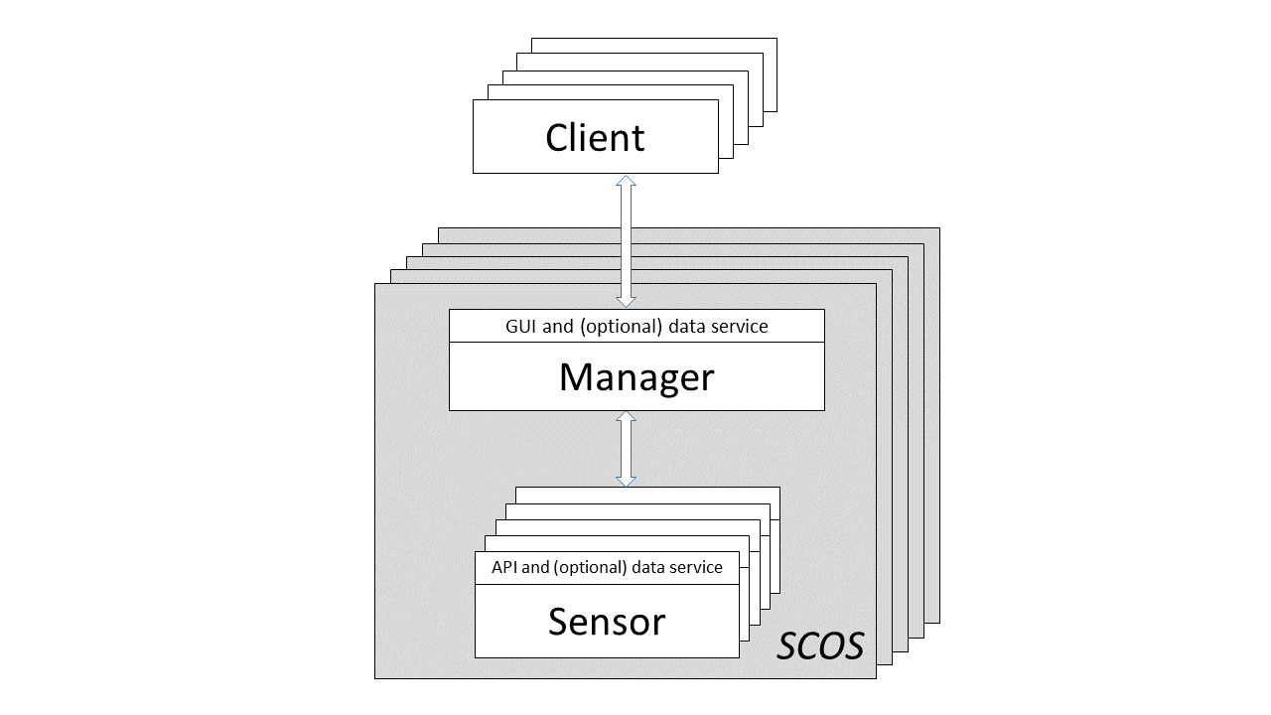
Figure 1. SCOS context diagram
  - Entities
The two entities that comprise the SCOS platform are the Manager (server application) and one or more Sensor(s) operating in the field. Together, Manager and Sensor(s) comprise the SCOS Platform.
- Manager: SCOS entity that allows clients (whether individuals or other systems) to interact with the SCOS Platform via web-based Graphical User Interface (GUI) and (optional) data service. It exposes the capabilities of the SCOS platform to users, manages tasks requests by users, and ultimately controls the registered sensors.
- Sensor: SCOS entity that allow users (whether individuals or other applications, e.g., Manager) to interact via web-based API and (optional) data services. The API allows users to discover capabilities, schedule actions, and download data. Sensors package data with required metadata in a standardized data format.
  - Interactions
Figure 2 describes the basic interactions between Client, Manager, and Sensor. The categories of interactions are sensor controller service, capabilities, schedule, acquisition, and data service.
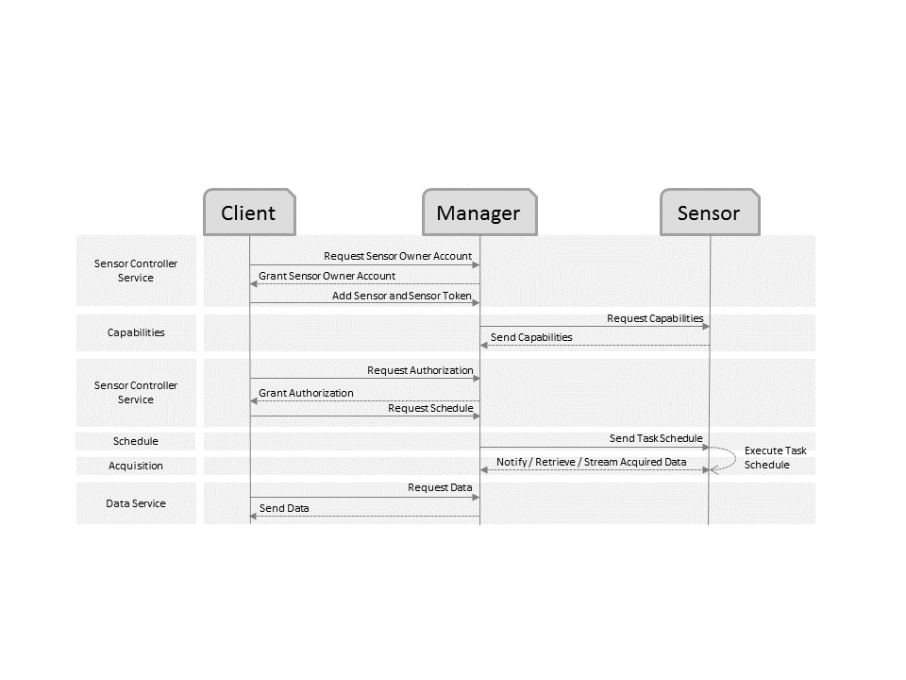
Figure 2. Interactions between Client, Manager, and Sensor
  - General Requirements
The primary goals of the SCOS architecture are to achieve broad sensing and data aggregation. To meet these goals, SCOS developers are required to meet general requirements categorized and described in the following subsections.
    - Connectivity, Control, and Access
The following requirements are related connectivity, sensor control, and data access.
- Connectivity and access: Sensors are to provide easy-to-used control via IP network. Manager is to be accessible to authorized users via the Internet.
- Discoverable capabilities: Entity capabilities and resources are discoverable, so they can be fully utilized by end user applications.
- Data access: SCOS entities are to make data available to authorized users.
- Data standardization: Compliance with a common metadata/data specification is required to allow for collaborative research, large-scale analytics, and sharing of sophisticated tools and methodologies. Data compliance is the subject of Section 8.
    - Security
The following requirements are related to system and information confidentiality, integrity, and availability.
- Security categorization: Information and systems are to be rated at the appropriate level of information security according to range of risk levels [1].
- Service Level Agreement (SLA): A contract between SCOS (service provider) and Client (end user) is required to define the level of service expected from the service provider.
- Security controls: Safeguards or countermeasures are required to avoid, detect, counteract, or minimize security risks to physical property, information, computer systems, or other assets [2]. Examples of relevant security controls include:
  - End user authentication to prevent unauthorized users from accessing internal entity functionality
  - Provisioned and configured Operating Systems (OSs)
  - System administration to manage users and implement data access controls
In general, security requirements are implementation specific.
    - Design Flexibility
The following requirements support the evolution of SCOS technology and broad deployments.
- REST API: Entities are required to expose Representational State Transfer (REST) APIs as an easy-to-use a means for end users to interact with the application over an Internet Protocol (IP) network. REST does not bind the service provider or end user applications to specific implementations.
- Extensible technologies, algorithms, and metrics: SCOS infrastructure enables evolution of centralized and edge processing, sensor technologies, and metrics. SCOS entities and associated interfaces add functionality independent of end user applications.
- Hardware, software, and OS agnostic: Sensor and Manager implementations are not bound to specific hardware, software, or operating system to allow for cost-performance tradeoffs to be considered during design process.
Additional security requirements specific to Sensor and Manager are the subject of Sections Error: Reference source not found and Error: Reference source not found, respectively.
- Sensor
This section provides models and requirements associated with the Sensor hardware and software.
  - Hardware
Figure 3 provides a block diagram of the basic sensor hardware model. Sensors are not required to have each component shown in the block diagram. There can be more sophisticated hardware models, e.g., with multiple antennas and/or multiple receivers connected to a single host controller. Integration can also be achieved, e.g., a mobile phone is an example of all components integrated into a single unit. Sensor definition, measurement type, and algorithm metadata requirements are defined in Section 7.
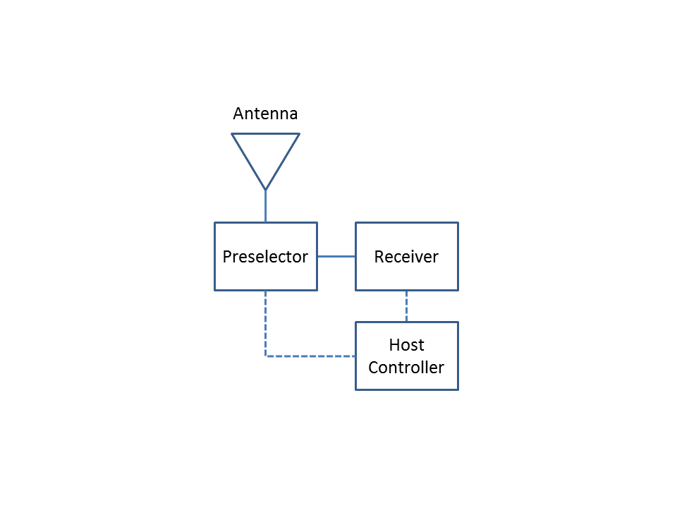
Figure 3. Sensor hardware model

- Antenna: Optional sensor hardware components that convert environmental electromagnetic fields into a voltage. An RF cable connects the antenna with the next hardware component.
- Preselector: Optional sensor hardware components that can provide preselection filtering, improved sensitivity via low noise amplification, calibration signal sources, etc.
- Receiver: Required sensor hardware components that capture discrete raw data (e.g., baseband representation of the signal) and can apply digital signal processing algorithms to the raw data to achieve a desired metric.
- Host Controller: Optional sensor hardware components that can provide control signals and messages to the preselector and receiver. Host controllers often provide data processing, data packaging, and web-accessible services.
  - Software
Sensor software provides a platform for operating a sensor, such as a software-defined radio (SDR), over a network. The goal is to provide a robust, flexible, and secure starting point for remote spectrum monitoring.
    - Functional Requirements
The following are functional requirements of the Sensor software:
- Provide status: Offer standard HTTP status codes to indicate the success or failure of API calls, storage available, time since last calibration, time since last restart, etc.
- Advertise capabilities: Capabilities are available actions. Actions are a function that the sensor owner implements and exposes to the API. Actions should be used to constrain Sensor tasks to the valid operational ranges of hardware components (e.g., frequency range of antenna, preselector, and receiver)
- Provide onboard scheduler: Task scheduling is to be provided on the sensor. Tasks are to be executed according to start/stop times, interval, and/or priority.
- Responsive schedule entries: Sensors are to be responsive to requested schedule entries by authorized users.
- Provide task results: Task results are to be recorded for each task after the action function returns, and includes metadata such as when the task started, when it finished, its duration, the result (success or failure), and a freeform detail string.
- Categorize security level of acquisitions: Acquisitions are to be tagged with the appropriate security categorization (i.e., low, medium, or high) to enable responsible data management.
- Access acquisitions: Acquisitions and metadata are accessible directly though API, while data is retrievable in an easy-to-use archive format with its associated metadata.
    - Interface
The following subsections describe required Sensor API endpoints with associated functions. Note: {version} in the path indicates the API version. The API uses standard HTTP status codes to indicate the success or failure of the API call. The body of the response will be JSON.
      - Acquisition Endpoint
The acquisition end point allows users to view, delete, and download acquisitions. The following HTTP functions are available (see Table 1 for list of schedule endpoint properties):
- Path: /api/{version}/acquisitions/{schedule_entry_name}/{task_id}/
- Methods: get, delete
Table 1. Acquisitions Endpoint Properties
Item | Type | Description
“url” | String | URL of entry
“schedule_entry” | String | The related schedule entry for the acquisition
“acquisitions_available” | String | The number of available acquisitions

Transport technologies are optional and implementation specific.
      - Capabilities Endpoint
The capabilities endpoint allows users to view permissible sensor actions. The following HTTP functions are available (see Table 2 for list of schedule endpoint properties):
- Path: /api/{version}/capabilities/
- Method: get
- Table 2. Capabilities and Schedule Endpoint Properties
Item | Type | Description
“url” | String | URL of entry
“validate_only” | Boolean | Only validate the input, do not modify the schedule
“is_private” | Boolean | Indicates whether the entry, and resulting data, are only visible to admins
“next_task_time” | String | UTC time (ISO 8601) the next task is scheduled for
“is_active” | Boolean | Indicates whether the entry should be removed from the scheduler without removing it from the system
“interval” | Integer | Seconds between tasks, or leave blank to run once
“name” | String | The unique identifier used in URLs and filenames (required to create schedule entry)
“acquisitions” | String | The list of acquisitions related to the entry
“callback_url” | String | If given, the scheduler will POST a `TaskResult` JSON object to this URL after each task completes
“created” | String | The date the entry was created
“relative_stop” | Integer | Seconds after start to stop
“results” | String | The list of results related to the entry
“stop” | String | UTC time (ISO 8601) to stop
“modified” | String | The date the entry was modified
“start” | String | UTC time (ISO 8601) to start, or leave blank for 'now’
“action” | String | The name of the action to be scheduled (required to create schedule entry)
“owner” | String | The name of the user who owns the entry
“next_task_id” | Integer | The id of the next task to be executed
“priority” | Integer | Lower number is higher priority (default=10)
      - Results Endpoint
The results endpoint allows users to view task results (per schedule). The following HTTP functions are available:
- Path: /api/{version}/results/{schedule_entry_name}/{task_id}/
- Methods: get
Table 3. Results Endpoint Properties
Item | Type | Description
“url” | String | URL of entry
“schedule_entry” | String | The related schedule entry for the acquisition
“results_available” | String | The number of available results
      - Schedule Endpoint
The schedule endpoint allows users to view, create (operationId “schedule_create”), and modify sensor schedule. The following HTTP functions are available (see Table 2 for list of schedule endpoint properties):
- Path: /api/{version}/schedule/{name}/
- Methods: delete, get, patch, post, put
      - Status Endpoint
The status endpoint allows users to view status of sensor. The following HTTP functions are available:
- Path: /api/{version}/status/
- Method: get
- Table 4. Status Endpoint Properties
Item | Type | Description
“url” | String | URL of entry
  - User Accounts
This section describes sensor authentication, user accounts, and permissions.
Authentication is performed via tokens. Tokens are automatically generated for all users. Non-admin user accounts do not initially have a password and so cannot log in to the browsable API. To set a password for a user (for testing purposes), an admin can do that in the Sensor Configuration Portal, but only the account's token should be stored and used for general purpose API access.
Sensor account types include:
- Admin: Sensor account type with full control over the sensor and can create schedule entries and view, modify, or delete any other user's schedule entries or acquisitions. Admins can create non-privileged user accounts. Admins can mark a schedule entry as private from unprivileged users.
- User (Sensor Operator): Unprivileged sensor account type which can create schedule entries and view, modify, and delete things they own, but which cannot modify or delete things they don't own. Actions marked admin_only are not schedulable, and schedule entries marked private by an admin (along with their results and acquisitions) are not visible to users.
- Manager
This section provides models and requirements associated with the Manager hardware and software.
  - Hardware
Manager is hosted on a server or virtual machine. Resources and configuration can be customized to meet design and SLA requirements.
  - Software
Manager is a web applications that simplifies the management and tasking of a network of sensors.
    - Functional Requirements
The following are software requirements for the Manager software:
- Operations: Sensor locations, status, and other diagnostics are displayed in operations view to allow for early detection of problems.
- Client requests: With appropriate permissions, Clients can download acquisitions already acquired. Based on SCOS platform capabilities, Clients can also request new actions to be scheduled.
- Distributed sensing actions: Schedule actions for groups of sensors
- SCOS Owner control: Clients can request new actions to be scheduled, but actions are not scheduled without SCOS Owner approval. It is the SCOS Owner’s prerogative to optimize data acquisition to maximize profit.
    - Interfaces
The following are required Manager services with associated functions:
- Sensor Controller Service: Allows Sensors to attach to the Manager, be authenticated and made an active node in the SCOS platform. Once a Sensor is authenticated and registered to a Manager, the sensor controller service can discover Sensor capabilities, schedule actions on the appropriate set of Sensors to fulfil the sensing request of the Client(s), and query current tasks and the state of a Sensor.
- Data Service: Receives acquisitions from each associated Sensor, provides acknowledgement of successful data transfer, and distributes data to Clients according to policies established by SCOS Owner.
    - User Accounts
This section describes Manager user accounts and associated permissions.
- Admin: Privileged account type with full control to change security settings, install software and hardware, access all files on the computer, and make changes to other user accounts.
- SCOS Owner: Manager account type with permission to approve actions that the SCOS platform will perform.
- Sensor Operator: Manager account type with permission to register sensors via authentication key exchange. With detailed knowledge of the Sensor hardware and software, the Sensor Operator makes required information, e.g, sensor definition and actions, available via Sensor API discovery or manual input.
- Client: Manager account type with permission to query available SCOS capabilities. The Client can request information on sensed data and/or request scheduled sensing actions.
- Procedures
This section describes required steps to achieve SCOS service provider and Client end user functionality.
  - Sensor Owner

  - SCOS Owner

    - Sensor Administrator

  - SCOS Admin

  - Sensor Operator

  - Client

- Data Specification
This SCOS SigMF namespace defines the data format required for the IEEE 802.22.3 draft standard. The goal is to standardize the control method and data transfer format for “time share” access to a networked fleet of sensors. Use cases require a solid solution for basic sensor control and RF data collection with flexibility to incorporate new sensing solutions and metrics in the future.
  - Conventions
The SCOS namespace uses and is fully compliant with the SigMF specification and conventions. Building upon the SigMF core namespace, the specification is enhanced through the implementation of a scos namespace, the details of which follow.
We have adopted SigMF’s conventions:
- The key words “MUST”, “MUST NOT”, “REQUIRED”, “SHALL”, “SHALL NOT”, “SHOULD”, “SHOULD NOT”, “RECOMMENDED”, “MAY”, and “OPTIONAL” in this document are to be interpreted as described in RFC 2119.
- JSON keywords are used as defined in ECMA-404. - Augmented Backus-Naur form (ABNF) is used as defined by RFC5234 and updated by RFC7405.
- Fields defined as “human-readable”, a “string”, or simply as “text” shall be treated as plaintext where whitespace is significant, unless otherwise specified.
- Information is given as global, capture, or annotation
- Data is formatted …
  - Global
Global information is applicable to the entire dataset.
Name | Required | Type | Unit | Description
sensor_id | true | string | N/A | Unique name for the sensor.
sensor_definition | true | object | N/A | Describes the sensor model components. See Sensor Object definition.
transmitter_definition | false | object | N/A | The transmitter that the measurement is designed to detect, e.g., propagation measurements. See Transmitter Object definition.
version | true | string | N/A | The version of the SigMF SCOS namespace extension.
schedule_entry | false | object | N/A | See ScheduleEntry Object definition.
task_id | false | integer | N/A | A unique identifier that increments with each task of a schedule_entry.
    - Sensor Object
The Sensor object contains the following name/value pairs:
Name | Required | Type | Unit | Description
Antenna | true | object | N/A | See Antenna Object definition.
Preselector | false | object | N/A | Description of preselector, e.g., RF paths
Receiver | true | object | N/A | See Receiver Object definition.
host_controller | false | string | N/A | Description of host computer. E.g. Make, model, and configuration.
    - Antenna Object
The Antenna object contains the following name/value pairs:
Name | Required | Type | Unit | Description
model | true | string | N/A | Antenna make and model number.
Type | false | string | N/A | Antenna type. E.g. "dipole", "biconical", "monopole", "conical monopole".
low_frequency | false | float | Hz | Low frequency of operational range.
high_frequency | false | float | Hz | High frequency of operational range.
Gain | false | float | dBi | Antenna gain in direction of maximum radiation or reception.
horizontal_gain_pattern | false | array of floats | dBi | Antenna gain pattern in horizontal plane from 0 to 359 degrees in 1 degree steps.
vertical_gain_pattern | false | array of floats | dBi | Antenna gain pattern in vertical plane from -90 to +90 degrees in 1 degree steps.
horizontal_beam_width | false | float | degrees | Horizontal 3-dB beamwidth.
vertical_beam_width | false | float | degrees | Vertical 3-dB beamwidth.
cross_polar_discrimination | false | float | N/A | Cross-polarization discrimination.
voltage_standing_wave_ratio | false | float | volts | Voltage standing wave ratio.
cable_loss | false | float | dB | Cable loss for cable connecting antenna and preselector.
Steerable | false | boolean | N/A | Defines if the antenna is steerable or not.
Mobile | false | boolean | N/A | Defines if the antenna is mobile or not.
    - Receiver Object
The Receiver object contains the following name/value pairs:
Name | Required | Type | Unit | Description
Model | true | string | N/A | Make and model of the receiver.
low_frequency | false | float | Hz | Low frequency of operational range of the receiver.
high_frequency | false | float | Hz | High frequency of operational range of the receiver.
noise_figure | false | float | dB | Noise figure of the receiver.
max_power | false | float | dBm | Maximum input power of the receiver.
    - Transmitter Object
The Transmitter object contains the following name/value pairs:
Name | Required | Type | Unit | Description
system_name | false | string | N/A | Name of system to be detected.
transmit_power | false | float | dBm | Transmitter power going into antenna.
Antenna | true | object | N/A | See Antenna Object definition.
Waveform | false | object | N/A | See SigMF waveform namespace
Latitude | false | float | degrees | Latitude.
Longitude | false | float | degrees | Longitude.
Altitude | false | float | meters | Altitude above mean sea level.
    - ScheduleEntry Object
The ScheduleEntry object contains the following name/value pairs:
Name | Required | Type | Unit | Description
name | true | string | N/A | The identification string assigned to the schedule entry. MUST be unique on the sensor.
start | false | datetime | ISO-8601 | Requested time to schedule the first task. If unspecified, task will start as soon as possible.
relative_stop | false* | integer | seconds | Relative seconds after start when the task will end.
absolute_stop | false* | datetime | ISO-8601 | Absolute time when the task will end.
interval | false | integer | seconds | Interval between tasks. If unspecified, task will run exactly once and then mark the entry inactive.
priority | false | integer | N/A | Priority of the entry, similar to applying nice. Lower numbers are higher priority. Default is 10.
action | true | string | N/A | Name of action to be performed.
    - DigitalFilter Object
The DigitalFilter object contains the following name/value pairs:
Name | Required | Type | Unit | Description
type | false | string | N/A | Description of digital filter, e.g., "FIR": Finite impulse response
length | false | integer | N/A | Number of taps.
frequency_cutoff | false | float | Hz | Frequency at which the magnitude response decreases (from its maximum) by attenuation_cutoff.
attenuation_cutoff | false | float | dB | Magnitude response threshold (below maximum) that specifies frequency_cutoff.
ripple_passband | false | float | dB | Ripple in passband.
attenuation_stopband | false | float | dB | Attenuation of stopband.
frequency_stopband | false | float | Hz | Point in filter frequency response where stopband starts.
  - Captures
Per SigMF, the Captures value is an array of capture segment objects that describe the parameters of the signal capture. The scos specification does not add any enhancements to this section.
  - Annotations
Per SigMF, the Annoations value is an array of annoation segment objects that describe anything regarding the signal data not part of the global and captures objtects. Each SigMF annotation segment object must contain a core:sample_start name/value pair, which indicates the first index at which the rest of the segment’s name/value pairs apply.
Name | Required | Type | Unit | Description
altitude | false | float | meters | The height of the antenna above mean sea level.
environment | false | string | N/A | A description of the environment where antenna is mounted. E.g. "indoor" or "outdoor".
dynamic_antenna_settings | false | object | N/A | Dynamic parameters associated with the antenna.
dynamic_preselector_settings | false | object | N/A | Dynamic parameters associated with the preselector.
dynamic_receiver_settings | false | object | N/A | Dynamic parameters associated with the receiver.
transmitter_identification | false | object | N/A | Transmitter identification parameters. See Transmitter Object definition.
measurement_type | true | object | N/A | The type of measurement acquired, e.g., TimeDomainDetection, FrequencyDomainDetection.
data_sensitivity | false | string | N/A | The sensitivity of the data captured. E.g. "low", "moderate" or "high".
detected_system_noise_powers | false | float | dBm | The detected system noise power referenced to the output of isotropic antenna.
temperature | false | float | celsius | Environmental temperature.
overload_flag | false | boolean | N/A | Flag indicator of system signal overload.

    - Measurement Types
The following annotation objects are used within the scos SigMF name space associated with measurement_type.
      - TimeDomainDetection Object
Time-domain detection algorithms are applied to IQ time series captured at a single frequency. The TimeDomainDetection object contains the following name/value pairs:
Name | Required | Type | Unit | Description
detector | true | string | N/A | E.g. "sample_power", "mean_power", "max_power", "min_power", "median_power", "m4s_power".
detection_domain | true | string | N/A | Domain in which detector is applied, i.e., "time".
number_of_samples | true | integer | N/A | Number of samples to be integrated over by detector.
units | true | string | N/A | Data units, e.g., "dBm", "watts", "volts".
reference | false | string | N/A | Data reference point, e.g., "receiver input", "antenna output", "output of isotropic antenna".

      - FrequencyDomainDetection Object
Frequency-domain detection algorithms are applied to discrete Fourier transforms of IQ time series captured at a single frequency. The FrequencyDomainDetection object contains the following name/value pairs:
Name | Required | Type | Unit | Description
detector | True | string | N/A | E.g. "fft_sample_iq", "fft_sample_power", "fft_mean_power", "fft_max_power", "fft_min_power", "fft_median_power", "fft_m4s_power".
detection_domain | True | string | N/A | Domain in which detector is applied, i.e., "frequency".
number_of_ffts | True | integer | N/A | Number of FFTs to be integrated over by detector.
units | True | string | N/A | Data units, e.g., "dBm", "watts", "volts".
Reference | False | string | N/A | Data reference point, e.g., "receiver input", "antenna output", "output of isotropic antenna".
number_of_samples_in_fft | True | integer | N/A | Number of samples in FFT to calcluate delta_f = samplerate/number_of_samples_in_fft.
Window | True | string | N/A | E.g. "blackman-harris", "flattop", "gaussian_a3.5", "gauss top", "hamming", "hanning", "rectangular".
equivalent_noise_bandwidth | False | float | Hz | Bandwidth of brickwall filter that has same integrated noise power as that of the actual filter.

      - SteppedFrequencyMeasurement Object
The SteppedFrequencyMeasurement object contains the following name/value pairs:
Name | Required | Type | Unit | Description
frequencies | false | array of floats | Hz | Center frequencies where stepped-frequency detections are performed.
algorithm | true | object | N/A | Algorithm applied to IQ samples. See TimeDomainDetection Object, FrequencyDomainDetection Object definition.

      - SweptTunedMeasurement Object
Swept-tuned measurement is a standard spectrum analyzer measurement. The SweptTunedMeasurement object contains the following name/value pairs:
Name | Required | Type | Unit | Description
frequency_start | true | float | Hz | First frequency of scan.
frequency_stop | true | float | Hz | Last frequency of scan.
frequency_step | true | float | Hz | Frequency step of scan.
dwell_time | true | float | seconds | Integration time of detector at each frequency step.
resolution_bandwidth | true | float | Hz | Resolution bandwidth.
video_bandwidth | true | float | Hz | Video bandwidth.
units | true | string | N/A | Data units, e.g., "dBm", "watts", "volts".
reference | false | string | N/A | Data reference point, e.g., "receiver input", "antenna output", "output of isotropic antenna".

NTIA SCOS Implementation
This Annex describes the NTIA/ITS reference implementation of the IEEE 802.22.3 Spectrum Characterization and Occupancy Sensing (SCOS).

scos-sensor
scos-sensor is NTIA/ITS Spectrum Monitoring group's work-in-progress reference implementation of the IEEE 802.22.3 Spectrum Characterization and Occupancy Sensing (SCOS) sensor. It is a platform for operating a sensor, such as a software-defined radio (SDR), over a network. The goal is to provide a robust, flexible, and secure starting point for remote spectrum monitoring.

Software
scos-sensor was designed by NTIA/ITS with the following goals in mind:
- Easy-to-use sensor control and data retrieval via IP network
- Low-cost, open-source development resources
- Design flexibility to allow developers to evolve sensor technologies and metrics
- Hardware agnostic
- Discoverable sensor capabilities
- Task scheduling using start/stop times, interval, and/or priority
- Standardized metadata/data format that supports cooperative sensing and open data initiatives
- Security controls that prevent unauthorized users from accessing internal sensor functionality
- Easy-to-deploy with provisioned and configured OS
- Quality assurance of software via automated testing prior to release
Sensor control is accomplished through a RESTful API. The API is designed to be rich enough so that multiple sensors can be automated effectively while being simple enough to still be useful for single-sensor deployments. For example, by advertising capabilites and location, an owner of multiple sensors can easily filter by frequency range, available actions, or geographic location. Yet, since each sensor hosts its own Browsable API, controlling small deployments is as easy as clicking around a website.
When a task acquires data, that data and a significant amount of metadata are stored in a local database. The full metadata can be read directly through the self-hosted website or retrieved in plain text via a single API call. Our metadata and data format is an extension of, and compatible with, the SigMF specification. The SCOS Data Transfer Specification describes the scos namespace.
When deploying equipment remotely, the robustness and security of software becomes a prime concern. scos-sensor sits on top of a popular open-source framework, which provides out-of-the-box protection against cross site scripting (XSS), cross site request forgery (CSRF), SQL injection, and clickjacking attacks, and also enforces SSL/HTTPS (traffic encryption), host header validation, and user session security. In addition to these, we have implemented an unprivileged user type so that the sensor owner can allow access to other users and API consumers while maintaining ultimate control. To minimize the chance of regressions while developing for the sensor, we have written almost 200 unit and integration tests.
We have tried to remove the most common hurdles to remotely deploying a sensor while maintaining flexibility in two key areas. First, the API itself is hardware agnostic, and the implementation assumes different hardware will be used depending on sensing requirements. Second, we introduce the high-level concept of "actions", which gives the sensor owner control over what the sensor can be tasked to do.

Architecture
Figure 4 illustrates the scos-sensor software architecture. scos-sensor uses an open source software stack that should be comfortable for developers familiar with Python.
- Persistent data is stored on disk in a relational database.
- A scheduler thread running in a Gunicorn worker process periodically reads the schedule from the database and performs the associated actions.
- A website and JSON RESTful API using Django REST framework is served over HTTPS via NGINX, a high-performance web server. These provide easy administration over the sensor.
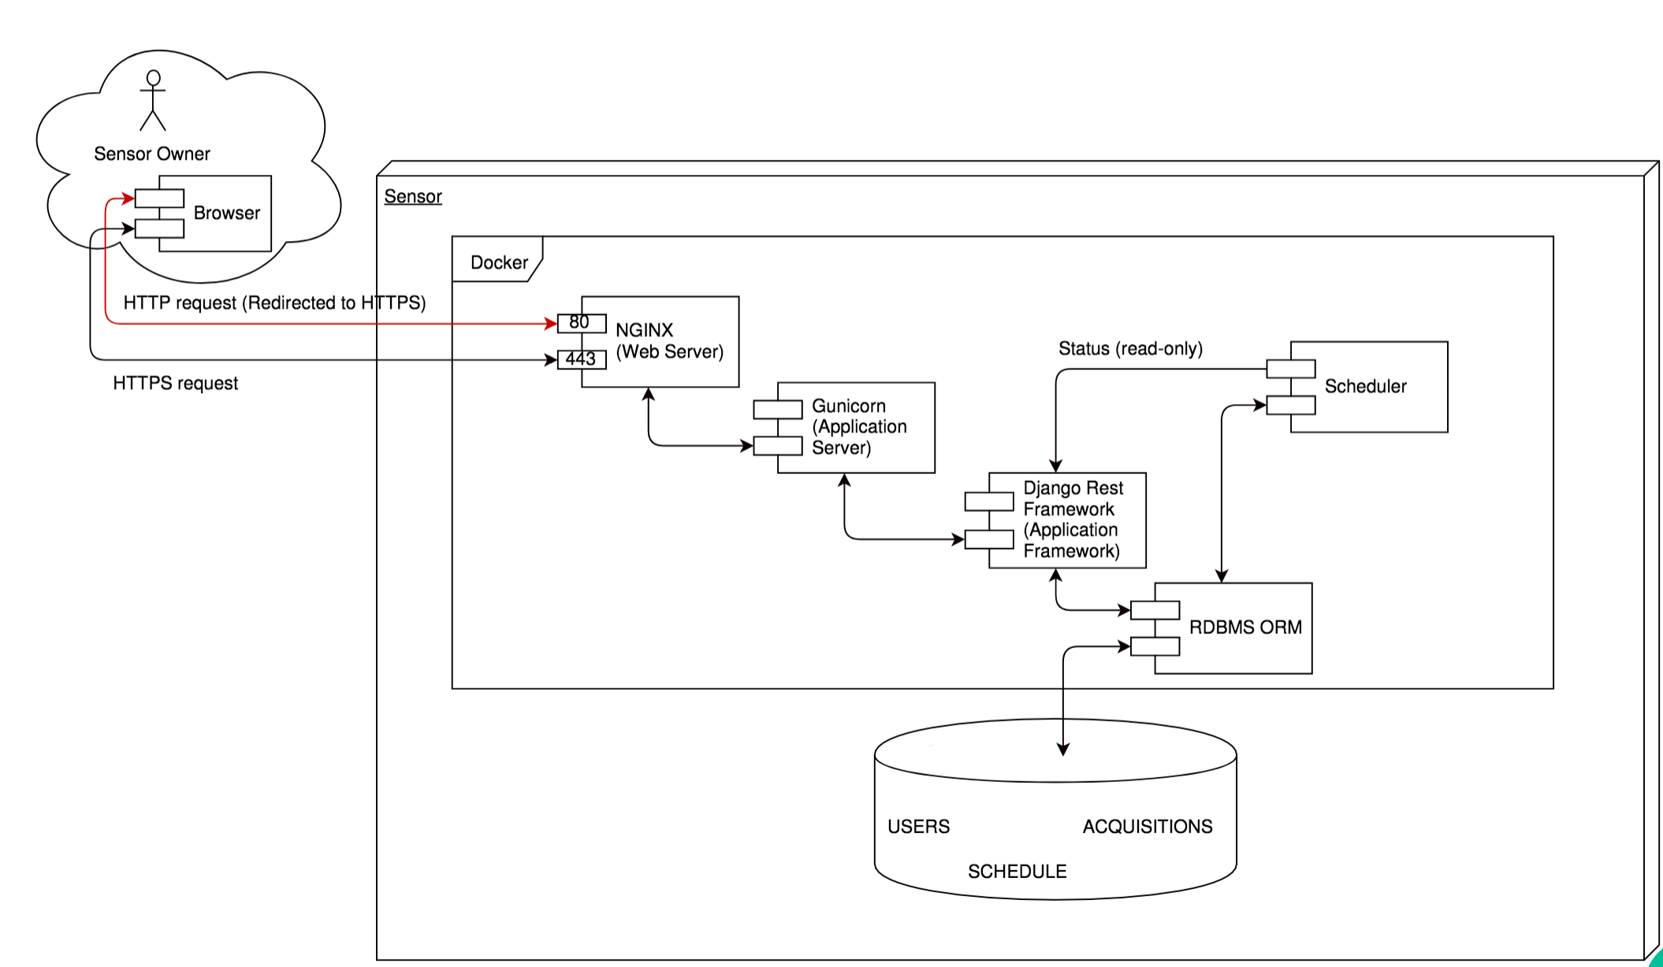
Figure 4. Sensor Software Architecture

Quick Start
This section describes how to spin up a production-grade sensor in just a few commands.
We currently support Ettus USRP B2xx software-defined radios out of the box, and any Intel-based host computer should work. ARM-based single-board computers have also been tested, but we do not prepare pre-build Docker containers at this time.
- Install git, Docker, and docker-compose.
- Clone the repository.
$ git clone https://github.com/NTIA/scos-sensor.git
$ cd scos-sensor
- Copy the environment template file and modify the copy if necessary, then source it.
$ cp env.template env
$ source ./env
- Run a Dockerized production-grade stack.
$ docker-compose up –d # start in background
$ docker-compose exec api /src/manage.py createsuperuser # create admin user
$ docker-compose logs --follow api # reattach terminal

Provisioning and Configuration Management
Large sensor deployments present unique challenges. At NTIA/ITS, we use Foreman and Puppet to handle hardware provisioning and configuration management. While a ground-up introduction to these tools is outside the scope of this repository, The Foreman and Puppet README should be enough to help someone familiar with these tools get up to speed.

Browsable API
Figure 5 illustrates the scos-sensor API root. Opening the URL to your sensor (localhost if you followed the Quickstart) in a browser, you will see a frontend to the API that allows you to do anything the JSON API allows.
Relationships in the API are represented by URLs which you can click to navigate from endpoint to endpoint. The full API is discoverable simply by following the links.
Scheduling an action is as simple as filling out a short form on /schedule (see Figure 6). Actions that have been scheduled show up in the schedule entry list on /schedule (see Figure 7).
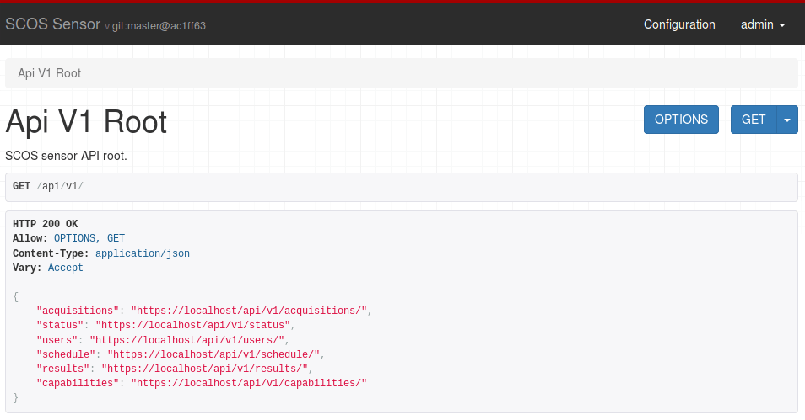
Figure 5. scos-sensor API root
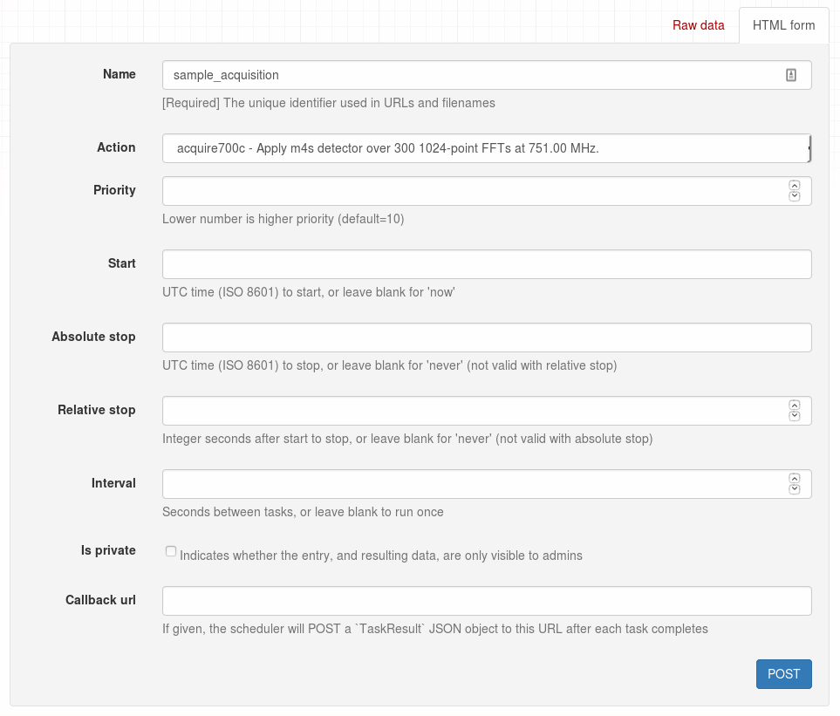
Figure 6. Example Schedule Form

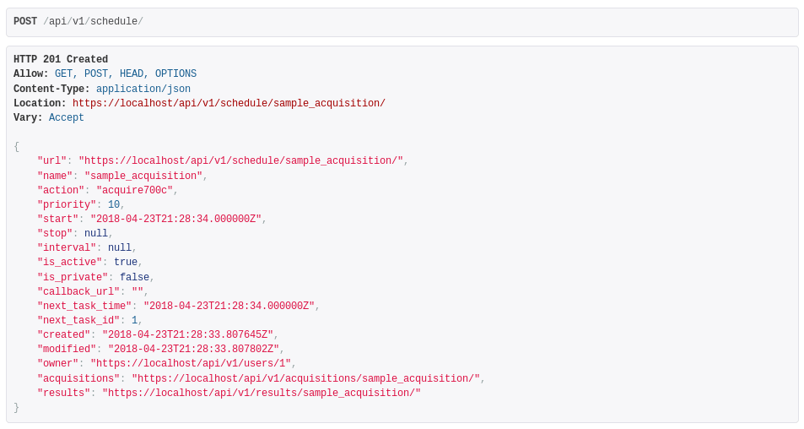
Figure 7. Example schedule entry on schedule endpoint

scos-manager
scos-manager is NTIA/ITS Spectrum Monitoring group's work-in-progress reference implementation of the IEEE 802.22.3 Spectrum Characterization and Occupancy Sensing (SCOS) Manager.

Architecture
Figure 8 provides an illustration of the Manager software model. Elements and functions in the Manager software model include:
- Data Database: Stores data collected by the Data Service for a limited period of time, or as long as physical storage limits allow. Transmits data to the appropriate Client(s).
- Data Service: Receives completed scan data (measurement data and metadata) from the Sensors and retransmits to the appropriate Client(s).
- Manager Database: Maintains the information from Sensors obtained during Sensor registration including Sensor capabilities, and information about to-be-scheduled, scheduled, and on-going tasks.
- Sensor Controller: Communicates with the Sensors using the Sensor API, receives the Sensor capabilities and status, and provides a task schedule from the Sensors along with necessary information for sending scan data to the Data Database. Manages and enforces user authentication and authorization, and acquisition policies.
- User Interface: This service provides a graphical interface through which Clients can interact with the Manager and access a set of functions provided by the system.
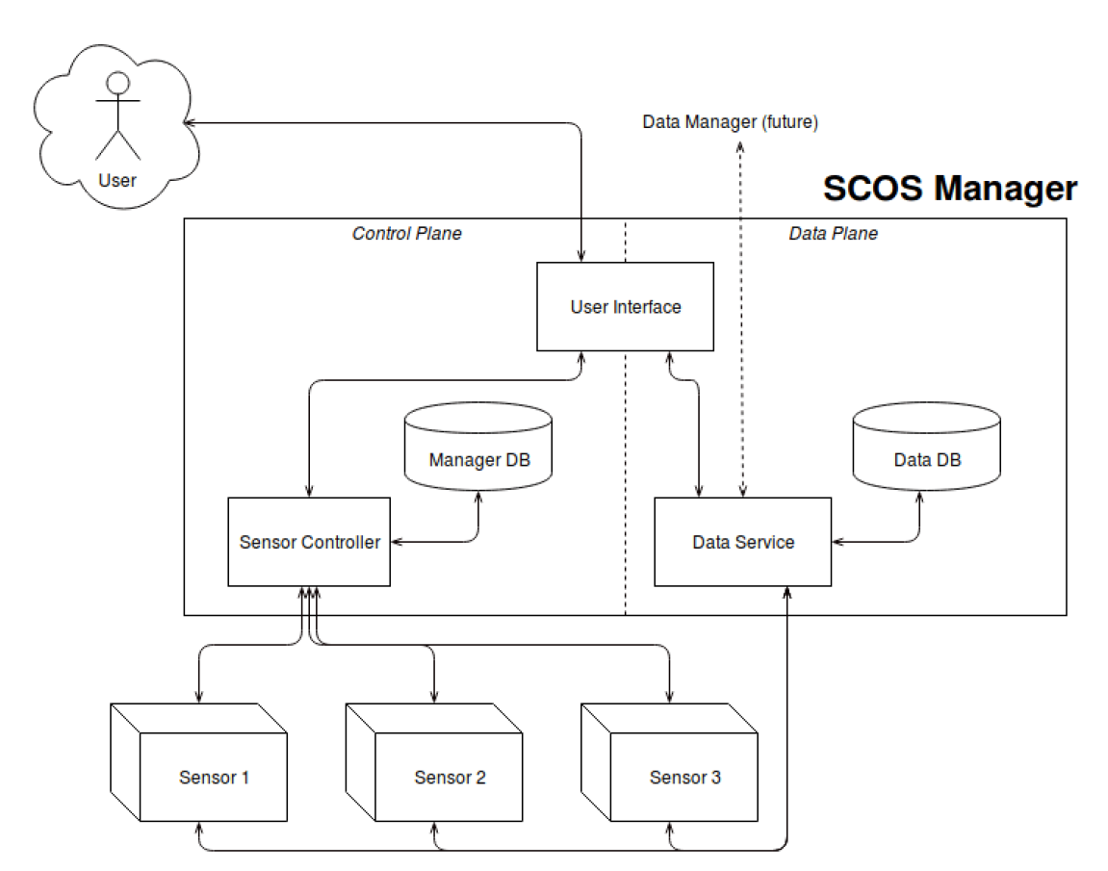
Figure 8. Manager Software Model

•The Institute of Electrical and Electronics Engineers, Inc. 3 Park Avenue, New York, NY 10016-5997, USA Copyright © varCRYear by The Institute of Electrical and Electronics Engineers, Inc. All rights reserved. Published varPublishedDate. Printed in the United States of America. IEEE is a registered trademark in the U.S. Patent & Trademark Office, owned by The Institute of Electrical and Electronics Engineers, Incorporated. PDF: ISBN varISBNpdf varStdIDpdf Print: ISBN varISBNprint varStdIDprint IEEE prohibits discrimination, harassment, and bullying. For more information, visit http://www.ieee.org/web/aboutus/whatis/policies/p9-26.html. No part of this publication may be reproduced in any form, in an electronic retrieval system or otherwise, without the prior written permission of the publisher.
IEEE Standards Dictionary Online is available at: http://dictionary.ieee.org .
National Telecommunications and Information Administration (NTIA) regulates government use of radio frequencies in the United States. The Institute for Telecommunication Sciences (ITS) is the NTIA research and development laboratory.

