Contribution To IEEE 802.22.3

From

Nilesh Khambekar, SpectrumFi, Inc.
Jul 27, 2016

SCOS Platform Functional Specification
and
A Suggestion Regarding SCOS standard document structure

Overview
This contribution summarizes the proposal presented in plenary meeting.

SCOS Platform Functional Specification
SCOS platform primarily manages the RF environment sensors and Sensing-Data.

The standard defines
- a sensing model to capture the sensor specifications.
- configuration and control API to manage the spectrum.
- policy that specifies certain regulatory-authority/operator-specific preferences and constraints.

Similarly, for the sensing-data. The standard defines
- A sensing-data model that specifies the format of the sensor measurements
- A sensing-data configuration and control defines the API for Data-stores that store the sensing-data.
- A sensing-data policy that captures the access-constraints for sensing-data.

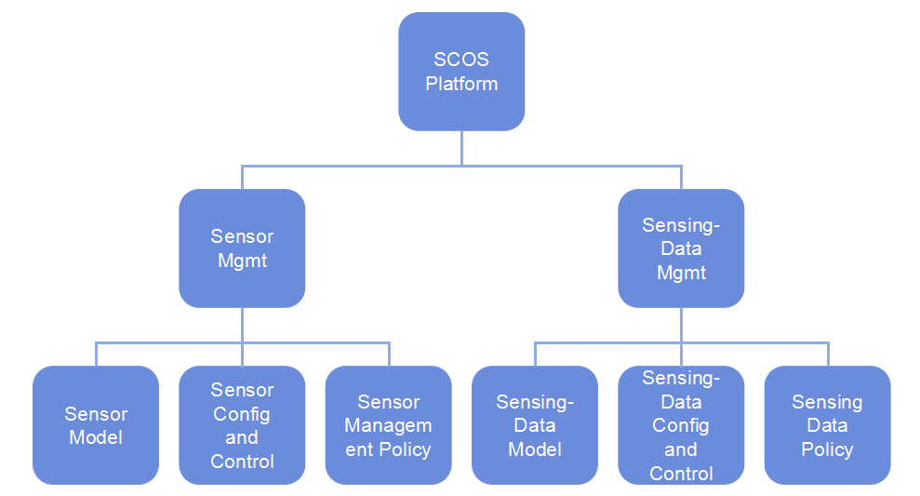

Suggestion regarding SCOS standard document structure
The SCOS standard document could have a layout based on the above functional specification. Here is a suggested document structure for IEEE 802.22.3.

- Overview
- Normative References
- Abbreviations and Acronyms
- SCOS Platform Requirements and constraints
  - Functional Requirements
    - Regulatory requirements
    - Operator requirements
    - Service-provider requirements
    - ..
    - Timing requirements
    - Network requirements
  - Security Requirements
  - Sensor requirement constraints
  - Data-store requirements

- SCOS Platform Architecture
- SCOS Platform Specification
- System Definitions

- Sensor Mangement
- Sensor Model
- Sensor Management API
- Sensor Management Policy

- Sensing-Data Management
- Sensing-data model
- Sensing-data management API
- Sensing-data management policy
- Interface Specification
  - SSM-SSD control interface
    - Registration
    - Query
    - Configuration
    - Notification
  - SSM-Data store Ingest interface
    - Registration
    - Data
    - Configuration
    - Notification
- SCOS Recommended Practices
- Appendices

