Radiocommunication Study Groups | 
Source: Document Annex 9 to Document 6A/264  Subject: Question ITU-R 132-2/6  Report ITU-R BT-2265  Recommendation ITU-R BT.1895 | Document USA 6A/xxx-E
 | 10 October 2013
 | English only
Modifications to the Annex 9 to Working Party 6A Chairman's Report
PRELIMINARY DRAFT
NEW REPORT ITU-R BT.[ASSESSDTTBCRS]
Assessment of interference into the broadcasting service from
cognitive devices in the frequency band 470-790 MHz

1 Introduction
The current version of Annex 9 to the WP 6A Chairman’s Report is based on very conservative assumptions on the potential interference produced by white space devices (WSDs) that could affect DTV operation in the TV broadcast bands. This contribution proposes to review these assumptions as to their validity and their practical implications and, according to the conclusions, to modify the text of the Annex 9 as indicated in ‘track change’ in Annex A to this document, and, when appropriate, make some adjustments to the Recommendation ITU-R BT.1895 and Report ITU-R BT-2265.

2 Assumed I/N requirement
The value of -20 dB I/N assumed in section 2.1.3 of Annex 9, which refers to Recommendation ITU-R BT.1895, seems to be out of context in the treatment of DTV broadcast interference protection. Such high value was originally developed for satellite communication systems where the variation of the signal level is very small (especially in the 4/6 GHz bands) and was based on the fact that transmission power is at a premium at the satellite. Note that this -20 dB I/N corresponds to a degradation of the C/N of only 0.043 dB.
The signal level variation is very different in the context of terrestrial DTV broadcasting with the commonly assumed 5.5 dB standard deviation for the location variability and the various standard deviations for time variation that can be extracted from the propagation model contained in the ITU-R P.1546 Recommendation, which is related to the frequency of operation, the broadcast antenna HAAT and the distance between the broadcast transmitter and the receiver. Table 2 presents some standard deviation values for the time variation for a number of typical broadcast transmission parameter values (i.e., frequency of operation, antenna HAAT and distance to the receiver).
In order to assess the impact of the I/N requirement on the service availability, a compound ‘location and time’ propagation model was developed based on the fact that the two variations in location and time can be considered as following two non-correlated log-normal models. The standard deviation of this new compound log-normal model can then be defined as follows:
σcompound = √(σlocation² + σtime²)
The DTV broadcast service performance requirement for this compound propagation model is:
Pcompound = 1- ((1- Plocation) * (1- Ptime)) = 1- ((1- 50%) * (1- 90%)) = 95%
With this model, the total signal fading at the stated performance requirement (i.e., 95%) can be calculated for various parameter values. One can then analyze the impact of various I/N values as it affects the probability of keeping the transmission link above the required C/N level.
Since it can be assumed that, according to results of numerous laboratory measurements, the impact of wideband digital modulation is similar to that of noise for DTV, whether the interfering signal is another DTV signal or a wideband digital modulation, this conclusion can readily be extended to the interference coming from WSD’s. A few I/N values were evaluated as to their effect on the C/N degradation as shown in Table 1.
TABLE 1
I/N values and their impact on the C/N degradation
I/N values (dB) | C/N degradation (dB)
-20 | 0.043
-10 | 0.414
-7.81 | 0.665
0 | 3.01
These C/N degradations can then be applied to the various total signal fading values obtained by the above compound propagation model to obtain the impact in terms of degradation in probability to maintain the required C/N. Table 2 presents these results for these four I/N values in typical DTV broadcast conditions.
As can be seen from Table 2, the reduction in signal availability at the DTV receiver caused by the -20 dB I/N value proposed in the current Annex 9 results in a degradation of the C/N requirement for only 0.071% to 0.081% of the cases, that is a resulting overall DTV service availability going from the initial requirement of 95% to 94.929% and 94.919%, proving that this -20 dB I/N requirement in the case of DTV broadcasting is excessively conservative.
A more practical value for I/N in the DTV broadcasting field and used in North-America can be extracted from Part 2 of the FCC-OET Bulletin 69. In order to limit the impact of co-channel interference in noise-limited reception condition (C/N= 16 dB, e.g., at the edge of the coverage area), a value of 23 dB C/I is used rather than the 15.19 dB co-channel DTV protection ratio measured in laboratory. This results in a I/N of -7.81 dB which corresponds to a C/N degradation of 0.665 dB. This is the third value explored in Tables 1 and 2. More reasonable degradations between 1.2% and 1.4% in probability to maintain the required C/N at the DTV receiver are obtained as shown in Table 2. This well established I/N value in North-America could very well be used as the criterion for WSD interference into DTV reception.
TABLE 2
Signal fading probability and impact of additional I/N requirements on the degradation of the service availability according to ITU-R. P.1546 Recommendation
Frequency of Operation (MHz) | TX antenna HAAT (m) | Distance to RX (km) | Fading between 50% and 90% time availability | σtime  (dB) | σlocation  (dB) | σcompound  (dB) | Degradation for  I/N= -20 dB | Degradation for  I/N= -10 dB | Degradation for  I/N= -7.81 dB | Degradation for  I/N= 0 dB
470 | 75 | 20 | 0.765 | 0.597 | 5.5 | 5.532 | 0.081% | 0.820% | 1.368% | 8.551%
470 | 75 | 50 | 2.226 | 1.737 | 5.5 | 5.768 | 0.078% | 0.785% | 1.307% | 8.073%
470 | 75 | 70 | 3.845 | 3.000 | 5.5 | 6.265 | 0.072% | 0.719% | 1.195% | 7.214%
470 | 150 | 20 | 0.453 | 0.354 | 5.5 | 5.511 | 0.081% | 0.824% | 1.374% | 8.596%
470 | 150 | 50 | 1.494 | 1.166 | 5.5 | 5.622 | 0.080% | 0.806% | 1.344% | 8.362%
470 | 150 | 70 | 3.129 | 2.442 | 5.5 | 6.018 | 0.075% | 0.751% | 1.248% | 7.619%
470 | 300 | 20 | 0.312 | 0.243 | 5.5 | 5.505 | 0.081% | 0.825% | 1.376% | 8.609%
470 | 300 | 50 | 0.688 | 0.537 | 5.5 | 5.526 | 0.081% | 0.821% | 1.370% | 8.564%
470 | 300 | 70 | 2.202 | 1.719 | 5.5 | 5.762 | 0.078% | 0.786% | 1.309% | 8.084%
600 | 75 | 20 | 0.777 | 0.606 | 5.5 | 5.533 | 0.081% | 0.820% | 1.368% | 8.549%
600 | 75 | 50 | 2.165 | 1.689 | 5.5 | 5.754 | 0.078% | 0.787% | 1.311% | 8.101%
600 | 75 | 70 | 3.689 | 2.879 | 5.5 | 6.208 | 0.072% | 0.726% | 1.207% | 7.304%
600 | 150 | 20 | 0.458 | 0.357 | 5.5 | 5.512 | 0.081% | 0.824% | 1.374% | 8.595%
600 | 150 | 50 | 1.522 | 1.188 | 5.5 | 5.627 | 0.080% | 0.806% | 1.343% | 8.353%
600 | 150 | 70 | 3.102 | 2.421 | 5.5 | 6.009 | 0.072% | 0.752% | 1.250% | 7.633%
600 | 300 | 20 | 0.327 | 0.255 | 5.5 | 5.506 | 0.081% | 0.825% | 1.375% | 8.608%
600 | 300 | 50 | 0.761 | 0.594 | 5.5 | 5.532 | 0.081% | 0.820% | 1.368% | 8.552%
600 | 300 | 70 | 2.284 | 1.782 | 5.5 | 5.782 | 0.078% | 0.783% | 1.304% | 8.047%
790 | 75 | 20 | 0.637 | 0.497 | 5.5 | 5.522 | 0.081% | 0.822% | 1.371% | 8.572%
790 | 75 | 50 | 2.370 | 1.849 | 5.5 | 5.802 | 0.077% | 0.780% | 1.299% | 8.007%
790 | 75 | 70 | 3.945 | 3.078 | 5.5 | 6.303 | 0.071% | 0.715% | 1.187% | 7.156%
790 | 150 | 20 | 0.326 | 0.255 | 5.5 | 5.506 | 0.081% | 0.825% | 1.375% | 8.608%
790 | 150 | 50 | 1.740 | 1.358 | 5.5 | 5.665 | 0.079% | 0.800% | 1.333% | 8.275%
790 | 150 | 70 | 3.372 | 2.631 | 5.5 | 6.097 | 0.074% | 0.740% | 1.230% | 7.484%
790 | 300 | 20 | 0.184 | 0.143 | 5.5 | 5.502 | 0.082% | 0.825% | 1.377% | 8.617%
790 | 300 | 50 | 0.962 | 0.751 | 5.5 | 5.551 | 0.081% | 0.817% | 1.363% | 8.511%
790 | 300 | 70 | 2.518 | 1.965 | 5.5 | 5.840 | 0.077% | 0.775% | 1.289% | 7.936%

Although slightly more conservative as can be seen in Table 2, giving percentages of probability degradation at the threshold of availability at the DTV receiver between 0.7% and 0.82%, a I/N of -10 dB, as per recommends 3 of Recommendation ITU-R BT.1895 and used in Report ITU-R BT.2265 and in section 3.1.1 below, also seems to be appropriate and would have the advantage of creating an harmonized value applicable everywhere. This would result in an overall DTV service availability going from the initial requirement of 95% to 94.3% and 94.18%
For the purpose of comparison, Table 2 also gives the performance degradation for I/N of 0 dB which corresponds to the degradation allowed for co-channel DTV interference. Such degradation ranges between 7% and 8.6% reduction of probability of maintaining the required C/N at the DTV receiver. The degradation in probability of maintaining the availability of the DTV reception for a I/N of -10 dB is therefore 10 times less than in the case of co-channel interference and 100 times less for a I/N of -20 dB according to the ITU-R P.1546 Recommendation for typical broadcast operation.
It can therefore be concluded that a value of -10 dB for I/N is more reasonable than -20 dB in the case of normal broadcast operation and modifications were made to this effect in the attached Annex 9. Note that a I/N of -20 dB is required to maintain a degradation of 1% of a transmission link in the case where the propagation follows a log-normal model with a 0.5 dB standard deviation. This kind of propagation model corresponds more closely to a C-band satellite communication system. This is likely where this -20 dB requirement comes from in recommend 2 of the ITU-R BT.1895 Recommendation. This value should therefore be used in the proper context.

3 DTV antenna discrimination
In the case where a WSD cannot be operated close to a DTV receiving installation for a given channel usage, this means that such WSD can only be located outside the broadcast service area since DTV receiving installations can be placed anywhere inside that area. The WSD would therefore need to be located outside, beyond a certain minimum distance from the edge of the DTV service area. Such minimum distance can be calculated and will depend on the level of signal that is generated by the WSD compared to the protection level required for proper DTV reception, taking into account the propagation loss between the two points. In the calculation of such minimum distance, the DTV receive antenna discrimination will need to be considered since the orientation of the DTV receive antenna toward the broadcast transmitter will be in the opposite direction to the direction of the potential interference coming from the WSD since the latter needs to be located outside the service area.
For the UHF TV band, the amount of discrimination, otherwise called ‘front-to-back’ ratio, was established at 14 dB. This factor therefore needs to be included in the interference calculations described in section 2.3 of Annex 9. It is understood that even if a simpler receive antenna, i.e., lower gain, can be used in a DTV receive installation at the edge of coverage, this 14 dB front-to-back ratio will still be applicable since the field strength available at that location will be higher than the minimum required to compensate for such lower gain antenna. This 14 dB antenna discrimination will still be applicable to calculate the interfering signal level for typical DTV receiving installations at the edge of the service area.

4 Percentage of time for protecting DTV broadcasting
In section 2.2.3, it is currently stated that: “For the purposes of this study, curves for land paths and one percent of the time were used.” Since the study is for the protection of DTV signal reception, the availability figures for the signal propagation should therefore be those applicable to DTV reception and not those related to the reception performance at the WSD. The time availability figure should therefore be 10%.

5 Consideration of multiple adjacent channels
In North-America, the spectrum regulators have decided to neglect the potential interference from the ‘multiple adjacent channels’ beyond the first adjacent channels (upper and lower), the so-called ‘taboo channels’, in the planning of the DTV broadcasting service as well as in the consideration of potential interference from WSDs. However, the ‘taboo channels’ corresponding to the analog NTSC broadcast service are still considered wherever this kind of service is still provided.
An interpretation of such approach for DTV protection is that these ‘taboo channels’ are seen as the result of mid 20th century vacuum tube technologies whereas it is expected that DTV receivers can now be implemented with 21st century technologies such as better RF front-end linearity, upper IF, better RF and IF filtering, etc. If the same level of effort, as put in improving the video display technologies (going from CRT’s to LCD’s, plasma displays, OLED, etc.), and even a fraction of it, is put in improving the DTV tuner performance, it seems clear that such ‘taboo channel’ requirements are no longer needed.
Although spectrum regulators are reluctant at imposing minimum standards for receivers, it is clear that the performance of such receivers has as much impact on the efficient use of the RF spectrum as the performance of the transmitters. The use of TV broadcast bands is a case in point. RF spectrum efficiency cannot be fully improved if last century technologies are kept as the basis for establishing new communication systems for this century.
A means to improving such efficiency in spectrum use is to develop conditions where communication systems can use the spectrum more efficiently, although with the potential situation where interference may occur due to poor receiver performance. It is then up to the industry to improve the receiver performance to resolve the problems. Competition amongst manufacturers to keep their share of the market with good quality consumer products will automatically lead to the inclusion of such improvements. This is ideally applicable when new generation of equipment comes on the market as is the case for these new and enhanced flat panel DTV receivers.
In the interest of improving the spectrum efficiency in the use of the TV bands, it is therefore proposed to remove the consideration of the ‘multiple adjacent channels’ in the attached Annex 9. Modifications to the text and the Tables can be found in ‘track change’ in the attached Annex A.

6 Direct-pickup interference
Direct-pickup interference from WSDs into cable-ready DTV sets was evaluated in 2007 in the USA by the FCC, before the adoption of WSD rules, and the results of this 2007 study were presented in a report that was appended to Annex 9 to Document 6A/264 and summarized in its section 4. The USA adopted WSD rules in 2010 and issued rules on consideration in 2012. Conclusions extracted from the 2007 NCTA filing to the FCC were also reported in detail in this section 4 as it relates to this type of direct-pickup interference and to the interference from WSDs into cable headend reception beyond the normal DTV broadcast contours.
A number of modifications to the current text are proposed to re-order the text in a more logical way, to clarify and improve the reading as well as to augment the section to include a more up-to-date representation of the situation, beyond the reported NCTA filing, including the rationale used to establish the regulatory environment in the USA with respect to direct-pickup interference and protection of cable headend DTV reception.

7 Conclusions
Resulting from the above discussions, a number of modifications are proposed in Annex A as ‘track changes’ to the current text of Annex 9 to Document 6A/264.
It is also proposed to consider modifying Recommendation ITU R BT.1895 to clarify the context in which the I/N values proposed in the Recommendation can be used. The real impact on TV broadcast service should relate to the extent of the received signal variability and should be considered in terms of probability of such impact on the service (e.g., % of location, % of time or % of cases) rather than a fractional increase of the noise power.
Finally, it is proposed to modify the Appendix 4 to Annex 1 to Report ITU-R BT.2265 to align with the proposal contained in section 5 above where interference from channels beyond the first adjacent channels should no longer be considered in order to lead to the development of better DTV receivers in view of rendering the use of the RF spectrum more efficient in the TV broadcast bands in the 21st century. Report ITU-R BT.2265 should also reflect the modifications proposed for Recommendation ITU R BT.1895 in the previous paragraph about the use of the I/N values in their appropriate context.
Annex A
Proposed modifications to Annex 9 to Document 6A/264
Radiocommunication Study Groups
Source: Document 6A/TEMP/108  Subject: Question ITU-R 132-2/6 | Annex 9 to  Document 6A/264-E
 | 10 May 2013
 | English only
Annex 9 to Working Party 6A Chairman's Report
PRELIMINARY DRAFT
NEW REPORT ITU-R BT.[ASSESSDTTBCRS]
Assessment of interference into the broadcasting service from
cognitive devices in the frequency band 470-790 MHz

1 Introduction
The implementation of cognitive systems without a specific frequency allocation in the Radio Regulations (which may include white space devices – WSDs), but that can utilize spectrum not occupied by incumbent services, should be done so without causing interference to existing services. Thus, perspectives for development of cognitive systems in the 470-790 MHz will depend on the presence of available frequency spectrum and on the range of allowable technical parameters for cognitive systems which provide compatibility with incumbent services. This report considers the simultaneous use of the frequency band 470-790 MHz by cognitive devices and the broadcasting service of ATSC and DVB-T systems. In order to mitigate interference into a broadcast receiver, separation distances are calculated for two types of cognitive devices: fixed base stations or user terminals and personal/portable devices.
This document presents the results of research on the following issue:
The example of application of first step methodology described in the Report ITU-R BT.2265 identifying cases that need further study of interference into the broadcasting service from cognitive devices.
Where noted, it also provides the results of public trials and resulting regulations that require the cognitive systems operating in the broadcast band to use a geolocation database to protect incumbent broadcasting and other services from harmful interference.
Annex 1 to this document contains results of CRS compatibility study performed in the Russian Federation that gives an indication of the amount of available frequency spectrum for CRS devices in a given region.

2 Assessment of interference into ATSC broadcasting system

2.1 Parameters

2.1.1 Broadcast receiving system ATSC
The ATSC planning parameters for DTV reception using a fixed antenna are tabulated in Table 2.1. The symbols correspond to those in Report ITU-R BT.2265. The isotropic antenna gain including feeder loss, G_{R}, is given by:
G_{R} = G_{d} + 2.15 - L_{f}
Table 2.1
System A Planning Parameters
Planning Parameter | Symbol | Value | Units
Bandwidth | B | 6 | MHz
Temperature | T | 290 | K
Receive system noise figure | F | 7 | dB
Receiver inherent noise | N_{R} | -129.2 | dBW
Feeder loss | L_{f} | 4 | dB
Receiver antenna gain | G_{d} | 10 | dBd
Isotropic receive antenna gain  including feeder loss | G_{R} | 8.15 | dBi
Receiving antenna front-to-back ratio | FB | 14 | dB
Receive antenna height | h₂ | 10 | m
Reception location probability | RLP | 50 | Percent
Reception time probability | RTP | 90 | Percent

In addition to co-channel interference, the broadcasting receiving System A is susceptible to interference from signals on first adjacent channels. The deterioration in the ATSC receiver sensitivity from adjacent-channel interference is determined by the total power of the interfering signal within the respective adjacent channel. The protection ratios for System A from Recommendation ITU-R BT.1368 for the first adjacent channels are summarized in Table 2.2.

TABLE 2.2
Adjacent-channel protection ratios,
N ± 1 for System A
Type of interference | Protection ratio (dB)
Lower adjacent channel interference (N – 1) | −28
Upper adjacent channel interference (N + 1) | −26

2.1.2 Cognitive device parameters
The planning parameters for the cognitive devices interfering with the broadcast receiving system are tabulated in Table 2.3. Two types of cognitive devices are considered: 1) a 4 Watt e.i.r.p. fixed transmitter for a base station or user terminal with an antenna height up to 250 metres (HAAT); and 2) a personal or portable transmitter operating at a height of 1.5 metres (HAAT) with a lower e.i.r.p. of 100 mW. The interference location probability is 50 percent and the interference time probability is one percent.
Table 2.3
Planning parameters for two cognitive devices
Planning Parameter | Value | Units
Frequency band | 470-790 | MHz
Interference location probability | 50 | Percent
Interference time probability | 1 | Percent
Fixed transmitter:
Maximum e.i.r.p. | 4 | W
Antenna height (HAAT) | up to 250 | m
Personal/portable transmitter:
Maximum e.i.r.p. | 100 | mW
Antenna height (HAAT) | 1.5 | m

2.1.3 Additional parameters
The following additional parameters are used to determine separation distances:
• In this study, I/N = -10 dB
• The summation of multiple interferers is not considered.
• Polarisation discrimination is not considered.
For specific scenarios and applications, polarisation and directivity discrimination may be considered. Report ITU-R BT.2265 provides methodologies for discrimination as well as multiple interferers.
It should be noted that multiple interferers may be significant. It has been reported, that combinations of undesired signals can cause interference on a desired channel. For example, as reported, if the desired channel is N, signals on channels N + K and N + 2K, where K is an integer between 1 and 10, will combine to cause interference into the desired channel N. These results were confirmed with the observation of single and double interference on adjacent-channels and multiple adjacent-channels. However, with improvement in the DTV tuners such as better RF front-end linearity and the use of high IF, this kind of interference mechanism can be avoided.

2.2 Methodology
This section considers the interference of devices without a frequency allocation in the Radio Regulations into the broadcasting service. Consequently, Report ITU-R BT.2265 is used to assess the level of interference caused by these devices. In order to mitigate the interference, separation distances are determined between the interfering device and the broadcast receiving system using the signal propagation model of Recommendation ITU-R P.1546.

2.2.1 Receiving system noise equivalent field-strength
The receiving system noise equivalent field-strength is calculated from equation 3 of Report ITU-R BT.2265. Since the field-strength is frequency dependent, values have been chosen to include the limits of the band 470-790MHz as well as the limits and mid-point of the band 470-698 MHz. The results are tabulated in Table 2.4. Field-strengths for other frequencies (i.e., 470, 584, 698, and 790 MHz) can be interpolated using the methodology in Section 5 of Annex 5 to Recommendation ITU-R P.1546-4.
Table 2.4
Noise equivalent field-strength at various frequencies for the receiving System A
Frequency | 470 MHz | 584 MHz | 698 MHz | 790 MHz
Noise equivalent field-strength (dB(µV/m)) | 23.3 | 25.2 | 26.7 | 27.8

In addition to the thermal noise power, environmental noise is present at the broadcast receive antenna. However, as shown in Report ITU-R BT.2265, the impact of environmental noise in the frequency band 470-790 MHz is minimal and is not considered here.

2.2.2 Individual median effective interfering field-strength threshold
The individual median effective interfering field-strength threshold, E_{I/N_th,} is derived from the noise equivalent field-strength in Table 2.4, the protection ratios in Table 2.2, and I/N. The results for the various frequencies are tabulated in Table 2.5.
Table 2.5
Individual median effective interfering field-strength thresholds, E_{I/N_th},
for System A at various frequencies
Type of interference | Interference field-strength threshold (dB(µV/m))
Type of interference | 470 MHz | 584 MHz | 698 MHz | 790 MHz
Co-channel (N) interference | 13.3 | 15.2 | 16.7 | 17.8
Lower adjacent channel interference (N – 1) | 41.3 | 43.2 | 44.7 | 45.8
Upper adjacent channel interference (N + 1) | 39.3 | 41.2 | 42.7 | 43.8

2.2.3 Propagation curves
Recommendation ITU-R P.1546 contains propagation curves of field-strength values for a 1 kW effective radiated power (e.r.p.) transmitter at nominal frequencies of 100, 600, and 2 000 MHz as a function of path type, discrete transmitting antenna heights (10, 20, 37.5, 75, 150, 300, 600, and 1200 metres HAAT), and distance from the transmitter (1 to 1000 km). The curves represent field-strength values exceeded at 50 percent of the locations within any area of approximately 500 m by 500 m and for 50 percent, 10 percent, and one percent of the time. For the purposes of this study, curves for land paths and 10 percent of the time were used.

2.2.3.1 Transmitting antenna height interpolation
The propagation curves can be interpolated for various transmitting antenna heights between 10 m and 1 200 m using equation 8 in section 4.1 of Annex 5 to Recommendation ITU-R P.1546-4. The height of the DTV receiving antenna is assumed to be at 10 m in all cases.

2.2.3.2 Transmitting antenna height extrapolation
Recommendation ITU-R P.1546 provides propagation curves for transmitting antenna heights between 10 and 1 200 metres. Since the personal/portable cognitive device has an antenna height of 1.5 metre, section 4.2 in Annex 5 is used to extrapolate the propagation curves. The propagation curves are further extrapolated for distances less than one km using the methodology found in section 14 of Annex 5. Again, the height of the DTV receiving antenna is assumed to be at 10 m in all cases.

2.2.3.3 Frequency interpolation
The propagation curves in Recommendation ITU-R P.1546 are specified for the nominal frequencies of 100, 600, and 2 000 MHz. These curves are interpolated using equation 14 in section 6 to Annex 5, for the specific frequencies of 470, 584, 698, and 790 MHz.

2.2.3.4 Transmitter power
The propagation curves in Recommendation ITU-R P.1546 are specified for a nominal transmitter of 1 kW e.r.p. or 0 dBkW ERP. The relationship between ERP and EIRP is given by the equation:
ERP = EIRP – 2.15
Consequently, the EIRP and ERP for the cognitive devices to be considered are shown in Table 2.6.
Table 2.6
Transmitter powers for fixed and personal/portable cognitive devices
Cognitive device | Power | Units
Fixed transmitter:
Maximum e.i.r.p. | 4 | W
Maximum EIRP | 6 | dBW
Maximum ERP | -26.15 | dBkW
Personal/portable transmitter:
Maximum e.i.r.p. | 100 | mW
Maximum EIRP | -10 | dBW
Maximum ERP | -42.15 | dBkW

2.2.3.5 Example propagation curves for a fixed cognitive transmitter
Figure 2.1 illustrates the resulting propagation curves interpolated from Recommendation ITU-R P.1546 for a fixed transmitter operating at antenna heights of 30 and 250 metres HAAT with an EIRP of 6 dBW. The curves have been interpolated for the frequencies 470, 698 and 790 MHz. Emax is the free-space field-strength propagation curve.
Figure 2.1
Field-strength propagation curves for a 4W (e.i.r.p.) fixed cognitive
transmitter at 30 and 250 metre (HAAT) antenna heights

2.2.3.6 Example propagation curves for a personal/portable cognitive transmitter
Figure 2.2 illustrates the resulting propagation curves extrapolated from Recommendation ITU-R P.1546 for a personal/portable transmitter operating at an antenna height of 1.5 metres HAAT with an EIRP of – 10 dBW. The curves have been extrapolated for the antenna height below 10 metres and the distance below 1 km. Emax is the free-space field-strength propagation curve.

Figure 2.2
Field-strength propagation curves for a 100mW (e.r.p.) personal/portable cognitive
transmitter at a 1.5 metre (HAAT) antenna height

2.2.3.7 Separation distance interpolation
The separation distance between the interfering cognitive device and the broadcast receiving system is determined by the intersection of the individual median effective interfering field-strength threshold, E_{I/N_th}, with the appropriate field-strength propagation curve. Since the tabulated data for the curves utilize discrete distance values, it is necessary to interpolate to obtain a precise separation distance. The equation for the separation distance, d_{sep}, is given by:
d_{sep} = d_{inf} (d_{sup} / d_{inf})^{ΔE} (2.1)
where:
ΔE = (E_{I/N_th} – E_{inf}) (E_{sup} – E_{inf})
and where:
d_{sep}: separation distance
E_{inf} : nearest tabulation field-strength less than E_{I/N_th}
E_{sup} : nearest tabulation field-strength greater than E_{I/N_th}
d_{inf} : distance value for E_{inf}
d_{sup} : distance value for E_{sup.}

2.3 Separation distances
The separation distances at the individual median effective interfering field-strength threshold for fixed cognitive devices operating at 4 Watts e.i.r.p. and 10, 30, 106 and 250 metre antenna heights (HAAT) are tabulated in Tables 2.7, 2.8, 2.9 and 2.10, respectively. Each table includes the separation distances for co-channel and first adjacent-channel (upper and lower) interferers into a broadcast receiving System A. Table 2.11 tabulates the separation distances for a personal/portable device interfering with a broadcast receiving System A. The tables illustrate the possibility of interference from cognitive devices operating outside the broadcast service area since the minimum separation distance to a DTV receiving installation is larger than what would be acceptable in practice (e.g., 16 m). For this reason, the interfering signal from the WSD would be received from the back of the DTV receiving antenna, i.e., a direction outside the main beam of the DTV antenna. As a result, the front-to-back ratio of the DTV receiving antenna needs to be taken into consideration. Specific application scenarios may need to consider the impact of aggregate interference caused by cognitive devices.
Table 2.7
Separation distances at the interference threshold for fixed cognitive devices
(operating at 4 Watts with a 10 metre HAAT antenna) interfering
with the ATSC system at various frequencies in the TV band
Type of interference | Separation distances from the closest DTV receiving installation at the edge of the DTV service area (km)
Type of interference | 470 MHz | 584 MHz | 698 MHz | 790 MHz
Co-channel (N) | 8.74 | 7.91 | 7.26 | 6.82
N-1 | 0.75 | 0.68 | 0.63 | 0.60
N+1 | 0.85 | 0.78 | 0.72 | 0.68
Table 2.8
Separation distances at the interference threshold for fixed cognitive devices
(operating at 4 Watts with a 30 metre HAAT antenna) interfering
with the ATSC system at various frequencies in the TV band
Type of interference | Separation distances from the closest DTV receiving installation at the edge of the DTV service area (km)
Type of interference | 470 MHz | 584 MHz | 698 MHz | 790 MHz
Co-channel (N) | 13.87 | 12.45 | 11.42 | 10.48
N-1 | 0.94 | 0.84 | 0.77 | 0.72
N+1 | 1.09 | 0.97 | 0.89 | 0.83
Table 2.9
Separation distances at the interference threshold for fixed cognitive devices
(operating at 4 Watts with a 100 metre HAAT antenna) interfering
with the ATSC system at various frequencies in the TV band
Type of interference | Separation distances from the closest DTV receiving installation at the edge of the DTV service area (km)
Type of interference | 470 MHz | 584 MHz | 698 MHz | 790 MHz
Co-channel (N) | 23.98 | 21.61 | 19.94 | 18.80
N-1 | 1.36 | 1.19 | 1.07 | 0.99
N+1 | 1.60 | 1.40 | 1.25 | 1.16
Table 2.10
Separation distances at the interference threshold for fixed cognitive devices
(operating at 4 Watts with a 250 metre HAAT antenna) interfering
with the ATSC system at various frequencies in the TV band
Type of interference | Separation distances from the closest DTV receiving installation at the edge of the DTV service area (km)
Type of interference | 470 MHz | 584 MHz | 698 MHz | 790 MHz
Co-channel (N) | 36.48 | 33.34 | 31.18 | 29.68
N-1 | 1.92 | 1.64 | 1.44 | 1.31
N+1 | 2.3 | 1.97 | 1.73 | 1.58
Table 2.11
Separation distances at interference threshold for personal/portable cognitive devices
(operating at 100 mW with a 1.5 metre HAAT antenna) interfering with
the ATSC system at various frequencies in the TV band
Type of interference | Separation distances from the closest DTV receiving installation at the edge of the DTV service area (km)
Type of interference | 470 MHz | 584 MHz | 698 MHz | 790 MHz
Co-channel (N) | 3.47 | 2.36 | 2.137 | 1.986
N-1 | 0.25 | 0.084 | 0.067 | 0.058
N+1 | 0.283 | 0.110 | 0.088 | 0.076

[Editorial Note – This table and its location in the document to be re-considered at a future meeting;
However, the results of another administration’s methodology and study result in regulations that provide lesser separation distances.
TABLE 2.12
Separation distances under FCC rules

Antenna height above average terrain of unlicensed device | Required separation (km) from digital or analog TV (full service or low power) protected contour
Antenna height above average terrain of unlicensed device | Co-channel  (km) | Adjacent  channel  (km)
Less than 3 meters | 4.0 | 0.4
3-Less than 10 meters | 7.3 | 0.7
10-Less than 30 meters | 11.1 | 1.2
30-Less than 50 meters | 14.3 | 1.8
50-Less than 75 meters | 18.0 | 2.0
75-Less than 100 meters | 21.1 | 2.1
100-Less than 150 meters | 25.3 | 2.2
150-Less than 200 meters | 28.5 | 2.3
200-250 meters | 31.2 | 2.4

The antenna height above ground for a fixed TVBD may not exceed 30 meters under that other administration’s rules.]

3 Assessment of interference into DVB-T broadcasting system

3.1 Method for initial compatibility assessment

3.1.1 Methodology
The estimation of the possibility of usage of WSDs without further studies can be carried out by determination of minimum separation distance between WSD and TV receiver antenna.
Minimum separation distances were determined by a study based on the calculation of the interference signal field strength using the formula:
$E_{{\text{INT}}_{\text{th}}}=E_{N}+I/N−{\text{μσ}}_{\text{INT}}+D_{\text{DIR}}+D_{\text{POL}}−\text{PR}(f_{\text{INT}}−f_{\text{BS}})+\text{PR}(0)$, (3.1)
where
- Field strength that corresponds to the receiving system noise power, dB(μV/m),
$σ_{\text{INT}}$ is the standard deviation of the shadowing between the interfering transmitter and the broadcast receiver,
- interference/noise ratio introduced to follow Recommendation ITU-R BT.1895 (dB),
$D_{\text{DIR}}$ is the broadcast receiver antenna directivity discrimination with respect to the interfering signal (dB),
$D_{\text{POL}}$ is the broadcast receiver polarisation discrimination with respect to the interfering signal (dB),
$\text{PR}(f_{\text{INT}}−f_{\text{BS}})$ is the appropriate broadcasting protection ratio for a frequency offset $f_{\text{INT}}−f_{\text{BS}}$ to protect the broadcast reception from interference (dB),
$\text{PR}(0)$ is the co-channel protection ratio (dB).
For WSDs the pessimistic scenario was considered, in which the effective height of user terminal was taken as 50 m, and the effective height of base station was taken as 70 m, assuming possible elevation changes and possible presence in high-rise buildings.
As protection ratios for DVB-T systems interfered with by cognitive systems, the protection ratios for DVB-T interfered with by LTE system from Recommendation ITU-R BT.1368 were used. The protection ratios for 90% of DVB-T receivers and partial traffic loading of LTE device were used. Protection ratios used are presented in Table 3.1.
Table 3.1
Protection ratios DVB-T interfered by cognitive devices used in calculation
 | Protection ratios DVB-T interfered by WSD, dB
Frequency offset, MHz | User equipment  (CRS UE) | Base station  (CRS BS)
0 | 19 | 19
1 | –12 | −20.5
9 | –32 | −21.5
18 | –35 | −24.5
27 | –36 | −28.5
36 | –37 | −32
45 | –38 | −35
54 | –40 | −37
63 | –37 | −38.5
72 | –33 | –39

The separation distances were calculated using Recommendation ITU-R P.1546.
The following assumptions were used in calculations:
– the summation of multiple interfering signals was not taken into account;
– polarisation and directivity discrimination are not considered;
– I/N= –10 dB;
– $σ_{\text{INT}}$ = 5.5 dB as the standard deviation of the shadowing between the interfering transmitter and the broadcast receiver;
– $μ$=1.645 as the Gaussian confidence factor related to target location percentage (95%).
The conclusion of the possibility to use the devices with the specified power and in the specified territory can be made on the basis of calculated separation distances.

3.1.2 Calculation of the separation distances
Some conclusions may be reached according to the frequency distribution in the Russian Federation in the band 470-862 MHz and according to the development plan of broadcasting services.
The use of 790-862 MHz band by WSDs was found as inappropriate due to WRC-12 decision on co-primary allocation of this band for mobile services. This is associated with the plan of Russian Federation to develop land mobile service in this band. In case of local use of land mobile service (for instance, only in the cities) there is the possibility to use the frequency channels occupied by land mobile service systems in the low populated areas by WSDs. However, in the 790-862 MHz band it is planned to use the IMT system, which will be used throughout the Russian Federation. So for WSDs there will be no “white spaces” in 790-862 MHz band and there is no sense to allocate this band to the usage of these devices.
Taking into account decisions of WRC-12 and future decisions of WRC-15 about possible co-primary allocation of 694-790 MHz band for IMT system in Region 1, number of “white spaces” will decrease, so it may be more difficult or even not possible for WSDs to operate in frequency bands with co-primary allocations for non-broadcasting services like an IMT.
It should be noted that in some countries the band 598-622 MHz (37, 38, 39 frequency channels) should be excluded from the usage by WSDs. It is connected with the fact that radio astronomical observatories which using 608-614 MHz band should be protected surely from unintentional interference of WSDs.
Taking into account the assumptions above, it is reasonable to take into consideration in this study the following parameters for WSDs:
– Frequency band: 470-694 MHz;
– Duplex type: TDD;
– Maximum e.i.r.p. for base station: 4 W;
– Maximum e.i.r.p. for portable/personal stations: 100 mW.
According to these parameters, for cognitive devices the separation distances were calculated which require no further studies of the interference and overloading of TV receivers. The separation distances (Rpr, km) are presented in Tables 3.2 and 3.3. The values of overloading thresholds (Oth, dBm) and corresponding separate distances for them (Roth, km) are presented in the tables for reference. The separation distances calculated assuming that CRS signals will have same impact onto broadcasting, as an LTE signals.For that purpose, protection ratios for interference from LTE to DVB-T have been used in calculation.

Table 3.2
The separation distances (maximum ERP)
 | CRS UE, 23 dBm and 50 m |  |  |  |  |  | CRS BS, 46 dBm and 70 m
Frequency offset, MHz | PR, dB | Eintmax, dBµV/m | Rpr, km | Oth, dBm | Eintmax, dBµV/m | Roth, km | PR, dB | Eintmax, dBµV/m | Rpr, km | Oth, dBm | Eintmax, dBµV/m | Roth, km
0 | 19 | 8.8 | 30 | – | – | – | 19 | 8.8 | 118.7 | - | - | -
1 | –12 | 39.8 | 4.8 | –23 | 98.5 | 0.037 | −20.5 | 48.3 | 14.1 | −40.8 | 80.7 | 4.1
9 | –32 | 59.8 | 1.1 | –46 | 75.5 | 0.53 | −21.5 | 49.3 | 13.3 | −35.5 | 86 | 2.2
18 | –35 | 62.8 | 0.86 | –47 | 74.5 | 0.59 | −24.5 | 52.3 | 11.1 | −39 | 82.5 | 3.3
27 | –36 | 63.8 | 0.79 | –44 | 77.5 | 0.42 | −28.5 | 56.3 | 8.7 | −32.5 | 89 | 1.6
36 | –37 | 64.8 | 0.73 | –43 | 78.5 | 0.375 | −32 | 59.8 | 6.9 | −31.5 | 90 | 1.4
45 | –38 | 65.8 | 0.68 | –41 | 80.5 | 0.295 | −35 | 62.8 | 5.6 | −29 | 92.5 | 1.2
54 | –40 | 67.8 | 0.58 | –39 | 82.5 | 0.235 | −37 | 64.8 | 4.9 | −28 | 93.5 | 0.94
63 | –37 | 64.8 | 0.73 | –35 | 86.5 | 0.149 | −38.5 | 66.3 | 4.4 | −26 | 95.5 | 0.74
72 | –33 | 60.8 | 1 | –32 | 89.5 | 0.105 | –39 | 66.8 | 4.2 | −25 | 96.5 | 0.66

Table 3.3
The separation distances (reduced ERP)
 | CRS UE, 0 dBm and 50 m |  |  |  |  |  | CRS BS, 16 dBm and 70 m
Frequency offset, MHz | PR, dB | Eintmax, dBµV/m | Rpr, km | Oth, dBm | Eintmax, dBµV/m | Roth, km | PR, dB | Eintmax, dBµV/m | Rpr, km | Oth, dBm | Eintmax, dBµV/m | Roth, km
0 | 19 | 8.8 | 8.2 | – | – | – | 19 | 8.8 | 23.7 | - | - | -
1 | –12 | 39.8 | 0.86 | –23 | 98.5 | 0.003 | −20.5 | 48.3 | 1.7 | −40.8 | 80.7 | 0.13
9 | –32 | 59.8 | 0.18 | –46 | 75.5 | 0.037 | −21.5 | 49.3 | 1.6 | −35.5 | 86 | 0.07
18 | –35 | 62.8 | 0.14 | –47 | 74.5 | 0.043 | −24.5 | 52.3 | 1.3 | −39 | 82.5 | 0.1
27 | –36 | 63.8 | 0.13 | –44 | 77.5 | 0.029 | −28.5 | 56.3 | 0.91 | −32.5 | 89 | 0.05
36 | –37 | 64.8 | 0.12 | –43 | 78.5 | 0.027 | −32 | 59.8 | 0.68 | −31.5 | 90 | 0.045
45 | –38 | 65.8 | 0.11 | –41 | 80.5 | 0.021 | −35 | 62.8 | 0.53 | −29 | 92.5 | 0.033
54 | –40 | 67.8 | 0.09 | –39 | 82.5 | 0.017 | −37 | 64.8 | 0.45 | −28 | 93.5 | 0.03
63 | –37 | 64.8 | 0.12 | –35 | 86.5 | 0.01 | −38.5 | 66.3 | 0.40 | −26 | 95.5 | 0.023
72 | –33 | 60.8 | 0.16 | –32 | 89.5 | 0.007 | -39 | 66.8 | 0.38 | −25 | 96.5 | 0.021

This evaluation of compatibility criteria for WSD based on the first step (Annex 1) of the methodology of Report ITU-R BT2265 shows that there are a lot of possible limitations in adjacent channels (channels n+1, …, n+8). The decreasing of the WSD power has not led to significant improvement of the situation, as even for reduced WSD power separation distances are more than 380 m for base station and more than 90 m for portable terminal. All administrations which allow implementation of CRS, have required the use of geolocation databases by cognitive devices to avoid harmful interference to broadcasting and other services. The database, with assistance of a geo-positioning system, can provide enough fidelity for identification of CRS location within “white space” for particular frequency channel. At the same time, it may be difficult to establish a hi-precision regulatory mechanism which could ensure that a mobile or portable CRS device will not appear at a distance less than XX meters to any television receiving antenna. In this case, to protect DTTB reception, mobile/portable CRS devices should not be allowed to transmit within service area of any broadcasting station. For fixed CRS devices, the most evident solution is a regulatory requirement providing that installation of CRS devices has to be done only by authorised personnel with necessary measures to avoid harmful interference to TV reception.
Further calculations of interference are necessary to evaluate the impact of interference in a numerical form using the detailed methodology given in section 3.2.

3.1.3 Definition of allowed power levels of portable WSD operating nearby TV receiver
The main purpose of the research was to assess the influence of a portable WSD LTE-type device which operates close to TV receiver, in one room. The induction via receiver case/input due to insufficient shielding of receiver itself and antenna feeder cable is assumed to be the source of interference.
As no LTE equipment was available at time of experiment, the following methodology was used:
1) Allowed power levels of portable DVB-T device were measured considering interference to DVB-T receiver.
2) Measurement of protection ratios (PR) for DVB-T receivers interfered with by DVB-T signal was carried out in order to verify correspondence of measured protection ratios of test receivers to values given in Recommendation ITU-R BT.1368-9.
3) The protection ratios from Recommendation ITU-R BT.1368-9 were taken for two cases: DVB-T vs. DVB-T and DVB-T vs. LTE. The difference between appropriate protection ratios was calculated and then an assumption was made that normal operation of DVB-T receiver could be possible with WSD power level which differs from values obtained for DVB-T vs. DVB-T case by calculated difference.

3.1.3.1 Definition of allowed power levels of portable transmitter equipment causing wideband spectrum interference operating nearby DVB-T receiver
The laboratory installation consisted of a DVB-T receiver (set-top-box) plugged to TV which displayed wanted signal and an imitator of portable interfering device (DVB-T signal generator and portable antenna, which moved nearby DVB-T receiver at the distance of approximately 1 meter). By changing the output level of interference generator and controlling quality of image on the screen, allowable power levels of portable device were measured. These measurements showed that output power level of the generator worked on adjacent channel could reach 20 dBm (antenna gain is 0 dB) without any interference to DVB-T receiver. It is important to note that value of 20 dBm for interference power level is not maximum allowed value since no measurements with higher levels were held.

3.1.3.2 Measurement of protection ratios (PR) for DVB-T receivers interfered with
by DVB-T
Three DVB-T receivers were used. For these receivers protection ratios DVB-T vs. DVB-T were measured for different frequency offsets (see Table 3.5). The comparison of measured PRs with values from the Recommendation ITU-R BT.1368-9 (see Table 5) shows that these three receivers may be considered typical.
Table 3.5
Results of measurement of protection ratios for DVB-T vs. DVB-T
Receiver | N | N+1 | N+2 | N+3 | N+4 | N+5 | N+6 | N+7 | N+8 | N+9
Rx1 | 17 | –27 | –46 | –50 | –51 | –51 | –51 | –51 | –51 | –40
Rx2 | 17 | –29 | –40 | –39 | –49 | –50 | –50 | –50 | –50 | –38
Rx3 | 18 | –30 | –41 | –47 | –50 | –49 | –49 | –48 | –48 | –43
Mean | 17 | –29 | –42 | –45 | –50 | –50 | –50 | –50 | –50 | –40

3.1.3.3 Application of protection ratios for case of DVB-T interfered with by
an LTE signal
To assess the difference between DVB-T vs. DVB-T signal and DVB-T vs. LTE signal appropriate protection ratios were compared. Table 3.6 shows protection ratios for DVB-T interfered with by an 8 MHz DVB-T signal (Recommendation ITU-R BT.1368-9, Table 17) and protection ratios for DVB-T interfered with by an 10 MHz LTE signal (Recommendation ITU-R BT.1368-9, Tables 38, 38a). In case of interference from LTE the highest values for the protection ratios were taken to correspond to the highest level of protection of broadcasting.
Table 3.6
Comparison of DVB-T/DVB-T and LTE/DVB-T protection rations
 | DVB-T interfered with by an 8 MHz DVB-T signal |  | DVB-T interfered with by an 10 MHz LTE signal |  | PR difference, dB
Channel | Interferer offset,  MHz | PR, dB  90th percentile | Interferer offset,  MHz | PR, dB  90th percentile | PR difference, dB
N+1 | 8 | −30 | 10 | –13 | –17
N+2 | 16 | −42 | 18 | –32 | –10
N+3 | 24 | −45 | 26 | –35 | –10
N+4 | 32 | −49 | 34 | –36 | –13
N+5 | 40 | −49 | 42 | –37 | –12
N+6 | 48 | −50 | 50 | –38 | –12
N+7 | 56 | −51 | 58 | –40 | –11
N+8 | 64 | −51 | 66 | –37 | –14
N+9 | 72 | −40 | 74 | –33 | –7
As seen from Table 5, in case of interference from LTE protection rations are higher than in case of interference from DVB-T for 7 to 17 dB.
Thus, considering that DVB-T receiver is more susceptible to interference from LTE signal, we can assume that normal operation of DVB-T receiver could be possible with power levels of WSDs which are lower than 20 dBm (obtained for DVB-T to DVB-T case) by PR difference (see Table 3.7).
Table 3.7
Non-interference level of LTE signal
Channel | PR difference, dB | Non-interference level of LTE signal, dBm
N+1 | –17 | 3
N+2 | –10 | 10
N+3 | –10 | 10
N+4 | –13 | 7
N+5 | –12 | 8
N+6 | –12 | 8
N+7 | –11 | 9
N+8 | –14 | 6
N+9 | –7 | 13

3.2 Method for detailed compatibility assessment
Method for detailed compatibility assessment provides the possibility to take into account results of simulations, relevant to methodology provided in Annex 2 of the Report ITU-R BT.2265. At the same time, for practical implementation purposes, this method has to require small number of computational resources. Computational simplicity of the method is considered to be necessary for the real-time CRS database engine implementation, taking into account large potential number of CRS devices which can address the database at the same time.

3.2.1 Propagation model for the protection of broadcasting service stations
– For the analysis of scenario with cognitive stations located beyond 1 km from the reception point of the broadcasting service, it is assumed to use ITU-R Recommendation P.1546-4 for field strength calculation. To calculate interference level, curves for 1% of time are used, and to calculate wanted field level, curves for 50% of time are used. The standard deviation of the interfering signal is assumed to be 5.5 dB.
– For distances less than 40m between receive location and interference location, field strength is calculated using the following formula for free space propagation:
ECR (dBμV/m) = ERP(dBkW) + 106.9 – 20log dkm = e.i.r.p.CR(dBm) + 44.75 – 20log dkm where standard deviation of the interfering signal is assumed to be 3.5 dB.
– For distances of 40 m to 1 km between receive location and interference location, field strength is calculated by the linear interpolation between the values for 40 m and 1 km.

3.2.2 Protection ratios for the protection of broadcasting service stations
For the protection of digital TV stations interfered with by cognitive radio stations, protection ratios as given in Table 3.8 are used.
Table 3.8
Protection ratios for wanted signal of digital TV interfered with
by typical signal of cognitive station
Interference channel | From N±8 to N±k (k>8) | N±7 | N±6 | N±5 | N±4 | N±3 | N±2 | N±1 | N
Protection ratio, dB | -49 | -48 | -47 | -46 | -45 | -44 | -43 | -30 | 19

For the protection of analogue TV stations it is assumed to use protection ratios for analogue TV stations interfered with by digital TV signal according to the Recommendation ITU-R P.1368-10 or data, based on the measured protection ratios for interference from typical cognitive device. The problem of interference in channels with frequency offsets being bigger than in the image channel
(> 72 MHz) for analogue tuners also exists. It should also be noted that the analogue signal is more sensitive to this interference than the digital signal.
The aggregate interference is taken into account in terms of the margin, , which is added to
the value of the interfering field. The value of this parameter can be determined using statistic modeling of typical configurations of broadcasting networks and cognitive station networks or using approximation formula. As a general approach to the calculation, this margin can be calculated according to the formula: = 10log₁₀(N) = 10log₁₀(10) = 10 dB, where N=10 is
the number of cognitive stations.

3.2.3 Basic calculations
The following requirement is to be met for a point where the broadcasting service signal is received:
(2.2)
E_{BS} – Wanted signal field strength of the broadcasting service station, dB(μV/m);
E_{min} – Minimum field strength for the wanted signal, dB(μV/m);
– Aggregate field strength of interfering fields from broadcasting service stations, dB(μV/m).
Sum of all interfering field strengths and of minimum median used field strength which provide reception is called used field strength:
(2.3)
Cognitive station generates the following interference level at the given receive location of broadcasting station (in logarithmic units):
(2.4)
,
where:
– field strength defined using propagation curves for 1% of time and 50% of locations according to the Recommendation ITU-R P.1546-4 or using formula for propagation in free space, taking into account appropriate distance between interferer and receiver (dBµV/m);
PR(Δf) – required protection ratio for the given frequency spacing (dB);
ΔEmin – correction for the protection ratio, taking into account degradation in the receiver efficiency when it is operating near threshold of sensitivity (taking into account notes to the tables with protection ratios in the Recommendation ITU-R P.1368-10). This correction is calculated as follows:
, dB (2.5)
ΔIM – margin for aggregate interference, dB
POL – polarization discrimination of receiving antenna, dB
DIR – directivity discrimination of receiving antenna, dB
СF – combined location correction factor, calculated as in Geneva-06 Agreement):
, dB (2.6)
where:
σ_{BS} : standard deviation of location variation for wanted signal (dB);
σ_{CR} : standard deviation of location variation for interfering signal (dB);
μ : distribution factor.
Interference level is considered as allowable if the following equation is fulfilled:
(2.7)

Where
- protection margin which equals to -0.5 dB. This criterion does not allow significant reduction of broadcasting station coverage area.
When estimating the broadcasting service interfered with cognitive station which is located in coverage area of protected stations, estimation of influence on TV receivers located in close proximity is conducted using typical scenarios of spatial location of cognitive station and wanted receiver (see Fig.3.1-3.4).
Figure 3.1
Fixed cognitive station and wanted receiver (fixed reception)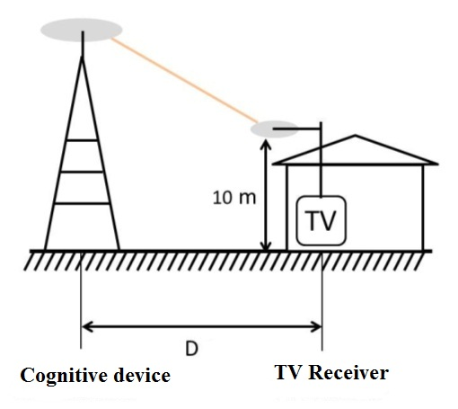
Figure 3.2
Mobile cognitive station and wanted receiver (fixed reception) 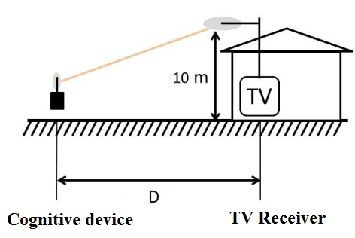
Figure 3.3
Fixed cognitive station and wanted receiver (mobile/portable reception) 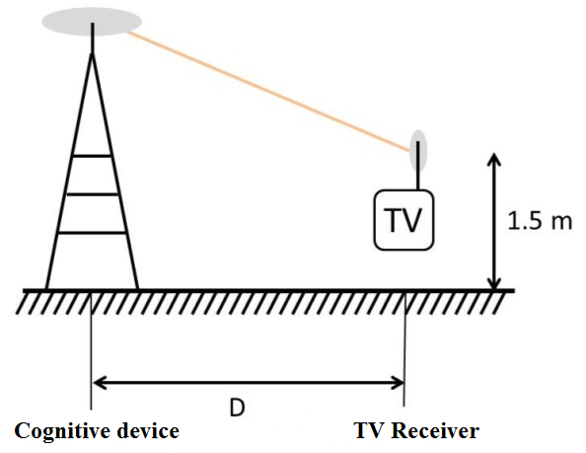
Figure 3.4
Mobile cognitive station and wanted receiver (mobile/portable reception) 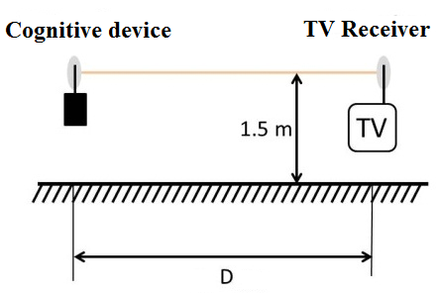

Spacing distances between cognitive station and TV receiver, D, which are used in typical calculation scenarios, may depend on certain conditions of typical house layout for a given area. In general case we can assume that this distance is 2 m for the case of mobile/portable reception interfered with by mobile cognitive station, and for other cases distance D = 20 m.

4 Direct-pickup interference caused by cognitive devices to cable broadcasting networks and television receivers

Cable television networks refer to a rapidly growing market segment of media services. Deficiency of terrestrial TV channels and the complication of installation of satellite receiving equipment in urban conditions contribute to the rapid development of the cable television networks. In spite of the growing competition from IPTV, cable networks are still cheaper in implementation and operation, do not require special subscriber equipment and do not suffer from peak bursts of user traffic that can lead to unavailability of services.
Nowadays, the majority (up to 75-90%) of the population in big and medium-sized cities receive TV programs through a cable network. It is expected that the cable networks will maintain their predominance in the big and medium-sized cities and also will be developed in the lower population agglomerations, especially in areas where apartment block buildings are built. Due to the fact, that regulators do not require from cable operators to switch to digital technologies, many of them will continue to work with the analogue TV system for some time, because this approach ensures maximum amount of subscribers. Meanwhile, the pressure to introduce HDTV services will force cable operators to broadcast in digital formats (ATSC, DVB-C, DVB-T/T2) in parallel with analogue TV services.
Cable networks use an extensive range of frequencies within their cable to carry their service. Parts of this range are common to the terrestrial TV broadcasting bands and therefore could be affected by cable ingress interference from what is being transmitted in these bands in close proximity to cable equipment .
In 2007, prior to adoption of regulations on broadband WSDs, the United States Federal Communications Commission (FCC) investigated a concern that TV receivers with a direct connection to a cable TV system may also be susceptible to interference from wireless network devices operating within the TV broadcast spectrum on locally unused broadcast channels (TV white spaces). A cable TV system is likely to have fewer unused TV channels (if any) since the signal level differential between these TV channels can be controlled on cable TV systems and kept within a few dB’s, hence avoiding objectionable adjacent channel interference. The FCC study investigated the potential for ingress into the cable TV system at the TV receiver. The study report can be found in Attachment 1 to Annex 2.
The 2007 FCC study used three digital TV receivers that were available in 2005 and were used in a previous FCC study. The cable TV signals, connected directly to the TV receiver, were typical 256-QAM signals set at a minimum signal level specified for the “input terminals of the first device located on the subscriber’s premises.” The interfering signal was an OFDM signal with a 4.8 MHz bandwidth co-channel with the cable TV channel to which the victim TV receiver was tuned. The OFDM signal was used to represent typical signals employed by wireless network systems, especially in portable applications. In each test, the power of the interfering signal applied to an antenna was adjusted to determine the minimum power level that caused interference to the operation of the TV receiver connected to the cable TV system. The tests evaluated the EIRP of the interferer for separation distances from the victim receiver of two and ten metres. These distances are typical for wireless networks operating in the same residence and adjacent residences, respectively. In most cases, the tests included a wall emulating multiple rooms or apartments in the separation between the interferer and the victim TV receiver.
It should be noted that the FCC used high quality “quad-shielded” coaxial cable for interconnections between the cable TV system and the victim receivers. That level of shielding is better than what is typically installed in the average home. It is not uncommon to find installed coaxial cable with only 50 to 80 percent shielding but it is not clear that such inadequate shielding deserves special attention for protection from ingress interference.
The FCC results indicate that cable TV systems can be adversely affected by wireless networks operating in the TV bands. Although the resulting direct-pickup interference levels measured on the three TV receivers are higher than the maximum level specified in the FCC Part 15.118(c3) (i.e., 100 mV/m at 1 metre), interference would still occur at power levels below the maximum levels specified for White Space devices by the United States regulations. A summary of the results is presented in Table 4.1.
Table 4.1
Summary of the direct-pickup interference levels from the FCC study
 | Interfering source EIRP
Distance | Part 15.118 | OET tests results
2 m | 1.2 dBm | 6.3 dBm | 8.5 dBm | 16.9 dBm
10 m | 15.2 dBm | 15.3 dBm | 15.4 dBm | 24.2 dBm
 |  | Minimum interfering EIRP |  | Median results

Fixed devices are permitted to operate at EIRP levels up to 36 dBm and portable devices to operate at 20 dBm. For the case where the interferer was two meters from the victim TV receiver, the minimum EIRP interference level with and without a wall was measured at 6.3 dBm. This scenario is typical of a wireless network operating in the same room as a TV receiver or on the other side of a wall. Thus the proposed power levels are 13.6 dB higher for portable wireless devices than the level necessary to ensure protection of the cable TV system. This excess value reduces to 11.4 dB for the most sensitive TV receiver in presence of an inter-unit townhouse wall and 3.1 dB for the median results. For the case where the interference is coming from the same room, the user of the wireless device can easily take measures to avoid such interference but in the case where this interference may come from an adjacent apartment, the solution may not be as simple.
For the case where the interferer was ten metres from the victim TV receiver, the minimum EIRP interference level with a wall was measured at 15.3 dBm. This scenario is typical of a wireless network being operated in an apartment building or townhouse. For this situation, the proposed power levels are 4.7 dB higher for portable wireless devices and 20.7 dB higher for fixed wireless devices than is necessary to ensure protection to the cable TV system. Using the median values reported for 10 metres separation, there is no direct-pickup interference from portable devices while there is an excess of 11.8 dB in the case of fixed wireless devices operating at the maximum transmit power.
In the development of the White Space devices regulations, the FCC established that 3 dB polarization mismatch, 5 dB indoor attenuation as well as 10 dB wall attenuation can be assumed. Furthermore, in the case of fixed devices that need to be installed at 10 metres above ground level, an 8.15 dB transmit antenna discrimination can be assumed. As a result, the distances needed to meet the maximum direct-pickup interfering levels are 2 metres for portable wireless devices operating at 100 mW EIRP and 5 metres for fixed wireless devices operating at 4 W EIRP. These resulting distances make the operation of 100 mW portable devices and 4 W fixed devices possible in practice. As a result, a further restriction on white space devices maximum EIRP was declined by the FCC.
In 2008, the National Cable & Telecommunications Association (NCTA) in the United States completed an extensive evaluation of the impact of white space devices (WSDs) and a further study included in Attachment 2 to Annex 2. There are two principal concerns. The first being the possible interference to TV interface devices such as VCRs, DVDs, and cable set top boxes that operate on or adjacent to TV channels in the low VHF band from 47 MHz to 72 MHz. NCTA asked that WSDs not be allowed to operate in the low VHF band.The NCTA also asked that WSDs should also be prohibited from the high VHF TV band, 174 MHz to 234 MHz. In addition, WSDs operating in the UHF band and in fixed locations should be limited in their proximity to residential buildings.
The second concern was the possible interference to cable headend reception of over-the-air broadcast signals. Although some cable operations have direct links to television stations, many cable systems receive terrestrial broadcast signals through tower-mounted, high gain directional terrestrial antennas, particularly in the rural and fringe areas. In order to mitigate the potential for interference, NCTA asked that WSD operation be restricted to only fixed devices, that no co-channel or adjacent channel WSD operation be permitted in the service area of the TV station, and that co-channel and adjacent channel WSD operation be restricted beyond the service area by a “line-of-sight” distance. NCTA also suggested that spectrum coordination be required before portable WSDs are operated on channels adjacent to those being received at a cable TV headend.
In its rules adopted subsequent to the 2007 and 2008 studies, the FCC retained the solution of relying on the geolocation of the white space devices and access to a database so that these devices are not allowed to operate in a sector located around registered cable headend reception systems. Such exclusion zone is based on minimum distances within the main beam of the cable receiving antenna for a specified beamwidth, and minimum distances outside this main beam for the co-channel and adjacent channels respectively.

Provided by Russian Federation example of usage the frequency band 470-862 MHz by cable TV operator «NCN» is presented in Figure 4.1. «NCN» provides cable television services in Moscow. Terrestrial TV signal is delivered to all apartments, which are connected to cable network, and monthly fee is automatically included in the bill for municipal services. The broadcasting network includes more than 40 channels in analog format. The part of «NCN» on the broadcasting cable market is 72% in Moscow, 76% in St. Petersburg, 49% in Yekaterinburg. The cable TV operators not only use all terrestrial ranges, they are also begin to use an extended cable range (below 470 MHz), despite the fact that old TV models don`t support this range. Thus, they have almost no opportunities of transferring programs from the bands 694-790 MHz and 790-862 MHz to the other parts of the spectrum.
FIGURE 4.1.
Example of using the UHF frequency band in the cable TV broadcasting network
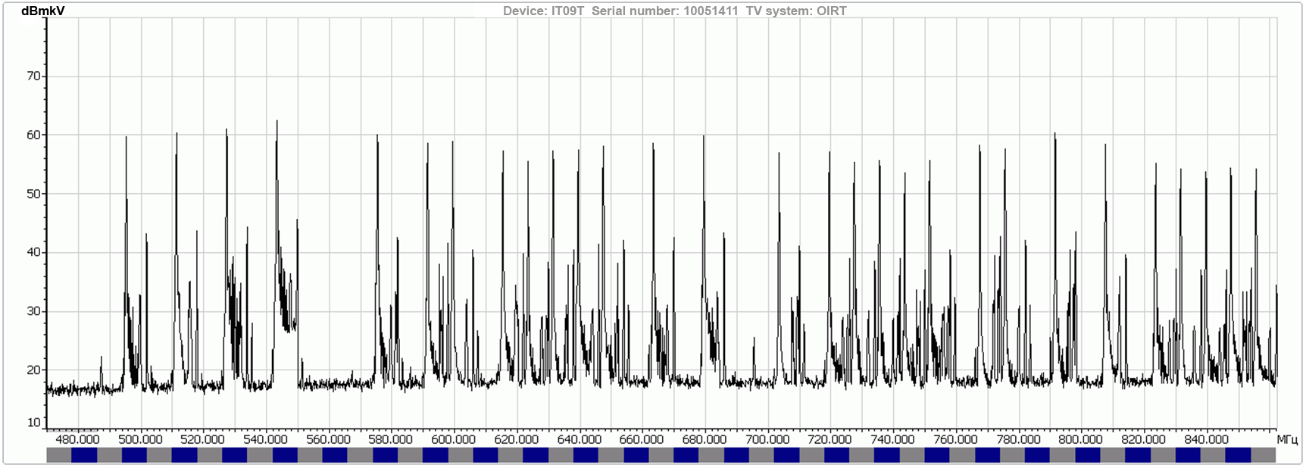

It is important to take into account, that cable network isolation (shielding) from the penetration of broadcast signals and other interference have limits. To identify opportunities for the simultaneous usage of radio frequency channels by terrestrial networks for portable reception (DVB-H standard) and cable TV networks, some researches were carried out in Moscow. According to the results of our work, broadcast/cable decoupling is about –30 dBd, moreover, in terms of shielding, the weakest point often is a TV receiver itself. Cable operators usually try not to use terrestrial channels due to the high level of interference. However, in case of implementation of cognitive devices, properly shielding of the cable networks and common aerial receiving systems elements become to be critical, but in the number of cases still won’t provide enough protection because of the physical and technical constrains and limited isolation within TV receiver itself.
An example of spectrograms for terrestrial and cable broadcasting in the frequency band 470-790 MHz, obtained in the same place from the receiving dipole antenna (terrestrial reception) and from the cable network of «NCN» in Moscow, is presented in Figure 4.2.
FIGURE 4.2.
The spectrograms of signals of terrestrial TV broadcasting and
signals of cable TV broadcasting in Moscow
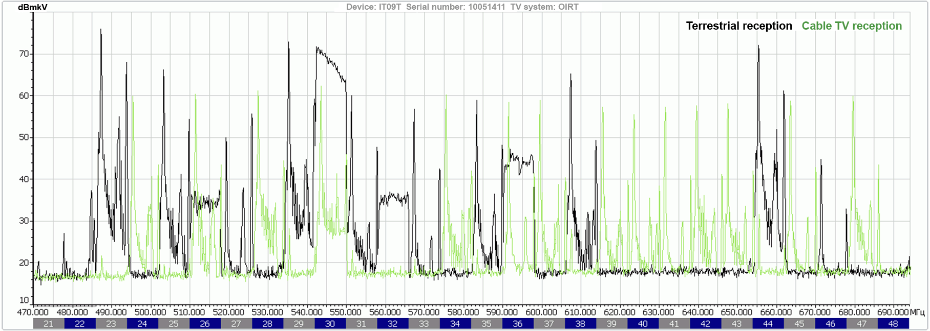

Interference signals from the terrestrial channels of analog and digital broadcasting in the 23, 25, 26, 30, 33, 35, 38, 44 TV channels are clearly visible in the spectrogram. In this example, suppression of terrestrial interference due to cable shielding is about 37 dB relative to the dipole antenna reception, considering carrier amplitude of analog signal. The distance from the powerful transmitting station «Ostankino», which broadcasts the majority of terrestrial channels, was 13.2 km. Obviously, the interference from cognitive radio base stations and user terminals, which could be located closer than 13.2 km or even in the proximity to the cable network line and television receivers, will significantly exceed the signals of powerful TV broadcasting transmitters, which are installed at significant distances. It took some series of actions to improve the interference resistance of the elements of cable network and to limit the transmitting stations’ radiation in certain directions to ensure compatibility of 36 low and medium power broadcast DVB-H stations installed in the city.
It is expected that during the implementation of cognitive systems in the UHF frequency bands, base stations` transmitters will be installed at different locations in cities and rural areas, and user terminals will be used almost everywhere. In such conditions, it is difficult to predict how to ensure compatibility of cognitive devices and cable TV broadcasting networks. The assurance of compatibility by conventional methods, such as careful planning of cognitive radio networks, reducing the power and using bandpass filters, will be possible only for the downlink – i.e. for base stations, which should be installed at a distance from houses and limited by the level of radiation in the direction of houses.

Annex 1
CRS compatibility studies performed in the Russian Federation
This annex contains results of CRS compatibility study performed in the Russian Federation what gives an indication of an amount of available frequency spectrum for CRS devices in a Moscow region.
In Russian Federation laboratory tests of CRS prototype devices were performed. These devices are capable to operate under control of geo-location database, sending requests with their indicated parameters (location coordinates, type of device, and operating bandwidth) and receiving frequency value for operation and allowable power value for transmission from the database. By now (March, 2013) two prototypes were tested using time division duplex (TDD). One of these prototypes was operating based on specifications developed by the manufacturer (CJSC R&PC «Micran»), the second prototype was operating based on WiMax standard (JSC «Concern «Sozvezdie»).
Lab tests to estimate the impact of cognitive devices on TV receivers revealed that the TV receivers under study have similar performance characteristics. Protection ratios for cognitive devices interfering with TV receivers are shown in Annex 1 (cognitive device transmitted during 50% of time and received during 50% of time). The data showed that protection ratios for frequency offsets exceeding 8 MHz (channel n+2 and further) insignificantly changed, and remained nearly the same for all channels of the frequency band, supposedly due to selectivity features of the TV receivers. Unfortunately, the set of TV receivers was rather limited, so it is planned to be expanded during further studies.
Measurements within the pilot area of the Moscow Region confirmed the lab test results on the criteria of electromagnetic compatibility. During operation of cognitive prototypes in the pilot network it was noticed that the level of channel traffic loading as well as the operational mode of the device impact the protection ratio. In mode with low transmitted traffic (12% transmission time, 88% reception time) protection ratios were increased by several decibels compared to balanced channel load (50% transmission time, 50% reception time). Pre-operation mode of the cognitive device such as search for a base station, change of emission parameters (bandwidth, modulation) increased interfering impact on reception of TV signal. The identified issues will be further studied.
Methods to assess impact and control for cognitive devices
The Russian Federation is currently conducting studies to establish efficient algorithms for geolocation database operation to control cognitive devices. More detailed estimations of cognitive device impact on TV receivers have been conducted for the Moscow Region, in order to adjust calculation algorithms for interference estimation within the database. DVB-T2 and DVB-H digital TV networks have been protected in the region as well as analogue television assignments. The entire region has been divided into small areas (pixels), and interference from a cognitive station located in the area has been estimated at different frequency channels. If interference from a cognitive station at the certain frequency channel hasn’t exceeded the allowable level, the channel is considered allowed for operation in the given area. And thus, analyzing all the pixels of the region, a map of available spectrum resource for a typical cognitive station was plotted (examples of these maps calculated using different methods are given below).

During detailed compatibility calculations, two methods were used to obtain numerical estimations of interfering impact on the broadcasting service in each specific geographical point:
– Monte Carlo statistic methodology to determine the degradation of the reception coverage (accordance to methodology described in Annex 2 to Report ITU-R BT.2265).
– Analytic calculation methodology comparing wanted field strength and usable field strength (based on approach from the Agreement GE-06).
Example of maps of available spectrum resource for a cognitive station
Parameters used for calculation of the examples:
– Calculation of raster for the map of available spectrum resource (pixel raster) = 1 km.
– ERP of typical cognitive station = 6 dBW.
– Antenna height of typical cognitive station = 30 m.
– Directivity of receive TV antenna has been considered for each point under consideration.
– Propagation models: ITU-R P.1546-4, ITU-R P.1812-2, as well as calculation of interfering field levels in close proximity to cognitive station using free-space loss equation.
– Aggregation of multiple interference was taken in consideration as a fixed
margin = 10 dB, which was added to the value of interfering field.
– Ideal areas of broadcasting station coverage were protected (not taking into account interference from other broadcasting stations).
– Cognitive frequency blocks of 6 MHz bandwidth with central frequencies the same as central frequencies of television channels was used in calculation (Fig. A.1).
Figure A.1
Channel raster for TV and cognitive device
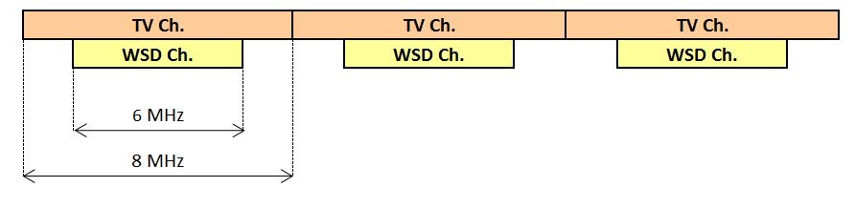
As protection ratios for digital television receivers are revised regularly on ITU level and depend both on TV receiver type and on different parameters of interfering signal (including percentage of channel loading, power control), in this calculation the model was used of dependency of protection ratios from frequency shift, which is based on the Recommendation ITU-R P.1368-10, materials of Sony and Philips contribution, submitted at the meeting of WP 6A on protection ratios for DVB-T2 receivers (Autumn, 2012) and measurements performed by the Russian Federation, which are shown in Table A.1.

Table A.1
Protection ratios for DVB-T2 wanted signal used when interference is caused
by typical signal of cognitive device
Interference channel | From N±8 to N±k (k>8) | N±7 | N±6 | N±5 | N±4 | N±3 | N±2 | N±1 | N
Protection ratio, dB | -49 | -48 | -47 | -46 | -45 | -44 | -43 | -30 | 19

For protection of analogue TV, protection ratios according to the Recommendation I
TU-R P.1368-10 were used for the case of wanted analogue K/SECAM signal interfered with by DVB-T signal.
For Monte-Carlo method, the criterion of allowed interference level was 1% degradation of location probability of coverage for digital broadcasting and 10% degradation for analogue broadcasting within a small area.
When assessing impact on broadcasting service from cognitive device which is located within the service area of protected stations, assessment of impact on nearby TV receivers is carried out using typical scenarios of spatial layout for interference sources and wanted signal receiver (see Fig. A.2).
Figure A.2
Interference source and wanted signal receiver
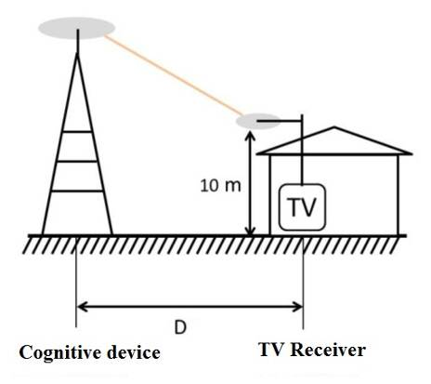

Using two calculation methods (statistic (degradation of location of coverage) and analytic (assessment of protection margin)) , maps of available radio spectrum were calculated for three layouts of interference source and wanted signal receiver (D = 50 m, 250 m, 500 m) for typical cognitive station which was assumed to be base station with fixed coordinates. Fixed coordinates means that we can provide such a separation distance. The map is colored with different colours, each colour means different number of available channels for use by typical cognitive station. Grey colour means no free channels, violet means one free channel, and so on, red color means 10 and more free channels in that pixel. Calculation was carried out using as an example the Moscow Region having very high spectrum loading. All operated analogue and digital TV stations were protected. Results are shown in Fig. A.3.

Figure A.3
Examples of calculated maps for available spectrum
Analytic method | Statistic method
D = 50 m
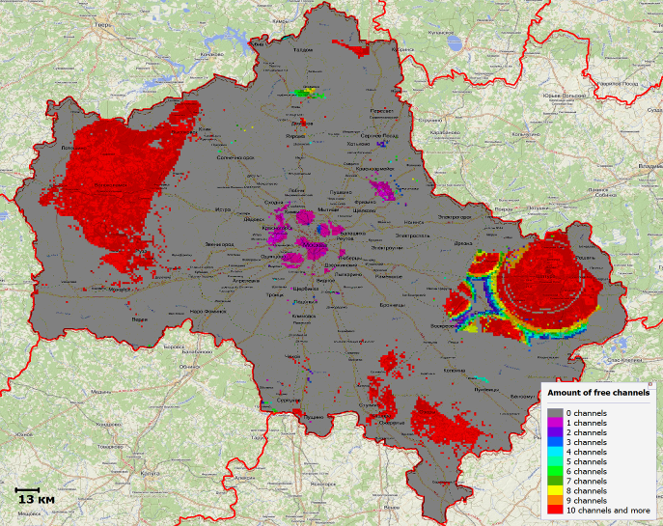 | 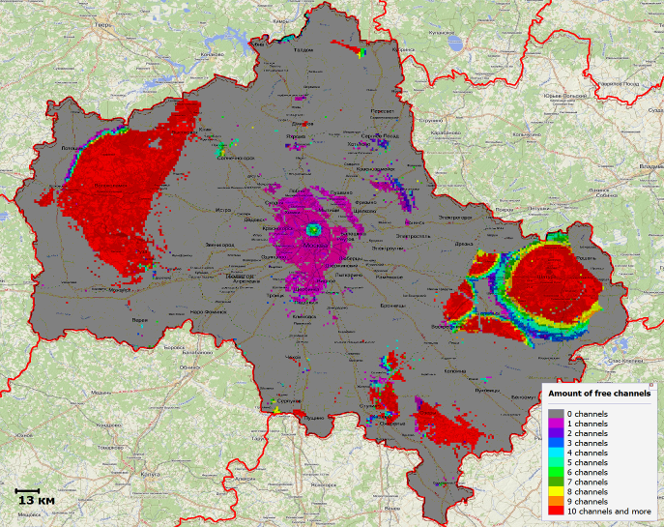
D = 250 m
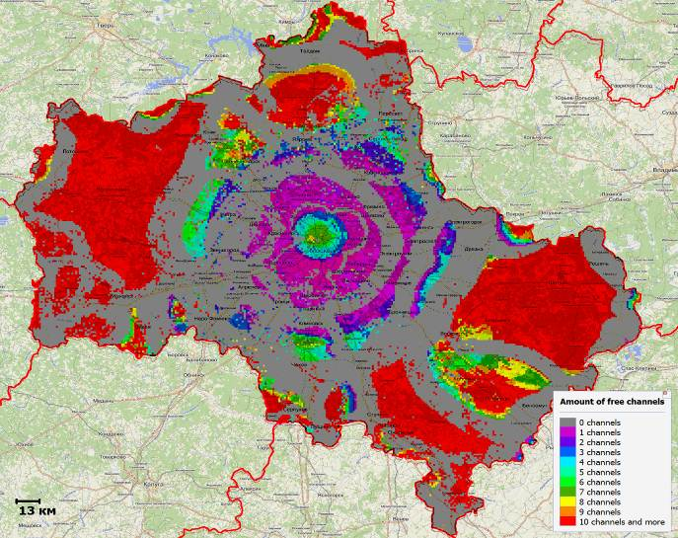 | 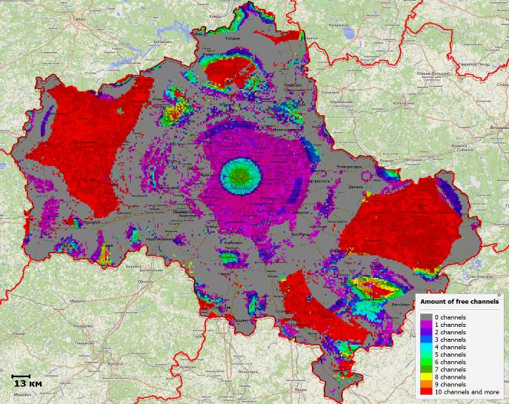
D = 500 m
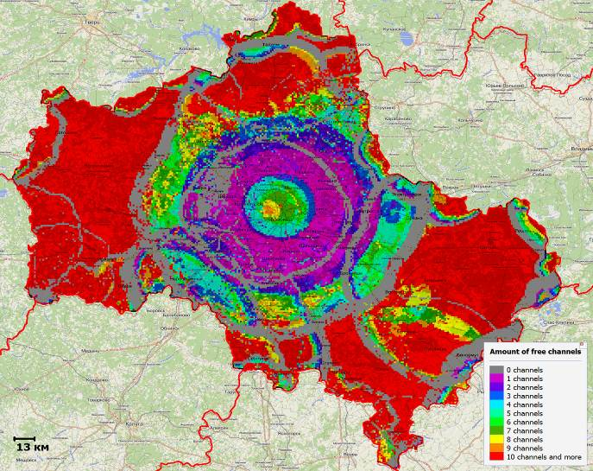 | 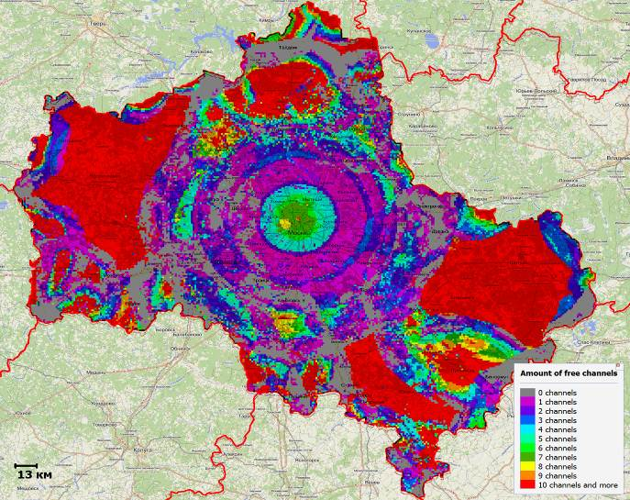
Appendix 1 to annex 1
Measured protection ratios for DVB-T2 receivers with interference
caused by cognitive station signal

DVB-T2 signal power at receiver input = -60 dBm | Receiver 1 | Receiver 2
Channel | Protection ratio, dB | Protection ratio, dB
N-14 | -41 | -42.5
N-13 | -40 | -42
N-12 | -40 | -42
N-11 | -39 | -42
N-10 | -39 | -42
N-9 | -38 | -42
N-8 | -38 | -42
N-7 | -38 | -42
N-6 | -38 | -42
N-5 | -38 | -41.5
N-4 | -38 | -41.5
N-3 | -38 | -41
N-2 | -37.5 | -41
N-1 | -39.5 | -35.5
N | 16 | 16
N+1 | -37 | -35
N+2 | -37.5 | -41
N+3 | -38 | -41
N+4 | -38 | -41.5
N+5 | -38.5 | -42
N+6 | -38.5 | -42
N+7 | -38.5 | -42
N+8 | -38.5 | -42
Parameters of wanted DTTB signal:
DVB-T2 standard, 64QAM 4/5 modulation, channel bandwidth 8 MHz
Parameters of interfering signal:
Standard developed by the manufacturer, TDD mode, channel bandwidth 6 MHz, transmission/reception channel loading 50%/50%

Annex 2
Results of USA studies on the issue of
direct-pickup interference to television receivers
In 2007, the United States FCC studied direct pickup interference after concerns were raised by NCTA. The FCC
study report can be found in Attachment 1.
Further study in 2008 by the NCTA may be found in Attachment 2.
After these studies, the FCC adopted requirements for analogue cable ready TV receivers to reject direct pickup interference, and after conducting its own tests for WSDs and noting that cable television systems have full discretion to design their equipment to be immune to ambient radio frequency energy, relied on a 100 mW (20 dBm) power limit and transmit power control for personal/portable devices to protect cable television systems and exclusion zones around registered cable headends as appropriate.

Attachment 1 to Annex 2
“Direct-pickup interference test of three consumer digital cable television receivers”, Office of Engineering and Technology, Federal Communications Commission (USA), OET Report FCC/OET 07-TR-1005, 31 July 2007.

Attachment 2 to Annex 2
“Summary of NCTA’s technical parameters for unlicensed TV band devices”, Ex Parte filing in
ET Docket No. 04-186, 10 September 2008.

______________

“Longley-Rice Methodology for Evaluating TV Coverage and Interference”, United States Federal Communications Commission Office of Engineering & Technology, OET Bulletin No. 69, 6 February 2004, Washington, DC.
Also see “Longley-Rice Methodology for Evaluating TV Coverage and Interference”, United States Federal Communications Commission Office of Engineering & Technology, OET Bulletin No. 69, 6 February 2004, Washington, DC. http://www.fcc.gov/Bureaus/Engineering_Technology/Documents/bulletins/oet69/oet69.pdf
The spectrum regulators in the USA and Canada have set the maximum allowable height-above-average-terrain (HAAT) of white space devices (WSDs) at 250 m while the maximum allowable height above ground level (AGL) of the WSD transmit antenna was set at 30 m.
I/N equals to -20 dB derived from requirement to not exceed the 10log of 1% of total receiving noise power.
Martin, S. F., “RF Performance of DTV Converter Boxes—An Overview of FCC Measurements” IEEE Transactions on Broadcasting, Vol. 56, No. 4, December 2010.
“Interference rejection thresholds of consumer digital television receivers available in 2005 and 2006”, FCC/OET 07-TR-1003, 30 March 2007.
Salehian, K., Y. Wu and G. Gagnon, “Performance of the Consumer ATSC-DTV Receivers in the presence of single and double interference on adjacent/taboo channels”, IEEE Transactions on Broadcasting, Vol. 56, No. 1, March 2010.
This step consists in identifying the case that needs further studies. The second step consists in carrying out detailed investigation based on the degradation of location percentages of DTTB coverage in each pixel of the coverage area.
FCC 08-260 Second Report and Order and Memorandum Opinion and Order, Released: November 14, 2008
“The potential adverse effects of unlicensed operation of new devices in TV broadcast bands on cable customers’ reception of cable service” Appendix 1 of NCTA comments in the matter of unlicensed operation in the TV broadcast bands, dated 31 January 2007, see http://fjallfoss.fcc.gov/prod/ecfs/retrieve.cgi?native_or_pdf=pdf&id_document=6518724319 and Appendix 2 see http://fjallfoss.fcc.gov/prod/ecfs/retrieve.cgi?native_or_pdf=pdf&id_document=6518724320.
NCTA ex parte filing dated 10 September 2008, see http://fjallfoss.fcc.gov/prod/ecfs/retrieve.cgi?native_or_pdf=pdf&id_document=6520066607.
NCTA ex parte filing dated 10 September 2008, see http://fjallfoss.fcc.gov/prod/ecfs/retrieve.cgi?native_or_pdf=pdf&id_document=6520066607.

