IEEE P802.22
Wireless RANs
Proposed Text for Group Resource Allocation (GRA)
Date: 2015-04-15
Author(s):
Name | Company | Address | Phone | email
Sung-Hyun Hwang | ETRI | Korea | +82-42-860-1133 | shwang@etri.re.kr
Gwang-Zeen Ko | ETRI | Korea | +82-42-860-4862 | gogogo@etri.re.kr
Byung-Jang Jeong | ETRI | Korea | +82-42-860-6765 | bjjeong@etri.re.kr
Myung-Sun Song | ETRI | Korea | +82-42-860-5046 | mssong@etri.re.kr
Jae-Ick Choi | ETRI | Korea | +82-42-860-6160 | jichoi@etri.re.kr
Abstract
This document proposes the normative text for the group resource allocation.
Notice: This document has been prepared to assist IEEE 802.22. It is offered as a basis for discussion and is not binding on the contributing individual(s) or organization(s). The material in this document is subject to change in form and content after further study. The contributor(s) reserve(s) the right to add, amend or withdraw material contained herein.

Release: The contributor grants a free, irrevocable license to the IEEE to incorporate material contained in this contribution, and any modifications thereof, in the creation of an IEEE Standards publication; to copyright in the IEEE’s name any IEEE Standards publication even though it may include portions of this contribution; and at the IEEE’s sole discretion to permit others to reproduce in whole or in part the resulting IEEE Standards publication. The contributor also acknowledges and accepts that this contribution may be made public by IEEE 802.22.

Patent Policy and Procedures: The contributor is familiar with the IEEE 802 Patent Policy and Procedures
<http://standards.ieee.org/guides/bylaws/sb-bylaws.pdf>, including the statement "IEEE standards may include the known use of patent(s), including patent applications, provided the IEEE receives assurance from the patent holder or applicant with respect to patents essential for compliance with both mandatory and optional portions of the standard." Early disclosure to the Working Group of patent information that might be relevant to the standard is essential to reduce the possibility for delays in the development process and increase the likelihood that the draft publication will be approved for publication. Please notify the Chair <Carl R. Stevenson> as early as possible, in written or electronic form, if patented technology (or technology under patent application) might be incorporated into a draft standard being developed within the IEEE 802.22 Working Group. If you have questions, contact the IEEE Patent Committee Administrator at <patcom@ieee.org>.

1. Suggested text

  - Group Resource Allocation
A large number of CPEs may be connected to the A-BS. Among them, some CPEs have similar traffic pattern, such as, payload size, traffic period, and data rate (PHY Mode), etc. It is a burden of MAP overhead to allocate the resources to all CPEs individually. The Group Resource Allocation (GRA) is very efficient for a group of CPEs communicating using a same PHY Mode and with a fixed payload size. The MAP overhead is significantly reduced by allocating the resources to the Group using bitmap format.

The group is composed of one A-CPE and many S-CPEs. Within the group, A-CPE is a controller of a group consisting of many S-CPEs. The A-CPE capabilities include access to the database services, identification of the group, network entry with A-BS, etc. All the S-CPEs within the group are synchronized to the A-CPE.

There are two types of group: fixed group and mobile (or portable) group. The type of group is determined according to the mobility of A-CPE. The A-CPE within fixed group is fixed on the building, house, tower, etc. The A-CPE within mobile (or portable) group is mobile (or portable) on the vehicles, etc.

The A-BS configures the group resource allocation by using the Group Resource Allocation Configuration (GRA-CFG) message, as shown in Table AM1. The A-BS creates a new group, identifies the devices that belonging to the group, and allocates the resources on a group basis. The GRA-CFG message includes the characteristics of group, such as Device Bitmap Size, Bitmap of Station ID, Group ID, Group Type, and Group Location. The group resource allocation configuration can be updated using the Group Resource Allocation Update (GRA-UPD) message, as shown in Table AN1. The A-BS uses GRA-UPD message to add a device to a group or delete a device from a group. The A-BS also uses GRA-UPD message to update the location of group. The DS/US-MAP message defines the access to the downstream/upstream resources, as shown in Table 25 and Table 34, respectively. The format of a DS/US-MAP IEs is defined for the Individual Resource Allocation (IRA), as shown in Table 26 and Table 35, respectively. And the format of a DS/US-MAP GRA IEs is defined for the Group Resource Allocation (GRA), as shown in Table L1 and Table P1, respectively.

The backup and candidate channels can also be updated on a group basis using Backup and Candidate Channel List IE, as shown in Table 22. When Group Flag is set to 1, the backup and candidate channels are used locally within a group. Otherwise, when Group Flag is set to 0, the backup and candidate channels are used globally within a cell. The backup and candidate channels are selected using the mobility and the location of A-CPE. Same channel is selected as the backup (or candidate) channel between the fixed groups. But if the groups could overlap, the backup (or candidate) channel shall be different to avoid interference among groups. On the other hand, different channels are selected as the backup (or candidate) channel between the fixed and the mobile group or between the mobile groups. But if the groups could not overlap, the backup (or candidate) channel could be same for frequency reuse. The backup and candidate channel list of each group shall be updated according to the periodic monitoring which checks whether the groups could overlap each other or new group appears. Therefore, when mobile group moves into other group, or when new group or incumbent user appears within a cell, the A-BS and CPEs can reduce the signaling overhead and can prevent QoS degradation by avoiding frequent channel switching.

Figure AY1—Example of backup channel selection

Figure AY1 shows an example of how the backup channel is selected. There are three fixed groups and single mobile group. The A-CPE of fixed groups is installed at the fixed object, such as farmhouse, building, tower, etc. The A-CPE of mobile group is installed at the mobile or portable object, such as car, train, ship, etc. In a relationship between the group 1 and the group 2, there are two fixed groups which are overlapping each other, thus the A-BS may allocate different backup channels, for example, backup channel #2 and backup channel #3, to the group 1 and the group 2, respectively. In a relationship between the group 1 and the group 3, there are two fixed groups which are not overlapping each other, thus the A-BS may allocate same backup channel, for example, backup channel #2, to both the group 1 and the group 3. In a relationship between the group 3 and the group 4, there are fixed and mobile groups which are overlapping each other, thus the A-BS may allocate different backup channels, for example, backup channel #2 and backup channel #3, to the group 3 and the group 4, respectively. In a relationship between the group 2 and the group 4, there are fixed and mobile groups which are not overlapping each other, thus the A-BS may allocate same backup channel, for example, backup channel #3, to both the group 2 and the group 4.

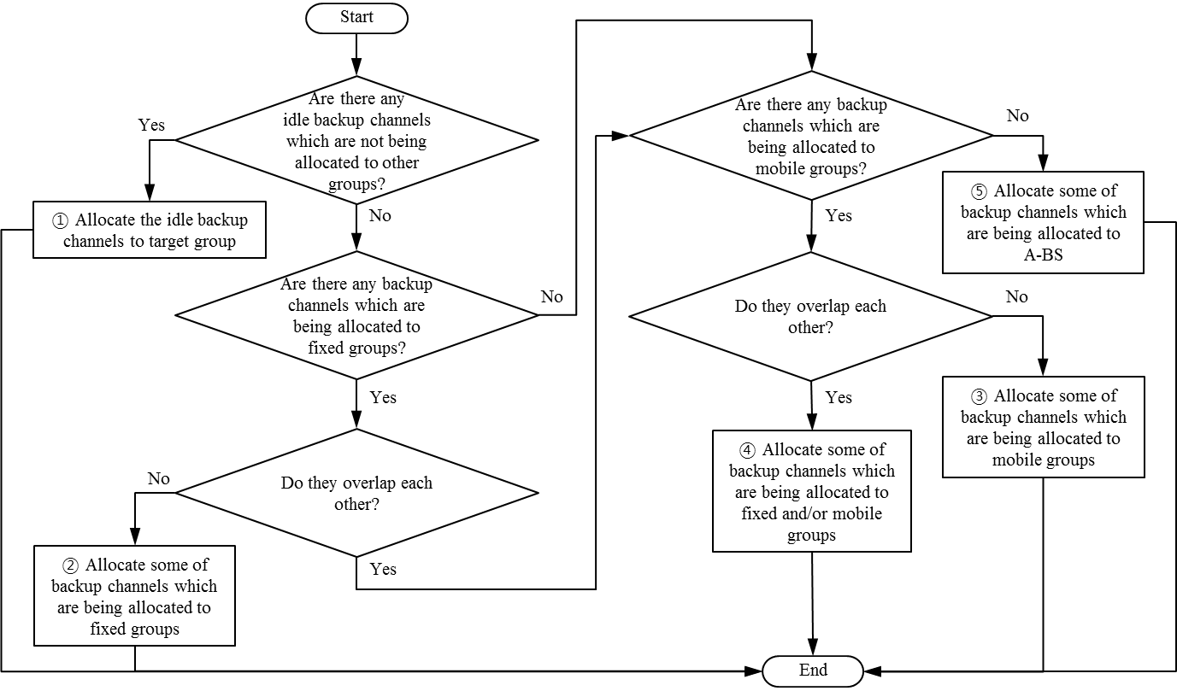
Figure AZ1—Example of backup channel decision

Figure AZ1 shows an example of how the backup channel is decided. When there are any idle backup channels which are not being allocated to other groups, the A-BS allocates the idle backup channels to the target group (1). When there are no idle backup channels to be allocated, the A-BS may first check if there exist any backup channels allocated to a fixed group. When there are any backup channels which are being allocated to fixed groups, and target group and fixed group do not overlap, the A-BS allocates the backup channels allocated to the fixed group, to the target group (2). A presence of a backup channel allocated to the fixed group may be first checked since a burden of changing the backup channels may exist when a state of a backup channel being currently allocated to a mobile group is changed to an unavailable backup channel, due to mobility of the mobile group, although it is determined that the allocated backup channel is available. When there are no backup channels which are being allocated to fixed groups, or when there are any backup channels which are being allocated to fixed groups but the target group and the fixed group overlap, the ABS may check if there exist any backup channels allocated to a mobile group. When there are backup channels which are being allocated to mobile groups, and the target group and the mobile group do not overlap, the A-BS allocates the backup channels allocated to the mobile group (3). Although there are backup channels which are being allocated to the mobile group, but the mobile group and the target group are also overlap, the A-BS allocates the backup channels allocated to the fixed group or the mobile group (4). When there are also no backup channels which are being allocated to mobile groups, the A-BS allocates the backup channels allocated to the A-BS, to the target group (5). When at least two overlapping groups share the backup channels or when the A-BS and some groups share the backup channels, the A-BS may use a mechanism for proper resources sharing between the overlapping groups or the A-BS and some groups after channel switching.

