IEEE P802.22
Wireless RANs
Proposed Text of MAC technical items related to 7.2X Multi-Channel Operation
Date: 2013-09-18
Author(s):
Name | Company | Address | Phone | email
Keat Beng Toh | Hitachi Kokusai Electric Inc. | 32,Miyuki-cho,Kodaira-shi,  Tokyo, 187-8511, Japan | +81-42-322-3111 | toh.keatbeng@h-kokusai.com
Keigo Hasegawa | Hitachi Kokusai Electric Inc. | 32,Miyuki-cho,Kodaira-shi,  Tokyo, 187-8511, Japan | +81-42-322-3111 | hasegawa.keigo@h-kokusai.com
Masayuki Takekawa | Hitachi Kokusai Electric Inc. | 32,Miyuki-cho,Kodaira-shi,  Tokyo, 187-8511, Japan | +81-42-322-3111 | takekawa.masayuki@h-kokusai.com
Kei Yanagisawa | Hitachi Kokusai Electric Inc. | 32,Miyuki-cho,Kodaira-shi,  Tokyo, 187-8511, Japan | +81-42-322-3111 | yanagisawa.kei@h-kokusai.com
Seishi Sasaki | Hitachi Kokusai Electric Inc. | 32,Miyuki-cho,Kodaira-shi,  Tokyo, 187-8511, Japan | +81-42-322-3111 | sasaki.seishi@h-kokusai.com
Masahiro Asano | Hitachi Kokusai Electric Inc. | 32,Miyuki-cho,Kodaira-shi,  Tokyo, 187-8511, Japan | +81-42-322-3111 | asano.masahiro@h-kokusai.com

Abstract
This document contains the proposed text of MAC technical items related to Multi-Channel Operation.
Notice: This document has been prepared to assist IEEE 802.22. It is offered as a basis for discussion and is not binding on the contributing individual(s) or organization(s). The material in this document is subject to change in form and content after further study. The contributor(s) reserve(s) the right to add, amend or withdraw material contained herein.

Release: The contributor grants a free, irrevocable license to the IEEE to incorporate material contained in this contribution, and any modifications thereof, in the creation of an IEEE Standards publication; to copyright in the IEEE’s name any IEEE Standards publication even though it may include portions of this contribution; and at the IEEE’s sole discretion to permit others to reproduce in whole or in part the resulting IEEE Standards publication. The contributor also acknowledges and accepts that this contribution may be made public by IEEE 802.22.

Patent Policy and Procedures: The contributor is familiar with the IEEE 802 Patent Policy and Procedures
<http://standards.ieee.org/guides/bylaws/sb-bylaws.pdf>, including the statement "IEEE standards may include the known use of patent(s), including patent applications, provided the IEEE receives assurance from the patent holder or applicant with respect to patents essential for compliance with both mandatory and optional portions of the standard." Early disclosure to the Working Group of patent information that might be relevant to the standard is essential to reduce the possibility for delays in the development process and increase the likelihood that the draft publication will be approved for publication. Please notify the Chair Apurva N. Mody <apurva.mody@ieee.org> as early as possible, in written or electronic form, if patented technology (or technology under patent application) might be incorporated into a draft standard being developed within the IEEE 802.22 Working Group. If you have questions, contact the IEEE Patent Committee Administrator at <patcom@ieee.org>.
Summary of this document

In this document, multi-channel operation for IEEE 802.22b is proposed to support enhanced broadband services and monitoring applications which require higher data throughput. The subclause structure in the proposed text is shown as follows.

7.2X Multi-Channel operation
7.2X.1 Channel allocation manager
7.2X.1.1 add new operating channel operation
7.2X.1.2 stop operating channel operation
7.2X.1.3 switch operating channel operation
7.2X.2 Multi-Channel operation at BS
7.2X.3 Multi-Channel operation at CPE

In this proposal, all the texts are described as new texts (without revision marks based on the 802.22 standard).

7.2X Multi-Channel operation

This clause describes the multi-channel operation supported by the IEEE Std. 802.22b, which is required to support enhanced broadband services and monitoring applications that require high data throughput. In the IEEE Std. 802.22-2011, single channel operation is supported as shown in Figure 7.2X-1 with maximum date rate of 22.69 Mbps. In Figure 7.2X-1, each CPE (CPE 1~CPE 5) is using the operating channel (f1) to communicate within the service area of BS where the operating channel (f1) is assigned by the spectrum manager using the available channel list. In the IEEE Std. 802.22-2011, even though there may be several available channels exist in the list, due to the constraint of the single channel operation of IEEE Std. 802.22-2011, those available channels cannot be utilized effectively since multi-channel operation is not supported.

Figure 7.2X-1 — Example of IEEE Std. 802.22-2011 deployment configuration
(Single channel operation)

The IEEE Std. 802.22b supports aggregate data rates greater than the maximum data rate supported by the IEEE Std. 802.22-2011 in order to extend its regional area broadband services to a broader range of applications such as real-time and near real-time monitoring, emergency broadband services, remote medical services, etc. which requires higher data rates. Therefore, multi-channel operation shall be considered as a means to achieve throughput greater than the maximum throughput supported by the IEEE Std. 802.22-2011.

The examples of multi-channel operation deployment configuration are shown in Figure 7.2X-2 and Figure 7.2X-3 respectively. In Figure 7.2X-2, it is assumed that there are 2 available operating channels within the service area of the BS. In this example, multi-channel operation on BS is illustrated where only the BS is capable of receiving and transmitting two or more operating channels and responsible to assign the operating channel to the associated CPEs within it’s service area. By performing the multi-channel operation on BS, the BS can utilize the available operating channels by distributing the operating channels among the associated CPEs. The multi-channel operation on BS can improve the individual CPE’s throughput by decreasing the total number of associated CPEs per operating channel. In Figure 7.2X-2, CPE 1 and CPE 2 are assigned to the operating channel (f1) to communicate with the BS while CPE 3, CPE 4 and CPE 5 are assigned to the operating channel (f2) to communicate with the BS. In this example, the total number of associated CPEs assigned per operating channel can be reduce to more than 40% compare to the single channel operation situation in Figure 7.2X-1.

In Figure 7.2X-3, it is assumed that there are 5 available operating channels within the service area of the BS. In this example, multi-channel operation on BS and CPEs is illustrated where both BS and associated CPEs are capable of receiving and transmitting two or more operating channels. BS is responsible to assign the operating channel to the associated CPEs within the service area for the utilization of available operating channels. In Figure 7.2X-3, CPE 1 is assigned to the operating channels (f1, f2, f3) to communicate with the BS while CPE 2 is assigned to the operating channels (f4, f5) to communicate with the BS. In this example, the BS can improve the individual CPE’s throughput by increasing the number of operating channels assigned to the associated CPEs.

Figure 7.2X-2 — Example of multi-channel operation deployment configuration
(Multi-channel operation on BS)

Figure 7.2X-3 — Example of multi-channel operation deployment configuration
(Multi-channel operation on BS and CPE)

7.2X.1 Channel allocation manager

The channel allocation manager (CAM) shown in Figure 7.2X.1-1 is responsible for the basic multi-channel operations such as add new operating channel operation which is described in subclause 7.2X.1.1, stop operating channel which is described in subclause 7.2X.1.2 and switch operating channel which is described in subclause 7.2X.1.3.

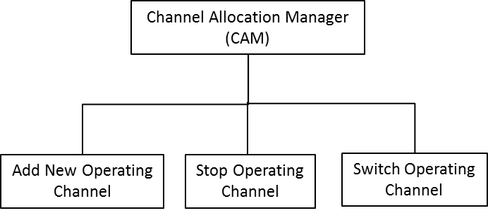

Figure 7.2X.1-1 — Channel allocation manager

A channel allocation manager is needed on the IEEE 802.22b devices (BS and CPEs) to perform multi-channel operations which are described in subclause 7.2X.1.1, 7.2X.1.2 and 7.2X.1.3.

In subclause 7.2X.1.1, detailed operation flow of add new operating channel is disccused. The add new operating channel function is responsible for allocating new operating channel to each available channel transceiver unit (CHU) of the IEEE 802.22b devices.

In subclause 7.2X.1.2, detailed operation flow of stop operating channel is discussed. The stop operating channel function is responsible for stopping the operating channel of the specific CHU of the IEEE 802.22b devices.

In subclause 7.2X.1.3, detailed operation flow of switch operating channel is discussed. The switch operating channel function is responsible for switching the operating channel of the specific CHU of the IEEE 802.22b devices.

A channel transceiver unit (CHU) is defined as a transceiver unit for a specific channel operation which is consists of a MAC and a PHY.

7.2X.1.1 add new operating channel operation

When the BS is ready to operate under the multi-channel operation, the following procedure of adding new operating channel is performed on both BS and CPE which have the capability of receiving and transmitting two or more operating channels.

The add new operating channel operation procedure shall consits of the following steps:

- BS-CAM selects a specific BS-CHU.
- BS-CAM commences operation request.
- BS-CHU commences operation acknowledgement.
- BS-CAM sends management information notification to BS-CHU.
- BS-CHU memorizes management information.
- BS-CHU performs frequency setting.
- BS-CHU performs synchronization.
- BS-CHU sends operation preparation completed notification to BS-CAM.
- BS-CHU broadcasts SCH.
- BS-CAM checks unused BS-CHU.
- CPE-CAM selects a specific CPE-CHU.
- CPE-CAM sends BS search command (All / specific channel) to the specific CPE-CHU.
- CPE-CHU performs BS search.
- CPE-CHU sends BS detected notification to CPE-CAM.
- CPE-CAM determines other operating CPE-CHU.
- CPE-CAM performs BSID matching.
- CPE-CAM sends BSID mismatch notification to CPE-CHU.
- CPE-CAM sends proceed notification to CPE-CHU.
- CPE-CHU performs synchronization.
- CPE-CHU sends synchronization completed notification to CPE-CAM.
- CPE-CAM checks unused CPE-CHU.
- CPE-CAM sends registration request to CPE management unit.
- CPE management unit sends registration completed notification to CPE-CAM.

The add new operating channel operation flow is shown in Fig. 7.2X.1.1-1.

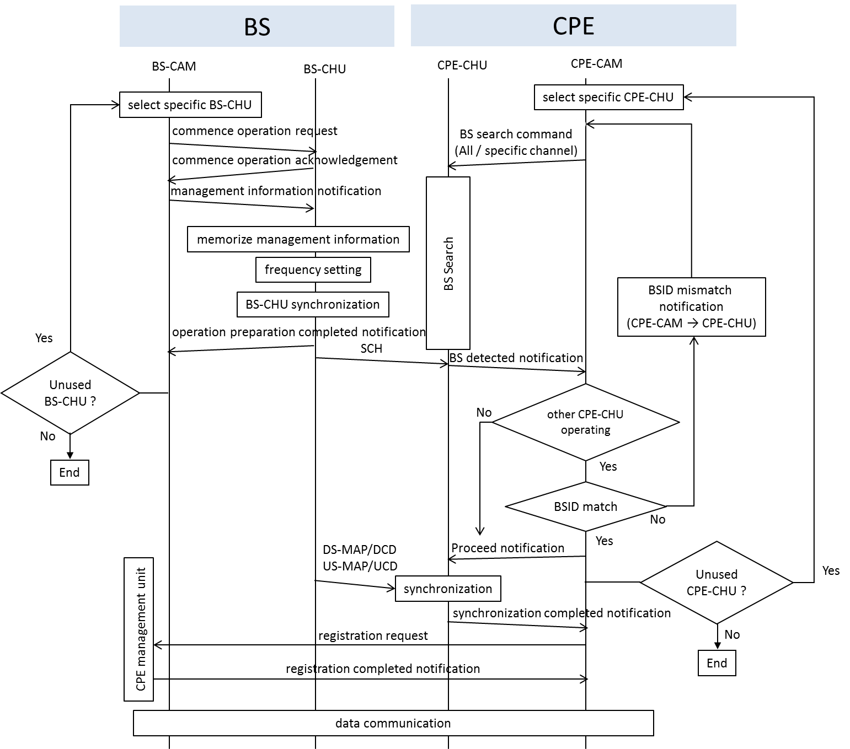

Figure 7.2X.1.1-1 — Operation flow for adding new operating channel

7.2X.1.1.1.1 BS-CAM selects a specific BS-CHU

The BS channel allocation manager (BS-CAM) shall select specific BS channel transceiver unit (BS-CHU) which is the target of add new operating channel operation. The BS-CAM shall select the BS-CHU which is in the state of unused or unassigned currently and the hardware is corresponds to the new operating channel’s frequency. The operating channel selection procedure may be included in this step.

7.2X.1.1.1.2 BS-CAM commences operation request

The BS-CAM shall send a commence operation request to the selected BS-CHU. The commence operation request may include the various parameters in connection with the PHY such as channel center frequency and its offset, etc., and some part of MIB information such as software version information, etc.

7.2X.1.1.1.3 BS-CHU commences operation acknowledgement

The BS-CHU shall send a commence operation acknowledgement to the BS-CAM. The commence operation acknowledgement may include the specific BS-CHU MIB information that is needed for BS-CAM such as device ID or serial number of the BS-CHU, etc. The BS-CHU shall responds with an error when the commence operation request is rejected due to the reasons such as mismatch of the software version, etc.

7.2X.1.1.1.4 BS-CAM sends management information notification to BS-CHU

The BS-CAM shall send a management information notification to the BS-CHU. The management information notification may mainly include the MIB information necessary for BS-CHU which is maintained by BS-CAM such as the ID to identify the connection between BS and CPE (carrier index which is associated with the physical or logical channel), etc. If the BS-CHU has a part of MAC layer function then the information on MIB which is used by MAC layer such as Station ID, MAC Address of BS, etc. shall be included.

7.2X.1.1.1.5 BS-CHU memorizes management information

The BS-CHU shall memorize the management information notified by the BS-CAM after the management information notification. Some part of the memorized information (MIB information) shall be immediately reflected on the BS-CHU or reflected as the initial value of the transition state.

7.2X.1.1.1.6 BS-CHU performs frequency setting

The BS-CHU shall perform the frequency setting procedure. The channel center frequency and its offset that was received in the commence operation request or management information notification shall be reflected in the local oscillator of BS-CHU.

7.2X.1.1.1.7 BS-CHU performs synchronization

The BS-CHU shall perform the BS-CHU synchronization procedure. This procedure is intended for network synchronization to synchronize the superframe, frame and TDD timing of a number of BS in a wireless communication system. Basically, this procedure shall synchronize the superframe to the start of each minute of the UTC time obtained from the GPS, etc. As a result, all the operating BS-CHU shall be synchronized with each other.

7.2X.1.1.1.8 BS-CHU sends operation preparation completed notification to BS-CAM

The BS-CHU shall send operation preparation completed notification to the BS-CAM. The BS-CHU shall send a response indicating an error when it fails on the mid-way of completing the operation preparation procedure.

7.2X.1.1.1.9 BS-CHU broadcasts SCH

The BS-CHU shall periodically broadcast a radio frame which included the SCH information.

7.2X.1.1.1.10 BS-CAM checks unused BS-CHU

The BS-CAM shall check whether there is any unused BS-CHU. If the unused BS-CHU exists, then the BS-CAM shall proceed to the select specific BS-CHU procedure.

7.2X.1.1.1.11 CPE-CAM selects a specific CPE-CHU

The CPE channel allocation manager (CPE-CAM) shall select specific CPE channel transceiver unit (CPE-CHU) which is target of add new operating channel operation. The CPE-CAM shall select the CPE-CHU which is in the state of unused or unassigned. In many cases, this procedure is triggered by the BS lost condition occurs in CPE where the CPE-CHU is selected.

7.2X.1.1.1.12 CPE-CAM sends BS search command (All / specific channel) to the specific CPE-CHU

The CPE-CAM shall send a BS search command (All / specific channel) to the selected CPE-CHU. The BS search command (All / specific channel) shall be performed by searching all the frequency channels that are corresponded by the selected CPE-CHU or by searching one or more specific frequency channels. The specific channel information shall be indicated by using the extended DCD message, newly defined management message, etc. to specify the BS operating channels that are not connected by any CPE or shall be estimated based on the backup channel information. To prevent overlapping with the other CPE-CHU channel, the channel which other CPE-CHU has already used shall not be searched. Moreover, the channel which other BS has already used that is identified by previous BS search command, etc. shall not be searched.

7.2X.1.1.1.13 CPE-CHU performs BS search

The CPE-CHU shall perform the BS search command by attempting to detect the radio signal (preamble and SCH) from BS at the target frequency of BS search command.

7.2X.1.1.1.14 CPE-CHU sends BS detected notification to CPE-CAM

The CPE-CHU shall send a BS detected notification to the CPE-CAM when it is able to detect the signal strength greater than or equal to a predetermined value that is defined in the BS search procedure. The BS detected notification shall include the BSID which is obtained by decoding the SCH information.

7.2X.1.1.1.15 CPE-CAM determines other operating CPE-CHU

The CPE-CAM shall determine whether there is any other operating CPE-CHU (connection status with BS). If there is no other operating CPE-CHU at that time, then it does not correspond to add new operating channel procedure (multi-channel operation). The CPE-CHU shall proceed to the synchronization process similarly to the conventional IEEE Std. 802.22-2011.

7.2X.1.1.1.16 CPE-CAM performs BSID matching

If there is other operating CPE-CHU detected at that time, the CPE-CAM shall determine the BSID of other operating CPE-CHU match with the BSID obtained by the CPE-CHU during BS detected notification.

7.2X.1.1.1.17 CPE-CAM sends BSID mismatch notification to CPE-CHU

If the BSID mismatch occurred, then the BS-CAM shall send a BSID mismatch notification to the CPE-CHU and the CPE-CHU shall resume its BS search process with the rest of the targeted frequency or the BS-CAM shall send a specific target frequency of BS search command to the CPE-CHU.

7.2X.1.1.1.18 CPE-CAM sends proceed notification to CPE-CHU

If the BSID match is confirmed, then the CPE-CAM shall send a proceed notification to the CPE-CHU to continue with the synchronization procedure.

7.2X.1.1.1.19 CPE-CHU performs synchronization

The CPE-CHU shall continue with the synchronization procedure with the frequency which is detected in SCH. In addition to the original synchronization procedure such as detecting and decoding the FCH, DS-MAP, etc. to obtain the parameters of the DS, this procedure shall included the reception of UCD message process to obtain the parameters of the US, the ranging process to adjust the TDD timing, etc.

7.2X.1.1.1.20 CPE-CHU sends synchronization completed notification to CPE-CAM

As a response to the proceed notification procedure, the CPE-CHU shall send a synchronization completed notification to the CPE-CAM. By referring to these notifications, the CPE-CAM can recognize the multi-channel operation when two or more CPE-CHUs are connected with the BS.

7.2X.1.1.1.21 CPE-CAM checks unused CPE-CHU

The CPE-CAM shall check whether there is any unused CPE-CHU. If the unused CPE-CHU exists, then the CPE-CAM shall proceed to the select specific CPE-CHU procedure.

7.2X.1.1.1.22 CPE-CAM sends registration request to CPE management unit

The CPE-CAM shall send a registration request to the BS for CPE registration after completed the multi-channel operation capability. The registration request shall contain the information (carrier index, etc.) which can uniquely identify each channel used in the multi-channel operation. Some management messages may be exchanged only between the BS-CHU and CPE-CHU if necessary.

7.2X.1.1.1.23 CPE management unit sends registration completed notification to CPE-CAM

The CPE management unit shall send a registration completed notification to the CPE-CAM.

7.2X.1.1.2 add new operating channel operation by using BS search command (specific channel)

As described in 7.2X.1.1.1.12, the BS search command can be conducted in 2 modes (All / specific channel). In this sub clause, the detailed operation flow for add new operating channel operation by using BS search command in specific channel mode is shown here. In this operation flow, the BS-CHU and CPE-CHU shall have at least one operating channel to enable the exchange of management message between BS and CPE.

The operation flow for add new operating channel operation by using BS search command in specific channel mode shall consits of the following steps:

- BS-CAM sends a aggregation information to BS-CHU1.
- BS-CHU1 forwards a aggregation information to CPE-CHU1.
- CPE-CHU1 forwards aggregation information to CPE-CAM.
- BS-CAM selects a specific BS-CHU.
- BS-CAM commences operation request.
- BS-CHU2 commences operation acknowledgement.
- BS-CAM sends management information notifcation to BS-CHU2.
- BS-CHU2 memorizes management information.
- BS-CHU2 performs frequency setting.
- BS-CHU2 performs synchronization.
- BS-CHU2 sends operation preparation completed notification to BS-CAM.
- BS-CHU2 broadcasts SCH.
- BS-CAM checks unused BS-CHU.
- CPE-CAM selects a specific CPE-CHU.
- CPE-CAM sends BS search command (All / specific channel) to the specific CPE-CHU2.
- CPE-CHU2 performs BS search.
- CPE-CHU2 sends BS detected notification to CPE-CAM.
- CPE-CAM determines other operating CPE-CHU.
- CPE-CAM performs BSID matching.
- CPE-CAM sends BSID mismatch notification to CPE-CHU2.
- CPE-CAM sends proceed notification to CPE-CHU2.
- CPE-CHU2 performs synchronization.
- CPE-CHU2 sends synchronization completed notification to CPE-CAM.
- CPE-CAM checks unused CPE-CHU.
- CPE-CAM sends registration request to CPE management unit.
- CPE management unit sends registration completed notification to CPE-CAM.

The add new operating channel operation by using BS search command (specific channel) operation flow is shown in Figure 7.2X.1.1-2.

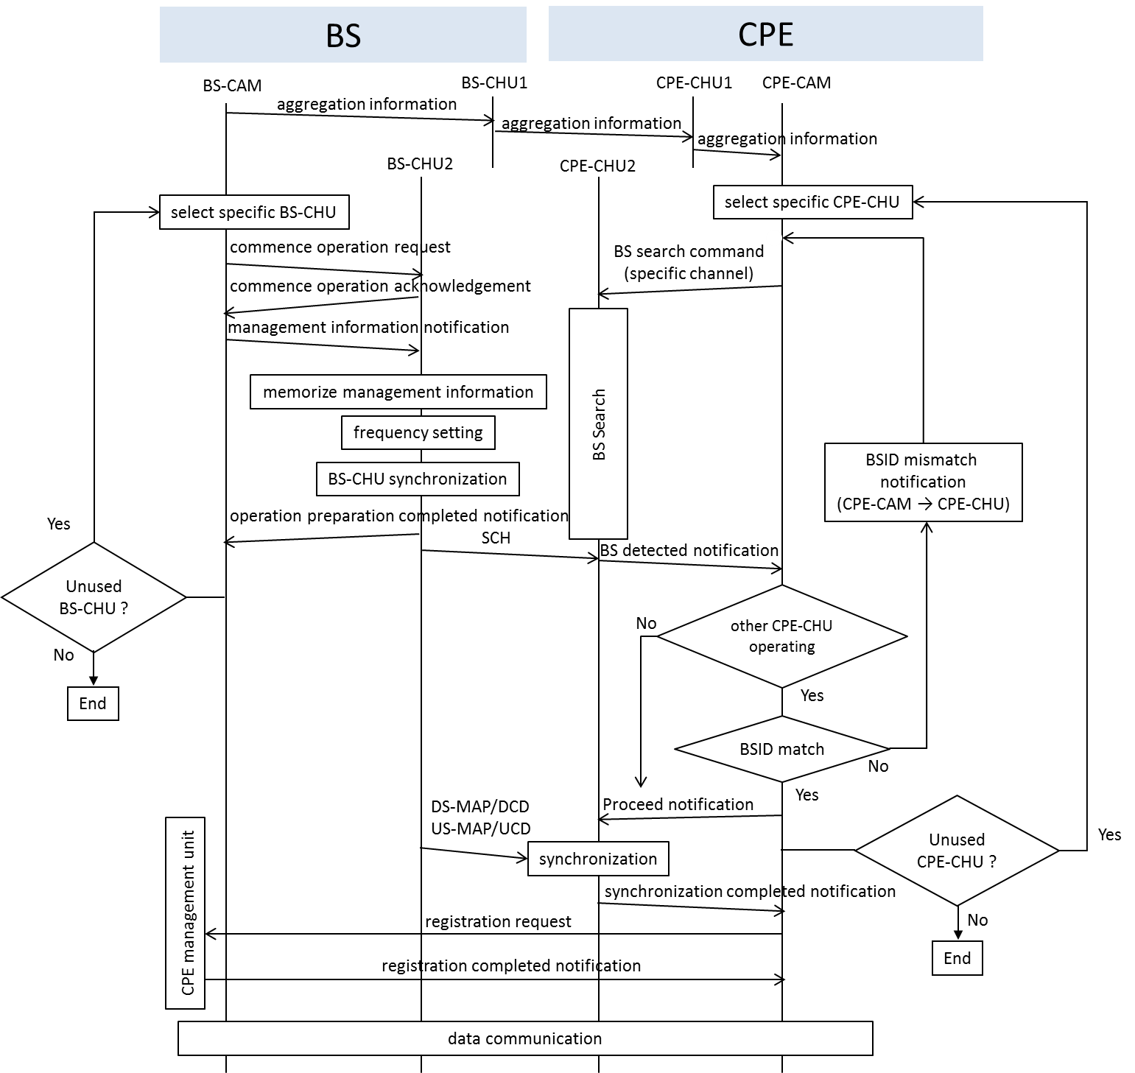

Figure 7.2X.1.1-2 — Operation flow for adding new operating channel by using BS search command (specific channel)

7.2X.1.1.2.1 BS-CAM sends an aggregation information to BS-CHU1

The BS-CAM shall send the aggregation information to the operating BS-CHU1 periodically during multi-channel operation and when to start a multi-channel operation.

7.2X.1.1.2.2 BS-CHU1 forwards an aggregation information to CPE-CHU1

The BS-CHU1 shall forward the aggregation information to the CPE-CHU1 after receiving the information from BS-CAM.

7.2X.1.1.2.3 CPE-CHU1 forwards aggregation information to CPE-CAM

The CPE-CHU1 shall forward the aggregation information to the CPE-CAM after receiving the information from BS-CHU1. The aggregation information shall be designed as a newly defined management message from BS-CAM. The detailed of the management message CAM-AIF is described in 7.7.X.1. The BS-CHU1 and CPE-CHU1 do not need to understand the content of the message when performing the forwarding process.

7.2X.1.1.2.4 BS-CAM selects a specific BS-CHU

The BS-CAM shall select specific BS-CHU which is the target of add new operating channel operation. The BS-CAM shall select the BS-CHU which is in the state of unused or unassigned currently and the hardware is corresponds to the new operating channel’s frequency. The operating channel selection procedure may be included in this step.

7.2X.1.1.1.5 BS-CAM commences operation request

The BS-CAM shall send a commence operation request to the selected BS-CHU. The commence operation request may include the various parameters in connection with the PHY such as channel center frequency and its offset, etc., and some part of MIB information such as software version information, etc.

7.2X.1.1.1.6 BS-CHU2 commences operation acknowledgement

The BS-CHU shall send a commence operation acknowledgement to the BS-CAM. The commence operation acknowledgement may include the specific BS-CHU MIB information that is needed for BS-CAM such as device ID or serial number of the BS-CHU, etc. The BS-CHU shall responds with an error when the commence operation request is rejected due to the reasons such as mismatch of the software version, etc.

7.2X.1.1.1.7 BS-CAM sends management information notification to BS-CHU2

The BS-CAM shall send a management information notification to the BS-CHU. The management information notification may mainly include the MIB information necessary for BS-CHU which is maintained by BS-CAM such as the ID to identify the connection between BS and CPE (carrier index which is associated with the physical or logical channel), etc. If the BS-CHU has a part of MAC layer function then the information on MIB which is used by MAC layer such as Station ID, MAC Address of BS, etc. shall be included.

7.2X.1.1.1.8 BS-CHU2 memorizes management information

The BS-CHU shall memorize the management information notified by the BS-CAM after the management information notification. Some part of the memorized information (MIB information) shall be immediately reflected on the BS-CHU or reflected as the initial value of the transition state.

7.2X.1.1.1.9 BS-CHU2 performs frequency setting

The BS-CHU shall perform the frequency setting procedure. The channel center frequency and its offset that was received in the commence operation request or management information notification shall be reflected in the local oscillator of BS-CHU.

7.2X.1.1.1.10 BS-CHU2 performs synchronization

The BS-CHU shall perform the BS-CHU synchronization procedure. This procedure is intended for network synchronization to synchronize the superframe, frame and TDD timing of a number of BS in a wireless communication system. Basically, this procedure shall synchronize the superframe to the start of each minute of the UTC time obtained from the GPS, etc. As a result, all the operating BS-CHU shall be synchronized with each other.

7.2X.1.1.1.11 BS-CHU2 sends operation preparation completed notification to BS-CAM

The BS-CHU shall send operation preparation completed notification to the BS-CAM. The BS-CHU shall send a response indicating an error when it fails on the mid-way of completing the operation preparation procedure.

7.2X.1.1.1.12 BS-CHU2 broadcasts SCH

The BS-CHU shall periodically broadcast a radio frame which included the SCH information.

7.2X.1.1.1.13 BS-CAM checks unused BS-CHU

The BS-CAM shall check whether there is any unused BS-CHU. If the unused BS-CHU exists, then the BS-CAM shall proceed to the select specific BS-CHU procedure.

7.2X.1.1.1.14 CPE-CAM selects a specific CPE-CHU

The CPE-CAM shall select specific CPE-CHU which is target of add new operating channel operation. The CPE-CAM shall select the CPE-CHU which is in the state of unused or unassigned. In many cases, this procedure is triggered by the BS lost condition occurs in CPE where the CPE-CHU is selected.

7.2X.1.1.1.15 CPE-CAM sends BS search command (All / specific channel) to the specific CPE-CHU2

The CPE-CAM shall send a BS search command (specific channel) to the selected CPE-CHU. The BS search command (specific channel) shall be performed by searching one or more specific frequency channels. The specific channel information shall be indicated by using the extended DCD message, newly defined management message, etc. to specify the BS operating channels that are not connected by any CPE or shall be estimated based on the backup channel information. To prevent overlapping with the other CPE-CHU channel, the channel which other CPE-CHU has already used shall not be searched. Moreover, the channel which other BS has already used that is identified by previous BS search command, etc. shall not be searched.

7.2X.1.1.1.16 CPE-CHU2 performs BS search

The CPE-CHU shall perform the BS search command by attempting to detect the radio signal (preamble and SCH) from BS at the target frequency of BS search command.

7.2X.1.1.1.17 CPE-CHU2 sends BS detected notification to CPE-CAM

The CPE-CHU shall send a BS detected notification to the CPE-CAM when it is able to detect the signal strength greater than or equal to a predetermined value that is defined in the BS search procedure. The BS detected notification shall include the BSID which is obtained by decoding the SCH information.

7.2X.1.1.1.18 CPE-CAM determines other operating CPE-CHU

The CPE-CAM shall determine whether there is any other operating CPE-CHU (connection status with BS). If there is no other operating CPE-CHU at that time, then it does not correspond to add new operating channel procedure (multi-channel operation). The CPE-CHU shall proceed to the synchronization process similarly to the conventional IEEE Std. 802.22-2011.

7.2X.1.1.1.19 CPE-CAM performs BSID matching

If there is other operating CPE-CHU detected at that time, the CPE-CAM shall determine the BSID of other operating CPE-CHU match with the BSID obtained by the CPE-CHU during BS detected notification.

7.2X.1.1.1.20 CPE-CAM sends BSID mismatch notification to CPE-CHU2

If the BSID mismatch occurred, then the BS-CAM shall send a BSID mismatch notification to the CPE-CHU and the CPE-CHU shall resume its BS search process with the rest of the targeted frequency or the BS-CAM shall send a specific target frequency of BS search command to the CPE-CHU.

7.2X.1.1.1.21 CPE-CAM sends proceed notification to CPE-CHU2

If the BSID match is confirmed, then the CPE-CAM shall send a proceed notification to the CPE-CHU to continue with the synchronization procedure.

7.2X.1.1.1.22 CPE-CHU2 performs synchronization

The CPE-CHU shall continue with the synchronization procedure with the frequency which is detected in SCH. In addition to the original synchronization procedure such as detecting and decoding the FCH, DS-MAP, etc. to obtain the parameters of the DS, this procedure shall included the reception of UCD message process to obtain the parameters of the US, the ranging process to adjust the TDD timing, etc.

7.2X.1.1.1.23 CPE-CHU2 sends synchronization completed notification to CPE-CAM

As a response to the proceed notification procedure, the CPE-CHU shall send a synchronization completed notification to the CPE-CAM. By referring to these notifications, the CPE-CAM can recognize the multi-channel operation when two or more CPE-CHUs are connected with the BS.

7.2X.1.1.1.24 CPE-CAM checks unused CPE-CHU

The CPE-CAM shall check whether there is any unused CPE-CHU. If the unused CPE-CHU exists, then the CPE-CAM shall proceed to the select specific CPE-CHU procedure.

7.2X.1.1.1.25 CPE-CAM sends registration request to CPE management unit

The CPE-CAM shall send a registration request to the BS for CPE registration after completed the multi-channel operation capability. The registration request shall contain the information (carrier index, etc.) which can uniquely identify each channel used in the multi-channel operation. Some management messages may be exchanged only between the BS-CHU and CPE-CHU if necessary.

7.2X.1.1.1.26 CPE management unit sends registration completed notification to CPE-CAM

The CPE management unit shall send a registration completed notification to the CPE-CAM.

7.2X.1.2 stop operating channel operation

When the BS is operating under the multi-channel operation, the following procedure of stop operating channel is performed on both BS and CPE to stop the operating channel which is request by the BS.

The stop operating channel operation procedure shall consits of the following steps:

- BS-CAM sends stop operation request to BS-CHU.
- BS-CHU starts stop operation timer.
- BS-CHU sends stop operation request acknowledgement to BS-CAM
- BS-CHU sends stop operation request to CPE-CHU.
- CPE-CHU starts stop operation timer.
- CPE-CHU sends stop operation notification to CPE-CAM.
- CPE-CAM sends stop operation approval/command to CPE-CHU.
- CPE-CHU sends stop operation request acknowledgement to BS-CHU.
- CPE-CHU checks stop operation timer expired and stops operation.
- CPE-CHU sends stop operation completed notification to CPE-CAM.
- BS-CHU checks stop operation timer expired and stops operation.
- BS-CHU sends stop operation completed notification to CPE management unit.

The stop operating channel operation flow is shown in Fig. 7.2X.1.2-1.

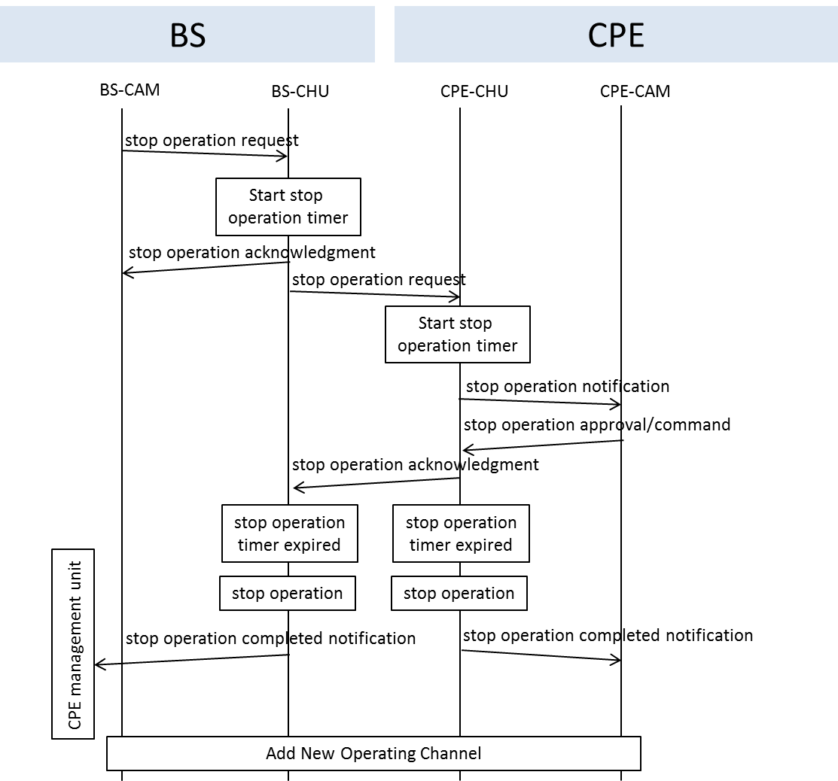

Figure 7.2X.1.2-1 — Operation flow for stopping operating channel

7.2X.1.2.1 BS-CAM sends stop operation request to BS-CHU

The BS-CAM shall send the stop operation request to the BS-CHU which is the target of stop operating channel operation.

7.2X.1.2.2 BS-CHU starts stop operation timer

The BS-CHU shall start the stop operation timer after receiving the stop operation request from BS-CAM. The start of the stop operation timer shall determine the frame number where the operation is scheduled to stop.

7.2X.1.2.3 BS-CHU sends stop operation request acknowledgement to BS-CAM

The BS-CHU shall send the stop operation request acknowledgement to the BS-CAM.

7.2X.1.2.4 BS-CHU sends stop operation request

The BS-CHU shall send the stop operation request to the CPE-CHU by using the downstream transmission. The stop operation request can be send as a new defined management message. The detailed of the management message CAM-STP is described in 7.7.X.2.

7.2X.1.2.5 CPE-CHU starts stop operation timer

Based on the information which specifies the target of the stop operation channel that can be obtained after receiving the stop operation request from the BS-CHU, the CPE-CHU shall confirm the target channel of the request. If the request is addressed to the CPE-CHU, then the CPE-CHU shall start the stop operation timer.

7.2X.1.2.6 CPE-CHU sends stop operation notification to CPE-CAM

The CPE-CHU shall send the stop operation notification to the CPE-CAM.

7.2X.1.2.7 CPE-CAM sends stop operation approval/command to CPE-CHU

The CPE-CAM shall send the stop operation approval/command to the CPE-CHU after the CPE-CAM is notified that the channel operation of the CPE-CHU will be stopped.

7.2X.1.2.8 CPE-CHU sends stop operation request acknowledgement to BS-CHU

The CPE-CHU shall send the stop operation request acknowledgement to the BS-CHU after receiving the stop operation approval/command from the CPE-CAM. The stop operation acknowledgement can be send as a new defined management message through the upstream transmission. The detailed of the management message CAM-STP-ACK is described in 7.7.X.3.

7.2X.1.2.9 CPE-CHU checks stop operation timer expired and stops operation

The CPE-CHU shall stop the operation when the stop operation timer is expired which means that it has reached the frame number that is set during the set stop operation timer procedure. The CPE-CHU shall stop all transmission and reception after the stop operation procedure is performed.

7.2X.1.2.10 CPE-CHU sends stop operation completed notification to CPE-CAM

The CPE-CHU shall send the stop operation completed notification to the CPE-CAM after completed the stop operation procedure.

7.2X.1.2.11 BS-CHU checks stop operation timer expired and stops operation

The BS-CHU shall stop the operation when the stop operation timer is expired and stop all the transmission and reception after the stop operation procedure is performed.

7.2X.1.2.12 BS-CHU sends stop operation completed notification to CPE management unit

The BS-CHU shall send the stop operation completed notification to the BS-CAM and CPE management unit after completed the stop operation procedure. The BS-CHU and CPE-CHU that has stopped their operation will be the target CHU for the add new operating channel procedure.

7.2X.1.3 switch operating channel operation

When the BS is operating under the multi-channel operation, the following procedure of switch operating channel is performed on both BS and CPE to switch the operating channel which is request by the BS.

The switch operating channel operation procedure shall consits of the following steps:

- BS-CAM sends channel switch request to BS-CHU.
- BS-CHU starts channel switch timer.
- BS-CHU sends channel switch request acknowledgement to BS-CAM.
- BS-CHU sends channel switch request to CPE-CHU.
- CPE-CHU starts channel switch timer.
- CPE-CHU sends channel switch notification to CPE-CAM.
- CPE-CAM sends channel switch approval/command to CPE-CHU.
- CPE-CHU sends channel switch request acknowledgement to BS-CHU.
- BS-CHU checks channel switch timer expired and performs channel switch.
- CPE-CHU checks channel switch timer expired and performs channel switch.
- BS-CHU sends channel switch completed notification to BS-CAM.
- BS-CHU broadcasts SCH.
- BS-CHU sends DS-MAP/DCD/US-MAP/UCD to CPE-CHU.
- CPE-CHU sends channel switch completed notifiction to CPE-CAM.
- CPE-CHU sends channel switch completed notifiction to CPE management unit.

The switch operating channel operation flow is shown in Fig. 7.2X.1.3-1.

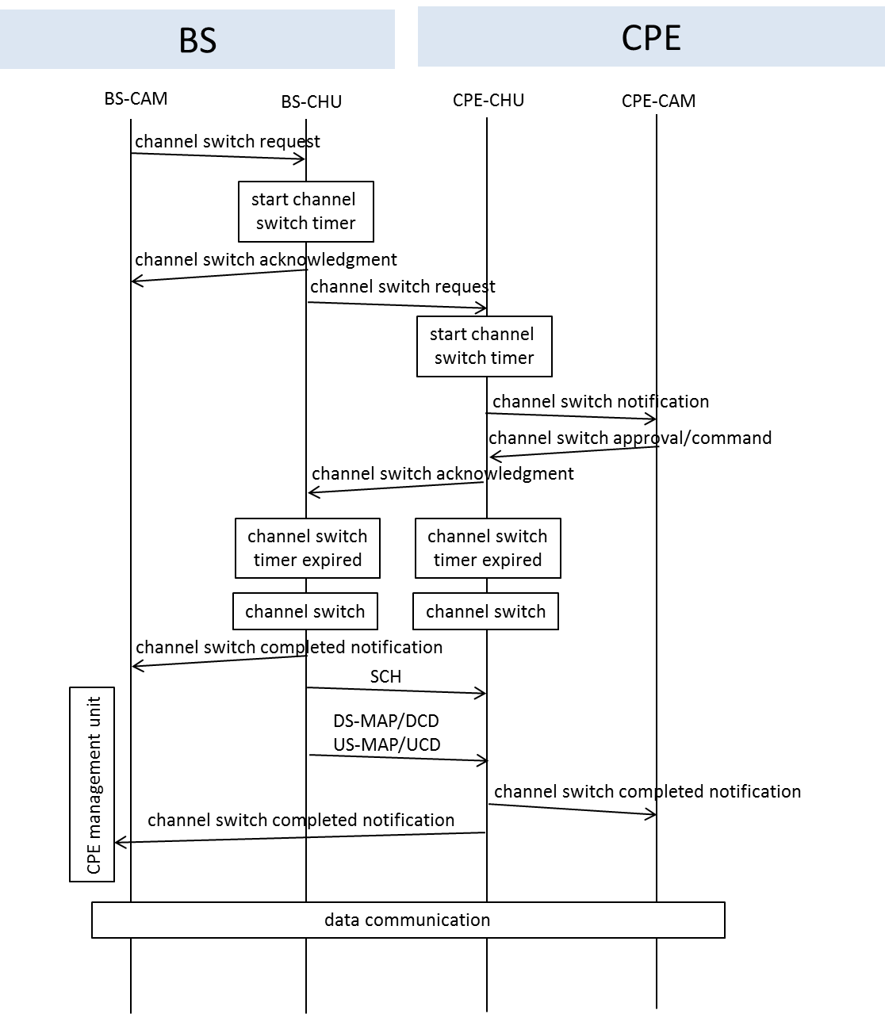

Figure 7.2X.1.3-1 — Operation flow for switching operating channel

7.2X.1.3.1 BS-CAM sends channel switch request to BS-CHU

The BS-CAM shall send the channel switch request to the BS-CHU which is the target of switch operating channel operation. The BS-CHU shall correspond to the requested switch operating channel’s frequency.

7.2X.1.3.2 BS-CHU starts channel switch timer

The BS-CHU shall start the channel switch timer after receiving the channel switch request from BS-CAM. The start of the channel switch timer shall determine the frame number where the new operating channel is scheduled to switch.

7.2X.1.3.3 BS-CHU sends channel switch request acknowledgement to BS-CAM

The BS-CHU shall send the channel switch request acknowledgement to the BS-CAM.

7.2X.1.3.4 BS-CHU sends channel switch request to CPE-CHU

The BS-CHU shall send the channel switch request to the CPE-CHU by using the downstream transmission. The channel switch request can be send as a new defined management message. The detailed of the management message CAM-SWH is described in 7.7.X.4. The management message shall be broadcasted to all the CPE and the CPE shall be able to receive and interpret the content of the management message.

7.2X.1.3.5 CPE-CHU starts channel switch timer

The CPE-CHU shall start the channel switch timer after receiving the channel switch request from the BS-CHU.

7.2X.1.3.6 CPE-CHU sends channel switch notification to CPE-CAM

The CPE-CHU shall send the channel switch notification to the CPE-CAM.

7.2X.1.3.7 CPE-CAM sends channel switch approval/command to CPE-CHU

The CPE-CAM shall send the channel switch approval/command to the CPE-CHU after the CPE-CAM is notified that the operating channel of the CPE-CHU will be switched.

7.2X.1.3.8 CPE-CHU sends channel switch request acknowledgement to BS-CHU

The CPE-CHU shall send the channel switch request acknowledgement to the BS-CHU after receiving the channel switch approval/command from the CPE-CAM. The channel switch request acknowledgement can be send as a new defined management message through the upstream transmission. The detailed of the management message CAM-SWH-ACK is described in 7.7.X.5.

7.2X.1.3.9 BS-CHU checks channel switch timer expired and performs channel switch

The BS-CHU shall switch to a new operating channel when the channel switch timer is expired which means that it has reached the frame number that is set during the start channel switch timer procedure. The BS-CHU shall modify the operating parameters within the RTG period and shall change the frequency of the local oscillator in order to switch to a new operating channel. Since channel switch is performed due to the necessity of termination of operation on current channel in most of the cases, a channel switch is enforced even if the channel switch acknowledgement is not receive from neither one of the CPEs.

7.2X.1.3.10 CPE-CHU checks channel switch timer expired and performs channel switch

The CPE-CHU shall switch to a new operating channel when the channel switch timer is expired.

7.2X.1.3.11 BS-CHU sends channel switch completed notification to BS-CAM

The BS-CHU shall send the channel switch completed notification to the BS-CAM after completed the channel switch procedure. This shall indicate that the channel switch procedure at the physical layer of BS-CHU is completed (such as the frequency of the local oscillator of BS-CHU is locked to the new channel, etc.).

7.2X.1.3.12 BS-CHU broadcasts SCH

The BS-CHU shall broadcast a radio frame which included the SCH information.

7.2X.1.3.13 BS-CHU sends DS-MAP/DCD/US-MAP/UCD to CPE-CHU

The BS-CHU shall send the DS-MAP/DCD/US-MAP/UCD information to CPE-CHU for synchronization procedure.

7.2X.1.3.14 CPE-CHU sends channel switch completed notification to CPE-CAM

The CPE-CHU shall send the channel switch completed notifiction to CPE-CAM when the frame containing SCH, etc. is received correctly. The channel switch completion notification shall indicate that the channel switch has been completed at the MAC layer.

7.2X.1.3.15 CPE-CHU sends channel switch completed notification to CPE management unit

The CPE-CHU shall send the channel switch completed notification to the CPE management unit. The channel switch completed notification can be send as a new defined management message through the upstream transmission. The detailed of the management message CAM-SWH is described in 7.7.X.3. Upon receiving the management message, the CPE management unit in BS shall update the latest information of the CPEs.

7.2X.2 Multi-channel operation at BS

This clause explain the operation flow of the BS’s channel allocation manager (BS-CAM) for commencing the multi-channel operation. The operation flow of commencing multi-channel operation at BS is shown in Fig. 7.2X.2-1. In order to perform the multi-channel allocation which is neccesary for multi-channel operation, three basic functions which are add new operating channel, stop operating channel and switch operating channel are newly defined. The detailed explanation of each function and it’s operation flow are described in subclause 7.2X.1.1, 7.2X.1.2 and 7.2X.1.3.

In commencing multi-channel operation at BS, the BS-CAM shall play the key role to decide the operating channel and determine the implementation of either one of the 3 basic functions as shown in Fig. 7.2X.2-1. The triggers for the BS-CAM to decide the operating channel are database access, BS sensing report, CPE sensing report and BS channel scheduling. The database access trigger shall refering to the database access result which concluded that there are changes in the available operating channels after accessing the whitespace database by the database access control in BS. The BS sensing report and CPE senseing report shall refer to the sensing report which concluded that there are changes in the available operating channels after performing the sensing process. These are triggers that caused by the changes in the available operating channels. The BS channel scheduling is the case where a particular operating channel is available under specific time scheduling by the BS.

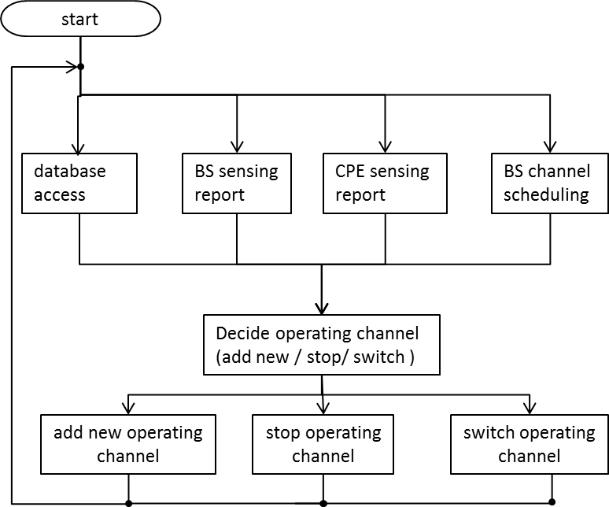

Figure 7.2X.2-1 — Commence multi-channel operation at BS

7.2X.3 Multi-channel operation at CPE

This clause explain the operation flow of the CPE’s channel allocation manager (CPE-CAM) for commencing the multi-channel operation. The operation flow of commencing multi-channel operation at CPE is shown in Fig. 7.2X.3-1. In order to perform the multi-channel allocation which is neccesary for multi-channel operation, the CPE-CAM also possess three basic functions which are add new operating channel, stop operating channel and switch operating channel. The detailed explanation of each function and it’s operation flow are described in subclause 7.2X.1.1, 7.2X.1.2 and 7.2X.1.3.

In commencing multi-channel operation at CPE, most of the triggers of the CPE-CAM operation are resulted from the BS control messages. The triggers for the CPE-CAM to commence the multi-channel operation are BS control message, CPE incumbent sensing report, CPE channel scheduling and BS lost message.The BS control message including the switch operating channel and stop operating channel control messages. When the CPE-CAM received the switch operating channel control message from the BS, it shall proceed to the switch operating channel procedure and switch to the operating channel as stated in the switch operating channel control message. When the CPE-CAM received the stop operating channel control message from the BS, it shall proceed to the stop operating channel procedure and stop the operating channel as stated in the stop operating channel control message. Furthermore, when the CPE incumbent sensing report showed the detection of incumbent or the CPE channel scheduling is scheduled to stop the operating channel, it shall proceed to the stop operating channel procedure as well. The BS lost message which indicates the lost connection between a CPE-CHU and a BS or the CPE channel scheduling for adding a new operating channel shall proceed to the add new operating channel procedure.

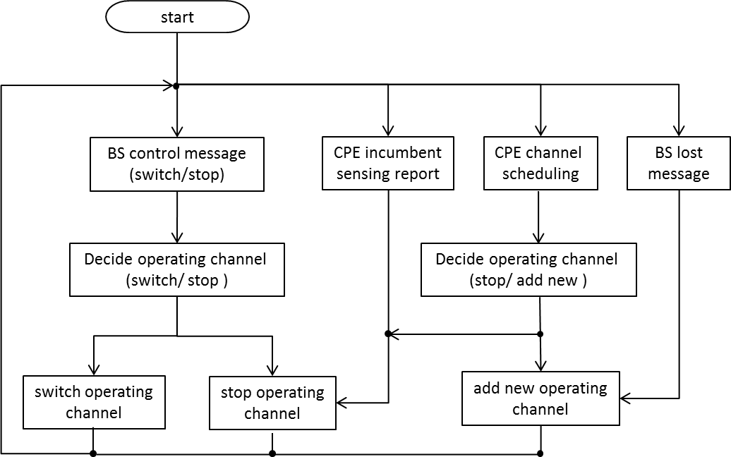

Figure 7.2X.3-1 — Commence multi-channel operation at CPE

