IEEE P802.22
Wireless RANs
Proposed Text of PHY technical items related to Section 9.6 of the Std.802.22-2011
Date: 2013-05-15
Author(s):
Name | Company | Address | Phone | email
Masayuki Oodo | NICT | 3-4, Hikarino-oka, Yokosuka, 239-0847, Japan |  | moodo@nict.go.jp
Zhang Xin | NICT | 20 Science Park Road, #01-09A/10 TeleTech Park, Singapore |  | amy.xinzhang@ieee.org
Chunyi Song | NICT | 3-4, Hikarino-oka, Yokosuka, 239-0847, Japan |  | songe@ieee.org
Keiichi Mizutani | NICT | 3-4, Hikarino-oka, Yokosuka, 239-0847, Japan |  | songe@ieee.org
Chang-Woo Pyo | NICT | 3-4, Hikarino-oka, Yokosuka, 239-0847, Japan |  | cwpyo@nict.go.jp
Pin-Hsun Lin | NICT | 3-4, Hikarino-oka, Yokosuka, 239-0847, Japan |  | pslin@nict.go.jp
Gabriel Porto Vilardi | NICT | 3-4, Hikarino-oka, Yokosuka, 239-0847, Japan |  | gpvillardi@nict.go.jp
Hiroshi Harada | NICT | 3-4, Hikarino-oka, Yokosuka, 239-0847, Japan |  | harada@ieee.org
Abstract
This document contains the proposed text of PHY technical items related to Section 9.6 of the current 802.22 standard.
Notice: This document has been prepared to assist IEEE 802.22. It is offered as a basis for discussion and is not binding on the contributing individual(s) or organization(s). The material in this document is subject to change in form and content after further study. The contributor(s) reserve(s) the right to add, amend or withdraw material contained herein.

Release: The contributor grants a free, irrevocable license to the IEEE to incorporate material contained in this contribution, and any modifications thereof, in the creation of an IEEE Standards publication; to copyright in the IEEE’s name any IEEE Standards publication even though it may include portions of this contribution; and at the IEEE’s sole discretion to permit others to reproduce in whole or in part the resulting IEEE Standards publication. The contributor also acknowledges and accepts that this contribution may be made public by IEEE 802.22.

Patent Policy and Procedures: The contributor is familiar with the IEEE 802 Patent Policy and Procedures
<http://standards.ieee.org/guides/bylaws/sb-bylaws.pdf>, including the statement "IEEE standards may include the known use of patent(s), including patent applications, provided the IEEE receives assurance from the patent holder or applicant with respect to patents essential for compliance with both mandatory and optional portions of the standard." Early disclosure to the Working Group of patent information that might be relevant to the standard is essential to reduce the possibility for delays in the development process and increase the likelihood that the draft publication will be approved for publication. Please notify the Chair Apurva N. Mody <apurva.mody@ieee.org> as early as possible, in written or electronic form, if patented technology (or technology under patent application) might be incorporated into a draft standard being developed within the IEEE 802.22 Working Group. If you have questions, contact the IEEE Patent Committee Administrator at <patcom@ieee.org>.
Summary of this document

In this document, OFDM subcarrier allocation for 802.22b is proposed. This item corresponds to Section 9.6 of the 802.22 stanadard as shown below.

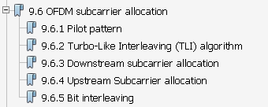

Subsection 9.6 of the 802.22 Standard

Basically, the subsection structure in the proposed text follows the current structure above. However, “Turbo-Like Interleaving (TLI) algorithm” is not used for the proposed PHY. Therefore the subsection related to TLI algorithm (Subsection 9.6.2) is deleted and the subsection related to the downstream subcarrier allocation (9.6.3) follows the subsection related to pilot pattern (9.6.1). As a result, the subsection structure in the prosed text is as follows.

9.X.6 OFDM subcarrier allocation
9.X.6.1 Pilot pattern
9.X.6.2 Downstream subcarrier allocation
9.X.6.3 Upstream subcarrier allocation
9.X.6.4 Bit interleaving

In this proposal, all the texts are described as new texts (without revision marks based on the section 9.6 of the 802.22 standard).

9.X.6 OFDM subcarrier allocation
Sampling frequencies are F_{s} =5.6 MHz, 6.53 MHz, and 7.47 MHz for the channel bandwidth of 6 MHz, 7 MHz, and 8 MHz, respectively. Subtracting the guard subcarriers from N_{FFT} (=1024), one obtains the set of used subcarriers which consists of both pilot subcarriers and data subcarriers. In the DS, the pilot subcarriers are allocated first; then data subcarriers are divided into subchannels. In the US, the set of used subcarriers is first partitioned into subchannels, and then the pilot subcarriers are allocated from within each subchannel.

9.X.6.1 Pilot pattern
9.X.6.1.1 Downstream (DS)

A slot (or a subchannel) in the DS is composed of four (4) OFDMA symbols and 16 subcarriers as shown in Figure 9.X.1.3.1-3. Within each slot, there are 48 data subcarriers and 16 fixed-position pilots. The subchannel is constructed from four (4) DS tiles. Each tile has four successive active subcarriers, and its configuration is illustrated in Figure 9.X.6.1.1-1.
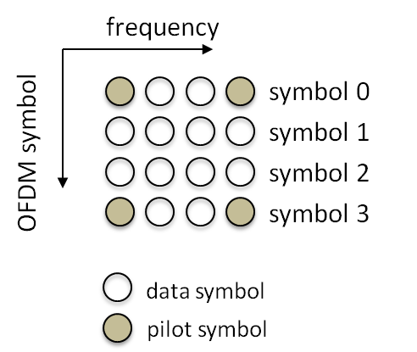

Figure 9.X.6.1.1-1 — Pilot pattern for DS

9.X.6.1.2 Upstream (US)
A slot (or a subchannel) in the US is composed of seven (7) OFDMA symbols and 8 subcarriers as shown in Figure 9.X.1.3.1-4. Within each slot, there are forty eight (48) data subcarriers and eight (8) fixed-position pilots. The subchannel is constructed from two UL tiles. Each tile has four successive active subcarriers, and its configuration is illustrated in Figure 9.X.6.1.1-2.
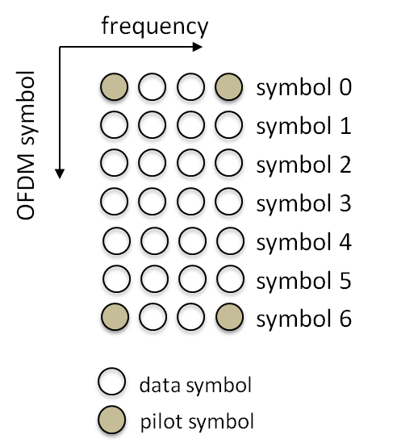

Figure 9.X.6.1.2-1 — Pilot pattern for US

9.6.2 Turbo-Like Interleaving (TLI) algorithm

(This subsection is not necessary for the proposed PHY based on 1K-FFT. Since the algorithms for interleaving (bit interleaving, subcarrier interleaving) are different from each other and also different from the legacy, interleaving algorithms are described in each subsection.)
9.X.6.2 Downstream subcarrier allocation
9.X.6.2.1 Symbol structure for subchannel in the downstream
The symbol structure is constructed using pilot, data, and null subcarriers. The symbol is first divided into basic tiles and null carriers are allocated. Pilot and data subcarriers are allocated within each tile. Table 9.X.6.2.1-1 summarizes the parameters of the symbol structure in the downstream (DS).

Table 9.X.6.2.1-1 — Symbol structure parameters in the downstream (DS)
Parameters | Value | Comments
FFT size | 1024
Number of DC subcarriers | 1 | Index 512 (counting from 0)
Number of Guard subcarriers, Left | 96 | —
Number of Guard subcarriers, Right | 95 | —
Number of used subcarriers (N_{used}) | 833 | Number of total subcarriers including DC, data and pilot
Number of subchannels (N_{subchannels}) | 52 | —
Number of tiles (N_{tiles}) | 208 | —
Number of tiles per subchannel (or slot) | 4 | —
Number of pilot subcarriers per slot | 16 | —
Number of data subcarriers per slot | 48 | —
Number of OFDM symbols per slot | 4 | —
Number of subcarriers per tile | 4 | —
Sequence for DS tile permutation (P_{t}) | 6, 48, 37, 21, 31, 40, 42, 32, 47, 30, 33, 18, 10, 15, 50, 51, 46, 23, 45, 16, 39, 35, 7, 25, 11, 22, 38, 28, 19, 17, 3, 27, 12, 29, 26, 5, 41, 49, 44, 9, 8, 1, 13, 36, 14, 43, 2, 20, 24, 4,34, 0 | used to allocate tiles to subchannel

9.X.6.2.2 Subcarrier allocation and data mapping onto subcarriers
The carrier allocation to subchannels is performed using the following procedure:
- Subcarriers shall be divided into the number of tiles (N_{tiles}) containing 4 adjacent subcarriers each (starting from carrier 0). The number of tiles (N_{tiles}) in the downstream is 208.
- Logical tiles are mapped to physical tiles in the FFT using Equation 9.X.6.2.2-1.

Tiles(s, n) = N_{subchannels} ・n+(P_{t}[(s+n) mod N_{subchannels}]+ DS_PermBase) mod N_{subchannels}
(Eq.9.X.6.2.2-1)
where
- Tiles(s, n) is the physical tile index in the FFT with tiles being ordered consecutively from the most negative to the most positive used subcarrier (0 is the starting tile index)
- n is the tile index 0,1,2,3 in a subchannel
- N_{subchannels} is the number of subchannels: 52
- s is the index number of a subchannel: 0…N_{subchannels}–1
- P_{t} is the sequence for the downstream tile permutation shown below
P_{t}= {6, 48, 37, 21, 31, 40, 42, 32, 47, 30, 33, 18, 10, 15, 50, 51, 46, 23, 45, 16, 39, 35, 7, 25, 11, 22, 38, 28, 19, 17, 3, 27, 12, 29, 26, 5, 41, 49, 44, 9, 8, 1, 13, 36, 14, 43, 2, 20, 24, 4,34, 0}
- DS_PermBase is an integer ranging from 0 to 31, which is set to preamble IDCell in the first zone

Example of the logical tile mapping to the physical tile is provided below to clarify the operation of Equation 9.X.6.3.2-1. In this example, tiles used for subchannel s = 2 in US_PermBase = 1 are computed.

  - Apply the permutation due to the selection of the subchannel (s = 2), rotate two times: {37, 21, 31, 40, 42, 32, 47, 30, 33, 18, 10, 15, 50, 51, 46, 23, 45, 16, 39, 35, 7, 25, 11, 22, 38, 28, 19, 17, 3, 27, 12, 29, 26, 5, 41, 49, 44, 9, 8, 1, 13, 36, 14, 43, 2, 20, 24, 4,34, 0, 6, 48 }.
  - Take the first 4 numbers, and add the DS_PermBase (perform modulo operation if needed): {38, 22, 32, 41}.
  - Finally, add the appropriate shift: {38, 74, 136, 197}.

- After allocating the pilot subcarriers within each tile, indexing of the data subcarriers within each slot is performed starting from the first symbol at the lowest indexed subcarrier of the lowest indexed tile, continuing in an ascending manner through the subcarriers in the same symbol, then going to the next symbol at the lowest indexed data subcarrier, and so on. Data subcarriers shall be indexed from 0 to 47. The indexing of the data subcarriers (48 data subcarriers) in one subchannel in DS is shown in Figure 9.X.6.2.2.1 -1

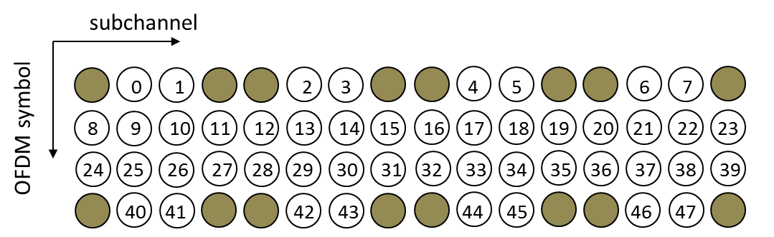

Figure 9.X.6.2.2-1 — DS data subcarrier index in one subchannel

- The mapping of data onto the subcarriers shall follow Equation 9.X.6.2.2-2. This equation calculates the subcarrier index to which the data constellation point is to be mapped.

Subcarrier(n, s) =(n + 13・ s) mod N_{subcarriers}
(Eq.9.X.6.2.2-2)
where
- Subcarrier(n, s) is the permutated subcarrier index corresponding to data subcarrier.
- n is a running index 0…47, indicating the data constellation point
- s is the subchannel number 0…51
- N_{subcarriers} is the number of data subcarriers per slot: 48
9.X.6.3 Upstream Subcarrier allocation
9.X.6.3.1 Symbol structure for subchannel in the upstream
The symbol structure is constructed using pilot, data, and null subcarriers. The symbol is first divided into basic tiles and null carriers are allocated. Pilot and data subcarriers are allocated within each tile. Table 9.X.6.3.1-1 summarizes the parameters of the symbol structure in the upstream (US).

Table 9.X.6.3.1-1 — Symbol structure parameters in the upstream (US)
Parameters | Value | Comments
FFT size | 1024
Number of DC subcarriers | 1 | Index 512 (counting from 0)
Number of Guard subcarriers, Left | 92 | —
Number of Guard subcarriers, Right | 91 | —
Number of used subcarriers (N_{used}) | 841 | Number of all subcarriers including DC, data and pilots used within a symbol
Number of subchannels (N_{subchannels}) | 105 | —
Number of tiles (N_{tiles}) | 210 | —
Number of tiles per subchannel | 2 | —
Number of pilot subcarriers per slot | 8 | —
Number of data subcarriers per slot | 48 | —
Number of OFDM symbols per slot | 7 | —
Number of subcarriers per tile | 4 | —
Sequence for US tile permutation (P_{t}) | 33, 52, 35, 67, 94, 13, 80, 6, 34, 45, 43, 68, 84, 66, 7, 37, 71, 89, 55, 101, 27, 60, 51, 14, 21, 17, 93, 72, 95, 73, 81, 24, 103, 86, 39, 29, 56, 62, 70, 64, 23, 22, 54, 15, 90, 76, 100, 33, 36, 18, 9, 91, 19, 26, 12, 92, 48, 25, 87, 74, 5, 31, 85, 40, 104, 2, 102, 69, 57, 50, 1, 44, 0, 20, 88, 79, 16, 28, 46, 42, 41, 59, 96, 97, 99, 82, 30, 49, 65, 77, 63, 11, 8, 75, 98, 38, 32, 83, 4, 47, 58, 61, 78, 10, 53 | used to allocate tiles to subchannel

9.X.6.3.2 Subcarrier allocation and data mapping onto subcarriers
The carrier allocation to subchannels is performed using the following procedure:

- The usable subcarriers in the allocated frequency band shall be divided into N_{tiles} physical tiles with parameters specified by Table 9.X.6.3.1-1. The number of tiles (N_{tiles}) in the upstream is 210.

- Logical tiles are mapped to physical tiles in the FFT using Equation 9.X.6.3.2-1.

Tiles(s, n) = N_{subchannels} ・n+(P_{t}[(s+n) mod N_{subchannels}]+ US_PermBase) mod N_{subchannels}
(Eq.9.X.6.3.2-1)
where
- Tiles(s, n) is the physical tile index in the FFT with tiles being ordered consecutively from the most negative to the most positive used subcarrier (0 is the starting tile index)
- n is the tile index 0,1 in a subchannel
- N_{subchannels} is the number of subchannels: 105
- s is the index number of a subchannel: 0…N_{subchannels}–1
- P_{t} is the sequence for the upstream tile permutation shown below
P_{t}= {33, 52, 35, 67, 94, 13, 80, 6, 34, 45, 43, 68, 84, 66, 7, 37, 71, 89, 55, 101, 27, 60, 51, 14, 21, 17, 93, 72, 95, 73, 81, 24, 103, 86, 39, 29, 56, 62, 70, 64, 23, 22, 54, 15, 90, 76, 100, 33, 36, 18, 9, 91, 19, 26, 12, 92, 48, 25, 87, 74, 5, 31, 85, 40, 104, 2, 102, 69, 57, 50, 1, 44, 0, 20, 88, 79, 16, 28, 46, 42, 41, 59, 96, 97, 99, 82, 30, 49, 65, 77, 63, 11, 8, 75, 98, 38, 32, 83, 4, 47, 58, 61, 78, 10, 53}
- US_PermBase is an integer value which is assigned by a management entity

Example of the logical tile mapping to the physical tile is provided below to clarify the operation of Equation 9.X.6.3.2-1. In this example, tiles used for subchannel s = 3 in US_PermBase = 2 are computed.

  - Apply the permutation due to the selection of the subchannel (s = 3), rotate three times: {67, 94, 13, 80, 6, 34, 45, 43, 68, 84, 66, 7, 37, 71, 89, 55, 101, 27, 60, 51, 14, 21, 17, 93, 72, 95, 73, 81, 24, 103, 86, 39, 29, 56, 62, 70, 64, 23, 22, 54, 15, 90, 76, 100, 33, 36, 18, 9, 91, 19, 26, 12, 92, 48, 25, 87, 74, 5, 31, 85, 40, 104, 2, 102, 69, 57, 50, 1, 44, 0, 20, 88, 79, 16, 28, 46, 42, 41, 59, 96, 97, 99, 82, 30, 49, 65, 77, 63, 11, 8, 75, 98, 38, 32, 83, 4, 47, 58, 61, 78,10, 53, 33, 52, 35}.
  - Take the first 2 numbers, and add the UL_PermBase (perform modulo operation if needed): {69, 96}.
  - Finally, add the appropriate shift: {69, 201}.

- After allocating the pilot subcarriers within each tile, indexing of the data subcarriers within each slot is performed starting from the first symbol at the lowest indexed subcarrier of the lowest indexed tile, continuing in an ascending manner through the subcarriers in the same symbol, then going to the next symbol at the lowest indexed data subcarrier, and so on. Data subcarriers shall be indexed from 0 to 47. The indexing of the data subcarrier (48 data subcarriers) in one subchannel in US is shown in Figure 9.X.6.3.2.1-1

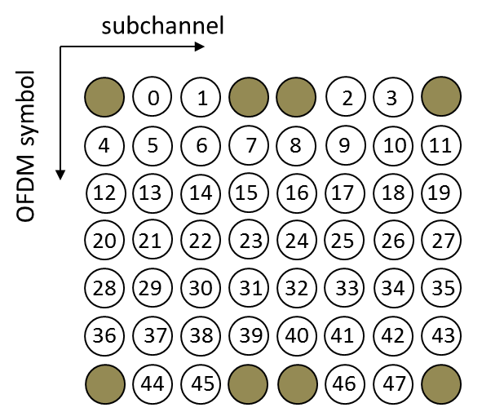

Figure 9.X.6.3.2-1 — US data subcarrier index in one subchannel

- The mapping of data onto the subcarriers shall follow Equation 9.X.6.3.2-2. This equation calculates the subcarrier index to which the data constellation point is to be mapped.

Subcarrier(n, s) =(n + 13・ s) mod N_{subcarriers}
(Eq.9.X.6.3.2-2)
where
- Subcarrier(n, s) is the permutated subcarrier index corresponding to data subcarrier.
- n is a running index 0…47, indicating the data constellation point
- s is the subchannel number 0…104
- N_{subcarriers} is the number of data subcarriers per slot: 48

For example, for subchannel 1 (s = 1), the first data constellation point (n = 0) is mapped onto Subcarrier (0,1) = 13, where 13 is the subcarrier with index 13 according to step a) in this subclause. Considering the upstream tile structure (4 subcarriers by 7 OFDM symbols), it can be seen that this is the second indexed subcarrier on the third symbol within the slot.
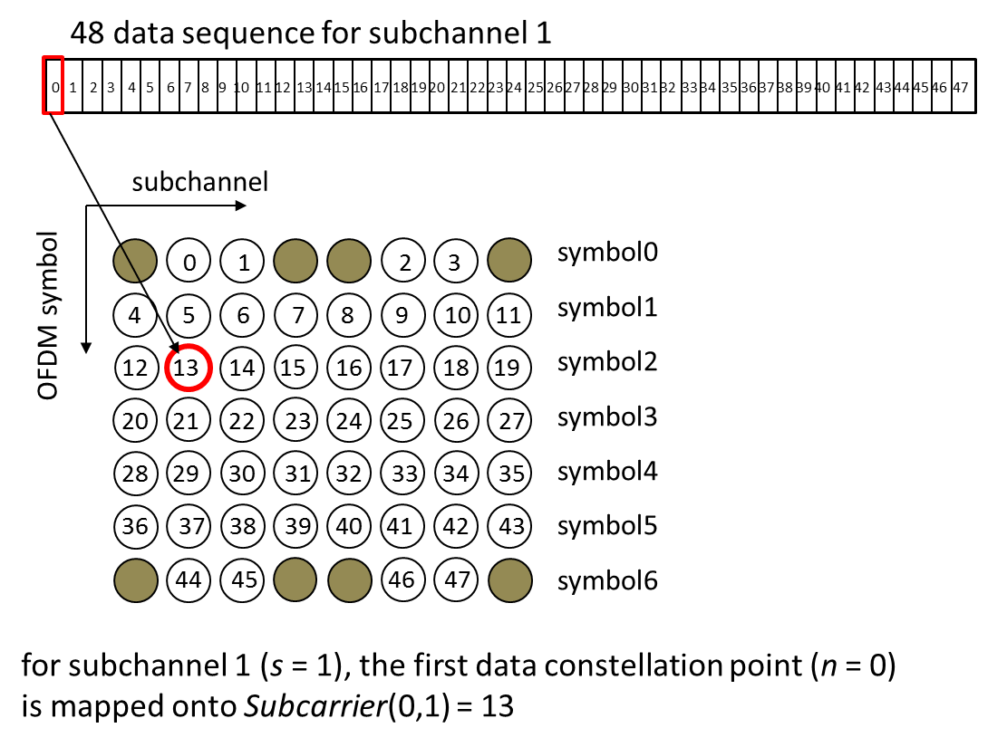

Figure 9.X.6.3.3-2 — Example of data mapping onto subcarrier (s=1, n=0)

Similarly, for subchannel 3, the ninth data constellation point (n = 8) is mapped onto Subcarrier (8, 3) =47. According to step a), this is the last indexed subcarrier of the seventh symbol within the slot.

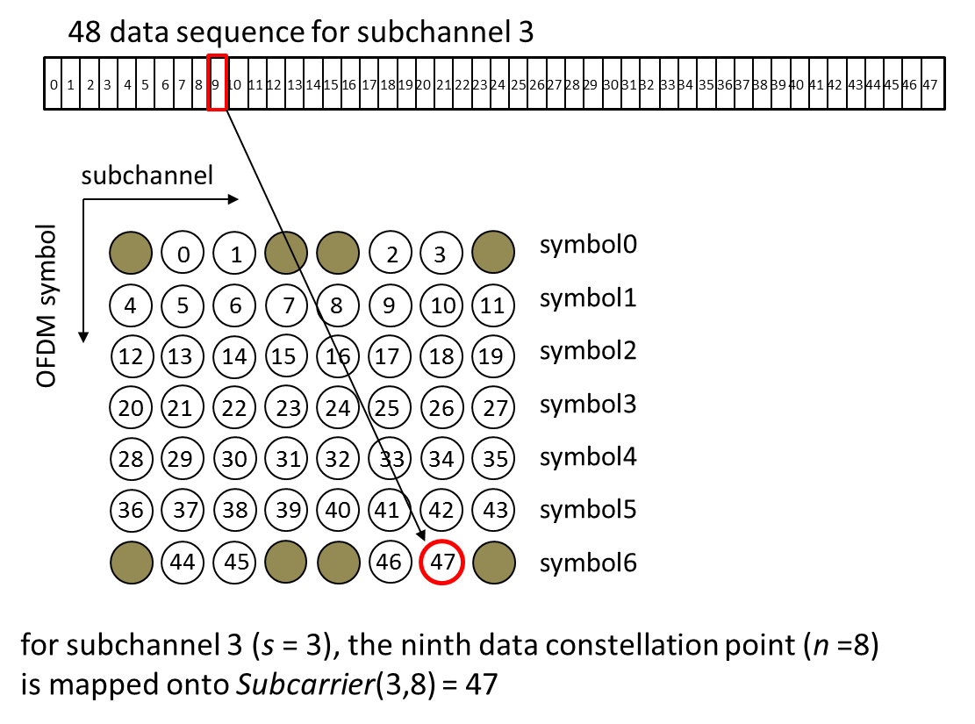

Figure 9.6.4.3-2 — Example of data mapping onto subcarrier (s=3, n=8)

9.X.6.3.3 Data subchannel rotation scheme
In the upstream, a rotation scheme shall be applied per OFDMA slot duration. On each slot duration, the rotation scheme shall be applied to all US subchannels that belong to the normal data burst. The rotation scheme is defined by applying the following rules:
- Per OFDMA slot duration, pick the subchannels that are used for the normal data burst (for the UIUC value larger than 13 in Table 36). Renumber these subchannels contiguously so that the lowest numbered physical subchannel is renumbered with 0. The total number of subchannels picked shall be designated N_{subchn}.
- The mapping function defined by rule a) shall define a function, f, so that temp1_subchannel_number = f (old_subchannel_number).
- Mark the first US OFDMA slot duration with the slot index S_{idx} = 0. Increase S_{idx} by 1 in every slot duration so that subsequent slots are numbered 1, 2, 3..., etc.
- Apply the following formula:
temp2_subchannel_number = (temp1_subchannel_number + 13×S_{idx}) mod N_{subchn}
- To get the new subchannel number, apply the following formula:
new_subchannel_number = f ^{–1}(temp2_subchannel_number)
where f ^{–1} (.) is the inverse mapping of the mapping defined in rule b).
- For subchannels that are used for control burst (for the UIUC value less than 14), new_subchannel_number = old_subchannel_number.
- The new_subchannel_number shall replace the old_subchannel_number in each allocation defined by 9.X.1.3.2 data mapping where the new_subchannel_number is the output of the rotation scheme and the old_subchannel_number is the input of the rotation scheme.

9.X.6.4 Bit interleaving
All encoded data bits shall be interleaved by a block interleaver with a block size corresponding to the number of coded bits per the encoded block size N_{cbps} (Possible values of N_{cbps} for each MCS are spedified later.) The interleaver is defined by a two-step permutation. The first ensures that adjacent coded bits are mapped onto nonadjacent subcarriers. The second permutation insures that adjacent coded bits are mapped alternately onto less or more significant bits of the constellation, thus avoiding long runs of lowly reliable bits.

Let N_{cpc} be the number of coded bits per subcarrier, i.e., 2, 4, or 6 for QPSK, 16-QAM, or 64-QAM, respectively. Let s = N_{cpc}/2. Within a block of N_{cbps} bits at transmission, let k be the index of the coded bit before the first permutation, m_{k} be the index of that coded bit after the first and before the second permutation and let j_{k} be the index after the second permutation, just prior to modulation mapping, and d be the modulo used for the permutation.

The first permutation is defined by Equation (9.X.6.4-1):

m_{k} = (Ncbps /d) ・kmod(d) + floor(k /d) k = 0, 1, .... , Ncbps – 1 d = 16 (9.X.6.4-1)

The second permutation is defined by Equation (9.X.6.4-2).

j_{k} = s ・floor(m_{k} / s) +(m_{k} + N_{cbps} – floor(d ・ m_{k} /N_{cbps}))_{mod(s)} k = 0, 1, ... , Ncbps – 1 d =16 (9.X.6.4-2)

The de-interleaver, which performs the inverse operation, is also defined by two permutations. Within a received block of N_{cbps} bits, let j be the index of a received bit before the first permutation; m_{j} be the index of that bit after the first and before the second permutation; and let k_{j} be the index of that bit after the second permutation, just prior to delivering the block to the decoder.

The first permutation is defined by Equation (9.X.6.4-3).

m_{j} = s ・floor(j/ s) + (j + floor(d ・ j/ Ncbps))mod(s) j = 0, 1, ... , Ncbps – 1 d = 16 (9.X.6.4-3)

The second permutation is defined by Equation (9.X.6.4-4).

k_{j} = d ・ mj – (Ncbps – 1)・floor(d ・mj / Ncbps) j = 0, 1, ... , Ncbps – 1 d = 16 (9.X.6.4-4)

The first permutation in the de-interleaver is the inverse of the second permutation in the interleaver, and conversely.

