IEEE P802.22
Wireless RANs
Functional Requirements for IEEE 802.22b amendment
Date: 2012-2-1
Author(s):
Name | Company | Address | Phone | email
Chang Woo Pyo | NICT | 3-4 Hikarion-Oka, Yokosuka, Japan | +81-46-847-5120 | cwpyo@ieee.org
Xin Zhang | NICT
Chunyi Song | NICT
Mingtuo Zhou | NICT
M. Azizur Rahman | NICT
Hiroshi Harada | NICT

Abstract
This document presents the functional requirements for IEEE 802.22b amendment.

Notice: This document has been prepared to assist IEEE 802.22. It is offered as a basis for discussion and is not binding on the contributing individual(s) or organization(s). The material in this document is subject to change in form and content after further study. The contributor(s) reserve(s) the right to add, amend or withdraw material contained herein.

Release: The contributor grants a free, irrevocable license to the IEEE to incorporate material contained in this contribution, and any modifications thereof, in the creation of an IEEE Standards publication; to copyright in the IEEE’s name any IEEE Standards publication even though it may include portions of this contribution; and at the IEEE’s sole discretion to permit others to reproduce in whole or in part the resulting IEEE Standards publication. The contributor also acknowledges and accepts that this contribution may be made public by IEEE 802.22.

Patent Policy and Procedures: The contributor is familiar with the IEEE 802 Patent Policy and Procedures
<http://standards.ieee.org/guides/bylaws/sb-bylaws.pdf>, including the statement "IEEE standards may include the known use of patent(s), including patent applications, provided the IEEE receives assurance from the patent holder or applicant with respect to patents essential for compliance with both mandatory and optional portions of the standard." Early disclosure to the Working Group of patent information that might be relevant to the standard is essential to reduce the possibility for delays in the development process and increase the likelihood that the draft publication will be approved for publication. Please notify the Chair Apurva Mody <apurva.mody@ieee.org> as early as possible, in written or electronic form, if patented technology (or technology under patent application) might be incorporated into a draft standard being developed within the IEEE 802.22 Working Group. If you have questions, contact the IEEE Patent Committee Administrator at <patcom@ieee.org>.

- Overview

The 802.22b amendment shall be developed in accordance with the P802.22b Project Authorization Request (PAR) [1] and its Five Criteria Statement (5C) [2].
The standard shall be developed as an amendment to 802.22. The resulting standard shall fit within the following scope:

“This amendment specifies alternate Physical Layer (PHY) and necessary Medium Access Control Layer (MAC) enhancements to IEEE std. 802.22-2011 for operation in Very High Frequency (VHF)/ Ultra High Frequency (UHF) TV broadcast bands between 54 MHz and 862 MHz to support enhanced broadband services and monitoring applications. The standard supports aggregate data rates greater than the maximum data rate supported by the IEEE Std. 802.22-2011. This standard defines new classes of 802.22 devices to address these applications and supports more than 512 devices in a network. This standard also specifies techniques to enhance communications among the devices and makes necessary amendments to the cognitive, security & parameters and connection management clauses. This amendment supports mechanisms to enable coexistence with other 802 systems in the same band.”

The functional requirements are presented as following.

2. Definition of Words

Shall: These words or the adjective "REQUIRED" means that the item is an absolute requirement.
Should: This word or the adjective “RECOMMENDED” means that there may exist valid reasons in particular circumstances to ignore this item, but the full implications should be understood and the case carefully weighed before choosing a different course.
May: This word or the adjective “OPTIONAL” means that this item is truly optional. One implementation may include the item because the target marketplace requires it or because it enhances the product, for example; another implementation may omit the same item

3. Functional Requirements

This amendment supports enhanced broadband services (e.g., emergency broadband, remote medical services, and marine broadband, etc) and monitoring applications (smart metering, critical infrastructer monitoring, homeland security/mornitoring, etc) in TVWS, which require high data throughput.

- Regulartory requirements
[Req01] This amendment should provide mechanisms to meet the regulatory requirements. e.g, FCC, Ofcom, etc.
For example, one of the mechanisms may be enhanced cognitive management.
Refere to regulartory requirements note document:

- Throughput
[Req02] This amendment shall provide a means of achieving aggregated throughput at least 2 times higher than the maximum throughput supported by the IEEE Std. 802.22-2011, e.g., Higher Modulation and Coding Scheme (MCS), MIMO, MISO, channel aggregation, etc.

- Device classes and complexity
[Req03] This amendment shall define at least two new classes of CPEs to effectively support different service applications of broadband services and monitoring applications. One class of CPE shall be designed with low complexity to fit for mornitoring applications.

For example,
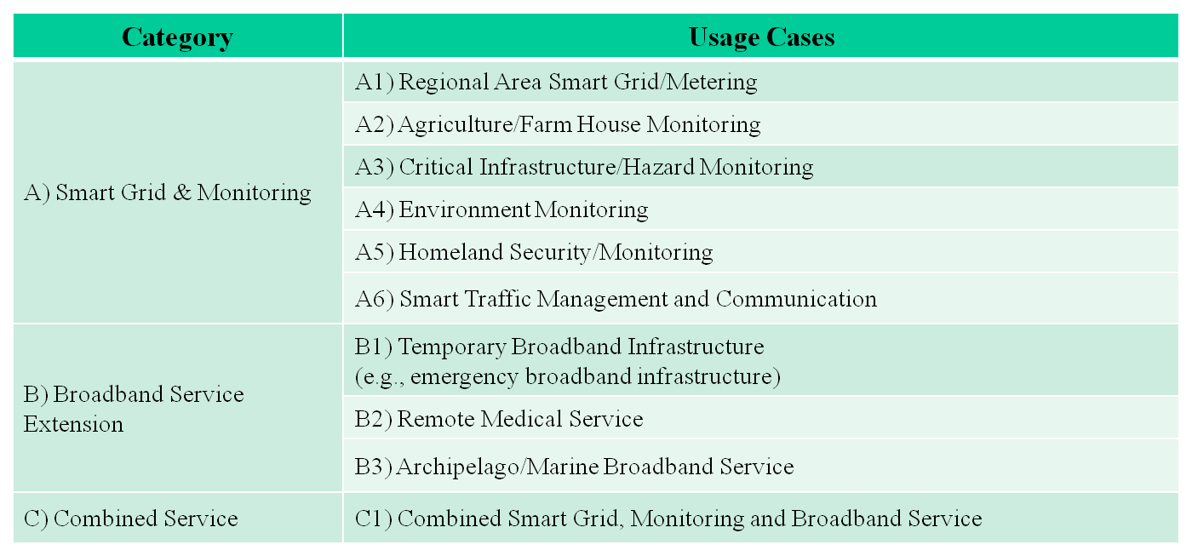

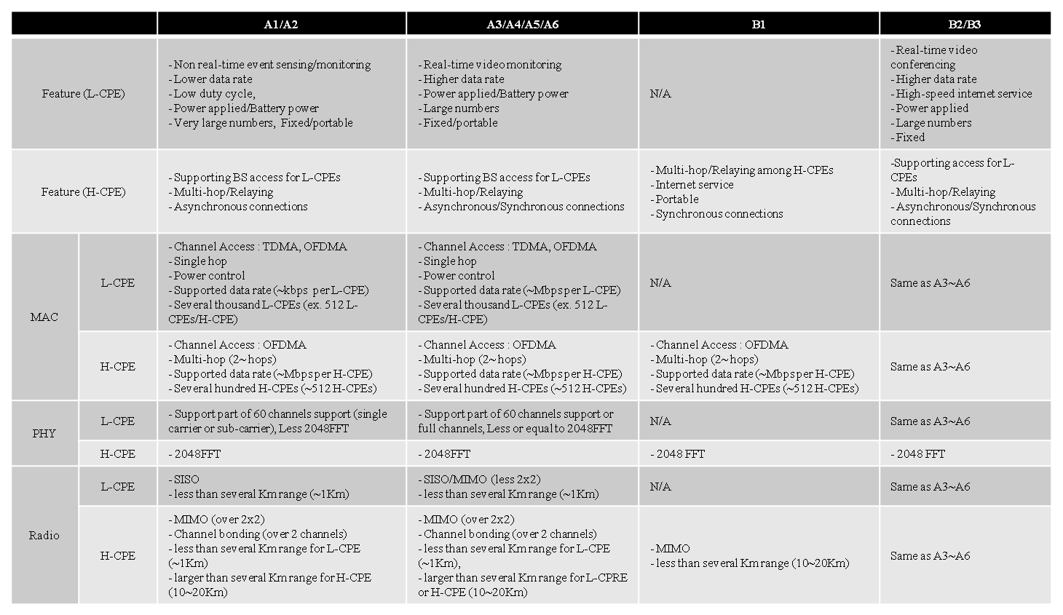

[Req04] This amendment should provide mechanisms of energy efficient operations, eg. Battery operated CPEs for monitoring applications.

- Number of devices
[Req05] This amendment shall support at least 2048 CPEs to cover a regional area network in some monitoring applications. For example, regional area smart grid/metering needs several thousands of L-CPEs.
.
- Network topology
[Req06] This amendment should support multi-hop connections within an WRAN network.
For example,
L-CPE <-> H-CPE <-> BS

[Req07] This amendment may support peer-to-peer communications between CPEs controlled by BS.
For example
H-CPE <-> H-CPE

- Real-time applications
[Req08] This amendment should support QoS mechanisms for real-time monitoring applications.

- Coexistence
[Req09] This amendment should support mechanisms to coexist with IEEE 802 other systems in the same band.

Security
[Req11] This amendment may provide enhancement to exsiting or alternate security mechanisms.
- Backward compatibility
[Req12] IEEE 802.22b BS should contain all the capabilities of the IEEE 802.22 BS, i.e., IEEE 802.22-2011 CPEs are able to communicate to IEEE 802.22b BS.

- Channelization
[Req13] This amendment should provide a means of channelization for cost-effective compliance with regulatory spectral mask.

4. Reference
1. IEEE P802.22b PAR in doc.: IEEE 802.22-yy/xxxxr004-rasg
2. IEEE P802.22b 5C in doc.: IEEE 802.22-yy/xxxxr00000-04-rasg
3. IEEE Std.802.22-2011
4. doc.: IEEE 802.22-yy/xxxxr0

Note

Antenna polarisation 
This must be specified as either horizontal polarisation, vertical polarisation, or slant (45 degrees) polarisation

A master WSD must communicate its technology identifier10 to a WSDB.

A master WSD must communicate its unique device identifier12 to a WSDB

3.18 After receiving instructions from a WSDB in relation to the maximum permitted EIRPs over the DTT channels, and prior to initiating transmissions within the UHF TV band, a master WSD must communicate to the WSDB the following information:

3.18.1 The lower and upper frequency boundaries13 of the in-block emissions of the master WSD, and those of the in-block emissions of its associated
slaves. A lower frequency will be specified as (470 + 8k + 0.2n) MHz, with the corresponding upper frequency specified as (470 + 8k + 0.2m) MHz, where 0 ≤ k ≤ 39, 0 ≤ n ≤ 39, 1 ≤ m ≤ 40, and n < m.

3.18.2 The maximum in-block EIRP spectral densities (in dBm/(0.2 MHz)) that the master WSD, and its associated slaves, actually radiate between each reported lower frequency boundary and its corresponding upper frequency boundary.

3.19 A master WSD must be able to receive the following information14 from a WSDB:
3.19.1 A list of lower and upper frequency boundaries15 within which the master WSD and its associated slave WSDs are authorised to operate A lower frequency will be specified as (470 + 8k + 0.2n) MHz, with the corresponding upper frequency specified as (470 + 8k + 0.2m) MHz, where 0 ≤ k ≤ 39, 0 ≤ n ≤ 39, 1 ≤ m ≤ 40, and n < m.
3.19.2 A maximum permitted master WSD EIRP spectral density, specified in units of dBm/(0.2 MHz), between each lower frequency boundary and its corresponding upper frequency boundary as described in 3.19.1.
3.19.3 A maximum permitted slave WSD EIRP spectral density, specified in units of dBm/(0.2 MHz), between each lower frequency boundary and its corresponding upper frequency boundary as described in 3.19.1.
3.19.4 A sensing level16 for the detection of DTT use of spectrum, specified in units of dBm/(8 MHz).
3.19.5 A sensing level16 (optional) for the detection of PMSE use of spectrum, specified in units of dBm/(0.2 MHz).
3.19.6 A single time validity for the parameters communicated by the WSDB as described in 3.19.1 to 3.19.5.
3.19.7 [Instruction for the master WSD and its associated slave WSDs to cease17 transmission within [x] seconds when instructed by the WSDB.]
3.19.8 [An acknowledgement from the WSDB, in the context of 3.18, that the reported information on the DTT channels and EIRP spectral densities actually used by the master and slave WSDs were received successfully by the WSDB18].

A master WSD must only transmit within the UHF TV band in accordance with the relevant instructions and parameters in 3.19 provided by an approved WSDB, and for a time period which does not exceed the time validity of those instructions and parameters.

3.23 A master WSD must meet the minimum adjacent channel leakage ratio19 (ACLR) values outlined in the table below.

3.24 [The maximum contiguous bandwidth of a master WSD must not exceed [x] MHz.]
3.25 [The maximum non-contiguous bandwidth of a master WSD must not exceed [x] MHz.]

3.27 Communications between a master WSD and a slave WSD for purposes of relaying WSDB-related instructions and parameters must employ secure protocols21 that avoid malicious corruption or unauthorized modification of the data.

4. 3 Communication between a slave WSD and a master WSD must not occur within the UHF TV band, unless the WSDs have already been authorised by a WSDB to radiate within the UHF TV band. (saying apuva contact to reza karimi explain the 802.22 operation)

4.4.6 A slave WSD may7 communicate its antenna height(s) above ground level to its serving master WSD.

4.5.2 Antenna polarisation  This must be specified as either horizontal polarisation, vertical polarisation, or slant (45 degrees) polarisation.

4.11 A slave WSD must be able to receive the following information28 from its serving master WSD:
4.11.1 An indication of the lower and upper frequency boundaries15 within which the slave WSD is authorised to operate.
4.11.2 A maximum permitted slave WSD EIRP spectral density, specified in units of dBm/(0.2 MHz), between each lower frequency boundary and its corresponding upper frequency boundary as described in 4.11.1.
4.11.3 A sensing level16 for the detection of DTT use of spectrum specified in units of dBm/(8 MHz).
4.11.4 A sensing level16 for the detection of PMSE use of spectrum, specified in units of dBm/(0.2 MHz).
4.11.5 A single time validity for the parameters communicated by the serving master WSD as described in 4.11.1 to 4.11.4.
4.11.6 [Instruction for the slave WSD to cease29 transmission within [x] seconds when instructed by a master WSD.]

4.8 A slave WSD must communicate its technology identifier25,26 to its serving master WSD.
4.9 [A slave WSD must communicate a unique device identifier27 to its serving master WSD.]

4.11 A slave WSD must be able to receive the following information28 from its serving master WSD:
4.11.1 An indication of the lower and upper frequency boundaries15 within which the slave WSD is authorised to operate.
4.11.2 A maximum permitted slave WSD EIRP spectral density, specified in units of dBm/(0.2 MHz), between each lower frequency boundary and its corresponding upper frequency boundary as described in 4.11.1.
4.11.3 A sensing level16 for the detection of DTT use of spectrum specified in units of dBm/(8 MHz).
4.11.4 A sensing level16 for the detection of PMSE use of spectrum, specified in units of dBm/(0.2 MHz).
4.11.5 A single time validity for the parameters communicated by the serving master WSD as described in 4.11.1 to 4.11.4.
4.11.6 [Instruction for the slave WSD to cease29 transmission within [x] seconds when instructed by a master WSD.]

A slave WSD may communicate with another slave WSD provided that each is controlled via communication over the UHF TV band31 by its serving master WSD. (some regurators may not accept to communication peer-to-peer)

4.15 A slave WSD must meet the minimum adjacent channel leakage ratio32 (ACLR) values outlined in the table below.

4.17 Portable/mobile slave WSDs, and non-geolocated fixed slave WSDs, must have antennas with gain not exceeding 2.15dBi33.

