IEEE P802.22
RF Mask Considerations
Date: 2011-11-10
Author(s):
Name | Company | Address | Phone | email
Gerald Chouinard | CRC | 3701 Carling Ave., Ottawa, Ontario, Canada K2H8S2 | 1-613-998-2500 | gerald.chouinard@crc.ca

Abstract
This document contains a review of the technical considerations for protecting DTV broadcasting taken in the process of developing the 802.22 Standard. In particular, RF mask characteristics for the WRAN transmissions needed to provide protection of DTV broadcast incumbents in the TV bands were considered as to their impact on the WRAN system design and as to their relationship to the susceptibility of the DTV receivers to the incoming interference from adjacent and alternate channels. At the end, it was concluded that the WRAN systems will likely have to adapt to whatever out-of-band emission requirements specified by the various regulatory domains and room was provided in the Annex A of the Standard to document the various RF masks that the WRAN systems will have to comply with in various regulatory domains.

Notice: This document has been prepared to assist IEEE 802.22. It is offered as a basis for discussion and is not binding on the contributing individual(s) or organization(s). The material in this document is subject to change in form and content after further study. The contributor(s) reserve(s) the right to add, amend or withdraw material contained herein.

Release: The contributor grants a free, irrevocable license to the IEEE to incorporate material contained in this contribution, and any modifications thereof, in the creation of an IEEE Standards publication; to copyright in the IEEE’s name any IEEE Standards publication even though it may include portions of this contribution; and at the IEEE’s sole discretion to permit others to reproduce in whole or in part the resulting IEEE Standards publication. The contributor also acknowledges and accepts that this contribution may be made public by IEEE 802.22.

Patent Policy and Procedures: The contributor is familiar with the IEEE 802 Patent Policy and Procedures
<http://standards.ieee.org/guides/bylaws/sb-bylaws.pdf>, including the statement "IEEE standards may include the known use of patent(s), including patent applications, provided the IEEE receives assurance from the patent holder or applicant with respect to patents essential for compliance with both mandatory and optional portions of the standard." Early disclosure to the Working Group of patent information that might be relevant to the standard is essential to reduce the possibility for delays in the development process and increase the likelihood that the draft publication will be approved for publication. Please notify the Chair <Apurva Mody> as early as possible, in written or electronic form, if patented technology (or technology under patent application) might be incorporated into a draft standard being developed within the IEEE 802.22 Working Group. If you have questions, contact the IEEE Patent Committee Administrator at <patcom@ieee.org>.

- Introduction

Protection of DTV broadcast incumbents in the TV White Space involves two key interference mechanisms:
  - the amount of out-of-band emission generated by the interfering device which falls into the channel selected by the DTV receiver.
  - the DTV receiver’s susceptibility to RF power present on channels adjacent, alternate or beyond to the selected channel resulting from the receiver’s channel limited selectivity’;

These two interference mechanisms were considered in the process of developing the 802.22 WRAN Standard in order to establish reasonable out-of-band emission rejection performance and protection ratios to provide protection of DTV broadcast operation. The two interference mechanisms were investigated and the results are reported in the two following section.

It became apparent, however that the 802.22 WG would not be able to specify its own performance requirements for the out-of-band emission nor for the level of susceptibility of the DTV receivers. In the first case, it is expected that each regulatory domain will have its own requirements based on the DTV Standard that they use and the way the DTV technology is deployed. In the second case, the performance of the DTV receivers as to their susceptibility to interference on adjacent, alternate and beyond channels has been determined and agreed upon by DTV receiver manufactures and is not something that can be changed easily.

It was therefore concluded that the 802.22 WRAN systems will have to adjust to these various requirements and that there will likely be various emission RF masks that the 802.22 WRAN transmissions will need to comply with. Annex A of the Standard has therefore been developed as the repository of these various regulatory domain dependent requirements that the 802.22 WRAN systems will have to comply. So far, it contains two specified RF masks for the USA and Canada. It is expected that more will be included as other regulatory domains specify their requirements.

Never-the-less, it was felt the it would be useful to describe the various considerations that need to be taken into account in the development of the criteria to be used for protecting DTV broadcast operation from 802.22 WRAN transmissions and this is explained in the following sections.

- WSD out-of-band emission performance requirements

The 802.22 WRAN Standard has not determined specific out-of-band emission requirements for the WRAN devices. The approach that was taken was that the devices would need to meet the RF Masks specified for the different Regulatory Domains. Annex A of the 802.22 Standard included the two TV White Space RF Mask specified so far, i.e., the USA FCC Mask and the Canadian RRBS Mask (Figures 1 and 2 below).

Figure 1: WSD transmission RF mask for the USA

Figure 2 RRBS transmission RF Mask for Canada

Notwithstand the fact that the 802.22 Working Group decided to rely on the different Regulatory Domains to specify their out-of-band emission requirements, the Group investigated the feasibility of various RF Masks with respect to the PHY parameters included in the Standard. Here is a set of Figures that were developed as part of this investigation.

Since the White Space Devices (WSDs) will need to be frequency agile, no channel filtering can be assumed in practice at the output of the RF power amplifier (PA). The main problem will then be to keep the spectrum re-growth level resulting from any non-linearity in the PA to a decent level. A relaxation of the FCC Mask to ease the requirement in meeting the demanding first inner corners (+/-3 MHz from the channel center) was considered as shown in Figure 3. Note that the superposed blue and green curves represent the results of computer simulations for a typical 802.22 WRAN signal passed through a PA at two different output backoff levels and show some practical considerations in determining realistic mask requirements. The conditions under which the computer simulations were carried out for the PA non-linearity are described in document: 22-08-0111-05-0000-spectral-mask-implications.ppt, available from the 802.22 documents repository < https://mentor.ieee.org/802.22/documents>.

As can be shown in Figure 3, the shape of such spectrum re-growth in not very friendly with a plateau approach for the RF Mask. Since it has been established from experimental evidence that the impact of an interfering signal onto DTV is related to the total amount of power falling into the channel bandwidth, except in cases of very narrowband interferers (<100 kHz), the equivalent power level was calculated for the proposed sloped segment and is shown in Figure 3 with the dotted line at 40 dB rejection relative to the in-channel power density.

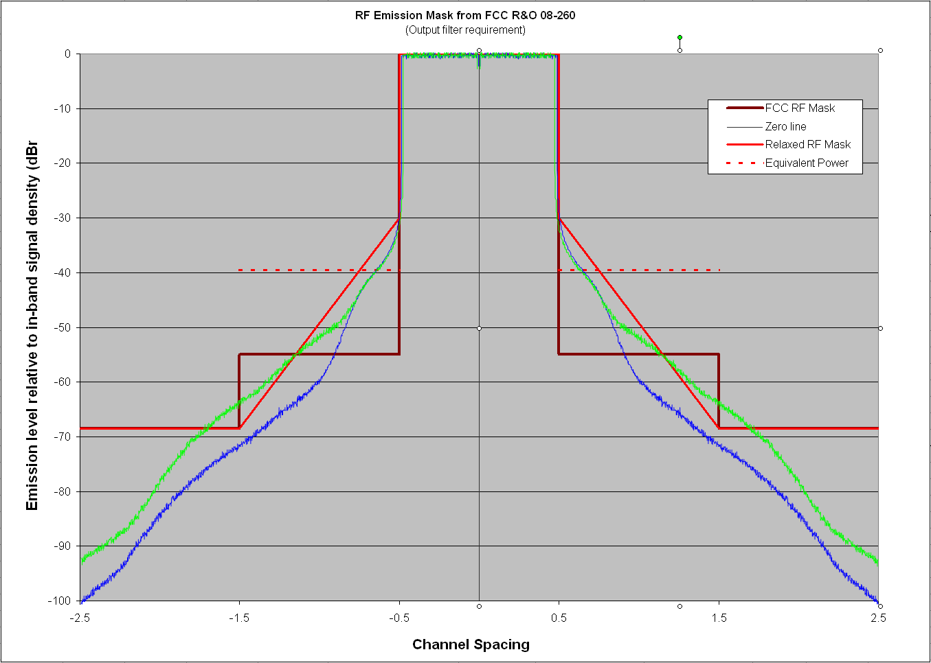
Figure 3: US FCC RF Mask for a 4 Watt WSD compared to simulated RF power amplifier out-of-band emission performance and a sloped RF Mask that would be easier to meet
(Green: 7.7 dB PA output backoff, Blue: 9.7 dB PA output backoff)

This is the reason why a sloped approach was used in developing the Canadian Mask for Remote Rural Broadband Systems (RRBS) as shown in Figure 4. Some relaxation of the out-of-band rejection requirement took place in the N+/-1 and N+/-2 channels for 4 Watt fixed installations since operation on these channels is not allowed in Canada because of the limitation in the DTV receiver susceptibility to interference (see section 4 on the EIRP profile). Note that the equivalent flat power levels falling in each channel for the sloped segments are indicated with the dotted lines in Figure 4 similar to what is shown in Figure 3.

Since it was decided to not allow operation in channels N+/-1 and N+/-2 in Canada because of the poor performance of the DTV receivers (see section 4 on the EIRP profile), the RF Mask in these adjacent channels (N+/-1 and N+/_2) was not be dictated by the amount of power falling in the channels selected by the DTV receivers in these cases since such case would not be allowed to occur by definition. The RF Mask should then be dictated by potential interference to other incumbent systems such as PMSE or other license-exempt systems. It is interesting to note that in the USA, operation on N+/-1for fixed and portable WSDs utilizing EIRP larger than 40 mW is not allowed in the FCC R&O 08-260 while these devices have still been required to meet the tight 72.8 dBc (i.e., 55 dBr) FCC RF Mask. The 55 dBr requirement really makes sense for portable devices operating at less than 40 mW EIRP since these devices are allowed to operate on N+/-1 but not the devices operating above 40 mW.

Figure 4: Canadian RRBS RF Mask compared to the FCC Mask for a 4 Watt WSD and simulated RF power amplifier out-of-band emission performance (Green: 7.7 dB PA output backoff, Blue: 9.7 dB PA output backoff)
(Note: the red dotted line represents the equivalent power level per channel for the Canadian Mask)

- Meeting the RF mask

When consideration is given to practical ways to meet a tight RF mask, there will likely be two approaches that the industry will adopt. One is to declare operation in more than one channel to accommodate sufficiently wide transition bands for the required reduction in out-of-band emission. For example, with one TV channel used for the transmitted signal as shown in Figure 4, a WSD operator may declare that he needs 3 contiguous TV channels so that his out-of-band emission rejection level meets the requirement. Another way will be for the WSD operator to reduce the effective bandwidth of his transmitted signal in the channel to allow for sufficient transition band on both sides to achieve the necessary out-of-band rejection at the edge of the channel. This is illustrated in Figure 5.

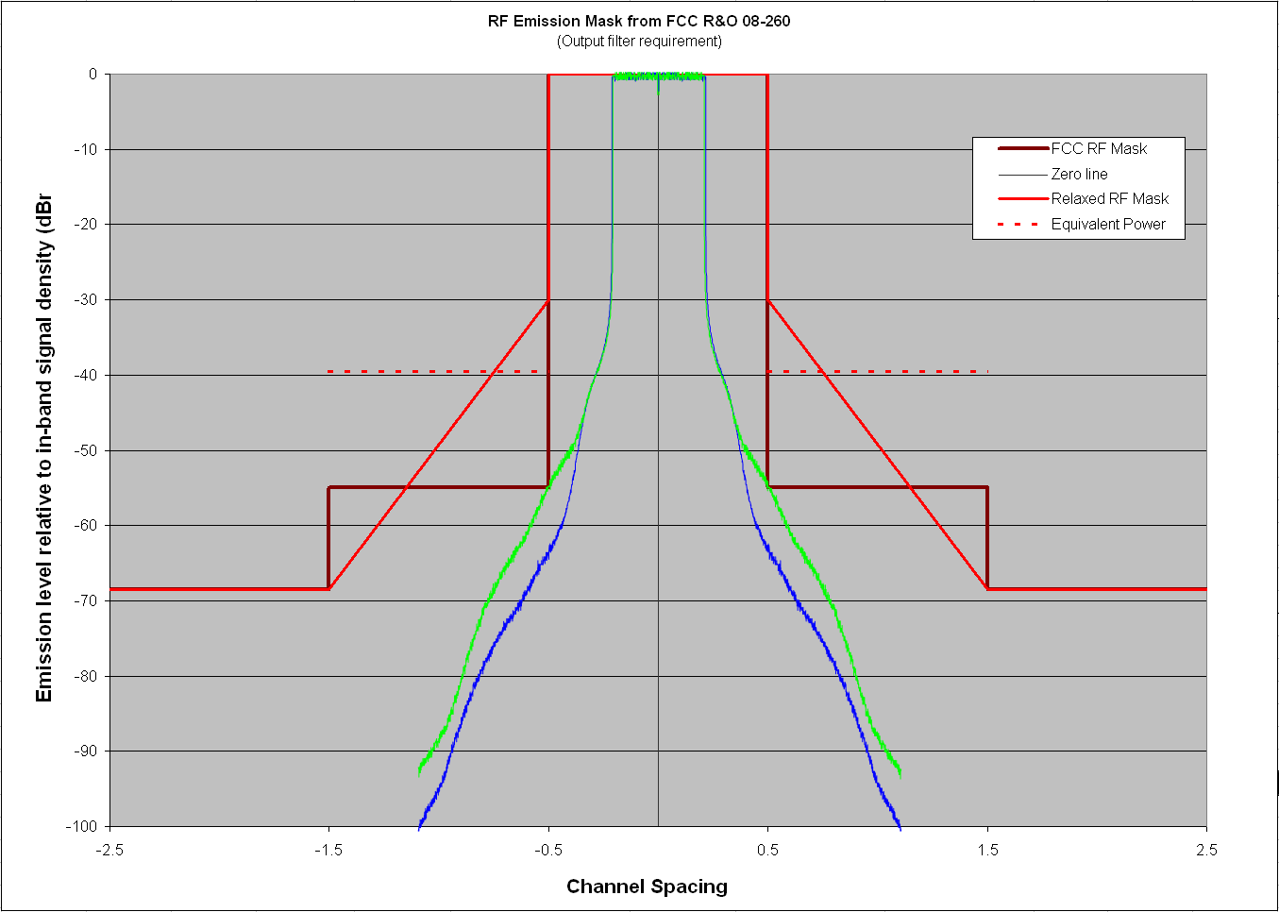
Figure 5: Reduction of the effective signal bandwidth to meet the out-of-band rejection requirement (Green: 7.7 dB PA output backoff, Blue: 9.7 dB PA output backoff)

In either case, this results in a reduced efficiency in the use of the spectrum. A proper balance therefore needs to be found between realistic out-of-band emission rejection and efficient use of the spectrum.

- DTV receiver susceptibility to interference

In dealing with the protection of DTV incumbents, the 802.22 WG identified, early in the process, the concept of the EIRP profile which documents the selectivity performance of the DTV receivers as a function of the maximum EIRP that a WSD can use at a reference minimum separation distance from a DTV receiver. The selectivity performance is directly related to the filtering and linearity performance of the DTV receiver which can be established through laboratory measurements. This has been documented and accepted as a performance goal by the DTV receiver industry through the Advanced Television Systems Committee (ATSC) (see ATSC A/74 Receiver Performance Guidelines.

The EIRP profile, as depicted in Figure 6, allows the representation of the DTV receiver selectivity performance in a practical system context. It represents the maximum EIRP that can be used by a WSD operating at a reference separation distance from a DTV receiver located at the edge of the coverage (i.e., at the noise-limited contour, -41 dBu in North America), and this, as a function of the channel separation between the channels on which the DTV receiver is trying to receive the DTV signal and the channel on which the WSD would be transmitting.

The assumptions for the calculation of the EIRP profile are that the WSD would be mounted outdoor at 18 m from the antenna of the DTV receiving installation (re: FCC R&O 08-160, Para.174) and would be line-of-sight. The worst case is depicted in orange in Figure 6 where both antennas are aimed toward each other (+/-30 degrees since the typical main beam width will be around 60 degrees at these frequencies). The green line represent represents the case where one of the two antennas is aimed away from the other antenna, providing a 14 dB backlobe rejection or, the two antennas are still aimed at each other but they are cross-polar to each other (e.g., the DTV antenna uses horizontal polarization while the WSD antenna uses vertical polarization), providing for 14 dB cross-polar isolation. Note that in the case of N and N+/-1, the WSD antenna and the DTV receive antenna are both assumed to be pointing away from each other since the WSD has to be, by definition, outside of the noise-protected contour.

Figure 6: EIRP profile representing the maximum EIRP that a WSD can use before producing excessive interference due to signal leakage into the desired channel at the DTV receiver as a result of the limited receiver filtering performance for various channel separations (separation distance= 18 m).

If the incumbent database is to produce the maximum EIRP that a WSD can use on specific channels at a specified location, the concept of EIRP profile that was developed by 802.22 can become very handy. Such EIRP profile can then be programmed in the algorithms that would be used in this database for the calculation of the maximum EIRP per TV channel. The database would need to concatenate the requirements for all DTV channels occupied in a given location, producing a compound EIRP profile that would include all constraints on the WSD maximum EIRP in the given location as shown in Figure 7.

Figure 2: Example of a concatenation of EIRP profiles resulting from the presence of multiple DTV channel in the area

The best approach for an optimum solution for specifying a reasonable RF Mask seems to be when a balance between the DTV receiver susceptibility to interference and the level of out-of-band rejection at the WSD is achieved fro the channel separations where the WSD is allowed to operate as conceptually illustrated in Figure 9 for the ATSC DTV system. This is the approach that was taken in developing the Canadian RRBS Mask where relaxation of the RF mask was allowed in N+/-1 and N+/-2 where the WSD are not allowed to operate, but where the proper balance between DTV receiver susceptibility and WSD out-of-band rejection was achieved as much a possible.

Figure 9: Achieving a balance between the DTV receiver interference susceptibility (left) and the WSD out-of-band emission requirement (right)

______________________

