IEEE P802.22
RF Mask Considerations
Date: 2011-11-04
Author(s):
Name | Company | Address | Phone | email
Gerald Chouinard | CRC | 3701 Carling Ave., Ottawa, Ontario, Canada K2H8S2 | 1-613-998-2500 | gerald.chouinard@crc.ca

Abstract
This document contains a review of the RF mask characteristics that would be needed to provide protection of DTV broadcast incumbents in the TV bands and the way such performance should be derived for the 802.22 WRAN systems for operation in TV White Space.

Notice: This document has been prepared to assist IEEE 802.22. It is offered as a basis for discussion and is not binding on the contributing individual(s) or organization(s). The material in this document is subject to change in form and content after further study. The contributor(s) reserve(s) the right to add, amend or withdraw material contained herein.

Release: The contributor grants a free, irrevocable license to the IEEE to incorporate material contained in this contribution, and any modifications thereof, in the creation of an IEEE Standards publication; to copyright in the IEEE’s name any IEEE Standards publication even though it may include portions of this contribution; and at the IEEE’s sole discretion to permit others to reproduce in whole or in part the resulting IEEE Standards publication. The contributor also acknowledges and accepts that this contribution may be made public by IEEE 802.22.

Patent Policy and Procedures: The contributor is familiar with the IEEE 802 Patent Policy and Procedures
<http://standards.ieee.org/guides/bylaws/sb-bylaws.pdf>, including the statement "IEEE standards may include the known use of patent(s), including patent applications, provided the IEEE receives assurance from the patent holder or applicant with respect to patents essential for compliance with both mandatory and optional portions of the standard." Early disclosure to the Working Group of patent information that might be relevant to the standard is essential to reduce the possibility for delays in the development process and increase the likelihood that the draft publication will be approved for publication. Please notify the Chair <Apurva Mody> as early as possible, in written or electronic form, if patented technology (or technology under patent application) might be incorporated into a draft standard being developed within the IEEE 802.22 Working Group. If you have questions, contact the IEEE Patent Committee Administrator at <patcom@ieee.org>.

- Introduction

Protection of DTV broadcast incumbents in the TV White Space involves two key interference mechanisms:
  - the DTV receiver’s susceptibility to RF power received on channels adjacent to the selected channel resulting from the victim’s adjacent channel limited selectivity’;
  - the amount of out-of-band emission generated by the interfering device which falls into the channel selected by the DTV receiver.

These two aspects will be dealt with below.

- DTV receiver susceptibility to interference

In dealing with the protection of DTV incumbents, the 802.22 WG identified, early in the process, the concept of the EIRP profile which documents the selectivity performance of the DTV receivers as a function of the maximum EIRP that a WSD can use at a reference minimum separation distance from a DTV receiver. The following Figure 1 depicts the EIRP profile that results from the performance of a generic ATSC DTV receiver as established by the ATSC A/74 Receiver Performance Guidelines, scaled for DTV reception at the edge of coverage (41 dBu) and for a reference minimum separation distance of 10 m.

Figure 1: EIRP profile representing the maximum EIRP that a WSD can use before producing excessive interference due to signal leakage into the desired channel at the DTV receiver as a result of the limited receiver filtering performance for various channel separations (maximum EIRP= 4 W, separation distance= 10m).

If the incumbent database is to produce the maximum EIRP that a WSD can use on specific channels at a specified location, the concept of EIRP profile can become very handy. Such EIRP profile can then be programmed in the algorithms that would be used in this database for the calculation of the maximum EIRP per TV channel. The database would need to concatenate the requirements for all DTV channels occupied in a given location, producing a compound EIRP profile that would include all constraints on the WSD maximum EIRP in the given location as shown in Figure 2.

Figure 2: Example of a concatenation of EIRP profiles resulting from the presence of multiple DTV channel in the area

- WSD out-of-band emission performance requirements

The 802.22 WRAN Standard has not determined specific out-of-band emission requirements for the WRAN devices. The approach that was taken was that the devices would need to meet the RF Masks specified for the different Regulatory Domains. Annex A of the 802.22 Standard included the two TV White Space RF Mask specified so far, i.e., the USA FCC Mask and the Canadian RRBS Mask (Figures 3 and 4 below).

Figure 3: WSD transmission RF mask for the USA

Figure 4 RRBS transmission RF Mask for Canada

Notwithstand the fact that the 802.22 Working Group decided to rely on the different Regulatory Domains to specify their out-of-band emission requirements, the Group investigated the feasibility of various RF Masks with respect to the PHY parameters included in the Standard. Here is a set of Figures that were developed to investigate this issue.

Figure 5: Comparison between the FCC Mask for 100 mW portable WSD, the FCC DTV Mask and the 802.16 Mask (Note the brown dotted line indicating the 1 dB DTV receiver desensitization in North America at 41 dBu)

A relaxation of the FCC Mask to ease the requirement in meeting the demanding first inner corners was considered as shown in Figure 6. Note that since the WSDs will need to be frequency agile, no channel filtering will be possible in practice at the output of the RF power amplifier (PA). The main problem will then be to keep the spectrum re-growth level resulting from any non-linearity in the PA to a decent level. The blue and green curves representing the results of computer simulations of a typical 802.22 WRAN signal passed through a PA at two different output backoff levels were superimposed to the graph to show practical considerations in determining the TF mask requirements. The conditions under which the computer simulations were carried out for the PA non-linearity are described in document: 22-08-0111-05-0000-spectral-mask-implications.ppt, available from the 802.22 documents repository < https://mentor.ieee.org/802.22/documents>. As can be shown in Figure 6, the shape of such spectrum re-growth in not very friendly with a plateau approach for the RF Mask. Since it has been established from experimental evidence that the impact of an interfering signal onto DTV is related to the total amount of power falling into the channel bandwidth, except in cases of very narrowband interferers, the equivalent power level was calculated for the sloped segment and is shown in Figure 6 with the dotted line.

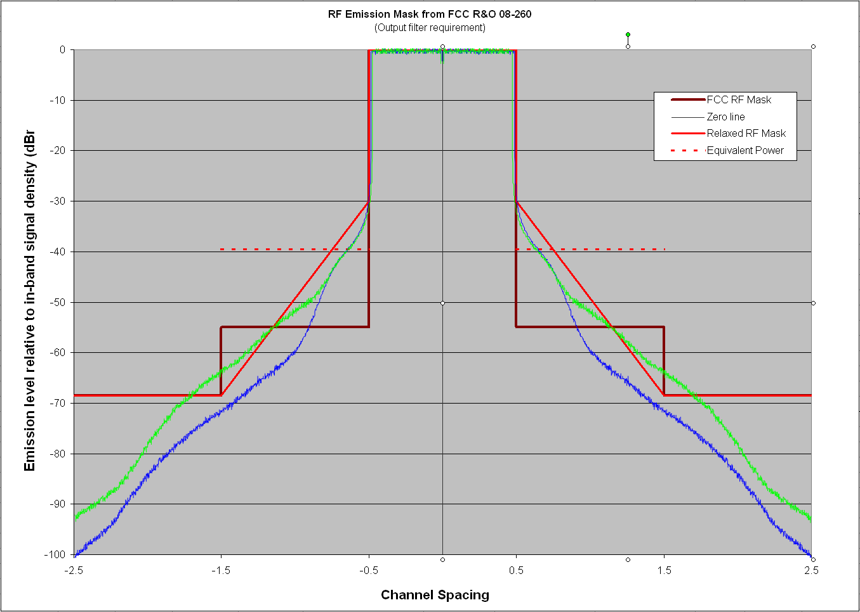
Figure 6: US FCC RF Mask for a 4 Watt WSD compared to simulated RF power amplifier out-of-band emission performance and a sloped RF Mask that would be easier to meet
(Green: 7.7 dB PA output backoff, Blue: 9.7 dB PA output backoff)

This is the reason why a sloped approach was used in developing the Canadian Mask for Remote Rural Broadband Systems (RRBS) as shown in Figure 7. Relaxation of the out-of-band rejection requirement took place in the N+/-1 and N+/-2 channels for 4 Watt fixed installations since operation on these channels is not allowed in any case because of the limitation in the DTV receiver susceptibility to interference (see section 2 on the EIRP profile). Note that the equivalent power levels falling in each channel for the sloped segments are indicated with the dotted lines in Figure 7.

In such case, the RF Mask in these adjacent channels (N+/-1 and N+/_2) should not be dictated by the amount of power falling in the channels selected by the DTV receivers since such case would not be allowed to occur. The RF Mask should then be dictated by potential interference to other incumbent systems such as PMSE or other license-exempt systems. It is interesting to note that in the USA, operation on N+/-1for fixed and portable WSDs utilizing EIRP larger than 40 mW is not allowed in the FCC R&O 08-260 while these devices have still been required to meet the tight 72.8 dBc (i.e., 55 dBr) FCC RF Mask. The 55 dBr requirement really makes sense for portable devices operating at less than 40 mW EIRP since these devices are allowed to operate on N+/-1.

Figure 7: Canadian RRBS RF Mask compared to the FCC Mask for a 4 Watt WSD and simulated RF power amplifier out-of-band emission performance (Green: 7.7 dB PA output backoff, Blue: 9.7 dB PA output backoff)
(Note: the red dotted line represents the equivalent power level per channel for the Canadian Mask)

When consideration is given to practical ways to meet a tight RF mask, there will likely be two ways that the industry could go about it. One is to declare operation in more than one channel to accommodate sufficiently wide transition bands for the required reduction in out-of-band emission. For example, with one TV channel used for the transmitted signal, a WSD operator may declare that he needs 3 contiguous TV channels so that his out-of-band emission rejection level meets the requirement. Another way is for the WSD operator to reduce the effective bandwidth of his transmitted signal in the channel to allow sufficient out-of-band rejection at the edge of the channel. This is illustrated in Figure 8.

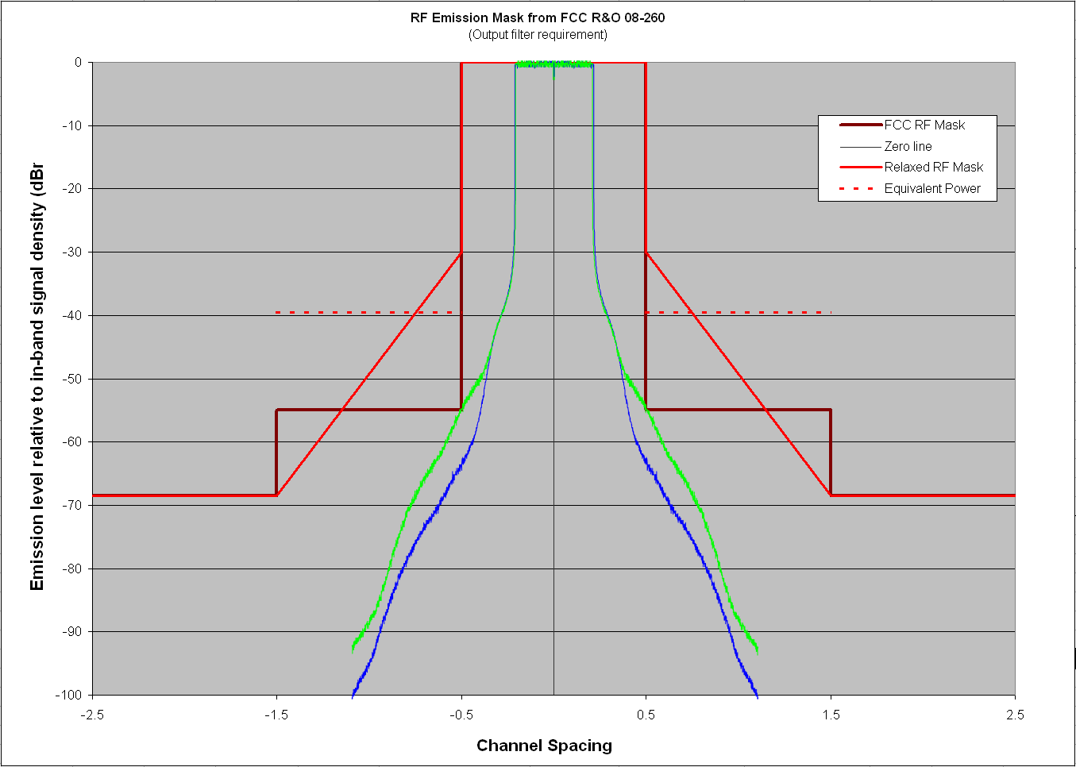
Figure 8: Reduction of the effective signal bandwidth to meet the out-of-band rejection requirement (Green: 7.7 dB PA output backoff, Blue: 9.7 dB PA output backoff)

Either way, this means reduced efficiency in spectrum use. The best approach for an optimum solution for specifying a reasonable RF Mask seems to be when a balance between the DTV receiver susceptibility to interference and the level of out-of-band rejection at the WSD is achieved as conceptually illustrated in Figure 9 for the ATSC DTV systems. This is the approach that was taken in developing the Canadian RRBS Mask.

Figure 9: Achieving a balance between the DTV receiver interference susceptibility (left) and the WSD out-of-band emission requirement (right)

