IEEE P802.22
Wireless RANs
Proposed resolution to comment no. 257: Part 1-Sensing methods for PAL and Other Analog TVs
Date: 2011-02-09
Author(s):
Name | Company | Address | Phone | email
M. Azizur Rahman | NICT | 3-4 Hikari no oka, Yokosuka, Kanagawa, Japan | +81-46-847-5060 | aziz@nict.go.jp
Chunyi Song | NICT | 3-4 Hikari no oka, Yokosuka, Kanagawa, Japan
Hiroshi Harada | NICT | 3-4 Hikari no oka, Yokosuka, Kanagawa, Japan
Abstract
This document presents spectrum sensing methods for PAL TV signals to partially resolve comment number 257 as listed in P802.22 D1 Sponsor Ballot Comments Database, IEEE 802.22-11-2r5.
Notice: This document has been prepared to assist IEEE 802.22. It is offered as a basis for discussion and is not binding on the contributing individual(s) or organization(s). The material in this document is subject to change in form and content after further study. The contributor(s) reserve(s) the right to add, amend or withdraw material contained herein.

Release: The contributor grants a free, irrevocable license to the IEEE to incorporate material contained in this contribution, and any modifications thereof, in the creation of an IEEE Standards publication; to copyright in the IEEE’s name any IEEE Standards publication even though it may include portions of this contribution; and at the IEEE’s sole discretion to permit others to reproduce in whole or in part the resulting IEEE Standards publication. The contributor also acknowledges and accepts that this contribution may be made public by IEEE 802.22.

Patent Policy and Procedures: The contributor is familiar with the IEEE 802 Patent Policy and Procedures
<http://standards.ieee.org/guides/bylaws/sb-bylaws.pdf>, including the statement "IEEE standards may include the known use of patent(s), including patent applications, provided the IEEE receives assurance from the patent holder or applicant with respect to patents essential for compliance with both mandatory and optional portions of the standard." Early disclosure to the Working Group of patent information that might be relevant to the standard is essential to reduce the possibility for delays in the development process and increase the likelihood that the draft publication will be approved for publication. Please notify the Chair Apurva Mody <apurva.mody@ieee.org> as early as possible, in written or electronic form, if patented technology (or technology under patent application) might be incorporated into a draft standard being developed within the IEEE 802.22 Working Group. If you have questions, contact the IEEE Patent Committee Administrator at <patcom@ieee.org>.

The Comment

No good sensing techniques are seen for DVB-T, PAL and NTSC. We cannot neglect analog TVs, as those continue to be used in many countries.

Add easily implementable techniques for DVB-T, PAL, and NTSC. Actually, the energy detection method itself is not good enough in many cases. Modification may be needed to improve its performance. If needed, such contributions can be supplied from the commenter.

Proposed Resolution Part 1:

We propose the following text, equations and figures regarding analog TV signal sensing be added in Annex C of P802.22 D1 to partially resolve the comment.

- Time Domain Correlation Based Method (CBM) for Sensing Analog TV Signals

  - Analog TV Signals Basics

In analog TV technology, moving pictures are produced by scanning horizontal lines (625 for all varities of PAL, except PAL-M and SECAM, 525 for NTSC and PAL-M) and showing those in two fields. Each horizontal line has duration of 64 microseconds in all varities of PAL except PAL-M and SECAM, 63.49 microseconds in PAL-M, and 63.56 microseconds in NTSC. In most of the standards, all except 25 lines per field contain video signal and are composed of several segments as shown in Fig. 1. It includes a horz sync pulse that has the highest amplitude normalized to unity or 100%. In the receiver, this helps synchronization and decoding of each line video signal (luminance and chrominance signals) that follows it. The luminance signal (also called Y signal, the black and white video signal) can vary within 0% to 75%. PAL and SECAM signals are usually channelized in 7 or 8 MHz channel and NTSC signals are usually channelized in a 6 MHz channel.

  - The Sensing System and Method

Fig. 2 shows a block diagram of the sensing system described in this section. The boxes shown in dashed line are optional. The procedure of the sensing technique has the following steps:
- The analog TV signal enters the radio frequency front end, which is then passed through a narrowband filter, if any, centered at the luminance or Y signal of the channel
- The signal is converted to baseband if the sensor is equipped with such a block, otherwise intermediate frequency conversion is performed
- The down converted signal is sampled and analog to digital converted
- Time offset is estimated and corrected if supported by hardware. This may be followed by frequency offset estimation and correction.
- The sampled data is correlated with a prior-stored reference template signal, for example, as shown in Fig. 3, which matches with the horz sync pulse. Since, video signal is unknown, mid value is used as reference for that segment. The data before and after correlation are stored in a buffer.
- Average the correlation outputs or select the maximum of the correlation outputs, if correlation is performed more than once.
- Detect based on a predefined threshold as decided following the above mentioned steps in the absence of any signal input.

  - Sensing Performance

The algorithms were tested by computer simulations and hardware implementations for PAL signal detection. In simulation studies, the PAL signal was simulated according to [2]. AWGN channel was considered. Fig. 4 shows the simulated receiver operating curves (P_D vs P_FA) for time and phase asynchronous CBM method. The baseband conversion was considered, however, narrowband filter wasn’t used. Sampling was done at 100 MHz. The figure shows that averaging over 2 correlations over two arbitrary horizontal lines suffices to fulfil the requirement (P_FA=0.1 and P_D=0.9) for SNR= -18 dB. Averaging over 4 lines meets similar requirements for SNR= -25 dB. The minimum sensing time is 128 microseconds for the former and 256 microseconds for the latter case. Fig. 5 shows the performance of the algorithm implemented in hardware while detecting -120 dBm PAL signal input from a signal generator, in a 8MHz channel (SNR=-15 dB without considering the noise figure). The narrowband filtering, baseband conversion operations were not realized. Time and phase asynchronous CBM method was utilized. Sampling frequency was 64 MHz on a signal down converted to intermediate frequency of 70 MHz, implying effective center frequency of 6 MHz of the sampled data. Two variants of the CBM method were used, where detection was performed based on the average of the correlation outputs or the maximum correlation output among 32 trials (lines). Both the variants show robust sensing capability in such level. However, as the sensing level becomes much lower, due to the sharp nature of the curves obtained from average CBM, it might have an edge over the maximum selection CBM. Note that performing 32 correlations means a minimum sensing duration of about 2 milliseconds. However since all the horizontal lines do not contain video, the sensing reliability may be improved by performing a predefined number of correlations scattered over frame duration. To decrease sensing time considerably, using a narrowband filter having a center frequency at the luminance signal or Y signal of the channel would help.

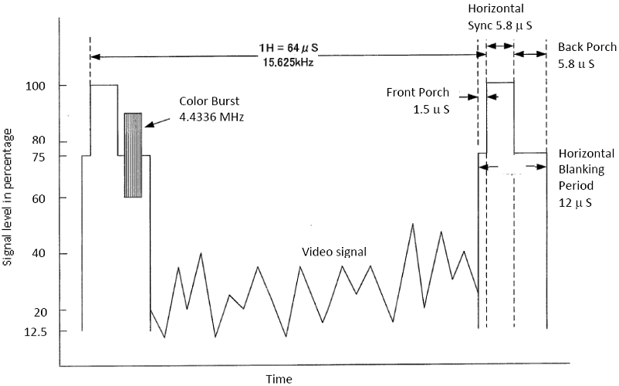

Fig. 1 Components of a PAL TV signal horizontal line.

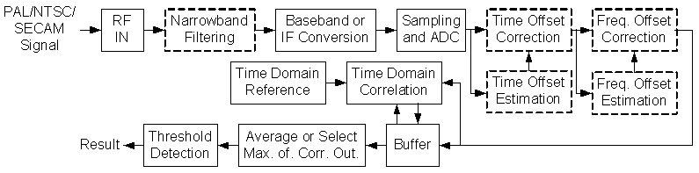

Fig. 2 Block diagram of analog TV signal sensing system.

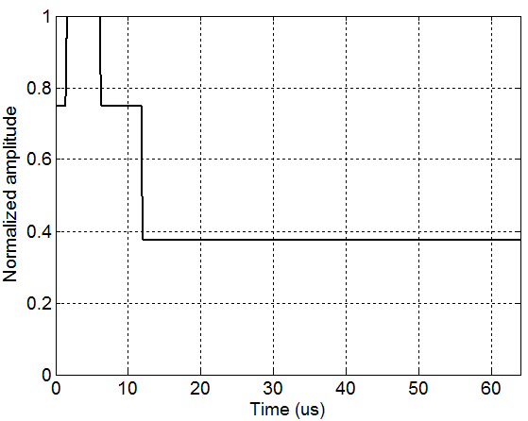

Fig. 3 Baseband equivalent of the reference template for analog TV signal sensing based on CBM.

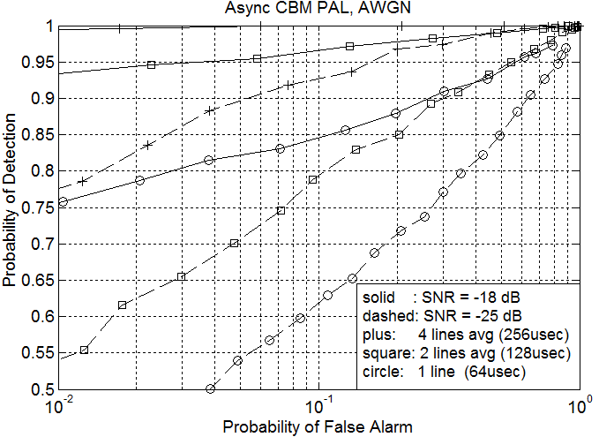
Fig. 4 Simulations: Probability of detection vs. probability of false alarm of PAL Sensing in AWGN channel based on CBM.

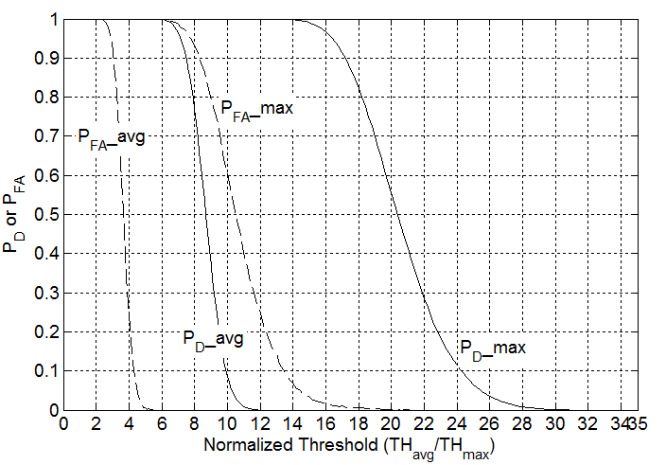
Fig. 5 Hardware Performance: Probability of detection and probability of false alarm vs. normalized threshold for sensing -120 dBm/8MHz (or SNR = -15 dB excluding noise figure) PAL TV signal.

- Improved Energy Detection Method for Sensing Analog TV Signals

Fig. 6 shows a block diagram of the sensing system described in this section. The procedure of the sensing technique is as follows:
- The analog TV signal enters the radio frequency front end, which is then passed through a narrowband filter centered at the luminance or Y signal of the channel.
- The filtered signal is sampled and analog to digital converted, squared and summed, and detection is performed based on a predefined threshold.
As seen in Fig. 7, an SNR gain of around 10 dB can be obtained, if a 300 kHz filter is used centering the Y signal.

Fig. 6 Improved energy detection method for analog TV detection.

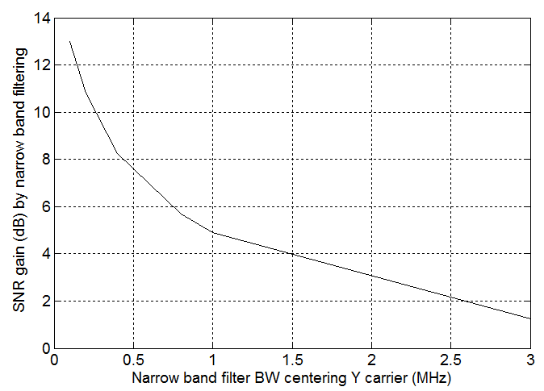

Fig. 7 Simulation: SNR gain by using a narrow band filter centering Y carrier of PAL signal.

References:
- M. A. Rahman, C. Song and H. Harada, "Spectrum Sensing and Detection of PAL TV Signals" IEICE Technical Report, SR2010-64, pp. 169-176, Oct. 29, 2010.
- ITU-R, “Coventional television systems,” BT.470.5.

