IEEE P802.22
Wireless RANs
Replacing CHO-UDP with IDC-UDP: proposed resolution for comments 220, 317 and 318
Date: 2010-08-12
Author(s):
Name | Company | Address | Phone | email
Gerald Chouinard | CRC | 3701 Carling Ave., Ottawa, Ontario, Canada K2H8S2 | 1-613-998-2500 | gerald.chouinard@crc.ca
Abstract
This contribution contains a proposal for resolving the above listed comments. A number of changes are needed to completely replace the CHO-UPD approach by the IDC-UPD approach based on the assumption that only a limited knowledge of the channel sets is needed at the CPE.

Although the channels sets defined for the SM at the BS is more extensive as explained in Clause 9, the only channel sets needed at the CPE will be:
- the operating channel, the current channel on which the CPE operates;
- the list of incumbent disallowed channels from the IDC-UPD message to speed up the sensing process; and
- the backup/candidate channel list periodically updated by the DCD so that the SSA knows which channels it has to 'clear' and in what order.

As a result, the scope of the CHO-UPD has been reduced and replaced by IDC-UPD message. The proposed modifications to the 802.22 Draft are given in the following pages.
Notice: This document has been prepared to assist IEEE 802.22. It is offered as a basis for discussion and is not binding on the contributing individual(s) or organization(s). The material in this document is subject to change in form and content after further study. The contributor(s) reserve(s) the right to add, amend or withdraw material contained herein.

Release: The contributor grants a free, irrevocable license to the IEEE to incorporate material contained in this contribution, and any modifications thereof, in the creation of an IEEE Standards publication; to copyright in the IEEE’s name any IEEE Standards publication even though it may include portions of this contribution; and at the IEEE’s sole discretion to permit others to reproduce in whole or in part the resulting IEEE Standards publication. The contributor also acknowledges and accepts that this contribution may be made public by IEEE 802.22.

Patent Policy and Procedures: The contributor is familiar with the IEEE 802 Patent Policy and Procedures
<http://standards.ieee.org/guides/bylaws/sb-bylaws.pdf>, including the statement "IEEE standards may include the known use of patent(s), including patent applications, provided the IEEE receives assurance from the patent holder or applicant with respect to patents essential for compliance with both mandatory and optional portions of the standard." Early disclosure to the Working Group of patent information that might be relevant to the standard is essential to reduce the possibility for delays in the development process and increase the likelihood that the draft publication will be approved for publication. Please notify the Chair <Apurva Mody> as early as possible, in written or electronic form, if patented technology (or technology under patent application) might be incorporated into a draft standard being developed within the IEEE 802.22 Working Group. If you have questions, contact the IEEE Patent Committee Administrator at <patcom@ieee.org>.
1. Modify sub-clause 6.10.20.7 as follows:

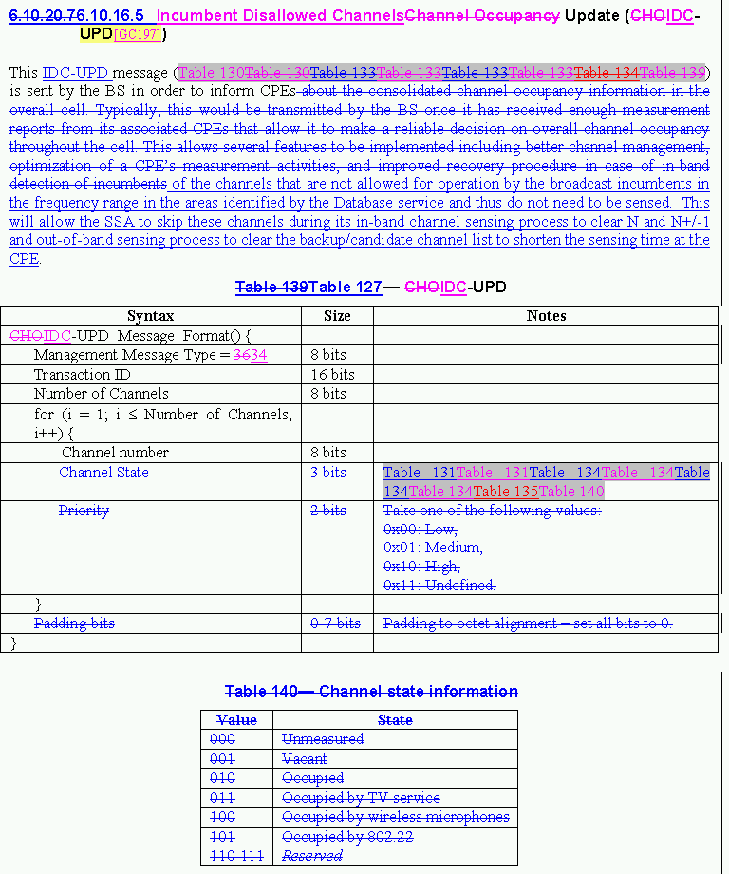

2. Modify section 6.25.1 as follows:

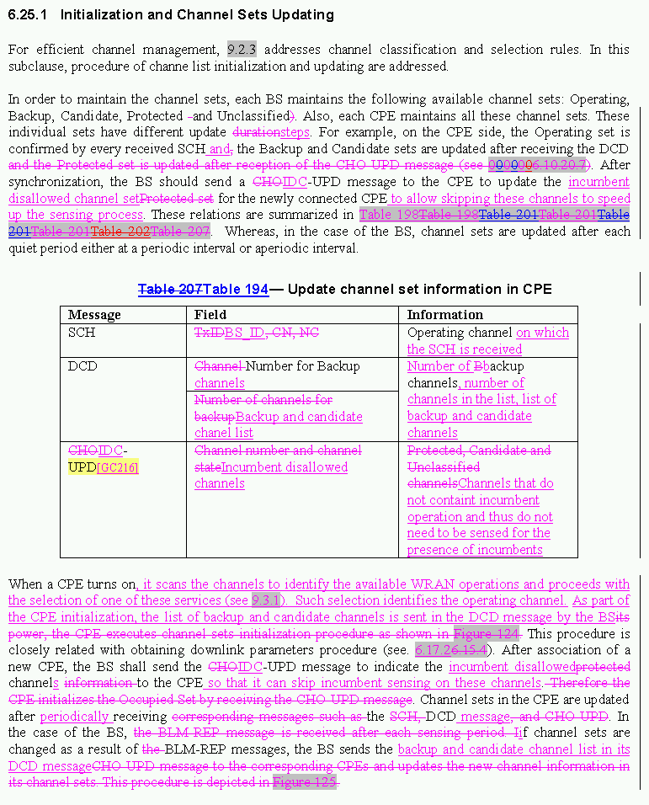

3. Delete Figures 125 and 126 as follows:

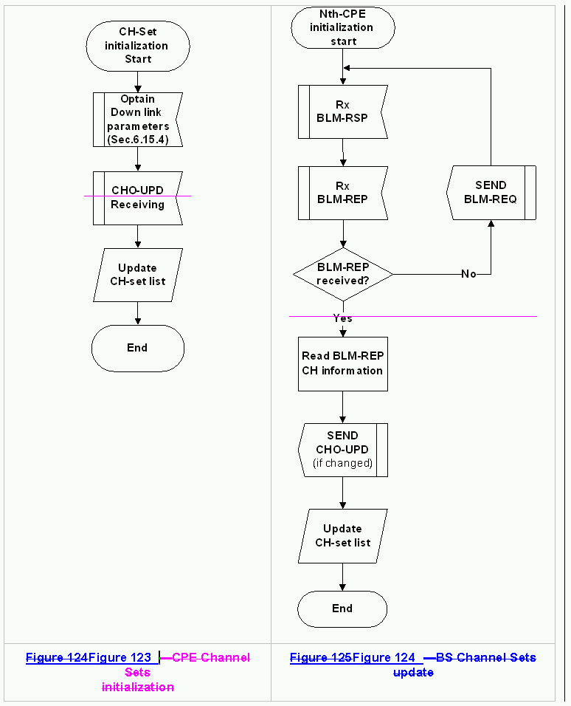

4. Other changes to replace CHO-UPD by IDC-UPD are contained in 22-10-84r9.

_________________________

