IEEE P802.22
Wireless RANs
Contention process: proposed resolution of comments 237, 238, 239, 240, 242, 243,
Date: 2010-08-10
Author(s):
Name | Company | Address | Phone | email
Gerald Chouinard | CRC | 3701 Carling Ave., Ottawa, Ontario, Canada K2H8S2 | 1-613-998-2500 | gerald.chouinard@crc.ca
Abstract
This contribution contains a proposal for resolving the above listed comments. A complete review of sub-clause 6.16 and Tables 41 and 42 has been done and many discrepancies with the current thinking have been found and corrections are proposed (e.g., contention is no longer used for ranging and SCW). Clarification on the way the opportunities are mapped in the opportunity window has been included.

These considerations also lead to the fact that the size of these two types of opportunities is knows (GMH for UCS and GMH_24 bits for BW Request. Why would they need to be repetitively specified as UCD channel IEs?

Furthermore, currently, the length of the GMH is 33 bits. This means that 7 bit padding would need to be added to every instance of a GMH whih seems to be wasteful. Is there a possibility to reduce the GMH to 32 bits?
Notice: This document has been prepared to assist IEEE 802.22. It is offered as a basis for discussion and is not binding on the contributing individual(s) or organization(s). The material in this document is subject to change in form and content after further study. The contributor(s) reserve(s) the right to add, amend or withdraw material contained herein.

Release: The contributor grants a free, irrevocable license to the IEEE to incorporate material contained in this contribution, and any modifications thereof, in the creation of an IEEE Standards publication; to copyright in the IEEE’s name any IEEE Standards publication even though it may include portions of this contribution; and at the IEEE’s sole discretion to permit others to reproduce in whole or in part the resulting IEEE Standards publication. The contributor also acknowledges and accepts that this contribution may be made public by IEEE 802.22.

Patent Policy and Procedures: The contributor is familiar with the IEEE 802 Patent Policy and Procedures
<http://standards.ieee.org/guides/bylaws/sb-bylaws.pdf>, including the statement "IEEE standards may include the known use of patent(s), including patent applications, provided the IEEE receives assurance from the patent holder or applicant with respect to patents essential for compliance with both mandatory and optional portions of the standard." Early disclosure to the Working Group of patent information that might be relevant to the standard is essential to reduce the possibility for delays in the development process and increase the likelihood that the draft publication will be approved for publication. Please notify the Chair <Apurva Mody> as early as possible, in written or electronic form, if patented technology (or technology under patent application) might be incorporated into a draft standard being developed within the IEEE 802.22 Working Group. If you have questions, contact the IEEE Patent Committee Administrator at <patcom@ieee.org>.
1. Modify sub-clause 6.16 as follows:
( Note that Tables 38, 39, 40, 44, 45 correspond to 41, 42, 43, 47 and 48 in D3.0)
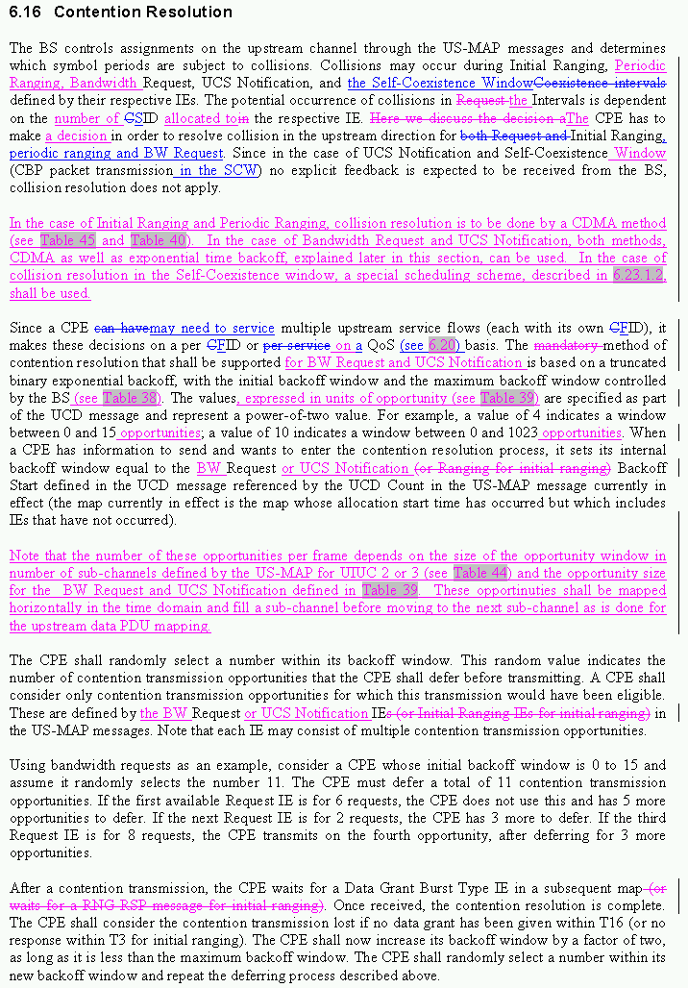
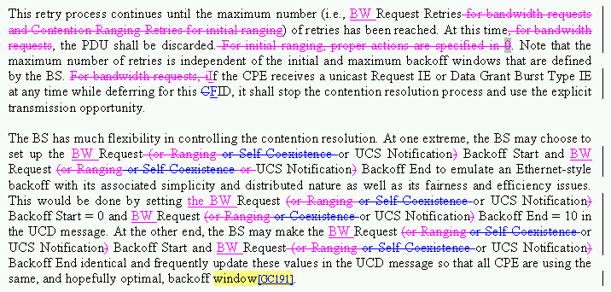

2. Modify Table 41 as follows:
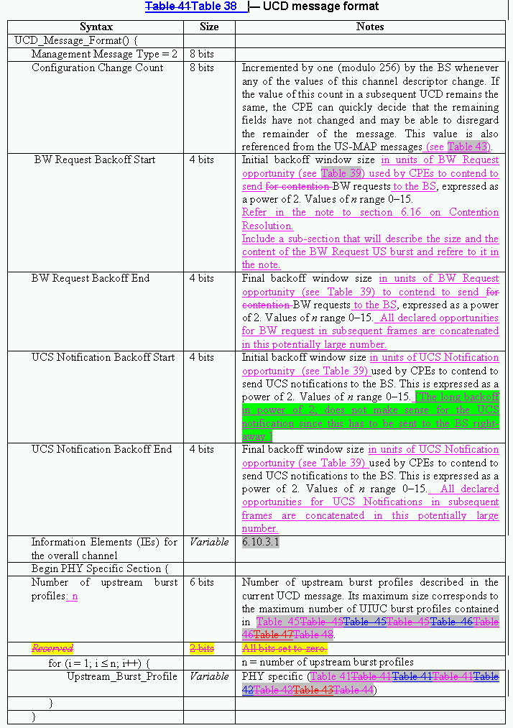
3. Modify Table 42 as follows:




