IEEE P802.22
Wireless RANs
Summarization of EAP Implementation Requirements
Date: 2010-07-28
Author(s):
Name | Company | Address | Phone | Email
Ranga Reddy | US Army | Fort Monmouth, NJ |  | Ranga.Reddy@us.army.mil
Abstract
This contribution summarizes the modifications to D3 that needed to implement an EAP-based authentication system for 802.22.
Notice: This document has been prepared to assist IEEE 802.22. It is offered as a basis for discussion and is not binding on the contributing individual(s) or organization(s). The material in this document is subject to change in form and content after further study. The contributor(s) reserve(s) the right to add, amend or withdraw material contained herein.

Release: The contributor grants a free, irrevocable license to the IEEE to incorporate material contained in this contribution, and any modifications thereof, in the creation of an IEEE Standards publication; to copyright in the IEEE’s name any IEEE Standards publication even though it may include portions of this contribution; and at the IEEE’s sole discretion to permit others to reproduce in whole or in part the resulting IEEE Standards publication. The contributor also acknowledges and accepts that this contribution may be made public by IEEE 802.22.

Patent Policy and Procedures: The contributor is familiar with the IEEE 802 Patent Policy and Procedures
<http://standards.ieee.org/guides/bylaws/sb-bylaws.pdf>, including the statement "IEEE standards may include the known use of patent(s), including patent applications, provided the IEEE receives assurance from the patent holder or applicant with respect to patents essential for compliance with both mandatory and optional portions of the standard." Early disclosure to the Working Group of patent information that might be relevant to the standard is essential to reduce the possibility for delays in the development process and increase the likelihood that the draft publication will be approved for publication. Please notify the Chair Apurva Mody <apurva.mody@ieee.org> as early as possible, in written or electronic form, if patented technology (or technology under patent application) might be incorporated into a draft standard being developed within the IEEE 802.22 Working Group. If you have questions, contact the IEEE Patent Committee Administrator at <patcom@ieee.org>.

Introduction

The contribution specifies the requirements needed to implement an EAP-based authentication system. There are several comments in the D3 comment database (DCN# 22-10/78r7, or latest revision) related to this process: 319, 470, 471, 472, 473, 479, 488, 489, 491, 496, 497, 498. This contribution will review each of these comments and the proposed resolutions. Only CID 479, doesn’t have the explicit resolution documented in this contribution. Another contribution will be provided to document the resolution for CID 479.

EAP-Related Comments

CID 319

Commentor: Ranga Reddy, Section 6.10.24, pg 110, line 7

Comment: From previous balloting it was agreed in security adhoc to bring EAP in as the primary authentication mechanism. The structure of the SCM Auth-Request, Auth-Reply, and Auth-Reject will have to change

Suggested Remedy: Update the SCM Auth-Request, Auth-Reply, and Auth-Reject to incorporate EAP signalling. This wil require changes to 6.10.24.1-3

EAP is a flexible security framework. While we don’t describe the EAP exchange itself in the specification of the 802.22 air interface, we do define SCM messages that encapsulate EAP messages exchanged between the BS and CPE during intital- and re-authentication. This entails removing the SCM Auth Request (6.10.24.1), SCM Auth Reply (6.10.24.2), SCM Auth Reject (6.10.24.3) that are currently defined in D3. Encoding of SCM messages, and the Message Response codes have to be updated as well.

[Modify the Table 182 as follows]

[-------------------------------------Start of text Modification----------------------------------]

Table 182 - SCM message codes
Element ID | SCM message type | MAC Management Message Name
1 | SCM Auth-RequestEAP Start | SCM-REQ
2 | SCM Auth-ReplyEAP Transfer | SCM-REQ/RSP
3 | SCM Auth-Reject | SCM-RSP
43 | SCM Key-Request | SCM-REQ
54 | SCM Key-Reply | SCM-RSP
65 | SCM Key-Reject | SCM-RSP
76 | SCM GSA-Add | SCM-RSP
87 | SCM GSA-Remove | SCM-RSP
88 | SCM TEK-Invalid | SCM-RSP
9 | SCM Auth Invalid | SCM-RSP
109—255 | reserved

[-------------------------------------End of text Modification----------------------------------]

[Modify Section 6.10.24.1: Change title to “SCM EAP Start”, and replace text in that section w/ the following]

[-------------------------------------Start of text Modification----------------------------------]

EAP Start shall be used during network entry to initiate an EAP session. The BS shall be capable of initiating an EAP session with EAP Start if the network authenticator does not. The “Key Sequence Number” attribute shall only be present in EAP Start messages transmitted during re-authentication. Note, that during re-authentication, the EAP Start message shall be protected by the MMP Key.

Table 6.10.24.1 - SCM EAP Start – Message Attributes
Attribute | Contents
Key Sequence Number | AK Sequence Number

[-------------------------------------End of text Modification----------------------------------]

[Modify Section 6.10.24.2: Change title to “SCM EAP Transfer”, and replace text in that section w/ the following]

[-------------------------------------Start of text Modification----------------------------------]

EAP Transfer shall be used when an EAP payload has to be transferred between the CPE and the network authenticator (throught the BS). The EAP Payload attribute shall be present in all EAP Transfer messages. The “Key Sequence Number” attribute shall only be present in EAP Transfer messages during re-authentication. Note, that during re-authentication, the EAP Start message shall be protected by the MMP Key.

Table 6.10.24.2 - SCM EAP Transfer – Message Attributes
Attribute | Contents
Key Sequence Number | AK Sequence Number
EAP Payload | Contains EAP authentication Data

[-------------------------------------End of text Modification----------------------------------]

[Remove Section 6.10.24.3 and 6.10.24.10]

[Modify Table 193 in Section 6.10.24.11 as follows, EAP authentication failures will be handled by definition of EAP state machine. Only need to define MRCs for Key Reject and TEK Invalid messages]

[-------------------------------------Start of text Modification----------------------------------]

Table 193 - Message Response Code
Message Response Code | Messages | Description
0x00 | All | No Information
0x01 | Auth Reject, Auth Invalid | Unauthorized CPE
0x012 | Auth Reject, Key Reject | Unauthorized SAID
0x03 | Auth Invalid | Unsolicited
0x024 | Auth Invalid, TEK Invalid | Invalid Key Sequence Number
0x035 | Auth InvalidKey Reject | Message (Key Request) authentication failure
0x06 | Auth Reject | Permanent Authorization failure
0x074-0xFF | Reserved | --

[-------------------------------------End of text Modification----------------------------------]

[Remove the following phrase from Table 188 and 191: “Possible Values are listed in Table 193”]

[Add the following text to 6.10.24.6, to better describe use of message response code’s sent by Key Reject message]

[-------------------------------------Start of text Modification----------------------------------]

Message Response Code is set to 0x01 when the Key Request was made for a SA that the CPE is not currently authorized for. Message Response Code is set to 0x03 when the Key Request message cannot be properly authenticated and decrypted.

[-------------------------------------End of text Modification----------------------------------]

[Add the following text to 6.10.24.9, to better describe use of message response code’s sent by Key Reject message]

[-------------------------------------Start of text Modification----------------------------------]

Message Response Code is set to 0x02 when sending TEK Invalid message.

[-------------------------------------End of text Modification----------------------------------]

CID 470

Commentor: Ranga Reddy, Section 7, pg 263, line 40

Comment: In previous balloting, there was a withdrawn comment to replace the certificate-based authentication with an EAP-based process.

Suggested Remedy: Change “digital-certificate-based CPE” to “EAP-based”

EAP is a flexible framework that allows any one of several authentication methods to be supported. However, in discussion of CID 472 the Security & Management ad-hoc has decided to recommend EAP-TLS or EAP-TTLS.

CID 471

Commentor: Ranga Reddy, Clause 7, Section 7.1, pg 264, line 29

Comment: Working group is behind transitioning to an EAP-based authentication mechanism.

Suggested Remedy: Update Figure 126, and text on lines 3-7 pg 265

The Figure below is a modification of Figure 126, and should be used to replace figure 126 in D3. Furthermore, the “Message authentication processing” block is removed as the text that follows Figure 126 in D3 does not contain a description of this block.

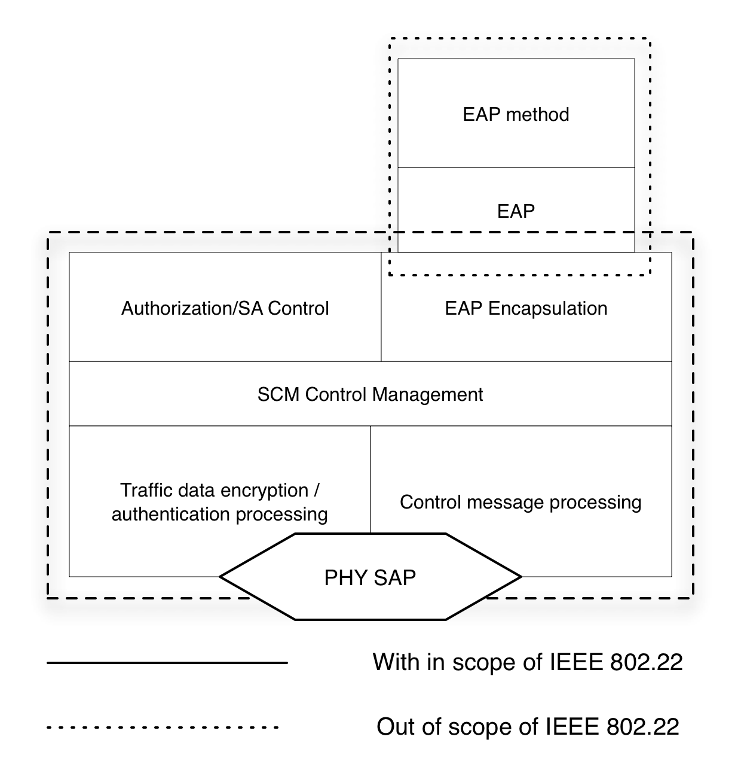

CID 472

Commentor: Ranga Reddy, Clause 7, Section 7.1.2, pg 265, line 19

Comment: In order to facilitate EAP integration provide a description of EAP here. Also the title of the section should be changed to reflect that this section (even currently) serves as an overview of the key management and authentication procedures.

Suggested Remedy:
- change the title of this section to "Key Management & Authentication Overview"
- Add the following text on (Note: the text strikeout in blue below reflects a modified resolution agreed to in ad-hoc calls):
[---------------------------------Start of text Modification---------------------------]
"EAP-based authentication uses Extensible Authentication Protocol framework [IETF RFC 3748]. EAP offers the operator to select an EAP Method (e.g., EAP-TLS [IETF RFC 2716]) to execute the authentication. Each EAP Method specifies a credential that is used to perform authentication and verify the device/user's identity. For example, EAP-TLS uses a X.509 certificate, while EAP-SIM uses a Subscriber Identity Module.
The EAP Method and associated credential are selectable by the operator. If EAP-TLS or EAP-TTLS is toshall be used, Section 7.5 defines the profile for the X.509 credential. In order to avoid security vulnerabilities, the EAP Method implemented in an 802.22 network should comply to the mandatory requirements stated in Section 2.2 of [IETF RFC 4017].
During initial authentication EAP transfer messages are not protected. For reauthentication, the EAP transfer messages are protected (encrypted and authenticated) using the MMP_Key (Section 7.xxx). If EAP reauthentication messages are fail their authentication verification (see 7.xxx) or are not protected, they shall be ignored by the BS and CPE."
[---------------------------------End of text Modification---------------------------]
- remove the text on lines 31-35 on pg 265
- Remove sections 7.1.3, 7.1.3.1, 7.1.3.2

The group, during Security & Management ad-hoc calls, decided to specify a specific EAP method. EAP-TLS or EAP-TTLS are one of the more stronger EAP methods. Ultimately, it’s the goal of the Security & Management ad-hoc to be compliant to any requirements of the database service provider. However, we will not change our specification of a particular EAP method or a default method that has to be supported unless specific requirements from the database service provider ask us to do so.

CID 473

Commentor: Ranga Reddy, Clause 7, Section 7.1.2, pg 265, line 20

Comment: This sentence that starts out on line 20 is wrong. Our security should/does allow mutual authentication. Also, the text that starts at the end of line 21 and runs through 24, is not in step with our desire to bring in EAP.

Suggested Remedy:
Modify the end of the sentence (on line 20) as follows:
[---------------------------------Start of text Modification---------------------------]
"The SCM protocol allows for mutual authentication where the BS authenticates CPEs andt not vice versa). It also supports periodic reauthentication/reauthorization and key refresh. The key management protocol uses X.509 digital certificates [IETF RFC 3280] together with RSA public-key encryption algorithm [PKCS #1] or a sequence starting with RSA authentication or even with ECC public-key encryption algorithm. It uses strong encryption algorithms to perform key exchanges between a CPE and BS. "
[---------------------------------End of text Modification---------------------------]

This comment is a simple text modification that has been accepted by the Security & Management ad-hoc to be in step with resolution of CID 470.

CID 479

Commentor: Ranga Reddy, Clause 7, Section 7.1.2, pg 265, line 20

Comment: Make modifications to section 7.2.2 to reflect the EAP-based authentication state machine; starting on line 14 pg 268 to line 26 pg 276

Suggested Remedy: Use 7.2.2.5 of 802.16-2009 as a template

This comment requires replacement of most of the text of Section 7.2.2 of D3. Section 7.2.2 starts off with an overview of the CPE authorization process, describes the authorization state machine as well as provides the state transition table, describes the messages, events, parameters, and actions that are associated with the authorization state machine. Currently all of this text is oriented along the lines of supporting certificate-based authorization. In order to bring in EAP, most of this text in 7.2.2 has to be updated or replaced entirely. Section 7.2.2.5 in IEEE 802.16-2009 provides a good template to use. Having said that’s 802.22’s implementation will mostly likely be simpler. The modified text will be provided in a track-changes document and will be available for review at some time in the future.

CID 488

Commentor: Ranga Reddy, Clause 7, Section 7.2.4.1, pg 284, line 13

Comment: AK deriviaton will have to change once we bring in EAP

Suggested Remedy: Update 7.2.4.1, as well as key hierarchy in 7.2.5 to reflect this change and derivation of MMP_Key in 7.2.4.6.2.

There are several modifications required:
- Update 7.2.4.1 as follows:
[---------------------------------Start of text Modification---------------------------]
“The AK will be derived by the BS and the CPE from the PAMK, when the ECC/RSAEAP-based authorization procedure has concluded.

After the authorization procedure has been performed, the CPE and BS will both posses the PAMK. The derivation of the AK varies is based on which keys are possessedthe following.

The AK shall be generated as follows:

  - AK = Dot22KDF (PAMK, CPE MAC Address | BSID | PAK | “AK”, 160)
[---------------------------------End of text Modification---------------------------]

- Figure 129 has to be update to reflect EAP-based key hierarchy

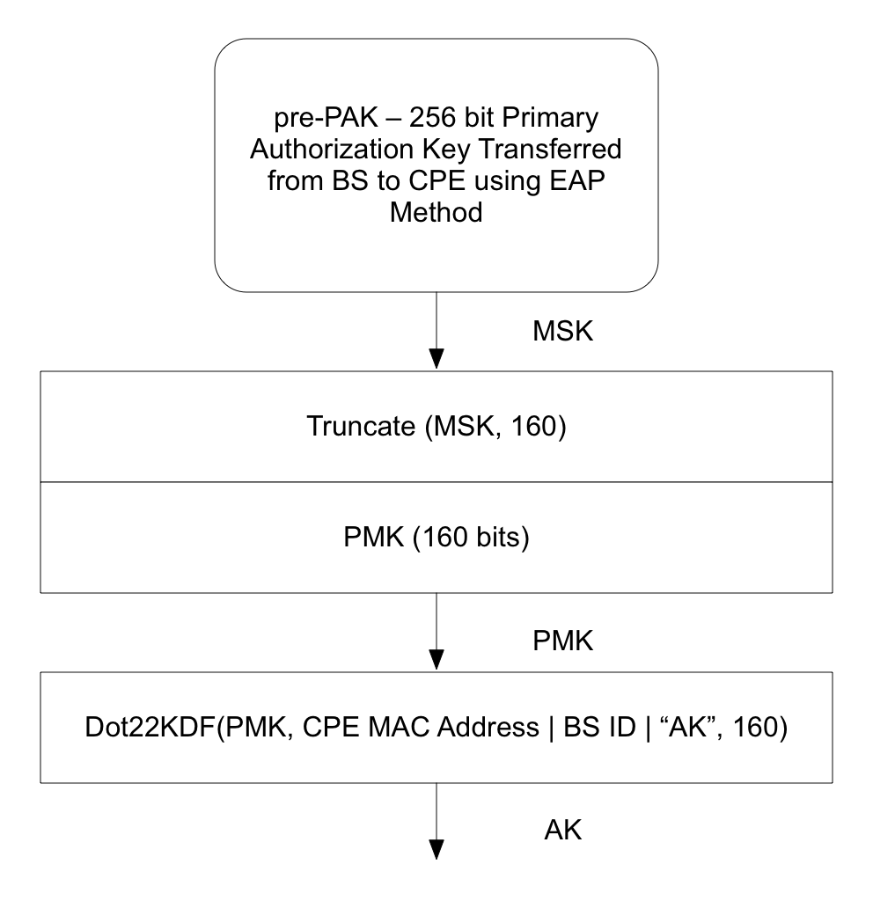

- Upon review MMP_Key deriviation in 7.2.4.6.2 does not need to be modified

CID 489

Commentor: Ranga Reddy, Clause 7, Section 7.2.6, pg 288, line 1

Comment: AK maintenance procedures will have to change once we bring in EAP

Suggested Remedy: Please update Section 7.2.6 accordingly

Update 7.2.6 as follows:
[---------------------------------Start of text Modification---------------------------]
The BS and CPE maintain cached AK as follows:

  - Successful completion of the SCM ECC/RSA EAP-based Authorizaiton and establishment of a PAKPMK, causes the activation of all the AK associated with the new PAK.
  - If the packet counter belonging to MMP key reaches its maximum value, the associated AK becomes permanently deactivated.
  - The BS and CPE must maintain the AK context (i.e., replay counters etc.) as long as they retain the AK.
[---------------------------------End of text Modification---------------------------]

This is a pretty much straight forward modification.

CID 491

Commentor: Ranga Reddy, Clause 7, Section 7.2.9.3, pg 290, line 12

Comment: This section will have to be updated as part of the transition to EAP.

Suggested Remedy: Update this seciton to reflect use of the PMK, pair-wise master Key that gets established as part of the EAP exchange

Update 7.2.9.3 as follows:
[---------------------------------Start of text Modification---------------------------]

7.2.9.3 PAKPMK context
The PAKPMK context includes all parameters associated with the PAKPMK. This context is created when RSAEAP-based
Authentication completes.

The PAKPMK context is described in Table 212.

Table 212— PAKPMK Context

Parameter | Size (bits) | Usage
PAKPMK | 160 | A key yielded from ECC/RSAEAP-based authentication
PAK Lifetime | 4 | PAK lifetime, from when the ECC/RSA-based authorization is achieved. The value of the PAK lifetime is initially set to a default value, Authorization Grace Time. The Authorization exchange may subsequently change this value.
PAK Sequence Number | 4 | PAKPMK sequence number, when the ECC/RSAEAP-based authentication is achieved and a key is generated. The MSB 2 bits are the sequence counter, and the least significant bits are set to 0.

[---------------------------------End of text Modification---------------------------]

CID 496/497

Commentor: Ranga Reddy, Clause 7, Section 7.4.3, pg 302, line 20 & 36

Comment: These sections will have to be updated as part of the transition to EAP.

Suggested Remedy: Update this section in accordance to requirements of transport of AK between BS and CPE at the end of EAP-based authentication

In reality this section only pertains to the old RSA/ECC-based authorization. However, we are specifying EAP-TLS/TTLS, which use X.509v3 based certificates. These certificates can be either RSA or ECC-based. IETF RFC 5246 “The Transport Layer Security (TLS) Protocol Version 1.2”, RFC 5281 “Extensible Authentication Protocol Tunneled Transport Layer Security Authenticated Protocol Version 0 (EAP-TTLSv0)”, and RFC 4492 “Elliptic Curve Cryptography (ECC) for Transport Layer Security (TLS)” already provide adequate reference to the constraints surrounding implementing EAP-TLS/TTLS and developing the proper credentials surrounding them. Suggestion is to modify Sections 7.4.3 and 7.4.4 as follows:

[---------------------------------Start of text Modification---------------------------]

7.4.3 Public Key Encryption of AKRequirements for EAP-TLS/TTLS
802.22 devices shall use EAP-TLS or EAP-TTLS to support device authentication. Implementation of authentication services (e.g. key agreement and digital signature processed) based on EAP-TLS or EAP-TTLS shall conform to the specifications as defined in the following IETF RFCs:

- RFC 5246 “The Transport Layer Security (TLS) Protocol Version 1.2”
- RFC 5281 “Extensible Authentication Protocol Tunneled Transport Layer Security Authenticated Protocol Version 0 (EAP-TTLSv0)”
- and RFC 4492 “Elliptic Curve Cryptography (ECC) for Transport Layer Security (TLS)”

AKs in Auth Reply messages shall be RSA or ECC public-key encrypted, using the CPE’s public key.

For RSA certificates, RSA public-key encryption uses 65537 (0x010001) as its public exponent and a modulus length of 1024 bits. The PKM protocol employs the RSAES-OAEP encryption scheme (PKCS #1). RSAES-OAEP requires the selection of a hash function, a mask-generation function, and an encoding parameter string. The default selections specified in PKCS #1 shall be used when encrypting the AK. These default selections are SHA-1 for the hash function, MGF1 with SHA-1 for the mask-generation function, and the empty string for the encoding parameter string.

For ECC certificates, ECC public key encryption is based upon the Elliptic Curve Integrated Encryption Scheme (ECIES) detailed in Section 5.1 of [SEC1]. Elliptic Curve domain parameters shall be selected based upon the recommendations in 7.5.1.5.2. The MAC and ENC schemes that are part of the ECEIS method will be handled by AES-CCM method as defined in 7.4.2.1.3. KDF to be used in ECIES will make use of Dot22KDF function defined in 7.2.4.7.

7.4.4 Digital Signatures
For RSA-based certificate, the RSA Signature Algorithm (PKCS #1) with SHA-1 [FIPS 186-2] shall be used. As with its RSA encryption keys, Privacy uses 65537 (0x010001) as the public exponent for its signing operation. Manufacturer CAs shall employ signature key modulus lengths of at least 1024 bits and no greater than 2048 bits.

For ECC-based certificate, the Elliptic Curve Digital Signature Algorithm (ECDSA) defined in Section 4 of [SEC1] shall be used. Elliptic Curve domain parameters shall be selected based upon the recommendations in 7.5.1.5.2. Domain parameters sets that are selected will produce keys of no less than 160 and no greater than 224 bits in length. SHA-1 shall be used as the hash function.
[---------------------------------End of text Modification---------------------------]

CID 498

Commentor: Ranga Reddy, Clause 7, Section 7.5, pg 303, line 1

Comment: In previous draft, we had brought in certificate based authentication. The group has decided to move to EAP based authentication. Having said that, this whole section may not be needed. However, if TVWS database access is based on some type of TLS transaction, it would benefit us to define a certificate profile within the standard

Suggested Remedy: Please include some introductory text for 7.5 that highlights the issues and why we choose to define a certificate profile. It should cover potential use of TLS type transactions for TVWS database acccess, and should that be true, it can be used as the definition for the credential in an EAP-TLS/TTLS type authenticatino.

This comment seeks to add some introductory text for Section 7.5. Something to explain the purpose of developing and describing a certificate profile in the base standard. Add the following text before Section 7.5.1:

[---------------------------------Start of text Modification---------------------------]

This standard mandates use of EAP-TLS or EAP-TTLS as the authentication mechanism. The certificate profile defined in this section provides a description of the credentials to be used for device authentication of 802.22 networks. This certificate profile may also be used to develop credentials for database service access.

[---------------------------------End of text Modification---------------------------]

References:

