IEEE P802.22
Wireless RANs
Draft Minutes of the Beijing Session of 802.22
May 2010
Date: 2010-06-06
Author(s):
Name | Company | Address | Phone | email
Apurva Mody | BAE Systems | P.O. Box 868, MER 15-2350, Nashua, NH 03061-0868 | 603-809-0459  404-819-0314 | apurva.mody@baesystems.com,  apurva_mody@yahoo.com

Notice: This document has been prepared to assist IEEE 802.22. It is offered as a basis for discussion and is not binding on the contributing individual(s) or organization(s). The material in this document is subject to change in form and content after further study. The contributor(s) reserve(s) the right to add, amend or withdraw material contained herein.

Release: The contributor grants a free, irrevocable license to the IEEE to incorporate material contained in this contribution, and any modifications thereof, in the creation of an IEEE Standards publication; to copyright in the IEEE’s name any IEEE Standards publication even though it may include portions of this contribution; and at the IEEE’s sole discretion to permit others to reproduce in whole or in part the resulting IEEE Standards publication. The contributor also acknowledges and accepts that this contribution may be made public by IEEE 802.22.

Patent Policy and Procedures: The contributor is familiar with the IEEE 802 Patent Policy and Procedures
<http://standards.ieee.org/guides/bylaws/sb-bylaws.pdf>, including the statement "IEEE standards may include the known use of patent(s), including patent applications, provided the IEEE receives assurance from the patent holder or applicant with respect to patents essential for compliance with both mandatory and optional portions of the standard." Early disclosure to the Working Group of patent information that might be relevant to the standard is essential to reduce the possibility for delays in the development process and increase the likelihood that the draft publication will be approved for publication. Please notify the Chair Apurva Mody <Apurva.mody@ieee.org> as early as possible, in written or electronic form, if patented technology (or technology under patent application) might be incorporated into a draft standard being developed within the IEEE 802.22 Working Group. If you have questions, contact the IEEE Patent Committee Administrator at <patcom@ieee.org>.
Abstract
This document contains the draft minutes of the May 2010 session of the 802.22 Working Group.
IEEE 802.22
Wireless Regional Area Networks
Beijing Session
May 2010

MINUTES

IEEE 802.22 Working Group Website
www.ieee802.org/22

IEEE 802.22 Working Group Officers

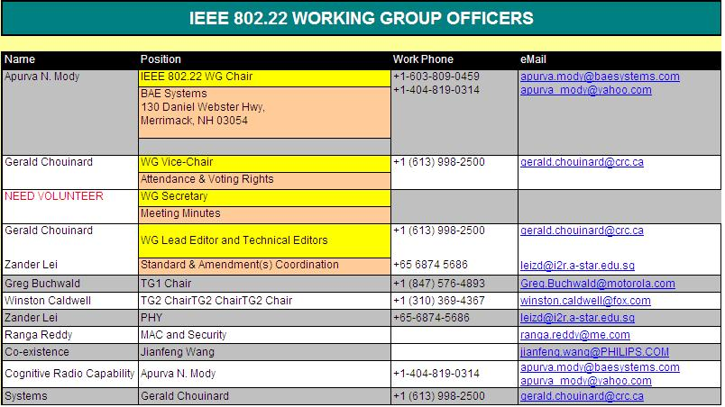

New Contributions and References
- Apurva Mody, May Interim Working Group Agenda - https://mentor.ieee.org/802.22/dcn/10/22-10-0070-03-0000-may-interim-working-group-agenda.xls
- Apurva Mody and Gerald Chouinard, Overview of IEEE 802.22 Standard and Core Technologies - https://mentor.ieee.org/802.22/dcn/10/22-10-0073-01-0000-ieee-802-22-overview-and-core-technologies.pdf
- Gerald Chouinard, WRAN Draft v3.0 Comment Database - https://mentor.ieee.org/802.22/dcn/10/22-10-0070-03-0000-may-interim-working-group-agenda.xls
- Winston Caldwell, Proposed Additional MIBs - https://mentor.ieee.org/802.22/dcn/10/22-10-0075-00-0000-proposed-additional-mibs.doc
- Winston Caldwell – Proposed Text, CPE Initialization Outline - https://mentor.ieee.org/802.22/dcn/10/22-10-0074-00-0000-proposed-text-cpe-initialization-outline.doc

Saturday, 15th, 9.00 a.m. – 5.00 p.m. Workshop Forum IEEE 802 Standards, Sensor Networks Standardization and ZigBee Telecom Service Profile

- Shanghai Institute of Microsystems and Information Technology in association with IEEE 802.15 organized the Workshop Forum on IEEE 802 Standards, Sensor Networks Standardization and ZigBee Telecom Service Profile
- Attendance –
  - The conference was attended by the Chairs of almost all the IEEE 802 Working Groups who held their interim meeting in Beijing – Steve Mills, President Elect (IEEE – Standards Association), Paul Nikolich (Chair, IEEE 802) Bruce Kraemer (Chair, IEEE 802.11), Dr. Bob Heile (Chair,IEEE 802.15 and ZigBee alliance), Dr. Roger Marks (IEEE 802.16 and VP, WiMAX Forum), Michael Lynch (IEEE 802.18), Dr. Tuncer Baykas (IEEE 802.19.1), Dr. Apurva N. Mody (IEEE 802.22)
  - Audience – 150 people from industry and academia
- Various IEEE 802 group Chairs presented highlights of their respective groups
- Prof. Xing Tao (SIMIT) and Dr. Liliang Li (Huawei) compered the workshop
- Afternoon sessions were mainly focused on IEEE 802.15 and ZigBee

Monday, May 17th 9.30 – 10.30 Opening Ceremony
- The Beijing interim meeting started with an opening ceremony where many Chinese Govt. officials were invited.
- Attendees
  - Approximately 250 IEEE 802 meeting participants and invitees attended the opening ceremony
  - Chinese officials - 1. Han Jun, Deputy Director General, Department of Science and Technology, 2. Dr. Gao Lin, Deputy Secretary General, China National Information Technology Standardization Technical Committee, 3. Dr. Li Shizhu, Deputy Director, Zhongguancum Science Park, 4. Karl Ma, Vice Director, Wuxi Tech-Park
- Steve Mills, President Elect, IEEE Standards Association gave a presentation on IEEE standardization process
- Chinese officials gave speeches.

Monday, May 17th 11.00 a.m. – 12.30 p.m. Joint Opening Plenary
- Attendance – Approximately 300 IEEE 802 meeting participants attended the meeting
- Bob Heile, Chair IEEE 802.15 provided an introduction
- Chairs of various groups provided an overview of their groups provided an overview of their standards, and their agenda during the Beijing interim –
  - Bruce Kraemer (Chair, IEEE 802.11), Dr. Bob Heile (Chair,IEEE 802.15), Michael Lynch (IEEE 802.18), Steve Shellhammer (IEEE 802.19), Dr. Apurva N. Mody (IEEE 802.22)

Monday, May 17th, 1.30 p.m. -3.30 p.m. IEEE 802.22 Working Group Opening Plenary

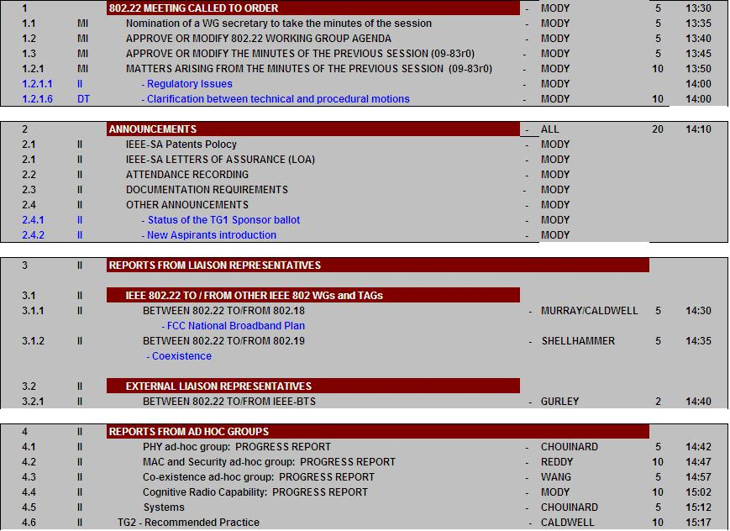

Apurva Mody decided to keep the minutes for the session

Monday, May 17th 4.00 p.m. – 6.00 p.m.

- IEEE 802.22 Draft v3.0, Comment resolution - https://mentor.ieee.org/802.22/dcn/10/22-10-0070-03-0000-may-interim-working-group-agenda.xls
- Comments were organized and prioritized

Monday, May 17th 7.30 p.m. – 9.30 p.m.

- IEEE 802.22 Draft v3.0, Comment resolution - https://mentor.ieee.org/802.22/dcn/10/22-10-0070-03-0000-may-interim-working-group-agenda.xls
- Comments were organized and prioritized
- Ranga Reddy and Jason Li attended this session over Skype
- Ranga presented his approach to reducing the number of CID bits to 12.
- Ranga proposed to the group that Command CHO-UPD be removed. There was a lot of discussion. Gwangzeen to present to the group why he thinks that CHO-UPD be kept.
- Most of the comments resolved were related to PHY
- The proposed resolutions can be found in - https://mentor.ieee.org/802.22/dcn/10/22-10-0078-05-0000-wran-draft-3-0-ballot-comments-database.xls

Tuesday, May 18th 8.00 a.m. – 10.00 a.m. PHY Comment Resolution

- IEEE 802.22 Draft v3.0, Comment resolution - https://mentor.ieee.org/802.22/dcn/10/22-10-0070-03-0000-may-interim-working-group-agenda.xls
- Comments were organized and prioritized
- Gerald Chouinard, Ranga Reddy and Jason Li attended this session over Skype
- Most of the comments resolved were related to PHY
- The proposed resolutions can be found in - https://mentor.ieee.org/802.22/dcn/10/22-10-0078-05-0000-wran-draft-3-0-ballot-comments-database.xls

Tuesday, May 18th 10.30 a.m. – 12.30 p.m. PHY Comment Resolution

- IEEE 802.22 Draft v3.0, Comment resolution - https://mentor.ieee.org/802.22/dcn/10/22-10-0070-03-0000-may-interim-working-group-agenda.xls
- Comments were organized and prioritized
- Gerald Chouinard, Ranga Reddy and Jason Li attended this session over Skype
- Most of the comments resolved were related to PHY
- The proposed resolutions can be found in - https://mentor.ieee.org/802.22/dcn/10/22-10-0078-05-0000-wran-draft-3-0-ballot-comments-database.xls

Tuesday, May 18th 1.30 p.m. – 3.30 p.m. MAC and Cognitive Comment Resolution

- IEEE 802.22 Draft v3.0, Comment resolution - https://mentor.ieee.org/802.22/dcn/10/22-10-0070-03-0000-may-interim-working-group-agenda.xls
- Comments were organized and prioritized
- Most of the comments resolved were related to Sections 6 and Section 9
- The proposed resolutions can be found in - https://mentor.ieee.org/802.22/dcn/10/22-10-0078-05-0000-wran-draft-3-0-ballot-comments-database.xls

Tuesday, May 18th 4.00 p.m. – 6.00 p.m. MAC and Cognitive Comment Resolution

- IEEE 802.22 Draft v3.0, Comment resolution - https://mentor.ieee.org/802.22/dcn/10/22-10-0070-03-0000-may-interim-working-group-agenda.xls
- Comments were organized and prioritized
- Most of the comments resolved were related to Sections 6 and Section 9
- The proposed resolutions can be found in - https://mentor.ieee.org/802.22/dcn/10/22-10-0078-05-0000-wran-draft-3-0-ballot-comments-database.xls

Tuesday, May 18th 7.30 p.m. – 9.30 p.m. Joint Meeting Between IEEE 802.11, 802.19 and IEEE 802.22

- Attendance – 50 IEEE 802 participants attended the meeting
- Rich Kennedy (RIMM, Chair, IEEE 802.11af) presided over the meeting
- Dr. Tuncer Baykas (NICT, Chair IEEE 802.19.1), Dr. Alex, Reznik (Interdigital), presented an overview of IEEE 802.19.1 on co-existence
- Dr. Apurva Mody presented overview of IEEE 802.22 and its co-existence mechanisms.

Wednesday, May 19th 8.00 a.m. – 10.00 a.m. MAC Comment Resolution
- IEEE 802.22 Draft v3.0, Comment resolution - https://mentor.ieee.org/802.22/dcn/10/22-10-0070-03-0000-may-interim-working-group-agenda.xls
- MAC Comments were resolved
- Ranga presented his approach to reducing the number of CID bits to 12. The group has tentatively agreed to accept this proposal provided Ranga brings in detailed instructions of all the places where the 802.22 draft will change due to this.
- Ranga proposed to the group that Command CHO-UPD be removed. There was a lot of discussion. Gwangzeen to present to the group why he thinks that CHO-UPD be kept.
- Gerald Chouinard, Ranga Reddy and Jason Li attended this session over Skype
- The proposed resolutions can be found in - https://mentor.ieee.org/802.22/dcn/10/22-10-0078-05-0000-wran-draft-3-0-ballot-comments-database.xls

Wednesday, May 19th 10.30 a.m. – 12.30 p.m. MAC Comment Resolution
- IEEE 802.22 Draft v3.0, Comment resolution - https://mentor.ieee.org/802.22/dcn/10/22-10-0070-03-0000-may-interim-working-group-agenda.xls
- MAC Comments were resolved
- Gerald Chouinard, Ranga Reddy and Jason Li attended this session over Skype
- The proposed resolutions can be found in - https://mentor.ieee.org/802.22/dcn/10/22-10-0078-05-0000-wran-draft-3-0-ballot-comments-database.xls

Wednesday, May 19th 1.30 p.m. – 3.30 p.m. Cognitive Radio Capability Comment Resolution
- IEEE 802.22 Draft v3.0, Comment resolution - https://mentor.ieee.org/802.22/dcn/10/22-10-0070-03-0000-may-interim-working-group-agenda.xls
- Cognitive Radio Capability Comments were resolved
- Gerald Chouinard and Jason Li attended this session over Skype
- The proposed resolutions can be found in - https://mentor.ieee.org/802.22/dcn/10/22-10-0078-05-0000-wran-draft-3-0-ballot-comments-database.xls

Wednesday, May 19th 4.00 p.m. – 6.00 p.m. Cognitive Radio Capability Comment Resolution
- IEEE 802.22 Draft v3.0, Comment resolution - https://mentor.ieee.org/802.22/dcn/10/22-10-0070-03-0000-may-interim-working-group-agenda.xls
- Cognitive Radio Capability Comments were resolved
- Gerald Chouinard Jason Li attended this session over Skype
- The proposed resolutions can be found in - https://mentor.ieee.org/802.22/dcn/10/22-10-0078-05-0000-wran-draft-3-0-ballot-comments-database.xls

Wednesday, Evening
- There was a Social

Thursday, May 20th 8.00 a.m. – 10.00 a.m. Security and Management Plane Procedures

- IEEE 802.22 Draft v3.0, Comment resolution - https://mentor.ieee.org/802.22/dcn/10/22-10-0070-03-0000-may-interim-working-group-agenda.xls
- Security and Management Plane Procedures related Comments were resolved
- Ranga Reddy, Gerald Chouinard and Jason Li attended this session over Skype
- The proposed resolutions can be found in - https://mentor.ieee.org/802.22/dcn/10/22-10-0078-05-0000-wran-draft-3-0-ballot-comments-database.xls

Thursday, May 20th 10.30 a.m. – 12.30 p.m. Security and Management Plane Procedures

- IEEE 802.22 Draft v3.0, Comment resolution - https://mentor.ieee.org/802.22/dcn/10/22-10-0070-03-0000-may-interim-working-group-agenda.xls
- Security and Management Plane Procedures related Comments were resolved
- Ranga Reddy, Gerald Chouinard and Jason Li attended this session over Skype
- The proposed resolutions can be found in - https://mentor.ieee.org/802.22/dcn/10/22-10-0078-05-0000-wran-draft-3-0-ballot-comments-database.xls

Thursday, May 20th 1.30 p.m. – 3.30 p.m. Systems Issues Comment Resolutions

- IEEE 802.22 Draft v3.0, Comment resolution - https://mentor.ieee.org/802.22/dcn/10/22-10-0070-03-0000-may-interim-working-group-agenda.xls
- Systems Issues related Comments were resolved
- Ranga Reddy, Gerald Chouinard and Jason Li attended this session over Skype
- Apurva to ask Victor Tawil to help solidify the Annex A on regulatory domain and classes.
- The proposed resolutions can be found in - https://mentor.ieee.org/802.22/dcn/10/22-10-0078-05-0000-wran-draft-3-0-ballot-comments-database.xls

Thursday, May 20th 4.00 p.m. – 6.00 p.m. MAC Comment Resolutions

- IEEE 802.22 Draft v3.0, Comment resolution - https://mentor.ieee.org/802.22/dcn/10/22-10-0070-03-0000-may-interim-working-group-agenda.xls
- MAC related Comments were resolved
- Ranga Reddy, Gerald Chouinard and Jason Li attended this session over Skype
- The proposed resolutions can be found in - https://mentor.ieee.org/802.22/dcn/10/22-10-0078-05-0000-wran-draft-3-0-ballot-comments-database.xls

Thursday, May 20th 7.30 – 9.30 p.m. Closing Plenary

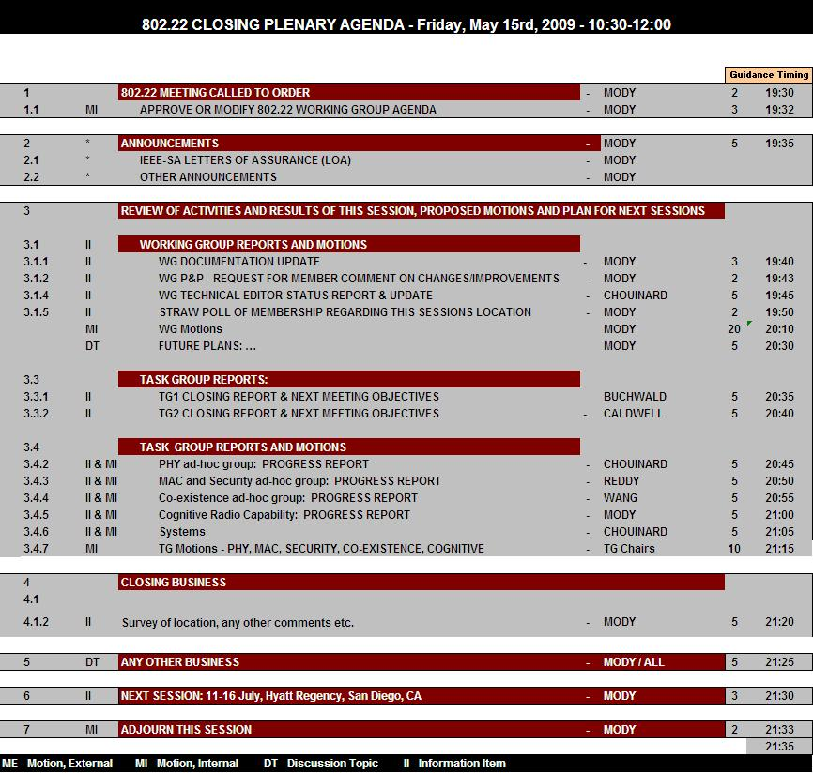
- Gerald Chouinard attended the IEEE 802.22 WG closing plenary over Skype

Following motions were made during the Beijing interim meeting

Working Group Motions
Motion 1
Empower the Editor to keep making editorial corrections as track changes to Draft v3.0 such as: correcting spelling mistakes, correct grammatical errors, improve sentence construction and place the new improved draft on the members only part of the IEEE 802.22 website every two weeks.
Move: Sasaki Shigenobu
Second: Aziz
Motion passes unanimously

Motion 2
Empower the Editor to incorporate the proposed resolutions agreed upon during the Beijing, May interim and the telecons in the weeks after, as track changes to Draftv3.0 and place the new improved draft on the members only part of the IEEE 802.22 website every two weeks.
Move: Jerry Kalke
Second: Sasaki
Motion passes unanimously.

Motion 3
Empower the Chair to launch 15 day electronic confirmation ballots as he sees fit, as an Excel spreadsheet of proposed resolutions to the comments contained in the Comment Database v3.0 OR as tracked changes to the Draft v3.0 posted as a new Draft on the members only site of the 802.22 website OR BOTH (These may be technical or editorial changes that are not necessarily contained in the comment database BUT they have been discussed in the interims, plenary or the face to face meetings).

Move: Aziz
Second: Sasaki Shigenobu
Motion passes unanimously.

Motion 4
Move that from Draftv4.0 and onwards, the 802.22 Working Group shall move to the re-circulation ballot phase.
Move: Apurva Mody
Second: Sasaki Shigenobu
Motion Passes Unanimously.

Motion 5
Adopt Ranga’ s proposal for 12 bit CID as illustrated in Document 22-09-0112 Rev1
Tabled until the interim meeting

Motion 6
Move that Working Group Re-circulation Ballot 4.0 for 802.22 Draft v4.0 shall be launched no later than 15 days from the end of the IEEE 802 July Plenary Meeting.
Move: Sasaki Shigenobu
Second: Jerry Kalke
Motion Passes Unanimously

Motion to Adjourn
Move: Sasaki
Second: Jerry
Passes Unanimously.

802.22 Attendance List

Beijing Interim Session
May 2010
1 | Filin | Stanislas | NICT, Japan
2 | Harada | Hiroshi | NICT, Japan
3 | Hwang | Sung Hyun | ETRI Daejeon, Korea
4 | Kalke | Jerome J. | CBS Corp.
5 | Kim | Chang-Joo | ETRI Daejeon, Korea
6 | Ko | Gwangzeen | ETRI Daejeon, Korea
7 | Lei | Zhongding | Institute for Infocomm Research, Singapore
8 | Lee | HyubWoo | Korea
9 | Lynch | Micheal | Chair of 802.18
10 | Mody | Apurva | BAE Systems
11 | Murray | Peter | Self-employed
12 | Rahman | Mohammad | NCIT, Japan
13 | Sasaki | Shigenobu | Niigata University, Japan
14 | Shellhammer | Stephen | Qualcomm
15 | Zeng | Yonghong | Institute for Infocomm Research, Singapore
16 | Zhao | Nan | ZTE, China
17 | Lin | Wang | Datang Mobile Communications Equipment
18 | Nikolich | Paul | YAS Ventures LLC.
19 | Chouinard | Gerald | CRC – Attended over Skype – No attendance credit granted.
20 | Reddy | Ranga | US Army, Attended over Skype – No attendance credit granted.
21 | Li | Jason | WiLAN, Attended over Skype – No attendance credit granted.

Note: Participants who had voting status appear in bold.

