IEEE P802.22
Wireless RANs
Proposed Resolutions to Comments Related to Section 9 – Draft v3.0
Date: 2010-06-18
Author(s):
Name | Company | Address | Phone | email
Apurva Mody | BAE Systems |  | 404-819-0314 | apurva.mody@baesystesms.com  apurva_mody@yahoo.com
Gerald Chouinard | CRC |  |  | Gerald.chouinard@crc.ca
Ranga Reddy | US Army |  |  | Ranga.reddy@us.army.mil

Abstract

The following document proposes resolutions to comments related to the Section 9.
Notice: This document has been prepared to assist IEEE 802.22. It is offered as a basis for discussion and is not binding on the contributing individual(s) or organization(s). The material in this document is subject to change in form and content after further study. The contributor(s) reserve(s) the right to add, amend or withdraw material contained herein.
Release: The contributor grants a free, irrevocable license to the IEEE to incorporate material contained in this contribution, and any modifications thereof, in the creation of an IEEE Standards publication; to copyright in the IEEE’s name any IEEE Standards publication even though it may include portions of this contribution; and at the IEEE’s sole discretion to permit others to reproduce in whole or in part the resulting IEEE Standards publication. The contributor also acknowledges and accepts that this contribution may be made public by IEEE 802.22.
Patent Policy and Procedures: The contributor is familiar with the IEEE 802 Patent Policy and Procedures
<http://standards.ieee.org/guides/bylaws/sb-bylaws.pdf>, including the statement "IEEE standards may include the known use of patent(s), including patent applications, provided the IEEE receives assurance from the patent holder or applicant with respect to patents essential for compliance with both mandatory and optional portions of the standard." Early disclosure to the Working Group of patent information that might be relevant to the standard is essential to reduce the possibility for delays in the development process and increase the likelihood that the draft publication will be approved for publication. Please notify the Chair Apurva N. Mody <Apurva.mody@ieee.org> as early as possible, in written or electronic form, if patented technology (or technology under patent application) might be incorporated into a draft standard being developed within the IEEE 802.22 Working Group. If you have questions, contact the IEEE Patent Committee Administrator at <patcom@ieee.org>.

- Cognitive Radio Capability
  - General
This clause describes the cognitive radio capabilities supported by the 802.22 standard, which are required to meet regulatory requirements for protection of incumbents as well as to provide for efficient operation of 802.22 networks. The cognitive radio capabilities include: BS Spectrum Manager (SM), Spectrum Sensing Automatons (SSA), Access to the Incumbent Database Services, Policy (Table 255 and Annex A), CPE Registration and Tracking, Spectrum Sensing Services and Geolocation Services.

802.22 devices shall employ cognitive radio capability, which shall enable them to make decisions about their radio operating behavior based on information from various sources such as sensing, geolocation, the database service, policy etc. The information should be obtained through communication with external incumbent databases, or through direct sensing for incumbents on TV channels that would be impacted by operation of the 802.22 device, or both. The information may also be the result of rules governing the particular regulatory domain where the device intends to operate (e.g. certain TV channels may be “off limits” because they were allocated for some other specific use). This clause defines the 802.22 functional entities, information elements, and procedures related to obtaining and managing this information.

The 802.22 device shall retrieve appropriate spectrum availability information based on the geographic coordinates of its intended operating location from an external database service, as described by procedures defined in this clause.

An 802.22 device shall also sense for the presence of incumbents in areas where the 802.22 device intends to operate, both prior to, and during operation. This includes sensing the prospective TV channels of operation as well as any other TV channels that might be subjected to harmful interference as a result of the operation of the 802.22 device. Signals that the 802.22 device shall sense for are:

· Television Broadcasts
· Wireless Microphone transmissions
· Transmissions from protecting devices, such as the 802.22.1 Wireless Beacon
· Other incumbent devices such as medical telemetry devices which may need to be protected in the local regulatory domain. (see footnote 20 page 8 of the FCC R&O 08-260)

The 802.22 systems shall select their operating, backup, candidate channel sets based on the procedures that are described in Section 9.2.3. The 802.22 transmission shall be controlled by various policies which are defined in 9.2.5 related to the Spectrum Manager Policies.

The Spectum Manager operation is described in detail in 9.2.

Note that 802.22 devices must also sense for other 802.22 systems that may be present and operating in their area. If such systems are discovered, the devices shall follow the coexistence procedures defined in the 802.22 MAC subclause Error: Reference source not found.

The organization of this clause is as follows: subclause 9.2 describes the Spectrum Manager Operation; subclause 9.3 describes the Spectrum Sensing Automaton; subclause 9.4 describes the Spectrum Sensing Function; subclause 9.5 describes the Geolocation; subclause 9.6 describes the Database Service and finally subclause 9.7 describes Primitives and Messaging associated with the cognitive functions
  - Spectrum Manager Operation
    - General
The Spectrum Manager, as shown in the P802.22 reference model (Error: Reference source not found), shall be part of the cognitive plane and shall always be present at the 802.22 BS. The SM is responsible for the most important tasks, such as maintaining spectrum availability information, channel selection, channel management, scheduling spectrum sensing operation, access to the database, enforcing 802.22 and regulatory domain policies, and enabling self-coexistence etc. The detailed operation of the SM is described in Section 9.2. Figure 1 shows the P802.22 Spectrum Manager along with its logical interfaces to various entities and operations.

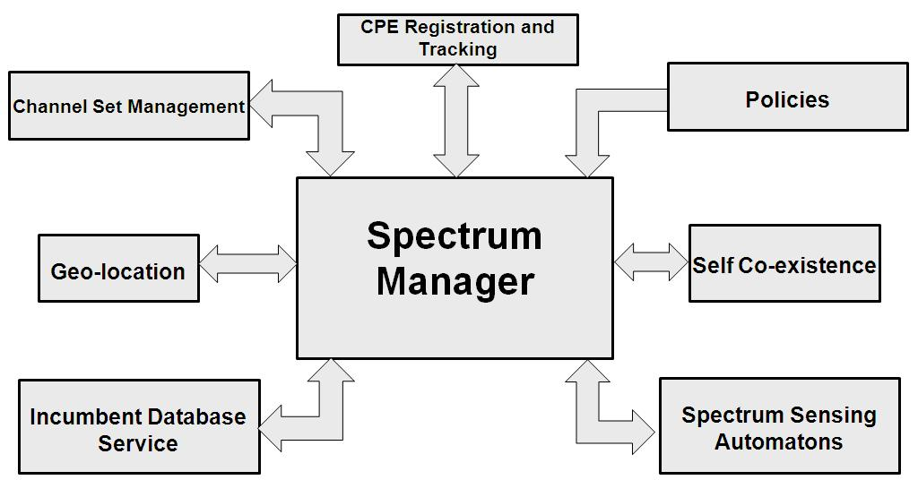
- — IEEE 802.22 Spectrum Manager and Logical Interfaces

All the 802.22 devices (BS and CPEs) shall also have an entity called the Spectrum Sensing Automaton (SSA). The SSA interfaces to the Spectrum Sensing Function (SSF) and executes the commands from the SM to enable spectrum sensing. The detailed operation of the SSA is described in Section 9.3. The following clauses describe the SM functionalities.

The SM is a central part of the WRAN BS, which shall be responsible for ensuring protection of incumbents and efficient spectrum utilization while complying with regulatory policies. For that, the SM centralizes all the decisions within the WRAN cell with respect to spectrum availability and utilization. In summary, the key functions of the SM are the following:

- Maintain spectrum availability Information;
- Channel classification and selection;
- Association control;
- Channel state management;
- Accessing the database service;
- Scheduling quiet periods for spectrum sensing;
- Enforcing 802.22 and regulatory domain policies
- Making channel move decisions for one or more CPEs or the entire cell
- Self-coexistence with other WRANs, etc.

These functions are described in the following clauses. It is important to note that this standard does not specify any particular SM implementation, but instead, it describes the mandatory behavior for any SM implementation in order to provide for proper protection of incumbents, compliance with regulatory domain policies, and interoperability amongst different WRAN implementations.
    - Maintain Spectrum Availability Information
The SM shall maintain the status of the spectrum (i.e. TV channels) available for WRAN operation at its location within a regulatory domain according to the policies and rules established for that domain (e.g. regulatory rules established by the FCC in the US for use of TV channels). The SM shall obtain information on the channel status with respect to the presence of incumbents and other WRANs in the area, and it shall use this information as input for its decisions with respect to channel selection, channel state management and self-coexistence mechanisms.

To maintain the status of the channels available for operation, the SM shall be able to aggregate information from at least the following sources:
- Incumbent database: The SM shall access incumbent databases through the higher layers. For the purposes of the 802.22 operation, a database containing location dependent available channels shall always exist. The SM shall be responsible for accessing an official incumbent database in the regulatory domains that mandate the presence of such a database. In the regulatory domains that do not mandate an official database, a database of available channels shall be provided by the operator.
- Geolocation: The SM shall be able to access geolocation information available at the BS to identify its own location, and it shall also be able to obtain location information from all CPEs associated with the BS or that are requesting association with the BS.
- Spectrum sensing: The SM shall interface with the Spectrum Sensing Automatons located within the BS and the CPEs. The SM shall use the MAC and PHY layer functionalities and management frames to control and coordinate spectrum sensing within the WRAN cell. The SM shall trigger the requests for the SSAs located within the BS and the CPEs to perform sensing and collect sensing reports. The SM shall combine the local sensing results with the results collected from CPEs.

The SM shall define the status of the channels with respect to the presence of incumbents by combining geolocation information, information from incumbent databases, and spectrum sensing results. For the purposes of the 802.22 operation, a database containing location dependent available channels shall always exist. When operating in a regulatory domain that does not require a database, all channels are initially assumed to be available. In this case, the SM shall define the status of the available channels based on spectrum sensing.

The channel availability information shall be defined during the network initialization and it shall be periodically updated during the network operation.

For example, in the US, the spectrum sensing information used to determine the channel availability status shall be updated every 2 sec for the operating channel and every 6 sec for backup channels. In addition, before the SM decides that a given channel is neither protected nor occupied based on spectrum sensing, it shall perform spectrum sensing of the channel at least every 6 sec within the last 30 sec. Although these values shall be used as default in the equipment, the actual values for these timings will depend on the regulatory domains and the specific values shall be obtained by the CPE through the MIBs at the time of initialization based on the regulatory classes as defined in Annex A.

    - Channel Classification and Selection
The SM shall assign the operating channel to the MAC/PHY modules in the WRAN. The SM shall also define the backup channel(s) and their corresponding priorities. The rest of the channels that are potentially available for operation, but that are not selected as the operating channel or as backup channel(s), may be classified as candidate, occupied or disallowed channel(s). The channels may be classified using the following categories:

Available: channels available for consideration for potential WRAN operation at a given location according to the official incumbent database service. Channels not deemed available by the databases are precluded for use by WRANs.

Available channels are further classified into one of the following categories:
- Disallowed: Channels that are precluded from use by the operator due to operational or local regulatory constraints.
- Operating: The current channel used for communication between BS and CPEs within a WRAN cell. The operating channel shall be sensed at least every 2 seconds for the signal types as required by a particular regulatory domain. The operating channel shall also be sensed every 2 seconds for the IEEE 802.22.1 wireless beacon in the regulatory domains where the operation of such a beacon is allowed.
- Backup: Channels that have been cleared to immediately become the operating channel in case the WRAN needs to switch to another channel. The BS may maintain multiple backup channels at any given time and shall order them according to their relative priorities. Backup channels shall be sensed for incumbent detection at least once every 6 seconds. A channel can stay in the backup channel list as long as no incumbent is found on this channel towards which harmful interference could be produced by the WRAN transmission.
- Candidate: Channels that are candidates to become a backup channel. These are channels that the BS may request the CPEs to sense to evaluate the possibility of elevating them to a backup channel status. Although sensing of candidate channels could be infrequent, before a candidate channel is elevated to backup channel, it must be sensed as incumbent-free at least every 6 seconds for no less than 30 seconds. If the first channel in the list can be confirmed to be clear of any incumbent operation towards which harmful interference could be produced by the WRAN transmission within the required time period, the base station can move it to the backup list if needed. The constitution of the candidate channel list relies on the extra time that the CPEs will have to do sensing beyond what is required to clear the backup channel list.
- Protected: Channels in which incumbent or the WRAN operation has been detected through sensing. Protected channels may be moved to the candidate channel set in the event that the incumbent or the WRAN systems have vacated the channel. Information from an incumbent database or sensing may be used for this purpose. A protected channel may also become a backup channel, but before a protected channel is elevated to backup channel status, it must be sensed as incumbent-free at least every 6 seconds for no less than 30 seconds. The SM should, when possible, determine the type of signals occupying every protected channel (see 9.2.5).
- Unclassified: channels that have not been sensed. These channels may be sensed according to the SM implementation. Once an unclassified channel has been sensed, it may be re-classified as protected or candidate channel depending on the sensing results.

For the above channel set as defined: “Disallowed”, “Operating”, “Backup”, “Candidate”, “Protected” and “Unclassified”, all the states in the set are exclusive to each other, i.e., a channel cannot belong to more than one state at a time. However, because of the WRAN self-coexistence mechanism, an operating channel for one WRAN system can also be the operating channel of another WRAN system (‘coexistence’) or belong to its backup or candidate list as explained in 9.2.3.1.

The specific algorithms for selecting the operating channel and defining how the backup and candidate channels are prioritized is outside the scope of this standard as long as these implementations meet the sensing requirements. However, any implementation of these algorithms shall use as input current channel availability information (as described in 9.2.2). Furthermore, other criteria may also be taken into account by the implementation, such as traffic requirements, location information, and coexistence with neighboring WRANs.
      - Transition Diagrams for Channel Sets
Each channel on the available TV channel list that is returned from the database service (see 9.7) belongs to one of the possible channel states by the SM. At the end of the quiet period, depending on the activity of incumbent users and channel quality each channel may transit to other states as shown by the state transition diagram in Figure 2. The transition diagram consists of 5 states and 9 events. The 5 states are described in 9.2.3. Note that these states are classified using spectrum sensing results obtained during WRAN initialization and operation. Therefore, disallowed and unavailable channels are omitted in this state transition diagram because those channels are classified by operator or database service. Possible Events for each state transition are described as follows:

Event 1: The channel in the operating, backup or candidate set becomes a member of the protected set as an incumbent is detected using spectrum sensing.
Event 2: Incumbent service releases the channel.
Event 3: No incumbent has been detected on this channel and the timing requirements for sensing as per the definition of the backup channel are satisfied by all CPEs reporting to the BS. (Furthermore, a prioritization among the back up channels can be made based on the measured channel quality.).
Event 4: The channel is released due to the termination of WRAN usage
Event 5: The channel becomes Operating by its new allocation to the WRAN service.
Event 6: The timing requirements for sensing are not satisfied as required by the definition of the backup channel by one or more CPEs. (Furthermore, a prioritization among the candidate channels can be made based on the measured channel quality.)

Event 7: Once an Unclassified channel has been sensed by all active CPEs, it can be re-classified as a Candidate channel by the SM if no incumbent service has been detected and reported within the predefined time duration
Event 8: If the channel is not sensed within the timing requirements as specified in the 802.22 standard or according to the regulatory domain requirements, the channel becomes Unclassified. (Note that a channel has to be sensed by all active CPEs within the pre-defined time duration and the results reported to the BS to not be considered as Unclassified.)

The following legend applies to the transition diagram depicted in Figure 2.
a) Ovals indicate the state of the channel (the channel set to which it belongs)
b) Transition lines (i.e., channel state transition) are labeled as Event / Action. Actions triggered by the events for this figure are the state transitions themselves, and so they have been omitted in this diagram.
c) The detailed explanation for each transition Event is given above.

- Channel set transition diagram
The channel set transition matrix is also presented in Table 250. Each row specifies the state transistion due to each event. Each column specifies state transition due to the events in each row for a particular current state.

A shaded cell within the transition matrix implies that either the specific event cannot or should not occur within that state. And if the event does occur, the SM shall ignore it. For example, the Candidate channel cannot transition to Operating channel directly.

- — Channel Set Transition Matrix
State  Events | Unclassified | Candidate | Backup | Operating | Protected
Event 1 | Protected | Protected | Protected | Protected
Event 2 |  |  |  |  | Unclassified
Event 3 |  | Backup
Event 4 |  |  |  | Candidate
Event 5 |  |  | Operating
Event 6 |  |  | Candidate
Event 7 | Candidate
Event 8 |  | Unclassified | Unclassified |  | Unclassified

      - Backup and Candidate Channel Prioritization Using Spectrum Etiquette
The channel selection at a cell obeys the spectrum etiquette rule so that the chosen channel does not interfere, or interferes with a minimum number of channels to be used by its neighbor cells. Without cooperation, the frequency selection in a cell may lead to one or more BS not having enough channels. For example, the available channel sets at BS1, BS2 and BS3 are {1, 3}, {1, 2, 3} and {1, 2, 3} respectively. If BS2 decides to use channel {1} and BS3 decides to use channel {3}, BS1 would have no channel to use. The cooperation also minimizes the channel collision probability when multiple cells switch their operational channels by avoiding use of the same backup channel set.

The channel-selection decision of each cell follows the flowchart in Error: Reference source not found. The terms of central cell and neighbor cells are relative concepts. Beside the definition of channel sets as in 9.2.3, the following additional channel sets are defined in spectrum etiquette operation:

- WRAN occupied Channel Set: channels that are operating channels of the discovered neighboring WRAN cell
- Neighbor WRAN Backup Channel Set: channels that are within the backup channel sets of the discovered neighboring WRAN cells. This channel set is built by listening to SCH/CBPs of the discovered neighboring cells carrying the backup channel information.
- Local Priority Set 1: = (Backup Channel Set U Candidate Channel Set) \ (WRAN-Occupied Channel Set U Neighbor WRAN Backup Channel Set)
- Local Priority Set 2: = (Backup Channel Set U Candidate Channel Set) \ (WRAN-Occupied Channel Set)
- Local Priority Set 3: = (WRAN-Occupied Channel Set)

Note that:
  - Symbols U, ∩, and \ are set operation of union, intersection, and exclusion, respectively.
  - Local Priority Sets 1~3 is local information, which is not shared with neighbor cells.

The spectrum etiquette is triggered by the following events:
- Incumbent discovery;
- Neighbor WRAN cells’ discovery/update;
- Operating channel switch demand; (e.g., due to interference);
- Contention request received from neighbor WRAN cells;
- Time-out for a predefined timer;
- Other predefined mechanism in implementation.

The procedure of WRAN spectrum etiquette is depicted in Error: Reference source not found and explained in the following item. Note that the triggering event is defined in the previous paragraph.
- The central builds/updates channel sets as described in Error: Reference source not found and 9.2.3, either by receiving indication from the geolocation database, or spectrum awareness of incumbents and WRANs. The neighboring WRAN occupied channel set and neighboring WRAN backup channel set are built/updated accordingly.
- Update backup channel set by choosing one or several channels from Local Priority Set 1; if Local Priority Set 1 is empty, update backup channel set by choosing one or several channels from Local Priority Set 2 which are backup channels by the least number of neighbor cells; (if several channels are backup channels of the same number of neighbor cells, the present cell shall choose from those channels randomly.) if Local Priority Set 2 is also empty, choose one or several channel from Local Priority Set 3 which are operating channels by the least number of neighbor cells; (if several channels are operating channels of the same number of neighbor cells, the present cell shall choose from those channels randomly.)
- If switching operating channel is necessary or demanded by higher layer indication (e.g., due to incumbent discovery in the operating channel, significant detected interference in the operating channel , or preferable channel quality of a backup channel, etc.), promote the first backup channel to operating channel; go to step 2 to update backup channel set;
- If the new operating channel is also an operating channel of a neighbor cell, initialize the coexistence contention procedure as described in Error: Reference source not found.
- Update the neighbor cells with new operating and backup channel sets via SCH/CBP.

The spectrum etiquette procedure is further illustrated using the example in Figure 3. The central cell has 6 neighbor cells. The central cell has one operating channel #1, one backup channel #2 (underlined), and one candidate channel #3 (double underlined). The channel sets information for the neighbor cells are accordingly noted as in Figure 3 (a). In Figure 3 (b), two incumbents appear in the central cell on the operating and backup channel, and thus the central cell is forced to change both its operating and backup channel. The spectrum etiquette is triggered. The former candidate channel #7 is promoted to operating channel, and channel #5 is promoted to backup channel, which is only used by one neighbor cell as the operating channel. All the neighbor cells perform spectrum etiquette after receiving the channel set update information from the central cell accordingly, and the resultant channel sets for each cell are illustrated in Figure 3 (b) and Table 2. If another incumbent appears in the central cell on channel #7, the central cell will have to use channel #5 as the operating channel and start contention based coexistence with its neighbor cell.
- Illustration of the procedure of spectrum etiquette

- — Illustration of the spectrum etiquette procedure

Central Cell Status | Before | Upon Incumbent Appearance | After Spectrum Etiquette
Operating Channel Set | 1 | 1 | 7
Backup Channel Set | 2 | 2 | 5
Candidate Channel Set | 7 | 3,4,5,6,7,8 | φ
WRAN-Occupied Channel Set | 3,4,5,6,8 | 3,4,5,6,8 | 3,4,5,6,8
Neighbour Backup Channel Set | 4,5,6,7,8 | 3,4,5,6,7,8 | 4,5,6,7,8
Local Priority Set 1: | 2 | 2 | φ
Local Priority Set 2: | 2,7 | 2,7 | φ
Local Priority Set 3: | 3,4,5,6,8 | 2,3,4,5,6,7,8 | 3,4,5,6,8

    - Association Control
Association is defined as the process by which the CPE completes the registration with the BS. When CPEs request association with a WRAN BS (see CPE initialization procedure described in 6.17.2Error: Reference source not found), the SM is responsible for granting or denying association rights to the requesting CPEs. For that, the SM shall consider location information, and basic and registered capabilities of each requesting CPE. The SM shall access the incumbent databases, to obtain the list of available channels and corresponding maximum EIRP limits at the CPE’s location, and based on the received information, the SM shall decide whether to grant association rights to the CPE in its current operating channel and indicate the maximum transmit EIRP allowed for the CPE. It is the responsibility of the SM to granting association rights to the requesting CPE while avoiding harmful interference to incumbents. The SM shall make a decision on CPE association during the CPE registration process (REG-REQ) if it is satisfied that the specifications and capabilities of the CPE are within the tolerable limits for it to join the network.

    - Spectrum Manager Policies
The SM shall be responsible for enforcing the 802.22 policies within the cell in order to guarantee the required protection of incumbents while supporting QoS for the WRAN users. The SM shall adhere to the policies as specified inTable 3.

Each of the policy in Table 3is identified using a Policy ID, the event that triggers the policy, the event description and the corresponding action.

Policies with enumeration 1 are related to the events initiated from the official incumbent database service but not from the locally generated operator database in case the local regulatory domain does not specify the use of such an incumbent database. For the purposes of the 802.22 operation, a database containing location dependent available channels shall always exist. When operating in a regulatory domain that does not require an official database, all channels are initially assumed to be available.

The SM shall be responsible for accessing an official incumbent database in the regulatory domains that mandate the presence of such a database. In the regulatory domains that do not mandate an official database, a database of available channels shall be provided by the operator.

Policies with enumeration 2 are related to an event that a TV signal is detected.

Policies with enumeration 3 are related to an event that a wireless microphone signal or the 802.22.1 beacon signal is detected.

Remaining policies are a combination of these earlier events or related to whether an 802.22 device is allowed to transmit under certain conditions.

The actions shall include:
- Switch the entire cell to a new operating channel;
- Direct a single CPE or a group of CPEs to a different operating channel when possible;
- Terminate operation in a given channel for a single CPE, a group of CPEs or the entire cell.

The SM shall use one of the channel management mechanisms defined in 9.2.3to execute the appropriate action.

Each channel management action may be triggered by one or more events. For instance, the action of switching channels for the entire cell may be triggered by the detection of an incumbent on the operating channel, by degradation of the QoS due to interference, or traffic load in the current channel.

Although different trigger events may be supported depending on the implementation, the trigger events and corresponding channel management actions shall be executed as described in Table 3 to provide protection of incumbents or as required by regulatory policies applicable within the regulatory domain.

- — Spectrum Manager Policies

Policy ID | 802.22 component involved | Event trigger | Event description | Action
1a | BS | OIDBS | If the SM is directed by the database service that the current operating channel is no longer available for the BS. | Set the Flag Initiate_Channel_Move to ‘1’. Initiate a channel switch of the entire cell to a new operating channel within (Tch_move - 0.5) seconds from the time when database informed the SM. The new operating channel should be the highest priority backup channel. Tch_move is to be found in Annex A for the various Regulatory domains where the WRAN operation takes place. The default value of the Tch_move shall be 2 seconds.
1b | CPE | OIDBS | If the SM is directed by the database service that the current operating channel is no longer available for some of the CPEs. | Option 1:  Set the Flag Initiate_Channel_Move to ‘1’. Initiate a channel switch of the entire cell to a new operating channel within (Tch_move - 0.5) seconds from the time when database informed the SM. The new operating channel should be the highest priority backup channel. The default value of the Tch_move shall be 2 seconds.  Option 2:  Dis-associate the CPEs that are not allowed to operate on the current channel within (Tch_move - 0.5) seconds from the time when the database informed the SM and continue normal operation with the other CPEs. A DREG-CMDwith Action Code = 0x04 (6.10.15), aimed at dropping their association on the current operating channel, shall be sent to these CPEs so that they no longer wait for an allocation in the US-MAP and/or transmit an opportunistic BW request UCS or Ranging request.Optionally, the BS may signal the affected CPEs to move to a particular channel using the DREG-CMD with Action Code = 0x00, in order to re-associate with another BS and continue their operation. The default value of the Tch_move shall be 2 seconds.
1c | BS | OIDBS | If the SM obtains information from an incumbent database that indicates the current operating channel will become unavailable for the BS at a specific time in the future. | Option 1:  Set the Flag Initiate_Channel_Move to ‘1’. Initiate a channel switch of the entire cell to a new operating channel no later than (Tch_move - 0.5) seconds after the time specified by the database. The new operating channel should be the highest priority backup channel. The default value of the Tch_move shall be 2 Seconds.  Option 2:  Dis-associate the CPEs that are not allowed to operate on the current channel within (Tch_move - 0.5) seconds after the time specified by the database and continue normal operation with the other CPEs. A DREG-CMD with Action Code = 0x04 (6.10.15) aimed at dropping their association on the current operating channel shall be sent to these CPEs so that they no longer wait for an allocation in the US-MAP and/or transmit an opportunistic BW request UCS or Ranging request. Optionally, the BS may signal the affected CPEs to move to a particular channel using the DREG-CMD with Action Code = 0x00, in order to re-associate with another BS and continue their operation. The default value of the Tch_move shall be 2 Seconds.
1d | CPE | OIDBS | If the SM obtains information from an incumbent database that indicates the current operating channel will become unavailable for some of the CPEs at a specific time in the future. | Option 1:  Schedule a channel switch for the entire cell to a new operating channel at least 0.5 seconds before the expected time (as obtained from the incumbent database) at which its current channel will become unavailable, by setting the Flag Initiate_Channel_Move to ‘1’. The new operating channel should be the highest priority backup channel.  Option 2:  If the channel is going to be unavailable for a period of time less than the CPE_Registration_Timer (6.17.9.xx), then temporarily dis-associate and disable the CPEs that are not allowed to operate on the current channel within (Tch_move - 0.5) seconds from the time when the database informed the SM and continue normal operation with the other CPEs. A DREG-CMD with Action Code = 0x01 shall be sent to the CPEs (see 6.10.15), so that the CPEs affected will shutdown their transmission and only listen on the channel. Later, the BS may signal the affected CPEs to move to return to normal operation on that channel using the DREG-CMD with Action Code = 0x03 in order to re-associate with another BS and continue their operation. If the period of unavailability is greater than the Resource Retain Timer, than the timer will expire and the CPE shall attempt re-association on the next available channel. The default value of the Tch_move shall be 2 seconds.
1e | BS | OIDBS | Where a database service exists for the regulatory domain of operation, if such a service becomes unavailable for greater than T_{NoDB} specified in Annex A for that domain (default value for T_{NoDB} shall be 1 hour). | The BS shall de-register its associated CPEs and terminate its own operation until the database service becomes available.
1f | CPE | OIDBS | Where a database service exists for the regulatory domain of operation, and if a new CPE is trying to register, | Do not allow the CPE to register to the network until the channel availability information is available.
2 | BS/CPE | Signal detected | If the signal detected on the operating channel or either of its first adjacent channels is a TV signal through the BS spectrum sensing function or through a combination of sensing results from multiple CPEs.  ¹ Detection threshold is to be found in Annex A for the various Regulatory domains where the WRAN operation takes place. | Note the information about the detection of TV signal and make it available according to the local regulatory requirements.  No  Set the Flag Initiate_Channel_Move to ‘1’. Initiate a channel switch of the entire cell to a new operating channel within (Tch_move - 0.5) seconds from the time when the TV signal was detected. The new operating channel should be the highest priority backup channel . The value for Tch_move is to be found in Annex B for the various Regulatory domains where the WRAN operation takes place. The default value of the Tch_move shall be 2 seconds.  Does the local  regulatory domain require to  vacate the channel on confirmation  of the presence of a  TV signal?  No further action  Yes
3a | BS/CPE | Signal detected | If the signal detected on the operating channel is a wireless microphone signal through the BS spectrum sensing function or through the sensing results from a CPE or a combination of multiple CPEs.²  ² The following action should apply to any of the nodes (BS or CPE) that detected the wireless microphone signal  Note: the variable Microphone Protection Radius (MPR) is defined in Annex A for the various Regulatory domains where the WRAN operation takes place. The default value of the MPR shall be 4 km. | Note the information about the detection of wireless microphone signal and make it available according to the local regulatory requirements.  Set the Flag Initiate_Channel_Move to ‘1’. Initiate a channel switch of the entire cell to a new operating channel within (Tch_move_wm - 0.5) seconds from the time when the wireless microphone signal was detected. The new operating channel should be the highest priority backup channel. The default value of the Tch_move_wm is to be found in Annex A for the various Regulatory domains where the WRAN operation takes place. The default value for the timer Tch_move_wm shall be 2 seconds.  Dis-associate the CPEs that are within the protected radius of the wireless microphone operation (Microphone Protection Radius - MPR) within (Tch_move_wm - 0.5) seconds from the time when the wireless microphone signal was detected and continue normal operation with the other CPEs. message DREG-CMD with Action Code = 0x04 (6.10.15), aimed at dropping their association on the current operating channel, shall be sent to these CPEs before dropping their association so that the CPEs no longer wait for an allocation in the US-MAP and/or transmit an opportunistic BW request, UCS or Ranging request. Optionally, the BS may signal the next channel to go to for the dis-associated CPEs before shutting down the communication. This is enabled by sending a DREG-CMD with Action Code = 0x01. The default value for MPR shall be 4 km.
3b | BS/CPE | Signal detected | If the signal detected on the operating channel is an 802.22.1 wireless microphone beacon signal .¹  ¹ The following action should apply to any of the nodes (BS or CPE) that detected the 802.22.1 wireless microphone beacon signal.  Note: the variable Microphone_Protection_Radius (MPR) is defined in Annex A for the various Regulatory domains where the WRAN operation takes place. The default value for MPR shall be 4 km.  Specific CPEs cease to operate or move  Option I (No Authentication) : BS skips the beacon authentication step and dis-associates the CPEs that are within less than MPR from the wireless microphone operation within (Tch_move - 0.5) seconds from the time when the 802.22.1 signal was detected and continue normal operation with other CPEs. A DREG-CMD MAC message shall be sent to these CPEs before dropping their association so that the CPEs no longer wait for an allocation in the US-MAP and/or transmit an opportunistic BW request, UCS notification or Ranging request.  Optionally, the BS may signal the next channel to go to for the dis-associated CPEs in the DREG-CMD message before shutting down the communication. The default value of Tch_move shall be 2 seconds. | Note the information about the detection of wireless microphone beacon signal and make it available according to the local regulatory requirements.  Complete cell move  Option I (No Authentication): BS skips the beacon authentication step. Set the Flag Initiate_Channel_Move to ‘1’ and initiate the switching of the entire cell to a new operating channel within (Tch_move - 0.5) seconds of the time when the beacon was detected. The new operating channel shall be the highest priority backup channel.  Option II (Authentication): A (Tch_move - 0.5) second timer is set. BS shall authenticate the beacon by scheduling quiet periods within (Tch_move - 0.5) seconds, ask the CPEs to capture the required portion of the 802.22.1 payload and decode the MSF1, MSF2, and/or MSF3 fields as found sufficient by the operator. If the 802.22.1 beacon is found to be authentic or (Tch_move - 0.5) seconds timer expires, then the BS shall initiate the switching of the entire cell to a new operating channel which should be the highest priority backup channel. If the beacon is found to be non-authentic, no action is taken. The default value of Tch_move shall be 2 seconds.  Specific CPEs cease to operate or move  Option I (No Authentication) : BS skips the beacon authentication step and dis-associates the CPEs that are within less than MPR from the wireless microphone operation within (Tch_move - 0.5) seconds from the time when the 802.22.1 signal was detected and continue normal operation with the other CPEs. A DREG-CMD MAC message shall be sent to these CPEs before dropping their association so that the CPEs no longer wait for an allocation in the US-MAP and/or transmit an opportunistic BW request, UCS or Ranging request. Optionally, the BS may signal the next channel to go to for the dis-associated CPEs in the DREG-CMD message before shutting down the communication. The default value of Tch_move shall be 2 seconds.  Option II (Authentication): A (Tch_move - 0.5) second timer is set. BS shall authenticate the beacon by scheduling quiet periods within (Tch_move - 0.5) seconds, ask the CPEs to capture the required portion of the 802.22.1 payload and decode the MSF1, MSF2, and/or MSF3 fields as found sufficient by the operator. If the 802.22.1 beacon is found to be authentic or (Tch_move - 0.5) seconds timer expires then the BS shall dis-associate the CPEs that are within MPR from the wireless microphone operation within (Tch_move - 0.5) seconds from the time when the 802.22.1 signal was detected and continue normal operation with the other CPEs. A DREG-CMD MAC message shall be sent to these CPEs before dropping their association so that the CPEs no longer wait for an allocation in the US-MAP and/or transmit an opportunistic BW request, UCS or Ranging request. Optionally, the BS may signal the next channel to go to for the dis-associated CPEs in the DREG-CMD message before shutting down the communication. If the beacon is found to be non-authentic, no action is taken. The default value of Tch_move shall be 2 seconds.
 |  |  | Option II (Authentication): A (Tch_move - 0.5) second timer is set. BS shall authenticate the beacon by scheduling quiet periods within (Tch_move - 0.5) seconds, ask the CPEs to capture the required portion of the 802.22.1 payload and decode the MSF1, MSF2, and/or MSF3 fields as found sufficient by the operator. If the 802.22.1 beacon is found to be authentic or (Tch_move - 0.5) seconds timer expires then the BS shall dis-associate the CPEs that are within MPR from the wireless microphone operation within (Tch_move - 0.5) seconds from the time when the 802.22.1 signal was detected and continue normal operation with the other CPEs. A DREG-CMD MAC message shall be sent to these CPEs before dropping their association so that the CPEs no longer wait for an allocation in the US-MAP and/or transmit an opportunistic BW request, UCS or Ranging request. Optionally, the BS may signal the next channel to go to for the dis-associated CPEs in the DREG-CMD message before shutting down the communication. If the beacon is found to be non-authentic, no action is taken. The default value of Tch_move shall be 2 seconds.
4 | BS/CPE | DB or Signal detected | If there is no backup channel available AND (if the database indicates that the current operating channel is not available or the signal detected on the operating channel is a wireless microphone or an 802.22.1 signal, or, in case of a TV signal, the signal is detected on the operating or any of its first adjacent channels) | Terminate the operation of the entire cell in the current operating channel within Tch_move seconds. The default value of Tch_move shall be 2 seconds.
5 | CPE | Signal detected | If before the CPE has registered with a BS on the same channel, the signal detected on the operating channel is a wireless microphone or an 802.22.1 signal, or, in case of a TV signal, the signal is detected on the operating or any of its first adjacent channels. | The CPE shall not transmit on that channel.
6 | CPE | Signal detected | If the signal detected on the operating channel is a wireless microphone or an 802.22.1 signal, or, in case of a TV signal, the signal is detected on the operating or any of its first adjacent channels and the CPE has already registered with the BS. | The CPE shall send a UCS to alert the BS of the presence of the detected signal in its coverage even if it did not plan to transmit because of the potential interference from the downstream transmission.
7 | BS/CPE | OIDBS or sensing | If the spectrum manager confirms the presence of any other device which is granted protection in the regulatory domain. | Comply to local regulations.
8 | Portable CPE | Geolocation | BS has determined that the position of the CPE has changed by greater than that specified by the local regulations (default +/-25 m) | BS shall request the CPE to geolocate and report its position to verify the change in location. If the location is confirmed to have changed, the BS shall immediately obtain a new list of available channels from the database service based on the new location of the CPE. If the service is prohibited for the affected CPE on the current operating channel at the new location then the BS shall de-register the CPE using DREG-CMD with Action Code = 0x04.

    - Spectrum Manager Operation
      - Spectrum Manager State Machine
- Spectrum Manager State Machine

Figure 4 describes the Spectrum Manager (SM) state machine diagram. The SM has two states of operation, namely, the SM at Network Initialization, and the SM at Network Operation.

The Timer T_{Wait_Before_Channel_Move} in the State SM at Network Initialization shall be initially set to a default value of 20 ms. However, the value of this timer shall be configurable in accordance with the other regulatory domain requirements as specified in the Annex A.

During the Network Initialization state, the primary responsibility of the SM shall be to find the operating channel.

Once the Timer T_{Wait_Before_Channel_Move} expires, the SM shall execute the Procedure SM_Find_Operating_Channel. The various tasks involved in order to find an operating channel have been illustrated in Figure 5.

In case, the SM at this stage already has an exclusive backup channel to operate on, the SM shall choose the operating channel based on spectrum etiquette as described in 9.2.3.2. The SM shall then execute the Procedure SM_Establish_Network in the Normal Mode and move to the State Spectrum Manager at Network Operation. This may happen when the SM was operating on some other channel before where it had already computed its backup channels, and now it is in a transition after it has initiated a channel move.

In case, no exclusive backup channels is available, the procedure to find an operating channel shall consist of accessing the incumbent database to obtain a list of available channels, discovering neighboring 802.22 systems, synchronizing and scheduling quiet periods, initiating sensing for the primary user signals and exploring the possibility to convert some of the available channel to an operating channel once the conditions in Clause 9.2.3 have been met.

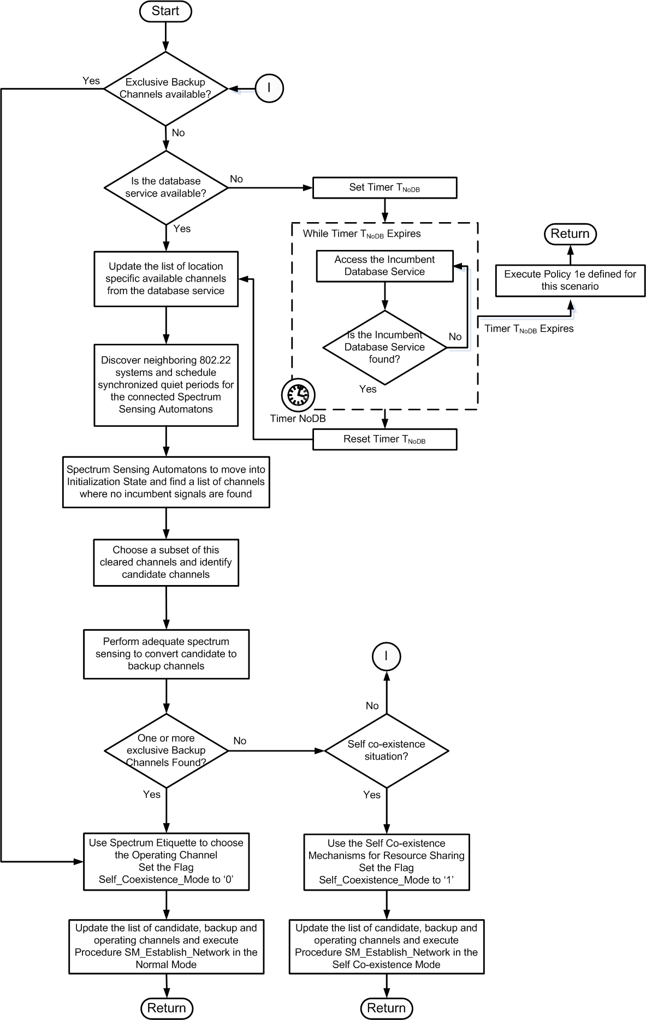
- Procedure Find_Operating_Channel

The SM shall make sure that the information from the database service has been refreshed within last T_{NoDB} minutes. If this is not the case, then it shall execute Policy 1e. Timer NoDB as specified in Procedure SM_Find_Operating_Channel indicates the longest time that a WRAN service can operate in the un-licensed band without refreshing the information from the incumbent database service. The timer values may be initially set to the United States regulatory domain, however they shall be configurable in accordance with the other regulatory domain requirements as specified in the Annex A.

The SM shall take into consideration the incumbent database service information, to find a list of available channels. The SM shall then synchronize its quiet periods to other 802.22 systems, schedule its own quiet periods and convey the quiet period information to the Spectrum Sensing Automatons through a Superframe Control Header (SCH) or an appropriate MAC message. The SSA shall move into the ‘Initialization State’ as described in 9.3.3. Based on the sensing information, the Spectrum Sensing Automatons shall provide the SM with a list of candidate channels as a subset of the available channels. The SM shall schedule further quiet periods to convert the list of candidate channels to backup channels.

A candidate channel shall become a backup channel and a backup channel shall become an operating channel based on the state transition diagram as specified in 9.2.3.

In case one or more exclusive backup channels are available, the SM shall choose an operating channel using spectrum etiquette as described in9.2.3.2. The SM shall set the Flag Self_Coexistence_Mode to ‘0’, execute the Procedure SM_Establish_Network and move to the State Spectrum Manager at Network Operation.

As soon as the SM moves to the State Network Operation, it shall set the Timer T_{Refresh_Database_Info}. The default value for the Timer T_{Refresh_Database_Info} shall be 1 hour, however, the value for this timer shall be configurable in accordance with the other regulatory domain requirements as specified in the Annex A.

In case no exclusive backup channels are found, the SM shall execute Procedure SM_Establish_Network in the Co-existence Mode. In this case, the SM shall set the Flag Self_Coexistence_Mode to ‘1’, execute the Procedure SM_Establish_Network and move to the State Spectrum Manager at Network Operation.

The Procedure SM_Establish_Network has been illustrated in Figure 6. Initially, the SM shall instruct the BS to synchronize to other 802.22 systems. If it is the Normal Mode of operation (Flag Self_Coexistence_Mode is ‘0’), the BS shall start transmission on the identified operating channel and wait for the CPEs to join the network. The CPE initialization operation and registration operation has been described in Error: Reference source not found and Error: Reference source not found respectively.

- Procedure Establish_Network

In the Self Co-existence Mode of operation, the BS shall execute Procedure SM_Self_Coexistence_Mode which is described below.

For each new CPE that has never before registered with the BS and that makes the registration request to the BS, the SM shall access the incumbent database service to verify if the current operating channel is available at the CPE location. In addition, the SM shall verify the security suite that the CPE supports and its spectrum sensing capabilities are within tolerable limits. If the SM finds that the current occupied channel is not available at the CPE location, or the CPE capabilities are less than required, it shall choose to prevent the CPE from registering to the network. The SM shall also track the location of the CPE in order to support portable operation and ensure that the operation of such a fixed or portable CPE is within the limits as specified in the regulatory domain requirements described in Annex A. Policy 8 in Clause 9.2.5 specifies the action to be taken in case the location of the CPE has been found to have changed.

The SM may also make a decision that in order to accommodate one or more such CPEs, it may need to move to another operating channel. In this case, the SM shall set the Flag Initiate_Channel_Move to ‘1’ and execute the Procedure SM_Initiate_Channel_Move. Figure 7illustrates the SM operation during Procedure SM_ CPE_Registration_and_Tracking.

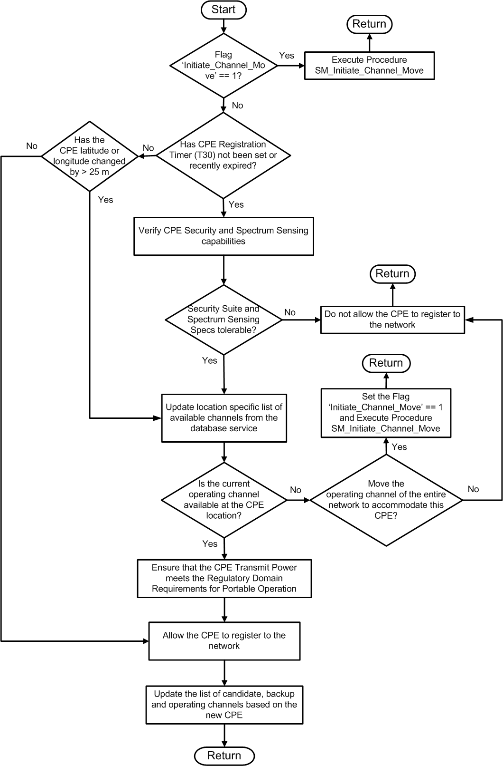

- Procedure SM_CPE_Registration_and_Tracking

In the event that the Timer T_{Refresh_Database_Info} expires, the SM shall execute Procedure SM_Database_Update has been illustrated in Figure 8. During this procedure, the SM shall verify that the current operating channel is available for itself and all its CPEs. If the current operating channel is available for the BS and all its associated CPEs, the BS shall continue the operation on the existing operating channel.

If the current operating channel is not available for the BS or one or more of its CPEs, the SM shall execute the policies as specified in the Spectrum Manager Policies in 9.2.5 and as shown inFigure 8. The SM shall also update the candidate and backup channel list based on the new information.

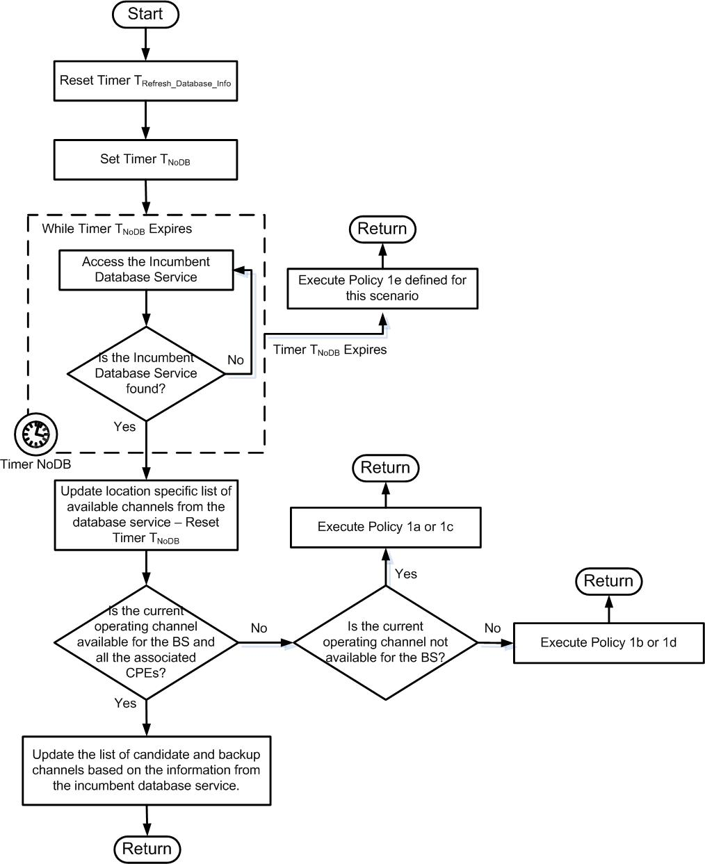
- Procedure SM_Database_Update

If the SM is notified that a signal is detected through the SSAs of the BS or one or more of its CPEs, the SM shall execute Procedure SM_Determine_Signal_Type_Execute_Policies. The Procedure SM_Determine_Signal_Type_Execute_Policies is illustrated in Figure 9. If a signal is detected, but its signal type cannot be determined, the SM shall schedule additional quiet periods for a larger spectrum sensing integration time. Based on the type of signal that is detected, the SM shall execute policies as specified in the Spectrum Manager Policies in 9.2.5.

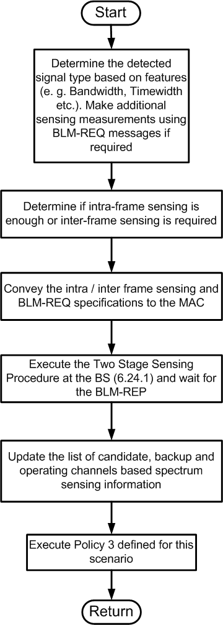
- Procedure SM_Determine_Signal_Type_Execute_Policies

SM shall constantly run the Procedure SM_Background_Processes. In this procedure, the SM shall be responsible for scheduling the quiet periods, assigning the sensing responsibilities to the corresponding SSAs, scheduling the CBP transmissions, scheduling the Self Co-existence Windows (SCWs) collecting the spectrum sensing reports (through BLM-REP), maintaining the channel state information, monitoring the link quality of various CPEs, and deciding if channel move is needed. The SM operation during Procedure SM_Background_Processes has been illustrated in Figure 10.

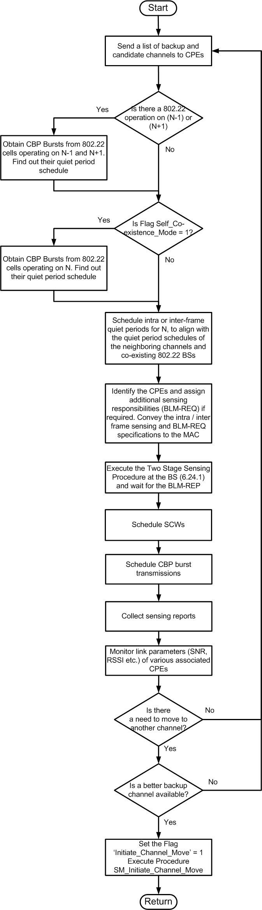
- Procedure SM_Background_Processes

In case the SM finds that there is a need to move to another channel, the SM shall Set the Flag Initiate_Channel_Move to ‘1’.

If the Flag Initiate_Channel_Move is set to ‘1’, then the SM shall execute Procedure SM_Initiate_Channel_Move. Procedure SM_Initiate_Channel_Move has been illustrated in Figure 11. During the execution of this procedure the SM shall reset the Flag Initiate_Channel_Move to ‘0’. If exclusive backup channels are available, the SM shall update the list of operating, candidate and backup channels, and execute Procedure SM_Establish_Network.

In case no exclusive backup channels are available, the SM shall execute Procedure SM_Find_Operating_Channel.

- Procedure SM_Initiate_Channel_Move

If the Flag Self_Coexistence_Mode is set to ‘1’, then the SM shall execute Procedure SM_Self_Coexistence_Mode as illustrated in Figure 12. During the Procedure SM_Self_Coexistence_Mode, the SM shall choose a BS to share the channel with, or allow another BS to share its own channel, alert the CPEs that the BS is in the Self Coexistence Mode via the Superframe Control Header (SCH), and assist the BS in executing Procedures that are defined in Error: Reference source not found on self co-existence mechanisms. In case an exclusive backup channel becomes available, the SM shall reset the Flag Self_Coexistence_Mode to ‘0’.

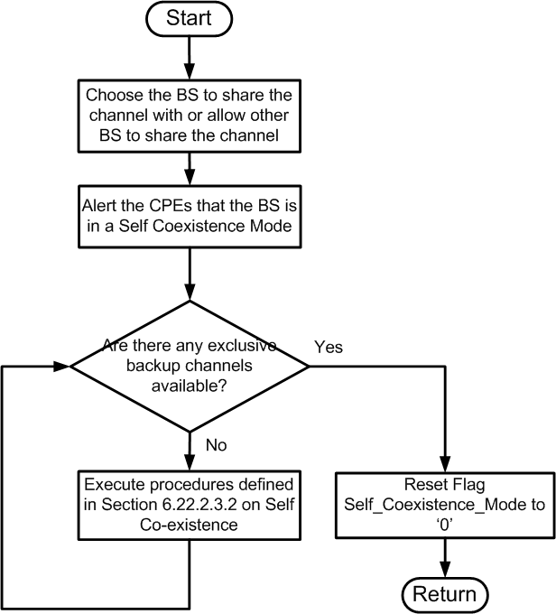
- Procedure SM_Self_Coexistence_Mode

  - Spectrum Sensing automaton (SSA)
All the P802.22 devices (BS and CPEs) shall also have an entity called the Spectrum Sensing Automaton (SSA). The SSA interfaces to the Spectrum Sensing Function (SSF) and executes the commands from the SM to enable spectrum sensing. The BS controls the sensing behavior of the SSA. However the SSA shall control its sensing behavior locally under the following six conditions:
- at the initial turn-on of the BS before it starts to transmit any signal;
- at the initial turn-on of the CPE before association is established with the base station;
- during the quiet periods defined by the SM and signaled by the BS through the SCH for in-band sensing;
- when the base station is not transmitting, for out-of-band sensing at the BS;
- during idle time at the CPE when the base station has not attributed any specific task to either the CPE sensing signal path (through the BLM-REQ message, see Error: Reference source not found) and when the CPE does not transmit or the CPE does not transmit and receive if the WRAN operation and RF sensing use the same tuner; and
- when the CPE loses contact with its base station.

The functionality of the SSA for these six specific cases, and embodied in the local sensing automaton, is covered by the normative behavioral models described in the following sub-clauses.

    - SSA State Machine Operation

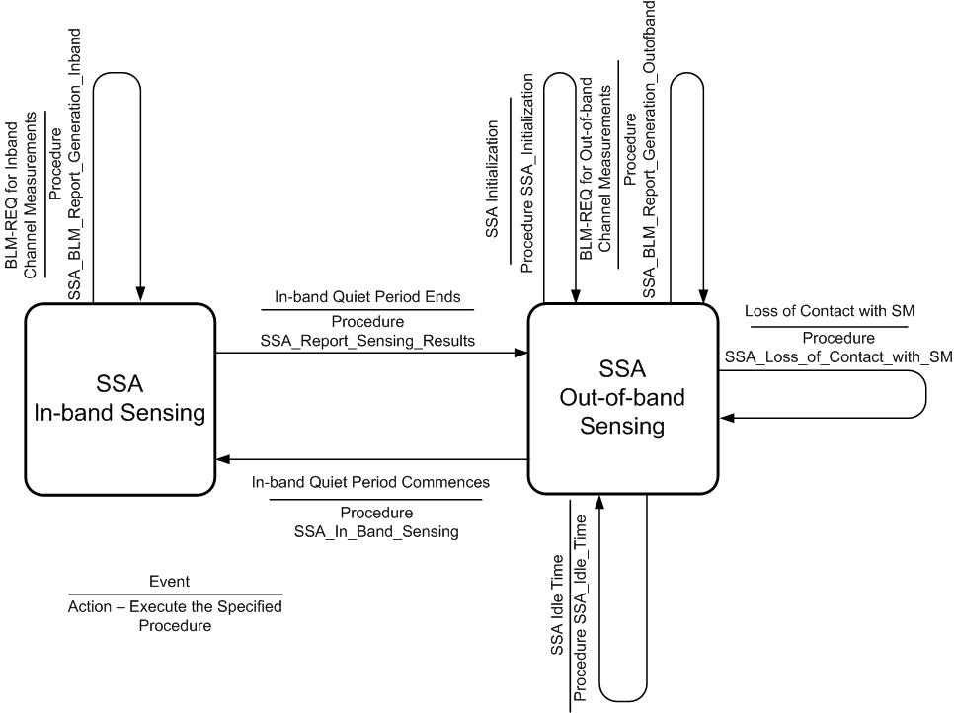
- — Spectrum Sensing Automaton State Machine Operation

The SSA State Machine operation is shown in Figure 13. The SSA state machine consists of two states. ‘SSA In-band Sensing’ and ‘SSA Out-of-band Sensing.’ During the SSA Out-of-band Sensing state, the SSA may execute any of the three procedures as described in the Sub-clauses 9.3.3, 9.3.4 and 9.3.16, based on the event that may have occurred.

During the Spectrum Manger scheduled in-band quiet periods, the SSA shall control in-band sensing on channels N and N+/-1.

    - Procedure SSA_In-band_Sensing
The SM at the BS is responsible for scheduling the in-band (channels N and N±1) quiet periods. The SSA shall autonomously utilize those quiet periods to perform in-band spectrum sensing and report the results of incumbent discovery to the SM.

Once a Quiet period is scheduled by the SM and signaled by the SCH to the CPE, the CPE will first verify if the sensing timers have lapsed since the last sensing on channels N or N±1. An urgent MAC message [still to be defined] will be sent to the BS to ask the SM to increase its scheduling of the quiet periods. Then, the SSA will verify that this quiet period is sufficiently long to initiate in-band sensing. This length will depend if the local capability of the sensor at the CPE. Depending on the sensing technology used, sensing may need to be done in a ‘contiguous’ fashion to reach the required sensing threshold or with a minimum time segment width to be able to aggregate a number of sensing instances to reach the required sensing threshold. If the quiet period that is scheduled is shorter than required, the SSA will have to skip sensing for that specific period. (Note that other CPEs that require less time to carry out sensing proceed with their sensing.)

If the sensing period is sufficiently long, the SSA shall undertake the sensing on N and N±1where needed. Once the quiet period is over, the in-band sensing shall be put on hold. At the start of the next scheduled quiet period, the SSA shall resume its in-band sensing activity by scanning successively N, N+1 and N-1 until it has reached the required sensing threshold. As a result, if an incumbent is discovered, the SSA shall either use the UCS flag in the header of its next upstream PDU (see 6.8.1.1) to signal the presence of the incumbent in the channel or, if no bandwidth has been allocated to it in the current upstream sub-frame but an opportunistic UCS Notification window has been scheduled (either CDMA or contention-based, see 6.10.4.1.1), it shall send a UCS Notification to the BS. The SSA shall also report the channel where the incumbent is detected using the CN subheader (see Table 4). If neither of the conditions exist, the SSA shall then wait to report on the next frame s when the opportunity is given.

At the start of every scheduled quiet period, the SSA shall verify whether channel N has been identified as empty in the CHO-UPD message (i.e., it is known that there is no incumbent in this channel). If it is the case, sensing on N can be skipped. It shall then verify that the sensing on the operating channel has been terminated, and if yes, whether it has been terminated since less than the repetition time required by the local regulator (see Annex A). It shall continue its sensing on the operational channel if not finished, re-initiate its sensing on the operational channel if the time lapsed since the previous completed sensing is larger than the specified repetition time. Otherwise, the SSA shall skip to N+1 and repeat the verification process, and then N-1.

- Procedure SSA_Inband_Sensing
    - Procedure SSA_Initialization
The functionality of the SSA local autonomous spectrum sensing process, when the BS is initially switched or the CPE is initiated before association with the base station, is described below and depicted in . This process is part of the more general BS and CPE initialization process described in sections BS initiation and CPE initializationError: Reference source not found. At initial turn-on and self-test, the SSA shall sweep a specific channel, a specified range of channels or all the channels that are likely to be impacted by the WRAN operating on a given channel depending on the pre-set at the BS or CPE or direction from the higher layers at the BS or CPE. If all TV channels of a range of operation need to be sensed, one additional channel at both ends of the range shall be sensed to cover the adjacent channel case unless it goes beyond the extent of the relevant TV band.

For each channel, an RSSI measurement shall be performed on the WRAN signal path and attempt shall be made to capture a WRAN superframe header or a CBP burst. If an SCH is captured and the level of the RF signal is sufficiently high (see Table 16), the WRAN signal path shall attempt to acquire the frame header, the broadcast PDU’s sent by the BS to advertise the WRAN service for BS and CPE initialization and channel occupancy provided from the base station by the CHO-UPD management packet. If an SCH can be acquired but the signal level is insufficient or a CBP burst can be captured, the presence of a WRAN signal shall be recorded along with the channel number and the measured RSSI. If an SCH or a CBP burst cannot be detected, RF signal sensing and signal classification shall be carried out to determine the presence of broadcast incumbents and their signal type. The result of the measurement and the signal classification shall be provided to the SM at the BS or stored locally at the CPE so that it can later be sent to the base station when association is established or later on upon request from the BS.

The channel shall then be incremented and the above initial sensing shall be repeated. The order in which the channels are to be sensed will be implementation dependent. Note that the channel occupancy list acquired from the SM can be used to skip the channels where no incumbent is known to be present.

Once all the TV channels to be scanned have been sensed, the information on the local WRAN channel occupancy that would not create interference to local incumbents on channels N and N±1 shall be made available to the higher layers at the BS and CPE. If there is no WRAN channel that can be used at the location of the device, its initialization shall be aborted. Depending on the device implementation, the information obtained from the various WRAN base stations may be presented to the local interface so that it could ultimately be displayed on a local screen to allow for an informed selection among available channels at the BS or local WRAN networks (similar to the Access Point selection in Wi-Fi) at the CPE. Local algorithms could also be implemented in the CPE to automate the process for choosing the WRAN network.

A second round of spectrum sensing shall then take place on the selected channel (N₀) and its adjacent channels (N₀+/-1). The WRAN signal path shall try to acquire an SCH or CBP burst to determine the timing of the quiet periods of a WRAN signal in this channel. If a WRAN signal is detected, RF signal sensing and signal classification shall then be carried out on channel N₀ by the sensing path during the quiet periods to verify the presence and attempt identification of incumbent service underneath the WRAN service at the specific device location.

The sensing process shall then move to sense the two adjacent channels during the quiet periods by sensing the presence of an incumbent signal and classifying its type. The findings shall be recorded and if incumbents are found in these channels, the selected channel shall be removed from the list of available WRAN services and the updated list shall be presented to the higher layers for the selection of another WRAN service. If no more WRAN service exists, the initialization shall be aborted. If no incumbent is present in the three channels, the initialization process shall continue as described in section on BS initialization or CPE initializationError: Reference source not found.

In the case of the CPE initialization, if the authorization is refused by the currently selected base station, the currently selected channel shall be removed from the list of available WRAN services at the CPE (entry “A” in ) and this list shall be presented to the higher layers at the CPE for a new channel selection to be made. Then, the next round of sensing process shall be repeated with the sensing of the newly selected channel (N₀) and its adjacent channels (N₀+/-1) as described above. If no incumbent is present in the three channels, the CPE initialization process shall continue as described in Error: Reference source not found.

Flow diagram Procedure SSA_Initialization

    - Procedure SSA_Idle_Time
In addition to being able to carry out the in-band sensing process and any higher priority sensing requests coming from the base station through the specific MAC messages described in Error: Reference source not found, the SSA shall have the necessary local routines to autonomously sense the TV channels in its backup/candidate channel list in the proper order of priority during its idle time. This process is described below and depicted in .

The SSA shall begin its autonomous sensing operation by sensing the first channel in the backup/candidate channel list. If the last sensing has been carried out less than T_{OUTsens}earlier, the sensing on this channel can be skipped. The next channel is then selected in the order of the backup/candidate channel list. The SSA shall try to go as deep as possible in the backup/candidate channel list given the amount of idle time provided for local sensing.

A measure of the depth reached by the local out-of-band sensing process shall be kept at the BS and at each CPE to keep track of the number of channels that the SSA has been able to ‘clear’, i.e., verify that there is no incumbent on the channel and its two adjacent channels within the validity period, between any interruption from the base station. After any interruption, the automaton shall restart its out-of-band sensing process with the first backup channel and the depth will track the number of channels that can be ‘cleared’ within the next . Due to the nature of the algorithm, this process will be directed to any channel reaching the end of its period of validity (T_{OUTsens} ) in order of priority from the first backup channel through the backup list and the candidate list.

Sensing through the WRAN signal path will be interrupted and the WRAN signal path will be re-tuned to the operating channel ‘N₀’ during the following intervals:
- Superframe headers
- Frame headers for the frames assigned to the base station to which the CPE is associated in a coexistence situation;
- Downstream frame at the BS;
- CPE receiving data during the DS subframe as signaled by the DS-MAP;
- CPE transmitting data during the US subframe as signaled by the US-MAP;
- CPE transmitting data during the opportunistic ranging/UCS notification/BW request window;
- CPE monitoring activity as requested by the base station for CBP packet capture;
- CPE transmitting activity as requested by the base station for CBP packet transmission.

For each channel ‘N’ for which the T_{OUTsens} validity period has lapsed, the SSA shall measure the RSSI on this channel ‘N’ through its sensing path as well as through its WRAN signal path and attempt to capture the SCH or CBP burst of a WRAN transmission on that channel. If the SCH or CBP information can be decoded, the SSA will sense channels N, N-1 and N+1 during the appropriate quiet periods and record the channel number, the RSSI, the signal type (or noise if none is found) and the time at which the sensing took place.

If there is no WRAN operation on the channel being sensed or the signal level is too low to decode the SCH or CBP burst, the sensing process shall verify whether there is WRAN operation on the two adjacent channels by trying to capture the SCH or the CBP burst to be able to schedule its sensing during the quiet intervals of these WRAN operations. If no WRAN operation is found on channels N and N+/-1, sensing on channel is N is then carried out with no concern about quiet periods. Since signal sensing has to be done on the adjacent channels, if no WRAN operation can be detected on N and N+/-1, the sensing process shall verify whether there is WRAN operation on N+/-2 to be able to sense N+/-1 during the quiet intervals of N+/-2 because of possible adjacent channel leakage that could mask the presence of incumbents on N+/-1. Sensing on N-1 and N+1 will then be carried out at any time or during quiet periods depending on whether WRAN operation is found in N-2 or N+2 respectively.

As a result, the SSA shall send a warning to the SM at the base station directly if located at the BS or using the BLM-RSP message with the “Unavailable Backup Channel” IE to be sent during the bandwidth allocation assigned to the CPE in the US-MAP or using the opportunistic BW Request mechanism to allow sending this MAC message in a later frame if an incumbent appears on one of the backup channels. Furthermore, if the depth reached by the SSA at the time of an interruption is less than the depth of the backup list, the SSA shall advise the SM directly if located at the BS or use the BLM-RSP message with the “Backup channel list clearance depth” IE to be sent during the US bandwidth allocation assigned to the CPE in the US-MAP or using the opportunistic BW Request mechanism to allow sending this MAC message in a later frame to warn the BS. Otherwise, the SSA shall be prepared to provide the information on its current sensing depth directly to the SM if located at the BS or with the BLM-RSP message with the IE “Backup/candidate channel list clearance depth” upon reception of the normal BLM-REQ MAC message whenever the base station requests it. This information collected by the base station from all SSA’s will be used to adjust the size of the backup channel list. The base station will be responsible for reserving sufficient idle time in the scheduling of the data traffic towards each of its CPEs to allow them the time to verify the availability of the backup channels and some extra candidate channels if possible.

Flow diagram for Procedure SSA_Idle_Time

    - Procedure SSA_Loss_of_Contact_with_SM
If the CPE looses contact with its base station, the SSA local intelligence shall make sure that a reasonable number of attempts are made to re-connect with the base station, while avoiding potential interference to licensed incumbents. The functionality of the SSA located at the CPE is summarized below for the loss of contact with the base station and depicted in 9.3.14.

The SSA shall first identify whether or not a WRAN signal is still present on the selected channel by trying to capture the superframe header (SCH). If successful within 2 seconds, attempts to re-associate shall be made through the BW Request opportunistic burst or upon specific invitation by the BS. If this does not work, the re-association shall start from an earlier stage with the CDMA ranging burst (entry ‘C’ in ). If re-association cannot be achieved within 2 seconds, then the CPE shall execute the second round of initial sensing for the co-channel and first adjacent channels cases to protect any broadcast incumbent that may have appeared in the affected channels since the loss of connection with the base station (entry ‘B’ in ).

If the WRAN signal is no longer present in the channel, then the CPE shall select the next TV channel in its back-up list and try to capture the SCH to synchronize with the base station on this new channel. If successful within 2 seconds, attempts to re-associate shall be made through the BW Request opportunistic burst or upon specific invitation by the BS, or through the earlier stage of the CDMA ranging burst (entry ‘C’ in ).

If the SCH capture on the new channel is not successful, then the CPE shall select the next TV channel on its backup list and repeat the process until a successful superframe capture is achieved. If re-association on all the valid channels in the backup list has failed, the CPE shall re-start its entire initialization process (entry ‘D’ in ).

- Flow diagram for Procedure SSA_Loss_of_Contact_with_SM

    - Example of sensing information representation at the SSA
Once association has been achieved, the base station may request the SSA to send the complete results of the initial sensing or any update thereof at anytime directly to the SM if located at the BS or using the BLM-REQ PDU if located at the CPE. The SSA will therefore need to keep the latest information stored by the sensing process in its local registers at all times. Table 4 gives an example of a possible representation of the information that needs to be stored locally. The SSA shall be capable of reporting the information from all rows of the table except for the two last rows that contain information obtained from the base station.

- — Example of sensing registers at the CPE
Channel number | … | 25 | 26 | 27 | 28 | 29 | 30 | …
Time of last sensing
Time of last positive
Sensing path RSSI
WRAN path RSSI
Signal type
WRAN service advertisement
Sensing path RSSI under WRAN
Signal type under WRAN
Channel occupancy from BS (CHO-UPD)

  - Spectrum Sensing
Spectrum sensing is the process of observing the RF spectrum of a television channel to determine its occupancy (by either incumbents or other WRANs).

The base station and all CPEs shall implement the Spectrum Sensing Function (SSF).

The SSF shall be driven by the SSA. The SSF shall observe the RF spectrum of a television channel and report the results of that observation to the SM (at the BS) via its associated SSA. The Spectrum Sensing Function (SSF) is described in Sub-clauses 9.4.1. The primitives for the SSF are described in 9.7.
    - The Spectrum Sensing Function (SSF)
The Spectrum Sensing Function observes the RF spectrum of a television channel for a set of signal types and reports the results of this observation. The spectrum sensing function is implemented in both the base station and the CPEs. There are MAC management frames that allow the base station to control the operation of the spectrum sensing function within each of the CPEs. Figure 16 illustrates the inputs and outputs of the spectrum sensing function.

The inputs to the spectrum sensing function come from the spectrum manager (SM) via SSA. The inputs to the spectrum sensing function are described in Sub-clause 9.4.1.1. The outputs from the spectrum sensing function are returned to the SM via SSA. The outputs of the spectrum sensing function are described in Sub-clause 9.4.1.2. The behaviour of the spectrum sensing function is described in Sub-clause 9.4.1.3.

Some of the possible sensing techniques that can be used to realize the spectrum sensing function are described inAnnex B. The use of any specific sensing technique is optional, as long as the inputs, outputs and behaviour meet the specification of this sub-clause.
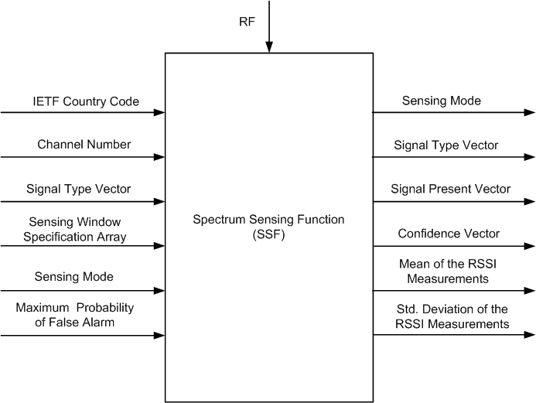

- The Spectrum Sensing Function
      - SSF Inputs
A summary of the spectrum sensing inputs is given in Table 5.

- — The Spectrum Sensing Function Input Signals
Input Name | Input Description | Length (bits) | Values
RF | Radio Frequency signal from the sensing antenna | N/A | N/A
IETF Country Code | Regulatory Domain of Operation | 16 | ASCII Characters –e.g., US represents United States of America
Channel Number | The channel number which is to be sensed by the SSF | 8 | 0-255
Channel Bandwidth | The bandwidth of the channel to be sensed by the SSF | 4 | 0000 = 6 MHz  0001 = 7 MHz  0010 = 8 MHz  0011 – 111 = Reserved
Signal Type Array | An array indicating the signal types for which the SSF is to sense | 32 | Described in Table 6
Sensing Window Specification Array | An array of sensing window specifications. Each SFS specifies the details of the sensing window for a given signal type being sensed | N*32, where N is the number of signal types enumerated in Signal Type Array. The 24 bits cover the NumSensingPeriods, SensingPeriodDuration &SensingPeriodInterval. | Ranges for values given in Table 298:Bits #0-7: NumSensingPeriodsBits #8-17: SensingPeriodDurationBits #18-31: SensingPeriodInterval
Sensing Mode | The sensing mode specifies which SSF outputs are valid and in some cases it specifies the behaviour of the SSF | 2 bits | Sensing modes specified in Table 8
Maximum Probability of False Alarm) | In sensing modes 0 and 1 this value specifies the maximum probability of false alarm for each sensing mode decision in the signal present array | 8 bits | Maximum Probability of False Alarm – 0x00 indicates ‘0’ and 0x01 indicates ‘0.001, and 0xFF = 0.255

The RF input is connected via an RF stage to the WRAN sensing antenna.

The IETF Country Code defines the regulatory domain of operation. For example, the IETF Country Code ‘US’ corresponds to the regulatory domain of the United States.

The channel number is the relative television channel number that the SSF is to sense. The center frequency for each channel number and the exact mapping between the relative channel number and the absolute channel number are given in Annex A.

The channel bandwidth is the bandwidth of the television channel that the SSF is to sense.

The signal type array (STA) indicates which signal types that are to be sensed for by the SSF. The array is a one-dimensional array of length STALength, indexed from 0 to STALength -1. The STA is a binary array whose elements are either zero or 1. The i-th element in the array specifies whether the SSF is to sense for i-th signal type. The mapping of STA index to signal type is given in Table 6.

The value of STALength is 32 and can be represented using 4 octets.
- — Signal Type Array Indices
STA Index | Signal Type
0 | Undetermined
1 | IEEE 802.22 WRAN
2 | ATSC
3 | DVB-T
4 | ISDB-T
5 | NTSC
6 | PAL
7 | SECAM
8 | Wireless Microphone
9 | IEEE 802.22.1 Sync Burst
10 | IEEE 802.22.1 PPDU MFS1
11 | IEEE 802.22.1 PPDU MSF2
12 | IEEE 802.22.1 PPDU MSF3
13-32 | Reserved

A one in index zero of the STA indicates sensing for any signal type, with no distinction between signal types. A one in index one of the STA indicates the SSF should sense for an 802.22 WRAN.

As an example, if the STA is given as follows:

STA= (0010111000000000…00)

then the SSF shall sense for an 802.22.1 Sync Burst, an ATSC signal, and NTSC signal and a wireless microphone. The regulatory class annex A specifies that, depending upon the regaultory domain of operation, some STA indices in the STA shall be set at all times.

The sensing window specification array (SWSA) is a two-dimensional array of length STA Length NX32. Each row of the SWSA is a sensing window specification (SWS). If the i-th element of the STA is one (1) then the i-th row of the SWSA shall be set to a valid sensing window specification. If the i-th row of the STA is set to zero (0) then the i-th row of the SWSA does not need to be set to a valid SWS since it will be ignored by the SSF.

A sensing window specification (SWS) consists of three parameters. These three parameters specify the window of time over which the SSF shall sense for specified signal type. Figure 17 illustrates a sensing window.

A sensing window consists of NumSensingPeriods number of sensing periods. The minimum number of sensing periods is one and the maximum number is 255. This maximum number is based on the need to avoid that a rogue BS could bring down other co-existing co-channel BSs in the area by excessive scheduling of quiet periods.

Each sensing period is of duration SensingPeriodDuration symbols and adjacent sensing periods are separated by SensingPeriodInterval symbols as shown in Figure 17.

The parameters in a sensing window specification are given in Table 7. Such sensing window can occupy a portion of a quiet period, an entire quiet period or multiple quiet periods.

The details on how quiet periods are scheduled are found in Error: Reference source not found.

- Sensing Window

- — Bounds of Sensing Window Specifications
Parameter Name | Range | Units | Value
NumSensingPeriods | 0 to 255 | integer | comes from SM or SSA
 |  |  | Default = 1, Cvalues from 128 to 255 are reserved
SensingPeriodDuration | 0 to 1023 | symbols | comes from SM or SSA
 |  |  | Default = 16 symbols
SensingPeriodInterval | 0 to 2047 | frames | comes from SM or SSA
 |  |  | Default = 200 frames

Quiet periods are scheduled by the MAC layer. Quiet periods can be scheduled using the superframe control header as described in Clause Error: Reference source not found. Also, quiet periods can be scheduled using the channel quiet request message, as described in Clause Error: Reference source not found. A general discussion on quiet periods can found in Clause Error: Reference source not found

The aggregate of all quiet period durations within which a spectrum sensing technique meets the required detection threshold for any signal type specified in Table 6 shall not exceed 200 ms. The processing latency to detect any signal shall not exceed 2 seconds.

The sensing mode specifies which outputs of the SSF are valid and in some cases the behavior of the SSF. Table 8 summarizes the valid SSF outputs for each of the sensing modes. The table also includes a description of each sensing mode.
- — Summary of the Sensing Modes
Sensing Mode | Valid SSF Outputs | Description
0 | Signal Present Array | For each signal type the SSF generates a binary decision as to whether the signal is present in the television channel
1 | Signal Present Array  Confidence Array | Same as sensing mode 0 with the addition of a confidence metric for binary decision
2 | Mean and standard deviation of the measured RSSI | For each signal type the SSF generates an estimate of the mean and standard deviation for up to 255 instantaneous RSSI measurements on a specified channel (see Error: Reference source not found).

Sensing Mode 0 is mandatory at the BS and the CPE.

Sensing Mode 1 is optional at the BS and the CPE.

Sensing Mode 2 is optional at the BS and the CPE.

The maximum probability of false alarm input specifies the behaviour of the elements of the signal present array when no signal is present on the RF input. The details of the behaviour of the SSF, and its dependence on this input parameter, are given in Clause 9.4.1.3.
      - SSF Outputs
The sensing mode and the signal type array are passed through the SSF. These parameters indicate which of the other SSF outputs are valid and hence are useful for subsequent processing. The MAC messages for specifying the sensing measurement report structure are covered in Clause Error: Reference source not found. There is a general description of sensing measurement reporting in Clause Error: Reference source not found.

The signal present array is a one-dimensional array of length STALength. Each element in the array is a signal present decision. Each decision can take on three possible values, which are given in Table 9. The i-th signal present decision corresponds to the i-th signal type as listed in Table 6.
- — Values of the Signal Present Decision
Value of Signal Present Decision | Length (bits) | Value of Signal Present Decision | Description
TRUE | 8 | 0xFF | SSF decided that the signal is present in the channel
FALSE | 8 | 0x00 | SSF decided that the signal is not present in the channel
NODECISION | 8 | 0x7F | The SSF makes no decision regarding the presence of the signal in the channel. This is the output when the SSF was not instructed to sense for the signal type.

The confidence array is a one- dimensional array of confidence metrics. The i-th confidence metric indicates the confidence in the i-th signal present decision. A confidence metric varies between a minimum of zero (0x00) indicating no confidence in the signal present decision and a maximum of 255 (0xFF) indicating total confidence in the signal present decision. The range of a confidence metric is given in Table 10 and shall be represented by an 8-bit variable. The Variable Confidence Metric at the present time shall always assume a value of 0x00 or 0xFF, and all other values are reserved.
- — Range of a Confidence Metric
Limit | Value | Description
Minimum confidence metric | 0x00 | No confidence in SPD
Maximum confidence metric | 10xFF | Total confidence in SPD

The RSSI measurement results are stored in a one-dimensional array of up to M instantaneous measurement results at the SSF for a channel. The integration time to acquire each RSSI measurement shall be set to a default 2 ms.. The representation of the multiple RSSI estimates at the SSF is given in Table 11 for a 8-bit resolution.
- — RSSI Measurements
Limit | Length (bits) | Value | Units | Description
RSSI | M X 8 | Signed Integer | dBm | Up to M RSSI measurements. M can be as large as 255. These RSSI shall be measured in dBm and shall be normalized for a 0 dBi antenna gain and 0 dB coupling and cable loss. Signed in units of dBm in 0.5 dB steps ranging from –104 dBm (encoded 0x00) to +23.5 dBm (encoded 0xFF). Values outside this range shall be assigned the closest extreme.

When the SM requests a number of repeated measurements through the BLM-REQ MAC message (see Error: Reference source not found), the SSF shall calculate the mean for the M values acquired in the RSSI one-dimentional array. The standard deviation for these M values shall also be calculated and will represent the dynamic aspect of the RSSI during the M measurements. The range of the mean and the standard deviation of the RSSI measurements that will be reported by the SSF in the BLM-RSP MAC message (see Error: Reference source not found) is given in Table 12.
- — Range of the Mean and Standard Deviation of a Field Strength Estimate Error
Parameter | Length (bits) | Value | Units | Description
RSSI | 8 | Signed Integer | dBm | Mean of the M RSSI measurements. Signed in units of dBm in 0.5 dB steps ranging from –104 dBm (encoded 0x00) to +23.5 dBm (encoded 0xFF). Values outside this range shall be assigned the closest extreme.
Standard Deviation | 8 | Integer | dB | Standard Deviation of the M RSSI measurements. Expressed in units of dB in 0.1 dB steps ranging from 0.0 dB (encoded 0x00) to +25.5 dB (encoded 0xFF). Values beyond +25.5 dB shall be encoded as 0xFF.
      - SSF Behavior
In this clause all references to signal power shall refer to the signal power in dBm measured at the input of the sensing receiver.
        - Sensing Mode 0
When the sensing mode is set to zero (0) the only valid SSF outputs are listed in Table 13.
- — Valid outputs in Sensing Mode 0
Sensing Mode
Signal Type Array
Signal Present Array

The values of Sensing Mode and Signal Type Array shall be the same as their input values.

In sensing mode zero, if the i-th element of the signal type array is zero then the i-th element of the SPA shall be set to NODECISION.
- — Summary of SPA for Sensing Mode Zero with STA(i) set to 0
Sensing Mode | STA Index  i | Signal Type | STA(i) | SPA(i)
0 | 0 | Undetermined | 0 | NODECISION
0 | 1 | IEEE 802.22 WRAN | 0 | NODECISION
0 | 2 | ATSC | 0 | NODECISION
0 | 3 | DVB-T | 0 | NODECISION
0 | 4 | ISDB-T | 0 | NODECISION
0 | 5 | NTSC
0 | 6 | PAL
0 | 7 | Secam
0 | 8 | Wireless microphone | 0 | NODECISION
0 | 9 | IEEE 802.22.1 Sync Burst | 0 | NODECISION
0 | 10 | IEEE 802.22.1 PPDU MSF1 | 0 | NODECISION
0 | 11 | IEEE 802.22.1 PPDU MSF2 | 0 | NODECISION
0 | 12 | IEEE 802.22.1 PPDU MFS3 | 0 | NODECISION
0 | 13-32 | Reserved

In sensing mode zero if the i-th element of the signal type array is set to one and there is no signal present at the sensing antenna then the i-th element of the SPA shall be FALSE with probability greater than or equal to 1-MPFA , where MPFA is the maximum probability of false alarm for that signal as specified in the regulatory domain requirements, Error: Reference source not found. The i-th element of the SPA sshal be set to TRUE with probability less than or equal to MPFA. The regulatory domain requirements for various signal types, the minimum detection and maximum false alarm probabilities (MPFA) at specified signal power thresholds is provided in Error: Reference source not found.

The behavior of the SSF in sensing mode 0 with the i-th element of STA set to one and with no signal present at the sensing antenna is summarized in Table 15.
- — Summary of SPA for Sensing Mode Zero with STA (i) set to 1 with no Signal Present
Sensing Mode | STA Index  i | Signal Type | STA(i) | SPA(i)
0 | 0 | Undetermined | 1 | FALSE
0 | 1 | IEEE 802.22 WRAN | 1 | FALSE
0 | 2 | ATSC | 1 | FALSE
0 | 3 | DVB-T | 1 | FALSE
0 | 4 | ISDB-T | 1 | FALSE
0 | 5 | NTSC | 1 | FALSE
0 | 6 | PAL | 1 | FALSE
0 | 7 | SECAM | 1 | FALSE
0 | 8 | Wireless Microphone | 1 | FALSE
0 | 9 | IEEE 802.22.1 Sync Burst | 1 | FALSE
0 | 10 | IEEE 802.22.1 PPDU MSF1 | 1 | FALSE
0 | 11 | IEEE 802.22.1 PPDU MSF2 | 1 | FALSE
0 | 12 | IEEE 802.22.1 PPDU MSF3 | 1 | FALSE
 | 13-32 | Reserved

In sensing mode zero with the i-th element of the STA set to one and if the signal is present in the channel at the specified signal power level given in Table 16, the i-th output of the SPA shall be TRUE with probability as specified for that signal type in that regulatory domain. The regulatory domain requirements for various signal types, the minimum detection and maximum false alarm probabilities at specified signal power thresholds is provided in Error: Reference source not found..

The behaviour of the SSF output SPA is specified in Table 16.
- — Summary of SSF Outputs for Sensing Mode Zero
Sensing Mode | STA Index  i | Signal Type | STA(i) | Signal Power  (dBm) | SPA(i)
0 | 0 | Undetermined | 1 | -90 | TRUE
0 | 1 | IEEE 802.22 WRAN | 1 | -93 | TRUE
0 | 2 | ATSC | 1 | -114 | TRUE
0 | 3 | DVB-T | 1 | Not Available | TRUE
0 | 4 | ISDB-T | 1 | Not Available | TRUE
0 | 5 | NTSC | 1 | -114 | TRUE
0 | 6 | PAL | 1 | Not Available | TRUE
0 | 7 | SECAM | 1 | Not Available | TRUE
0 | 68 | Wireless Microphone | 1 | -114 | TRUE
0 | 9 | IEEE 802.22.1 Sync Burst | 1 | -117 | TRUE
0 | 10 | IEEE 802.22.1 PPDU MSF1 | 1 | -117 | TRUE
0 | 11 | IEEE 802.22.1 PPDU MSF2 | 1 | -117 | TRUE
0 | 12 | IEEE 802.22 1 PPDU MSF3 | 1 | -109 | TRUE

        - Sensing Mode 1
When the sensing mode is set to one, the only valid SSF outputs are listed in Table 17.
- — Valid outputs in Sensing Mode 1
Sensing Mode
Signal Type Array
Signal Present Array
Confidence Array
The values of sensing mode, signal type array and signal present array shall be the same as in sensing mode 0.

If the i-th element of the signal type array is set to zero then the i-th element of the confidence array is set to 0.

If the i-th element of the signal type array is set to one then the i-th element of the confidence array is a confidence metric indicating the confidence the SSF has in the i-th element of the signal present array. A confidence metric is a measure of the confidence of a decision. The range of a confidence metric is given in Table 10.

        - Sensing Mode 2
When the sensing mode is set to two the only valid SSF outputs are listed in Table 18.
- — Valid outputs in Sensing Mode 2
Sensing Mode
Signal Type Array
Mean of the RSSI Measurements
Standard Deviation of the RSSI Measurements

The values of sensing mode and signal type array are the same as their input values.

The output consists of the mean resulting from M instantaneous RSSI measurements for a particular channel, where M can be as large as 255. The integration time to acquire each RSSI measurement shall be set to a default 2 ms.

The output also consists of the standard deviation calculated from the M instantaneous RSSI measurements and it represents the dynamic nature of the channel over M RSSI measurements.
    - Special SSF considerations for the IEEE 802.22.1 beacon
The 802.22.1 beacon has been developed with the goal of allowing detection within a reasonable time window that allows 802.22 systems to attempt to provide tolerable QoS. The beacon has been designed such that the synch burst and index can be acquired within 5.1 ms, including the slippage due to the asynchronous capture of the burst. When types of signals such as DTV and analog TV need to be sensed, proper sensing schemes should be used to allow detection at the required sensing threshold within the same sensing window. The 802.22.1 beacon can also provide additional information such as the location of the beacon (MSF1), the beacon signature (MSF2) and its authentication (MSF3) with correspondingly larger sensing periods. See Error: Reference source not found.

The WRAN shall take the action of vacating a channel on which a valid 802.22.1 beacon signal has been received. Reception of the beacon is defined as either detection or demodulation of the beacon signal.

Acceptable methods to comply with detection of the beacon include energy detection, baud rate detection, correlation to the spreading sequence, or synchronization and determination of start-of-frame from the index. Other methods also exist. The WRAN must cease operation on a channel on which a beacon is detected unless the WRAN operator chooses to demodulate the beacon and perform further verification and validation of the received beacon signal. Performing demodulation of the beacon signal increases confidence that a received beacon signal is legitimate. The degree to which demodulation is performed is also at the discretion of the WRAN operator but if validity is detected at the point at which the WRAN chooses to stop further investigation of the demodulated beacon, it must protect the incumbent. It shall be at the discretion of the WRAN operator to determine the degree to which sequential steps are taken to validate the beacon. It can, therefore, make a decision after reception of MSF1 should it choose to do so. It may further choose to receive MSF1 combined with MSF2, and, if absolute confirmation is desired, MSF3. A determination of validity may be assessed at each step.

Demodulation of MSF1 allows the WRAN operator to acquire location and other pertinent information pertaining to the device protected by the beacon signal. The WRAN can, therefore, determine the best method to protect the incumbent device. This may include vacating the channel, reduction of power in the azimuth of the protected incumbent or moving a portion of its CPEs to a second channel. Other methods of protection also exist. Demodulation of the beacon information may, therefore, impact the WRAN operator and a BS's ability to schedule traffic in an optimal manner. In these cases, the QoS for a portion of the WRAN clients may not be satisfied while adequately protecting the incumbent.

Finally, if the WRAN operator is suspicious of the validity of a beacon signal, it may verify the signature and certificate of the beacon utilizing the data received in MSF2 and MSF3. MSF2 contains the signature and MSF3 contains the public key certificate. In general, MSF3 demodulation is not required as the certificate is generally available over the internet. See Error: Reference source not found for more details.

Beacon information to be reported depends on the sensing mode. There are 2 sensing modes: nominal (sync/index only) and beacon frame (MSF content).

1. Nominal sensing mode: this is the 5.1 ms quiet period used to sense for the beacon sync frame. The sync frame contains the 15-bit sync word, a (15,7) BCH-encoded index, and 2 reserved bits.
· Sync word above threshold (needs only one bit)
· BCH-encoded index passes error correction (needs only one bit)
· Decoded index (needs only 5 bits for the 31 unique values including the index-0 inter-device communication period that is either all zeros if not aggregating or is opened up for RTS/ANP)
· Total number of bits required is 7.

- —

Syntax | Size | Notes
Sync | 1 bit | 1 = sync found  0 = sync absent  If sync absent, remaining values except reserved bit are don’t cares and are set to 0.
Index Status (only if “sync found”) | 1 bit | 1 = passed decoding  0 = failed decoding
Index Value | 5 bits | Binary value of the index
Other Detection  Methods | 1 bit | Correlation on spreading sequence or energy detection above threshold  1 = above threshold  0 = below threshold

2. Beacon frame sensing mode: this mode is only activated for 802.22 devices which have reported a positive response from the nominal sensing mode. That is, the Sync was “sync found” and the Index Status was “passed decoding.” At this point there are several options:

[a] Capture MSF1 alone (no authentication) and find that it passes convolutional decoding and CRC. Report the MSF1 contents to the BS (requires 15 decoded bytes (the original 17 minus the 2 byte CRC) or 120 bits). If it did not pass CRC, it would not pass the information along but would report a failed CRC. Depending on whether the BS received a successful MSF1 decoding from another CPE, it might change the TV channel or schedule another long quiet period to try again to get a successful MSF1 decoding.

[b] Capture MSF1 and MSF2 (for BS-performed authentication, where BS has access to certificates via backhaul). Report the relevant MSF1 content (15 bytes = 120 bits) and the signature portion of MSF2 (44 bytes = 352 bits) for a total of 59 bytes = 472 bits. If both CRC1 and CRC2 failed, it would not pass the information along but would report the failed CRCs. If MSF2 failed but MSF1 passed CRC, the CPE could at least report MSF1 (15 bytes) if requested by the BS. If MSF1 failed but MSF2 passed CRC, there is no useful information to report (0 bytes). Depending on whether the BS received a successful MSF1 + MSF2 decoding from another CPE, it might change the TV channel or schedule another long quiet period to try again to get a successful MSF1 + MSF2 decoding.
· Optionally, a BS could collect a successful MSF1 from one CPE and a successful MSF2 from a different CPE. So, if one CPE reports only MSF1 passed and another reports only MSF2 passed, the BS could request the appropriate information be passed from the respective CPEs, rather than schedule another long quiet period. This is sort of a spatial diversity.

[c] Capture MSF1, MSF2 and MSF3 (for BS-performed authentication where the BS does not have backhaul access to the certificates). All CRCs need to be passed to be able to perform an authentication. If MSF1 passes but MSF2 and MSF3 fail, at least MSF1’s contents could be sent if the BS requests.
· Again, optionally a BS could collect a successful MSF1 from one CPE, a successful MSF2 from another CPE, and a successful MSF3 from yet another CPE, or it could accept multiple subframes from a single CPE, i.e. if CPE 1 has successful MSF1 and MSF3 decoding and CPE 2 has successful MSF2 decoding, the BS could use the two subframes from CPE1 and the single subframe from CPE 2.

[d] For a CPE that has authentication capabilities, it could capture MSF1, MSF2 and MSF3. After error decoding and checking of CRC of all subframes, it would report just the relevant MSF1 content (15 bytes) plus the successful authentication flag. If authentication failed, it could report MSF1. If some CRCs passed, it could report the successful subframes and let the BS try to get the missing subframes from another CPE.

A multi-frame handshaking transfer can be used here. First, depending on the mode, the CPEs report which subframes were successfully decoded. Then the BS can examine from its collection of CPEs which ones can provide the successful subframes and assemble its collective superframe from the constituent parts. Then CPEs transmit the relevant portions of the subframes as requested. There need to be different downlink messages to do all of this as well.

- —

Syntax | Size | Notes
CRC1 status | 1 bit | 1 = passed  0 = failed  Used for all modes
CRC2 status | 1 bit | 1 = passed  0 = failed  Used for modes b, c and d.
CRC3 status | 1 bit | 1 = passed  0 = failed  Used for modes c and d.
Authentication status | 2 bits | 00 = no authentication capability at the CPE  01 = passed  10 = failed  11 = not used  Used for mode d.
Sync/index status | 1 bit | 1 = frame aligned  0 = frame misaligned  Based on observed index words, the device did not capture the required portion of the superframe.
Reserved | 2 bits

Based on this initial response from a CPE, the BS might request it to send a second message with the relevant portions of the MAC subframes:

- —

Syntax | Size | Notes
MSF ID | 3 bits | Bit map of MSFs being reported:  100 = MSF1 alone  010 = MSF2 alone  001 = MSF3 alone  110 = MSF1 + MSF2  101 = MSF1 + MSF3  011 = MSF2 + MSF3  111 = MSF1, MSF2, MSF3
MSF Data | variable | Min = 15 bytes (MSF1 alone)  Max = 15 + 44 + 31 = 90 bytes (MSF1, MSF2 and MSF3)  All combinations of 15, 44 and 31 bytes.
Padding | 5 bits | To make integer number of total bytes

  - Geolocation
Two modes of geolocation can be used with the 802.22 standard. Satellite-based geolocation is mandatory. Terrestrial-based geolocation assisted by the CDMA ranging, super-frame preamble, frame preamble and the coexistence beacon protocol is also described below.

The geolocation technology shall detect if any device in the network moves by more than +/-25 m. In such case of a portable CPE, the BS and CPE shall follow the local regulations and shall obtain the new list of available channels from the database service based on the new location of the device. Policy 8 has been defined in Clause 9.2.5 to this effect.

    - Satellite-based Geolocation
The BS shall use its satellite-based geolocation capability to determine the latitude and longitude of its transmitting antenna within a radius of 50 m. The BS may also use the altitude information derived from the satellite-based geolocation capability.

Each CPE shall use its satellite-based geolocation technology to determine the latitude and longitude of its transmitting antenna within a radius of 50 m. Each CPE may also use its altitude above mean sea level. Each CPE shall provide its geolocation co-ordinates using the NMEA strings to the BS during the registration process. The WRAN system shall use the NMEA strings provided by each CPE’s satellite-based geolocation subsystem to determine the location of the CPEs.

The satellite-based geolocation antenna shall be co-located (i.e., <=1 m separation) with the transmit and sensing antennas.

Lock to satellite-based geolocation system is not necessary to continue operation. It could continue for 4 to 6 hours after losing the lock as long as the WRAN coarse and fine ranging does not detect a major distance change. If a large move is detected, the CPE shall be de-registered (see 6.17.9 and 6.10.15) via the DREG-CMD at once.

    - Terrestrially-based Geolocation
THIS SECTION TO BE REPLACED BY THE CONTENTS OF THE CONTRIBUTION 22-10-0076 REV2

  - Database Service
    - System Model for the Database Access
The system model that has been assumed all along in the development of the 802.22 Standard is a point-to-multipoint model for extending broadband access to less populated rural areas where more available TV channels can be found. In this model, the base station (BS) is assumed to control all RF parameters of its associated customer premises equipment (CPE) (i.e., frequency, EIRP, modulation, etc.) in a “master-slave” relationship so that the responsibility of protecting the TV broadcast incumbents is fully carried by the Wireless Regional Area Network (WRAN) operator. When this model was applied to an interface to the database service proposed in the FCC R&O 08-260, the initial finding made by the 802.22 Working Group was that this interface is to take place entirely between the database service and the BS rather than with its individual CPEs. The system architecture and interface to the database services that the 802.22 Working Group has developed is depicted in Figure 18.

- Structure of the 802.22 WRAN access to the database service

    - Database service access
The BS will initially enlist with the database service as a fixed device. It will also enlist all its associated CPEs with their geographic location, device identification, etc. as obtained at association on a real time basis since its association may depend on the response from the database service. On an ongoing basis, the BS will then query the database (at least once every 24 hours) using the M-DB-AVAILABLE-CHANNEL-REQUEST message so that it can retrieve the channel information. Furthermore, the database service could send any update relevant to the BS operation through ‘push’ internet technology since the network address of the base station is provided as part of the messages. Such ‘push’ technology would allow for a better reaction time than the 24 hours minimum access time currently specified while keeping the database traffic to a minimum.

The WRAN operator should have the responsibility of securing any communication between the database service and the base stations (e.g., using SSH or TLS with self-signed certificates) since he has the responsibility to avoid interference to TV incumbents from any device in his network.

    - Security for these messages
Security on the messages exchanged between the Base Station and the database service will be critical for the proper operation of the systems to allow authentication of the database provider as well as the WRAN system querying the service. Security will also be necessary to avoid the message exchange being altered on the backhaul connection. The network shall only support SSL on the link between the database service and the BS to provide transport layer security. The 802.22 network shall support device and database service authentication based on Elliptic-Curve-Cryptography (ECC). We note that the RSA is outdated while ECC provides more security with less overhead and faster processing.

  - Primitives
    - Database Service Primitives
The following list of messages, present in the Draft 802.22 Standard, defines the necessary messaging to support access to the database service by the BS. The format described below shall be used for the messages sent directly to the database service as well as those received directly from the database service. Note that all variable length ASCII strings shall be null terminated.

      - M-DB-AVAILABLE-REQUEST
M-DB-AVAILABLE-REQUEST: message that allows the BS to verify that it is connected to the database service in order to receive channel availability and maximum allowed EIRP updates.

Name | Type | Length | Description
Base station-ID | ASCII String | Variable | In US, this is FCC-ID
Serial Number | ASCII String | Variable
Access Type | Integer | 1 byte | The value identifies the type of access being used for communication to the database.  0x00 = URL  0x01 = IPv4 IP address  0x02 = IPv6 IP address  0x03-0xFF = Reserved
Database Service Network Address {
If (Access Type = 0x00)
Database Service URL | ASCII String | Variable | A fully qualified URL starting with, http:// or https://
Else If (Access Type = 0x01)
Database Service IPv4 Address | Integer | 4 bytes | IPv4 network address for database service
Else if (Access Type = 0x02)
Database Service IPv6 Address | Integer | 16 bytes | IPv6 network address for database service
Else (Access Type = 0x03 – 0xFF)
Reserved mechanism | ASCII String and/or Integer | Variable | Reserved to allow identification of other access mechanisms
}
Database port number | Integer | 2 bytes | Port number of the internet connection
Base Station Network Address {
If (Access Type = 0x00)
Database Service URL | ASCII String | Variable | A fully qualified URL starting with, http:// or https://
Else If (Access Type = 0x01)
Database Service IPv4 Address | Integer | 4 bytes | IPv4 network address for database service
Else if (Access Type = 0x02)
Database Service IPv6 Address | Integer | 16 bytes | IPv6 network address for database service
Else (Access Type = 0x03 – 0xFF)
Reserved mechanism | ASCII String and/or Integer | Variable | Reserved to allow identification of other access mechanisms
}
Base station port number | Integer | 2 bytes | Port number of the internet connection
Timestamp | ASCII String | NMEA 0183 $ZDA string | Timestamp of the present request at time of transmission and as encoded in the $ZDA substring of the NMEA 0183 string.

      - M-DB-AVAILABLE-CONFIRM
M-DB-AVAILABLE-CONFIRM: message that allows the database service to confirm that the BS is still connected to the database service.

Name | Type | Length | Description
Base station-ID | ASCII String | Variable | In US, this is FCC-ID
Serial Number | ASCII String | Variable
Timestamp | ASCII String | NMEA 0183 $ZDA string | Copied from the timestamp in the M-DB-AVAILABLE-REQUEST.

      - M-DEVICE-ENLISTMENT-REQUEST
M-DEVICE-ENLISTMENT-REQUEST: message that allows the BS to enlist with the database service a device that has joined its WRAN network.

Name | Type | Length | Description
Device Type | Integer | 1 byte | The value identifies the type of device obtained as part of its process to associate  0x00 = Fixed base station  0x01 = Fixed CPE  0x02 = Personal/portable mode 1  0x03 = Personal/portable mode 2  0x04-0xFF = Reserved
Device-ID | ASCII String | Variable | In US, this is FCC-ID
Serial Number | ASCII String | Variable
Location Data String | ASCII String | NMEA 0183 | The value identifies the location of the device (latitude, longitude).
Responsible Party Name | ASCII String | Variable
If (Device Type = 0x00) {
Contact Name | ASCII String | Variable
Contact Physical Address | ASCII String | Variable
Contact Email Address | ASCII String | Variable
Contact Telephone Number } | ASCII String | Variable
If (Device Type = 0x00 or 0x01) {
Antenna height | ASCII String | 1 byte | Antenna height above ground level in meters.
Antenna information | ASCII String | 72 bytes | Antenna directionality information of the device in dB relative to the main lobe maximum gain for every 5 degree azimuth clockwise starting from the direction of the maximum antenna gain expressed in unit of 0.25 dB over the range –63.75 dB (encoded 0x00) to 0 dB (0xFF).  (to allow the database calculation of the channel availability and the maximum allowed EIRP values at the registering location).
}
If (Device Type = 0x01) {
Access Type | Integer | 1 byte | The value identifies the type of access being used for communication to the database.  0x00 = URL  0x01 = IPv4 IP address  0x02 = IPv6 IP address  0x03-0xFF = Reserved
Base Station Network Address {
If (Access Type = 0x00)
Database Service URL | ASCII String | Variable | A fully qualified URL starting with, http:// or https://
Else If (Access Type = 0x01)
Database Service IPv4 Address | Integer | 4 bytes | IPv4 network address for database service
Else if (Access Type = 0x02)
Database Service IPv6 Address | Integer | 16 bytes | IPv6 network address for database service
Else (Access Type = 0x03 – 0xFF)
Reserved mechanism | ASCII String and/or Integer | Variable | Reserved to allow identification of other access mechanisms
}
Base station port number | Integer | 2 bytes | Port number of the internet connection
}
Timestamp | ASCII String | NMEA 0183 $ZDA string | Timestamp of the present request at time of transmission and as encoded in the $ZDA substring of the NMEA 0183 string.

      - M-DEVICE-ENLISTMENT-CONFIRM
M-DEVICE-ENLISTMENT-CONFIRM: message that allows the database service to confirm to the BS that the new device has been successfully registered.

Name | Type | Length | Description
Device-ID | ASCII String | Variable | In US, this is FCC-ID
Serial Number | ASCII String | Variable
Timestamp | ASCII String | NMEA 0183 $ZDA string | Copied from the timestamp in the M-DB-AVAILABLE-REQUEST.

      - M-DB-AVAILABLE-CHANNEL-REQUEST
M-DB-AVAILABLE-CHANNEL-REQUEST: message that allows the BS to request a list of available channels and maximum allowed EIRP per channel from the database service for the specified type of device at the particular location.

Name | Type |  | Length |  |  | Description
Device Type | Integer |  | 1 byte |  |  | The value identifies the type of device at the geo-location registering  0x00 = Fixed base station  0x01 = Fixed CPE  0x02 = Personal/portable mode 1  0x03 = Personal/portable mode 2  0x04-0xFF = Reserved
Device-ID | ASCII String |  | Variable |  |  | In US, this is FCC-ID
Serial Number | ASCII String |  | Variable
Location Data String | Char |  | NMEA 0183 ASCII string |  |  | The value identifies the location of the device (latitude, longitude).
Timestamp |  | ASCII String |  | NMEA 0183 $ZDA string | Timestamp of the present request at time of transmission and as encoded in the $ZDA substring of the NMEA 0183 string.

      - M-DB-AVAILABLE-CHANNEL-CONFIRM

M-DB-AVAILABLE-CHANNEL-CONFIRM: message that is used by the database service to inform the BS whether its request for available channels and maximum allowed EIRP was successfully received by the database service.

Name | Type | Length | Description
Device Type | Integer | 1 byte | The value identifies the type of device at the geo-location registering  0x00 = Fixed base station  0x01 = Fixed CPE  0x02 = Personal/portable mode 1  0x03 = Personal/portable mode 2  0x04-0xFF = Reserved
Device-ID | ASCII String | Variable | In US, this is FCC-ID
Serial Number | ASCII String | Variable
Location Data String | Char | NMEA 0183 ASCII string | The value identifies the location of the device (latitude, longitude).
Timestamp | ASCII String | NMEA 0183 $ZDA string | Copied from the timestamp in the M-DB-AVAILABLE-CHANNEL-REQUEST.

      - M-DB-AVAILABLE-CHANNEL-INDICATION
M-DB-AVAILABLE-CHANNEL-INDICATION: message that is used to return to the BS the list of available channels as provided by the database service in the form of channel, maximum allowed EIRP, and availability schedule.

Name | Type | Length | Description
Device- ID | ASCII String | Variable | In US, this is FCC-ID
Serial number | ASCII String | Variable
Number of Channels Available | Integer | 1 byte
{ If( Number of Channels Available > 0) |  |  | If the number of channels is equal to 0, this means that the device cannot operate.
For (i=1 to Number of Channels Available, i++) {  Channel_Number  Max_Allowed_EIRP (dBm)  Availability schedule  } | Vector of 2xN bytes and a number of pairs of NMEA 0183 $ZDA strings | Variable | List of available channel numbers and corresponding maximum allowed EIRP expressed in dBm over the range the range –64 dBm (encoded 0x00) to +63.5 dBm (encoded 0xFF) as well as the availability schedule (start and stop date/time) for each channel in Universal date and time system.
}
Status Message | ASCII String | Variable | Various status messages coming from the Database service (e.g. unapproved device flag)
Timestamp | ASCII String | NMEA 0183 $ZDA string | Copied from the timestamp in the M-DB-AVAILABLE-CHANNEL-REQUEST.

      - M-DB-DELIST-REQUEST
M-DB-DELIST-REQUEST: message that allows the BS to request the database service to remove the enlistment of a device that was associated with that base station.

Name | Type | Length | Description
Device-ID | ASCII String | Variable | In US, this is FCC-ID
Serial Number | ASCII String | Variable
Responsible Party Name | ASCII String | Variable
Location Data String | Char | NMEA 0183 ASCII string | The value identifies the location of the device (latitude, longitude).

      - M-DB-DELIST-CONFIRM
M-DB-DELIST-CONFIRM: message that is used to inform the BS whether its request to remove the enlistment of a device that was associated with that base station was successfully received and executed by the database service.

Name | Type | Length | Description
Device-ID | ASCII String | Variable | In US, this is FCC-ID
Serial Number | ASCII String | Variable
Responsible Party Name | ASCII String | Variable
Location Data String | Char | NMEA 0183 ASCII string | The value identifies the location of the device (latitude, longitude).

    - BS Configurationand Monitoring Primitives
The BS SM occasionally sends the available TV channel list to its NCMS for additional channel classification. The available TV channel list can be presented to its NCMS to have TV channels classified as disallowed. The classification of an operating TV channel by the BS is also performed by its NCMS. The M-SAP is an interface that provides a means of exchange information between the SM and the NCMS in the BS. Table 22 summarizes the primitives supported by the SM to pass the available TV channel list and to receive disallowed TV channel classifications and the selected operating TV channel through the M-SAP interface. The primitives are discussed in the subclauses referenced in the table.

- — Available TV Channel List Primitives supported by the M-SAP
Name | Request | Indication | Confirm
M-AVAIL-TV-CH-REPORT | 9.6.1.1 |  | 9.7.2.2
M-DISALLOWED-TV-CHS |  | 9.7.2.3
M-OPERATING-TV-CH |  | 9.7.2.4

      - M-AVAIL-TV-CH-REPORT.request
The M-AVAIL-TV-CH-REPORT.request primitive is sent by the BS SM to request the NCMS for a selection of an operating TV channel based on the available TV channel list information provided this primitive. Table 23 specifies the parameters for the M-AVAIL-TV-CH-REPORT.request primitive.

- — M-AVAIL-TV-CH-REPORT.request parameters
Name | Type | Valid Range | Description
For (i=1 to Number of Channels Avaliable, i++) {  Channel_Number  Maximum Allowed EIRP  } | List of available TV channels and their Maximum Allowed EIRP |  | List of available TV channels and corresponding Maximum Allowed EIRP.
Mode |  |  | The expected response from the NCMS  0 = Test  1 = Request for disallowed TV channel classification  2 = Request for selection of operating TV channel

        - When generated
The M-AVAIL-TV-CH-REPORT.request primitive is generated by the BS SM and issued to the NCMS either (depending on the mode) to request disallowed TV channel classification or selection of an operating TV channel during BS initialization as described in Error: Reference source not found.
        - Effect on receipt
When the NCMS receives the M-AVAIL-TV-CH-REPORT.request primitive, it generates a M-AVAIL-TV-CH-REPORT.confirm primitive to notify the SM if the request was successfully received.

      - M-AVAIL-TV-CH-REPORT.confirm
The M-WRAN-SERVICE-REPORT.confirm primitive allows the NCMS to inform the SM if the receipt of the available TV channel list was successful. Table 24 specifies the parameters for the M-AVAIL-TV-CH-REPORT.confirm primitive.

- — M-WRAN-SERVICE-REPORT.confirm parameters
Name | Type | Valid Range | Description
Status | Enumeration | SUCCESS,  INVALID_REQUEST | The value indicates whether the request to select a WRAN service was successfully generated.

        - When generated
The M-AVAIL-TV-CH-REPORT.confirm primitive is generated by the NCMS and issued to its MIB when a M-AVAIL-TV-CH-REPORT.request primitive is received to indicate whether the available TV channel list was successfully generated.
        - Effect on receipt
When the SM of a CPE receives the M-AVAIL-TV-CH-REPORT.confirm primitive and depending on the mode, it expects the NCMS either to return nothing, an M-DISALLOWED-TV-CHS.indication primitive with classified disallowed channels, or an M-OPERATING-TV-CH.indication with the selected TV channel.

      - M-DISALLOWED-TV-CHS.indication
The M-DISALLOWED-TV-CHS.indication primitive is used by the NCMS to return the disallowed TV channels on the available TV channel list to the SM per its request. Table 25 specifies the parameters for the M-DISALLOWED-TV-CHS.indication primitive.

- — M-DISALLOWED-TV-CHS.indication parameters
Name | Type | Valid Range | Description
For (i=1 to Number of Channels Disallowed, i++) {  Channel_Number  } | List of disallowed TV channels |  | List of disallowed TV channels.

        - When generated
The M-DISALLOWED-TV-CHS.indication primitive is generated by the NCMS and issued to the MIB to indicate the disallowed channels from the available TV channel list.
        - Effect on receipt
When the SM receives the M-DISALLOWED-TV-CHS.indication it will identify whether the response to its request for the NCMS to classify TV channels as disallowed from the available TV channel list was successfully received by the NCMS, in which case, the SM will obtain the classified disallowed TV channels and the BS will continue to the following steps of initialization and perform detection, described in Error: Reference source not found. If the response is not successful the SM may decide to issue another request.

      - M-OPERATING-TV-CH.indication
The M-OPERATING-TV-CH.indication primitive is used by the NCMS to return the selected operating TV channel on the available TV channel list to the SM per its request. Table 26 specifies the parameters for the M-DISALLOWED-TV-CHS.indication primitive.

- — M-OPERATING-TV-CH.indication parameters
Name | Type | Valid Range | Description
Channel_Number | The selected operating channel | 0-80 | The selected operating channel

        - When generated
The M-OPERATING-TV-CH.indication primitive is generated by the NCMS and issued to the MIB to indicate the selected operating TV channel from the available TV channel list.
        - Effect on receipt
When the SM receives the M-OPERATING-TV-CH.indication it will identify whether the response to its request for the NCMS to select the operating TV channel from the available TV channel list was successfully received by the NCMS, in which case, the SM will obtain the selected operating TV channel and the BS will continue to commence operation on the selected channel. If the response is not successful the SM may decide to issue another request.

    - CPE Reports the Resulting Available WRAN Services List
The selection of WRAN service by the CPE is performed by its NCMS. The M-SAP is an interface that provides a means of exchange information between the SA and the NCMS. Table 27 summarizes the primitives supported by the SM to pass the available WRAN services list and the selcted WRAN service through the M-SAP interface. The primitives are discussed in the subclauses referenced in the table.

- — Available WRAN Sevices List Primitives supported by the M-SAP
Name | Request | Indication | Confirm
M-WRAN-SERVICE-REPORT | 9.7.3.1 |  | 9.7.3.2
M-WRAN-SERVICE-RESPONSE |  | 9.7.3.3

      - M-WRAN-SERVICE-REPORT.request
The M-WRAN-SERVICE-REPORT.request primitive is sent by the CPE SA to request the NCMS for a selection of a WRAN service based on the available WRAN service list information provided this primitive. Table 28 specifies the parameters for the M-WRAN-SERVICE-REPORT.request primitive.

- — M-WRAN-SERVICE-REPORT.request parameters
Name | Type | Valid Range | Description
For (i=1 to Number of Channels Available, i++) {  WRAN service  Channel_Number  RSSI  } | List of available WRAN services, the TV channel, and the received signal strength |  | List of available WRAN services, corresponding TV channel, and received signal strength.

        - When generated
The M-WRAN-SERVICE-REPORT.request primitive is generated by the CPE SA and issued to the NCMS to request a selection of a WRAN service during CPE initialization as described in Error: Reference source not found.
        - Effect on receipt
When the NCMS receives the M-WRAN-SERVICE-REPORT.request primitive, it generates a M-WRAN-SERVICE-REPORT.confirm primitive to notify the SM if the request was successfully received.

      - M-WRAN-SERVICE-REPORT.confirm
The M-WRAN-SERVICE-REPORT.confirm primitive allows the NCMS to inform the SA if the request to select an available WRAN service was successful. Table 29 specifies the parameters for the M-WRAN-SERVICE-REPORT.confirm primitive.

- — M-WRAN-SERVICE-REPORT.confirm parameters
Name | Type | Valid Range | Description
Status | Enumeration | SUCCESS,  INVALID_REQUEST | The value indicates whether the request to select a WRAN service was successfully generated.

        - When generated
The M-WRAN-SERVICE-REPORT.confirm primitive is generated by the NCMS and issued to the MIB when a M-WRAN-SERVICE-REPORT.request primitive is received to indicate whether the request to select a WRAN service was successfully generated.
        - Effect on receipt
When the SA of a CPE receives the M-WRAN-SERVICE-REPORT.confirm primitive, it expects the NCMS to return an M-WRAN-SERVICE-RESPONSE.indication primitive with a selected WRAN service.

      - M-WRAN-SERVICE-RESPONSE.indication
The M-WRAN-SERVICE-RESPONSE.indication primitive is used by the NCMS to return a selected WRAN channel from the available WRAN service list to the SA per its request. Table 30 specifies the parameters for the M-WRAN-SERVICE-RESPONSE.indication primitive.

- — M-WRAN-SERVICE-RESPONSE.indication parameters
Name | Type | Valid Range | Description
Selected Channel Number | Integer | 0-80 | The value identifies the selected channel of the WRAN service.

        - When generated
The M-WRAN-SERVICE-RESPONSE.indication primitive is generated by the NCMS and issued to the MIB to indicate the selected channel from the available WRAN service list.
        - Effect on receipt
When the SA receives the M-WRAN-SERVICE-RESPONSE.indication it will identify whether the response to its request for the NCMS to select a channel from the available WRAN service list was successfully received by the NCMS, in which case, the SA will obtain the selected channel and CPE will continue to the following steps of initialization. If the response is not successful the SA may decide to issue another query.

    - Spectrum Sensing Services
The 802.22 PHY layer shall provide local spectrum sensing services through its SSF accessed through the SM-SSF-SAP. Table 31 summarizes the spectrum sensing primitives supported through the SM-SSF-SAP interface. The primitives are discussed in the sub-clauses referenced in the table.

- — Spectrum Sensing Primitives supported by the SM-SSF-SAP
Name | Request | Indication | Confirm
SM-SSF-SAP-CHANNEL-SENSING | 9.7.4.1 |  | 9.7.4.2
SM-SSF-SAP-SENSING-RESULTS |  | 9.7.4.3

      - SM-SSF-SAP-CHANNEL-SENSING.request
The SM-SSF-SAP-CHANNEL-SENSING.request primitive allows the SM to request the local PHY SSF unit to perform spectrum sensing. Table 32 specifies the parameters for the SM-SSF-SAP-CHANNEL-SENSING.request primitive.

- — SM-SSF-SAP-CHANNEL-SENSING.request parameters
Name | Type | Length (bits) | Value / Description
IETF Country Code | ASCII | 16 bits | See Error: Reference source not found
Channel Number | Integer | 8 bits | The channel number which is to be sensed by the SSF. Range as specified in Table 257.
Channel Bandwidth | Integer | 4 bits | The bandwidth of the channel to be sensed by the SSF. Values as specified in Table 257.
Sensing Mode | Integer | 2 bits | The sensing mode specifies which SSF outputs are valid as specified in Table 10.
Signal Type Array | Array | 32 bits | An array indicating which signal types the SSF is to sense for as specified in Table 8.
Sensing Window Specification Array | Array | N X 32 | N is the number of signal types enumerated (that are equal to ‘1’) in the Signal Type Array.  Sensing window specifications as given inTable 7and Table 10.  Each element in the Sensing Window Specification consists of:  NumSensingPeriods SensingPeriodDuration  SensingPeriodInterval
Maximum Probability of False Alarm Array | Array | N X 8 | N is the number of signal types enumerated (that are equal to ‘1’) in the Signal Type Array.  This value is valid only for sensing modes 0 and 1. Each element specifies the maximum probability of false alarm for the corresponding signal type decision in the sensing present Array.  Range of PFA as specified in Table 7.

        - When generated
The SM-SSF-SAP-CHANNEL-SENSING.request primitive is generated by the SM and issued to the SSF to request the local PHY SSF to perform spectrum sensing.
        - Effect on receipt
When the SSF receives the SM-SSF-SAP-CHANNEL-SENSING.request primitive, it requests the local PHY SSF to perform spectrum sensing.

On receipt of the SM-SSF-SAP-CHANNEL-SENSING.request the SSF shall issue a SM-SSF-SAP- CHANNEL-SENSING.confirm primitive to the SM with a status value.

      - SM-SSF-SAP-CHANNEL-SENSING.confirm
The SM-SSF-SAP-CHANNEL-SENSING.confirm primitive is used to inform the SM whether its request to the local PHY SSF was successfully generated by the SM. Table 33 specifies the parameters for the SM-SSF-SAP-CHANNEL-SENSING.confirm primitive.

- — SM-SSF-SAP-CHANNEL-SENSING.confirm parameters
Name | Type | Length (bits) | Value / Description
IETF Country Code | ASCII | 16 bits | See Error: Reference source not found.
Channel Number | Integer | 8 bits | The channel number which is to be sensed by the SSF. Range is specified in Table 7.
Sensing Mode | Integer | 2 bits | The sensing mode specifies which SSF outputs are valid as specified in Table 10.
Status | Enumeration | 2 bits | 0x00: INVALID_REQUEST  0x01: INVALID_SIGNAL_TYPES  0x10: RESERVED  0x11: SUCCESS  The value indicates whether the sensing request was successfully generated.
Invalid Signal Type Array | Array | 32 bits | An array indicating which signal types the SSF will not be able to sense as specified in Table 8.  This attribute is valid only if the Status = INVALID_SIGNAL_TYPEs

        - When generated
The SM-SSF-SAP-CHANNEL-SENSING.confirm primitive is generated by the SSF and issued to its SM to indicate whether the received SM-SSF-SAP-CHANNEL-SENSING.request was valid and whether the SSF is able to perform sensing for the signal types as requested. If the SSF is able to perform the sensing in the requested sensing mode and with the requested probability of false alarm for all types of signals requested, the Status code shall be set to SUCCESS. If the SSF does not support the requested sensing mode, the status value should be INVALID_REQUEST. If one or more of the signal types in the request is not valid or the SSF does not have the capability to sensing a requested signal type, the status code should be set to INVALID_SIGNAL_TYPE and the corresponding invalid signal types shall be indicated in the Invalid Signal Type Array.

        - Effect on receipt
When the SM receives the SM-SSF-SAP-CHANNEL-SENSING.confirm primitive, it will identify whether its request to the local PHY SSF was successfully received by the SSF. The status parameter indicates the appropriate error code from Error: Reference source not found in case the request is invalid.

      - SM-SSF-SAP-SENSING-RESULTS.indication
The SM-SSF-SAP-SENSING-RESULTS.indication primitive is used to inform the SM when the results of a previously issued request to the local PHY SSF were successfully generated by the SSF. Table 34 specifies the parameters for the SM-SSF-SAP-SENSING-RESULTS.indication primitive.

- — SM-SSF-SAP-SENSING-RESULTS.indication parameters
Name | Type | Length (bits) | Value / Description
IETF Country Code | ASCII | 16 bits | See Error: Reference source not found.
Channel Number | Integer | 8 bits | The channel number that is to be sensed by the SSF. Range as specified in Table 7.
Sensing Mode | Integer | 2 bits | The sensing mode specifies which SSF outputs arevalid as specified in Table 10.
Signal Type Array | Array | 32 bits | An Array indicating which signal types the SSF is to sense as specified in Table 8.
Signal Present Array | Array | N X 2 | N is the number of signal types enumerated (that are equal to ‘1’) in the Signal Type Array.  Each element in the Array is a signal present decision.  Each decision can take on three possible values, as given in Table 11.
Confidence Array | Array | N X 8 | Confidence array is only valid for Sensing Mode 2.  Each element in the confidence Array is a confidence metric for the sensing result for the corresponding signal type as defined in Table 11.  0x00: No confidence  0x01to 0xFE: Reserved  0xFF: Full confidence
RSSI Measurements | Integer | 8 bits | RSSI Measurement is only valid for Sensing Mode 3.  Each RSSI measurement result is a signed integer number encoded with 8 bits (see ). BS can ask the CPE for up to 255 measurements of the RSSI. In such case, each RSSI measurement will represent the mean of the multiple measurement results.
RSSI Standard Deviation | Integer | 8 bits | RSSI Measurement is only valid for Sensing Mode 3.  BS can ask the CPE for up to 255 measurements of the RSSI. In such case, this parameter represent the result of the standard deviation calculation done on these multiple RSSI measurements results.

        - When generated
The SM-SSF-SAP-SENSING-RESULTS.indication primitive is generated by the SSF and issued to the SM to indicate the results of a previously issued request to the local PHY SSF have been generated.
        - Effect on receipt
When the SM receives the SM-SSF-SAP-SENSING-RESULTS.indication it will obtain the sensing results to its request to the local PHY SSF.

    - Geolocation Services
The PHY layer provides local geolocation services through its satellite-based location acquisition unit to the SM/SSA through the SM-GL-SAP. Table 35 summarizes the geolocation primitives supported through the SM-GL-SAP interface. The primitives are discussed in the subclauses referenced in the table.

- — Geolocation Primitives supported by the SM-GL-SAP
Name | Request | Indication | Confirm
SM-GL-SAP-GEOLOCATION | 9.7.5.1 |  | 9.7.5.2
SM-GL-SAP-GEOLOCATION-RESULTS |  | 9.7.5.3

      - SM-GL-SAP-GEOLOCATION.request
The SM-GL-SAP-GEOLOCATION.request primitive allows the SM to request the local PHY geolocation unit to perform geolocation. Table 36 specifies the parameters for the SM-GL-SAP-GEOLOCATION.request primitive.

- — SM-GL-SAP-GEOLOCATION.request parameters
Name | Type | Valid Range | Description
NMEA Sentence Request | String | (length 6 octets) | NMEA 0183 ASCII string (e.g. $GPGGA)

        - When generated
The SM-GL-SAP-GEOLOCATION.request primitive is generated by the SM and issued to its SSF to request the local PHY geolocation service to perform geolocation.
        - Effect on receipt
When the Geolocation receives the SM-GL-SAP-GEOLOCATION.request primitive, it requests the local PHY geolocation service to perform geolocation.

On receipt of the SM-GL-SAP-GEOLOCATION.request the Geolocation shall issue a SM-GL-SAP-GEOLOCATION.confirm primitive to the SM with a status value.

      - SM-GL-SAP-GEOLOCATION.confirm
The SM-GL-SAP-GEOLOCATION.confirm primitive is used to inform the SM whether its request to the local PHY geolocation service was successfully generated by the Geolocation. Table 37 specifies the parameters for the SM-GL-SAP-GEOLOCATION.confirm primitive.

- — SM-GL-SAP-GEOLOCATION.confirm parameters
Name | Type | Valid Range | Description
Status | Enumeration | SUCCESS, INVALID_REQUEST | The value indicates whether the requested query was successfully generated.

        - When generated
The SM-GL-SAP-GEOLOCATION.confirm primitive is generated by the Geolocation and issued to its SM to indicate whether the received SM-GL-SAP-GEOLOCATION.request was valid, in which case the Geolocation acquires the requested NMEA sentence from the local PHY geolocation service.
        - Effect on receipt
When the SM receives the SM-GL-SAP-GEOLOCATION.confirm primitive, it will identify whether its request to the local PHY geolocation service was successfully received by the Geolocation. The status parameter indicates the appropriate error code from Error: Reference source not found in case the local PHY geolocation service was not available.

      - SM-GL-SAP-GEOLOCATION-RESULTS.indication
The SM-GL-SAP-GEOLOCATION-RESULTS.indication primitive is used to inform the SM when a response to a previously issued request to the local PHY geolocation service was successfully received by the Geolocation. Table 38 specifies the parameters for the SM-GL-SAP-GEOLOCATION-RESULTS.indication primitive.

- — SM-GL-SAP-GEOLOCATION-RESULTS.indication parameters
Name | Type | Valid Range | Description
Length | Integer | 0-128 | Length of the location data string in octets (0 to 128 characters)
Location Data String | Char | NMEA string | NMEA 0183 ASCII string

        - When generated
The SM-GL-SAP-GEOLOCATION-RESULTS.indication primitive shall be generated by the Geolocation and issued to the SM to indicate the reception of a response to a query previously issued to the local PHY geolocation service.
        - Effect on receipt
When the SM receives the SM-GL-SAP-GEOLOCATION-RESULTS.indication it shall identify whether the response to its request to the local PHY service was successfully received by the Geolocation, in which case, the SM will obtain NMEA string containing the latitude and longitude information. If the response is not successful the SM may decide to issue another request.

    - Antenna primitives
Essential antenna information is provided to the MAC by the antenna through the M-SAP. The M-SAP is an interface that provides a means of exchanging information between the SM at the BS MAC and the SSA at the CPE MAC and their respective antenna. Table 39 summarizes the primitives supported by the MAC to access antenna information through the M-SAP interface. The primitives are discussed in the subclauses referenced in the Table.

- — Antenna Primitives supported by the M-SAP
Name | Request | Indication | Confirm | Response
M-ANTENNA-INTEGRATED | 9.7.6.1 |  | 9.7.6.2
M-ANTENNA-INFORMATION | 9.7.6.3 |  |  | 9.7.6.4

      - M-ANTENNA-INTEGRATED.request
The M-ANTENNA-INTEGRATED.request primitive allows the MAC to identify whether the device’s antenna is integrated or non-integrated through the M-SAP in order to know whether it is required to get antenna gain information for calculation of EIRP. The M-ANTENNA-INTEGRATED.request primitive has no attributes.
        - When generated
The M-ANTENNA-INTEGRATED.request primitive shall be generated by the MAC and issued to its antenna to identify the whether its antenna is integrated or non-integrated.
        - Effect on receipt
When the antenna receives the M-ANTENNA-INTEGRATED.request primitive, the antenna shall generate an M-ANTENNA-INTEGRATED.confirm primitive to indicate whether the antenna is integrated or non-integrated.

      - M-ANTENNA-INTEGRATED.confirm
The M-ANTENNA-INTEGRATED.confirm primitive allows the antenna to inform the MAC whether it is integrated or non-integrated through the M-SAP. Table 40 specifies the parameters for the M-ANTENNA-INTEGRATED.confirm primitive.

- — M-ANTENNA-INTEGRATED.confirm parameters
Name | Type | Valid Range | Description
Antenna Type | Integer | 0-1 | The value indicates whether the antenna is integrated or non-integrated.  0 = integrated antenna  1= non-integrated antenna

        - When generated
The M-ANTENNA-INTEGRATED.confirm primitive shall be generated by the antenna and issued to its MAC when an M-ANTENNA-INTEGRATED.request primitive is received to indicate whether the antenna is integrated or non-integrated through the M-SAP.

        - Effect on receipt
When the MAC receives the M-ANTENNA-INTEGRATED.confirm primitive, the SM at the BS and the SSA at the CPE shall identify whether the antenna is integrated or non-integrated.

      - M-ANTENNA-INFORMATION.request
The M-ANTENNA-INFORMATION.request primitive allows the MAC to request antenna information from the antenna. The M-ANTENNA-INFORMATION.request primitive has no attributes.
        - When generated
The M-ANTENN-INFORMATION.request primitive shall be generated by the SM of a BS or the SSA of the CPE and issued to their respective antenna for antenna information.
        - Effect on receipt
When the antenna receives the M-ANTENNA-INFORMATION.request primitive, the antenna shall generate an M-ANTENNA-INFORMATION.response containing information that describes the attributes of the antenna.
      - M-ANTENNA-INFORMATION.response
The M-ANTENNA-INFORMATION.response primitive is used to respond to the MAC request with antenna information. Table 41 specifies the parameters for the M-ANTENNA-INFORMATION.response primitive.

- — M-ANTENNA-INFORMATION.reponse parameters
Name | Type | Valid Range | Description
For (i=1 to Number of Channels, i++) {  Channel_Number  Maximum Gain  } | List channels and max gain per channel |  | List Channel Numbers and corresponding maximum gain (dBi).

        - When generated
The M-ANTENNA-INFORMATION.response primitive shall be generated by the antenna and issued to the MAC to respond with information about the antenna.
        - Effect on receipt
When the MAC receives the M-ANTENNA-INFORMATION.response, MAC shall store the maximum gain (dBi) for each channel so that the device can convert from transmit power to EIRP.

¹ Channel quality refers to a compounded qualitative assessment of the likelihood of the channel to be occupied by an incumbent, the occupancy pattern, the number of CPEs that would be affected by the incumbent and the level of interference-plus-noise in the channel. This assessment has to do with the implementation of the spectrum manager and does not need to be standardized.
See footnote 20 page 8 of the FCC R&O 08-260. The RSSI measurements will generate more useful information than a simple signal detection and classification. When sufficiently high-SNR signals are present, the signal classification schemes developed for low signal SNRs may be replaced by simpler, faster and more effective signal classification schemes. Such fast incumbent signal classification schemes will be implementation dependent.
A time buffer ‘x’ representing the time to go through one typical round of the out-of-band sensing, as depicted in , should be removed from the T_{OUTsens} requirement to avoid that this time requirement lapses during the sensing process.
This power level is based on the assumption of a 0 dBi sensing antenna gain, 0 dB connector and cable loss, VSWR = 1:1. Note that, in order to account for the possible desensitization of the sensing detector by distant WRAN operation where the signal level at the CPE location is too low to allow detection of the SCH to identify its quiet period scheduling, a 3 dB increase in detector sensitivity or RF front-end performance may be needed.
Assumed sensing RF front-end Noise Figure = 10 dB
The 50 m limit comes from the FCC R&O. No current requirement exists on the accuracy of the antenna height.
For the purpose of this document, the base station is assumed to be the operator’s contact point for the database service.
Note that this interface allows enlistment of TVBD devices (beyond 802.22 BS and CPE) that may not need to be formally “registered” as required by the FCC R&O 08-260 for potential broader capability and applicability of the database service.
Antenna directionality will represent the antenna gain pattern in the horizontal plane in dB referred to the gain of its main lobe and it is assumed that the database service will use its knowledge of the geolocation of the base station and the device being enlisted to calculate the azimuth of the device antenna main lobe for interference calculations in the case of base station and CPE operation. Omnidirectional antennas shall be assumed as the default.
See footnote 3.
See footnote 3.

