IEEE P802.22
Wireless RANs
IEEE 802.22 Spectrum Manager Operation
Date: 2010-04-06
Author(s):
Name | Company | Address | Phone | email
Apurva Mody | BAE Systems |  | 404-819-0314 | apurva.mody@baesystesms.com  apurva_mody@yahoo.com
Abstract
The following document proposes resolutions to comments related to the Spectrum Manager – Section 9.2.6 in the IEEE 802.22 Draft v2.0.
Notice: This document has been prepared to assist IEEE 802.22. It is offered as a basis for discussion and is not binding on the contributing individual(s) or organization(s). The material in this document is subject to change in form and content after further study. The contributor(s) reserve(s) the right to add, amend or withdraw material contained herein.

Release: The contributor grants a free, irrevocable license to the IEEE to incorporate material contained in this contribution, and any modifications thereof, in the creation of an IEEE Standards publication; to copyright in the IEEE’s name any IEEE Standards publication even though it may include portions of this contribution; and at the IEEE’s sole discretion to permit others to reproduce in whole or in part the resulting IEEE Standards publication. The contributor also acknowledges and accepts that this contribution may be made public by IEEE 802.22.

Patent Policy and Procedures: The contributor is familiar with the IEEE 802 Patent Policy and Procedures
<http://standards.ieee.org/guides/bylaws/sb-bylaws.pdf>, including the statement "IEEE standards may include the known use of patent(s), including patent applications, provided the IEEE receives assurance from the patent holder or applicant with respect to patents essential for compliance with both mandatory and optional portions of the standard." Early disclosure to the Working Group of patent information that might be relevant to the standard is essential to reduce the possibility for delays in the development process and increase the likelihood that the draft publication will be approved for publication. Please notify the Chair <Carl R. Stevenson> as early as possible, in written or electronic form, if patented technology (or technology under patent application) might be incorporated into a draft standard being developed within the IEEE 802.22 Working Group. If you have questions, contact the IEEE Patent Committee Administrator at <patcom@ieee.org>.
    - 9.2.6 Spectrum Manager Operation

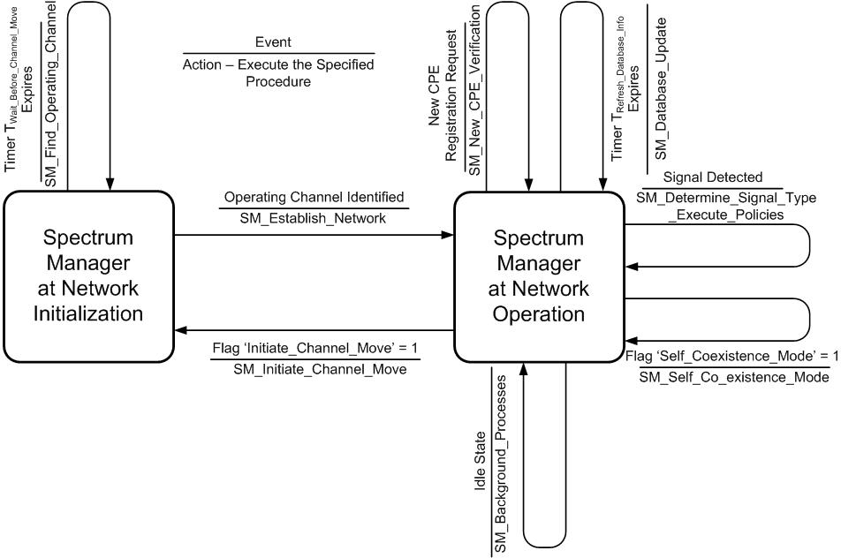
- Spectrum Manager State Machine Diagram

Error: Reference source not found describes the Spectrum Manager (SM) state machine diagram. The SM has two states of operation, namely, the SM at Network Initialization, and the SM at Network Operation.

The Timer T_{Wait_Before_Channel_Move} in the State SM at Network Initialization shall be initially set to a default value of 20 ms. However, the value of this timer shall be configurable in accordance with the other regulatory domain requirements as specified in the Error: Reference source not found.

During the Network Initialization state, the primary responsibility of the SM shall be to find the operating channel.

Once the Timer T_{Wait_Before_Channel_Move} expires, the SM shall execute the Procedure SM_Find_Operating_Channel. The various tasks involved in order to find an operating channel have been illustrated in Figure 184. The tasks to find an operating channel shall consist of accessing the incumbent database to obtain a list of available channels, discovering neighboring 802.22 systems, synchronizing as well as scheduling quiet periods, and initiating sensing for the primary user signals.
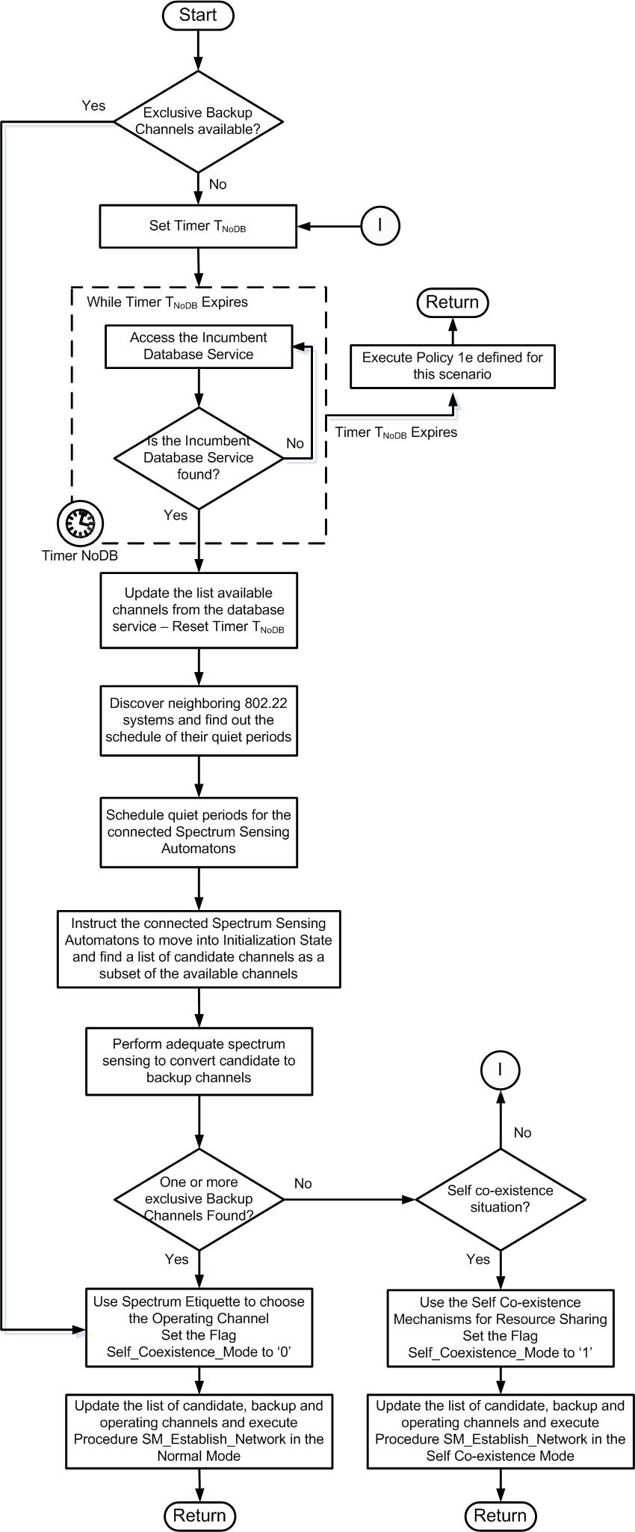
- — Procedure Find Operating Channel
In case, the SM at this stage already has an exclusive backup channel to operate on, the SM shall choose the operating channel based on spectrum etiquette as described in Section 6.22.2.3.1. The SM shall then execute the Procedure Establish the Network and move to the State Spectrum Manager at Network Operation

If no exclusive backup channels are available, the SM shall set the Timer T_{NoDB}. Timer T_{NoDB} as specified in Procedure SM_Find_Operating_Channel, indicates the longest time that a WRAN service can operate in the un-licensed band with no access to the database service. The timer values may be initially set to the United States regulatory domain, however they shall be configurable in accordance with the other regulatory domain requirements as specified in the Error: Reference source not found.

The SM shall initially take into consideration the incumbent database service information, to find a list of available channels. The SM shall then synchronize its quiet periods to other 802.22 systems, schedule its own quiet periods and command the Spectrum Sensing Automatons to go into the ‘Initialization State’ as described in Section 9.3.1. Based on the sensing information, the Spectrum Sensing Automatons shall provide the SM with a list of candidate channels as a subset of the available channels. The SM shall schedule further quiet periods to convert the list of candidate channels to backup channels.

A candidate channel shall become a backup channel and a backup channel shall become an operating channel based on the state transition diagram as specified in Section 9.2.3

In case one or more exclusive backup channels are available, the SM shall choose an operating channel using spectrum etiquette as described in Section 6.22.2.3.1. The SM shall execute the Procedure SM_Establish_Network and move to the State Spectrum Manager at Network Operation

As soon as the SM moves to the State Network Operation, it shall set the Timer T_{Refresh_Database_Info}. The default value for the Timer T_{Refresh_Database_Info} shall be 1 hour, however, the value for this timer shall be configurable in accordance with the other regulatory domain requirements as specified in the Error: Reference source not found.

In case no exclusive backup channels are found, the SM shall execute Procedure Establish Network in the Co-existence Mode. The self co-existence mechanisms have been described in Section 6.22.2.3.2.

The Procedure SM_Establish_Network has been illustrated in Figure 185. Initially, the SM shall instruct the BS to synchronize to other 802.22 systems. If it is the Normal Mode of operation, the BS shall start transmission on the identified operating channel and wait for the CPEs to join the network. The CPE initialization operation and registration operation has been described in Sections 6.17.2 and 6.17.9 respectively.

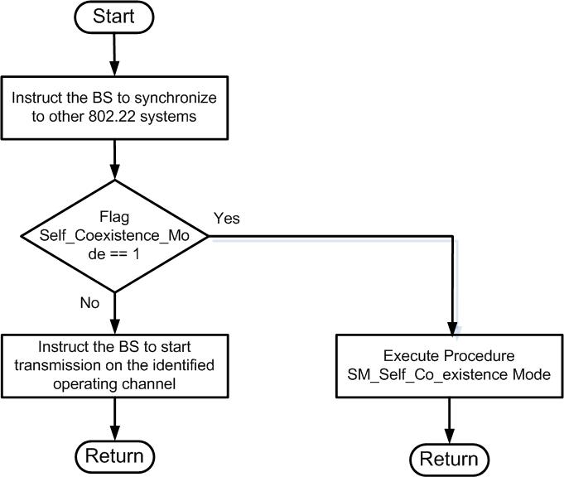
- — Procedure Establish Network
In the Self Co-existence Mode of operation, the BS shall execute Procedure SM_Self_Co_existence_Mode which is described below.

For each new CPE that has never before registered with the BS and that makes the registration request to the BS, the SM shall access the incumbent database service to verify if the current operating channel is available at the CPE location. In addition, the SM shall verify the security suite that the CPE supports and its spectrum sensing capabilities. If the SM finds that the current occupied channel is not available at the CPE location, or the CPE capabilities are less than required, it shall choose to prevent the CPE from registering to the network. Figure 186 illustrates the SM operation during Procedure SM_New_CPE_Verification.

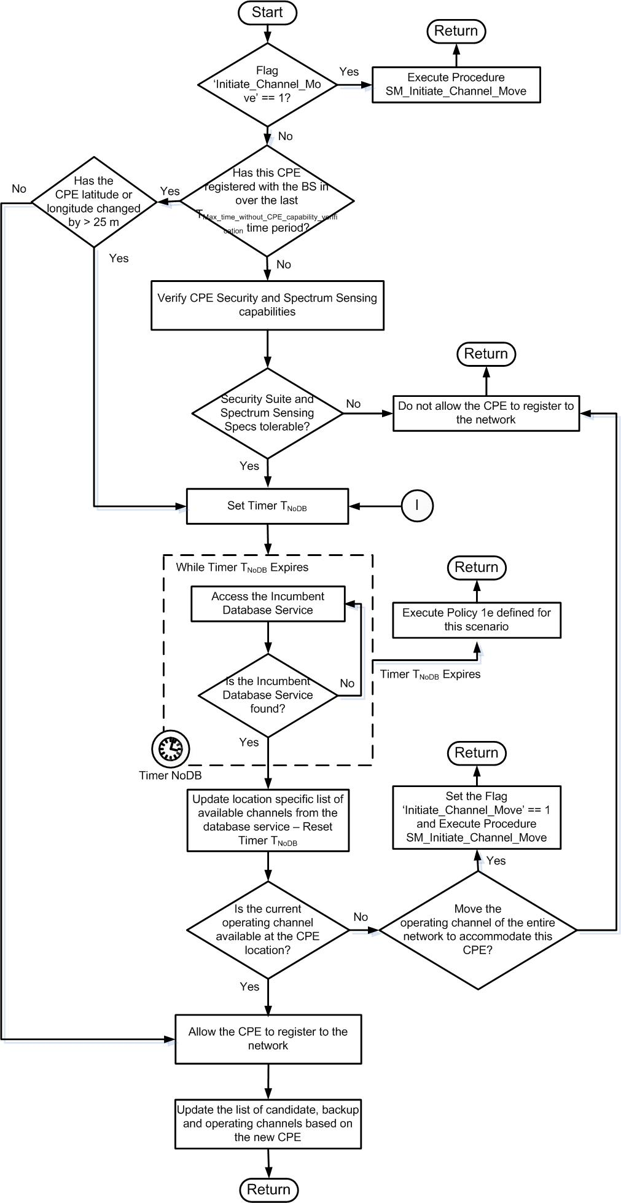
- — Procedure SM_New_CPE_Verification

In the event that the Timer T_{Refresh_Database_Info} expires, the SM shall execute Procedure SM_Database_Update. During this procedure, the SM shall verify that the current operating channel is available for itself and all its CPEs. If the current operating channel is available for the BS and all its associated CPEs, the BS shall continue the operation on the existing operating channel.

If the current operating channel is not available for the BS or one or more of its CPEs, the SM shall execute the policies as specified in the Spectrum Manager Policies in Section 9.2.5. The SM shall also update the candidate and backup channel list based on the new information. Figure 187 illustrates the SM operation during the Procedure SM_Database_Update.

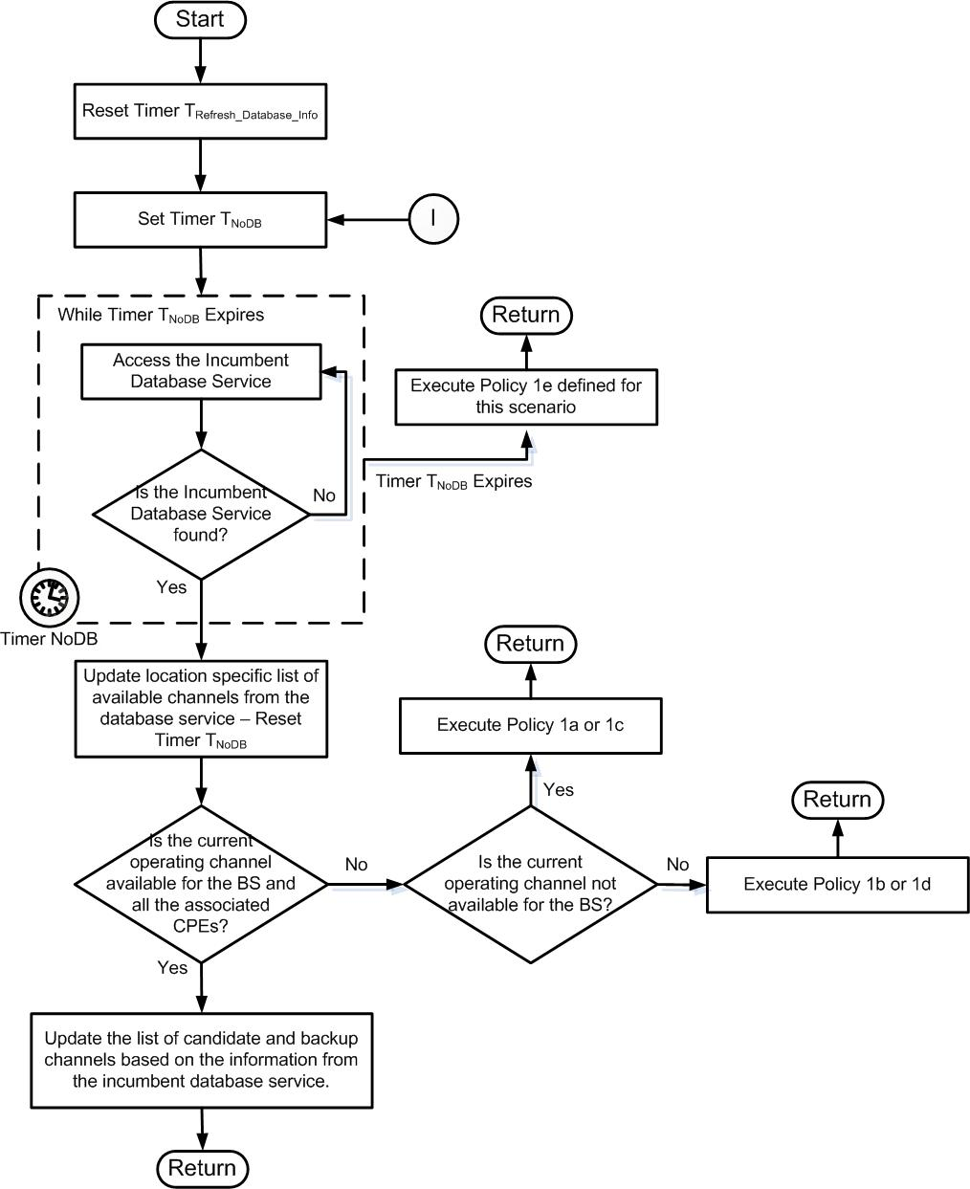
- — Procedure SM_Database_Update
If the SM is notified that a signal is detected through the Spectrum Sensing Automaton of the BS or one or more of its CPEs, the SM shall execute Procedure SM_Determine_Signal_Type_Execute_Policies. The Procedure SM_Determine_Signal_Type_Execute_Policies is illustrated in Figure 188. If a signal is detected, then the SM shall attempt to find the type of the signal that has been detected. Based on the type of the signal, the SM shall execute policies as specified in the Spectrum Manager Policies in Section 9.2.5.

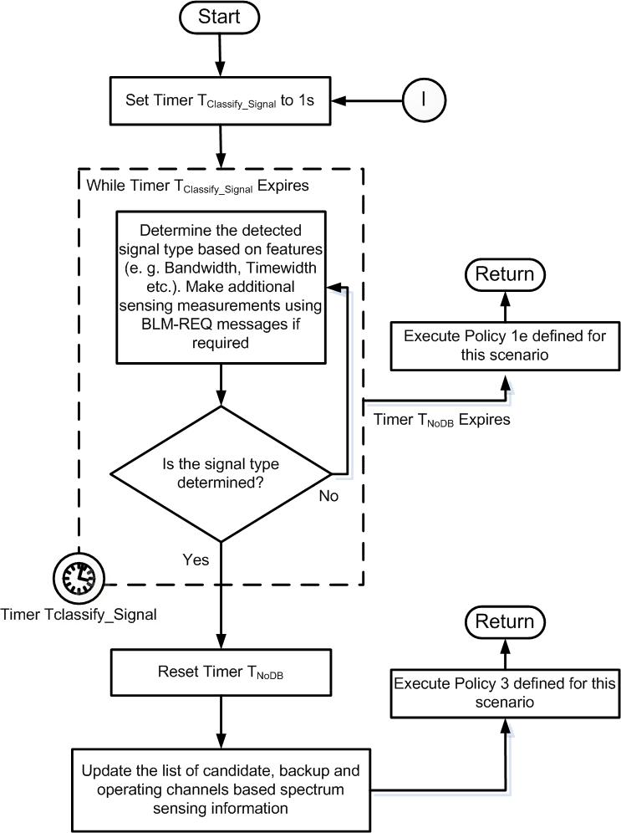
- — Procedure SM_Determine_Signal_Type_Execute_Policies

While the SM is idle, (no events are occurring), the SM shall run the Procedure SM_Background_Processes. In this procedure, the SM shall be responsible for scheduling the quiet periods, assigning the sensing responsibilities to the corresponding SSAs at the CPEs (SSA operation during the idle time), collecting the spectrum sensing reports (through BLM-REP), maintaining the channel state information, monitoring the link quality of various CPEs, and deciding if channel move is needed. The SM operation during Procedure SM_Background_Processes has been illustrated in Figure 189.

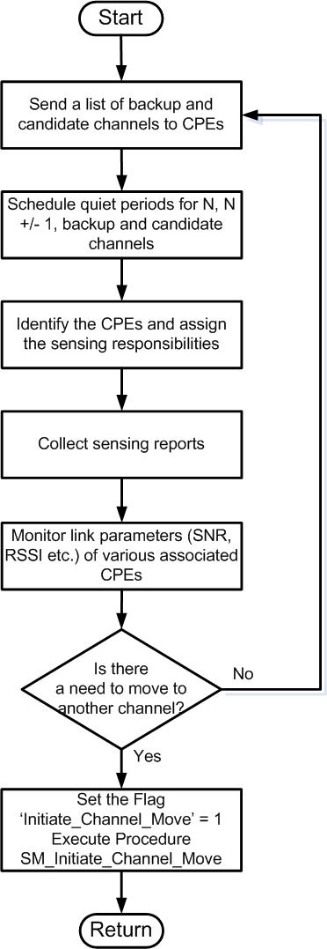
- — Procedure SM_Background_Processes

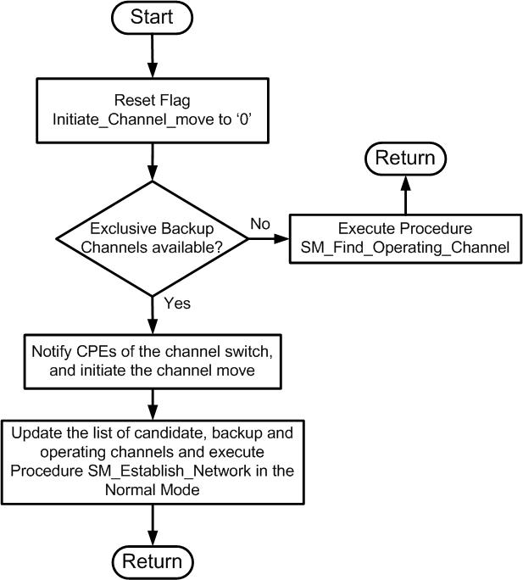
- — Procedure SM_Initiate_Channel_Move

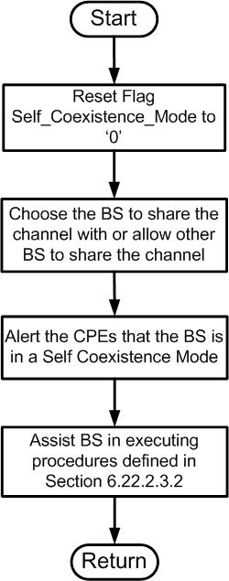
- — Procedure SM_Self_Coexistence_Mod

802.22.1 Beacon Authentication
The WRAN shall take the action of vacating a channel on which a valid 802.22.1 beacon signal has been received. Reception of the beacon is defined as either detection or demodulation of the beacon signal.

Acceptable methods to comply with detection of the beacon include energy detection, baud rate detection, correlation to the spreading sequence, or synchronization and determination of start-of-frame from the index. Other methods also exist. The WRAN must cease operation on a channel on which a beacon is detected unless the WRAN operator chooses to demodulate the beacon and perform further verification and validation of the received beacon signal. Performing demodulation of the beacon signal increases confidence that a received beacon signal is legitimate. The degree to which demodulation is performed is also at the discretion of the WRAN operator but if validity is detected at the point at which the WRAN chooses to stop further investigation of the demodulated beacon, it must protect the incumbent. It shall be at the discretion of the WRAN operator to determine the degree to which sequential steps are taken to validate the beacon. It can, therefore, make a decision after reception of MSF1 should it choose to do so. It may further choose to receive MSF1 combined with MSF2, and, if absolute confirmation is desired, MSF3. A determination of validity may be assessed at each step.

Demodulation of MSF1 allows the WRAN operator to acquire location and other pertinent information pertaining to the device protected by the beacon signal. The WRAN can, therefore, determine the best method to protect the incumbent device. This may include vacating the channel, reduction of power in the azimuth of the protected incumbent or moving a portion of its CPEs to a second channel. Other methods of protection also exist. Demodulation of the beacon information may, therefore, reduce the impact of QoS for a portion of the WRAN clients while adequately protecting the incumbent.

Finally, if the WRAN operator is suspicious of the validity of a beacon signal, it may verify the signature and certificate of the beacon utilizing the data received in MSF2 and MSF3. MSF2 contains the signature and MSF3 contains the public key certificate. In general, MSF3 demodulation is not required as the certificate is generally available over the internet. See Error: Reference source not found for more details.

