IEEE P802.22
Wireless RANs
Proposed Resolution to Comments Related to the Spectrum Manager Operation - Section 9.2
Date: 2010-03-08
Author(s):
Name | Company | Address | Phone | email
Apurva Mody | BAE Systems |  | 404-819-0314 | Apurva_mody@yahoo.com
Abstract
The following document proposes resolutions to comments related to Section 9.2. These comments are 1043, 1044, 1045, 1048, 1049, 1050, 1059, 1062, 1064, 1065, 1066, 1068, 1069, 1070, 1071, 1076, 1080, 1114, 1118, 1126, 1143
Notice: This document has been prepared to assist IEEE 802.22. It is offered as a basis for discussion and is not binding on the contributing individual(s) or organization(s). The material in this document is subject to change in form and content after further study. The contributor(s) reserve(s) the right to add, amend or withdraw material contained herein.

Release: The contributor grants a free, irrevocable license to the IEEE to incorporate material contained in this contribution, and any modifications thereof, in the creation of an IEEE Standards publication; to copyright in the IEEE’s name any IEEE Standards publication even though it may include portions of this contribution; and at the IEEE’s sole discretion to permit others to reproduce in whole or in part the resulting IEEE Standards publication. The contributor also acknowledges and accepts that this contribution may be made public by IEEE 802.22.

Patent Policy and Procedures: The contributor is familiar with the IEEE 802 Patent Policy and Procedures
<http://standards.ieee.org/guides/bylaws/sb-bylaws.pdf>, including the statement "IEEE standards may include the known use of patent(s), including patent applications, provided the IEEE receives assurance from the patent holder or applicant with respect to patents essential for compliance with both mandatory and optional portions of the standard." Early disclosure to the Working Group of patent information that might be relevant to the standard is essential to reduce the possibility for delays in the development process and increase the likelihood that the draft publication will be approved for publication. Please notify the Chair <Carl R. Stevenson> as early as possible, in written or electronic form, if patented technology (or technology under patent application) might be incorporated into a draft standard being developed within the IEEE 802.22 Working Group. If you have questions, contact the IEEE Patent Committee Administrator at <patcom@ieee.org>.
Resolution of comments related to Section 9.2
1043, 1044, 1045, 1048, 1049, 1050, 1059, 1062, 1064, 1065, 1066, 1068, 1069, 1070, 1071, 1076, 1080, 1118, 1126, 1143

Comment 1118 – Gerald Chounard - Minimum performance of sensing schemes should be either specified in the standard rather than being left to implementation, or the BS could refuse association with a CPE with excessively poor sensing performance because the extent of quiet periods needed to meet the sensing threshold would be too large and affect the WRAN system throughput and QoS.

Resolution - Needs text in section 9.4 and also it needs to be added to the initialization phase ( CBC-REQ/RSP (transmitted in the Basic CID) so that the BS can agree to associate with the CPE with the given performance or not. (If done in the CBC instead of during the initial registration, it may need to be verified during the registration process.)
See resolution of comment #1049.
Or, specific metrics to define the performance of the sensing devices should be devined: minimum contiguous time required for sensing and the number of repetitions to reach the sensing threshold: that is 2 IE's to be transferred from the CPE to BS (sse Table 259 for QP parameter definition).
The group accepts in principle that minimum performance of the sensing schemes specified in the standard rather than being left as implementation. The performance metrics shall have the following parameters : sensing threshold (dBm) as shown in Table 268, sensing period duration (e.g., 5 ms) and number of periods, sensing period interval should be greater than 1 frame.
See resolution of comments #1045 #1049 and reconcile.
10.01.26: The CBC request will contain the necessary parameters to define the sensing performance as given in resolution of comment #1049 (i.e., sensing period duration and contiguous versus segmented).
Action: MAC ad-hoc group: Refer to comment #1049 and take the sensing parameters and incorporate them in the CBC-REQ and CBC-RSP messages.

Final Proposed Resolution – Counter

Discussed during the March 2010 Plenary – CBC-REQ, CBC-RSP messages on basic capabilities should be kept at a minimum length to reduce the amount of transmission that is taking place before registration. See Document 22-09-0224 Rev 4 Policies 5 and 6.

So these parameters need to be included in the REG-REQ and REG-RSP messages. This also helps because the Registration messages are protected through authentication.

sensing threshold (dBm) as shown in Table 268, sensing period duration (e.g., 5 ms) and number of periods, sensing period interval should be greater than 1 frame.
[----------------------
Editor – Please note the following changes in Section 6.10.7.3.7.5 ------------]

          - Measurement Support
Table 72— Information elements
Syntax | Size | Notes
MS_IE() {
Element ID | 8 bits | 17
Length | 16 bits | n*7 + 5 (bytes)
STA Array | 32 bits | Signal Type Array that Spectrum Sensing Function is capable of sensing for
Dedicated Interface | 2 bits | 00: No dedicated radio sensing interface available  01: Dedicated radio sensing interface #1  10: Dedicated radio sensing inferface #2  11: Dedicated radio sensing interface #3
for (i = 1; i ≤ n; i++) { |  | n = For each bit index that is ‘1’ in the STA Array, indicating the signal that Spectrum Sensing Function is capable of sensing.
Sensitivity Threshold | 12 bits | Only applies for incumbent profiles.  Signed number which indicates the threshold (in dBm) to be used by CPEs for detection.
PD | 8 bits | Probability of Detection. 0x00 indicates ‘0’ and 0xFF indicates ‘1’
MPFA | 8 bits | Maximum Probability of False Alarm – 0x00 indicates ‘0’ and 0x01 indicates ‘0.001’
Recommended NumSensingPeriods | 7 bits | See Table 259 – Number of sensing periods required.
Recommended SensingPeriodDuration | 10 bits | See Table 259 – Sensing Period Duration as specified as an integer number of symbols
Recommended SensingPeriodInterval | 11 bits | See Table 259 – Sensing Period Interval as specified in the integer number of frames
}
}
Padding Bits | 6 bits | To make this IE an integer number of bytes.

- — System profiles
Table 73 — Signal Type Array Indices [Note – Editor to incorporate the most up to date version of the STA Type Array Table 258]
STA Index | Signal Type
0 | Any Signal Type
1 | IEEE 802.22 WRAN
2 | ATSC
3 | DVB-T
4 | ISDB-T
5 | NTSC
6 | PAL
7 | SECAM
8 | Wireless Microphone
9 | IEEE 802.22.1 Sync Burst
10 | IEEE 802.22.1 PPDU MFS1
11 | DVB-TIEEE 802.22.1 PPDU MSF2
12 | IEEE 802.22.1 PPDU MSF3
13-32 | Reserved

Comment 1049 – Gerald Chouinard - The local CPE automaton needs to inform the BS of the capability of the sensing schemes in the CPE, I.e., needed sensing time to reach the sensing threshold, contiguous sensing or segmented. This should be sent to the BS at association so that the quiet periods can be properly scheduled. The BS should consider the performance compared to its other CPEs and accept association or reject the CPE with excessively poor performance since it would slow down the whole cell due to excessively long sensing time which would result in long quiet periods affecting QoS. Minimum performance requirement should be established for sensing by industry.
Final Resolution – Superceded. See the proposed resolution to Comment 1118.

Comment 1126 – Thomas Kiernan - The current Spectrum Sensing Function, the way it is defined is quite complicated
Discussion on the universally synchronized quiet period to reduce the Spectrum Sensing Synchronization Complexity took place in Nov.09 and it was decided to continue with the current QP scheduling scheme through the SCH. Consideration of synchronized QP was postpone to later.
Keep the Status Quo in using the sensing the way it is. Gerald to provide text for Section 9.3.3
Final Proposed Resolution – Comment Withdrawn – March 2010 Plenary - Tom Kiernan is willing to withdraw his comment provided the group keeps this issue in the back of its mind.

Comment 1143 – Apurva Mody - Define the MPFA value, or if the value is to be implementation dependent add it's definition to Table 298
Final Resolution – Counter - Discussed this Comment in the March 2010 Orlando Plenary - Counter - Discussed this comment during the March 2010 Orlando Plenary. This is not a regulatory issue. However, the MPFA and Prob. of detection (PD) values need to be reported to the SM to ensure that the SSF is capable of meeting the regulatory requirements. Re-concile with Commen 1118. See Document 22-10-0034 Latest Rev. that contains the MPFA and PD values for each signal that have been added to the REG REQ message.

Comments 977, 980, 1043, 1044, 1045, 1048, 1050, 1064, 1065, 1068, 1069, 1071, 1076
All these comments are related to the Spectrum Manager Operation. There is a need to re-vamp the Figure 183 and propose a state based implementation of the Spectrum Manager Operation.

Proposed Resolution
All these comments are related to the Spectrum Manager Operation, and Figure 183. It would be best to illustrate the Spectrum Manager Operation from the current flow diagram version to the state model based version. Proposed new Figure 183 based on State Model based illustration is as shown.

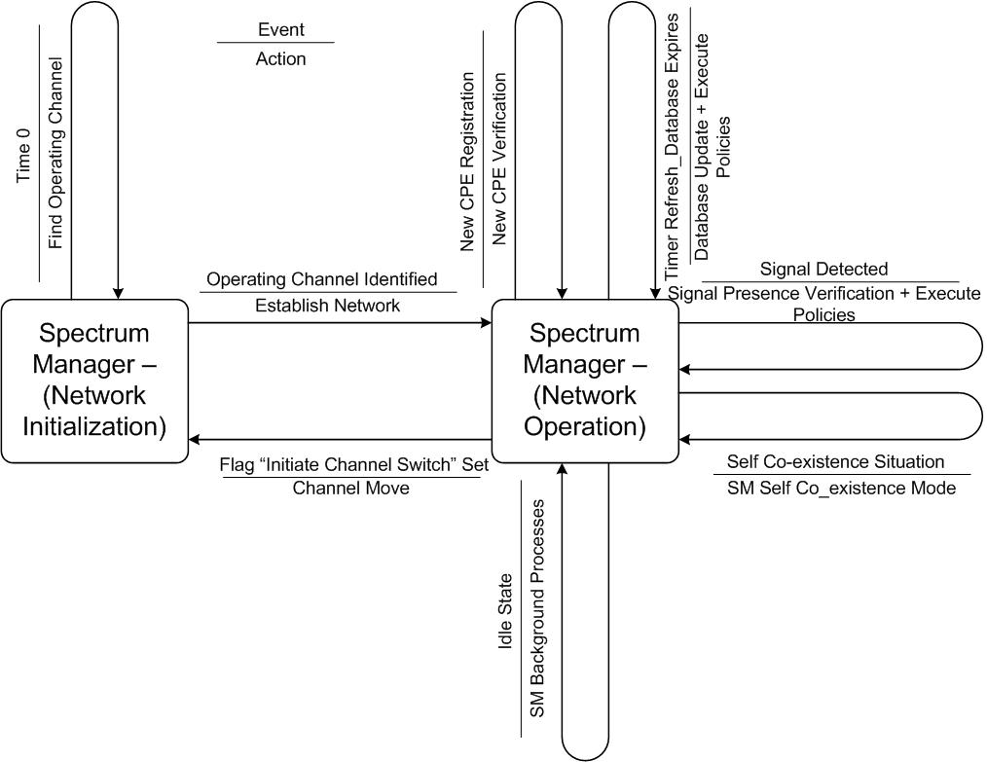

Comments 1062, 1066, 1070 (same as 1066), 1080, 1082, 1084 (same as 1082) – All these comments are related to Signal Authentication step and Figure 184.
Proposed Resolution – Counter - The proposed resolution to these comments can be found in Document 22-10-0024 Rev 5.

[-----------------Editor - Please Replace the Existing Section 9.2.6 with the following--------------]
[Editor - Please Replace the Existing Section 9.2.8 with Contents of Document 22-10-0024-03-]

[-------------------------------------------- End of Section 9.2.8 ----------------------------------]

