IEEE P802.22
Wireless RANs
Proposed Resolution to Comments Related to Figure 184
Date: 2010-02-23
Author(s):
Name | Company | Address | Phone | email
Apurva Mody | BAE Systems |  | 404-819-0314 | apurva.mody@baesystesms.com  Apurva_mody@yahoo.com
Abstract
The following document proposes resolutions to comments related to Figure 184. These include Comments – 1066, 1070 (same as 1066), 1080, 1082, 1084 (same as 1082)
Notice: This document has been prepared to assist IEEE 802.22. It is offered as a basis for discussion and is not binding on the contributing individual(s) or organization(s). The material in this document is subject to change in form and content after further study. The contributor(s) reserve(s) the right to add, amend or withdraw material contained herein.

Release: The contributor grants a free, irrevocable license to the IEEE to incorporate material contained in this contribution, and any modifications thereof, in the creation of an IEEE Standards publication; to copyright in the IEEE’s name any IEEE Standards publication even though it may include portions of this contribution; and at the IEEE’s sole discretion to permit others to reproduce in whole or in part the resulting IEEE Standards publication. The contributor also acknowledges and accepts that this contribution may be made public by IEEE 802.22.

Patent Policy and Procedures: The contributor is familiar with the IEEE 802 Patent Policy and Procedures
<http://standards.ieee.org/guides/bylaws/sb-bylaws.pdf>, including the statement "IEEE standards may include the known use of patent(s), including patent applications, provided the IEEE receives assurance from the patent holder or applicant with respect to patents essential for compliance with both mandatory and optional portions of the standard." Early disclosure to the Working Group of patent information that might be relevant to the standard is essential to reduce the possibility for delays in the development process and increase the likelihood that the draft publication will be approved for publication. Please notify the Chair <Carl R. Stevenson> as early as possible, in written or electronic form, if patented technology (or technology under patent application) might be incorporated into a draft standard being developed within the IEEE 802.22 Working Group. If you have questions, contact the IEEE Patent Committee Administrator at <patcom@ieee.org>.
Resolution of comments related to Figure 184
Comments 1066, 1070
How does the incumbent authentication take place?
Comment 1080
Charles Einolf – Figure 184, B2 is a dead-end.
Comments 1182 and 1184
The following modified figure is proposed in lieu of the current Figure 184 to address the following comments –
Comment 182 and 184 - Figure 184 - Once the decision is made, it is not clear if the flow should jump to I (Network Initialization) or S (Sensing Updates). Flow corresponding to B2 is not defined

[-----------------Editor - Please Replace the Existing Section 9.2.8 with the following-----------------]
    - Signal Presence Confirmation
Error: Reference source not found shows the signal presence confirmation step. The flow diagram is representative of the state when the 802.22 system has already gone through the process of finding the right channel on which to operate, the network has been initialized and a signal is detected through sensing either in-band or out-of-band.

Once the network has been initialized, and a signal is detected through sensing, the BS shall perform the following steps to confirm the presence of the signal.

In case the 802.22 system is still operating on the same channel where the signal is detected, the signal presence confirmation shall be carried out ensuring that the channel abandonment timing requirements of the regulatory domain are not violated. In case the signal presence confirmation can not be carried out within the allocated time to vacate the channel, then the signal presence confirmation may be carried out in an out-of-band sensing mode. This will help the 802.22 system to decide whether it wants to re-enter the channel as a candidate channel.

- If the 802.22 system is operating on the channel where a signal was detected or its adjacent (N +/- 1) channels, then a Timer Txx is set for (Tch_move – 0.5) seconds to count down to zero. Otherwise, the Timer Txx is set to 4 seconds.
- While the timer is not expired, the Spectrum Manager shall conduct the following steps to confirm the presence of the detected signal -
  - The detected signal is classified based on the collected features such as bandwidth, time-width etc.
  - If the features of the detected signals resemble that of an incumbent signal, then the signal presence IS confirmed. Set the Flag “Signal Presence Confirmation Conclusive” to ‘1’ and return.
  - If the features do not resemble a known incumbent, then the SM shall find other CPEs/ BS within 4 km of the BS / CPE that detected the signal.
  - If the SM does find other BS / CPEs within 4 km of the node that detected the signal through sensing, then SM shall execute a Voting Rule based collaborative sensing with voting threshold of 20% to confirm the presence of the signal. SM may schedule additional quiet periods for sensing using BLM-REQ message if necessary.
  - If the Voting Rule threshold is exceeded, then the signal presence IS confirmed. The SM shall set the Flag “Signal Presence Confirmation Conclusive” to ‘1’ and return.
  - If the Voting Rule threshold is not exceeded, then the SM can not confirm the presence of the signal.
  - If the SM can not find other BS / CPEs within 4 km of the CPE or the BS that detected the signal through sensing and if it is in the out of band sensing mode, then the SM shall schedule quiet period spanning 2 seconds for the node that detected the signal.
  - If the node is able to detect the signal for 20% of its measurements over the 2 s period then the signal presence IS confirmed. The SM shall set the Flag “Signal Presence Confirmation Conclusive” to ‘1’ and return.
  - If the signal presence can not be confirmed using any of the abovementioned steps and the Timer xx has not expired, then the signal presence is NOT confirmed. The SM shall set the Flag “Signal Presence Confirmation Conclusive” to ‘1’ and return.
- In case the Timer xx expires before any of the actions specified in Step 2 can be completed, or the Spectrum Manager operational flow changes, the SM may record all the sensing information, set the Flag “Signal Presence Confirmation Conclusive” to ‘0’ and use default values. The default value for the in-band and N +/- 1 channels shall be “Signal Presence Confirmed” and for the out-of-band channels that are not N +/- 1 shall be “Signal Presence Not Confirmed.”

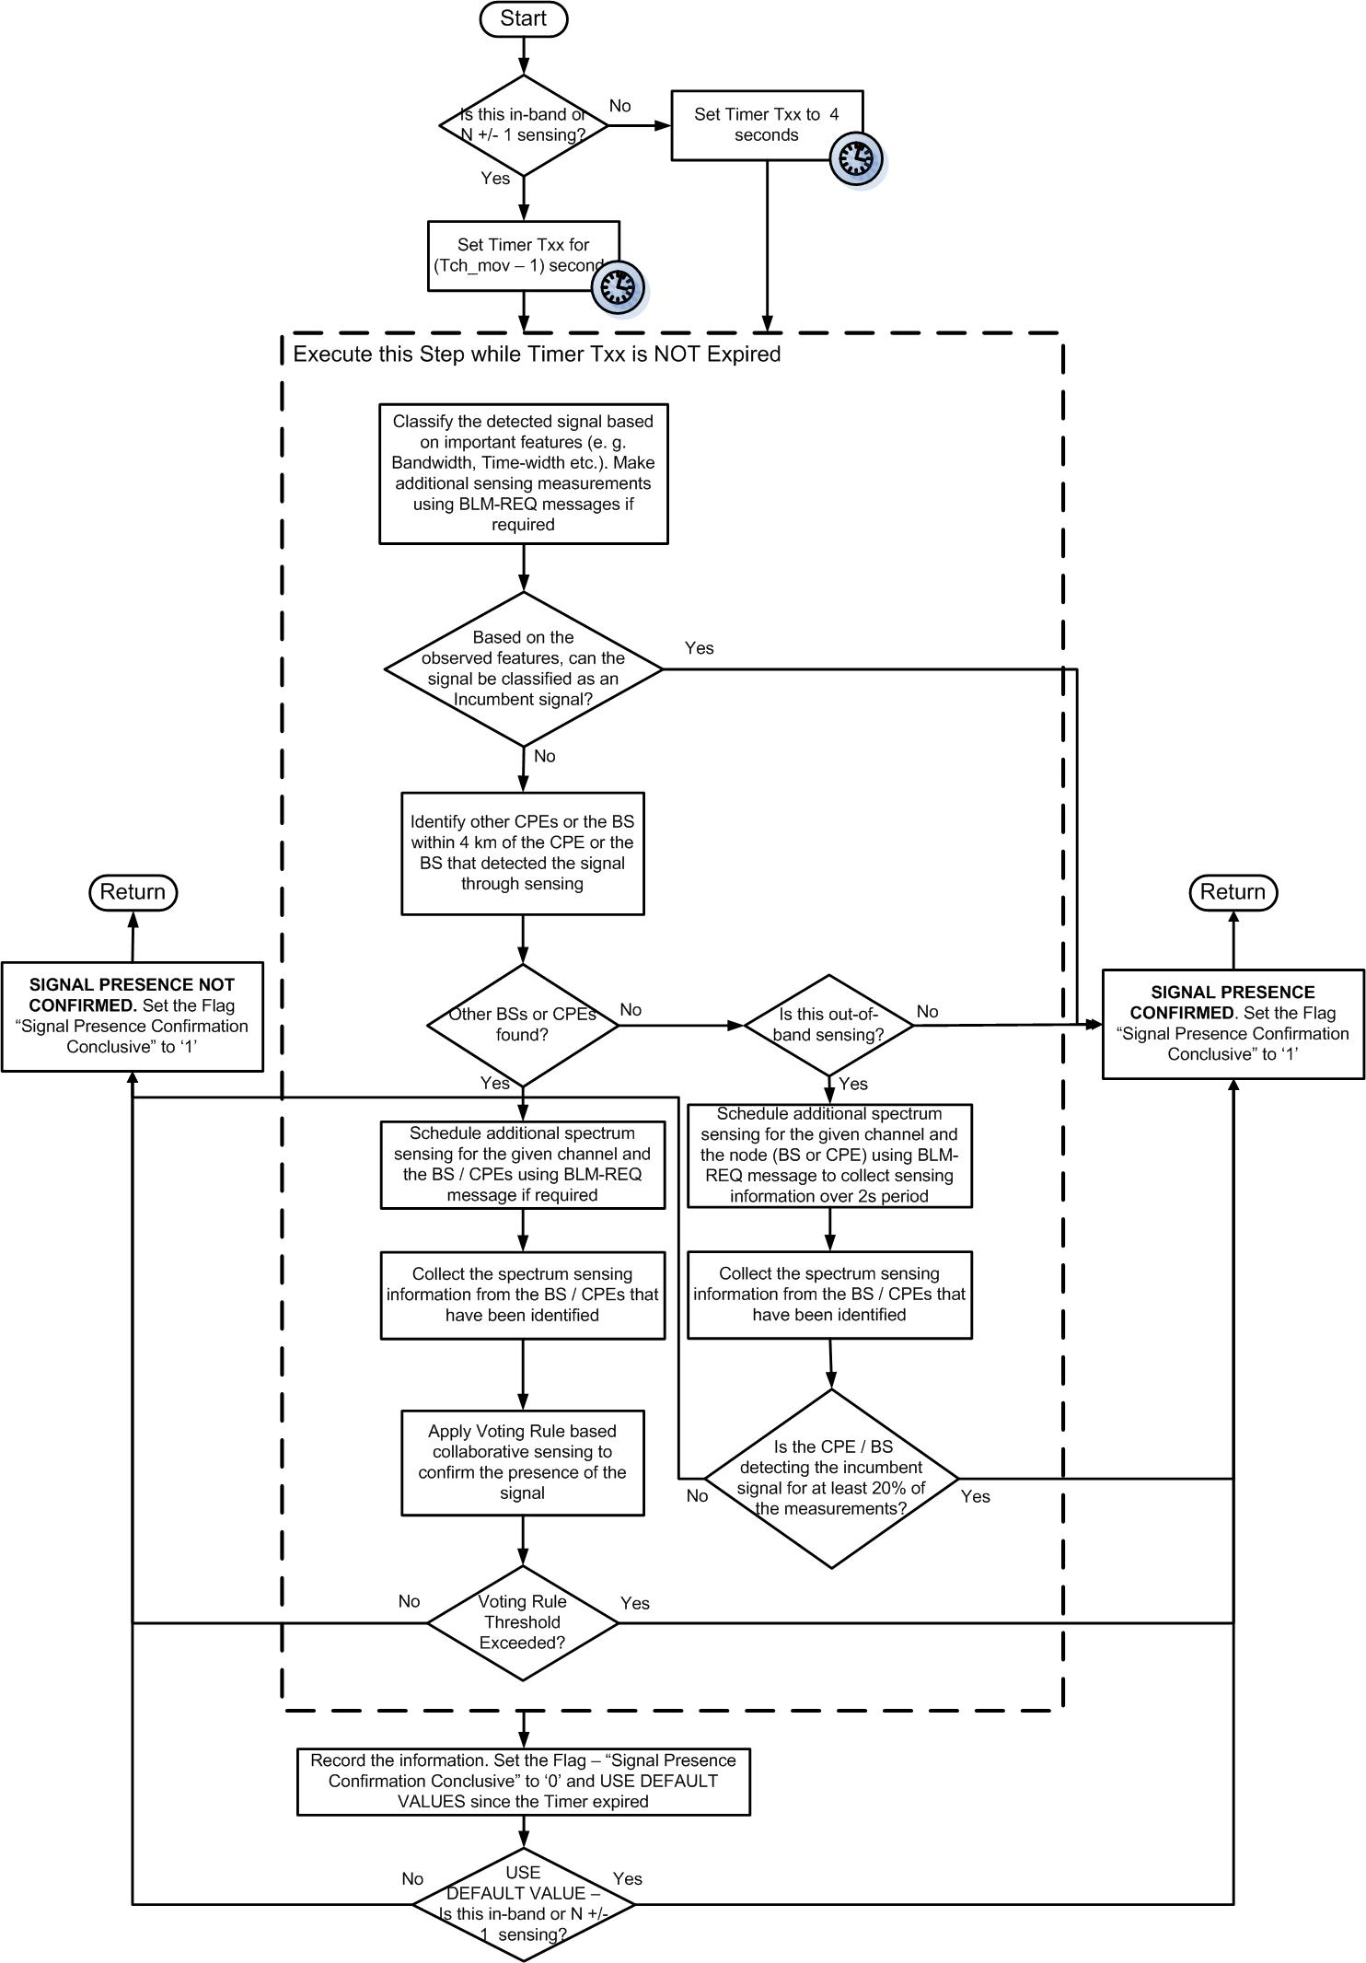
Figure 184. Signal Presence Confirmation

