IEEE P802.22
Wireless RANs
Proposed Text for Sections 6.17.8 through 6.17.13
Date: 2010-07-07
Author(s):
Name | Company | Address | Phone | email
Winston Caldwell | Fox | 10201 W. Pico Blvd.  Los Angeles, CA 90035 | 310-369-4367 | Winston.caldwell@fox.com
Abstract
This document represents the proposed edits to the text for sections 6.17.8 through 6.17.13 of Draft v2.0 to resolve comment 402.
Notice: This document has been prepared to assist IEEE 802.22. It is offered as a basis for discussion and is not binding on the contributing individual(s) or organization(s). The material in this document is subject to change in form and content after further study. The contributor(s) reserve(s) the right to add, amend or withdraw material contained herein.

Release: The contributor grants a free, irrevocable license to the IEEE to incorporate material contained in this contribution, and any modifications thereof, in the creation of an IEEE Standards publication; to copyright in the IEEE’s name any IEEE Standards publication even though it may include portions of this contribution; and at the IEEE’s sole discretion to permit others to reproduce in whole or in part the resulting IEEE Standards publication. The contributor also acknowledges and accepts that this contribution may be made public by IEEE 802.22.

Patent Policy and Procedures: The contributor is familiar with the IEEE 802 Patent Policy and Procedures
<http://standards.ieee.org/guides/bylaws/sb-bylaws.pdf>, including the statement "IEEE standards may include the known use of patent(s), including patent applications, provided the IEEE receives assurance from the patent holder or applicant with respect to patents essential for compliance with both mandatory and optional portions of the standard." Early disclosure to the Working Group of patent information that might be relevant to the standard is essential to reduce the possibility for delays in the development process and increase the likelihood that the draft publication will be approved for publication. Please notify the Chair <Wendong Hu> as early as possible, in written or electronic form, if patented technology (or technology under patent application) might be incorporated into a draft standard being developed within the IEEE 802.22 Working Group. If you have questions, contact the IEEE Patent Committee Administrator at <patcom@ieee.org>.

    - BS Transmit Channel Sets to CPE
The BS shall send the channel sets to the new CPE. The channel sets are described in Error: Reference source not found. The channel sets that are sent to the initializing CPE are the backup channels and the candidate channels. The channel sets are sent in a DCD message, as described in Error: Reference source not found and in Error: Reference source not found to Error: Reference source not found. The BS shall send DCD channel information elements 11 and 12. Error: Reference source not found describes information element 12 as the backup and candidate channel list. It is a prioritized list of the channels with the backup channel set higher in priority than the candidate channel set. The two sets are identified by sending information element 11 which provides the number of the higher prioritized backup channel set. Each channel in DCD information element 12 is characterized by both the channel number.
    - Registration
Registration is the process by which the CPE is allowed entry into the network and a managed CPE receives its Secondary Management CID and thus becomes manageable. To register with a BS, the CPE shall send a REG-REQ message to the BS. The BS shall respond with a REG-RSP message. The REG-RSP message shall include the Secondary Management CID.

Figure 49 shows the procedure that shall be followed by the CPE.

- CPE Registration

Once the CPE has sent a REG-REQ to the BS, it shall wait for a REG-RSP to authorize it to forward traffic to the network. Figure 50 shows the waiting procedure that shall be followed by the CPE.

- Wait for REG-RSP—CPE [The Managed CPE? conditional block in the diagram needs to be removed since all CPEs are managed.]

The BS shall perform the operations shown in Figure 51. Note that the Timer T13 represents the time allowed for a CPE, following receipt of a REG-RSP message, to send a TFTP-CPLT message to the BS, and its minimum time is specified in Error: Reference source not found. In addition, the Timer T28 is the time allowed for the BS to complete the transmission of channel sets, its default value is specified in Error: Reference source not found.

- Registration at BS [The Managed CPE? conditional block in the diagram needs to be removed since all CPEs are managed.]

    - IP Version Negotiation
The CPE may include the IP version parameter (Error: Reference source not found) in the REG-REQ message to indicate which versions of IP it supports on the Secondary Management Connection. When present in the REG-REQ message, the BS shall include this IP version parameter in the REG-RSP message to command the CPE to use the indicated version of IP on the secondary management connection. The BS shall command the use of exactly one of the IP versions supported by the CPE.

The omission of the IP Version Parameter in the REG-REQ message shall be interpreted as IPv4 support only. Consequently, the omission of the IP Version Parameter in the REG-RSP message shall be interpreted as a command to use IPv4 on the secondary management connection.
    - Establish IP connectivity
The CPE shall invoke DHCP mechanism [IETF RFC 2131] in order to obtain an IP address and any other parameters needed to establish IP connectivity. If the CPE has a configuration file, the DHCP response shall contain the name of a file that contains further configuration parameters.

Establishment of IP connectivity shall be performed on the CPE’s secondary management connection as shown in .

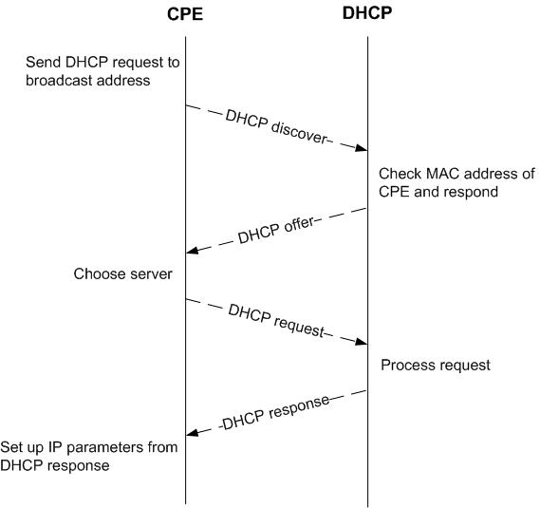
- Establishing IP connectivity

In case where dynamic IP configuration is not preferred, the CPE shall obtain an IP address from its base station.
    - Establish Time of Day
The CPE and BS shall have the current date and time. This is required for time-stamping logged events for retrieval by the management system. This needs not be authenticated and shall be accurate to the nearest second.

The protocol by which the time of day shall be retrieved is defined in IETF RFC 868. Referring to , the request and response shall be transferred using user datagram protocol (UDP). The time retrieved from the server [universal coordinated time (UTC)] shall be combined with the time offset received from the response of the CPE to create the current local time. Establishment of time of day shall be performed on the CPE’s secondary management connection.

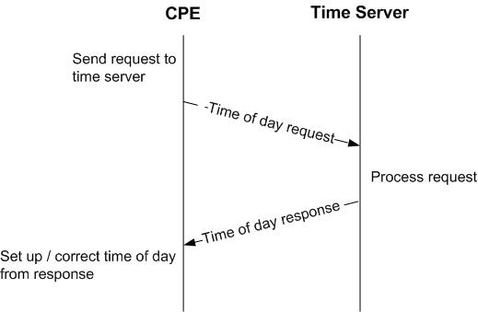
- Establishing time of day
Successfully acquiring the Time of Day is not mandatory for a successful registration, but is necessary for ongoing operation. The specific timeout for Time of Day Requests is implementation dependent.
    - Transfer Operational Parameters
The CPE shall download the CPE’s configuration file using TFTP on its own secondary management connection as shown in . The CPE shall use an adaptive timeout for TFTP based on binary exponential backoff [IETF RFC 1123, IETF RFC 2349].

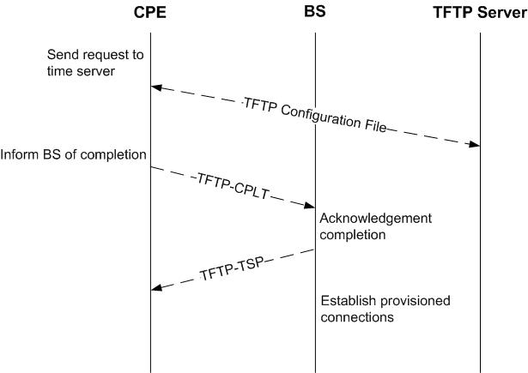
- Transferring operational parameters

When the configuration file download has completed successfully, the CPE shall notify the BS by transmitting the TFTP-CPLT message on the CPE’s primary management connection. Transmissions shall continue successfully until a TFTP-RSP message is received with response “OK” from the BS (see Figure 55 and Figure 56) or the CPE terminates retransmission due to retry exhaustion.
    - Secondary Management Connection
Upon sending a REG-RSP, the BS shall wait for a TFTP-CPLT. If the timer T13 (defined in Error: Reference source not found) expires, the BS shall restart the registration process (REG-REQ/RSP) with the CPE. (see Figure 55). Note that the Timer T26 refers to the time waited for TFTP-RSP. If T26 expires, then TFTP-CPLT is attempted until the maximum number of retries is exhausted. Upon the exhaustion, the CPE shall be deregistered (i.e. forced to reinitialize MAC) by sending a DREG-REQ with Action Code set to 0x05 to force itself to reattempt system access or 0x04 to shut itself down (see Figure 56).

- Wait for TFTP-CPLT at the BS

- Wait for TFTP-RSP at the CPE

    - Neighboring Network Discovery
After a CPE has registered with a WRAN BS, it shall perform neighboring network discovery in order to identify other nearby WRANs and enable efficient self-coexistence, if the CPE has not already done so. The neighboring network discovery involves listening to the medium for CBP packets or BS SCH transmitted by other WRAN BSs. This network discovery mechanism is described in Error: Reference source not found.

- Set Up Connections
After the transfer of operational parameters for the CPE, the BS shall send DSA-REQ messages (Error: Reference source not found) to the CPE to set up connections for preprovisioned service flows belonging to the CPE. The CPE responds with DSA-RSP messages. This is described further in subclause Error: Reference source not found.

References:

