IEEE P802.22
Wireless RANs
802.22 PAR modification for portable CPEs
Date: 2009-09-24
Author(s):
Name | Company | Address | Phone | email
Gerald Chouinard | CRC | 3701 Carling Ave. Ottawa, Ontario Canada K2H 8S2 | 613-998-2500 | gerald.chouinard@crc.ca
Abstract
This document discusses the possibility and advantages of modifying the current 802.22 PAR to add the use of portable user terminals where the WRAN signal levels are sufficiently high closer to the base stations. Keeping the original point-to-multipoint network topology and the same master/slave WRAN cell approach will result in minimal change to the 802.22 basic standard in order to accommodate these portable terminals.

The results of a cursory look at the additional requirements as well as the changes proposed to the original 802.22 PAR and 5 Criteria are presented.
Notice: This document has been prepared to assist IEEE 802.22. It is offered as a basis for discussion and is not binding on the contributing individual(s) or organization(s). The material in this document is subject to change in form and content after further study. The contributor(s) reserve(s) the right to add, amend or withdraw material contained herein.

Release: The contributor grants a free, irrevocable license to the IEEE to incorporate material contained in this contribution, and any modifications thereof, in the creation of an IEEE Standards publication; to copyright in the IEEE’s name any IEEE Standards publication even though it may include portions of this contribution; and at the IEEE’s sole discretion to permit others to reproduce in whole or in part the resulting IEEE Standards publication. The contributor also acknowledges and accepts that this contribution may be made public by IEEE 802.22.

Patent Policy and Procedures: The contributor is familiar with the IEEE 802 Patent Policy and Procedures
<http://standards.ieee.org/guides/bylaws/sb-bylaws.pdf>, including the statement "IEEE standards may include the known use of patent(s), including patent applications, provided the IEEE receives assurance from the patent holder or applicant with respect to patents essential for compliance with both mandatory and optional portions of the standard." Early disclosure to the Working Group of patent information that might be relevant to the standard is essential to reduce the possibility for delays in the development process and increase the likelihood that the draft publication will be approved for publication. Please notify the Chair <Carl R. Stevenson> as early as possible, in written or electronic form, if patented technology (or technology under patent application) might be incorporated into a draft standard being developed within the IEEE 802.22 Working Group. If you have questions, contact the IEEE Patent Committee Administrator at <patcom@ieee.org>.

802.22 PAR modification for portable CPEs

1- Introduction
Now that the regulation requirements are known for the use of personal/portable TVBDs in the TV White Spaces, it is appropriate to consider a limited extension to the original 802.22 PAR so that the WRAN operators can also provide service from their base station to portable user terminals where the signal level permits, beyond the original service over a larger area to fixed CPE installations. Although extensive portable operation could potentially be provided in the TV White Spaces such as that provided by WPAN, WLAN and WMAN technologies, it is proposed to limit the portable operation to user terminals that would be in closer proximity to the base stations than the fixed user terminals. This would allow for minimal changes to the basic standard since the point-to-multipoint master/slave relationship between the base station and its CPEs would be preserved and all basic PHY, MAC and cognitive radio features would be the same.

2- Extension of the WRAN Model
The Wireless Regional Networks for which the 802.22 standard is being developed are expected to operate in low population density areas and provide broadband access to data networks using vacant TV channels in the VHF and UHF bands allocated to the Television Broadcasting Service in the frequency range between 54 MHz and 862 MHz while avoiding interference to the broadcast incumbents in these bands. A typical application can be the coverage of the rural area around a village as illustrated in Figure 1 within a radius of 17 km to 30 km depending on the EIRP of the base station using adaptive modulation although the MAC should be able to accommodate user terminals located as far as 100 km when exceptional RF signal propagation conditions prevail.

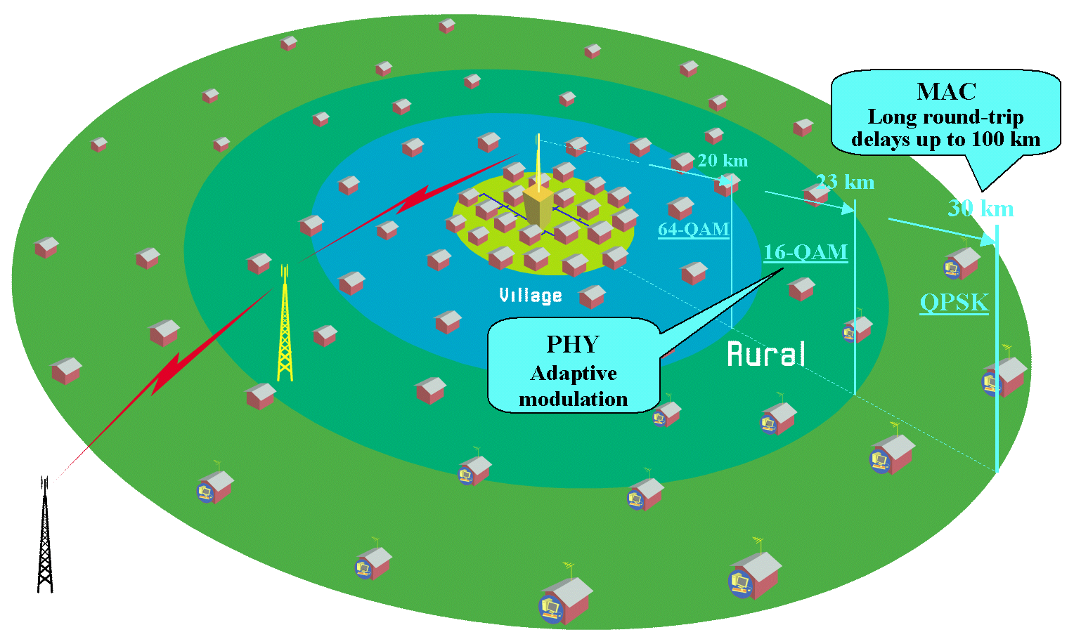
- Typical application of the 802.22 WRAN standard
The addition of portable user terminals to this model will allow nomadic use of lower power portable terminals in the vicinity of the base station where the lower allowed transmitted signal level and lower user terminal antenna gain will still be sufficient to establish reliable communication with the base station. It should be noted that the capability of such portable terminals will be limited by the fact that hand-off will not be provided between WRAN base stations but rather simpler de-association and re-association between different base stations as would be the case for the fixed terminals. This way, the master/slave relationship between the BS and these portable terminals will be similar to that for the fixed terminals and the cognitive radio features will be kept simple.
The only difference will be that the location of these portable terminals will need to be tracked more frequently than in the case of the fixed terminals. However, since their distance to the base station will be smaller than in the case of fixed terminals, the list of available channels will be driven by the more distant CPEs in the case of presence of DTV operation. This would not necessarily be the case for the presence of wireless microphone operation and the same sensing process as for fixed terminals and in the same 2 seconds time frame will be needed.

3- Required changes
A number of limited changes will be needed.
3.1- 802.22 PAR and 5C
Only a few changes are needed to extend the scope of the 802.22 PAR to include personal/portable devices to the WRAN operation while still keeping it as a point-to-multipoint master/slave BS-user terminal operation. The proposed changes are highlighted in the attached PAR and 5C.
3.2- Functional Requirement Document (FRD)
The original Functional Requirement Document (22-05-0007-47-0000_RAN_Requirements.doc) may need to be updated to reflect this extension. This should not be a major task since the original requirements for fixed operation will still apply to portable terminals. The Working Group should take advantage of this revision to update the FRD with requirements that are more closely related to the current state of the 802.22 Standard development.
3.3- 802.22 Draft Standard
A careful review of the 802.22 standard should be undertaken to identify the modifications required to accommodate these portable terminals in parallel with the comment resolution process so that this extension of the scope of the project does not result in any delay in the approval of the standard.
4- Action plan
In recognition of the above, it is proposed to take the steps necessary to bring this 802.22 PAR modification to the 802 Executive Committee at the November 2009 session for approval recognizing that the impact on the process for approving the 802.22 standard will be minimal and that the inclusion of portable terminals to the 802.22 operation may bring a number of new applications of the technology that could be attractive for the industry and bring more service to the subscribers.
____________________________

PAR FORM

PAR Status: New PAR
PAR Approval Date: 2004-09-23
PAR Signature Page on File: Yes
1. Assigned Project Number: 802.22
2. Sponsor Date of Request: 2004-07-08
3. Type of Document: Standard for
4. Title of Document:
Draft: Information Technology -Telecommunications and information exchange between systems – Wireless Regional Area Networks (WRAN) - Specific requirements - Part 22: Cognitive Wireless RAN Medium Access Control (MAC) and Physical Layer (PHY) specifications: Policies and procedures for operation in the TV Bands
5. Life Cycle: Full-Use
6. Type of Project:
6a. Is this an update to an existing PAR? No
6b. The Project is a: New Standard
7. Working Group Information:
Name of Working Group: IEEE 802.22 Wireless Regional Area Networks
Approximate Number of Expected Working Group Members: 50
8. Contact information for Working Group Chair:
Name of Working Group Chair: Wendong Hu
Telephone: 408-467-8410 FAX:
Email: wendong.hu@st.com
9. Contact information for Co-Chair/Official Reporter, Project Editor or Document Custodian if different from the Working Group Chair:
Name of Co-Chair/Official Reporter, Project Editor or Document Custodian:
Telephone: FAX:
Email:
10. Contact information for Sponsoring Society or Standards Coordinating Committee:
Name of Sponsoring Society and Committee: Computer Society Local and Metropolitan Area Networks
Name of Sponsoring Committee Chair: Paul Nikolich
Telephone: 857-205-0050 FAX: 781-334-2255
Email: paul.nikolich@att.net
Name of Liaison Rep. (if different from the Sponsor Chair):
Telephone: FAX:
Email:

Name of Co-Sponsoring Society and Committee:
Name of Co-Sponsoring Committee Chair:
Telephone: FAX:
Email:
Name of Liaison Rep. (if different from the Sponsor Chair):
Telephone: FAX:
Email:
11. The Type of ballot is: Individual Sponsor Ballot
Expected Date of Submission for Initial Sponsor Ballot: 2007-01-01
12. Fill in Projected Completion Date for Submittal to RevCom: 2007-06-01
Explanation for Modified PAR that completion date is being extended past the original four-year life of the PAR:
13. Scope of Proposed Project:
This standard specifies the air interface, including the medium access control layer (MAC) and physical layer (PHY), of point-to-multipoint wireless regional area networks for fixed and portable user terminals operating in the VHF/UHF TV broadcast bands between 54 MHz and 862 MHz.
Is the completion of this document contingent upon the completion of another document? No
14. Purpose of Proposed Project:
This standard is intended to enable deployment of interoperable 802 multivendor wireless regional area network products, to facilitate competition in broadband access by providing alternatives to wireline broadband access and extending the deployability of such systems into diverse geographic areas, including sparsely populated rural areas, while preventing harmful interference to incumbent licensed services in the TV broadcast bands.
It is in the best interest of users and the industry to strive for a level of coexistence between wireless systems. IEEE 802.22 WG provides mechanisms for coexistence with other systems in the TVWS band. One approach is a common coexistence mechannism that may be used by other TVWS systems; other approaches are also possible.

14a. Reason for the standardization project:
There is a large, untapped market for broadband wireless access in rural and other unserved/underserved areas where wired infrastructure cannot be economically deployed. Products based on this standard will be able to serve those markets and increase the efficiency of spectrum utilization in spectrum currently allocated to, but unused by, the TV broadcast service. The regulatory environment for operation of such broadband wireless access systems in the TV bands has been clarified in some countries (e.g., in the USA through the FCC R&O 08-240) and the scope of this project has been adjusted accordingly to clarify the capability and flexibility of operation.
15. Intellectual Property:
Has the sponsor reviewed the IEEE patent policy with the working group? Yes
Is the sponsor aware of copyrights relevant to this project? No
Is the sponsor aware of trademarks relevant to this project? No
Is the sponsor aware of possible registration of objects or numbers due to this project? No
16. Are there other documents or projects with a similar scope? No

Similar Scope Project Information:
17. Is there potential for this document (in part or in whole) to be adopted by another national , regional or international organization? Do not know at this time
If yes, please answer the following questions:
Which International Organization/Committee?
International Contact
Information?
18. If the project will result in any health, safety, or environmental guidance that affects or applies to human health or safety, please explain in five sentences or less.
19. Additional Explanatory Notes: (Item Number and Explanation)
Item 4: “Wireless Regional Area Network” (“WRAN”) - a point-to-multipoint network for operation over large, potentially sparsely populated areas (e.g. rural areas) for fixed user terminals, taking advantage of the favorable propagation characteristics in the VHF and low UHF TV bands as well as for portable user terminals operating in the vicinity of the fixed base station. The unique requirements of operating on a strict non-interference basis in spectrum assigned to, but unused by, the incumbent licensed services requires a new approach using purpose-designed cognitive radio techniques that will permeate both the PHY and MAC layers. The IEEE 802.18 Study Group chartered to develop this PAR does not believe that any existing IEEE 802 PHY/MAC combination can meet these requirements without extensive modifications. The Study Group has therefore concluded that placing the project in a new Working Group is the most efficient approach.

The Working Group will maintain ongoing communications with the joint effort of the IEEE Communications and EMC Societies as it determines the technical definition of non-interference, harmful interference, their measurement and acceptable mitigation.

CRITERIA FOR STANDARDS DEVELOPMENT (FIVE CRITERIA)

Broad Market Potential
A standards project authorized by IEEE 802 shall have a broad market potential. Specifically, it shall have the potential for:
a) Broad sets of applicability.
b) Multiple vendors and numerous users.
c) Balanced costs (LAN versus attached stations).
IEEE 802 standards for wireless devices are widely implemented and widely used for numerous applications, such as local area networking, wireless internet hotspots, streaming video, and even “first mile” access applications. Tens of millions of WLAN radios have been shipped, from multiple vendors, and costs are attractive enough that they are now built into “stations” as diverse as laptop PC’s and video cameras. Extending 802 wireless networking to other parts of the spectrum will further broaden this range of applicability.
Opening up presently unused blocks of spectrum, coupled with the attractive propagation characteristics of the VHF/UHF TV bands, will extend the availability of broadband services and applications by enabling longer-distance and non-LOS links. This is especially necessary for economic viability of broadband services in low population density rural (and other unserved or underserved) areas. This will also provide additional capacity to help alleviate spectrum congestion in more densely populated areas through scalability (lower transmit power and lower antenna heights to gain cellular-like frequency reuse).
The TV bands are being studied for re-allocation on a global basis both in the ITU-R and in individual countries as they transition from analog to digital broadcasting and spectrum is freed up accordingly. Pursuing global harmonization will further broaden the applicability and increase the economies of scale of wireless networking in this region of the spectrum to the benefit of manufacturers, service providers, and users alike.
While only fixed broadband wireless access operation was to be allowed by regulation in the US at the time of the original PAR, the regulatory environment has since been clarified with the publication of the FCC R&O 08-260 where personal/portable operation has also been allowed under specific conditions. Indications are that the same trend is taking place in other countries as well (e.g. OFCOM in UK). The addition of these devices in the TV bands will expand the type of applications and this clarification is proposed accordingly to allow the development of the 802.22 standard to accommodate fully interoperable fixed and portable user terminals operating under the control of 802.22 fixed base stations in a master/slave relationship.

Compatibility
IEEE 802 defines a family of standards. All standards shall be in conformance with the IEEE 802.1 Architecture, Management, and Interworking documents as follows: 802 Overview and Architecture, 802.1D, 802.1Q, and parts of 802.1f. If any variances in conformance emerge, they shall be thoroughly disclosed and reviewed with 802. Each standard in the IEEE 802 family of standards shall include a definition of managed objects which are compatible with systems management standards.
The proposed standard will take advantage of the better non-LOS propagation characteristics and longer reach potential at these lower frequencies, and will provide robust and reliable mechanisms to prevent harmful interference to licensed operations in the TV bands. Where feasible for the application, it will draw on concepts and technologies from existing 802 wireless standards. By extension, it will be compatible with the 802 architecture, including 802.1D, 802.1Q, and parts of 802.1f.

Distinct Identity
Each IEEE 802 standard shall have a distinct identity. To achieve this, each authorized project shall be:
a) Substantially different from other IEEE 802 standards.
b) One unique solution per problem (not two solutions to a problem).
c) Easy for the document reader to select the relevant specification.
No current 802 wireless standard specifies operation in the VHF and lower portion of the UHF spectrum, i.e., the TV bands, where, because of the more favorable propagation characteristics, it is possible to cover extensive areas in LOS and non-LOS conditions, making it economically feasible to serve even sparsely populated rural areas. Also, no current 802 wireless standard includes the ability to determine the presence of licensed users in the TV band and adjust its frequency of operation, power level, and/or other operational characteristics so as to avoid harmful interference to these operations.

Technical Feasibility
For a project to be authorized, it shall be able to show its technical feasibility. At a minimum, the proposed project shall show:
a) Demonstrated system feasibility.
b) Proven technology, reasonable testing.
c) Confidence in reliability.
The favorable propagation characteristics at VHF and lower UHF frequencies are well documented in the literature, and demonstrated in the field by decades of practical operational experience, both in urban and rural environments.
Existing 802 wireless standards (e.g. 802.11h) have demonstrated that detection and avoidance of operation in spectrum occupied by licensed users is technically feasible.
As a result of the migration of TV stations from analog to DTV operation, there is a large body of work documenting the appropriate co- and adjacent-channel D/U power ratios that would avoid harmful interference with TV services.
There is a similar body of work documenting the appropriate co- and adjacent-channel D/U power ratios that would avoid harmful interference for land mobile and other licensed services.
Long term experience with hundreds of millions of mass produced WLAN devices and consumer TV devices demonstrates that the technology is highly reliable.

Economic Feasibility
For a project to be authorized, it shall be able to show economic feasibility (so far as can reasonably be estimated), for its intended applications. At a minimum, the proposed project shall show:
a) Known cost factors, reliable data.
b) Reasonable cost for performance.
c) Consideration of installation costs.
The economic feasibility of IEEE 802 wireless devices is well-documented. The cost factors for system components used in mass-market consumer TV devices are well established. As these devices will autonomously determine the presence of licensed operations and avoid them, installation costs will be minimal or non-existent. The resulting standard would even bring economically viable broadband access to lower population density rural areas, supporting the societal goal of bridging the ‘digital divide’.

______________________________

