IEEE P802.22
Wireless RANs
Resolution for MAC comment:
Text change for Section 9.2.2
Date: 2009-05-13
Author(s):
Name | Company | Address | Phone | email
Chang-Joo Kim | ETRI | Korea | +82-42-860-1230 | cjkim@etri.re.kr
Myung-Sun Song | ETRI | Korea | +82-42-860-5046 | mssong@etri.re.kr
Gwang-Zeen Ko | ETRI | Korea | +82-42-860-4862 | gogogo@etri.re.kr
Sung-Hyun Hwang | ETRI | Korea | +82-42-860-1133 | shwang@etri.re.kr
Jung-Sun Um | ETRI | Korea | +82-42-860-4844 | korses@etri.re.kr

Abstract
This document provides the resolutions for comment 491. This document provides harmonization with Section 6.21.3.2.1.

Notice: This document has been prepared to assist IEEE 802.22. It is offered as a basis for discussion and is not binding on the contributing individual(s) or organization(s). The material in this document is subject to change in form and content after further study. The contributor(s) reserve(s) the right to add, amend or withdraw material contained herein.

Release: The contributor grants a free, irrevocable license to the IEEE to incorporate material contained in this contribution, and any modifications thereof, in the creation of an IEEE Standards publication; to copyright in the IEEE’s name any IEEE Standards publication even though it may include portions of this contribution; and at the IEEE’s sole discretion to permit others to reproduce in whole or in part the resulting IEEE Standards publication. The contributor also acknowledges and accepts that this contribution may be made public by IEEE 802.22.

Patent Policy and Procedures: The contributor is familiar with the IEEE 802 Patent Policy and Procedures
<http://standards.ieee.org/guides/bylaws/sb-bylaws.pdf>, including the statement "IEEE standards may include the known use of patent(s), including patent applications, provided the IEEE receives assurance from the patent holder or applicant with respect to patents essential for compliance with both mandatory and optional portions of the standard." Early disclosure to the Working Group of patent information that might be relevant to the standard is essential to reduce the possibility for delays in the development process and increase the likelihood that the draft publication will be approved for publication. Please notify the Chair <Carl R. Stevenson> as early as possible, in written or electronic form, if patented technology (or technology under patent application) might be incorporated into a draft standard being developed within the IEEE 802.22 Working Group. If you have questions, contact the IEEE Patent Committee Administrator at <patcom@ieee.org>.

Comment 491

<<Related Section 6.21.2.3.1, pp.420>>
The terminology used for the various sets and pools of frequencies (or "TV channels" to be consistent with the rest of the document) should be consistent with the sets defined by the Spectrum Manager. Or alternatively, it should be shown how the TV channel sets in the Spectrum Manager map to these 4 sets of channels.).

Remedy:
After discussion of the 6.21.2.3.1, WRAN occupied set is newly added in Draft v.1.1. Therefore the 9.2.2 should be harmonized with Sec.6.21.2.3.1. This document provides such harmonization.

Modification of Section 9.2.2

    - Channel Classification and Selection
The SM is responsible for selecting the operating channel and assigning it to the MAC/PHY modules in the WRAN. The SM is also responsible for defining the backup channel(s) and their corresponding priorities. The rest of the channels that are potentially available for operation, but that are not selected as the operating channel or as backup channel(s), may be classified as candidate, occupied or disallowed channel(s). The channels may be classified using the following categories:
Why not explained Unavailable channel here! Maybe we should add the text of unavailable channel. Please refer Section 3(Definitions) in our draft v.1.0.
Available: channels available for consideration for potential WRAN operation at a given location according the incumbent databases, if such databases exist. Channels not deemed available by the databases are precluded for use by WRANs. If no incumbent database exists, all channels are considered available. Available channels must be further classified into the following categories:
Question: Is database mandatory or not? If database is mandatory, we need correction of some of above sentences.
- Disallowed: channels that are precluded from use by the operator due to operational or local regulatory constraints.
- Operating: the current channel used for communication between BS and CPEs within a WRAN cell. In order to ensure protection of incumbents, the operating channel must be sensed at least every 2 seconds.
- Backup: channels that have been cleared to immediately become the operating channel in case the WRAN needs to switch to another channel. The BS may maintain multiple backup channels at any given time and shall order them according to their relative priorities. Backup channels shall be sensed for incumbent detection at least once every 6 seconds. A channel can stay in the backup channel list as long as no incumbent is found on this channel towards which objectionable interference could be produced by the WRAN transmission.
- Candidate: channels that are candidates to become a backup channel. These are channels that the BS may request the CPEs to sense to evaluate the possibility of elevating them to a backup channel status. Although sensing of candidate channels could be infrequent, before a candidate channel is elevated to backup channel, it must be sensed as incumbent-free at least every 6 seconds for no less than 30 seconds. If the first channel in the list can be confirmed clear of any incumbent operation towards which objectionable interference could be produced by the WRAN transmission within the required time period, the base station can move it to the backup list if needed. The constitution of the candidate channel list relies on the extra time that the CPEs will have to do sensing beyond what is required to clear the backup channel list.
- Incumbent Occupied: channels in which incumbent operation has been detected through sensing. Incumbent occupied channels may be moved to the candidate channel set in the event the incumbent is found to have left the channel. Sensing is needed to determine whether the incumbent is still present on the channel, but sensing could be infrequent in these channels. An incumbent occupied channel may also become a backup channel, but before an incumbent occupied channel is elevated to backup channel, it must be sensed as incumbent-free at least every 6 seconds for no less than 30 seconds. The SM should, when possible, identify the type of signal occupying every incumbent occupied channel (see Error: Reference source not found).
- WRAN Occupied: channels in which WRAN operations from other WRAN cells have been detected through neighbor WRAN discovery. A channel in WRAN occupied channel set can also be included in the candidate, backup or operating channel sets when necessary. Neighbor WRAN discovery is needed to determine whether the neighbor WRAN is still present on the channel.
- Unclassified: channels that have not been sensed. These channels may be sensed according to the SM implementation. Once an unclassified channel has been sensed, it may be re-classified as occupied or candidate channel depending on the sensing results.
For the above channel set defined, “Disallowed”, “Operating”, “Backup”, “Candidate”, “Incumbent Occupied”, WRAN Occupied and “Unclassified” channel sets are exclusive to each other, i.e., a channel cannot be included in more than one of said six(eight) sets; while a channel can simultaneously be included in “WRAN occupied ” channel set and one of the said six sets.

The specific algorithms for selecting the operating channel and defining how the backup and candidate channels are prioritized is outside the scope of this standard as long as these implementations meet the sensing requirements. However, any implementation of these algorithms shall use as input current channel availability information (as described in Section Error: Reference source not found) and combine the channel status information with predefined rules applicable to the specific regulatory domain. Furthermore, other criteria may also be taken into account by the implementation, such as traffic requirements, location information, and coexistence with neighboring WRANs.

[Option 1 for Sec.9.2.2.1]
      - Transition Diagram for Channel Sets
Any channel belongs to one of possible channel sets in the BS. At the end of quiet period, it may transit to other set as shown by the state transition diagram in Figure 123. Note that WRAN occupied set is omitted for simplicity of the figure. Depending on the activities of incumbent users and channel quality, 7 possible transitions can be observed. The condition for each transition is described as follows:

- The channel in Operating, Backup or Candidate set becomes a member of occupied set as incumbent user appears.
- Incumbent service releases the channel
- The poorest channel in Backup set goes to a member of Candidate set as its quality is worse than a new member of Backup set. And an IU appears during the last 30ms.
- The channel is released due to the termination of WRAN usage and its quality is worse than an existing member of the Backup set.
- The channel becomes Operating by new allocation to a WRAN service.
- If the channel quality is better than an existing member of the Backup set, then it replaces the member of Backup set. Also, these channels satisfy that any IU do not appear during the last 30ms
- The channel is released due to the termination of WRAN usage and its quality is better than an existing member of the Backup set.

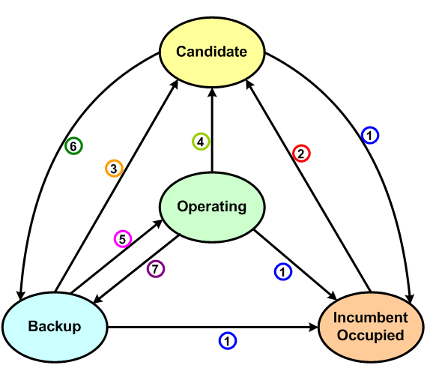
Figure 1 Channel Set Transition Diagram

[We can simply modify the figure as above by ignoring the “WRAN Occupied Set”, or, if we want to introduce the “WRAN Occupied Set”, the relation may become quite complicated. I would imagine the following figure, where the “WRAN Occupied Set” not only overlaps with “Operating”, “Backup” and “Candidate” sets to allow frame-based coexistence, but also even overlaps with “Incumbent Occupied” set, e.g., an incumbent w-microphone is operating in channel N for the present cell 1, but a neighboring cell 2 can still operating on channel N since it does not interference the w-microphone. In this case, channel N is included in both “incumbent occupied” and “WRAN occupied”. Then, how to draw the transit diagram as above seems complicated…]
]

[Option 2 for Sec.9.2.2.1]
      - Transition Diagram for Channel Sets
Any channel belongs to one of possible channel sets in the BS. At the end of quiet period, it may transit to other set as shown by the state transition diagram in Figure 123. Depending on the activities of incumbent users and channel quality, 7 possible transitions can be observed. The condition for each transition is described as follows:

- The channel in Operating, Backup or Candidate set becomes a member of occupied set as incumbent or other WRAN user appears.
- Incumbent or other WRAN service releases the channel
- The poorest channel in Backup set goes to a member of Candidate set as its quality is worse than a new member of Backup set. And an IU appears during the last 30ms.
- The channel is released due to the termination of WRAN usage and its quality is worse than an existing member of the Backup set.
- The channel becomes Operating by new allocation to a WRAN service.
- If the channel quality is better than an existing member of the Backup set, then it replaces the member of Backup set. Also, these channels satisfy that any IU do not appear during the last 30ms
- The channel is released due to the termination of WRAN usage and its quality is better than an existing member of the Backup set.
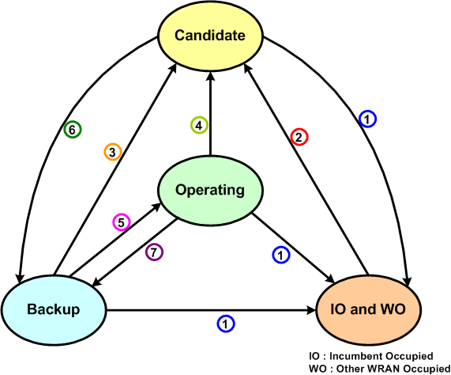
Figure 2 Channel Set Transition Diagram

[Missing points]
- Direct path from WO to Backup: WRAN occupied can change to Backup set directly.
- While coexistence mode between WRAN cells Operating set is equal to WO set.This notification should be added in the figure

[Option 3 for Sec.9.2.2.1]
      - Transition Diagram for Channel Sets
Any channel belongs to one of possible channel sets in the BS. At the end of quiet period, it may transit to other set as shown by the state transition diagram in Figure 123. Depending on the activities of incumbent users and channel quality, 11 possible transitions can be observed. The condition for each transition is described as follows:

- The channel in Operating, Backup or Candidate set becomes a member of incumbent occupied set as incumbent user appears.
- Incumbent service releases the channel
- The poorest channel in Backup set goes to a member of Candidate set as its quality is worse than a new member of Backup set. And an IU appears during the last 30ms.
- The channel is released due to the termination of WRAN usage and its quality is worse than an existing member of the Backup set.
- The channel becomes Operating by new allocation to a WRAN service.
- If the channel quality is better than an existing member of the Backup set, then it replaces the member of Backup set. Also, these channels satisfy that any IU do not appear during the last 30ms
- The channel is released due to the termination of WRAN usage and its quality is better than an existing member of the Backup set.
- The channel in Backup or Candidate set becomes a member of WRAN occupied set as other WRAN user uses the channel.
- Other WRAN user releases the channel whose quality is better than an existing member of the Backup set
- Other WRAN user releases the channel whose quality is poorer than an existing member of the Backup set
- Operating channel is shared with adjacent cell(s). In such case WRAN occupied set is equial to Operating set.

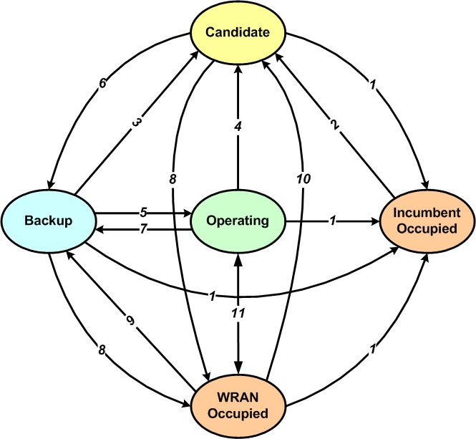
Figure 3 Channel Set Transition Diagram

