IEEE P802.22
Wireless RANs
P802.22 WRAN systems as a means of providing broadband service to rural areas in response to the FCC NOI Docket 09-51 and Document 09-31
“National Broadband Plan in the USA”
Date: 2009-05-12
Author(s):
Name | Company | Address | Phone | email
Gerald Chouinard | CRC | 3701 Carling Avenue, Ottawa, Ontario, Canada K2H 8S2 | 1-613-998-2500 | gerald.chouinard@crc.ca
Abstract
This contribution is a first contribution from the 802.22 WG to describe the advantages of the upcoming 802.22 Standard to address the FCC NOI on National Broadband Plan.
This text is submitted to 802.18 in view of preparing a consolidated view from the IEEE 802 perspective in reaction to the above NOI.
Notice: This document has been prepared to assist IEEE 802.22. It is offered as a basis for discussion and is not binding on the contributing individual(s) or organization(s). The material in this document is subject to change in form and content after further study. The contributor(s) reserve(s) the right to add, amend or withdraw material contained herein.

Release: The contributor grants a free, irrevocable license to the IEEE to incorporate material contained in this contribution, and any modifications thereof, in the creation of an IEEE Standards publication; to copyright in the IEEE’s name any IEEE Standards publication even though it may include portions of this contribution; and at the IEEE’s sole discretion to permit others to reproduce in whole or in part the resulting IEEE Standards publication. The contributor also acknowledges and accepts that this contribution may be made public by IEEE 802.22.

Patent Policy and Procedures: The contributor is familiar with the IEEE 802 Patent Policy and Procedures
<http://standards.ieee.org/guides/bylaws/sb-bylaws.pdf>, including the statement "IEEE standards may include the known use of patent(s), including patent applications, provided the IEEE receives assurance from the patent holder or applicant with respect to patents essential for compliance with both mandatory and optional portions of the standard." Early disclosure to the Working Group of patent information that might be relevant to the standard is essential to reduce the possibility for delays in the development process and increase the likelihood that the draft publication will be approved for publication. Please notify the Chair <Carl R. Stevenson> as early as possible, in written or electronic form, if patented technology (or technology under patent application) might be incorporated into a draft standard being developed within the IEEE 802.22 Working Group. If you have questions, contact the IEEE Patent Committee Administrator at <patcom@ieee.org>.

IEEE 802 Comments on the FCC NOI Docket 09-53

National Broadband Plan

- Introduction
The IEEE 802.22 Working Group has been developing a wireless air interface, including the medium access control layer (MAC) and physical layer (PHY), especially dedicated to the extension of broadband access to low population density rural areas by using fixed point-to-multipoint Wireless Regional Area Networks (WRAN) operating at lower frequencies. These take advantage of the better signal propagation characteristics in the frequency bands used by the Television Broadcasting Service in the frequency range 54 MHz to 698 MHz (TV channels 2 to 51) open to wireless communication by the R&O 08-160.
- Purpose
This standard is intended to enable cost-effective deployment of interoperable 802 multi-vendor wireless regional area network products. It will facilitate competition in broadband access by providing alternatives to wireline broadband access. It will also extend the feasibility to deploy such systems into diverse geographic areas, including sparsely populated rural areas where more TV channels are vacant and where the better signal propagation will provide extended reach while preventing harmful interference to incumbent licensed services.
- Reference Model
A typical application of WRAN’s can be the coverage of the rural area around a village using adaptive modulation as illustrated in Figure 1 within a radius of 17 km . The coverage afforded in a typical application is limited by how an operator configures the system. The technology incorporated into the MAC is designed to accommodate user terminals located as far as 100 km, when exceptional RF signal propagation conditions prevail. Figure 1 gives a pictorial description of the coverage and varying levels of service that are possible with an 802.22-based communications system.

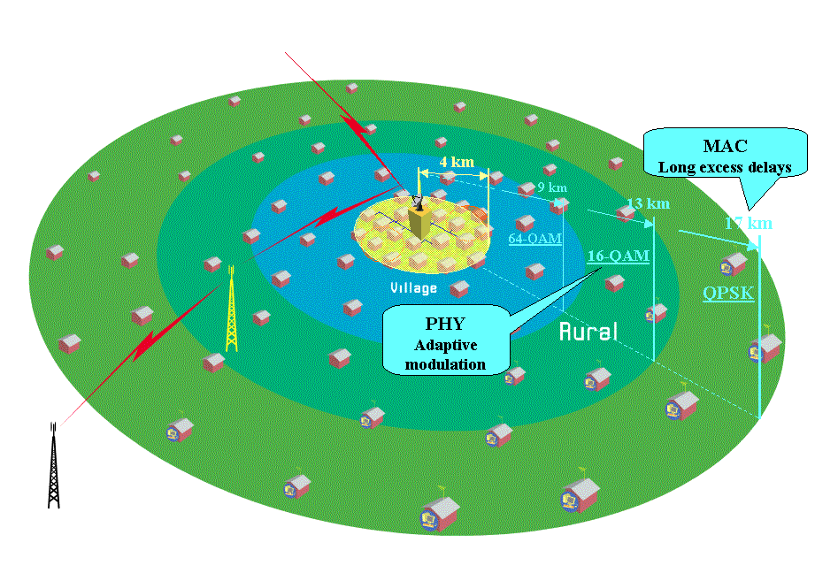
- Typical application of the 802.22 WRAN standard
The user net-peak-throughput is 18.72 Mbit/s per 6 MHz TV channel for either upstream or downstream at short range. Typical WRAN cells can provide service to up to 255 subscribers per TV channel.

The standard utilizes advanced cognitive radio techniques to prevent interference to incumbents, including geo-location capability, provision to access a database of incumbent services, and spectrum-sensing technology to detect the presence of incumbent users. In addition to cognitive radio techniques that allows an 802.22 system to avoid harmful interference to incumbents, 802.22 supports cognitive radio techniques known as coexistence mechanisms. Coexistence mechanisms allow 802.22 systems to talk to each other in order to make sure that the spectrum is shared amongst the users and utilized as efficiently as possible. Combining the cognitive radio techniques used to avoid interference to incumbents with coexistence technology allows services to be deployed in instances where available spectrum may be a scarcity while requiring minimal pre-planning (when compared to traditional wireless/wireline broadband service rollouts). 802.22 also includes security mechanisms for non-cognitive as well as cognitive functions providing security not only for the subscriber and the service provider as well as the broadcast incumbent. The security features include enhancing availability of spectrum and service, reducing probability of denial of service, authentication of signals and users, accountability and audit trail, authorization to access the spectrum and the network, integrity of data, confidentiality and privacy of user and management information.

Figure 2 illustrates the main characteristics of the 802.22 WRAN standard relative to the other existing wireless network standards.

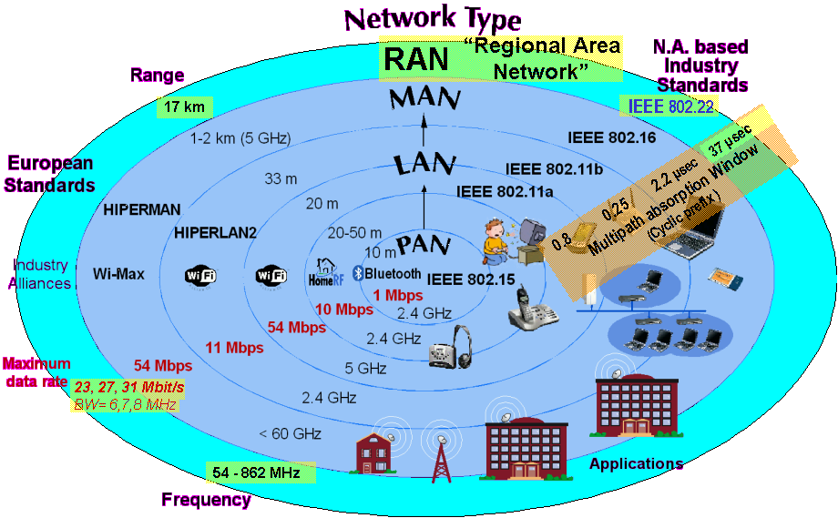
- Characteristics of the WRAN standard relative to other wireless network standards

___________________________________

