IEEE P802.22
Wireless RANs
FCC R&O 08-260
P802.22 as a means to provide broadband service to rural areas in response to the FCC NOI Docket 09-51 and document 09-31
“National Broadband Infrastructure in the USA”
Date: 2009-05-12
Author(s):
Name | Company | Address | Phone | email
Gerald Chouinard | CRC | 3701 Carling Avenue, Ottawa, Ontario, Canada K2H 8S2 | 1-613-998-2500 | gerald.chouinard@crc.ca
Abstract
This contribution is a first contribution from the 802.22 WG to describe the advantages of the potential 802.22 standard to address the FCC NOI on National Broadband Infrastructure.
This text ix contributed to 802.18 for preparing a consolidated view from the IEEE 802 perspective in reaction to the above NOI.
Notice: This document has been prepared to assist IEEE 802.22. It is offered as a basis for discussion and is not binding on the contributing individual(s) or organization(s). The material in this document is subject to change in form and content after further study. The contributor(s) reserve(s) the right to add, amend or withdraw material contained herein.

Release: The contributor grants a free, irrevocable license to the IEEE to incorporate material contained in this contribution, and any modifications thereof, in the creation of an IEEE Standards publication; to copyright in the IEEE’s name any IEEE Standards publication even though it may include portions of this contribution; and at the IEEE’s sole discretion to permit others to reproduce in whole or in part the resulting IEEE Standards publication. The contributor also acknowledges and accepts that this contribution may be made public by IEEE 802.22.

Patent Policy and Procedures: The contributor is familiar with the IEEE 802 Patent Policy and Procedures
<http://standards.ieee.org/guides/bylaws/sb-bylaws.pdf>, including the statement "IEEE standards may include the known use of patent(s), including patent applications, provided the IEEE receives assurance from the patent holder or applicant with respect to patents essential for compliance with both mandatory and optional portions of the standard." Early disclosure to the Working Group of patent information that might be relevant to the standard is essential to reduce the possibility for delays in the development process and increase the likelihood that the draft publication will be approved for publication. Please notify the Chair <Carl R. Stevenson> as early as possible, in written or electronic form, if patented technology (or technology under patent application) might be incorporated into a draft standard being developed within the IEEE 802.22 Working Group. If you have questions, contact the IEEE Patent Committee Administrator at <patcom@ieee.org>.

IEEE 802 Comments on the FCC NOI xx-yyy

National Broadband Infrastructure

- Introduction

The IEEE 802.22 Working Group has been developing a wireless air interface, including the medium access control layer (MAC) and physical layer (PHY), especially dedicated to the extension of broadband access to lower population density rural areas by using fixed point-to-multipoint wireless regional area networks operating at lower frequencies to take advantage of the better signal propagation characteristich in the frequency bands to the Television Broadcasting Service in the frequency range 54 MHz to 697MHz (TV channels 2 to 51) also open to wireless communication by the R&O 08-160.
- Purpose
This standard is intended to enable cost-effective deployment of interoperable 802 multi-vendor wireless regional area network products, to facilitate competition in broadband access by providing alternatives to wireline broadband access and extending the deployability of such systems into diverse geographic areas, including sparsely populated rural areas where more TV channels are vacant and where the better signal propagation will provide extended reach , while preventing harmful interference to incumbent licensed services in the TV broadcast bands.
- Reference Model
The Wireless Regional Networks for which the 802.22 standard is being developed are expected to operate in low population density areas and provide broadband access to data networks using vacant TV channels in the VHF and UHF bands allocated to the Television Broadcasting Service in the frequency range between 54 MHz and 693 MHz while avoiding interference to the broadcast incumbents in these bands. A typical application can be the coverage of the rural area around a village as illustrated in Figure 1 within a radius of 17 km to 30 km depending on the EIRP of the base station using adaptive modulation. The coverage afforded in a typical application is limited by how an operator configures the system. The technology incorporated into the MAC is designed to accommodate user terminals located as far as 100 km, when exceptional RF signal propagation conditions prevail. Figure 1 gives a pictorial description of the coverage and varying levels of service that are possible with an 802.22-based communications system.
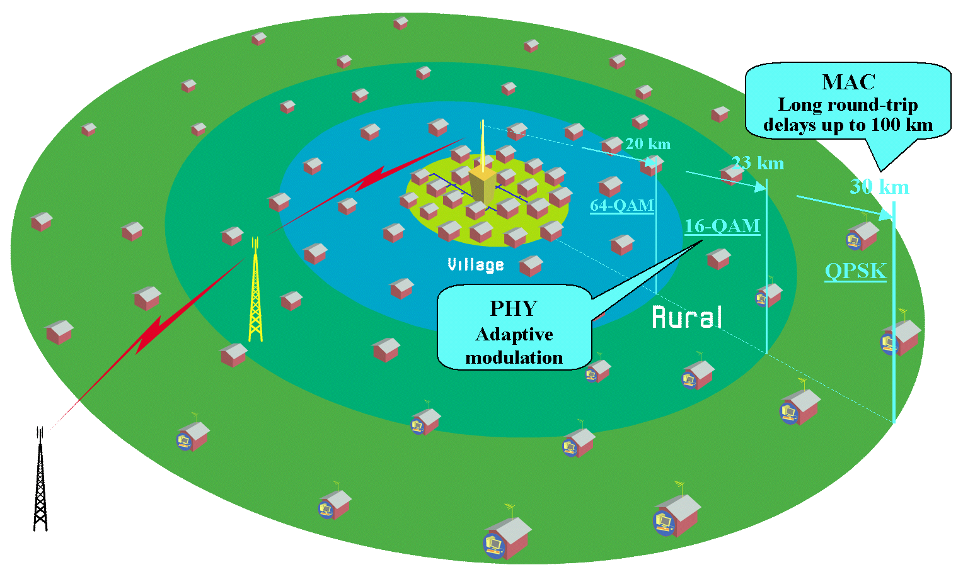
- Typical application of the 802.22 WRAN standard

The capacity at the user terminal is expected to be typically of 1.5 Mbit/s in the downstream and 384 kbit/s in the upstream. The user net-peak-throughput is 18.72 Mbps per 6 MHz TV channel for either upstream or downstream. The service availability due to RF propagation is assumed to be at 50% of locations to allow the service provider to reach subscribers in fringe areas and 99.9% of the time to provide a reliable connection where it is possible. The average spectrum efficiency over the coverage area will to be around 2 bps/Hz given the adaptive modulation parameters and the various operating constraints in a 6 MHz TV channel bandwidth and a 40:1 oversubscription ratio resulting from the stochastic nature of the data network usage, this translates into a total of 255 user terminals that can be served by the base station per TV channel.

The standard utilizes cognitive radio techniques to mitigate interference to incumbents, including geo-location capability, provision to access a database of incumbent services, and spectrum-sensing technology to detect the presence of incumbent users. In addition to cognitive radio techniques that allow an 802.22 system to avoid harmful interference to incumbents, 802.22 supports cognitive radio techniques known as coexistence mechanisms. Coexistence mechanisms allow 802.22 systems to talk to each other in order to make sure that the spectrum is shared amongst the systems and utilized as efficiently as possible. Combining the cognitive radio techniques used to avoid interference to incumbents with coexistence technology allows services to be deployed in instances where available spectrum may be a scarcity while requiring minimal pre-planning (when compared to traditional wireless/wireline broadband service rollouts).

Figure 2 illustrates the main characteristics of the 802.22 WRAN standard relative to the other existing wireless network standards.

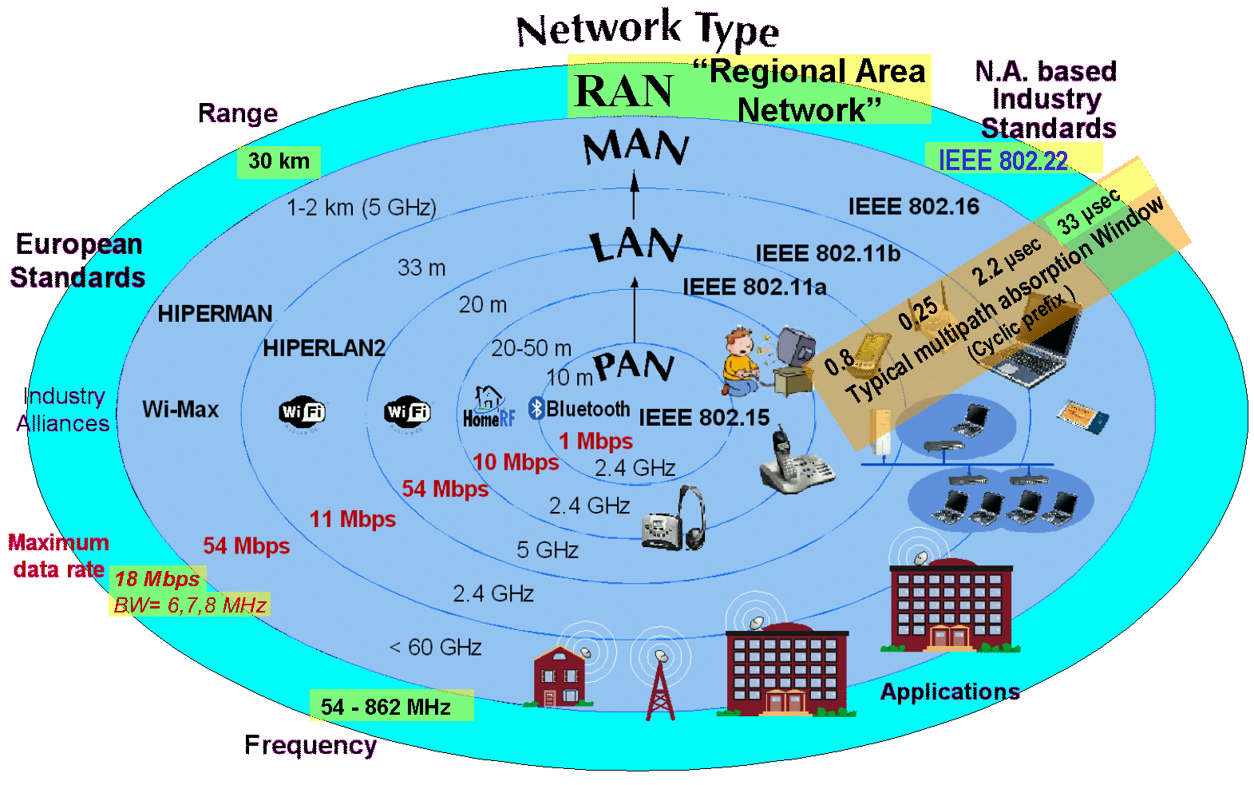
- Characteristics of the WRAN standard relative to other wireless network standards

___________________________________

