IEEE P802.22
Wireless RANs
Resolution for MAC comment 491and 495:
Text change for Section 6.21.3.2.1 Spectrum Etiquette
Date: 2009-04-21
Author(s):
Name | Company | Address | Phone | email
Chang-Joo Kim | ETRI | Korea | +82-42-860-1230 | cjkim@etri.re.kr
Myung-Sun Song | ETRI | Korea | +82-42-860-5046 | mssong@etri.re.kr
Gwang-Zeen Ko | ETRI | Korea | +82-42-860-4862 | gogogo@etri.re.kr
Sung-Hyun Hwang | ETRI | Korea | +82-42-860-1133 | shwang@etri.re.kr
Jung-Sun Um | ETRI | Korea | +82-42-860-4844 | korses@etri.re.kr

Abstract
This document provides the resolutions for comment 491 and 495. This document provides harmonization of some terminologies with Section 9.2.2(Spectrum Manager).

Notice: This document has been prepared to assist IEEE 802.22. It is offered as a basis for discussion and is not binding on the contributing individual(s) or organization(s). The material in this document is subject to change in form and content after further study. The contributor(s) reserve(s) the right to add, amend or withdraw material contained herein.

Release: The contributor grants a free, irrevocable license to the IEEE to incorporate material contained in this contribution, and any modifications thereof, in the creation of an IEEE Standards publication; to copyright in the IEEE’s name any IEEE Standards publication even though it may include portions of this contribution; and at the IEEE’s sole discretion to permit others to reproduce in whole or in part the resulting IEEE Standards publication. The contributor also acknowledges and accepts that this contribution may be made public by IEEE 802.22.

Patent Policy and Procedures: The contributor is familiar with the IEEE 802 Patent Policy and Procedures
<http://standards.ieee.org/guides/bylaws/sb-bylaws.pdf>, including the statement "IEEE standards may include the known use of patent(s), including patent applications, provided the IEEE receives assurance from the patent holder or applicant with respect to patents essential for compliance with both mandatory and optional portions of the standard." Early disclosure to the Working Group of patent information that might be relevant to the standard is essential to reduce the possibility for delays in the development process and increase the likelihood that the draft publication will be approved for publication. Please notify the Chair <Carl R. Stevenson> as early as possible, in written or electronic form, if patented technology (or technology under patent application) might be incorporated into a draft standard being developed within the IEEE 802.22 Working Group. If you have questions, contact the IEEE Patent Committee Administrator at <patcom@ieee.org>.

Comment 491

<<Related Section 6.21.2.3.1, pp.420>>
The terminology used for the various sets and pools of frequencies (or "TV channels" to be consistent with the rest of the document) should be consistent with the sets defined by the Spectrum Manager. Or alternatively, it should be shown how the TV channel sets in the Spectrum Manager map to these 4 sets of channels.).

Comment 495
Active channel is not correct

Remedy:
This document provides modified text of Section 6.21.2.3.1 which is the first approach as mentioned Vlantis, George. To hamonize with channel set definition in Sec. 9, Section 6.21.2.3.1 should be modified as follows
1.frequency→channel
2.candidate channel →backup channel
3.active channel →operating channel

Modification of Section 6.21.3.2.1

        - Spectrum Etiquette
The channel selection at a cell obeys the spectrum etiquette rule so that the chosen channel does not interfere, or interferes with a minimum number of channels to be used by its neighbor cells. Without cooperation, the frequency channel selection in a cell may lead to one or more BS not having enough channels. For example, the available backup channels sets at BS1 and BS2 are {1, 3}, and {1, 2, 3} respectively. If BS2 decides to use {1, 3}, BS1 would have no channel to use. The cooperation is also necessary for load balancing. Say BS1 is heavy loaded while BS2 is not. BS2 could use {2}, then BS1 can use {1, 3}.

The channel-selection decision of each cell follows the flowchart in . The terms of central cell and neighbor cells are relative concepts. Beside the candidate backup and active operating sets, Fpool and Flocal are defined and used for describing the principles of spectrum etiquette. In the description below, the scope of “frequencies channels” is defined by the BS Channel Parameter IE(See 6.7.1.2.1.19).

- Fcandidate Fbackup set, CellID := the frequencies that do not interfere with incumbent users. channels that can become the operating channel right away(See 9.2.2).
- F active operating set, CellID := the frequencies that the cell has selected. the current channel used for communication between BS and CPEs within a WRAN cell(See 9.2.2).
- Fpool := the frequencies channels that are usable in the central cell and are not used by neighbor cells := Fcandidatebackup set, Central \ (union of the active channels of all its neighbor cells)
- Flocal := Fpool \ {union of the candidatebackup sets of all its neighbor cells}

Note that:
  - Symbols U, ∩, and \ are set operation of union, intersection, and exclude, respectively.
  - Note that Fpool and Flocal are local information, which are not shared with neighbor cells. That is why they do not need CellID.

The procedure of WRAN spectrum etiquette is as follows.
- The central cell decides its Fcandidatebackup set, and Fpool.
- The central cell selects frequencies from the Fpool according to the following etiquette principles.
  - Try to use the frequencies channels that cannot be used by neighbor cells at all. In other words, use first the frequencies channels in Flocal
  - If the central cell has got enough frequencies channels, go to Step 3. Otherwise, try to select frequencies channels from the rest of Fpool with the consideration of avoiding those that will affect most of its neighbor cells. For example, use first the frequencies channels that are not shared by more than one neighbor cells, then other frequencies channels that may affect more and more neighbor cells.
  - If the central cell has got enough frequencies channels, go to Step 3. Otherwise, it continues the self-coexistence procedure using interference-free scheduling as shown in Error: Reference source not found and .
- Update neighbor cells of its Fcandidatebackup set, and F active operating set. Go back to Step 1.

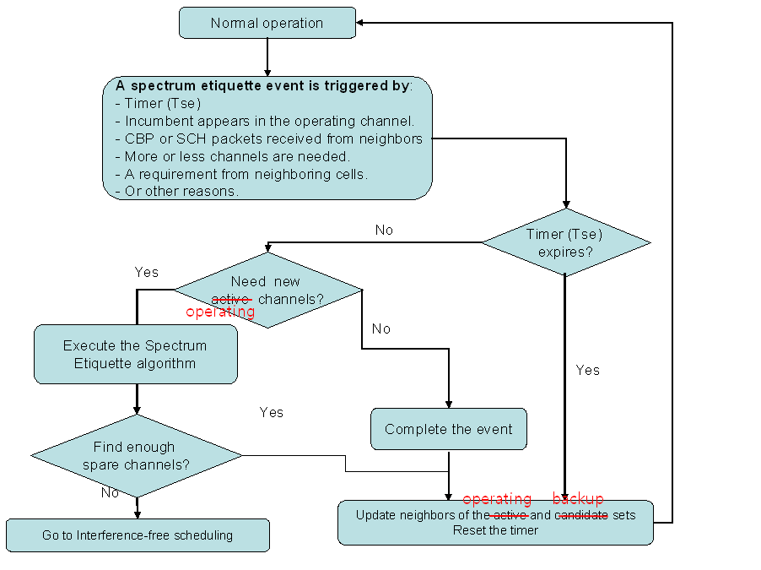
The flow chart of channel selection and update with neighbors

The spectrum etiquette procedure is further illustrated using the example in . The central cell has 6 neighbor cells (N1, …, N6). Neighbor cell N1 has the candidatebackup channel set {1, and 3}, with channel 2 being used. The similar messages for neighbor cells N2 to N6 are shown in the table. The pool of availablebackup channels (i.e., Fpool) of the central cell are {4, and 11}. Channel 4 is a candidatebackup channel of neighbor cells N3, N5 and N6. Therefore, channel 11 is in the local channel set (i.e., Flocal), which will be selected by the central cell as its active operating channel.
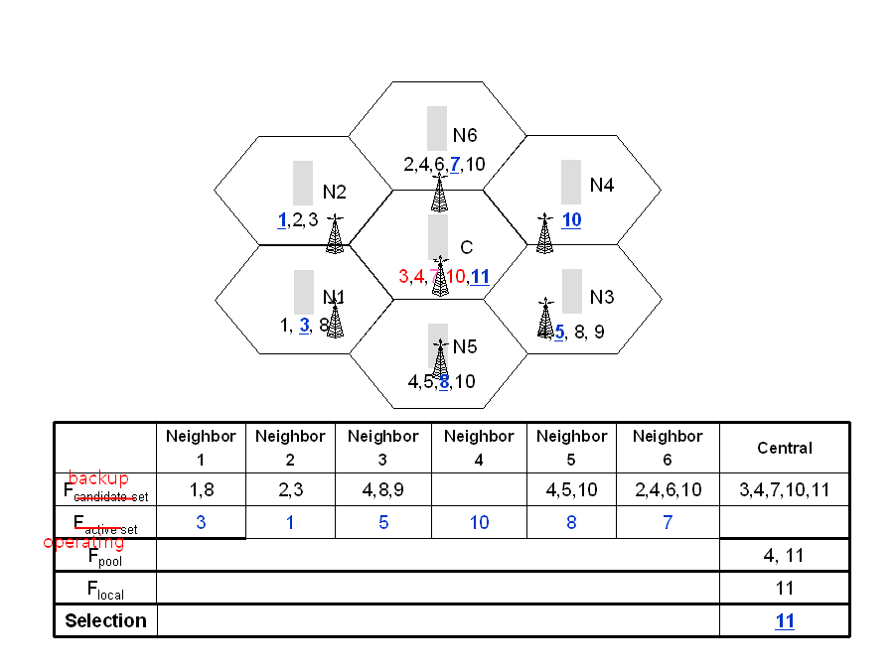
Illustration of the procedure of spectrum etiquette

