IEEE P802.22
Wireless RANs
Section 9 - Cognitive Radio Capability – Missing Sections and Details
Date: 2009-03-12
Author(s):
Name | Company | Address | Phone | email
Apurva Mody | BAE Systems | P.O. Box 868, MER 15-2350, Nashua, NH 03061-0868 | 603-885-2621  404-819-0314 | apurva.mody@baesystems.com,  apurva_mody@yahoo.com
Ranga Reddy | US Army (CERDEC) | Ft Monmouth, NJ | - | Ranga.reddy@us.army.mil
Tom Kiernan | US Army (CERDEC) | Ft Monmouth, NJ | - | Thomas.kiernan@us.army.mil
Abstract
This document provides the detailed description of the missing content in Section 9 - Cognitive Radio Capabilities in 802.22 v1.5 draft standard.

Notice: This document has been prepared to assist IEEE 802.22. It is offered as a basis for discussion and is not binding on the contributing individual(s) or organization(s). The material in this document is subject to change in form and content after further study. The contributor(s) reserve(s) the right to add, amend or withdraw material contained herein.

Release: The contributor grants a free, irrevocable license to the IEEE to incorporate material contained in this contribution, and any modifications thereof, in the creation of an IEEE Standards publication; to copyright in the IEEE’s name any IEEE Standards publication even though it may include portions of this contribution; and at the IEEE’s sole discretion to permit others to reproduce in whole or in part the resulting IEEE Standards publication. The contributor also acknowledges and accepts that this contribution may be made public by IEEE 802.22.

Patent Policy and Procedures: The contributor is familiar with the IEEE 802 Patent Policy and Procedures
<http://standards.ieee.org/guides/bylaws/sb-bylaws.pdf>, including the statement "IEEE standards may include the known use of patent(s), including patent applications, provided the IEEE receives assurance from the patent holder or applicant with respect to patents essential for compliance with both mandatory and optional portions of the standard." Early disclosure to the Working Group of patent information that might be relevant to the standard is essential to reduce the possibility for delays in the development process and increase the likelihood that the draft publication will be approved for publication. Please notify the Chair <Carl R. Stevenson> as early as possible, in written or electronic form, if patented technology (or technology under patent application) might be incorporated into a draft standard being developed within the IEEE 802.22 Working Group. If you have questions, contact the IEEE Patent Committee Administrator at <patcom@ieee.org>.
1.0 Cognitive Radio Capabilities – Missing Content and Details
This document proposes the details of the missing content in Section 9, Cogntive Radio Capabilities in the 802.22 draft standards document, v1.5

Cognitive Radio Capabilities Ad-hoc suggests that the following sections be inserted into Section 9
9.3 Spectrum Manager Operation

9.3.1 Introduction

9.3.2 Spectrum Manager Operation at BS Initialization

There is no information on CPEs – MAC is in charge, MAC asks the SM to find the best channel to use
1. Get the data from the incumbent database
2. Get geolocation information
3. Terrain data
4. Sensing from the BS
5. Channel classification
6. Spectrum Etiquette
7. Co-existence ()
8. Channel selection

9.3.3 Spectrum Manager Behavior during Regular Operation after Initialization
Connection established but no information on CPEs –
1. Get the data from the incumbent database which may or may nor recide on the local network.
2. Get geolocation information from CPEs
3. Optimization between network topology (CPE locations) and load balancing - External Host through the MIBs
4. Sensing information from CPEs and Update info from BS
5. Incumbent classification
6. Channel selection based on Spectrum Etiquette – operating channel, backup channel and candidate channel
7. Propogate the channel list to CPEs (MAC Function) – Define a MIB that contains these lists
8. Co-existence ()
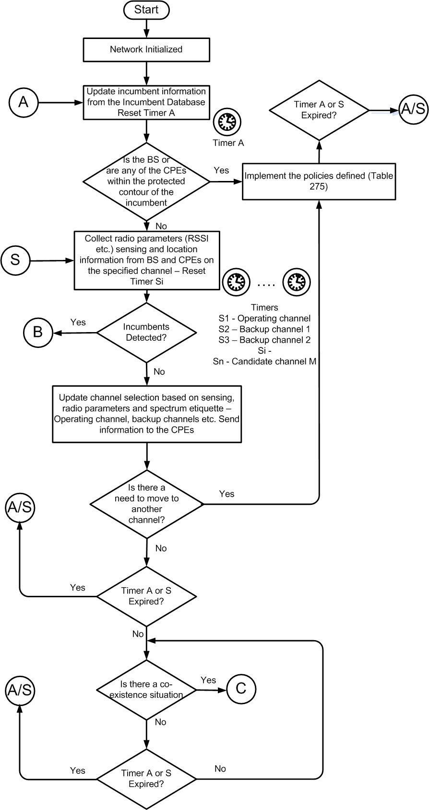
9.3.4 Spectrum Manager Behavior when Incumbent Detected
- Read the policies defined in Section 9
- Execute

9.3.5 Collaborative Sensing for Security in 802.22

