IEEE P802.22
Wireless RANs
Text of An Enhanced Quiet Period Synchronization Method for 802.22 WRAN Networks
Date: 2008-10-20
Author(s):
Name | Company | Address | Phone | email
Haiguang Wang | Hisilicon Technologies | Harbor Networks Building, Zhongguancun Software Park, Haidian District, Beijing China | +86 10 82829148 | wanghaiguang@huawei.com
Shulan Feng | Hisilicon Technologies | Harbor Networks Building, Zhongguancun Software Park, Haidian District, Beijing China | +86 10 82829148 | fengsl@huawei.com
Jinnan Liu | Hisilicon Technologies | Harbor Networks Building, Zhongguancun Software Park, Haidian District, Beijing China | +86 10 82829148 | liujinnan@huawei.com
Abstract
To avoid interferences, network-wide quiet periods (QPs) are usually scheduled for the purpose of channel sensing in cognitive radio (CR) networks. The recent IEEE 802.22 draft standard requires that adjacent base stations (BSs) should synchronize their QP in scheduling. However, we find that the current design is incomplete in handling the dynamic of synchronized QP. The problem is that BSs cannot handle the decreasing of synchronized QP duration. This can cause the wastage of network resources. To solve the problem, we propose a Synchronization Counter (SC)-based method in this paper. With the method, the BSs can accurately synchronize the QP when the duration varies. It makes the synchronization more accurate and thus saves the network resources. We have veri¯ed the proposed scheme with simulation and provide the performance results that reveal the basic features of network-wide QP synchronization.
Notice: This document has been prepared to assist IEEE 802.22. It is offered as a basis for discussion and is not binding on the contributing individual(s) or organization(s). The material in this document is subject to change in form and content after further study. The contributor(s) reserve(s) the right to add, amend or withdraw material contained herein.

Release: The contributor grants a free, irrevocable license to the IEEE to incorporate material contained in this contribution, and any modifications thereof, in the creation of an IEEE Standards publication; to copyright in the IEEE’s name any IEEE Standards publication even though it may include portions of this contribution; and at the IEEE’s sole discretion to permit others to reproduce in whole or in part the resulting IEEE Standards publication. The contributor also acknowledges and accepts that this contribution may be made public by IEEE 802.22.

Patent Policy and Procedures: The contributor is familiar with the IEEE 802 Patent Policy and Procedures
<http://standards.ieee.org/guides/bylaws/sb-bylaws.pdf>, including the statement "IEEE standards may include the known use of patent(s), including patent applications, provided the IEEE receives assurance from the patent holder or applicant with respect to patents essential for compliance with both mandatory and optional portions of the standard." Early disclosure to the Working Group of patent information that might be relevant to the standard is essential to reduce the possibility for delays in the development process and increase the likelihood that the draft publication will be approved for publication. Please notify the Chair <Carl R. Stevenson> as early as possible, in written or electronic form, if patented technology (or technology under patent application) might be incorporated into a draft standard being developed within the IEEE 802.22 Working Group. If you have questions, contact the IEEE Patent Committee Administrator at <patcom@ieee.org>.
- Introduction

With the current design 6.6.1 and 6.21.2.3, the IEEE 802.22 standard requires the BSs to schedule network-wide QP for spectrum sensing. To avoid interference from adjacent cells when sensing, the nearby BSs are also required to synchronize their QP. The synchronization here means that the QP of different BSs should start and end at the same time. The QPs are synchronized by exchanging control messages among the BSs directly or indirectly. The standard has defined several parameters for the scheduling of QP, such as the sensing frequency, the duration of QP in each frame etc. However, with our analysis, we find that the existing design does not support the dynamic of synchronized QP well. With the existing design, BSs know when to increase the duration of QP for the synchronization purposes, but do not know when to decrease the duration when it can be reduced network-widely. This may lead to overallocation on QP and thus cause wastage of network resources. Over-allocation here means that BSs synchronize on a QP that exceeds the need of all BSs.

- Problem with Current Design

Assuming there are K BSs in a given region, denoted as BS₁, BS₂, …, BS_{K}. We define a Graph G(V;E) for the network formed with BSs, in which V = {BS_{i}, i = 1, 2, …, K} and E ={ l_{ij} if BS_{i} and BS_{j} are overlapping}. We assume that G(V;E) is a connected graph. Therefore, all the BSs in G(V,E) should synchronize on one QP duration (QPD) for intra-frame sensing.
We use $D_{\text{min}}^{i}$ to denote the minimum value of QPD required by BS_{i} without considering synchronization. We use D_{syn} to denote the synchronized value of QPD. According to the IEEE 802.22 standard, we have:
$D_{\text{syn}}=\text{max}\left\{D_{\text{min}}^{i},i=1,2,\text{.}\text{.}\text{.},K\right\}$ (1)
D_{syn} is used by all the BSs in the G(V;E) for Intra-frame Sensing.
To synchronize the QPD, each BS has to define a variable, denoted as $D_{\text{syn}}^{i}$ to keep the current value of synchronized QPD. BSs set the value of Intra-Frame Sensing Duraion (IFS-D) field in CBP packets based on it. The initial value of $D_{\text{syn}}^{i}$is set to $D_{\text{min}}^{i}$. When BS_{i} receives CBP from neighboring BS, assuming from BS_{j} , it updates$D_{\text{syn}}^{i}$ based on following algorithm:
if $D_{\text{syn}}^{i}<D_{\text{syn}}^{j}$ then
$$D_{\text{syn}}^{i}=D_{\text{syn}}^{j}$$
else
do not change the value of $D_{\text{syn}}^{i}$.
endif

Figure 1: QPD updating algorithm derived from 802.22 draft standard
It is derived based on the content of IEEE 802.22 starndard. With this algorithm, after a few rounds of CBP exchanging, the BSs are able to synchronize their QPD to the largest minimum required QPD among the BSs. Once synchronized, we should have$D_{\text{syn}}^{1}=D_{\text{syn}}^{2}=\text{.}\text{.}\text{.}=D_{\text{syn}}^{K}=D_{\text{syn}}$.
$D_{\text{syn}}$may not always be a static value after synchronization. It can change over time due to variations of $D_{\text{min}}^{i}$. The value of $D_{\text{syn}}$can either increase or decrease. We verified the design and found that it is fine for the current design in handling the increasing of$D_{\text{syn}}$, which is caused by the increasing of certain$D_{\text{syn}}^{i}$. However, when the value of $D_{\text{syn}}$decreases, with the current design, the BSs cannot synchronize to the desired D_{syn}. This requires us to design a new method so that BSs can resynchronize their QP on a shorter duration.

- Our Solution

And eventually we find that the solution using Synchronization Counter is the best one. In the design, for each BS, BSi, we define a variable served as synchronization counter, named as${\text{SC}}_{D}^{i}$ . It takes value from 1 to SC_{max}, where SC_{max} is a predetermined value and we are going to discuss it later in this section. The value of ${\text{SC}}_{D}^{i}$ is sent along with the $D_{\text{syn}}^{i}$ in CBP packets and their values are updated with the algorithm shown in Figure 2:

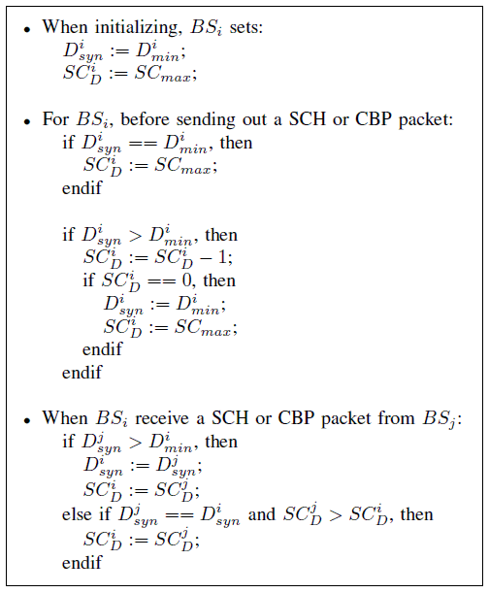
Figure 2: The proposed algorithm

- Illustration of the proposed algorithm

We use the network formed with BS shown in Figure 3 as an example, in which the edge between BSs represent the overlapping relationship. Assuming at t1, all BSs have synchronized to Dsyn = 2. For BS1, as $D_{\text{syn}}^{1}=D_{\text{min}}^{1}$, according to step 2, ${\text{SC}}_{D}^{1}$ is always set to SCmax. For BS2, based on step 3, ${\text{SC}}_{D}^{2}$ is set to ${\text{SC}}_{D}^{1}={\text{SC}}_{\text{max}}$ when receiving CBP packets from BS1. Because of $D_{\text{min}}^{2}<D_{\text{syn}}^{2}$D2, according to step 2, ${\text{SC}}_{D}^{2}$ is minus by one when BS2 sends out CBP packets. This results in ${\text{SC}}_{D}^{3}={\text{SC}}_{\text{max}}−1$. Similarly, for BS4, BS5,…,BS7, they have ${\text{SC}}_{D}^{i}={\text{SC}}_{\text{max}}−H_{c}+1$, where HC is the hop count from BSi to BS1. As long as the value of SCmax is greater than the diameter of G(V;E), the value of ${\text{SC}}_{D}^{i}$of BSi will be greater than zero. Here we assume that no CBP packet is corrupted during transmission. When the value of Dsyn increases, the process of synchronizatin is similar to the one described for algorithm derived according to the starndard. So we are not going to repeat it here.
Now we look at the case of Dsyn decreases. We still assume that, at time t2, $D_{\text{min}}^{1}$ is decreased to 1. With the proposed algorithm, as $D_{\text{min}}^{1}<D_{\text{syn}}$, the value of ${\text{SC}}_{D}^{1}$starts to decrease when BS1 sending out CBP packets. As BS2 depends on BS1 in maintaining the value of ${\text{SC}}_{D}^{2}$, its value also starts to decrease. And so on for BS3, BS4, …, BS7. Table 1 shows an instance of ${\text{SC}}_{D}^{i}$ decreasing at BS1 to BS4, where $Δ$ is the duration of a superframe given that CBP packets is sent once for every superframe.When ${\text{SC}}_{D}^{i}$ reduces to zero, BSi set $D_{\text{syn}}^{i}=D_{\text{min}}^{i}$ and starts the resynchronization of QP. In this example, it is BS7 that starts the resynchronization process first, and then followed by BS6, and so on. Eventually, all $D_{\text{syn}}^{i}$ converge to the new value of Dsyn, or 1 symbol duration in this example.
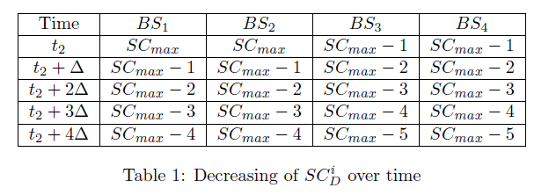
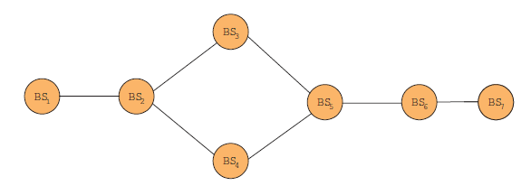
Figure 3: An example network formed with BSs
Now we look at the value of SCmax. From above discussion, we know that ${\text{SC}}_{D}^{i}={\text{SC}}_{\text{max}}−H_{c}+1$, where HC is the hop count from BSi to the nearest BS with $D_{\text{min}}^{i}=D_{\text{syn}}$. The maximum value of HC is the diameter of the network. Thus, to use the proposed algorithm, the value of SCmax must be greater than the diameter of the network formed with BSs. Else, some BSs may not be able to synchronize with other BSs. Another factor we need to consider is channel corruption. When CBP packets are corrupted, the value of ${\text{SC}}_{D}^{i}$ can be reduced to a smaller value than ${\text{SC}}_{\text{max}}−H_{c}+1$. For example, one CBP loss on link l12 causes ${\text{SC}}_{D}^{2}$decrease to ${\text{SC}}_{\text{max}}−1$. Consecutively losing of k CBP packets can lead it reduces to ${\text{SC}}_{\text{max}}−k$. Therefore, when choosing the value of SCmax, we should also reserve some spaces for possible CBP packet losses. Here we would like to recommend that ${\text{SC}}_{\text{max}}>1\text{.}5\text{diet}(G(V,E))$, where $\text{diet}(G(V,E))$ refers to the diameter of the graph.
From above discussions, we can conclude that the propose method is able to reduce the synchronized QP when necessary. The algorithm can also be applied in the synchronization of other parameters of QP such as Intra-Frame Sensing Cycle Length and Intra-Frame Sensing Bitmap. We will address on these issues in our future work.

- Design Verification

We have implemented the QP synchronization protocol together with the proposed algorithm in network simulator NS-2 [2]. With the simulation program, we have verified our design and studied its performance in synchronization. In the following part of this section, we first introduce the simulation configuration parame- ters used in the study, which are chosen according to the IEEE 802.22 standard [1], and then we present the simulation results.
In our simulation, we choose a region of 100km x 100km and put 20 BSs randomly in it. Figure 4 shows the location of the BSs in the region. The network diameter is about 7 hops. The transmission power of BS is set to 4 Watts. The antenna gain is set to 6dB. We choose the path loss model polynomial power decay and the expontent is set to 2.6. The con¯guration results in a radio transmission range of 33 kilometers, which is a typical transmission range of 802.22 BSs. We set the channel bandwidth to 6MHz and use QPSK with 1/2coding scheme in transmitting CBP packets. An error model based on QPSK with 1=2 coding is implemented at the physical layer. The transmission rate is set to 4.5Mbps. We assume that BSs receives CBP packet from neighboring BSs directly. We choose SCmax to be 15 by assuming that we can use four bits to carry the SC information.
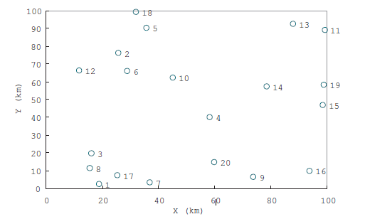
Figure 4: The Location of BSs
For QP duration, it is counted in number of symbols according to the specification. We assume that the minimum required duration of QP for a given BS varies over time and follows Normal distribution with mean value of 3 and standard deviation of 2. The changes of QP are independent among BSs and the interval follows an exponential distribution with mean value of 60 seconds. We set the values of Intra-frame Sensing Cycle Length, Intra-Frame Sensing Offset and Intra-Frame Sensing Btimap to one. The simulation time in our study is one hour.
Figure 5 shows the variation of the synchronized QPD over time. We randomly choose BSs 1, 5, 10, 15 and 20 and show their results. We can observe that the synchronized duration of QP firstly increases from 6 to 9 and then decrease to 5 gradually; and then increases again. After analyzing the traces from simulation, we concluded that our algorithm worked as expected and could handle the dynamic of Dsyn. Each time, when the duration of QP increases, BSs can adapt to the change quickly and neatly. When it decreases, the BSs have to decrease to the minimum required QP duration first and then synchronize to the new Dsyn gradually. As expected, when Dsyn increases, the mean time for the network converging to the new Dsyn is 0.93 seconds in average, short than the value when Dsyn decreases, which is 1.21 seconds in average.
In our study, we have also found that channel corruption resulted in adjustment of QP at some BSs. For example, as Figure 5 shows, BS1, BS5 and BS10 were forced to adjust their QPD at time 246.56, 262.76, 271.53 respectively. It is because the link l4;10, l20;7 are very weak. They have caused CBP packets to be dropped consecutively and further triggered the resynchronization of QP of these nodes. The resynchronization takes one or two superframes. It is rather short and the negative effect to network should be trivial.
Figure 6 shows the detailed process of how the nodes synchronize to a shorter QPD. As expected, BSs further away from the BS with $D_{\text{min}}^{i}=D_{\text{syn}}$ start the adjustment first. At the beginning, they set $D_{\text{syn}}^{i}=D_{\text{min}}^{i}$ and then gradually converge to the new value of Dsyn. With the selected BSs, the duration is less than one second. With one hour simulation, the average time for resynchronization is 1.21 seconds when Dsyn decreases.
As it may take several seconds for the BSs to resynchronize to a new value of QPD, in a real network, it is possible that a BS transmits data in the QP of other BSs and thus cause false alarm in spectrum sensing. To avoid this, we propose that a BS should avoid to using the previous QP duration for data transmission for several seconds after it synchronize on a new QPD.
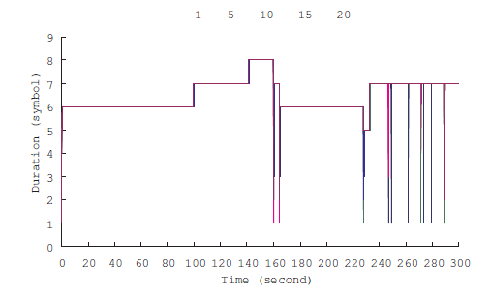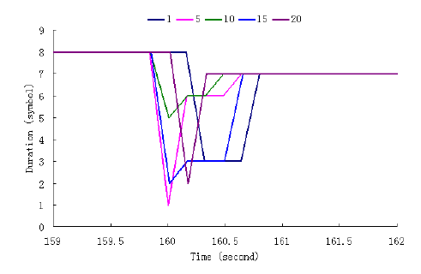
Figure 5: The variation of synchronized QPD Figure 6: The process of synchronization to a shorter QPD

- Conclution

In this proposal, we have proposed a method for the synchronization of QP for Intra-frame Sensing as the original one in the 802.22 standard is incomplete. We use a synchronization counter to decide when the BSs should reduce their QP duration to a smaller value and then start the resyncrhonization process. This enables BSs flexibly adjust the duration of QP according to their requirement. It saves the network resources and thus can increase the network throughput.

References:
- IEEE P802.22 DRAFTv1.1Draft Standard for Wireless Regional Area Networks Part 22: Cognitive Wireless RAN Medium Access Control (MAC) and Physical Layer (PHY) speci¯cations: Policies and procedures for operation in the TV BandsMarch 2008.
- The Network Simulator - ns-2, http://www.isi.edu/nsnam/ns/.

Proposed Text

    - Superframe Control Header

- — Superframe control header format
Syntax | Size | Notes
Superframe_Control_Header_Format() { |  | 1 OFDM symbol long and transmitted with modulation/coding described in section 8.3.2.2
CT | 1 bits | Content Type  Indicates the type of the content following the transmission of the SCH.  Superframe = 0  CBP Beacon = 1
Superframe Number | 8 bits | Positive integer that represents the superframe number (modulo 255). This field shall be incremented by 1 upon every new superframe.
TTQP | 12 bits | Time To Quiet Period  Used for in-band inter-frame sensing, it indicates the time span between the transmission of this information and the next scheduled quiet period for inter-frame sensing.  The 8 left most bits index the superframe number and the 4 right most bits index the frame number when the next scheduled quiet period for inter-frame sensing will start.
DQP | 4 bits | Duration of Quiet Period  Used for in-band inter-frame sensing, it indicates the duration of the next scheduled quiet period.  If this field is set to a value different from 0 (zero), it indicates the number of frames starting from TTQP that shall be used to perform inter-frame sensing.  If this field is set to 0, it cancels the next scheduled quiet period for inter-frame sensing or indicates that no inter-frame sensing are currently scheduled]
Tx ID | 48 bits | MAC address that uniquely identifies the CPE or BS transmitting the SCH.
CN | 8 bits | Channel Number  Indicates the physical TV channel number used by the BS.
CP | 2 bit | Cyclic Prefix Factor  Specifies the size of the cyclic prefix used by the PHY in the frame transmissions in this superframe. Pre-determined values are:  1 = ¼ symbol period  2= 1/8 symbol period  3= 1/16 symbol period  4= 1/32 symbol period
Length | 8 bits | The length in bytes of the information following the SCH.
Intra-frame Sensing Cycle Length | 8 bits | Specified in number of superframes, it indicates the number of superfames for which the intra-frame sensing specification is valid.  If this field is set to 0, no intra-frame sensing is scheduled or the current intra-frame sensing is canceled.
Intra-frame Sensing Cycle Offset | 8 bits | Valid only if intra-frame Sensing Cycle Length > 0.  Used for in-band intra-frame sensing.  Specified in number of superframes, it indicates the offset from this SCH transmission to the beginning of the first superframe in the current intra-frame sensing cycle.
Intra-frame Sensing Cycle Frame Bitmap | 16 bits | Valid only if intra-frame Sensing Cycle Length > 0.  Valid for a unit of superframe, each bit in the bitmap corresponds to one frame within the superframe. If the bit is set to 0, intra-frame sensing shall not be performed in the corresponding frame. If the bit is set to 1, intra-frame sensing shall be performed within the frame for the duration specified by Intra-frame Sensing Duration.  This bitmap applies to all superframes within the Intra-frame Sensing Cycle Length.
Intra-frame Sensing Duration | 5 bits | Valid only if Intra-frame Sensing Cycle Length > 0.  If this field is set to a value different from 0 (zero): It indicates the number of symbols starting from the end of the frame that shall be used to perform intra-frame sensing.
Synchronization Counter for Intra-frame Sensing Duration | 8 bits | Valid only if Intra-frame Sensing Duration > 0.  This field is used for the purpose of Intra-frame Sensing Duration synchronization among overlapping BSs.
IEs | Variable (integer of bytes) | Optional Information Elements which could be transmitted with the SCH. They are:  MAC version  Current transmit power  Location configuration information  DTV acknowledgement (TBD)  Wireless microphone acknowledgement  Sensing information (6.8.22.1.1)
HCS | 8 bits | Header Check Sequence  See
Reserved | 4 bits | All bits shall be set to zero.
}

      - Synchronization of Overlapping Quiet Periods
[Skip the first two parapgraph]

Once the superframes are synchronized, and since the intra-frame sensing quiet periods always start at the end of a frame, the BS synchronizes the intra-frame sensing quiet periods by adjusting its Intra-frame Sensing Cycle, Intra-frame Sensing Cycle Frame Bitmap according to the information received from other cells. The BS also adjusts the Intra-frame Sensing Duration to the largest amongst the overlapping cells.

In order to allow the Intra-frame Sensing Duration after synchronization adapt to the variation of Intra-frame Sensing Duration, each BS, denoted as BS_{i}, should maintain a variable named Synchronization Counter for Intra-frame Sensing Duration, denoted as ${\text{SC}}_{D}^{i}$. This value is sent together with Intra-frame Sensing Duration in SCH and CBP. It should be updated according to following algorithms:
Figure xxx: Algorithm to update the Intra-frame Sensing Duration
where $D_{\text{syn}}^{i}$is the currently synchronized Intra-frame Sensing Duration of BS_{i} and$D_{\text{min}}^{i}$is the minimum requirement on Intra-frame Sensing Duration by BS_{i}. SC_{max} is predefined value.

