IEEE P802.22
Wireless RANs
Resolution for MAC comment 561:
Channel Set Transition Diagram
Date: 2008-09-05
Author(s):
Name | Company | Address | Phone | email
Chang-Joo Kim | ETRI | Korea | +82-42-860-1230 | cjkim@etri.re.kr
Myung-Sun Song | ETRI | Korea | +82-42-860-5046 | mssong@etri.re.kr
Gwang-Zeen Ko | ETRI | Korea | +82-42-860-4862 | gogogo@etri.re.kr
Sung-Hyun Hwang | ETRI | Korea | +82-42-860-1133 | shwang@etri.re.kr
Jung-Sun Um | ETRI | Korea | +82-42-860-4844 | korses@etri.re.kr

Abstract
This document provides the proposed resolutions for comment 561.

Notice: This document has been prepared to assist IEEE 802.22. It is offered as a basis for discussion and is not binding on the contributing individual(s) or organization(s). The material in this document is subject to change in form and content after further study. The contributor(s) reserve(s) the right to add, amend or withdraw material contained herein.

Release: The contributor grants a free, irrevocable license to the IEEE to incorporate material contained in this contribution, and any modifications thereof, in the creation of an IEEE Standards publication; to copyright in the IEEE’s name any IEEE Standards publication even though it may include portions of this contribution; and at the IEEE’s sole discretion to permit others to reproduce in whole or in part the resulting IEEE Standards publication. The contributor also acknowledges and accepts that this contribution may be made public by IEEE 802.22.

Patent Policy and Procedures: The contributor is familiar with the IEEE 802 Patent Policy and Procedures
<http://standards.ieee.org/guides/bylaws/sb-bylaws.pdf>, including the statement "IEEE standards may include the known use of patent(s), including patent applications, provided the IEEE receives assurance from the patent holder or applicant with respect to patents essential for compliance with both mandatory and optional portions of the standard." Early disclosure to the Working Group of patent information that might be relevant to the standard is essential to reduce the possibility for delays in the development process and increase the likelihood that the draft publication will be approved for publication. Please notify the Chair <Carl R. Stevenson> as early as possible, in written or electronic form, if patented technology (or technology under patent application) might be incorporated into a draft standard being developed within the IEEE 802.22 Working Group. If you have questions, contact the IEEE Patent Committee Administrator at <patcom@ieee.org>.

Comment 561

To resolve the comment 561, this contribution suggests the original text as following:
Section 6.21.4.1→ merged with Section 6.21.4.3 as Section 6.21.4.1(Doc: 08/0267)
Section 6.21.4.2→Moved to Section 9.2.2.1(Doc: 08/0268)
Section 6.21.4.3→merged with Section 6.21.4.1

- Delete whole Section 6.21.4.2
- Create a new subsection 9.2.2.1
- Add following text to subsection 9.2.2

      - (9.2.2.1) Transition Diagram for Channel Sets
Any channel belongs to one of possible channel sets in the BS. At the end of quiet period, it may transit to other set as shown by the state transition diagram in Figure 123. Depending on the activities of incumbent users and channel quality, 7 possible transitions can be observed. The condition for each transition is described as follows:

- The channel in Operating, Backup or Candidate set becomes a member of occupied set as incumbent user appears.
- Incumbent service releases the channel
- The poorest channel in Backup set goes to a member of Candidate set as its quality is worse than a new member of Backup set. And an IU appears during the last 30ms.
- The channel is released due to the termination of WRAN usage and its quality is worse than an existing member of the Backup set.
- The channel becomes Operating by new allocation to a WRAN service.
- If the channel quality is better than an existing member of the Backup set, then it replaces the member of Backup set. Also, these channels satisfy that any IU do not appear during the last 30ms
- The channel is released due to the termination of WRAN usage and its quality is better than an existing member of the Backup set.

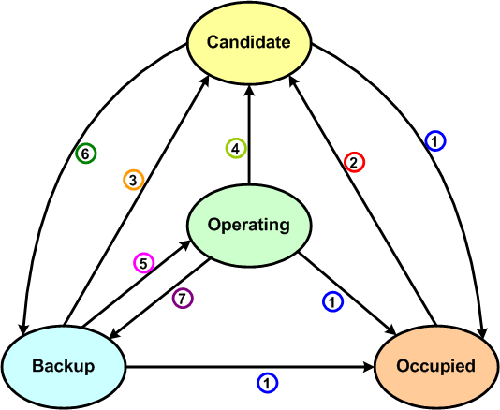
Figure 1 Channel Set Transition Diagram

