IEEE P802.22
Wireless RANs
Notice: This document has been prepared to assist IEEE 802.22. It is offered as a basis for discussion and is not binding on the contributing individual(s) or organization(s). The material in this document is subject to change in form and content after further study. The contributor(s) reserve(s) the right to add, amend or withdraw material contained herein.

Release: The contributor grants a free, irrevocable license to the IEEE to incorporate material contained in this contribution, and any modifications thereof, in the creation of an IEEE Standards publication; to copyright in the IEEE’s name any IEEE Standards publication even though it may include portions of this contribution; and at the IEEE’s sole discretion to permit others to reproduce in whole or in part the resulting IEEE Standards publication. The contributor also acknowledges and accepts that this contribution may be made public by IEEE 802.22.

Patent Policy and Procedures: The contributor is familiar with the IEEE 802 Patent Policy and Procedures
<http://standards.ieee.org/guides/bylaws/sb-bylaws.pdf>, including the statement "IEEE standards may include the known use of patent(s), including patent applications, provided the IEEE receives assurance from the patent holder or applicant with respect to patents essential for compliance with both mandatory and optional portions of the standard." Early disclosure to the Working Group of patent information that might be relevant to the standard is essential to reduce the possibility for delays in the development process and increase the likelihood that the draft publication will be approved for publication. Please notify the Chair <Carl R. Stevenson> as early as possible, in written or electronic form, if patented technology (or technology under patent application) might be incorporated into a draft standard being developed within the IEEE 802.22 Working Group. If you have questions, contact the IEEE Patent Committee Administrator at <patcom@ieee.org>.

Definition of Management Terms & Concepts
Date: 2008-07-16
Author(s):
Name | Company | Address | Phone | email
Ranga Reddy | US Army (CERDEC) | Ft Monmouth, NJ | - | Ranga.reddy@us.army.mil
Edward Au | Institute for Infocomm Research | 21 Heng Mui Keng Terrace, Singapore 119613 | 65-68745666 | ks.au@ieee.org / ksau@i2r.a-star.edu.sg
Apurva Mody | BAE Systems | Merrimack, NH | - | Apurva_mody@yahoo.com  Apurva.mody@baesystems.com
Tom Kiernan | US Army (CERDEC) | Ft Monmouth, NJ | - | Thomas.kiernan@us.army.mil
Zander Lei | Institute for Infocomm Research | 21 Heng Mui Keng Terrace, Singapore 119613 | 65-68745666 | leizd@i2r.a-star.edu.sg
Abstract
This document provides text to be adopted as a resolution for Comments #093 and #370 in 802.22/D1 Comment Database [1] or latest revision. It is a harmonization of contributions 08/0166r2 and 08/0176r0.

Introduction

This document proposes text to be accepted as a resolution for comments #93 and #370 in [2] comment database, document [1]. The text that original commenter cites, is almost a mirror for text in [3]. Because of this, the proposed remedy includes leaving the text on page 15 (lines 18-21) alone; while proposing additional text to provide clarification.

Instructions to the editor are [enclosed in square brackets, and highlighted by bold and italics]. Deletions of existing text are denoted with red lettering, strikethrough, and underline. Additions/modifications to existing text are denoted with red lettering and underline.

Text Proposal

[-----------------------------------------------Beginning of Text Proposal----------------------------------------------------]

[No modification of text on page 15, lines 18 – 21]

[Add the following subsection after Section 1.3]

1.3.1 Management Reference Model

The 802.22 devices can include Customer Premise Equipment (CPE) or Base Stations (BS). As the 802.22 devices may be part of a larger network and therefore would require interfacing with entities for management and control purposes, a Network Control and Management System (NCMS) abstraction has been introduced in this standard as a "black box" containing these entities. The NCMS abstraction allows the PHY/MAC layers specified in 802.22 to be independent of the network architecture, the transport network, and the protocols used at the backend and therefore allows greater flexibility. NCMS logically exists at BS and CPE side of the radio interface, termed NCMS(BS) and NCMS(CPE), respectively. Any necessary inter-BS coordination is
handled through the NCMS(BS).

Figure RKR1 shows a management reference model of WRAN networks. It consists of a network management system (NMS), managed nodes, and a Network Control System. Managed nodes, such as BS and CPE, collect and store the managed objects in the format of WRAN Interface MIB (e.g., wranIfMib) and Device MIB (e.g., wranDevMib) that are made available to NMSs via management protocols, such as Simple Network Management Protocol (SNMP). Unmanaged BS/CPE do not collect this information. MIB definitions are specified in Clause [TBD]. A Network Control System contains the service flow and the associated QoS information that have to be populated to BS when a CPE enters into a BS network.

The management information between CPE and BS will be carried over the secondary management connection for managed CPE. If the secondary management connection does not exist, the SNMP messages, or other management protocol messages, may go through another interface in the customer premise or on a transport connection over the air interface.

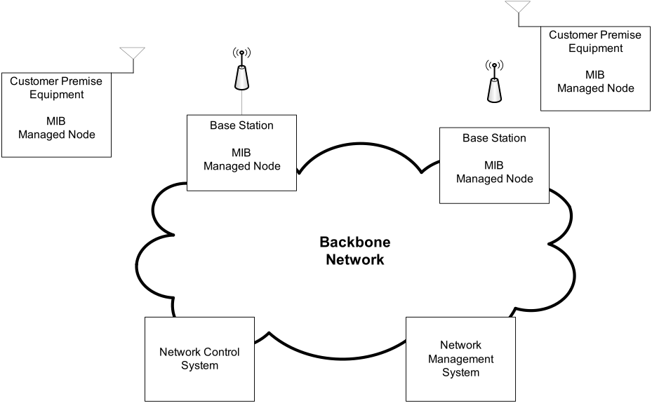
Figure RKR1 – Management Reference Model

Examples of services provided by the NCMS include; AAA Services, RRM Services, Security Services, Service Flow Management Services, Location Based Services (LBS) management, and Network Management Services.

The NCMS is interfaced to CPE/BS through various SAPs. These SAPs and their interfaces into the Data, Management/Control, and Cognitive Planes are described in Section 6.2.

[Add the following section after Section 1.3]

1.4 Managed Objects

The definition of managed objects in this standard is expressed in Structure of Management Information Version 2 (SMIv2). It supports a management protocol agnostic approach, including SNMP.

[Add the following references to clause 2]

IETF RFC2578, “Structure of Management Information Version 2 (SMIv2)”, K. McCloghrie, D. Perkins, J. Schoenwaelder, J. Case, M. Rose, S. Waldbusser, April 1999

IETF RFC2758 "Definitions of Managed Objects for Service Level Agreements Performance Monitoring", K. White, February 2000

[Add the following definitions to clause 3]
3.xx Management Information Base (MIB): A collection of information that is organized hierarchically. MIBs are accessed using a network-management protocol such as SNMP. They are comprised of managed objects and are identified by object identifiers.
3.xx Managed object: It is one of any number of specific characteristics of a managed device. Managed objects are comprised of one or more object instances, which are essentially variables. Managed object is also referred to as a MIB object, an object, or a MIB.
3.xx Managed node: A node that collects and stores the managed objects in the format of MIB. It is made available to the network management system via management protocols, such as Simple Network Management Protocol (SNMP).
3.xx Managed CPE: It is one kind of managed nodes that supports secondary management connection.
3.xx Unmanaged CPE: A CPE that does not support secondary management connection.

[---------------------------------------------------------End of Text Proposal-----------------------------------------------]

References

[1] Chouinard, Gerald, “WRAN Draft 1.0 Comment Database”, IEEE 802.22/0146r09, May 2008.

[2] IEEE 802.22 Working Group, “IEEE P802.22 / Draft 1.0, Draft Standards for Wireless Regional Area Networks, Part 22: Cognitive Wireless RAN Medium Access Control (MAC) and Physical Layer (PHY) specifications: Polices and Procedures for operation in the TV Bands”, 802.22_DRAFTv1.0, 2008.

[3] IEEE 802.16 Working Group, “Draft Standard for Local and metropolitan area Networks, Part 16: Air Interface for Broadband Wireless Access Systems”, P802.16Rev2/D5, June 2008.

