IEEE P802.22 Wireless RANs
Response to interleaving comment 680
Last Updated - Date: 2008-07-14
Author(s):
Name | Company | Address | Phone | email
Isabelle Siaud | Orange Labs | Rue du Clos Courtel  35510 Cesson-Sévigné France | +33 299 124 629 | isabelle.siaud@orange-ftgroup.com
John Benko | Orange Labs | 801 Gateway Blvd, S San Francisco, CA USA | 1-650-875-1593 | john.benko@orange-ftgroup.com

Abstract

This document is a response to comment ID 680. It provides further explanatory text and figures.
.
Notice: This document has been prepared to assist IEEE 802.22. It is offered as a basis for discussion and is not binding on the contributing individual(s) or organization(s). The material in this document is subject to change in form and content after further study. The contributor(s) reserve(s) the right to add, amend or withdraw material contained herein.

Release: The contributor grants a free, irrevocable license to the IEEE to incorporate material contained in this contribution, and any modifications thereof, in the creation of an IEEE Standards publication; to copyright in the IEEE’s name any IEEE Standards publication even though it may include portions of this contribution; and at the IEEE’s sole discretion to permit others to reproduce in whole or in part the resulting IEEE Standards publication. The contributor also acknowledges and accepts that this contribution may be made public by IEEE 802.22.

Document Policy and Procedures: The contributor is familiar with the IEEE 802 Document Policy and Procedures
<http://standards.ieee.org/guides/bylaws/sb-bylaws.pdf>, including the statement "IEEE standards may include the known use of document(s), including document applications, provided the IEEE receives assurance from the document holder or applicant with respect to documents essential for compliance with both mandatory and optional portions of the standard." Early disclosure to the Working Group of document information that might be relevant to the standard is essential to reduce the possibility for delays in the development process and increase the likelihood that the draft publication will be approved for publication. Please notify the Chair <Carl R. Stevenson> as early as possible, in written or electronic form, if documented technology (or technology under document application) might be incorporated into a draft standard being developed within the IEEE 802.22 Working Group. If you have questions, contact the IEEE Document Committee Administrator at <patcom@ieee.org>.

Recommended modifications
The following modifications are proposed as a resolution/response to comment #680. Suggested text to be modified or added is highlighted for clarity.
    - Subcarrier allocation method
A sub-channel which is a set of 28 contiguous sub-carriers (24 data and 4 pilot) is a basic unit to define the subcarrier permutation in both downstream and upstream directions. There are 60 sub-channels per symbol.

Sub-carrier interleaving shall use the block interleaving algorithm, described in this section and illustrated by Figure X. The interleaving algorithm, L(k) is implemented by an iterative turbo-based structure using an interleaving unit I(k,k1). It generates dedicated interleaving patterns resulting from the selection of three integer parameters {p,q,j}, where (j) is the iteration, and p and q two integer parameters. The iterative structure allows the generation of desired interleaving patterns in a scalable way,. L(k) depends on the selection of {p,q,j} to generate the interleaving pattern .
For the first iteration, k1=k. The expression of the interleaving algorithm is:
For the next iterations, k1=, the expression is:
L(k) provides the position index of the input sequence X located at the k-th position index in the output sequence Y:. the k-th sub-carrier index after the interleaving process corresponds to the L(k)-th sub-carrier position index in the input sequence (Y(k)=X(L(k))). The Figure xx below shows an example interleaving for the downlink, section 8.5.2.1 (pilots not included).
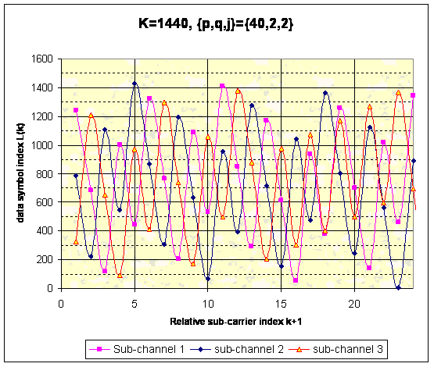
Figure xx: Example interleavering for the downlink channel
The following parameters fully describe the interleaving:
K, the number of interleaved sub-carriers, ie interleaving block size, p, the interleaving partitioning size (integer multiplicative factor of K), q, an integer parameter, and j, the iteration number.
I(k,k1) is built on a combination of two algebraic functions L₀,p and L₁,p,q, characterized by two inputs and one output implementing modulo operations. Regarding a given current iteration j, inputs of the function L₀,p are fed with the input index position k and the feedback of the previous iteration j-1 of the algorithm,, while function L₁,p,q is fed with k and the output of the function L₀,p associated with the current iteration j.

For the first iteration, j=1, L₀,p,L₁,p,q, and L(k) are expressed, as follow:

(1)
For the next iterations j, we have:
(2)
Figure x : The interleaving structure L(k)
      - Downstream Sub-carrier allocation
In the downstream, the interleaving is performed upon blocks of 1440 data sub-carriers (24x60). The interleaving spreading is optimized for s values ranged from 1, …. 23 and between sub-channels where s is the spacing between subcarriers spacings between subcarriers at position i and i+s in the output sequence (where spacing, s=1, …. 23,24, 48, etc). The interleaving spreading is given by .

The sub-carrier allocation in the downstream is performed using the following procedure:

- All possible null sub-carriers are first allocated;
- The pilot sub-carriers are then allocated using a spacing of 1 every 7 sub-carriers;
- The remaining sub-carriers shall be allocated sequentially following the interleaving pattern L(k), as described in section 8.5.2, with interleaving parameters {K,p,q,j} as defined in Table 253 below.

Figure xxx shows an example allocation for the first OFDMA symbol in a burst, where P is a Pilot tone, and L(x), represents the location of the tone before permutation:

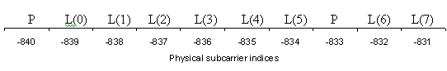
Figure xxx: Example allocation for first OFDMA symbol in a burst
Table 253: Interleaving parameters for the downstream sub-carrier mapping allocation
Interleaving  depth | Interleaving  parameters |  |  | Interleaving spreading ΔL(s)  (informative)
K | P | q | j | s=1 | s=2 | s=4 | s=24 | s=48
1440 | 40 | 2 | 2 | 559 | 322 | 644 | 456 | 528
      - Upstream Sub-carrier allocation
In the upstream, two subchannels are reserved for Ranging/BW requests, etc, or data bursts. When these sub-channels are not used for control signaling, they can be used for data (pilots here are allocated as is shown in Figure 143, logically and then mapped to the appropriate tone index # shown in Table 254 using the offsets (-19, -11, +11, +19) cycled every four successive frames and starting at the beginning of each superframe, or as specified by the Permutation base UCD channel IE as indicated in Table 57). The permutation is then performed upon For the remaining 58 subchannels, the permutation is performed with size K=1624 sub-carriers (58x28, pilots are included). The interleaving spreading is optimized for s values (where s is the spacing between 2 sub-carriers before interleaving) ranging from 1, …., 28 and between sub-channels. These pilots are initially interspersed logically, before interleaving, among the data-tones of the 58 sub-channels as depicted in Figure 143. The sub-carrier allocation is performed using the following procedure:

1) All possible null sub-carriers are first allocated.
2) The sub-carriers of the 2 sub-channels used for "Ranging/BW requests" are allocated using the tone index # given in Table 254 below and applying the offsets (-19, -11, +11, +19) cycled every four successive frames and starting at the beginning of each superframe, or applying the offset specified by the Permutation base UCD channel IE as indicated in Table 57 for the current frame.
3) The remaining 1624 sub-carrier indices are filled sequentially using the output of the interleaving pattern L(k), as described in section 8.5.2, with interleaving parameters {K,p,q,j} defined in the Table 255 below. If an index is already occupied by a ranging or DC sub-carrier, is skipped over and the following index is used. Figure xy shows an example allocation for an offset of -19, where PR is a Ranging/BW Pilot tone , R is a Ranging/BW data tone, and L(x) represents the location of the tone before permutation:

L(0) L(1) L(2) L(3) L(4) L(5) L(6) PR R L(7)
Figure xy: Example allocation for uplink (with an offset of -19)

8.6.3 Bit interleaving
The same interleaver L(k), used for sub-carrier interleaving, shall be used to interleave encoded bits at the output of the encoder. The interleaving algorithm (detailed in the sub-carrier allocation section) is described by the block size K and three integer parameters {p,q,j}. The algorithm depends on the interleaving pattern of the previous iteration (j-1), the bit position index (k), and two integer parameters (p,q). p is the interleaving partition size, which is a multiple of the interleaving block size K. The interleaving pattern for the iteration (j) is given by:

For the iteration j=1, L(k) is expressed by :

Error: Reference source not found provides nine unique sets of interleaving parameters {p,q,j} for binary interleaving sizes K. For simplicity, the parameter q is set to "2" for all binary interleaving. Table 268 also provides informative information about the interleaving spreading (ΔL(s), see section 8.5.2.1)) for different values of s (the spacing between bits after interleaving, ΔL(s) provides the distance between input bits x(k) separated in the output sequence by s-1 positions (Y(k+s)=X((L(k+s))).

