IEEE P802.22
Wireless RANs
Recommended Text for Section 7 on Security in 802.22
Date: 2008-08-25
Author(s):
Name | Company | Address | Phone | email
Apurva Mody | BAE Systems | P.O. Box 868, MER 15-2350, Nashua, NH 03061-0868 | 603-885-2621  404-819-0314 | apurva.mody@baesystems.com,  apurva_mody@yahoo.com
Ranga Reddy | US Army (CERDEC) | Ft Monmouth, NJ | - | Ranga.reddy@us.army.mil
Tom Kiernan | US Army (CERDEC) | Ft Monmouth, NJ | - | Thomas.kiernan@us.army.mil
Matt Sherman | BAE Systems | Wayne, NJ | 973-633-6344 | Matthew.sherman@baesystems.com
Abstract
This document provides the recommended normative and informative text to be included in Section 7 of the 802.22 Standard.

Notice: This document has been prepared to assist IEEE 802.22. It is offered as a basis for discussion and is not binding on the contributing individual(s) or organization(s). The material in this document is subject to change in form and content after further study. The contributor(s) reserve(s) the right to add, amend or withdraw material contained herein.

Release: The contributor grants a free, irrevocable license to the IEEE to incorporate material contained in this contribution, and any modifications thereof, in the creation of an IEEE Standards publication; to copyright in the IEEE’s name any IEEE Standards publication even though it may include portions of this contribution; and at the IEEE’s sole discretion to permit others to reproduce in whole or in part the resulting IEEE Standards publication. The contributor also acknowledges and accepts that this contribution may be made public by IEEE 802.22.

Patent Policy and Procedures: The contributor is familiar with the IEEE 802 Patent Policy and Procedures
<http://standards.ieee.org/guides/bylaws/sb-bylaws.pdf>, including the statement "IEEE standards may include the known use of patent(s), including patent applications, provided the IEEE receives assurance from the patent holder or applicant with respect to patents essential for compliance with both mandatory and optional portions of the standard." Early disclosure to the Working Group of patent information that might be relevant to the standard is essential to reduce the possibility for delays in the development process and increase the likelihood that the draft publication will be approved for publication. Please notify the Chair <Carl R. Stevenson> as early as possible, in written or electronic form, if patented technology (or technology under patent application) might be incorporated into a draft standard being developed within the IEEE 802.22 Working Group. If you have questions, contact the IEEE Patent Committee Administrator at <patcom@ieee.org>.
7. Security sublayers
Traditional broadband communications systems such as 802.16 contain data, control and management functions which require protection. However, due to the unique characteristics of the 802.22 systems which include cognitive radio capability as well as long range, enhanced security mechanisms are needed. These security features provide protection for the 802.22 users, service providers and most importantly, the incumbents, who are the primary users of the spectrum. As a result, the protection mechanisms in 802.22 are divided into several security sublayers which target non-cognitive as well as cognitive functionality of the system and the interactions between the two.

The Security Sublayers 1 and 2 provide subscribers with privacy, authentication, or confidentiality (In security parlance, confidentiality = privacy + authenticity) across the broadband wireless network. It does this by applying cryptographic transforms to MAC PDUs carried across connections between CPE and BS. In addition, these security sublayers provide operators with strong protection from theft of service. In cognitive radio systems, confidentiality and privacy mechanisms need to protect not just the data but, also sensitive spectrum occupancy information from the competitors and the spectrum management information used by the BS to configure the operation of the CPEs. The BS protects against unauthorized access to these data transport services by securing the associated service flows across the network. The security sublayers employ an authenticated client/server key management protocol in which the BS, the server, controls distribution of keying material to client CPE. Additionally, the basic security mechanisms are strengthened by adding digital-certificate-based CPE device-authentication to the key management protocol. If during capabilities negotiation, the CPE specifies that it does not support IEEE 802.22 security, step of authorization and key exchange shall be skipped. The BS, if provisioned so, shall consider the CPE authenticated; otherwise, the CPE shall not be serviced. Neither key exchange nor data encryption performed.

To enhance the security for the cognitive functionality in 802.22, Security Sublayers 3 is introduced. The security mechanisms for this layer include authentication and availability, authorization, confidentiality and privacy. The authentication mechanisms validate the availability of spectrum for the primary and the secondary users of the spectrum. This includes authentication of the incumbent sensing information to avoid Denial of Service (DoS) attacks such as replay and ghosting, authentication of the 802.22.1 beacon frame utilizing the security features that are already embedded in it, authentication of the geolocation and co-existence information, as well as detection and reporting of spurious transmissions. The authorization mechanisms attempt to make the spectrum manager functionality tamper proof by allowing only the authorized personnel and information to configure it.

7.1 Security Architecture for the Data / Control and Management Planes

Privacy has two component protocols as follows:

a) An encapsulation protocol for securing packet data across the fixed BWA network. This protocol defines a set of supported cryptographic suites, i.e., pairings of data encryption and authentication algorithms, and the rules for applying those algorithms to a MAC PDU payload.
b) A key management protocol (PKM) providing the secure distribution of keying data from the BS to the CPE. Through this key management protocol, the CPE and the BS synchronize keying data; in addition, the BS uses the protocol to enforce conditional access to network services.

The protocol stack for the security components of the system are shown in Figure xxx.

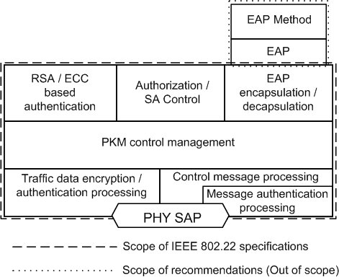

Figure xxx — Security Sublayer 1

— PKM Control Management: This stack controls all security components. Various keys are derived and generated in this stack.
— Traffic Data Encryption/Authentication Processing: This stack encrypts or decrypts the traffic data and executes the authentication function for the traffic data.
— Control Message Processing: This stack processes the various PKM-related MAC messages.
— Message Authentication Processing: This stack executes message authentication function. The HMAC, CMAC, or several short-HMACs can be supported.
- RSA-based Authentication: This stack performs the RSA-based authentication function using the CPE’s X.509 digital certificate and the BS’s X.509 digital certificate, when the RSA-based authorization is selected as an authorization policy between a CPE and a BS.
- ECC-based authentication: This stack performs the Elliptic Curve Cryptography (ECC) based authentication function, when the ECC-based authorization is selected as an authorization policy between a CPE and a BS.
— EAP Encapsulation/Decapsulation: This stack provides the interface with the EAP layer, when the EAP-based authorization or the authenticated EAP-based authorization is selected as an authoriza-tion policy between a CPE and a BS.
— Authorization/SA Control: This stack controls the authorization state machine and the traffic encryption key state machine.
— EAP and EAP Method Protocol: These stacks are outside of the scope of this standard.

7.1.1 Secure encapsulation of MAC PDUs
Encryption services are defined as a set of capabilities within the MAC security sublayer. MAC header information specific to encryption is allocated in the generic MAC header format.
Encryption is always applied to the MAC PDU payload when required by the selected ciphersuite; the generic MAC header is not encrypted. All MAC management messages shall be sent in the clear to facilitate registration, ranging, and normal operation of the MAC.
The format of MAC PDUs carrying encrypted packet data payloads is specified in 6.x.x.x
7.1.2 Key management protocol
The PKM protocol allows for both mutual authentication and unilateral authentication (e.g., where the BS authenticates CPE, but not vice versa). It also supports periodic reauthentication/reauthorization and key refresh. The key management protocol uses either EAP [IETF RFC 3748] or X.509 digital certificates [IETF RFC 3280] together with RSA public-key encryption algorithm [PKCS #1] or a sequence starting with RSA authentication and followed by EAP authentication or even with ECC public-key encryption algorithm. It uses strong encryption algorithms to perform key exchanges between a CPE and BS.

The PKM’s authentication protocol establishes a shared secret (i.e., the AK) between the CPE and the BS. The shared secret is then used to secure subsequent PKM exchanges of TEKs. This two-tiered mechanism for key distribution permits refreshing of TEKs without incurring the overhead of computation-intensive operations.

A BS authenticates a client CPE during the initial authorization exchange. Each CPE presents its credentials, which will be a unique X.509 digital certificate issued by the CPE’s manufacturer (in the case of RSA authentication) or an operator-specified credential (in the case of EAP-based authentication).

The BS associates a CPE’s authenticated identity to a paying subscriber and hence to the data services that subscriber is authorized to access.

Since the BS authenticates the CPE, it may protect against an attacker employing a cloned CPE that masquerades as a legitimate subscriber’s CPE.

The traffic key management portion of the PKM protocol adheres to a client/server model, where the CPE (a PKM “client”) requests keying material and the BS (a PKM “server”) responds to those requests. This model ensures that individual CPE clients receive only keying material for which they are authorized.

The PKM protocol uses MAC management messaging, i.e., PKM-REQ and PKM-RSP messages defined in 6.x.x.x. The PKM protocol is defined in detail in 7.x.
7.1.3 Authentication protocol
A CPE uses the PKM protocol to obtain authorization and traffic keying material from the BS and to support periodic reauthorization and key refresh.
PKM supports three distinct authentication protocol mechanisms:
- RSA protocol [PKCS #1 v2.1 with SHA-1(FIPS 186-2)] (support is mandatory in PKMv1; support is optional in PKMv2)
- ECC based authentication protocol.
— Extensible Authentication Protocol (optional unless specifically required)
7.1.3.1 PKM RSA authentication
The PKM RSA authentication protocol uses X.509 digital certificates [IETF RFC 3280], the RSA public-key encryption algorithm [PKCS #1] that binds public RSA encryption keys to MAC addresses of CPEs.
A BS authenticates a client CPE during the initial authorization exchange. Each CPE carries a unique X.509 digital certificate issued by the CPE’s manufacturer. The digital certificate contains the CPE’s Public Key and CPE MAC address. When requesting an AK, a CPE presents its digital certificate to the BS. The BS verifies the digital certificate, and then uses the verified Public Key to encrypt an AK, which the BS then sends back to the requesting CPE.
All CPEs using RSA authentication shall have factory-installed RSA private/public key pairs or provide an internal algorithm to generate such key pairs dynamically. If a CPE relies on an internal algorithm to generate its RSA key pair, the CPE shall generate the key pair prior to its first AK exchange, described in 7.2.1. All CPEs with factory-installed RSA key pairs shall also have factory-installed X.509 certificates. All CPEs that rely on internal algorithms to generate an RSA key pair shall support a mechanism for installing a manufacturer-issued X.509 certificate following key generation.
7.1.3.2 PKM EAP authentication
PKM EAP Authentication uses Extensible Authentication Protocol [IETF RFC 3748] in conjunction with an operator-selected EAP Method (e.g. EAP-TLS [IETF RFC 2716]). The EAP method will use a particular kind of credential – such as an X.509 certificate in the case of EAP-TLS, or a Subscriber Identity Module in the case of EAP-SIM.
The particular credentials and EAP methods that are to be used are outside of the scope of this specification. However, the EAP method selected should fulfill the “mandatory criteria” listed in section 2.2 of RFC 4017. Use of an EAP method not meeting these criteria may lead to security vulnerabilities.
During reauthentication, the EAP transfer messages are protected with an HMAC/CMAC Tuple. The BS and CPE must discard unprotected EAP transfer messages, or EAP transfer messages with invalid HMAC/ CMAC Digests during reauthentication.

7.1.3.3 PKM ECC authentication

:
:
:
:

7.1.4 Mapping of connections to SAs
The following rules for mapping connections to SAs apply:

a) All transport connections shall be mapped to an existing SA.

b) Multicast transport connections may be mapped to any Static or Dynamic SA.

c) The secondary management connection shall be mapped to the Primary SA.

d) The basic and the primary management connections shall not be mapped to an SA.

The actual mapping is achieved by including the SAID of an existing SA in the DSA-xxx messages together with the CID. No explicit mapping of secondary management connection to the Primary SA is required.

7.1.5 Cryptographic suite
A cryptographic suite is the SA’s set of methods for data encryption, data authentication, and TEK exchange. A cryptographic suite is specified as described in 11.x.x. The cryptographic suite shall be one of the ones listed in Table xxx.

7.2 PKM protocol
There are one / two Privacy Key Management Protocols supported in this standard: PKM version 1 and PKMv2 with more enhanced features such as new key hierarchy, AES-CMAC, AES key wraps, and MBS.
7.2.1 PKM version 1
7.2.1.1 Security associations (SAs)
A security association (SA) is the set of security information a BS and one or more of its client CPEs share in order to support secure communications across the IEEE 802.22 network. Three types of SAs are defined: Primary, Static, and Dynamic. Each CPE establishes a primary security association during the CPE initialization process. Static SAs are provisioned within the BS. Dynamic SAs are established and eliminated, on the fly, in response to the initiation and termination of specific service flows. Both Static and Dynamic SAs may be shared by multiple CPEs.
An SA’s shared information shall include the cryptographic suite employed within the SA. The shared information may include TEKs and Initialization Vectors. The exact content of the SA is dependent on the SA’s cryptographic suite.
SAs are identified using SAIDs.
Each CPE shall establish an exclusive Primary SA with its BS. The SAID of any CPE’s Primary SA shall be equal to the Basic CID of that CPE.
Using the PKM protocol, a CPE requests from its BS an SA’s keying material.
The BS shall ensure that each client CPE only has access to the SAs it is authorized to access.
An SA’s keying material [e.g., data encryption standard (DES) key and CBC IV] has a limited lifetime. When the BS delivers SA keying material to a CPE, it also provides the CPE with that material’s remaining lifetime. It is the responsibility of the CPE to request new keying material from the BS before the set of keying material that the CPE currently holds expires at the BS. Should the current keying material expire before a new set of keying material is received, the CPE shall perform network entry as described in x.x.x.
In certain cryptographic suites, key lifetime may be limited by the exhaustion rate of a number space, e.g., the PN of AES in CCM mode [i.e., CTR mode with cipher block chaining message authentication code (CBC-MAC)]. In this case, the key ends either at the expiry of the key lifetime or the exhaustion of the number space, which ever is earliest. Note that in this case, security is not determined by the key lifetime.

7.2.1.2 CPE authorization and AK exchange overview
CPE authorization, controlled by the Authorization state machine, is the process of the BS’s authenticating a client CPE’s identity:

a) The BS and CPE establish a shared AK by RSA/ECC from which a key encryption key (KEK) and message authentication keys are derived.
b) The BS provides the authenticated CPE with the identities (i.e., the SAIDs) and properties of Primary and Static SAs for which the CPE is authorized to obtain keying information.

After achieving initial authorization, a CPE periodically reauthorizes with the BS; reauthorization is also managed by the CPE’s Authorization state machine. TEK state machines manage the refreshing of TEKs.

7.2.1.2.1 Authorization via RSA authentication protocol

A CPE begins authorization by sending an Authentication Information message to its BS. The Authentication Information message contains the CPE manufacturer’s X.509 certificate, issued by the manufacturer itself or by an external authority. The Authentication Information message is strictly informative; i.e., the BS may choose to ignore it. However, it does provide a mechanism for a BS to learn the manufacturer certificates of its client CPE.

The CPE sends an Authorization Request message to its BS immediately after sending the Authentication Information message. This is a request for an AK, as well as for the SAIDs identifying any Static SAs the CPE is authorized to participate in.

The Authorization Request includes

- A manufacturer-issued X.509 certificate.
- A description of the cryptographic algorithms the requesting CPE supports. A CPE’s cryptographic capabilities are presented to the BS as a list of cryptographic suite identifiers, each indicating a particular pairing of packet data encryption and packet data authentication algorithms the CPE supports.
- The CPE’s Basic CID. The Basic CID is the first static CID the BS assigns to a CPE during initial ranging
- the primary SAID is equal to the Basic CID.

In response to an Authorization Request message, a BS validates the requesting CPE’s identity, determines the encryption algorithm and protocol support it shares with the CPE, activates an AK for the CPE, encrypts it with the CPE’s public key, and sends it back to the CPE in an Authorization Reply message. The authorization reply includes

- An AK encrypted with the CPE’s public key.
- A 4-bit key sequence number, used to distinguish between successive generations of AKs.
- A key lifetime.
- The identities (i.e., the SAIDs) and properties of the single primary and zero or more Static SAs the CPE is authorized to obtain keying information for.

While the Authorization Reply shall identify Static SAs in addition to the Primary SA whose SAID matches the requesting CPE’s Basic CID, the Authorization Reply shall not identify any Dynamic SAs.

The BS, in responding to a CPE’s Authorization Request, shall determine whether the requesting CPE, whose identity can be verified via the X.509 digital certificate, is authorized for basic unicast services, and what additional statically provisioned services (i.e., Static SAIDs) the CPE’s user has subscribed for. Note that the protected services a BS makes available to a client CPE can depend upon the particular cryptographic suites for which the CPE and the BS share support.

A CPE shall periodically refresh its AK by reissuing an Authorization Request to the BS. Reauthorization is identical to authorization with the exception that the CPE does not send Authentication Information messages during reauthorization cycles. The description of the authorization state machine in 7.2.1.6 clearly indicates when Authentication Information messages are sent. To avoid service interruptions during reauthorization, successive generations of the CPE’s AKs have overlapping lifetimes. Both the CPE and BS shall be able to support up to two simultaneously active AKs during these transition periods. The operation of the Authorization state machine’s Authorization Request scheduling algorithm, combined with the BS’s regimen for updating and using a client CPE’s AKs (see 7.3), ensures that the CPE can refresh.

7.2.1.2.2 Authorization via ECC authentication protocol

:
:
:

7.2.1.3 TEK exchange overview
7.2.1.3.1 TEK exchange overview for PMP topology

Upon achieving authorization, a CPE starts a separate TEK state machine for each of the SAIDs identified in the Authorization Reply message. Each TEK state machine operating within the CPE is responsible for managing the keying material associated with its respective SAID. TEK state machines periodically send Key Request messages to the BS, requesting a refresh of keying material for their respective SAIDs.

The BS responds to a Key Request with a Key Reply message, containing the BS’s active keying material for a specific SAID.

The TEK is encrypted using appropriate KEK derived from the AK.

Note that at all times the BS maintains two active sets of keying material per SAID. The lifetimes of the two generations overlap so that each generation becomes active halfway through the life of it predecessor and expires halfway through the life of its successor. A BS includes in its Key Replies both of an SAID’s active generations of keying material.

The Key Reply provides the requesting CPE, in addition to the TEK and CBC IV, the remaining lifetime of each of the two sets of keying material. The receiving CPE uses these remaining lifetimes to estimate when the BS will invalidate a particular TEK and, therefore, when to schedule future Key Requests so that the CPE requests and receives new keying material before the BS expires the keying material the CPE currently holds.

The operation of the TEK state machine’s Key Request scheduling algorithm, combined with the BS’s regimen for updating and using an SAID’s keying material (see 7.4), ensures that the CPE will be able to continually exchange encrypted traffic with the BS.

A TEK state machine remains active as long as

a) The CPE is authorized to operate in the BS’s security domain, i.e., it has a valid AK, and
b) The CPE is authorized to participate in that particular SA, i.e., the BS continues to provide fresh key-ing material during rekey cycles.

The parent Authorization state machine stops all of its child TEK state machines when the CPE receives from the BS an Authorization Reject during a reauthorization cycle. Individual TEK state machines can be started or stopped during a reauthorization cycle if a CPE’s Static SAID authorizations changed between successive reauthorizations.

Communication between Authorization and TEK state machines occurs through the passing of events and protocol messaging. The Authorization state machine generates events (i.e., Stop, Authorized, Authorization Pending, and Authorization Complete events) that are targeted at its child TEK state machines. TEK state machines do not target events at their parent Authorization state machine. The TEK state machine affects the Authorization state machine indirectly through the messaging a BS sends in response to a CPE’s requests: a BS may respond to a TEK machine’s Key Requests with a failure response (i.e., Authorization Invalid message) to be handled by the Authorization state machine.
7.2.1.3.2 Reserved
7.2.1.4 Security capabilities selection
As part of their authorization exchange, the CPE provides the BS with a list of all the cryptographic suites (pairing of data encryption and data authentication algorithms) the CPE supports. The BS selects from this list a single cryptographic suite to employ with the requesting CPE’s primary SA. The Authorization Reply the BS sends back to the CPE includes a primary SA-Descriptor that, among other things, identifies the cryptographic suite the BS selected to use for the CPE’s primary SA. A BS shall reject the authorization request if it determines that none of the offered cryptographic suites are satisfactory.
The Authorization Reply also contains an optional list of static SA-Descriptors; each static SA-Descriptor identifies the cryptographic suite employed within the SA. The selection of a static SA’s cryptographic suite is typically made independent of the requesting CPE’s cryptographic capabilities. A BS may include in its Authorization Reply static SA-Descriptors identifying cryptographic suites the requesting CPE does not support; if this is the case, the CPE shall not start TEK state machines for static SAs whose cryptographic suites the CPE does not support.
If the SA holds an encryption method, all MAC PDUs sent with CIDs linked to this SA must have EC bit set to ‘1’ in the Generic MAC Header. If the SA has no encryption method, the EC bit must be set to ‘0’ in the Generic MAC Header. Other combinations are not allowed; MAC PDUs presenting other combinations should be discarded.
7.2.1.5 Authorization state machine
The Authorization state machine consists of six states and eight distinct events (including receipt of messages) that can trigger state transitions. The Authorization finite state machine (FSM) is presented below in a graphical format, as a state flow model (Figure xxx2), and in a tabular format, as a state transition matrix (Table xxx1).
The state flow diagram depicts the protocol messages transmitted and internal events generated for each of the model’s state transitions; however, the diagram does not indicate additional internal actions, such as the clearing or starting of timers, that accompany the specific state transitions. Accompanying the state transition matrix is a detailed description of the specific actions accompanying each state transition; the state transition matrix shall be used as the definitive specification of protocol actions associated with each state transition.
The following legend applies to the Authorization State Machine flow diagram depicted in Figure 160.
a) Ovals are states.
b) Events are in italics.
c) Messages are in normal font.
d) State transitions (i.e., the lines between states) are labeled with <what causes the transition>/<messages and events triggered by the transition>. So “timeout/Auth Request” means that the state received a “timeout” event and sent an Authorization Request (“Auth Request”) message. If there are multiple events or messages before the slash “/” separated by a comma, any of them can cause the transition. If there are multiple events or messages listed after the slash, all of the specified actions shall accompany the transition.

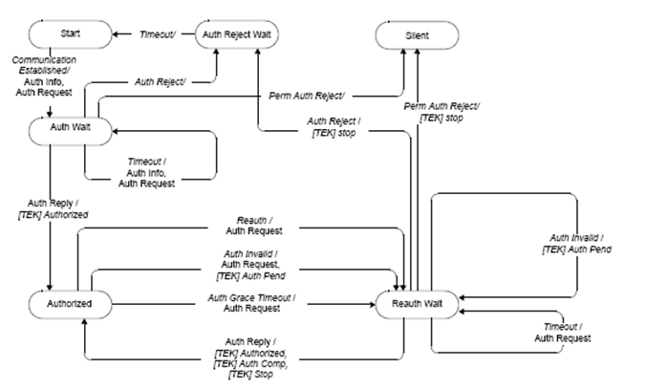

Figure xxx2. Authorization state machine flow diagram

The Authorization state transition matrix presented in Table xxx1 lists the six Authorization machine states in the topmost row and the eight Authorization machine events (includes message receipts) in the leftmost column. Any cell within the matrix represents a specific combination of state and event, with the next state (the state transitioned to) displayed within the cell. For example, cell 4-B represents the receipt of an Authorization Reply (Auth Reply) message when in the Authorize Wait (Auth Wait) state. Within cell 4-B is the name of the next state, “Authorized.” Thus, when an CPE’s Authorization state machine is in the Auth Wait state and an Auth Reply message is received, the Authorization state machine will transition to the Authorized state. In conjunction with this state transition, several protocol actions shall be taken; these are described in the listing of protocol actions, under the heading 4-B, in 7.2.1.5.5.

A shaded cell within the state transition matrix implies that either the specific event cannot or should not occur within that state, and if the event does occur, the state machine shall ignore it. For example, if an Auth Reply message arrives when in the Authorized state, that message should be ignored (cell 4-C). The CPE may, however, in response to an improper event, log its occurrence, generate an SNMP event, or take some other vendor-defined action. These actions, however, are not specified within the context of the Authorization state machine, which simply ignores improper events.

Table xxx – Authorization Finite State Machine State Transition Matrix
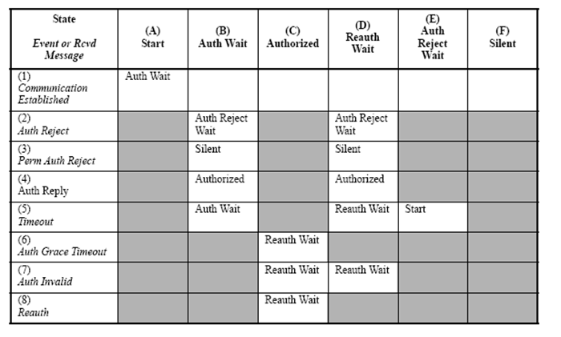

7.2.1.5.1 States

- Start: This is the initial state of the FSM. No resources are assigned to or used by the FSM in this state—e.g., all timers are off, and no processing is scheduled.
- Authorize Wait (Auth Wait): The CPE has received the “Communication Established” event indicating that it has completed basic capabilities negotiation with the BS. In response to receiving the event, the CPE has sent both an Authentication Information and an Auth Request message to the BS and is waiting for the reply.
- Authorized: The CPE has received an Auth Reply message that contains a list of valid SAIDs for this CPE. At this point, the CPE has a valid AK and SAID list. Transition into this state triggers the creation of one TEK FSM for each of the CPE’s privacy-enabled SAIDs.
- Reauthorize Wait (Reauth Wait): The CPE has an outstanding reauthorization request. The CPE was either about to expire (see Authorization Grace Time in Table xxx2) its current authorization or received an indication (an Authorization Invalid message from the BS) that its authorization is no longer valid. The CPE sent an Auth Request message to the BS and is waiting for a response.
- Authorize Reject Wait (Auth Reject Wait): The CPE received an Authorization Reject (Auth Reject) message in response to its last Auth Request. The Auth Reject’s error code indicated the error was not of a permanent nature. In response to receiving this reject message, the CPE set a timer and transitioned to the Auth Reject Wait state. The CPE remains in this state until the timer expires.
- Silent: The CPE received an Auth Reject message in response to its last Auth Request. The Auth Reject’s error code indicated the error was of a permanent nature. This triggers a transition to the Silent state, where the CPE is not permitted to pass subscriber traffic. The CPE shall, however, respond to management messages from the BS issuing the Perm Auth Reject.

7.2.1.5.2 Messages

Note that the message formats are defined in detail in 6.X.X.X.

- Authorization Request (Auth Request): Request an AK and list of authorized SAIDs. Sent from SS to BS.
- Authorization Reply (Auth Reply): Receive an AK and list of authorized, static SAIDs. Sent from BS to SS. The AK is encrypted with the SS’s public key.
- Authorization Reject (Auth Reject): Attempt to authorize was rejected. Sent from the BS to the SS.
- Authorization Invalid (Auth Invalid): The BS may send an Authorization Invalid message to a client SS as follows:
- An unsolicited indication, or
- A response to a message received from that SS. In either case, the Auth Invalid message instructs the receiving SS to reauthorize with its BS. The BS responds to a Key Request with an Auth Invalid message if (1) the BS does not recognize the SS as being authorized (i.e., no valid AK associated with SS) or (2) verification of the Key. Request’s keyed message digest (in HMAC-Digest attribute) failed. Note that the Authorization Invalid event, referenced in both the state flow diagram and the state transition matrix, signifies either the receipt of an Auth Invalid message or an internally generated event.
- Authentication Information (Auth Info): The Auth Info message contains the SS manufacturer’s X.509 Certificate, issued by an external authority. The Auth Info message is strictly an informative message the SS sends to the BS; with it, a BS may dynamically learn the manufacturer certificate of client SS. Alternatively, a BS may require out-of-band configuration of its list of manufacturer cer-tificates.

7.2.1.5.3 Events

- Communication Established: The Authorization state machine generates this event upon entering the Start state if the MAC has completed basic capabilities negotiation. If the basic capabilities negotia-tion is not complete, the SS sends a Communication Established event to the Authorization FSM upon completing basic capabilities negotiation. The Communication Established event triggers the SS to begin the process of getting its AK and TEKs.
- Timeout: A retransmission or wait timer timed out. Generally a request is resent.
- Authorization Grace Timeout (Auth Grace Timeout): The Authorization Grace timer timed out. This timer fires a configurable amount of time (the Authorization Grace Time) before the current authori-zation is supposed to expire, signalling the SS to reauthorize before its authorization actually expires. The Authorization Grace Time takes the default value from Table 549 or may be specified in a configuration setting within the Auth Reply message.
- Reauthorize (Reauth): SS’s set of authorized static SAIDs may have changed. This event may be generated in response to an SNMP set and meant to trigger a reauthorization cycle.
- Authorization Invalid (Auth Invalid): This event is internally generated by the SS when there is a failure authenticating a Key Reply or Key Reject message, or externally generated by the receipt of an Auth Invalid message, sent from the BS to the SS. A BS responds to a Key Request with an Auth Invalid if verification of the request’s message authentication code fails. Both cases indicate BS and SS have lost AK synchronization. A BS may also send to an SS an unsolicited Auth Invalid message, forcing an Auth Invalid event.
- Permanent Authorization Reject (Perm Auth Reject): The SS receives an Auth Reject in response to an Auth Request. The error code in the Auth Reject indicates the error is of a permanent nature. What is interpreted as a permanent error is subject to administrative control within the BS. Auth Request processing errors that can be interpreted as permanent error conditions include the follow-ing:
- Unknown manufacturer (do not have CA certificate of the issuer of the SS Certificate).
- Invalid signature on SS certificate.
- ASN.1 parsing failure.
- Inconsistencies between data in the certificate and data in accompanying PKM data attributes.
- Incompatible security capabilities. When an SS receives an Auth Reject indicating a permanent failure condition, the Authorization State machine moves into a Silent state, where the SS is not permitted to pass subscriber traffic. The SS shall, however, respond to management messages from the BS issuing the Perm Auth Reject. The managed SS may also issue an SNMP Trap upon entering the Silent state.
- Authorization Reject (Auth Reject): The SS receives an Auth Reject in response to an Auth Request. The error code in the Auth Reject does not indicate the failure was due to a permanent error condition. As a result, the SS’s Authorization state machine shall set a wait timer and transition into the Auth Reject Wait State. The SS shall remain in this state until the timer expires, at which time it shall reattempt authorization.

NOTE — The following events are sent by an Authorization state machine to the TEK state machine:

- [TEK] Stop: Sent by the Authorization FSM to an active (non-START state) TEK FSM to terminate the FSM and remove the corresponding SAID’s keying material from the SS’s key table.
- [TEK] Authorized: Sent by the Authorization FSM to a nonactive (START state), but valid TEK FSM.
- [TEK] Authorization Pending (Auth Pend): Sent by the Authorization FSM to a specific TEK FSM to place that TEK FSM in a wait state until the Authorization FSM can complete its reauthorization operation.
- [TEK] Authorization Complete (Auth Comp): Sent by the Authorization FSM to a TEK FSM in the Operational Reauthorize Wait (Op Reauth Wait) or Rekey Reauthorize Wait (Rekey Reauth Wait) states to clear the wait state begun by a TEK FSM Authorization Pending event.

7.2.1.5.4 Parameters

All configuration parameter values take the default values from Table CFX1 or may be specified in the Auth Reply message.

- Authorize Wait Timeout (Auth Wait Timeout): Timeout period between sending Authorization Request messages from Auth Wait state (see 11.9.19.2).
- Authorization Grace Timeout (Auth Grace Timeout): Amount of time before authorization is sched-uled to expire that the SS starts reauthorization (see 11.9.19.3).
- Authorize Reject Wait Timeout (Auth Reject Wait Timeout): Amount of time an SS’s Authorization FSM remains in the Auth Reject Wait state before transitioning to the Start state (see 11.9.19.7).

7.2.1.5.5 Actions

Actions taken in association with state transitions are listed by <event> (<rcvd message>) --> <state> below:

1-A Start (Communication Established) → Auth Wait

a) Send Auth Info message to BS

b) Send Auth Request message to BS

c) Set Auth Request retry timer to Auth Wait Timeout

2-B Auth Wait (Auth Reject) → Auth Reject Wait

a) Clear Auth Request retry timer

b) Set a wait timer to Auth Reject Wait Timeout

2-D Reauth Wait (Auth Reject) → Auth Reject Wait

a) Clear Auth Request retry timer

b) Generate TEK FSM Stop events for all active TEK state machines

c) Set a wait timer to Auth Reject Wait Timeout

3-B Auth Wait (Perm Auth Reject) → Silent

a) Clear Auth Request retry timer

b) Disable all forwarding of SS traffic

3-D Reauth Wait (Perm Auth Reject) → Silent

a) Clear Auth Request retry timer

b) Generate TEK FSM Stop events for all active TEK state machines

c) Disable all forwarding of SS traffic

4-B Auth Wait (Auth Reply) → Authorized

a) Clear Auth Request retry timer

b) Decrypt and record AK delivered with Auth Reply

c) Start TEK FSMs for all SAIDs listed in Authorization Reply (provided the SS supports the cryptographic suite that is associated with an SAID) and issue a TEK FSM Authorized event for each of the new TEK FSMs

d) Set the Authorization Grace timer to go off “Authorization Grace Time” seconds prior to the supplied AK’s scheduled expiration

4-D Reauth Wait (Auth Reply) → Authorized

a) Clear Auth Request retry timer

b) Decrypt and record AK delivered with Auth Reply

c) Start TEK FSMs for any newly authorized SAIDs listed in Auth Reply (provided the SS supports the cryptographic suite that is associated with the new SAID) and issue TEK FSM Authorized event for each of the new TEK FSMs

d) Generate TEK FSM Authorization Complete events for any currently active TEK FSMs whose corresponding SAIDs were listed in Auth Reply

e) Generate TEK FSM Stop events for any currently active TEK FSMs whose corresponding SAIDs were not listed in Auth Reply

f) Set the Authorization Grace timer to go off “Authorization Grace Time” seconds prior to the supplied AK’s scheduled expiration

5-B Auth Wait (Timeout) → Auth Wait

a) Send Auth Info message to BS

b) Send Auth Request message to BS

c) Set Auth Request retry timer to Auth Wait Timeout

5-D Reauth Wait (Timeout) → Reauth Wait

a) Send Auth Request message to BS

b) Set Auth Request retry timer to Reauth Wait Timeout

5-E Auth Reject Wait (Timeout) → Start

a) No protocol actions associated with state transition

6-C Authorized (Auth Grace Timeout) → Reauth Wait

a) Send Auth Request message to BS

b) Set Auth Request retry timer to Reauth Wait Timeout

7-C Authorized (Auth Invalid) → Reauth Wait

a) Clear Authorization Grace timer

b) Send Auth Request message to BS

c) Set Auth Request retry timer to Reauth Wait Timeout

d) If the Auth Invalid event is associated with a particular TEK FSM, generate a TEK FSM Authorization Pending event for the TEK state machine responsible for the Auth Invalid event (i.e., the TEK FSM that either generated the event, or sent the Key Request message the BS responded to with an Auth Invalid message)

7-D Reauth Wait (Auth Invalid) → Reauth Wait

a) If the Auth Invalid event is associated with a particular TEK FSM, generate a TEK FSM Authorization Pending event for the TEK state machine responsible for the Auth Invalid event (i.e., the TEK FSM that either generated the event, or sent the Key Request message the BS responded to with an Auth Invalid message)

8-C Authorized (Reauth) → Reauth Wait

a) Clear Authorization Grace timer

b) Send Auth Request message to BS

c) Set Auth Request retry timer to Reauth Wait Timeout

7.2.1.6 TEK state machine
The TEK state machine consists of six states and nine events (including receipt of messages) that can trigger state transitions. Like the Authorization state machine, the TEK state machine is presented in both a state flow diagram (Figure XTEK_flow_diag) and a state transition matrix (Table TEK_FSM). As was the case for the Authorization state machine, the state transition matrix shall be used as the definitive specification of protocol actions associated with each state transition.
Shaded states in Figure XTEK_flow_diag (Operational, Rekey Wait, and Rekey Reauthorize Wait) have valid keying material and encrypted traffic can be passed.
The Authorization state machine starts an independent TEK state machine for each of its authorized SAIDs.
As mentioned in 7.2.1.3, the BS maintains two active TEKs per SAID. The BS includes in its Key Replies both of these TEKs, along with their remaining lifetimes. The BS encrypts DL traffic with the older of its two TEKs and decrypts UL traffic with either the older or newer TEK, depending upon which of the two keys the CPE was using at the time. The CPE encrypts UL traffic with the newer of its two TEKs and decrypts DL traffic with either the older or newer TEK, depending upon which of the two keys the BS was using at the time. See 7.4 for details on CPE and BS key usage requirements.
Through operation of a TEK state machine, the CPE attempts to keep its copies of an SAID’s TEKs synchronized with those of its BS. A TEK state machine issues Key Requests to refresh copies of its SAID’s keying material soon after the scheduled expiration time of the older of its two TEKs and before the expiration of its newer TEK. To accommodate for CPE/BS clock skew and other system processing and transmission delays, the CPE schedules its Key Requests a configurable number of seconds before the newer TEK’s estimated expiration in the BS. With the receipt of the Key Reply, the CPE shall always update its records with the TEK Parameters from both TEKs contained in the Key Reply message. Figure XTEK_flow illustrates the CPE’s scheduling of its key refreshes in conjunction with its management of an SA’s active TEKs.

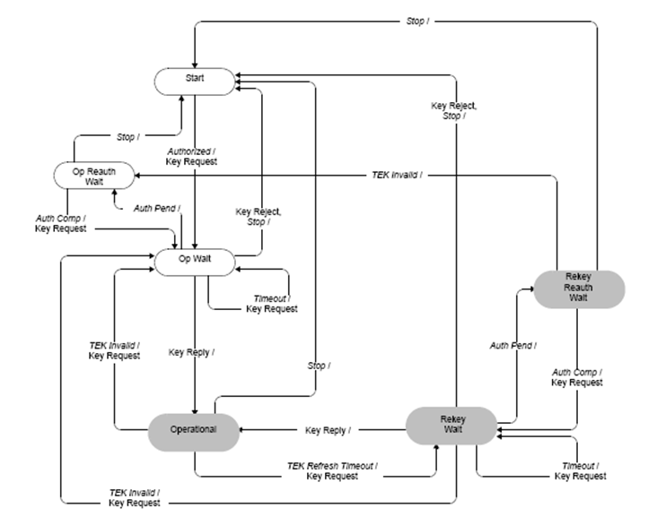

Figure XTEK_flow_diag TEK state machine flow diagram

7.2.1.6.1 States
— Start: This is the initial state of the FSM. No resources are assigned to or used by the FSM in this state —e.g., all timers are off, and no processing is scheduled.
- Operational Wait (Op Wait): The TEK state machine has sent its initial request (Key Request) for its SAID’s keying material (TEK and CBC IV), and is waiting for a reply from the BS.
- Operational Reauthorize Wait (Op Reauth Wait): The wait state the TEK state machine is placed in if it does not have valid keying material while the Authorization state machine is in the middle of a reauthorization cycle.
- Operational: The CPE has valid keying material for the associated SAID.
- Rekey Wait: The TEK Refresh Timer has expired and the CPE has requested a key update for this SAID. Note that the newer of its two TEKs has not expired and can still be used for both encrypting and decrypting data traffic.
- Rekey Reauthorize Wait (Rekey Reauth Wait): The wait state the TEK state machine is placed in if the TEK state machine has valid traffic keying material, has an outstanding request for the latest keying material, and the Authorization state machine initiates a reauthorization cycle.

7.2.1.6.2 Messages

Note that the message formats are defined in detail in 6.x.x.x.x.

Table TEK-FSM TEK Finite State Machine State Transition Matrix

- Key Request: Request a TEK for this SAID. Sent by the CPE to the BS and authenticated with keyed message digest. The message authentication key is derived from the AK.
- Key Reply: Response from the BS carrying the two active sets of traffic keying material for this SAID. Sent by the BS to the CPE, it includes the SAID’s TEKs, encrypted with a KEK derived from the AK. The Key Reply message is authenticated with a keyed message digest; the authentication key is derived from the AK.
- Key Reject: Response from the BS to the CPE to indicate this SAID is no longer valid and no key will be sent. The Key Reject message is authenticated with a keyed message digest; the authentication key is derived from the AK.
- TEK Invalid: The BS sends an CPE this message if it determines that the CPE encrypted an UL PDU with an invalid TEK, i.e., an SAID’s TEK key sequence number, contained within the received PDU’s MAC header, is out of the BS’s range of known, valid sequence numbers for that SAID.
7.2.1.6.3 Events
— Stop: Sent by the Authorization FSM to an active (non-START state) TEK FSM to terminate TEK FSM and remove the corresponding SAID’s keying material from the SS’s key table. See Figure 160. — Authorized: Sent by the Authorization FSM to a nonactive (START state) TEK FSM to notify TEK FSM of successful authorization. See Figure XTEK_flow_diag.
- Authorization Pending (Auth Pend): Sent by the Authorization FSM to TEK FSM to place TEK FSM in a wait state while Authorization FSM completes reauthorization. See XTEK_flow_diag.
- Authorization Complete (Auth Comp): Sent by the Authorization FSM to a TEK FSM in the Opera-tional Reauthorize Wait or Rekey Reauthorize Wait states to clear the wait state begun by the prior Authorization Pending event. See Figure XTEK_flow_diag.
- TEK Invalid: This event is triggered by either an CPE’s data packet decryption logic or by the receipt of a TEK Invalid message from the BS.
An CPE’s data packet decryption logic triggers a TEK Invalid event if it recognizes a loss of TEK key synchronization between itself and the encrypting BS. For example, an SAID’s TEK key sequence number, contained within the received DL MAC PDU header, is out of the CPE’s range of known sequence numbers for that SAID.
A BS sends an CPE a TEK Invalid message, triggering a TEK Invalid event within the CPE, if the BS’s decryption logic recognizes a loss of TEK key synchronization between itself and the CPE.
- Timeout: A retry timer timeout. Generally, the particular request is retransmitted.
- TEK Refresh Timeout: The TEK refresh timer timed out. This timer event signals the TEK state machine to issue a new Key Request in order to refresh its keying material. The refresh timer is set to fire a configurable duration of time (TEK Grace Time) before the expiration of the newer TEK the CPE currently holds. This is configured via the BS to occur after the scheduled expiration of the older of the two TEKs.

7.2.1.6.4 Parameters
All configuration parameter values take the default values from Table 549 or may be specified in Auth Reply message.
- Operational Wait Timeout: Timeout period between sending of Key Request messages from the Op Wait state (see 11.9.19.4).
- Rekey Wait Timeout: Timeout period between sending of Key Request messages from the Rekey Wait state (see 11.9.19.5).
- TEK Grace Time: Time interval, in seconds, before the estimated expiration of a TEK that the CPE starts rekeying for a new TEK. TEK Grace Time takes the default value from Table 549 or may be specified in a configuration setting within the Auth Reply message and is the same across all SAIDs (see 11.9.19.6).

7.2.1.6.5 Actions
Actions taken in association with state transitions are listed by <event> (<rcvd message>) --> <state>:
1-B Op Wait (Stop) → Start
a) Clear Key Request retry timer
b) Terminate TEK FSM
1-C Op Reauth Wait (Stop) → Start
a) Terminate TEK FSM
1-D Operational (Stop) → Start
a) Clear TEK refresh timer, which is timer set to go off “TEK Grace Time” seconds prior to the TEK’s scheduled expiration time
b) Terminate TEK FSM
c) Remove SAID keying material from key table
1-E Rekey Wait (Stop) → Start
a) Clear Key Request retry timer
b) Terminate TEK FSM
c) Remove SAID keying material from key table
1-F Rekey Reauth Wait (Stop) → Start
a) Terminate TEK FSM
b) Remove SAID keying material from key table
2-A Start (Authorized) → Op Wait
a) Send Key Request message to BS
b) Set Key Request retry timer to Operational Wait Timeout
3-B Op Wait (Auth Pend) → Op Reauth Wait
a) Clear Key Request retry timer
3-E Rekey Wait (Auth Pend) → Rekey Reauth Wait
a) Clear Key Request retry timer
4-C Op Reauth Wait (Auth Comp) → Op Wait
a) Send Key Request message to BS
b) Set Key Request retry timer to Operational Wait Timeout
4-F Rekey Reauth Wait (Auth Comp) → Rekey Wait
a) Send Key Request message to BS
b) Set Key Request retry timer to Rekey Wait Timeout
5-D Operational (TEK Invalid) → Op Wait
a) Clear TEK refresh timer
b) Send Key Request message to BS
c) Set Key Request retry timer to Operational Wait Timeout
d) Remove SAID keying material from key table
5-E Rekey Wait (TEK Invalid) → Op Wait
a) Clear TEK refresh timer
b) Send Key Request message to BS
c) Set Key Request retry timer to Operational Wait Timeout
d) Remove SAID keying material from key table
5-F Rekey Reauth Wait (TEK Invalid) → Op Reauth Wait
a) Remove SAID keying material from key table
6-B Op Wait (Timeout) → Op Wait
a) Send Key Request message to BS
b) Set Key Request retry timer to Operational Wait Timeout
6-E Rekey Wait (Timeout) → Rekey Wait
a) Send Key Request message to BS
b) Set Key Request retry timer to Rekey Wait Timeout
7-D Operational (TEK Refresh Timeout) → Rekey Wait
a) Send Key Request message to BS
b) Set Key Request retry timer to Rekey Wait Timeout
8-B Op Wait (Key Reply) → Operational
a) Clear Key Request retry timer
b) Process contents of Key Reply message and incorporate new keying material into key database
c) Set the TEK refresh timer to go off “TEK Grace Time” seconds prior to the key’s scheduled expiration
8-E Rekey Wait (Key Reply) → Operational
a) Clear Key Request retry timer
b) Process contents of Key Reply message and incorporate new keying material into key database
c) Set the TEK refresh timer to go off “TEK Grace Time” seconds prior to the key’s scheduled expiration
9-B Op Wait (Key Reject) → Start
a) Clear Key Request retry timer
b) Terminate TEK FSM
9-E Rekey Wait (Key Reject) → Start
a) Clear Key Request retry timer
b) Terminate TEK FSM
c) Remove SAID keying material from key table

7.2.2 PKM Version 2
7.2.2.1 TEK exchange overview for PMP topology
If the CPE and BS decide “No authorization” as their authorization policy, the CPE and BS shall perform neither SA-TEK handshake nor Key Request/Key Reply handshake. In this case, target SAID value, which may be included in DSA-REQ/RSP messages, shall be Null SAID.

Upon achieving authorization, a CPE starts a separate TEK state machine for each of the SAIDs identified in the Authorization Reply or PKMv2 SA-TEK-RSP message, if data traffic encryption is provisioned for one or more service flows. Each TEK state machine operating within the CPE is responsible for managing the keying material associated with its respective SAID.

TEK state machines periodically send Key Request messages to the BS, requesting a refresh of keying material for their respective SAIDs. The BS responds to a Key Request with a Key Reply message, containing the BS’s active keying material for a specific SAID. TEKs and KEKs may be either 64 bits or 128 bits long. SAs employing any ciphersuite with a basic block size of 128 bits shall use 128-bit TEKs and KEKs.

Otherwise 64-bit TEKs and KEKs shall be used. The name TEK-64 is used to denote a 64-bit TEK and TEK-128 is used to denote a 128-bit TEK. Similarly, KEK-64 is used to denote a 64-bit KEK and KEK-128 is used to denote a 128-bit KEK.

For SAs using a ciphersuite employing DES-CBC, the TEK in the Key Reply is triple DES (3-DES) (encrypt-decrypt-encrypt or EDE mode) encrypted, using a two-key, 3-DES KEK derived from the AK.

For SAs using a ciphersuite employing 128 bits keys, such as AES-CCM mode, the TEK in the Key Reply is AES encrypted using a 128-bit key derived from the AK and a 128-bit block size.

Note that at all times the BS maintains two diversity sets of keying material per SAID. The lifetimes of the two generations overlap so that each generation becomes active halfway through the life of it predecessor and expires halfway through the life of its successor. A BS includes in its Key Replies both of an SAID’s active generations of keying material.

For SAs using a ciphersuite employing CBC mode encryption the Key Reply provides the requesting CPE, in addition to the TEK and CBC IV, the remaining lifetime of each of the two sets of keying material. For SAs using a ciphersuite employing AES-CCM mode, the Key Reply provides the requesting CPE, in addition to the TEK, the remaining lifetime of each of the two sets of keying material. The receiving CPE uses these remaining lifetimes to estimate when the BS will invalidate a particular TEK and, therefore, when to schedule future Key Requests so that the CPE requests and receives new keying material before the BS expires the keying material the CPE currently holds. For AES-CCM mode, when more than half the available PN numbers in the 31-bit PN number space are exhausted, the CPE shall schedule a future Key Request in the same fashion as if the key lifetime was approaching expiry. The operation of the TEK state machine’s Key Request scheduling algorithm, combined with the BS’s regimen for updating and using an SAID’s keying material (see 7.3), ensures that the CPE will be able to continually exchange encrypted traffic with the BS.

A TEK state machine remains active as long as

a) The CPE is authorized to operate in the BS’s security domain, i.e., it has a valid AK, and

b) The CPE is authorized to participate in that particular SA, i.e., the BS continues to provide fresh key-ing material during rekey cycles.

The payloads of MAC PDUs sent on connections that belong to an SA that includes data encryption shall be encrypted. A MAC PDU with a payload received on such a connection with the EC bit not set shall be discarded. A MAC PDU without a payload received on such a connection shall be processed if its EC bit is set to 0, and should be discarded if its EC bit is set to 1.

7.2.2.2 Key derivation

The PKMv2 key hierarchy defines what keys are present in the system and how the keys are generated. Since there are two authentication schemes, one based on RSA and one based on EAP, there are two primary sources of keying material. IEEE 802.22 systems shall use RSA based authentication scheme. The keys used to protect management message integrity and transport the TEKs are derived from source key material generated by the authentication and authorization processes. The RSA-based authorization process yields the pre-Primary AK (pre-PAK) and the EAP based authentication process yields the MSK. Keys used to protect MBS traffic are derived from the MBSAK, which is supplied by means outside the scope of this specification. These keys form the roots of the key hierarchy. All PKMv2 key derivations are based on the Dot16KDF algorithm as defined in 7.5.4.6.1. The MSK is the shared “master key” that is derived by the two sides in the course of executing the EAP inner method. The authentication part of the authorization flow (and the involvement of the generic EAP layer) is now complete.

7.2.2.2.1 RSA-based authorization

When the RSA-based authorization is negotiated as authorization policy, the PKMv2 RSA-Request, the PKMv2 RSA-Reply, the PKMv2 RSA-Reject, and the PKMv2 RSA-Acknowledgement messages are used to share the pre-PAK. The pre-PAK is sent by the BS to the SS encrypted with the public key of the SS certificate. Pre-PAK is mainly used to generate the PAK. The optional EIK for transmitting authenticated EAP payload (see 7.2.2.2.2) are also generated from pre-PAK: EIK | PAK = Dot16KDF(pre-PAK, SS MAC Address | BSID | “EIK+PAK”, 320) PAK will be used to generate the AK (see 7.2.2.2.3) if RSA authorization was used. PAK is 160 bits long.

7.2.2.2.2 EAP authentication

If a RSA mutual authorization took place before the EAP exchange, the EAP messages may be protected using EIK-EAP Integrity Key derived from pre-PAK (see 7.2.2.2.1). EIK is 160 bits long. The product of the EAP exchange that is transferred to IEEE 802.16 layer is the Master Session Key (MSK), which is 512 bits in length. This key is known to the AAA server, to the Authenticator (transferred from AAA server) and to the SS. The SS and the authenticator derive a PMK (Pairwise Master Key) by truncating the MSK to 160 bits. The PMK derivation from the MSK during first EAP method is as follows: PMK ⇐ truncate (MSK, 160) After the successful initial authentication, the SS shall initiate reauthentication prior to expiration of PMK lifetime by sending the PKMv2 EAP Start message signed by H/CMAC_KEY_U derived from the AK. Either the BS or SS may initiate reauthentication at any time prior to expiration of PMK lifetime. After expiration of the PMK lifetime, authentication must be performed using initial authentication procedures.

7.2.2.2.3 AK derivation

The AK will be derived by the BS and the CPE from the PMK (from EAP-based authorization procedure) and/ or the PAK (from RSA-based authorization procedure). Note that PAK and/or PMK can be used according to the value of Authorization Policy Support field included in the SBC-REQ/RSP messages.

After the authorization procedure has been performed, the CPE and BS will both posses the PAK. After the EAP based authentication procedure, the MS and the Authenticator will both possess the PMK. If both the authorization and EAP based authentication procedure were performed, the MS and the Authenticator will possess both the PAK and PMK. The derivation of the AK varies based on which keys are possessed.

The AK shall be generated as follows:

If (PAK and PMK)
AK ⇐ Dot16KDF (PAK PMK, CPE MAC Address | BSID | PAK | “AK”, 160)

Else

If (PAK)
AK ⇐ Dot16KDF (PAK, CPE MAC Address | BSID | PAK | “AK”, 160)

Else // PMK only

AK ⇐ Dot16KDF(PMK, SS MAC Address | BSID | “AK”, 160);

Endif
Endif

7.2.2.2.4 KEK derivation

The KEK is derived directly from the AK. The KEK is defined in 7.2.2.2.9. It is used to encrypt the TEKs, GKEK and all other keys sent by the BS to SS in unicast message.

7.2.2.2.5 GKEK derivation

GKEK is randomly generated at the BS or a network entity (for example, an ASA server) and transmitted to the SS encrypted with the KEK. There is one GKEK per Group Security Association. GKEK is used to encrypt the GTEKs sent by the BS to the SSs in the same multicast group or MBS group.

7.2.2.2.6 Traffic encryption key (TEK)

The TEK is generated as a random number in the BS and is encrypted using the corresponding TEK encryption algorithm (e.g., AES key wrap for SAs with TEK encryption algorithm identifier in the cryptographic suite is equal to 0x04), keyed with the KEK and transferred between BS and CPE in the TEK exchange.
7.10 Security sublayer Architecture for the Cognitive Plane (Informative)

Unlike 802.11 and 802.16 which usually operate in the licensed spectrum, cognitive radio based WRANs need to operate in the unlicensed spectrum or White spaces as secondary occupiers of the spectrum. Mechanisms have been defined in various sections of the 802.22 standard to protect the incumbents who are the primary occupiers of the spectrum (e.g. spectrum sensing, geolocation, spectrum management, spectrum etiquette etc.). This section provides further details on how to protect the incumbents as well as the 802.22 sytems against various types of Denial of Service (DoS) attacks targeted at the cognitive functions of the 802.22 systems. As a result, the Security Sub-layer 2 has been introduced in the cognitive plane of the 802.22 entity. The cognitive plane consists of a Spectrum Sensing Function (SSF), a Geolocation Function and a Spectrum Manager (SM) at the BS or the Spectrum Automaton at the CPE.

Figure XCP1 (a) shows the 802.22 Protocol Reference Model (PRM) with its Cognitive Plane functions containing Security Sublayer 2 at the BS. Figure XCP1 (b) shows the 802.22 PRM with its Cognitive Plane functions containing Security Sublayer 2 at the CPE. Details on the PRM itself can be found in Section 6.2.

Organization - Sections 7.10 defines the detailed functionalities that 802.22 systems need to provide to ensure the security at the cognitive plane. Section 7.11 defines the operations / mechanisms of the Security Sublayer 2 to provide the functionalities defined in 7.10.

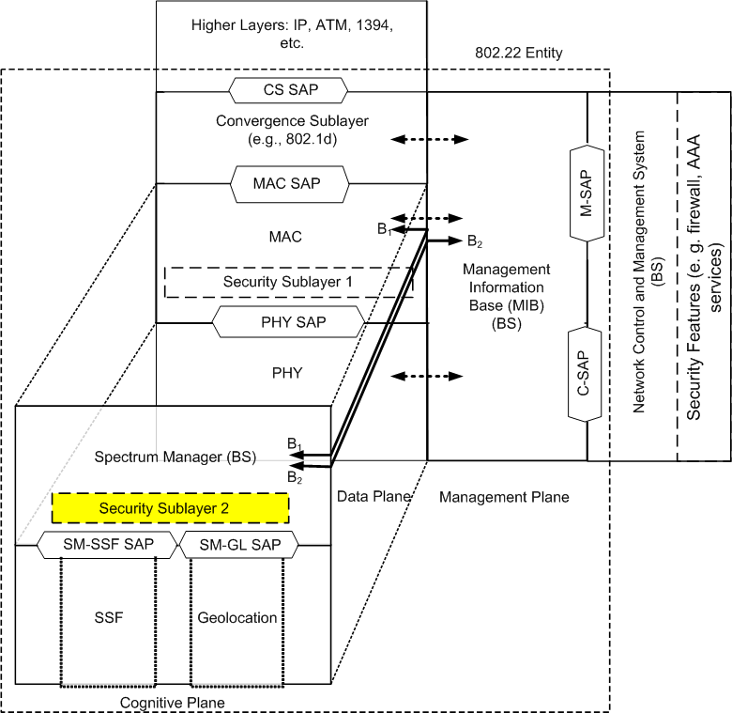
(a)

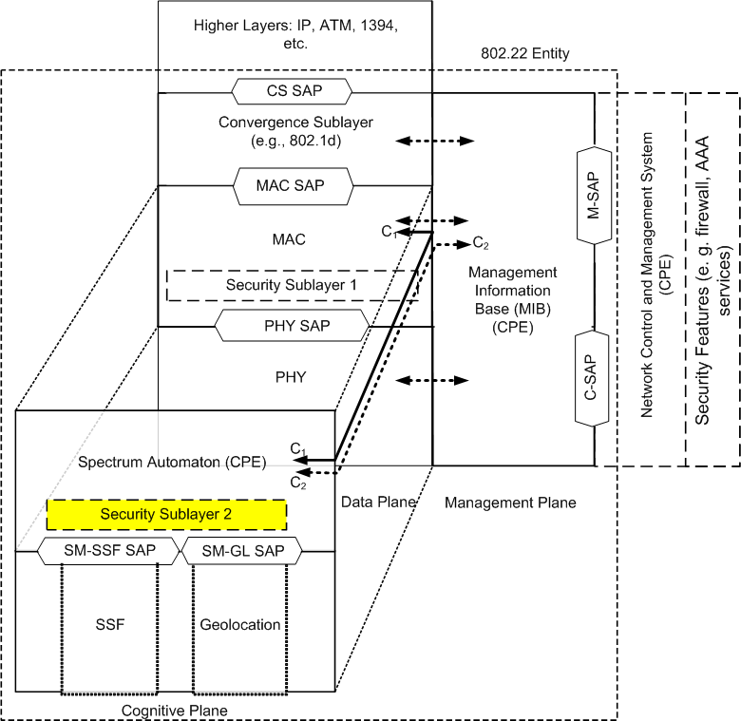
(b)
Figure XCP1 (a) PRM of the 802.22 BS showing Security Sublayer 2 which provides protection for the cognitive functions at the BS (b) PRM of the 802.22 CPE with Security Sublayer 2 which provides protection for the cognitive functions at the CPE

Some of basic security functions of this layer and the remediation measures required to protect these functions include:

7.10.1 Availability

This is the primary function of any network. If there is a perception, real or not, that a particular type of network is unreliable due to service or security issues then that network type will not be utilized by WRAN operators or end-users. In the case of cognitive networks availability refers to ability of the BSs to properly sense the available spectrum and make it available to the CPEs. This means that the BSs must have built-in security mechanisms that can:
  - Ensure the availability of the spectrum for the primary (incumbents) and the secondary (WRAN) users
  - Mitigate any DoS-type attacks against BS, CPE, and other supporting devices such as the ones used to generate 802.22.1 beacons.

7.10.2 Authentication

This functionality provides assurance that the communicating parties, sender and receiver, are who they purport to be. In cognitive networks there is the added problem of distinguishing between the valid incumbents of the spectrum and the secondary users. WRAN operators must be able to:
  - Validate incumbent TV signals and the wireless microphone beacons
  - Detect and counter man-in-the-middle and similar type attacks that attempt to steal available spectrum space.
  - Detect and counter any spoofing and similar type attacks
  - Authenticate geolocation information
  - Authenticate co-existence information of neighboring WRAN systems
  - Detection and reporting of spurious transmissions from other CPEs

7.10.3 Authorization

Different network entities will have different privilege levels. For example, a BS may be authorized to forcibly remove an interfering CPE from the network but the adjacent CPE reporting the interference will not. In cognitive networks the ability of the BS spectrum manager to sense the available spectrum, make decisions regarding its use and enforce those decisions at the CPE level is an important authorization example. For a cognitive network to properly function:
  - Only the authorized parties are allowed to configure the spectrum manager at the BS and the spectrum automaton at the CPE
  - Configuration information is identified and protected

7.10.4 Identification

Identification works hand-in-hand with authentication in assuring both incumbent and secondary spectrum users that the communicating entities are known. To that end it is necessary that cognitive networks provide mechanisms that will:
  - Positively identify transmitting/receiving BS and CPE equipment
  - Ensure that the identification methods employed cannot be compromised through spoofing or similar type attacks.
  - Protect against replay-type attacks which employ previously transmitted valid identifiers.

7.10.5 Integrity

Integrity is the assurance that the information transmitted over the medium arrives at its destination unaltered. Integrity provides write protection for the content. This is especially difficult in wireless networks because of the uncontrolled nature of the medium. Also the fact that certain portions of the data must be altered to ensure proper transmission and delivery (timestamps, source, destination etc.) compounds the problem. Cognitive networks must:
  - Protect against Co-Existence Beaconing (“CBP”) falsification
  - Protect against replay-type attacks using previously transmitted valid data

7.10.6 Confidentiality/Privacy

Confidentiality works closely with integrity to ensure read as well as write protection for data. This is usually carried out using encryption and ciphers that can operate at the link and higher layers. One must account for the fact that the wireless medium is more sensitive to transmission errors due to propagation effects such as shadowing, fading as well as un-intentional interference. This sensitivity can wreak havoc with complex ciphers and cause numerous re-transmissions resulting in wasted bandwidth. With cognitive networks this sensitivity is especially troublesome because of the opportunistic nature of spectrum use by the secondary users and the fact that use of the spectrum is not guaranteed. Cognitive networks, therefore, must provide:
  - Support for robust ciphers and encryption methods
  - Mechanisms to safeguard WRAN operator’s spectrum availability information from eavesdropping by competitors or would-be hackers.

7.11 Security Mechanisms for the Cognitive Plane

7.11.1 Collaborative Sensing Mechanisms

Annex C

Let

H₀: Hypothesis such that the incumbent is not occupying the channel being sensed
H₁: Hypothesis such that the incumbent is occupying the channel being sensed

Let x(n) be the received signal at the input of the SSF, where n is the running index of the samples

$x(n)=\left\{\begin{matrix}w(n) & →H_{0} \\ s(n)+w(n) & →H_{1}\end{matrix}\right.$ (C.1),

where s(n) is the authentic incumbent signal, and w(n) is the noise. Hence the goal of the SSF is to decide between hypotheses H₀ and H₁.

Let y(n) be the decision statistic, and λ be some threshold used to choose between the Hypotheses H₀ and H₁ respectively. Then the detection probability (P_{d}) and the false alarm probability (P_{f}) can be denoted by

$\begin{aligned}P_{d}=P\left(y>λ|H_{1}\right) \\ P_{f}=P\left(y>λ|H_{0}\right)\end{aligned}$ (C.2)

Consider a group of N localized sensors, monitoring a specific area, collaboratively trying to distinguish between Hypotheses H₀ and H₁. If the group collectively decides that the incumbent signal is detected when the detection statistic at, at least one of the sensors exceeds the threshold, then the sensors are said to follow the OR rule of the collaborative sensing. Under these circumstances, the network detection and false alarm probabilities are denoted by Q_{d} and Q_{f} respectively, and given by

$\begin{aligned}Q_{d}^{\text{OR}}=1−{\left(1−P_{d}\right)}^{N} \\ Q_{f}^{\text{OR}}=1−{\left(1−P_{f}\right)}^{N}\end{aligned}$ (C.3)

Under the OR rule of collaborative sensing, the net detection as well as false alarm probabilities increase.

However, consider another signal c(n), which statistically looks similar to the authentic signal s(n), such that, when transmitted, it may result in false detection of the signal s(n). Assume that c(n) will be detected by at least L sensors where (L<N). Let P_{C} be the probability that c(n) is transmitted (ON) at a particular instant of time. If the OR rule of the collaborative sensing is followed, then the probability of detection of an authentic incumbent signal is give by

$Q_{d}^{C,\text{OR}}=\left(1−P_{C}\right)\left(1−{\left(1−P_{d}\right)}^{N}\right)=\left(1−P_{C}\right)−\left(1−P_{C}\right){\left(1−P_{d}\right)}^{N}$ (C.4)

and the false alarm probability = probability that Hypothesis H₁ is selected when H₀ is true is given by

$Q_{f}^{C,\text{OR}}=\text{min}\left[P_{C}+\left(1−{\left(1−P_{f}\right)}^{N}\right), 1\right]$ (C.5)

This means that the net authentic signal detection probability is upper bounded by the duty cycle (P_{C}) of the false signal c(n). If c(n) is ON all the time (that is P_{C} = 1), then, Q^{C}_{d} = 0, which means that a particular channel always appears to be occupied, even when NO authentic incumbent signal is present. If c(n) is OFF all the times then Q^{C}_{d} = $\left(1−{\left(1−P_{d}\right)}^{N}\right)$ and probability of authentic incumbent detection is the same as in C.3. Note, that the false alarm probability has gone up considerably and is governed by the value of P_{C}.

Now consider a case where instead of the OR rule of collaborative sensing, the AND rule is followed. Under these circumstances, the incumbent signal is said to be detected if and ONLY if all the N localized sensors detect the signal. In absence of c(n), the detection and false alarm probabilities are given by

$\begin{aligned}Q_{d}^{\text{AND}}={\left(P_{d}\right)}^{N} \\ Q_{f}^{\text{AND}}={\left(P_{f}\right)}^{N}\end{aligned}$ (C.6),

which means that both, the detection as well as the false alarm probabilities gone down.

Let P_{C} be the probability that c(n) is transmitted at a particular instant of time and some L<N sensors are able to detect it. If the AND rule of the collaborative sensing is followed, then the probability that an authentic incumbent signal is detected is given by,

$Q_{d}^{C,\text{AND}}={\left(P_{d}\right)}^{N}$ (C.6).

which means that even in presence of a false signal c(n), the probability that an authentic incumbent signal is detected, still remains the same as in C.6. Similarly, the false alarm probability = probability that Hypothesis H₁ is selected when H₀ is true, and is given by

$Q_{f}^{C,\text{AND}}={\left(P_{f}\right)}^{N}$ (C.7)

As an example, let P_{d} = 0.9, let P_{f} = 0.1, let N = 2, L = 1, and P_{C} = 0.5, then

$P_{d}$= 0.9 | $Q_{d}^{\text{OR}}$ = 0.99 | $Q_{d}^{C,\text{OR}}$ = 0.495 | $Q_{d}^{\text{AND}}$ = 0.81 | $Q_{d}^{C,\text{AND}}$ = 0.81
$P_{f}$= 0.1 | $Q_{f}^{\text{OR}}$ = 0.19 | $Q_{f}^{C,\text{OR}}$ = 0.69 | $Q_{f}^{\text{AND}}$ = 0.01 | $Q_{f}^{C,\text{AND}}$ = 0.01

References:

- A. Mody, T. Kiernan, “Meeting Minutes of the Security Ad-Hoc Group in 802.22” https://mentor.ieee.org/802.22/file/08/22-08-0163-07-0000-meeting-minutes-of-the-security-ad-hoc-group-in-802-22.doc
- A. Mody, R. Reddy, T. Kiernan, M. Sherman, “Recommended text for Section 7 on Security in 802.22” - https://mentor.ieee.org/802.22/file/08/22-08-0174-07-0000-recommended-text-for-section-7-on-security-in-802-22.doc was presented and discussed
- A. Mody, R. Reddy, T. Kiernan, M. Sherman, “Table of Contents for Section 7”. https://mentor.ieee.org/802.22/file/08/22-08-0165-00-0000-table-of-content-for-the-security-section-in-802-22.doc
- A. Mody, R. Reddy, T. Kiernan, M. Sherman, “Scope and the Workplan for the Security Ad-Hoc Group” – https://mentor.ieee.org/802.22/file/08/22-08-0159-00-0000-scope-agenda-workplan-and-timeline-for-the-security-ad-hoc-in-802-22.doc
- A. Mody, R. Reddy, T. Kiernan, M. Sherman, DJ Shyy, “Presentation on the PRM and Security Enhancements in 802.22 – 802.22 Threat Analysis” https://mentor.ieee.org/802.22/file/08/22-08-0083-07-0000-security-and-prm-enhancements-in-80222-v3.ppt
- A. Mody, R. Reddy, M. Sherman, T. Kiernan, DJ Shyy, “Security and Protocol Reference Model Enhancements in 802.22,” https://mentor.ieee.org/802.22/file/08/22-08-0083-04-0000-security-and-prm-enhancements-in-80222-v3.ppt
- IEEE 802.16 Draft Standard for Broadband Wireless Access – P802.16Rev2/D5 (June 2008) – Section 7 – Security Sublayer
- Security Enhancement for 802.16e - A SDD Proposal for 802.16m -www.wirelessman.org/tgm/contrib/C80216m-08_046.doc
- http://www.navigadget.com/index.php/2007/01/29/gps-and-gsm-jammer/
- M. Barbeau, “WiMAX Threat Analysis”, Proceedings of the ACM, Q2SWinet’05, October 13, 2005, Montreal, Quebec, Canada.
- S. Xu, M. Matthews, “Security Issues in Privacy and Key Management Protocols of 802.16,” Proceedings of the ACM SE’06, March 10-12, 2006, Melbourne, Florida, USA
- D. Johnston and J. Walker, “Overview of IEEE 802.16 Security,” IEEE Security and Privacy, Magazine Published by the IEEE Computer Society, 2004
- Y. Xiao, X. Shen and D. Du, Wireless Network Security, Springer Series on Signals and Communications Technology, 2006
- Qusay H. Mahmoud, Cognitive Networks, Towards Self Aware Networks, Wiley, Sept. 2007 – Chapter 11, Security Issues in Cognitive Radio Networks
- Amita Sethi, Potential Denial of Service Threat Assessment for Cognitive Radios, MS Thesis, University of Colorado at Boulder, 2008.

