IEEE P802.22
Wireless RANs
Incumbent Database Query Model
Date: 2008-05-30
Author(s):
Name | Company | Address | Phone | email
Charles Cooper | du Treil, Lundin & Rackley, Inc. | Sarasota, Florida | 941.329.6000 | CHARLES@DLR.COM

Abstract
Proposed model to determine the EIRP for CPE’s and BS’s to protect imcumbent users.
Notice: This document has been prepared to assist IEEE 802.22. It is offered as a basis for discussion and is not binding on the contributing individual(s) or organization(s). The material in this document is subject to change in form and content after further study. The contributor(s) reserve(s) the right to add, amend or withdraw material contained herein.

Release: The contributor grants a free, irrevocable license to the IEEE to incorporate material contained in this contribution, and any modifications thereof, in the creation of an IEEE Standards publication; to copyright in the IEEE’s name any IEEE Standards publication even though it may include portions of this contribution; and at the IEEE’s sole discretion to permit others to reproduce in whole or in part the resulting IEEE Standards publication. The contributor also acknowledges and accepts that this contribution may be made public by IEEE 802.22.

Patent Policy and Procedures: The contributor is familiar with the IEEE 802 Patent Policy and Procedures
<http://standards.ieee.org/guides/bylaws/sb-bylaws.pdf>, including the statement "IEEE standards may include the known use of patent(s), including patent applications, provided the IEEE receives assurance from the patent holder or applicant with respect to patents essential for compliance with both mandatory and optional portions of the standard." Early disclosure to the Working Group of patent information that might be relevant to the standard is essential to reduce the possibility for delays in the development process and increase the likelihood that the draft publication will be approved for publication. Please notify the Chair <Carl R. Stevenson> as early as possible, in written or electronic form, if patented technology (or technology under patent application) might be incorporated into a draft standard being developed within the IEEE 802.22 Working Group. If you have questions, contact the IEEE Patent Committee Administrator at <patcom@ieee.org>.

IEEE 802.22 CPE & BS INCUBMENT DATABASE SERVICE
- Allocation Analysis
  - Using known geographic coordinates for CPE’s & BS’s, calculate the bearing in degrees true from the CPE to BS
  - Calculate CPE interfering contour
    - Using a three-second or better terrain database, determine ground elevation for CPE location
    - Using determined ground elevation, calculate the CPE transmitting antenna height above average terrain (haat) for at least 36 equally spaced radials and assumed 10 meter height above ground level.
  - Repeat the below procedure for each possible CPE channel
    - Co-channel protection
      - For each CPE radial haat, calculate the distance to the CPE F(50,10) 18 dbu contour using a typical CPE antenna radiation pattern with the major lobe in the direction of the BS and the maximum EIRP of 4 watts. This is the interfering region
      - For each co-channel protected television station located within 175 kilometers (?) from the CPE & obtained from the incumbent database, calculate the protected contour (or region) based upon the FCC propagation curves and 36 equally spaced radials. This is the protected region.
      - If the two regions intersect, then determine the ERP the CPE would have to reduce to eliminate the region intersection, if such reduction is possible.
    - Adjacent-channel protections
      - For each radial haat, calculate the distance to the CPE F(50,10) 67 dbu contour using a typical CPE radiation pattern with the major lobe in the direction of the BS and the maximum EIRP of 4 watts. This is the interfering region
      - For each adjacent channel protected television station located within 125 kilometers (?) from the CPE, calculate the calculate the protected contour (or region) based upon the fcc propagation curves and 36 equally spaced radials.
      - If the two regions intersect, then determine the erp the cpe would have to reduce to eliminate the region intersection, if such reduction is possible.

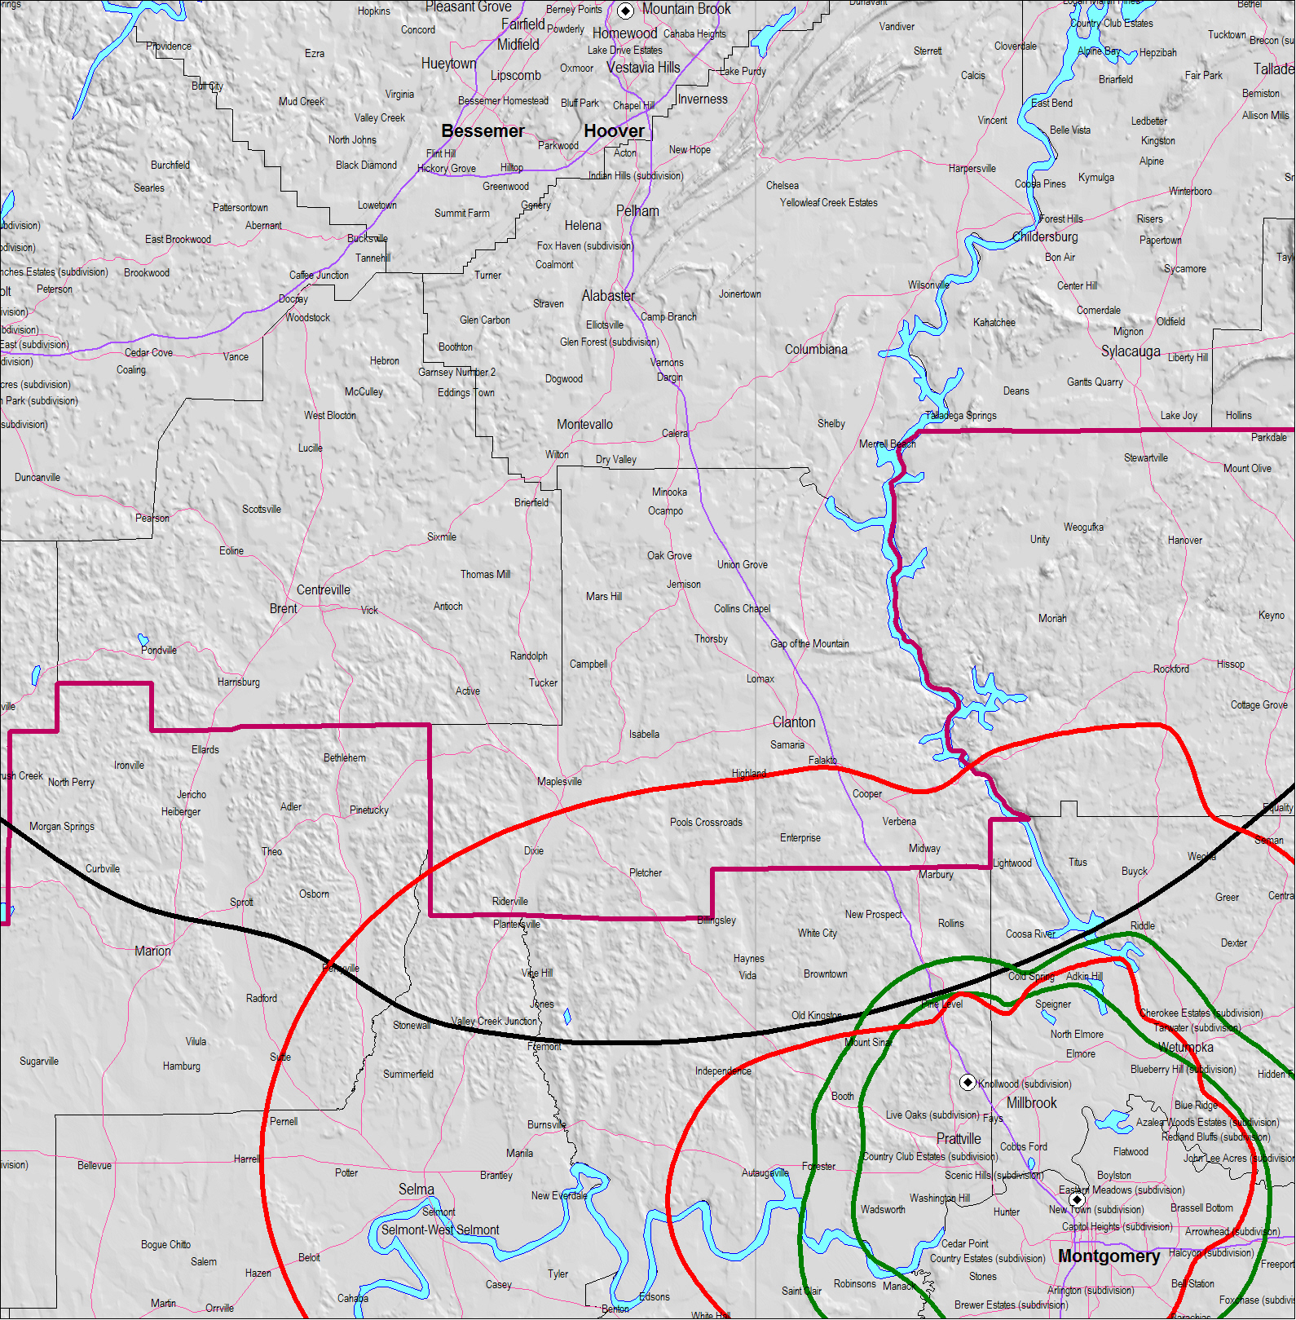
WABM-DT Birmingham, AL
CH 36 885 KW (MAX-DA) 406 M
Noise-Limited Contour (41 dBu)
BS 100 W EIRP
18 dBu F(50,10)
BS 25 W EIRP
18 dBu F(50,10)
CPE 4 W EIRP
18 dBu F(50,10)
CPE 4 W EIRP
18 dBu F(50,10)
CPE 1 W EIRP
18 dBu F(50,10)
Figure 1. Montgomery Channel 36 CBE & BS Example.

Above is a frequency planning example for a CPE at location near Montgomery, Alabama. To determine the permissible EIRP for the CPE, the following information is sent to the incumbent database service:

CPE Geographic Location:
32° 30’ 46” North Latitude/86° 26’ 16” West Longitude
BS Geographic Location:
32° 24’ 22” North Latitude/86° 19’ 09” West Longitude

Intermediate Calculations for Channel 36:
Direction from CPE to BS: 137° True
Database Search: Co-Channel: WABM at Birmingham, AL 113.2 km away
No adjacent-channel stations of concern

Below is the CPE Radiation Pattern (from the proposed standard:

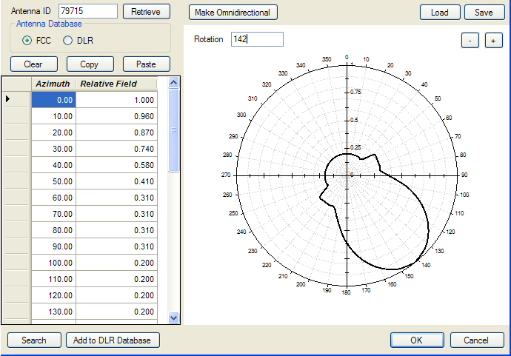

Using the above antenna radiation pattern with the major lobe in the direction of the BS (at 137° True), the EIRP would have to be decreased from 4 watts to 1 watt EIRP not to have overlap as shown on the Figure 1 map.

The interfering contours are based upon the WRAN_Model.

