IEEE P802.22
Wireless RANs
Text on Resource Allocation in 802.22 for Improved Self Co-Existence
Date: 2008-05-06
Author(s):
Name | Company | Address | Phone | email
Apurva Mody | BAE Systems | P.O. Box 868, MER 15-2350, Nashua, NH 03061-0868 | 603-885-2621  404-819-0314 | apurva.mody@baesystems.com,  apurva_mody@yahoo.com
Ranga Reddy | US Army, | Ft. Monmouth, NJ |  | ranga.reddy@us.army.mil
Matthew Sherman | BAE Systems | Wayne, NJ |  | matthew.sherman@baesystems.com
Tom Kiernan | US Army | Ft. Monmouth |  | thomas.kiernan@us.army.mil
Abstract
- This contribution discusses methods for resource allocation in situations that demand self co-existence
- We propose Two Modes of operation – Normal mode and Co-existence Mode
- We propose that an 802.22 system will try and resolve the channel selection issues with neighboring WRAN systems, first, based on spectrum etiquette.
- If channel selection does not get resolved using spectrum etiquette, then the 802.22 system will go into the Co-Existence Mode. Co-Existence Mode of operation is utilized when interference free scheduling, dynamic resource renting / offering or contention is required for resource sharing
- We propose sub-frame creation and sharing – concepts similar to the ones discussed in IEEE 802.16h
- In the co-existence mode, the sub-frames are divided into sets. Clock-wise or anti-clock-wise rotation policy is followed to achieve diversity and control message passing.
- The self co-existence windows are utilized to pass important management information. However, majority of information is exchanged with other cells using DS and US slots / sets – enabling self co-existence windows to be utilized more effectively for intra-frame sensing of incumbents and WRANs
Notice: This document has been prepared to assist IEEE 802.22. It is offered as a basis for discussion and is not binding on the contributing individual(s) or organization(s). The material in this document is subject to change in form and content after further study. The contributor(s) reserve(s) the right to add, amend or withdraw material contained herein.

Release: The contributor grants a free, irrevocable license to the IEEE to incorporate material contained in this contribution, and any modifications thereof, in the creation of an IEEE Standards publication; to copyright in the IEEE’s name any IEEE Standards publication even though it may include portions of this contribution; and at the IEEE’s sole discretion to permit others to reproduce in whole or in part the resulting IEEE Standards publication. The contributor also acknowledges and accepts that this contribution may be made public by IEEE 802.22.

Patent Policy and Procedures: The contributor is familiar with the IEEE 802 Patent Policy and Procedures
<http://standards.ieee.org/guides/bylaws/sb-bylaws.pdf>, including the statement "IEEE standards may include the known use of patent(s), including patent applications, provided the IEEE receives assurance from the patent holder or applicant with respect to patents essential for compliance with both mandatory and optional portions of the standard." Early disclosure to the Working Group of patent information that might be relevant to the standard is essential to reduce the possibility for delays in the development process and increase the likelihood that the draft publication will be approved for publication. Please notify the Chair <Carl R. Stevenson> as early as possible, in written or electronic form, if patented technology (or technology under patent application) might be incorporated into a draft standard being developed within the IEEE 802.22 Working Group. If you have questions, contact the IEEE Patent Committee Administrator at <patcom@ieee.org>.

1.1 Introduction
This contribution discusses methods for resource allocation in situations that demand self co-existence. We propose Two Modes of operation – Normal mode and Co-existence Mode. We propose that an 802.22 system will try and resolve the channel selection issues with neighboring WRAN systems, first, based on spectrum etiquette. If channel selection does not get resolved using spectrum etiquette, then the 802.22 system will go into the Co-Existence Mode. Co-Existence Mode of operation is utilized when interference free scheduling, dynamic resource renting / offering or contention is required for resource sharing. We propose sub-frame creation and sharing – concepts similar to the ones discussed in IEEE 802.16h. In the co-existence mode, the sub-frames are divided into sets. Clock-wise or anti-clock-wise rotation policy is followed to achieve diversity and control message passing. The self co-existence windows are utilized to pass important management information. However, majority of information is exchanged with other cells using DS and US slots / sets – enabling self co-existence windows to be utilized more effectively for intra-frame sensing of incumbents and WRANs

The current Draft of 802.22 proposes the use of Coexistence Beaconing Protocol (CBP) as the de facto method for co-existence. CBP is proposed to be used for
- Spectrum Etiquette
- Interference Free Scheduling
- Dynamic Resource Renting and Offering
- Contention based access

Co-existence in 802.22 is likely to be a demanding and challenging task due to its un-licensed usage. We propose that an 802.22 system will try and resolve the channel selection issues with neighboring WRAN systems, first, based on Spectrum Etiquette. If channel selection does not get resolved using Spectrum Etiquette, then the 802.22 system will go into the Co-Existence Mode. Co-Existence Mode will consist of
- Interference Free Scheduling
- Dynamic Resource Renting and Offering
- Contention
This contribution proposes the underlying technique to enable each of the above mentioned mechanisms of Interference Free Scheduling, Dynamic Resource Renting and Offering and Contention using sub-frame creation and sub-frame sharing.

1.2 Co-Existence is Necessary
Figure 1 shows the case, when co-existence is necessary in a WRAN system. Co-existence is necessary when a Base Station (BS) such as the BS_{A} can not use any other channel except for one of the channels used by its neighboring BSs.
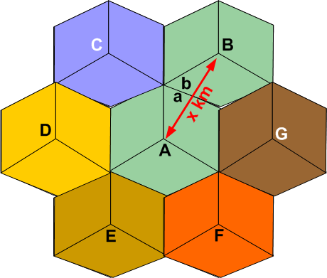
Figure 1. Hexagonal cell architecture for 802.22 system

1.3 Proposed Co-Existence Mechanism
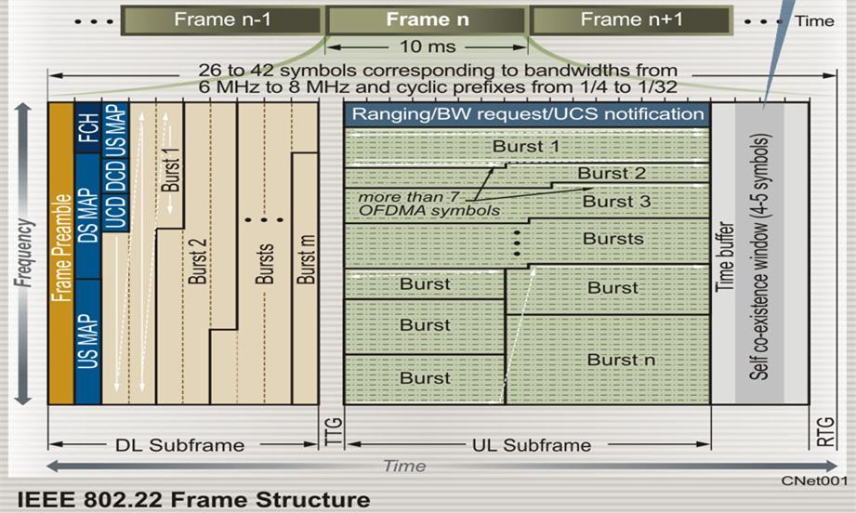
Figure 2. Current frame structure for 802.22 systems

Figure 2 shows the current frame structure for the 802.22 systems. Majority of synchronization methods existing today, perform time and frequency synchronization based on the 4 x 512 or 2 x 1024 structure inherent in the preambles. We utilize the concept of sub-frame creation to keep the underlying 802.22 frame structure and receiver architecture intact.
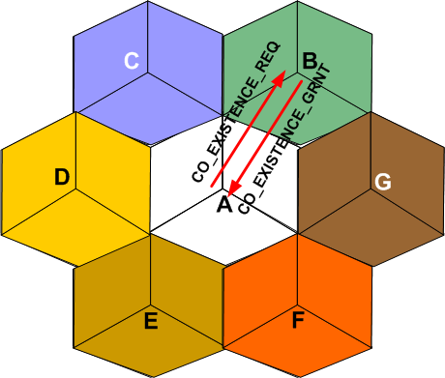
Figure 3. The co-existence request and grant mechanism
Figure 3 shows the co-existence request and grant mechanism for 802.22 system. In the Co-Existence Mode Cell A decides to share the channel with Cell B.
- Since BS B is the existing user of the given channel, BS A requests channel sharing with BS B using CO_EXISTENCE_REQ message using CBP, backhaul or some other means. In response to the request from BS A, BS B agrees to the scheduling of a co-existence frame using CO_EXISTENCE_GRNT message. BS B can deny the request using CO_EXISTENCE_DEN message
- BS B schedules CO-EXISTENCE Frames in the subsequent super-frames.

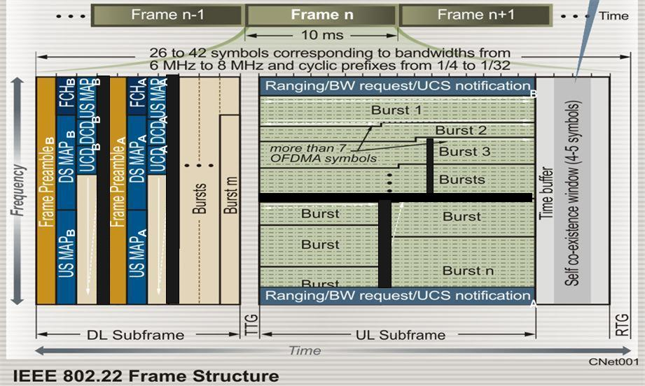
Figure 4. Sub-frame creation and shraring in 802.22 for resource allocation during the Co-Existence Mode.

The Figure 4 shows sub-frame creation and sub-frame sharing in IEEE 802.22 frame structure for resource allocation during co-existence. These concepts come from IEEE 802.16h – Improved Co-existence for License Exempt Operation.
During the COEXISTENCE_FRAME
- BS B sends out its preamble and DS / US MAPs first.
- Based on the side information received through geo-location, BS B performs user time slot and sub-channel allocation to divide cell into logical sectors as shown in the Figure 1 above.
- BS B leaves enough room to accommodate the users of BS A in the channel / frame
- BS A decodes the DS and US MAPs originating from BS B and sends out its own preamble and DS / US MAPs that may or may not co-inside with those of BS B as shown in Figure 2.

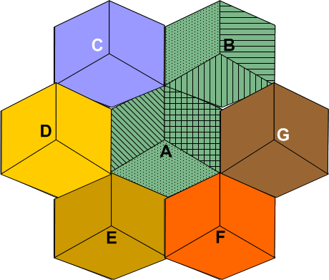
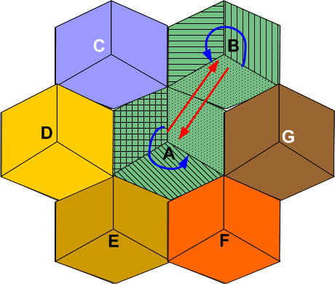
Figure 5. Logical sector rotation to achieve resource allocation diversity during Co-Existence Mode and formation of control channels for co-existence information exchange.

Figure 5 shows how BS A and B follow the sector rotation policy within the subsequent frames of the COEXISTENCE_FRAME in order to achieve diversity and create a periodic dedicated channel for information exchange between the cells.

Co-existence
Information

Co-Existence Information Exchange
Figure 6. This figure shows that BSs are close enough to decode eachothers’ information, then slots in the DS and US may be used to exchange the co-existence information as shown above.

Figure 6 shows how if the co-existing BSs are close enough to decode eachothers’ information, then slots in the DS and US may be used to exchange the co-existence information as shown above. This will help in utilizing the self co-existence window for intra-frame sensing for incumbent and WRAN discovery.

1.4 Summary and Conclusions
This contribution discussed methods for resource allocation in situations that demand self co-existence. We proposed Two Modes of operation – Normal mode and Co-existence Mode. We propose that an 802.22 system will try and resolve the channel selection issues with neighboring WRAN systems, first, based on spectrum etiquette. If channel selection does not get resolved using spectrum etiquette, then the 802.22 system will go into the Co-Existence Mode. Co-Existence Mode of operation is utilized when interference free scheduling, dynamic resource renting / offering or contention is required for resource sharing. We proposed sub-frame creation and sharing – concepts similar to the ones discussed in IEEE 802.16h. In the co-existence mode, the sub-frames were divided into sets. Clock-wise or anti-clock-wise rotation policy is followed to achieve diversity and control message passing. The self co-existence windows were utilized to pass important management information. However, majority of information was exchanged with other cells using DS and US slots / sets – enabling self co-existence windows to be utilized more effectively for intra-frame sensing of incumbents and WRANs

References
[1] A. Mody, Ranga Reddy, Matthew Sherman and Tom Kiernan “Resource Allocation in 802.22 for Improved
Self Co-Existence” Doc. 22-08-0092-01-0000_resource_allocation_for_coexistence.ppt
[2] WRAN Reference Model - 22-04-0002-16-0000_WRAN_Reference_Model.xls
[3] Gerald Chouinard, “Co-existence Capacity Allocation Methods,”
[4] Ranga Reddy, “DL/UL Resource Allocation for Improved Intra-system Coexistence,” IEEE 802.16 Contribution C80216m-08/200r1

