IEEE P802.22
Wireless RANs
Protocol Reference Model Enhancements, Management Reference Model, Network Reference Model and Remote Management of the CPEs in 802.22
Date: 2008-11-13
Author(s):
Name | Company | Address | Phone | Email
Apurva Mody | BAE Systems | P.O. Box 868, MER 15-2350, Nashua, NH 03061-0868 | 603-885-2621  404-819-0314 | apurva.mody@baesystems.com,  apurva_mody@yahoo.com
Ranga Reddy | US Army (CERDEC) | Ft Monmouth, NJ | - | Ranga.reddy@us.army.mil
Matt Sherman | BAE Systems | Wayne, NJ | 973-633-6344 | Matthew.sherman@baesystems.com
Tom Kiernan | US Army (CERDEC) | Ft Monmouth, NJ | - | Thomas.kiernan@us.army.mil
Dave Cavalcanti | Philips | 345 Scarborough Rd, Briarcliff Manor, NY | 914-945-6083 | Dave.cavalcanti@philips.com
Abstract
This document proposes the changes to the Figure 9 and the text on Page 14 under Reference Architecture, of the Draftv1.1 IEEE 802.22 Standards Document. The enhancements to the protocol reference model (PRM) are necessary, since the current architecture shown in the Figure 9, displays the Spectrum Manager / Spectrum Automaton in the MAC Layer Management Entity which will be eventually replaced by the Management Information Base (MIB). In addition, the current version, spectrum sensing, and geolocation information needs to traverse through PLME and MLME-PLME SAP before it reaches the Spectrum Manager / Automaton. The current diagram does not support modularized security features to protect the cognitive functionality of 802.22. Neither does the current PRM allow for remote CPE management.

The proposed, enhanced PRM contained in this document keeps the Data / Control and Management Plane functionalily intact, while creating a new plane, the Cognitive Plane with its own features and components which include the Spectrum Sensing Function, the Geolocation function, Spectrum Manager / Automaton and dedicated Security Sublayers. A Network Control and Management System abstraction is provided for remote management and configuration of the CPEs and MIBs are included for completeness.

Notice: This document has been prepared to assist IEEE 802.22. It is offered as a basis for discussion and is not binding on the contributing individual(s) or organization(s). The material in this document is subject to change in form and content after further study. The contributor(s) reserve(s) the right to add, amend or withdraw material contained herein.

Release: The contributor grants a free, irrevocable license to the IEEE to incorporate material contained in this contribution, and any modifications thereof, in the creation of an IEEE Standards publication; to copyright in the IEEE’s name any IEEE Standards publication even though it may include portions of this contribution; and at the IEEE’s sole discretion to permit others to reproduce in whole or in part the resulting IEEE Standards publication. The contributor also acknowledges and accepts that this contribution may be made public by IEEE 802.22.

Patent Policy and Procedures: The contributor is familiar with the IEEE 802 Patent Policy and Procedures
<http://standards.ieee.org/guides/bylaws/sb-bylaws.pdf>, including the statement "IEEE standards may include the known use of patent(s), including patent applications, provided the IEEE receives assurance from the patent holder or applicant with respect to patents essential for compliance with both mandatory and optional portions of the standard." Early disclosure to the Working Group of patent information that might be relevant to the standard is essential to reduce the possibility for delays in the development process and increase the likelihood that the draft publication will be approved for publication. Please notify the Chair <Carl R. Stevenson> as early as possible, in written or electronic form, if patented technology (or technology under patent application) might be incorporated into a draft standard being developed within the IEEE 802.22 Working Group. If you have questions, contact the IEEE Patent Committee Administrator at <patcom@ieee.org>.
1.1 Reference Architecture

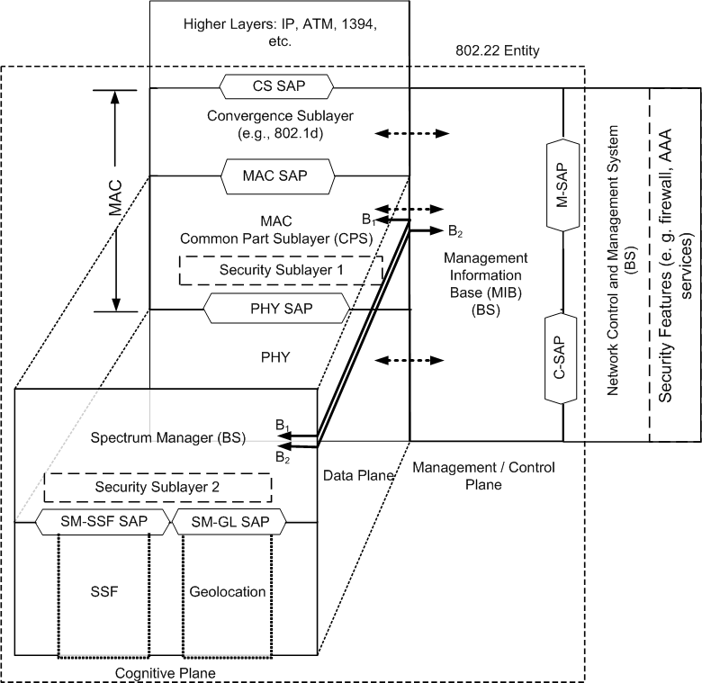
(a)

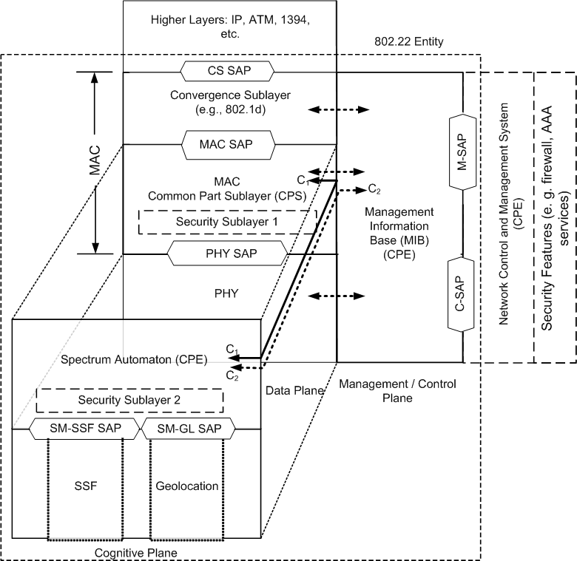
(b)
PHY: Physical Layer
MAC: Medium Access Control Layer
CS: Convergence Sublayer
MIB: Management Information Base
PHY SAP: Physical Layer Service Access Point
MAC SAP: Medium Access Control Service Access Point
CS SAP: Convergene Sublayer Service Access Point
SSF: Spectrum Sensing Function
SM: Spectrum Manager
SA: Spectrum Automaton
SM-SSF SAP: Spectrum Manager, Spectrum Sensing Function Service Access Point
SM-GL SAP: Spectrum Manager, Geolocation Service Access Point
Security Sublayer¹: Security functions for the Data / Control, Plane
Security Sublayer²: Security functions for the Cognitive Plane

NCMS: Network Control and Management System
AAA: Authentication, Authorization and Accounting
M-SAP: Management Service Access Point
C-SAP: Control Service Access Point

Figure 9 (a) Protocol Reference Model (PRM) of the 802.22 BS (b) PRM of the 802.22 CPE

The IEEE 802.22 reference architecture is depicted in Figure 1. A unique characteristic of this architecture is its cognitive nature. The reference architecture needs to account for the fact that the spectrum availability in the TV bands can be fragmented, i.e., some TV channels can be occupied by incumbents in an area while others can be available for WRAN transmission, and this availability can vary in time. It is therefore of paramount importance to define an air interface that is frequency agile and can adjust to the fragmented and time-variable spectrum availability while avoiding interference to the TV band incumbent services. This is done through the use of cognitive radio techniques whose required functional capabilities are established in this standard. In particular, the system architecture shall be defined such that it can keep track of multiple TV channels to know which of these channels are occupied by incumbents and which can be used for WRAN transmission to allow for dynamic frequency selection to avoid interference to incumbents on a real-time basis.

As a result, in addition to the data and management / control planes that exist in other IEEE 802 standards, we introduce the concept of the cognitive plane. The Protocol Reference Model (PRM) shown in Figure 1, keeps the data and management / control plane functionalily intact, while creating a new plane, the cognitive plane to support the cognitive radio capabilities. Note that the data plane, in addition to carrying the data, also carries the management and control information.

The data plane, consist of the Physical (PHY) Layer, the Medium Access Control (MAC) Layer and the Convergence Sub-layer (CS). Service Access Points (SAP) are added in between these layers to allow modularization of the system, where different components may be disjoint and/or from different vendors. A SAP is provided with a well-defined interface or primitives to exchange the information, by virtue of which these different components can talk to each other.

The MAC comprises of three sublayers, service-specific CS, the MAC Common Part Sublayer (CPS) and the Security Sublayer 1. The service-specific CS provides transformation or mapping of external network data, received through the CS SAP, into MAC Service Data Units (SDUs) received by the MAC CPS through the MAC SAP. This includes classifying external network SDUs and associating them to the proper MAC Service Flow Identifier (SFID) and Connection Identifier (CID). Multiple CS specifications are provided for interfacing with various protocols. The internal format of the CS payload is unique to the CS, and the MAC CPS is not required to understand the format of or parse any information from the CS payload.

The MAC Layer provides the core MAC functionality of system access, connection establishment, and connection maintenance. It receives data from the various CSs, through the MAC SAP, classified to particular MAC connections. An example of MAC CPS service definition is given in Annex XXX1. Quality of Service (QoS) is applied to the transmission and scheduling of data over the PHY. The MAC also contains the Security Sublayer 1, providing mechanisms for authentication, secure key exchange, encryption etc. Data, PHY control, and statistics are transferred between the MAC CPS and the PHY via the PHY SAP. The 802.22 devices include Customer Premises Equipment (CPE), or Base Stations (BS).

The cognitive plane has its own features and components which include the Spectrum Sensing Funtion (SSF), the Geo-location (GL) function, the Spectrum Manager / Spectrum Automaton (SM/ SA) and dedicated Security Sublayer 2.

The SSF implements spectrum sensing algorithms and the GL module is used to determine the location of the 802.22 device (BS or CPE). The SSF and the GL modules are described in Section X, and Section Y, respectively.

The SM resides in the cognitive plane at the same layer as the MAC CPS in the data plane as shown in Figure 1. Some of the functions of the SM include: maintaining spectrum availability information, and making decisions on channel selection, channel management and self-coexistence mechanisms. A corresponding spectrum management entity is also defined at the CPE called Spectrum Automaton, which operates as a slave to the SM at the BS. Figure 1 (a) and 1 (b) show the PRMs at the BS and the CPE respectively, with a few a minor distinctions.

The SM has a key role in the overall architecture as it is the central point at the base station where all the information on the spectrum availability resulting from the sensing is gathered. Based on this combined information and on predefined sharing rules, SM provides the configuration information to the MAC, which in turn remotely configures various CPEs. Explicit connections B₁ and B₂ have been shown in Figure 1 (a). Connection B₂ is used for configuration of the Spectrum Manager at the BS as well as to convey and report the environment monitoring information via the MIBs. Connection B₁ is used to configure the SA at the CPE (e. g. candidate and back-up channel sets, channels to be sensed etc.) as well as gather information from the CPEs (e. g. local sensing information, local geolocation information etc.).

The SM also has other capabilities such as taking requests from the MAC/PHY. For example, if an interference situation arises (e.g., with incumbents or other 802.22 cells) during normal operation in the channel, this is detected by the MAC which informs the SM. SM will then take appropriate action to resolve the issue such as switching channels. In order to do this, the MAC may inquire the SM about the most suitable channel to switch to (e.g., based on several criteria including the number of CPEs with which it is dealing, the average CPE range, traffic type), and uses the informed response from the SM to perform the switching operation.

The CPE SA is a much simpler entity including only essential features to allow proper CPE operation when it is not under the control of a BS, such as during initialization (before association with the BS), and basic functionalities to respond/react to the BS’s requests and commands. An SA may also ask its SSF to perform periodic sensing functions based on the requirements specified in the standard. The functions of the SM and CPE SA are described in Section 9.2 and Section X, respectively. Explicit connections C₁ and C₂ have been shown in Figure 1 (b). Connection C₂ is used to convey the environment monitoring information (e. g, list of service providers detected) via the MIBs to the 802.22 entity as well as allow the user to choose the service provider with which he/ she prefers to be associated with. C₂ can not be used for configuration of the Spectrum Automaton (SA). SA can only be configured by a BS through Connection C₁. C₁ is also used to convey the local environment information such as sensing and geolocation to the BS.

To enhance the security for the cognitive radio based access, Security Sublayer 2 is introduced in the cognitive plane, in addition to the Security Sublayer 1 at the data plane. Security Sublayer 2 provides enhanced protection to the incumbents as well as necessary protection to the 802.22 systems. The functions of the Security Sublayers 1 and 2 include ensuring spectrum and service availability, various forms of device, data and signal authentication, authorization, data, control and management message integrity, confidentiality, non-repudiation etc. The functions of the Security Sublayers 1 and 2 are described in Section 7.

The management / control plane consists of the Management Information Base (MIB). MIB is a database of primitives used to manage the network entities (e. g. BS, CPE, switches, routers etc.). The MIB primitives are used for system configuration, monitoring statistics, notifications, triggers, CPE and session management, Radio Resources Management (RRM), spectrum sensing and gelocation reporting etc. The MIB parameters may either be obtained from the network, they may be pre-defined within the system, or they may be obtained from another device (e. g. BS) after an exchange of information over the communication medium. MIB at the CPE is a subset of MIB at the BS.

Management Reference Model

See Document 08-212 Rev2 related to Ivan Reed’ s comment – Managed CPE. (https://mentor.ieee.org/802.22/file/08/22-08-0212-01-0000-definition-of-management-terms-concepts.doc) – This document is included here for completeness and to maintain continuity.

The 802.22 devices can include Customer Premise Equipment (CPE) or Base Stations (BS). As the 802.22 devices may be part of a larger network and therefore would require interfacing with entities for management and control purposes, a Network Control and Management System (NCMS) abstraction has been introduced in this standard as a "black box" containing these entities. The NCMS abstraction allows the PHY/MAC layers specified in 802.22 to be independent of the network architecture, the transport network, and the protocols used at the backend and therefore allows greater flexibility. NCMS logically exists at BS and CPE side of the radio interface, termed NCMS (BS) and NCMS (CPE), respectively. Any necessary inter-BS coordination required for configuration and management functions may be handled through the NCMS (BS). In order to provide correct MAC operation, NCMS shall be present within each CPE.

Figure [RKR1] shows a management reference model of WRAN networks. It consists of a Network Management System (NMS), managed nodes, and a Network Control System (NCS). Managed nodes, such as BS and CPE, collect and store the managed objects in the format of WRAN Interface MIB (e.g., wranIfMib) and Device MIB (e.g., wranDevMib) that are made available to NMSs via management protocols, such as Simple Network Management Protocol (SNMP). Unmanaged BS/CPE do not collect this information. MIB definitions are specified in Clause [TBD]. A Network Control System contains the service flow and the associated QoS information that have to be populated to BS when a CPE enters into a BS network.

The management information between CPE and BS shall be carried over the secondary management connection for managed CPE. If the secondary management connection does not exist, the SNMP messages, or other management protocol messages, may go through another interface in the customer premise or on a transport connection over the air interface.

Figure RKR1 – Management Reference Model

Examples of services provided by the NCMS include; Authentication Authorization and Accounting (AAA) Services, Radio Resources Management (RRM) Services, Security Services, Service Flow Management Services, Location Based Services (LBS) management, and Network Management Services.

The NCMS is interfaced to CPE/BS through various SAPs. This specification includes a Control-SAP (C-SAP) and Management-SAP (M-SAP) that expose control plane and management plane functions to upper layers. The C-SAP and M-SAP interfaces are described in clause XXX2. The NCMS uses the C-SAP and M-SAP to interface with the 802.22 entity.
Management SAP (M-SAP)
The Management SAP may include, but is not limited to primitives related to:
- System configuration
- Monitoring Statistics
- Notifications/Triggers
- Sensing and Geolocation Reporting

Control SAP (C-SAP)

The Control SAP may include, but is not limited to primitives related to:
- Subscriber and Session Management
- Radio Resource Management
- AAA server signaling etc.

Network Reference Model

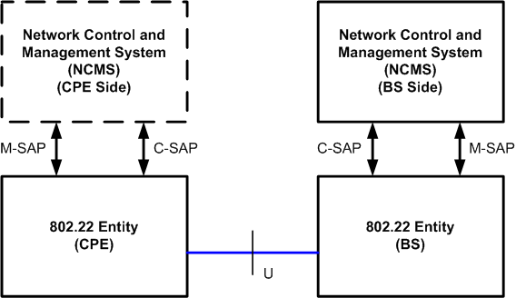
Figure NRM: 802.22 Network Reference Model

Figure NRM describes a simplified network reference model. Multiple CPEs may be attached to a BS. CPEs communicate to the BS over the U interface using a Primary Management Connection, a Basic Connection or a Secondary Management Connection

CPE and BS Interface

This standard observes the following correlation:

• MAC management PDUs that are exchanged on the basic management connection trigger or are triggered by primitives that are exchanged over the C-SAP.
• MAC management PDUs that are exchanged on the primary management connection trigger or are triggered by primitives that are exchanged over either the C-SAP or the M-SAP depending on the particular management or control operation.
• Messages that are exchanged over the secondary management connection trigger or are triggered by primitives that are exchanged over the M-SAP.

802.22 entity to NCMS Interface

This interface is a set of SAPs between an 802.22 entity and NCMS. It is decomposed into two parts: the M-SAP is used for less time sensitive Management plane primitives and the C-SAP is used for more time sensitive Control plane primitives that support security context management, radio resource management etc.

Managed Objects

The definition of managed objects in this standard is expressed in Structure of Management Information Version 2 (SMIv2). It supports a management protocol agnostic approach, including SNMP.

[Add the following references to clause 2]

IETF RFC2578, “Structure of Management Information Version 2 (SMIv2)”, K. McCloghrie, D. Perkins, J. Schoenwaelder, J. Case, M. Rose, S. Waldbusser, April 1999

IETF RFC2758 "Definitions of Managed Objects for Service Level Agreements Performance Monitoring", K. White, February 2000

[Add the following definitions to clause 3]
3.xx Management Information Base (MIB): A collection of information that is organized hierarchically. MIBs are accessed using a network-management protocol such as SNMP. They are comprised of managed objects and are identified by object identifiers.
3.xx Managed object: It is one of any number of specific characteristics of a managed device. Managed objects are comprised of one or more object instances, which are essentially variables. Managed object is also referred to as a MIB object, an object, or a MIB.
3.xx Managed node: A node that collects and stores the managed objects in the format of MIB. It is made available to the network management system via management protocols, such as Simple Network Management Protocol (SNMP).
3.xx Managed CPE: It is one kind of managed nodes that supports secondary management connection.
3.xx Unmanaged CPE: A CPE that does not support secondary management connection.

Informative Section on Conversion of Primitives in Section 9 to MIBs

Existing Prmitive
    - SME-MLME-DB-QUERY.request
The SME-MLME-DB-QUERY.request primitive allows the SM to request the SME to access an incumbent database in order to obtain channel availability information. Table 280 specifies the parameters for the SME-MLME-QUERY-BD.request primitive.

Table 280 — SME-MLME-DB-QUERY.request parameters
Name | Type | Valid Range | Description
Database_type | Integer | 0-8 | The value identifies the type of database for which the query is directed.  0 = TV Incumbent Database  1 = Part 74 Incumbent Database
Latitude | Char | NMEA string
Longitude | Char | NMEA string

      - When generated
The SME-MLME-DB-QUERY.request primitive shall be generated by the SM of a BS and issued to its SME to request the SME to query an external incumbent database.

      - Effect on receipt
When the SME of a BS receives the SME-MLME-DB-QUERY.request primitive, SM generates a query to the external database available corresponding to the type indicated in the Database_type attribute.

On receipt of a the SME-MLME-DB-QUERY.request with the Database_type corresponding to a type of database which is not available or which is not accessible through the SME, the SME of the BS shall issue a SME-MLME-DB-QUERY.confirm primitive to the MLME with status value of INVALID_REQUEST.

Existing Primitive SME-MLME-DB-QUERY.request Amended to M-DB-QUERY.req MIB

    - M-DB-QUERY.req
The M-DB-QUERY.req primitive allows the SM to request the NCMS to access an incumbent database in order to obtain channel availability information. Table 280 specifies the parameters for the M-QUERY-BD.request primitive.

Function

M-DB-QUERY.req
(
Operation_Type: Get,
Destination: BS,
Attribute_List:
Database Type
Latitude
Longitude
)

Table 280 — M-DB-QUERY.req parameters
Name | Type | Valid Range | Description
Database_type | Integer | 0-8 | The value identifies the type of database for which the query is directed.  0 = TV Incumbent Database  1 = Part 74 Incumbent Database
Latitude | Char | NMEA string
Longitude | Char | NMEA string

      - When generated
The M-DB-QUERY.req primitive shall be generated by the SM of a BS and issued to its NCMS to request the NCMS to query an external incumbent database.

      - Effect on receipt
When the NCMS of a BS receives the M-DB-QUERY.req primitive, NCMS generates a query to the external database available corresponding to the type indicated in the Database_type attribute.

On receipt of the M-DB-QUERY.req with the Database_type corresponding to a type of database which is not available or which is not accessible through the NCMS, the NCMS of the BS shall issue an M-DB-QUERY.confirm primitive to the M-SAP with status value of INVALID_REQUEST.

References:

- D. Cavalcanti, Document 08-105, Reference Architecture, Updated Text.
- A. Mody, T. Kiernan, “Meeting Minutes of the Security Ad-Hoc Group in 802.22” https://mentor.ieee.org/802.22/file/08/22-08-0163-07-0000-meeting-minutes-of-the-security-ad-hoc-group-in-802-22.doc
- A. Mody, R. Reddy, T. Kiernan, M. Sherman, “Recommended text for Section 7 on Security in 802.22” - https://mentor.ieee.org/802.22/file/08/22-08-0174-07-0000-recommended-text-for-section-7-on-security-in-802-22.doc was presented and discussed
- A. Mody, R. Reddy, T. Kiernan, M. Sherman, “Table of Contents for Section 7”. https://mentor.ieee.org/802.22/file/08/22-08-0165-00-0000-table-of-content-for-the-security-section-in-802-22.doc
- IEEE 802.16 P802.16Rev2/D7 October 2008) Draft Standard for Local and Metropolitan Area Networks – Part 16 – Air Interface for Broadband Wireless Access System
- IEEE 802.16g IEEE Standard for Local and Metropolitan Area Networks Part 16 – Air Interface for Broadband Wireless Access System, Amendment 3- Management Plane Procedures and Services
- A. Mody, R. Reddy, T. Kiernan, M. Sherman, “Scope and the Workplan for the Security Ad-Hoc Group” – https://mentor.ieee.org/802.22/file/08/22-08-0159-00-0000-scope-agenda-workplan-and-timeline-for-the-security-ad-hoc-in-802-22.doc
- A. Mody, R. Reddy, T. Kiernan, M. Sherman, DJ Shyy, “Presentation on the PRM and Security Enhancements in 802.22 – 802.22 Threat Analysis” https://mentor.ieee.org/802.22/file/08/22-08-0083-07-0000-security-and-prm-enhancements-in-80222-v3.ppt
- R. Reddy, E.Au, A. Mody, T.Kiernan, Z. Lei, “Definitions of the Management Terms and Concepts,” - https://mentor.ieee.org/802.22/file/08/22-08-0212-01-0000-definition-of-management-terms-concepts.doc

