IEEE P802.22
Wireless RANs
Protocol Reference Model Enhancements in 802.22
Date: 2008-07-13
Author(s):
Name | Company | Address | Phone | email
Apurva Mody | BAE Systems | P.O. Box 868, MER 15-2350, Nashua, NH 03061-0868 | 603-885-2621  404-819-0314 | apurva.mody@baesystems.com,  apurva_mody@yahoo.com
Ranga Reddy | US Army (CERDEC) | Ft Monmouth, NJ | - | Ranga.reddy@us.army.mil
Matt Sherman | BAE Systems | Wayne, NJ | 973-633-6344 | Matthew.sherman@baesystems.com
Tom Kiernan | US Army (CERDEC) | Ft Monmouth, NJ | - | Thomas.kiernan@us.army.mil
Dave Cavalcanti | Philips | 345 Scarborough Rd, Briarcliff Manor, NY | 914-945-6083 | Dave.cavalcanti@philips.com
Abstract
This document proposes the changes to the Figure 9 on Page 14 titled Reference Architecture, of the Draftv1.0 IEEE 802.22 Standards Document. The enhancements to the protocol reference model (PRM) are necessary, since the current architecture shown in the Figure 9, displays the Spectrum Manager / Spectrum Automaton in the MAC Layer Management Entity which will be eventually replaced by the Management Information Base (MIB). In addition, the current version, spectrum sensing, and geolocation information needs to traverse through PLME and MLME-PLME SAP before it reaches the Spectrum Manager / Automaton. The current diagram does not support modularized security features to protect the cognitive functionality of 802.22. Neither does the current PRM allow for remote CPE management.

The proposed, enhanced PRM contained in this document keeps the Data / Control and Management Plane functionalily intact, while creating a new plane, the Cognitive Plane with its own features and components which include the Spectrum Sensing Function, the Geolocation function, Spectrum Manager / Automaton and dedicated Security Sub-layers. A Network Control and Management System abstraction is provided for remote management and configuration of the CPEs.

Notice: This document has been prepared to assist IEEE 802.22. It is offered as a basis for discussion and is not binding on the contributing individual(s) or organization(s). The material in this document is subject to change in form and content after further study. The contributor(s) reserve(s) the right to add, amend or withdraw material contained herein.

Release: The contributor grants a free, irrevocable license to the IEEE to incorporate material contained in this contribution, and any modifications thereof, in the creation of an IEEE Standards publication; to copyright in the IEEE’s name any IEEE Standards publication even though it may include portions of this contribution; and at the IEEE’s sole discretion to permit others to reproduce in whole or in part the resulting IEEE Standards publication. The contributor also acknowledges and accepts that this contribution may be made public by IEEE 802.22.

Patent Policy and Procedures: The contributor is familiar with the IEEE 802 Patent Policy and Procedures
<http://standards.ieee.org/guides/bylaws/sb-bylaws.pdf>, including the statement "IEEE standards may include the known use of patent(s), including patent applications, provided the IEEE receives assurance from the patent holder or applicant with respect to patents essential for compliance with both mandatory and optional portions of the standard." Early disclosure to the Working Group of patent information that might be relevant to the standard is essential to reduce the possibility for delays in the development process and increase the likelihood that the draft publication will be approved for publication. Please notify the Chair <Carl R. Stevenson> as early as possible, in written or electronic form, if patented technology (or technology under patent application) might be incorporated into a draft standard being developed within the IEEE 802.22 Working Group. If you have questions, contact the IEEE Patent Committee Administrator at <patcom@ieee.org>.
1.1 Reference Architecture

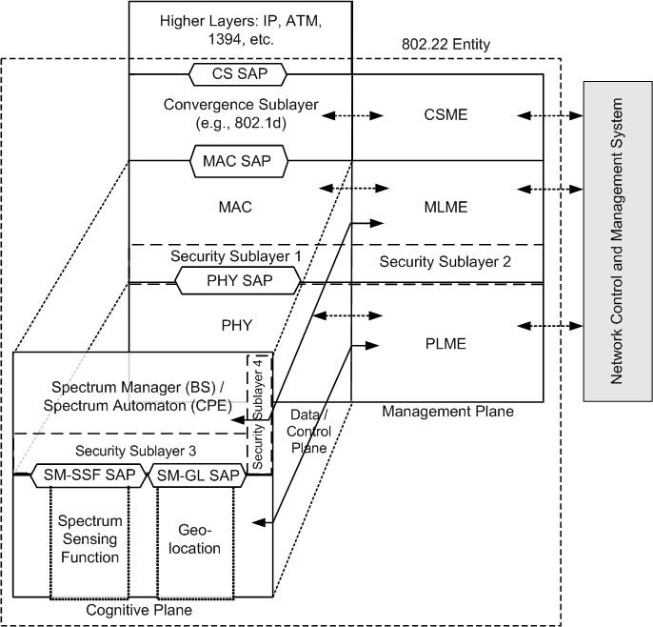

PHY: Physical Layer
MAC: Medium Access Control Layer
CS: Convergence Sublayer
PLME: PHY Layer Management Entity
MLME: MAC Layer Management Entity
CSME: CS Management Entity
PHY SAP: Physical Layer Service Access Point
MAC SAP: Medium Access Control Service Access Point
CS SAP: Convergene Sublayer Service Access Point
SSF: Spectrum Sensing Function
SM / SA: Spectrum Manager / Spectrum Automaton
SM-SSF SAP: Spectrum Manager, Spectrum Sensing Function Service Access Point
SM-GL SAP: Spectrum Manager, Geolocation Service Access Point
Security Sublayer^{1, 2, 3, 4} – Security Sublayers for the Data/ Control, Management and the Cognitive Planes
NCMS: Network Control and Management System

Figure 1. Protocol Reference Architecture for an 802.22 BS or the CPE

The IEEE 802.22 reference architecture is depicted in Figure 1. A unique characteristic of this architecture is its cognitive nature. The reference architecture needs to account for the fact that the spectrum availability in the TV bands can be fragmented, i.e., some TV channels can be occupied by incumbents in an area while others can be available for WRAN transmission, and this availability can vary in time. It is therefore of paramount importance to define an air interface that is frequency agile and can adjust to the fragmented and time-variable spectrum availability while avoiding interference to the TV band incumbent services. This is done through the use of cognitive radio techniques whose required functional capabilities are established in this standard. In particular, the system architecture shall be defined such that it can keep track of multiple TV channels to know which of these channels are occupied by incumbents and which can be used for WRAN transmission to allow for dynamic frequency selection to avoid interference to incumbents on a real-time basis.

As a result, in addition to the Data / Control and Management Planes that exist in other IEEE 802 standards, we introduce the concept of the Cognitive Plane. The PRM shown in Figure 1, keeps the Data / Control and Management Plane functionalily intact, while creating a new plane, the Cognitive Plane to support the cognitive radio capabilities.

The Data / Control Plane consist of the Physical Layer (PHY), the Medium Access Control Layer (MAC) and the Convergence Sub-layer (CS). Service Access Points (SAP) are added in between these layers allowing modularization of the system, where different components may be disjoint and/or from different vendors. A SAP is provided with a well-defined interface or primitives to exchange the information, by virtue of which these different components can talk to each other.

The Management Plane consists of the various management entities viz. PHY Layer Management Entity (PLME), the MAC Layer Management Entity (MLME), and the Convergence Sublayer Management Entity (CSME). These management entities contain the primitives which are used for system / device configuration.

The Cognitive Plane has its own features and components which include the Spectrum Sensing Funtion (SSF), the Geo-location (GL) function, the Spectrum Manager / Spectrum Automaton (SM/ SA) and dedicated security sub-layers.

The SSF implements spectrum sensing algorithms and the GL module is used to determine the location of the 802.22 device (BS or CPE). The SSF and the GL modules are described in Section X, and Section Y, respectively.

The SM resides in the Cognitive Plane at the same layer as the MAC in the Data/ Control Plane as shown in Figure 1. Some of the functions of the SM include: maintaining spectrum availability information, and making decisions on channel selection, channel management and self-coexistence mechanisms. A corresponding spectrum management entity is also defined at the CPE called Spectrum Automaton, which operates as a slave to the SM at the BS. The CPE SA is a much simpler entity including only essential features to allow proper CPE operation when it is not under the control of a BS, such as during initialization (before association with the BS), and basic functionalities to respond/react to the BS’s requests and commands. An SA may also ask its SSF to perform periodic sensing functions based on the requirements specified in the standard. The functions of the SM and CPE SA are described in Section 9.2 and Section X, respectively. The SM has a key role in the overall architecture as it is the central point at the base station where all the information on the spectrum availability resulting from the sensing is gathered. Based on this combined information and on predefined sharing rules, SM provides the configuration information to the MLME, which in turn configures the MAC to utilize the correct channels.

The SM also has other capabilities such as taking requests from the MAC/PHY. For example, if an interference situation arises (e.g., with incumbents or other 802.22 cells) during normal operation in the channel, this is detected by the MAC which informs the MLME which in turn passes on this information to the SM. SM will then take appropriate action to resolve the issue such as switching channels. In order to do this, the MAC may inquire the SM about the most suitable channel to switch to (e.g., based on several criteria including the number of CPEs with which it is dealing, the average CPE range, traffic type), and uses the informed response from the SM to perform the switching operation.

To enhance the security for the cognitive radio based access, Security Sublayers 3 and 4 are introduced in the Cognitive Plane, in addition to the Security Sublayers 1 and 2 at the Data / Control and Management Planes. These Security Sub-layers provide the enhanced protection to the incumbents as well as provide the necessary protection to the 802.22 systems. The functions of the Security Sub-layers include ensuring spectrum and service availability, various forms of device, data and signal authentication, authorization, data, control and management message integrity, confidentiality, non-repudiation etc. The operation of the Security Sublayers 1, 2, 3 and 4 are are described in Section 7.10 and 7.11 respectively.

Finally the concept of a Network Control and Management System (NCMS) abstraction has been introduced as a "black box". The NCMS abstraction allows the specified PHY/MAC layers to be independent of the network architecture, the transport network, and the protocols used at the backend, hence allowing greater flexibility. NCMS logically exists at BS and CPE side of the radio interface, termed NCMS (BS) and NCMS (CPE), respectively. Any necessary inter-BS coordination is handled through the NCMS (BS). NCMS allows remote management of a CPE by the exchange of configuration parameters.

References:

[1] D. Cavalcanti, Document 08-105, Reference Architecture, Updated Text.

