IEEE P802.22
Wireless RANs
Protocol Reference Model Enhancements in 802.22
Date: 2008-05-06
Author(s):
Name | Company | Address | Phone | email
Apurva Mody | BAE Systems | P.O. Box 868, MER 15-2350, Nashua, NH 03061-0868 | 603-885-2621  404-819-0314 | apurva.mody@baesystems.com,  apurva_mody@yahoo.com
Ranga Reddy | US Army (CERDEC) | Ft Monmouth, NJ | - | Ranga.reddy@us.army.mil
Matt Sherman | BAE Systems | Wayne, NJ | 973-633-6344 | Matthew.sherman@baesystems.com
Tom Kiernan | US Army (CERDEC) | Ft Monmouth, NJ | - | Thomas.kiernan@us.army.mil
Dave Cavalcanti | Philips | 345 Scarborough Rd, Briarcliff Manor, NY | 914-945-6083 | Dave.cavalcanti@philips.com
Abstract
This document proposes the changes to the Figure 9 on Page 14 titled Reference Architecture, of the Draftv1.0 IEEE 802.22 Standards Document. The enhancements to the protocol reference model (PRM) are necessary, since the current architecture shown in the Figure 9, does not support the addition of modularized security features to protect the cognitive functionality in the PRM. The proposed, enhanced PRM contained in this document keeps the Data / Control and Management Plane functionalily intact, while creating a new plane, the Cognitive Plane with its own features and components which include dedicated security sub-layers used for functions such as authentication of the sensing, Geolocation, co-existence information etc.
Notice: This document has been prepared to assist IEEE 802.22. It is offered as a basis for discussion and is not binding on the contributing individual(s) or organization(s). The material in this document is subject to change in form and content after further study. The contributor(s) reserve(s) the right to add, amend or withdraw material contained herein.

Release: The contributor grants a free, irrevocable license to the IEEE to incorporate material contained in this contribution, and any modifications thereof, in the creation of an IEEE Standards publication; to copyright in the IEEE’s name any IEEE Standards publication even though it may include portions of this contribution; and at the IEEE’s sole discretion to permit others to reproduce in whole or in part the resulting IEEE Standards publication. The contributor also acknowledges and accepts that this contribution may be made public by IEEE 802.22.

Patent Policy and Procedures: The contributor is familiar with the IEEE 802 Patent Policy and Procedures
<http://standards.ieee.org/guides/bylaws/sb-bylaws.pdf>, including the statement "IEEE standards may include the known use of patent(s), including patent applications, provided the IEEE receives assurance from the patent holder or applicant with respect to patents essential for compliance with both mandatory and optional portions of the standard." Early disclosure to the Working Group of patent information that might be relevant to the standard is essential to reduce the possibility for delays in the development process and increase the likelihood that the draft publication will be approved for publication. Please notify the Chair <Carl R. Stevenson> as early as possible, in written or electronic form, if patented technology (or technology under patent application) might be incorporated into a draft standard being developed within the IEEE 802.22 Working Group. If you have questions, contact the IEEE Patent Committee Administrator at <patcom@ieee.org>.
1.1 Reference Architecture

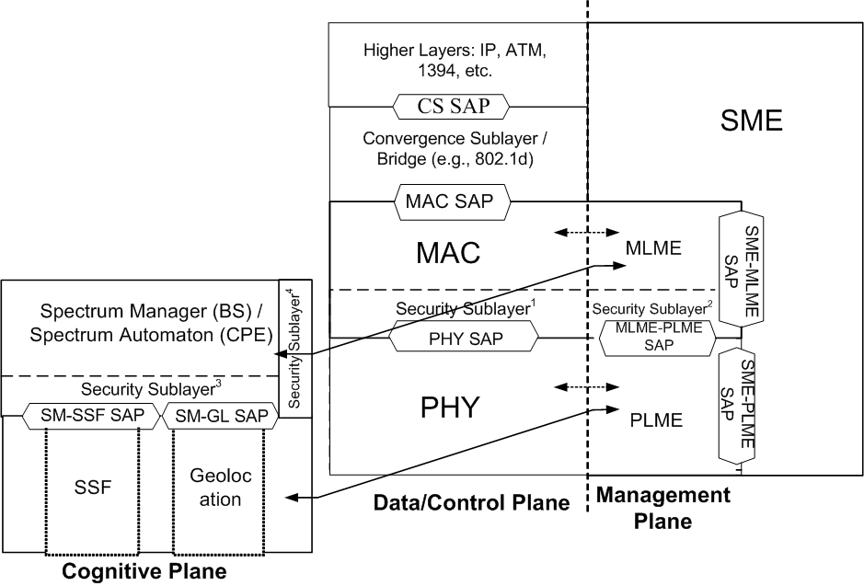

SSF: Spectrum Sensing Function
SM-SSF SAP: Spectrum Manager, Spectrum Sensing Function Service Access Point
SM-GL SAP: Spectrum Manager, Geolocation Service Access Point
SME-MLME SAP: Station Management Entity – MAC Layer Management Entity Service Access Point
SME-PLME SAP: Station Management Entity- PHY Layer Management Entity Service Access Point
MLME-PLME SAP: MAC Layer Management Entity PHY Layer Management Entity Service Access Point
CS SAP: Convergene Sublayer Service Access Point (Optional)
Security Sublayer¹, Security Sublayer², Security Sublayer³: Mandatory Security Sublayers
Security Sublayer⁴: Optional Security Sublayer

Figure 1. Protocol Reference Architecture for an 802.22 BS or the CPE

The IEEE 802.22 reference architecture is depicted in Figure 1. A unique characteristic of this architecture is its cognitive nature. The reference architecture needs to account for the fact that the spectrum availability in the TV bands can be fragmented, i.e., some TV channels can be occupied by incumbents in an area while others can be available for WRAN transmission, and this availability can vary in time (e.g., wireless microphone operation). It is therefore of paramount importance to define a MAC/PHY air interface that is frequency agile and can adjust to the fragmented and time-variable spectrum availability while avoiding interference to the TV band incumbent services. This is done through the use of cognitive radio techniques whose required functional capabilities are established in this standard. In particular, the MAC/PHY air interface shall keep track of multiple TV channels to know which of these channels are occupied by incumbents and which can be used for WRAN transmission to allow for dynamic frequency selection to avoid interference to incumbents on a real-time basis.

As a result, in addition to the Data / Control and Management Planes that exist in other IEEE 802 standards, we introduce the concept of the Cognitive Plane. The PRM shown in Figure 1, keeps the Data / Control and Management Plane functionalily intact, while creating a new plane, the Cognitive Plane to support the cognitive radio capabilities. The Cognitive Plane has its own features and components which include the Spectrum Sensing Funtion (SSF), the Geo-location (GL) function, the Spectrum Manager (SM) and dedicated security sub-layers used for functions such as authentication of the sensing, geolocation, co-existence, spectrum management etc. information.

The SSF implements spectrum sensing algorithms and the GL module is used to determine the location of the 802.22 device (BS or CPE). The SSF and the GL modules are described in Section X, and Section Y, respectively.

The SM is part of the Station Management Entity (SME) as shown in Figure 1. Some of the functions of the SM includes: maintaining spectrum availability information, and making decisions on channel selection, channel management and self-coexistence mechanisms. A corresponding spectrum management entity is also defined at the CPE called Spectrum Automaton, which operates as a slave of the SM at the BS. The CPE SA is a much simpler entity including only essential features to allow proper CPE operation when it is not under the control of a BS, such as during initialization (before association with the BS), and basic functionalities to respond/react to the BS’s requests and commands. An SA may also perform periodic sensing functions based on the requirements specified in the standard. The functions of the SM and CPE SA are described in Section 9.2 and Section X, respectively. The SM has a key role in the overall architecture as it is the central point at the base station where all the information on the spectrum availability resulting from the sensing is gathered. Based on this combined information and on predefined sharing rules, the SM assigns channels to the MAC/PHY.

The SM has also other capabilities such as taking requests from the MAC/PHY. For example, if an interference situation arises (e.g., with incumbents or other 802.22 cells) during normal operation in the channel, this is detected by the MAC which shall then be capable of taking appropriate actions to resolve the issue such as switching channels. In order to do this, the MAC may inquire the SM about the most suitable channel to switch to (e.g., based on several criteria including the number of CPEs with which it is dealing, the average CPE range, traffic type), and uses the informed response from the SM to perform the switching operation.

To enhance the security for the cognitive radio based access, Security Sublayers 3 and 4 are introduced in the Cognitive Plane, in addition to the Security Sublayers 1 and 2. The Security Sublayers 1, 2 and 3 are manadatory, however, implementation of a Security Sublayer 4 may be optional. The Security Sublayers 1 and 2 are described in Sections 7.x and 7.y respectively, and the Security Sublayers 3 and 4 are described in Sections 7.z and 7.w respectively.

References:

[1] D. Cavalcanti, Document 08-105, Reference Architecture, Updated Text.

