IEEE P802.22
Wireless RANs
Revised text on the CPE network entry and initialization process
Date: 2008-03-20
Author(s):
Name | Company | Address | Phone | email
Edward Au | Huawei & HKUST | Department of ECE, HKUST, Clear Water Bay, Hong Kong | 852-2358-8027 | eeedward@ust.hk
Abstract
This contribution provides the revised text on Sections 6.16.2.8.2 – 6.16.8 of the Working Document v0.5.0.
Notice: This document has been prepared to assist IEEE 802.22. It is offered as a basis for discussion and is not binding on the contributing individual(s) or organization(s). The material in this document is subject to change in form and content after further study. The contributor(s) reserve(s) the right to add, amend or withdraw material contained herein.

Release: The contributor grants a free, irrevocable license to the IEEE to incorporate material contained in this contribution, and any modifications thereof, in the creation of an IEEE Standards publication; to copyright in the IEEE’s name any IEEE Standards publication even though it may include portions of this contribution; and at the IEEE’s sole discretion to permit others to reproduce in whole or in part the resulting IEEE Standards publication. The contributor also acknowledges and accepts that this contribution may be made public by IEEE 802.22.

Patent Policy and Procedures: The contributor is familiar with the IEEE 802 Patent Policy and Procedures
<http://standards.ieee.org/guides/bylaws/sb-bylaws.pdf>, including the statement "IEEE standards may include the known use of patent(s), including patent applications, provided the IEEE receives assurance from the patent holder or applicant with respect to patents essential for compliance with both mandatory and optional portions of the standard." Early disclosure to the Working Group of patent information that might be relevant to the standard is essential to reduce the possibility for delays in the development process and increase the likelihood that the draft publication will be approved for publication. Please notify the Chair <Carl R. Stevenson> as early as possible, in written or electronic form, if patented technology (or technology under patent application) might be incorporated into a draft standard being developed within the IEEE 802.22 Working Group. If you have questions, contact the IEEE Patent Committee Administrator at <patcom@ieee.org>.
After updating the Section, the text and figures in blue should be added in the Working Document.

6.16.2.8.2 Ranging Parameter Adjustments

Adjustment of local parameters (e.g. transmit power) in a CPE as a result of the receipt or non-receipt of a RNG-RSP message is considered to be implementation-dependent with the following restrictions:

- All parameters shall be within the approved range at all times.
- Power adjustment shall start from the initial value selected with the algorithm described in subclause 6.16.2.8.1 unless a valid power setting is available from non-volatile storage, in which case this value may be used a the starting point.
- Power adjustment shall be capable of being reduced or increased by the specified amount in response to the RNG-RSP messages.
- If, during initialization, power in increased to the maximum value without a response from the BS, it shall wrap back to the minimum.

6.16.3 CPE Transmits Basic Capabilities

Immediately following the completion of initial ranging, the CPE informs the BS of its basic capabilities by transmitting a CBC-REQ message (see Table 138) with its capabilities set to “on” (see Figure 36). Note that T18 is a timer used for waiting CBC-RSP timeout and the default value is 5ms (see Table 288).

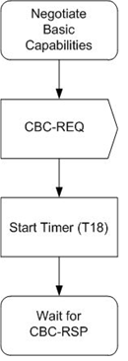
Figure 36. Negotigate basic capabilities at CPE.

The BS responds with a CBC-RSP message (see Table 139) with the intersection of the CPE’s and BS’s capabilities set to “on” (see Figure 37 and Figure 38 respectively). The timer T9 refers to the time allowed between the BS sending a RNG-RSP to a CPE, and receiving a CBC-REQ from that same CPE, and the minimum value is 300ms. Note that the CPE capability information is presented in subclause 6.9.15.

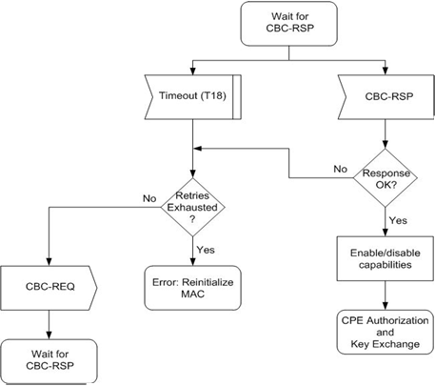
Figure 37. Wait for CBC-RSP at CPE.

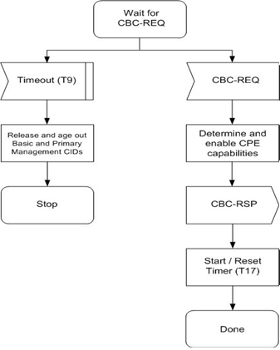
Figure 38. Negotiate basic capabilities at BS.
6.16.4 CPE Authorization, Transmission of MAC Address, and Key Exchange

[Author’s Note: The following text exists in Winston’s contribution 07/0248r19 but it is missing in the Working Document v0.5.0.]

If all of the required capabilities are present in the CPE, the BS and CPE continue with performing authorization, transmitting CPE MAC address to the BS, and exchanging keys, as described in Section 7.2. If the required capabilities are not present, BS authorization of the CPE fails on the selected channel and the selected channel and its BS are removed from further consideration. If there are any other BSs available with which to associate, this modified list of options is presented to the higher user layers.

6.16.5 BS Requests NMEA Data from CPE

[Author’s Note: The following text exists in Winston Caldwell’s contribution 07/0248r19 but it is missing in the Working Document v0.5.0.]

The BS shall send a Location Data Request to the CPE as defined in Table 174.

6.16.6 CPE Transmits NMES Data to BS

[Author’s Note: The following text exists in Winston Caldwell’s contribution 07/0248r19 but it is missing in the Working Document v0.5.0.]

The CPE shall securely send a Location Data Report to the BS as defined in Table 175.

6.16.7 Validate the NMEA String

[Author’s Note: Only update the subclause number.]

6.16.8 BS Transmit Channel Sets and Maximum Allowed EIRP Array to CPE

[Author’s Note: Only update the subclause number.]

6.16.9 Registration

Registration is the process by which the CPE is allowed entry into the network and a managed CPE receives its Secondary Management CID and thus becomes manageable. To register with a BS, the CPE shall send a REG-REQ message to the BS. The BS shall respond with a REG-RSP message. For a CPE that has indicated being a managed CPE in the REG-REQ message, the REG-RSP message shall include the Secondary Management CID.

Figure 39 shows the procedure that shall be followed by the CPE. Note that the timer T6 is used for waiting the registration response, and its maximum value is 3s (see Table 288).
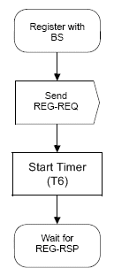
Figure 39. CPE Registration. [Author’s Note: It’s a new figure]

Once the CPE has sent a REG-REQ to the BS, it shall wait for a REG-RSP to authorize it to forward traffic to the network. Figure 40 shows the waiting procedure that shall be followed by the CPE.

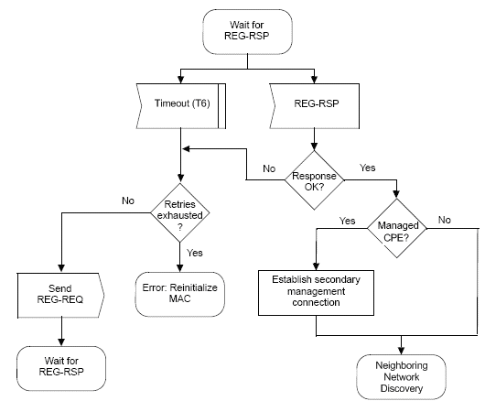

Figure 40. Wait for REG-RSP at CPE. [Author’s Note: It’s a new figure]

The BS shall perform the operations shown in Figure 41. Note that the Timer T13 is the time allowed for a CPE, following receipt of a REG-RSP message, to send a TFTP-CPLT message to the BS, and its minimum time is 15 minutes. In addition, the Timer T28 is the time allowed for BS to complete the transmission of channel sets and minimum allowable EIRP array, its default value is TBD.
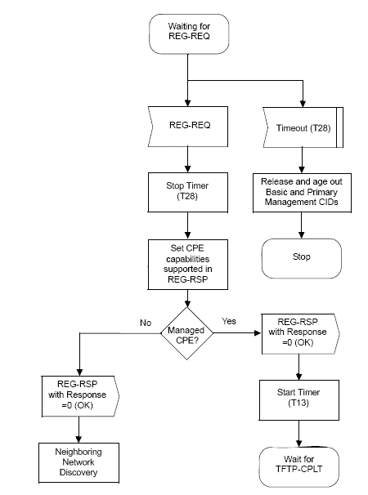
Figure 41. Registration at BS. [Author’s Note: It’s a new figure]

6.16.9.1 Secondary Management Connection

For managed CPE, upon sending a REG-RSP, the BS shall wait for a TFTP-CPLT. If the Timer T13 expires, the BS shall both de-assign the management CIDs from that CPE and make some provision for aging out those CIDs (see Figure 42 and Figure 43). Note that the Timer T26 refers to the time waited for TFTP-RS, and its maximum and minimum values are 200ms and 10ms, respectively.

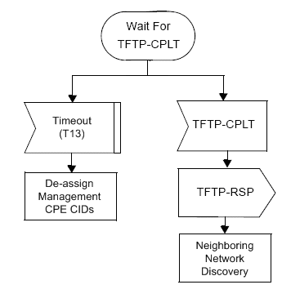
Figure 42. Wait for TFTP-CPLT at the BS. [Author’s Note: It is a new figure]

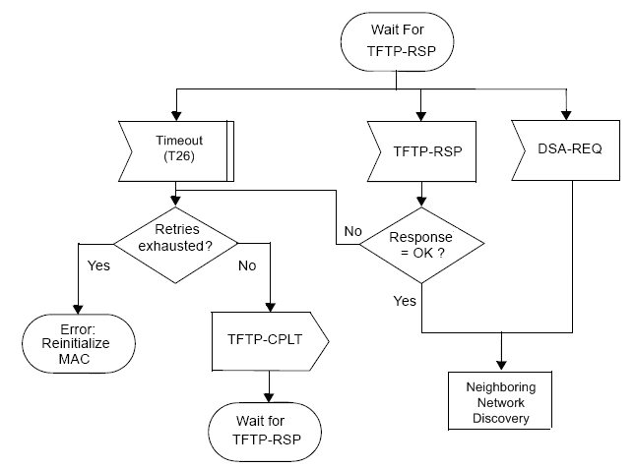
Figure 43. Wait for TFTP-CPLT at the CPE. [Author’s Note: It is a new figure]

6.16.10 CPE Report Sensing Results and Discovered Neighboring Networks

After a CPE has registered with a WRAN BS, it shall perform network discovery in order to identify neighboring WRANs and eneable efficient self-coexistence. The neighboring network discovery involves listening to the medium for CBP packets or BS SCH transmitted by other WRAN BSs. This network discovery mechanism is described in Section 6.21.3.8.3.

