IEEE P802.22
Wireless RANs
Proposed Resolution for RNG-RSP Information Elements
Date: 2008-0x-xx
Author(s):
Name | Company | Address | Phone | email
Chang-Joo Kim | ETRI | Korea | +82-42-860-1230 | cjkim@etri.re.kr
Myung-Sun Song | ETRI | Korea | +82-42-860-5046 | mssong@etri.re.kr
Gwang-Zeen Ko | ETRI | Korea | +82-42-860-4862 | gogogo@etri.re.kr
Sung-Hyun Hwang | ETRI | Korea | +82-42-860-1133 | shwang@etri.re.kr
Jung-Sun Um | ETRI | Korea | +82-42-860-4844 | korses@etri.re.kr
Abstract
This submission describes the proposed resolution for RNG-RSP IE on caluse 6.9.6 of working document v0.4.8.
Notice: This document has been prepared to assist IEEE 802.22. It is offered as a basis for discussion and is not binding on the contributing individual(s) or organization(s). The material in this document is subject to change in form and content after further study. The contributor(s) reserve(s) the right to add, amend or withdraw material contained herein.

Release: The contributor grants a free, irrevocable license to the IEEE to incorporate material contained in this contribution, and any modifications thereof, in the creation of an IEEE Standards publication; to copyright in the IEEE’s name any IEEE Standards publication even though it may include portions of this contribution; and at the IEEE’s sole discretion to permit others to reproduce in whole or in part the resulting IEEE Standards publication. The contributor also acknowledges and accepts that this contribution may be made public by IEEE 802.22.

Patent Policy and Procedures: The contributor is familiar with the IEEE 802 Patent Policy and Procedures
<http://standards.ieee.org/guides/bylaws/sb-bylaws.pdf>, including the statement "IEEE standards may include the known use of patent(s), including patent applications, provided the IEEE receives assurance from the patent holder or applicant with respect to patents essential for compliance with both mandatory and optional portions of the standard." Early disclosure to the Working Group of patent information that might be relevant to the standard is essential to reduce the possibility for delays in the development process and increase the likelihood that the draft publication will be approved for publication. Please notify the Chair <Carl R. Stevenson> as early as possible, in written or electronic form, if patented technology (or technology under patent application) might be incorporated into a draft standard being developed within the IEEE 802.22 Working Group. If you have questions, contact the IEEE Patent Committee Administrator at <patcom@ieee.org>.

6.9.6 RNG-RSP

In clause 6.9.6 RNG-RSP, two imformation elements may be included in table 73.
: To support CDMA ranging for initial ranging process, the elements of ‘CDMA code’ and ‘Transmission opportunity offset’ are required. It is related to the following paragraph on the clause 6.16.3.1 of working document v0.4.8.

In the case that the CPE uses CDMA, the CPE shall send a CDMA code at a power level below P_{TX_IR_MAX}, measured at the antenna connector. If the CPE does not receive a response, the CPE shall send a new CDMA code at the next appropriate Initial Ranging transmission opportunity at one step higher power level. If the CPE receives a RNG-RSP message containing the parameters of the code it has transmitted and status continue, it shall consider the transmission attempt unsuccessful but implement the corrections specified in the RNG-RSP and issue another CDMA code after the appropriate backoff delay. If the CPE receives an US-MAP containing a CDMA allocation IE with the parameters of the code it has transmitted, it shall consider the RNG-RSP reception successful, and proceed to send a unicast RNG-REQ on the allocated BW.

So, we need to define two elements in table 73.

- —RNG-RSP message format
Syntax | Size | Notes
RNG-RSP_Message_Format() {
Management Message Type = 5 | 8 bits
Information Elements (IEs) | Variable | Table 73
If (!byte_boundary)
Padding Bits | 0-7 bits
}

Information Element 1-8 of Table 73 are used for normal CDMA ranging purposes. Information Elements 6-10 of Table 73 are used for CDMA geolocation re-try purposes.
- —Information elements
Name | Element ID  (1 byte) | Length  (bytes) | Value
Timing adjust | 1 | 4 | Signed number in units of system clock [Define system clock]
Power level adjust | 2 | 1 | Signed in units of 0.5 dB
Offset frequency adjust | 3 | 2 | Signed number in Hertz
Ranging status | 4 | 1 | [Explain, reference section.]
Downstream operational burst profile | 5 | 2 | [Need description of value, see 802.16, Dave]
CPE MAC address | 6 | 6 | A required parameter when the CID in the MAC header is the Initial Ranging CID.
Basic CID | 7 | 2 | A required parameter if the RNG-RSP message is being sent on the Initial Ranging CID in response to a RNG-REQ message that was sent on the Initial Ranging CID. 12 bits CID plus 4 last bits set to 0.
Primary Management CID | 8 | 2 | A required parameter if the RNG-RSP message is being sent on the Initial Ranging CID in response to a RNG-REQ message that was sent on the Initial Ranging CID. 12 bits CID plus 4 last bits set to 0.
Action Superframe Number | 9 | 1 | The superframe number (modulo 255) at which Channel Action shall be performed.
Action Frame Number | 10 | 1 | Integer value greater than or equal to zero that indicates the starting frame number, within the Action Superframe Number, at which the Channel Action shall be performed by all CPEs. First 4 bits indicate the action frame number, the other bits shall be set to 0.
CDMA code | 11 | 1 | A unique code assigned to the CPE, to be used for dedicated ranging. Code is from the initial ranging codeset.
Transmission opportunity offset | 12 | 1 | A unique transmission opportunity assigned to the CPE, to be used for dedicated ranging in units of symbol duration

For convinence, refer below table which is the reference table of RNG-RSP message on the cluase 11.6 of the 802.16 standard.
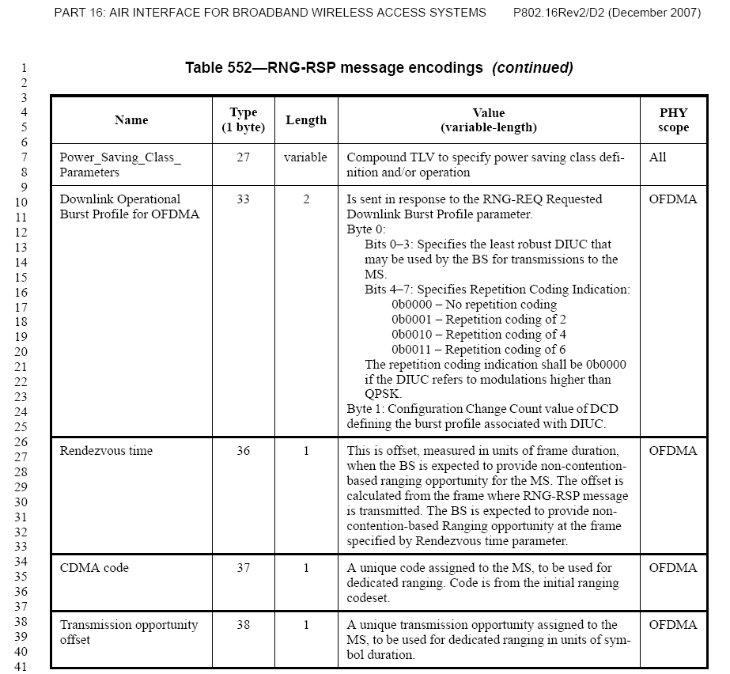

[Reference]

[1] IEEE802.16, P802.16Rev2/D2 Part 16: Air Interface for Broadband Wireless Access Systems, Dec. , 2007

