IEEE P802.22
Wireless RANs
Coexistence Capacity Allocation Method
Date: 2008-03-05
Author(s):
Name | Company | Address | Phone | email
Gerald Chouinard | CRC | 3701 Carling Avenue, Ottawa, Ontario, Canada K2H 8S2 | 1-613-998-2500 | gerald.chouinard@crc.ca
Abstract
This contribution presents the pros and cons of allocating WRAN capacity among nearby co-channel WRAN base stations on a frame-by-frame basis (inter-frame capacity allocation) or using different parts of the same frame (intra-frame capacity allocation). Action items are identified for the 802.22 WG as a consequence of these considerations.
Notice: This document has been prepared to assist IEEE 802.22. It is offered as a basis for discussion and is not binding on the contributing individual(s) or organization(s). The material in this document is subject to change in form and content after further study. The contributor(s) reserve(s) the right to add, amend or withdraw material contained herein.

Release: The contributor grants a free, irrevocable license to the IEEE to incorporate material contained in this contribution, and any modifications thereof, in the creation of an IEEE Standards publication; to copyright in the IEEE’s name any IEEE Standards publication even though it may include portions of this contribution; and at the IEEE’s sole discretion to permit others to reproduce in whole or in part the resulting IEEE Standards publication. The contributor also acknowledges and accepts that this contribution may be made public by IEEE 802.22.

Patent Policy and Procedures: The contributor is familiar with the IEEE 802 Patent Policy and Procedures
<http://standards.ieee.org/guides/bylaws/sb-bylaws.pdf>, including the statement "IEEE standards may include the known use of patent(s), including patent applications, provided the IEEE receives assurance from the patent holder or applicant with respect to patents essential for compliance with both mandatory and optional portions of the standard." Early disclosure to the Working Group of patent information that might be relevant to the standard is essential to reduce the possibility for delays in the development process and increase the likelihood that the draft publication will be approved for publication. Please notify the Chair <Carl R. Stevenson> as early as possible, in written or electronic form, if patented technology (or technology under patent application) might be incorporated into a draft standard being developed within the IEEE 802.22 Working Group. If you have questions, contact the IEEE Patent Committee Administrator at <patcom@ieee.org>.
Coexistence Capacity Allocation Method

1. Introduction
The 802.22 WRAN system needs to be able to withstand coexistence among a number of overlapping WRAN cells using the same TV channel by sharing the capacity among these cells rather than being adversely affected by interference and possibly brought down to system failure. This is an important system feature for operation in a license-exempt environment where a new WRAN cell could start operating in the neighbourhood of already well-established cells. Such operation should result in a new sharing of the channel capacity rather than destructive interference.
Although a number of schemes have been proposed at the MAC layer to allow for such capacity sharing in a more or less equitable manner, the conditions for the PHY layer to successfully operate in such an environment where collisions will occur have not been completely explored and, as it currently stands, will make the system fail in certain geographical arrangements of the base stations and the CPEs. The requirements for proper operation in such collision environment need to be clearly established so that the right portions of the transmitted WRAN signal are ruggedized to sustain operation in this environment.
Two options for the allocation of the WRAN capacity to various overlapping co-channel WRAN cells are explored where the capacity is shared on a frame-by-frame basis (inter-frame capacity allocation) or using different parts of the same frame (intra-frame capacity allocation). The requirements on the PHY layer are identified for each allocation method so that a proper choice can be made.

2. RF signal levels resulting from overlapping WRAN cells
The WRAN signal availability at the edge of coverage is assumed to be 50% of locations (one household over two being reached at the edge) and 99.9% time for reliable two-way data communications, i.e., F(50,99.9), while the interference power is predicted at F(50,10). Figure 1 represents the case where an adjacent WRAN cell is as close as possible without impacting the main WRAN cell. For flat land and using the ITU-R P.1546 propagation model, the distance between the two WRAN base stations is 52 km. At that distance, the signal differential at any CPE inside the coverage area is at least 6 dB, thank’s to the front-to-back CPE antenna discrimination, allowing for proper reception of the QPSK, rate: 1/2 modulation used at the edge of coverage. The SINR at the edge of the coverage would be less than 6 dB and tend to push the separation distance between base stations to a larger value but a 3 dB margin has been built in the WRAN basic link equation, allowing for an equal amount of power from thermal noise and co-channel interference at the edge of coverage. A different system trade-off could be used in favour of a leaner link budget to slightly extend the coverage of a base station; for example 1 dB WRAN receiver desensitization caused by co-channel WRAN interference (rather than the above 3 dB) would result in a keep-out distance for the closest co-channel base station that would go from the above 52 km to 60 km.

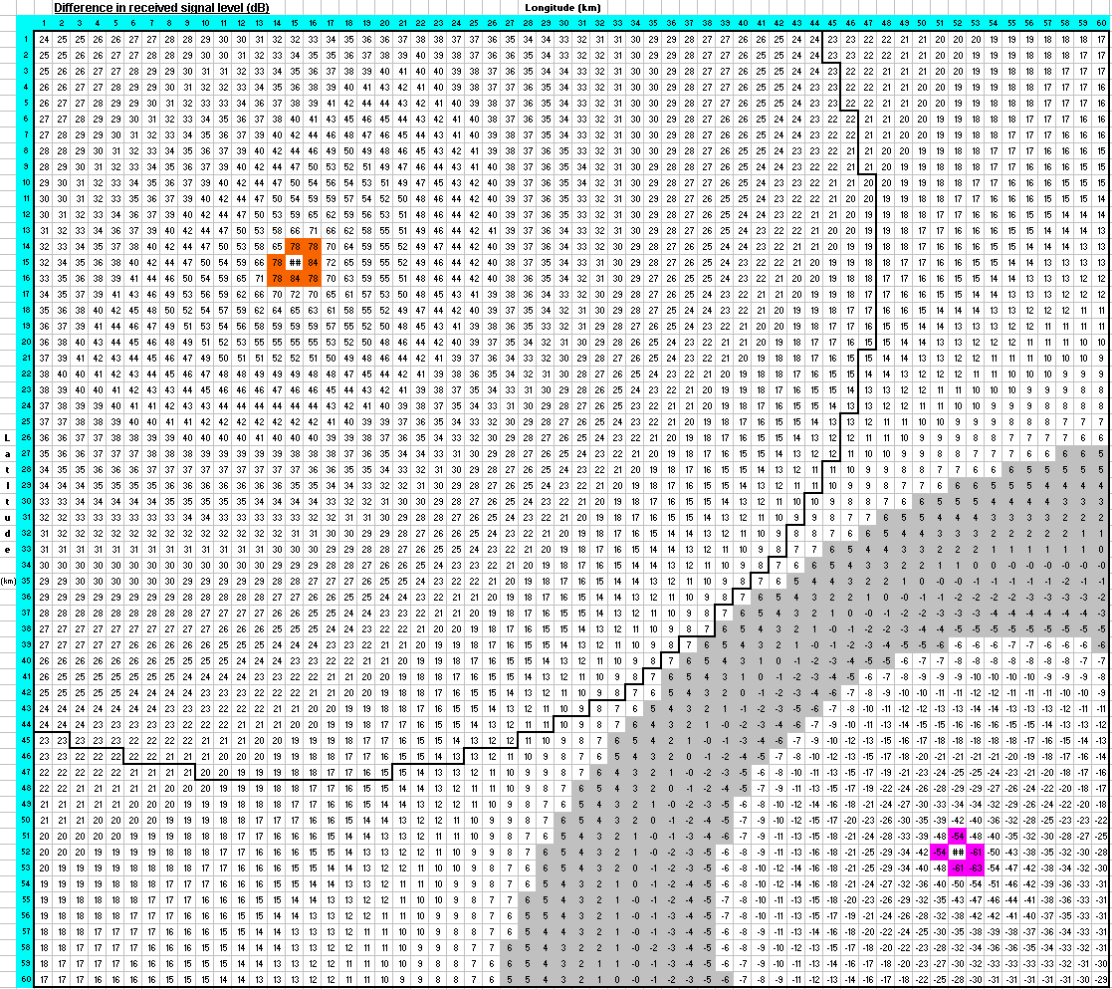
52 km
31 km
Figure 1: Minimum distance between co-channel base stations before coexistence operation
Figure 2 represents a worse case condition for the operation of two overlapping cells using the same channel. When a second WRAN base station is progressively moved closer to an existing base station, a worst case occurs when this second base station just enters in the coverage zone of the first base station because the CPEs on the edge of the coverage zone start to see this second base station in the same direction as their own base station, therefore no longer offering the 14 dB front-to-back ratio discrimination that they can offer if the second base station is outside the contour. It represents the case where the largest negative differential will occur between the signal level received from the wanted base station and the signal level arriving from this second base station. As can be seen in the figure, such signal differential can be as high as –54 dB and even higher if the CPE is located closer to this second base station. If the second base station is moved closer to the first base station, this negative signal differential will tend to decrease because the signal level from the first base station will increase with the reduction of the distance to this first base station.
The first critical condition of operation is that the CPE will need to discriminate among signals having level difference of 54 dB and higher to be able to receive its own base station in presence of a second nearby base station. The only type of signal multiplexing that can operate in such high signal differential situation is TDM (the FFT used for OFDM will not allow proper signal decoding in FDM in such environment because of the limited isolation in the frequency domain; CDM requires even smaller signal differential to operate). The AGC at the CPE receiver will however need to take special measures to behave properly in presence of such high signal level differential so that the proper AGC level is restored quickly for the signal destined to the given CPE.
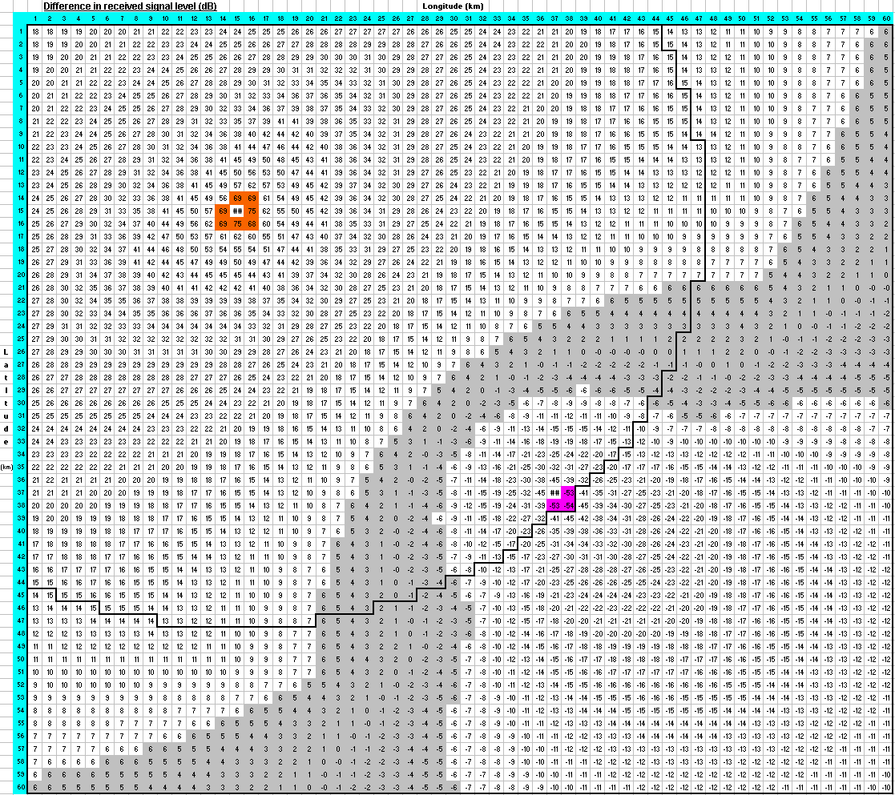
31 km
31 km
Figure 2: Worse case condition of WRAN cell ovelap
A similar condition will occur on the upstream path where the receiver of the second base station will be overwhelmed by the high power signal coming from the nearby CPE that tries to reach its distant base station while it tries to decode the upstream packets coming from its own distant CPEs. This large signal level differential will create a similar problem at the receiver of the second base station and only TDM will allow for proper isolation as long as the AGC behaves properly under temporary high signal level reception by quickly restoring the gain for proper detection of the wanted signal.
A second critical condition of operation is illustrated in Figure 2 by the grey zone where the differential between the signals received from the two base stations is small, e.g., +/-6 dB as illustrated in the Figure. This is the condition under which a CPE trying to receive colliding packets would have to oprate. If the demodulation and decoding of these packets cannot be done for SIR of less than 6 dB (typical for QPSK, rate: 1/2), the CPEs would not be able to receive either of the two signals in this grey zone. As will be seen in the following sections, the CPE will need to, at least, acquire the base station synchronization and some management information to locate when its own base station uses the channel to be able to operate. This minimum information will need to be captured under collision conditions.
Theoretically, the grey zone would vanish if the CPE were able to demodulate and decode the signal under a 0 dB SIR condition but, due to the fact that the propagation of the two paths from the base stations will vary in time, a minimum amount of hysteresis will be needed to avoid the CPE continuously hunting between the two signals. Looking at the ITU-R 1546 propagation model at a distance of 30 km for the wanted base station and 22 km for the interfering base station, the two standard deviations can be deduced for these distances (0.8 dB and 0.6 dB respectively). For a combined time availability of 99.9%, the margin to be used to avoid unnecessary hunting is found to be 2.8 dB. This means that this 2.8 dB signal differential will be exceeded for only 0.1% of the time. In other words, in order to ensure that either one of the two received signals from the co-channel base stations in demodulated and decoded in any overlapping location, the demodulation and decoding needs to work down to a –2.8 dB SIR for a time availability of 99.9%. This will define the modulation scheme and FEC coding for the data bursts that need to be decoded under collision conditions.

3. Inter-frame capacity allocation
In the case where the capacity will be distributed among overlapping co-channel WRAN cells on the basis of time-division-multiplexing of the transmission frames, only the superframe preamble and the SCH will need to be received under collision conditions. The –2.8 dB SIR will therefore only need to apply to the superframe preamble and header.
Although the superframe preamble with its rugged PN-sequence is capable of detection in negative SINR, it is not clear whether orthogonal PN-sequences will be needed to differentiate the preambles for successful detection in these collision conditions. This will need to be clarified.
The modulation and coding currently used for the SCH do not allow for detection in negative SINR. New and more robust SCH modulation and coding will need to be developed.
Since the CPE will only be able to capture the stronger SCH, the information on this SCH should be common from all the base stations in the neighbourhood. Its size should be minimum because the overhead to allow decoding under collision conditions will be very high. It should only carry the information on the allocation of the 16 frames in the superframe to each WRAN cells in the area and the timing of the inter-frame quiet periods. The SCH payload defined in the Working Document will need to be reviewed in this context.
The superframe header could be used for frequency synchronization since the frequency would be common to all WRAN cells but not for time synchronization since the propagation time from the strongest base station will not be the same as the propagation time from the base station to which the CPE may be associated. The CPE will need to acquire its time synchronization from the header of the frame that is destined to it, with no reliance on the superframe header.
Even though the capacity loading on a specific base station may be low in some cases and therefore the frame assignment to this base station may decrease, the associated CPEs will need to acquire the frame information at a sufficient pace to keep their time synchronization. Some work would be needed to quantify the medium term time stability of the CPEs but it is expected that they would require at least one frame per superframe to keep time synchronization within adequate tolerance. More work is needed here. In this context and until more reliable information is available on the CPE time stability, a minimum of one frame per superframe is assumed and the MAC layer coexistence algorithms will be limited to assign a variable number of frames in a superframe to all coexisting WRAN cells based on their loading. Each WRAN cell would get at least 1/16 of the capacity at any time.
The second constraint on the pace at which a WRAN cell will be allocated frames in a superframe has to do with QoS. For real-time applications such as VoIP, a latency of 20 ms on a transmission path is considered by many as the maximum acceptable. This would mean that every other frame would need to be assigned to a same base station. This would result in a constant and equal capacity allocated to two co-channel WRAN cells, not allowing for capacity adaptation, and it would not be possible if more than two co-channel WRAN cells operate in a neighbourhood. It will therefore be hard to reconcile QoS and coexistence operation using inter-frame capacity allocation.
Special care will be needed for the design of the AGC of the CPE receiver because the various frames coming from different base stations on the downstream will be received at widely different power levels and the AGC will need to keep track of the level of the superframe header and the level of the wanted frame while blocking the interfering frames. On the upstream, the AGC of the receiver of the base station will need to keep track of the level of the upstream burst on the frames allocated to it while blocking the bursts in other frames intended to other base stations.
Because of the extra overhead required to ruggedize the superframe preamble and SCH, should the 802.22 standard allow for two modes of operation, a normal one similar to what is currently in the Working Document and a more rugged one for coexistence operation? In such case, how and when would the switch from the normal mode to the rugged mode take place? Would operators always know when a coexistence problem comes up?

4. Intra-frame capacity allocation
The use of the intra-frame capacity allocation would allow preserving QoS for real-time applications since portions of each frame could be allocated to a given CID.
However, since all frames have to be used by overlapping co-channel WRAN cells, both the superframe and the frame headers will need to be ruggedized to operate in a collision environment (i.e., operate down to –2.8 dB SINR). The overhead will be much more extensive since the frame header carries much more information (i.e., FCH, DS/US-MAPs, DCD/UCD, etc.).
Furthermore, because of the large signal differential identified in section 2, which would occur in a near-far situation, either on the downstream where the signal from a nearby BS1 would be received at the CPE at much higher level that the signal from the far-away BS2 to which the CPE would try to associate, or the upstream where the low power signal from a distant CPE would be overwhelmed at the BS1 receiver by a close-by high power CPE that is trying to communicate with the distant BS2. Because of the limited dynamic range of the FFT, the low-power carriers could not be decoded properly if they are frequency multiplexed.
The only option is to use time-division-multiplexing to apportion the frames among the different co-channel WRAN cells. Because of different propagation times from the base stations to the CPEs on the downstream and CPEs to the base stations on the upstream, buffers will need to be included between the bursts to avoid collisions. This would be possible in the downstream because the capacity mapping is in the vertical direction (sweeping all sub-channels before moving to the next symbol) but it would be more difficult in the upstream direction since the capacity allocation is in the horizontal direction to minimize the peak EIRP by stretching the burst transmission over time. The only possibility would be to use the 7-symbol columns proposed by ETRI for the upstream but this would limit the number of base stations being served by a frame to at most 4 if most of the frame is taken up for upstream. Also, time buffers will be needed between the 7-symbol columns to avoid collisions. In order to keep the integrity of the time synchronization, these buffers will need to be an integer number of symbols (normally one, covering for propagation distance differences of up to 100 km). These buffer symbols will also represent extra overhead in the system transmissions. This is illustrated in Figure 3.
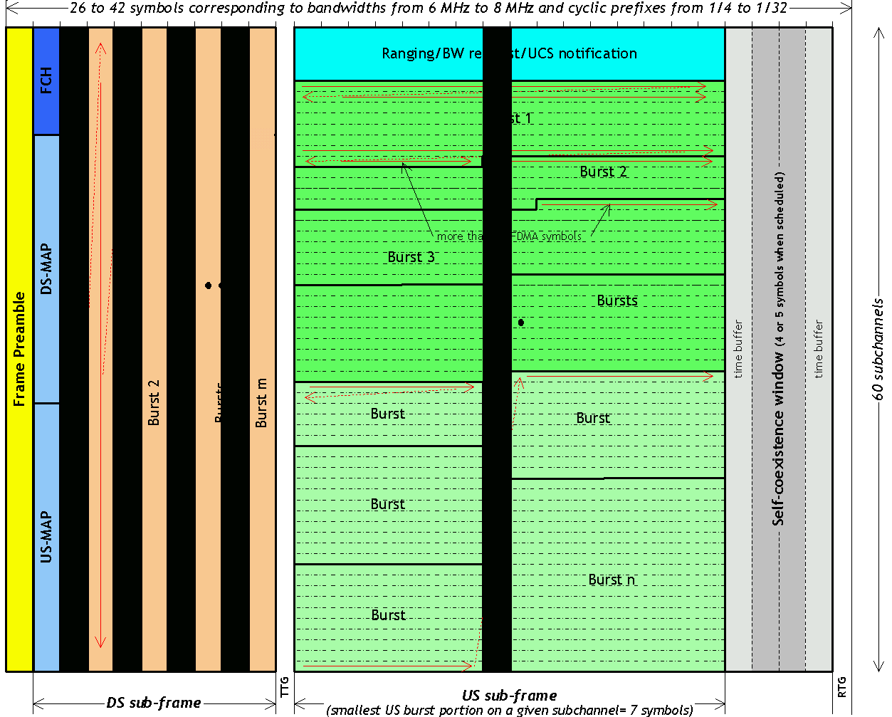
Figure 3: Illustration of the time buffers between the various data bursts.
All co-channel overlapping BSs will need to use the same ratio between downstream and upstream to have a common TTG time to avoid downstream and upstream packets collide. Therefore, the downstream/upstream capacity allocation would have to be fixed in the case of coexistence, removing the advantage of a TDD system.
Another problem is the AGC at the receivers in the case where there is a large signal level differential between the various parts of a frame. The high power portions will tend to drive the AGC in an erratic way unless this AGC is told to apply the right gain at the right time to decode the right burst and discard any other burst.

4. Conclusion
It would seem that, for practical reasons, the inter-frame capacity allocation will be the only reasonable choice. Unfortunately, QoS will have to suffer in coexistence situations. Although frequency synchronization could be extracted from the superframe header, the CPEs will need to rely only on the frame header for the time synchronization and they will need to hold their time synchronization over a number of frames without a possibility for refresh since the other frames would be destined to other CPEs. It was assumed in this case that the CPEs will be able to hold their time synchronization over a superframe resulting in a minimum pace for frame allocation to any BS of one frame per superframe. Verification will be needed as to the practicality of this assumption. As a consequence, the coexistence algorithms proposed at the MAC layer will need to consider what is practical at the PHY layer.
The SCH MAC section will need to be reviewed to minimize the required payload because of the expected high overhead required to protect the SCH in a collision environment.
The modulation and coding of the superframe header will need to be re-defined to sustain collisions.
Investigations will be needed on whether a ‘normal’ mode and a ‘collision’ mode can be included in the 802.22 standard and how and when the switch from one mode to another will be made.

_______________________________________

