IEEE P802.22
Wireless RANs
Geolocation/Database Primitives
Date: 2007-11-10
Author(s):
Name | Company | Address | Phone | email
Winston Caldwell | Fox | 10201 W. Pico Blvd.  Los Angeles, CA 90064 | 310-369-4367 | Winston.caldwell@fox.com
Abstract
The necessary primitives through the MAC-SAP, the MLME(SM)-SAP, the PLME(SM)-SAP, and the PLME(GL)-SAP interfaces to accomplish the geolocation and the database query functionalities are defined in this document.

Notice: This document has been prepared to assist IEEE 802.22. It is offered as a basis for discussion and is not binding on the contributing individual(s) or organization(s). The material in this document is subject to change in form and content after further study. The contributor(s) reserve(s) the right to add, amend or withdraw material contained herein.

Release: The contributor grants a free, irrevocable license to the IEEE to incorporate material contained in this contribution, and any modifications thereof, in the creation of an IEEE Standards publication; to copyright in the IEEE’s name any IEEE Standards publication even though it may include portions of this contribution; and at the IEEE’s sole discretion to permit others to reproduce in whole or in part the resulting IEEE Standards publication. The contributor also acknowledges and accepts that this contribution may be made public by IEEE 802.22.

Patent Policy and Procedures: The contributor is familiar with the IEEE 802 Patent Policy and Procedures
<http://standards.ieee.org/guides/bylaws/sb-bylaws.pdf>, including the statement "IEEE standards may include the known use of patent(s), including patent applications, provided the IEEE receives assurance from the patent holder or applicant with respect to patents essential for compliance with both mandatory and optional portions of the standard." Early disclosure to the Working Group of patent information that might be relevant to the standard is essential to reduce the possibility for delays in the development process and increase the likelihood that the draft publication will be approved for publication. Please notify the Chair <Carl R. Stevenson> as early as possible, in written or electronic form, if patented technology (or technology under patent application) might be incorporated into a draft standard being developed within the IEEE 802.22 Working Group. If you have questions, contact the IEEE Patent Committee Administrator at <patcom@ieee.org>.

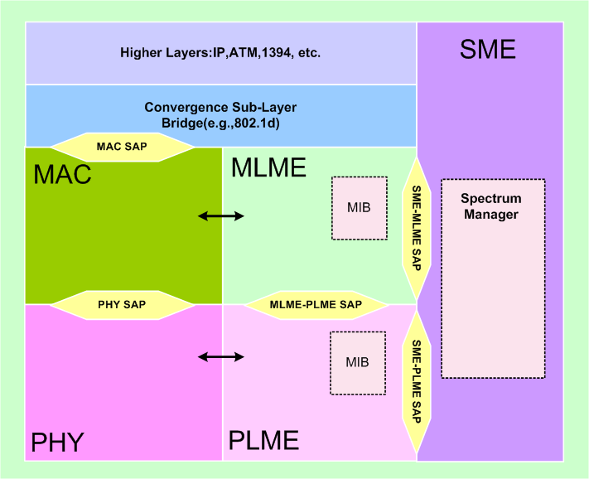

Database Query Primitives supported by the MAC-SAP
Name | Request | Indication | Confirm
MAC-AVAILABLE-CH-DB

MAC-AVAILABLE-CH-DB.request

Name | Type | Valid Range | Description
Database |  |  | The database for which the query is directed.  0 = Incumbent Database  1 = Part 74 Database  2 = Part 15 Database
For(i=0; i<Number of Coordinates Served by Device; i++) { |  |  | Array of coordinates representing the area that the device serves.
Latitude
Longitude
}

MAC-AVAILABLE-CH-DB.confirm

Name | Type | Valid Range | Description
For(i=0; i<Number of Coordinates Served by Device; i++) { |  |  | Array of coordinates representing the area that the device serves.
Latitude
Longitude
For(j=0; j<Number of Available Channels; j++) { |  |  | Array of available channels for each coordinate.
Available Channel Number
}
}

Spectrum Manager Primitives supported by the MLME(SM)-SAP
Name | Request | Indication | Confirm
MLME(SM)-AVAILABLE-CH
MLME(SM)-LOCATION

MLME(SM)-AVAILABLE-CH.request

Name | Type | Valid Range | Description
Database |  |  | The database for which the query is directed.  0 = Incumbent Database  1 = Part 74 Database  2 = Part 15 Database
For(i=0; i<Number of Coordinates Served by Device; i++) { |  |  | Array of coordinates representing the area that the device serves.
Latitude
Longitude
}

MLME(SM)-AVAILABLE-CH.confirm

Name | Type | Valid Range | Description
For(i=0; i<Number of Coordinates Served by Device; i++) { |  |  | Array of coordinates representing the area that the device serves.
Latitude
Longitude
For (j=0; j<Number of Available Channels; j++) { |  |  | Array of available channels for each coordinate.
Available Channel Number
}
}

MLME(SM)-LOCATION.request

Name | Type | Valid Range | Description
Destination Address | Device Address |  | The destination address for the device which the location information is being requested.

MLME(SM)-LOCATION.confirm

Name | Type | Valid Range | Description
Length | Integer | 0 to 65535 characters | Length of the location data string in octets.
Location Data String | ASCII |  | NMEA 0183 ASCII string

Spectrum Manager Primitives supported by the PLME(SM)-SAP
Name | Request | Indication | Confirm
PLME(SM)-OPERATING-CH

PLME(SM)-OPERATING-CH.indication

Name | Type | Valid Range | Description
Operating Channel Number | Integer |  | The selected operating channel for the WRAN network.

Geolocation Primitives supported by the PLME(GL)-SAP
Name | Request | Indication | Confirm
PLME(GL)-LOCATION

PLME(SM)-LOCATION.request

Name | Type | Valid Range | Description
Operating Channel Number | Integer |  | The selected operating channel for the WRAN network.

PLME(SM)-LOCATION.confirm

Name | Type | Valid Range | Description
Length | Integer | 0 to 65535 characters | Length of the location data string in octets.
Location Data String | ASCII |  | NMEA 0183 ASCII string

References:

