IEEE P802.22
Wireless RANs
RF Mask for the 802.22 WRAN Standard
Date: 2007-10-31
Author(s):
Name | Company | Address | Phone | email
Gerald Chouinard | CRC | 3701 Carling Avenue, Ottawa, Ontario, Canada K2H 8S2 | 1-613-998-2500 | gerald.chouinard@crc.ca
Abstract
This contribution summarizes the information relevant to the discussion on the RF Mask to be specified for WRAN out-of-band emission in the 802.22 WRAN standard.
Notice: This document has been prepared to assist IEEE 802.22. It is offered as a basis for discussion and is not binding on the contributing individual(s) or organization(s). The material in this document is subject to change in form and content after further study. The contributor(s) reserve(s) the right to add, amend or withdraw material contained herein.

Release: The contributor grants a free, irrevocable license to the IEEE to incorporate material contained in this contribution, and any modifications thereof, in the creation of an IEEE Standards publication; to copyright in the IEEE’s name any IEEE Standards publication even though it may include portions of this contribution; and at the IEEE’s sole discretion to permit others to reproduce in whole or in part the resulting IEEE Standards publication. The contributor also acknowledges and accepts that this contribution may be made public by IEEE 802.22.

Patent Policy and Procedures: The contributor is familiar with the IEEE 802 Patent Policy and Procedures
<http://standards.ieee.org/guides/bylaws/sb-bylaws.pdf>, including the statement "IEEE standards may include the known use of patent(s), including patent applications, provided the IEEE receives assurance from the patent holder or applicant with respect to patents essential for compliance with both mandatory and optional portions of the standard." Early disclosure to the Working Group of patent information that might be relevant to the standard is essential to reduce the possibility for delays in the development process and increase the likelihood that the draft publication will be approved for publication. Please notify the Chair <Carl R. Stevenson> as early as possible, in written or electronic form, if patented technology (or technology under patent application) might be incorporated into a draft standard being developed within the IEEE 802.22 Working Group. If you have questions, contact the IEEE Patent Committee Administrator at <patcom@ieee.org>.
RF Mask for the 802.22 WRAN Standard

1. RF Mask deduced from the Functional Requirement Document
The Functional Requirement Document developed by the 802.22 WG (22-05-0007-47-0000_RAN_Requirements.doc) specifies what follows in its section 15.1.7:
“15.1.7 Out-of-band emission mask for WRAN systems
According to the model of 15.1.6, it is tentatively concluded that in order to protect DTV receivers and to protect wireless microphones, 4 W EIRP WRAN CPEs and base stations SHALL meet the limits specified in Table 15.1.7.

 | If WRAN operates
 | First adjacent channel to wireless microphone | Second adjacent channel and beyond to TV or wireless microphone
WRAN first adjacent channel limit | 4.8 uV/m | 200 uV/m
WRAN second adjacent channel and beyond limit | 4.8 uV/m | 4.8 uV/m*
Table 15.1.7: Emission levels (measured at 3 m in 120 kHz bandwidth)
* This number is derived from a 20 dBuV/m field strength at 10m, measured in 6 MHz. and assumes no polarization discrimination. If a proposer suggests a relaxation based on the use of polarization discrimination or some other approach, they SHALL provide supportive documentation to justify such a relaxation.”
Supposing that the worst case of interference from a CPE into a DTV receiver is when they are located line-of-sight at 10 m from each other, a 4 Watt EIRP transmission from the CPE will produce a field of:
10*log(4)-10*log(4π*10*10) + 10*log(120π) = 0.8 dB(V/m)
or 120.8 dB(uV/m) in 6 MHz
(Re: 22-04-0002-15-0000_WRAN_Reference_Model.xls)
This corresponds to a field of:
10*log(4)-10*log(4π*3*3) + 10*log(120π) + 10*log(0.12/6) = -5.7 dB(V/m)
or 114.3 dB(uV/m) at 3 m in 120 kHz bandwidth if the power is spread evenly within the 6 MHz bandwidth.
The 4.8 uV/m level stated in the table corresponds to 13.4 dB(uV/m) at 3 m in 120 kHz. This corresponds to a 1 dB desensitization of the DTV receiver located at the edge of the protected contour (i.e., DTV receive level is 41 dBuV/m) with no antenna cross-polar discrimination. The 200 uV/m corresponds to 46 dB(uV/m). This value corresponds to the out-of-band emission level allowed from Part 15-209a devices.
The following RF mask can thus be developed based on the above values from the Functional Requirement Document. This RF mask is for a CPE transmitting at 4 Watt EIRP. Note that if vertical polarization is used at the CPE, a relaxation of the RF mask which corresponds to the typical polarization discrimination between the receive antenna maximum gain and the cross-polar gain toward any azimuth (typically 14 dB, i.e., -2 dBi cross-polar discrimination toward any azimuth which corresponds to the antenna backlobe level) can be assumed.

Figure 1: 802.22 WRAN RF Mask proposed in the Functional Requirement Document (red curve) and its relaxed version assuming 14 dB X-pol DTV antenna discrimination for vertically polarized WRAN signals

2. RF Mask specified in the 802.16 WMAN Standard
The following section 8.5.2 was extracted from a recent revision of the 802.16 standard.
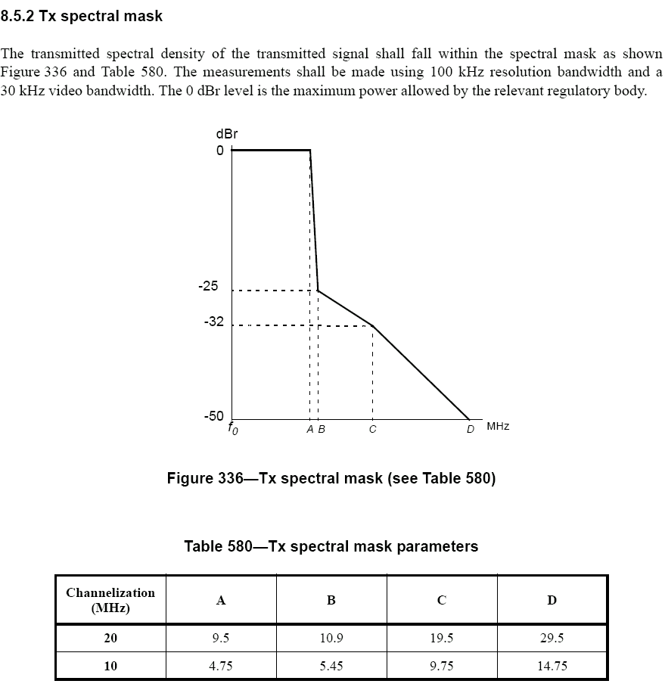

3. RF Mask used in Canada for the Remote Rural Broadband Systems
Canada has decided to allow applications for licensed use of four TV channels (25, 34, 35 and 43) in the Northern and rural areas of Canada. The technical guidelines for such applications are contained in reference [3]:
Section 4 of these guidelines specifies what follows:
“4. Emission Limits
An out-of-band emission mask will be developed and included in an appropriate Radio Standard Specification (RSS). Until such time, RRBS stations (including base and subscriber stations) shall meet the Digital TV (DTV) mask (i.e. the Canadian Relaxed Mask) as described in Appendix 3 of Broadcasting Procedures and Rules 7, Application Procedures and Rules for Digital Television (DTV) Undertakings (BPR-7).”
The DTV RF Mask is contained in Appendix 3 of the Canadian BPR-7 and appears below.
BPR-7 also indicates that: "The relaxed mask can also be used for low-power DTV stations." It is expected that this relaxed mask (dotted line) will therefore apply to the low-power Remote Rural Broadband Systems.
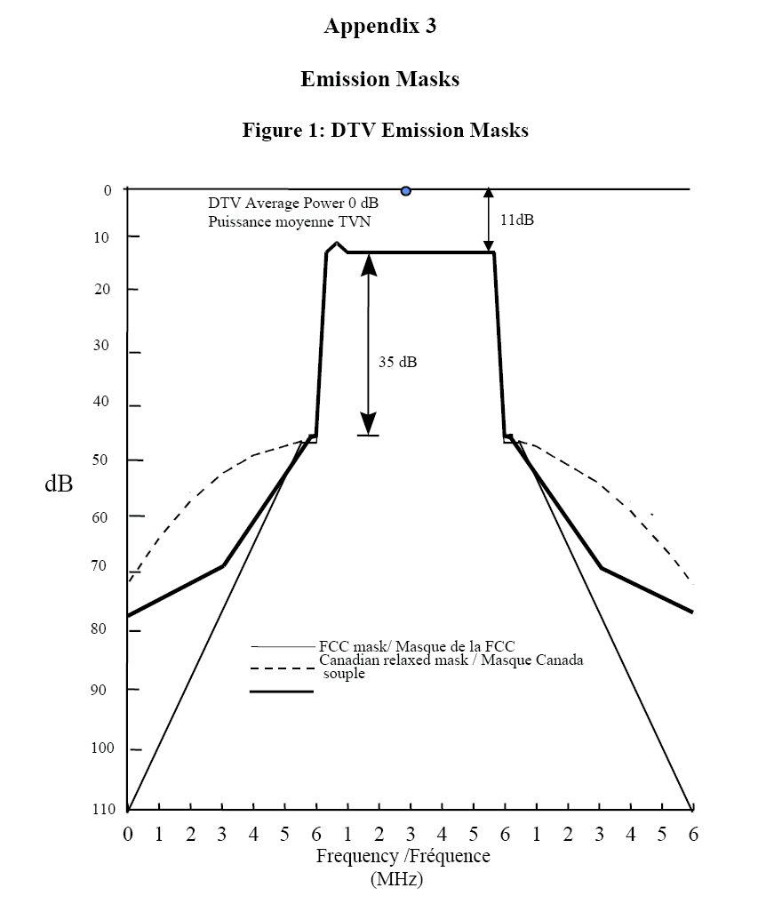

5. Conclusions
The RF mask proposed in the Functional Requirement Document for the future 802.22 WRAN systems is much more demanding than the RF masks specified for the 802.16 WMAN systems and the DTV RF masks used in the US and in Canada. More discussions are needed to come up with a realistic mask that will protect the Broadcast incumbents as well as allow 802.22 WRAN systems to operate with reasonable output amplifier and filter complexity given that the base station and CPE RF transmission chains are to be frequency agile over a large number of TV channels and that the CPEs have to be amenable to low cost solutions.
The fact that the transmit WRAN antenna and the receive DTV antenna will very unlikely be looking at each other in the case of operation on adjacent channels since the base station and the CPEs have to be located outside the protected contour should allow relaxation of the RF mask to cover this condition. Furthermore, the use of vertical polarization for WRAN transmission should also allow a relaxation of the RF mask for all channel separations since it is unlikely that the cross-polar discrimination in any direction will be less than the front-to-back ratio of the DTV receive antenna

6. Reference
[1] 22-05-0007-47-0000_RAN_Requirements.doc
[2] 802.16 WMAN Standard, 2004
[3] Guidelines GL-05, Issue 1, “Interim Technical Guidelines for Remote Rural Broadband Systems (RRBS) Operating in the Band 512-698 MHz (TV Channels 21 to 51)”, Spectrum Management and Telecommunications, Industry Canada, March 2007
[3] FCC-OET Bulletin 69

_______________________________________

