IEEE P802.22
Wireless RANs
Structure and concatenation rule for SBTC
Last Updated - Date: 2007-09-09
Author(s):
Name | Company | Address | Phone | email
Xu Changlong | I2R | Heng Mui Keng Terrace, Singapore  119613 | +6568747588 | clxu@i2r.a-star.edu.sg
Ying-Chang Liang | I2R | Heng Mui Keng Terrace, Singapore  119613 | +6568747588 | clxu@i2r.a-star.edu.sg
Zhongding Lei | I2R | Heng Mui Keng Terrace, Singapore  119613 | +6568747588 | clxu@i2r.a-star.edu.sg
Yonghong Zeng | I2R | Heng Mui Keng Terrace, Singapore  119613 | +6568747588 | clxu@i2r.a-star.edu.sg
Anh Tuan Hoang | I2R | Heng Mui Keng Terrace, Singapore  119613 | +6568747588 | athoang@i2r.a-star.edu.sg
Francois Chin | I2R | Heng Mui Keng Terrace, Singapore  119613 | +6568747588 | chinfrancois@i2r.a-star.edu.sg

Abstract
This submission contains the updated normative SBTC text to be included in the 802.22 draft standard. The text comprised of the structure and the concatenation rule for shortened block turbo codes.
Notice: This document has been prepared to assist IEEE 802.22. It is offered as a basis for discussion and is not binding on the contributing individual(s) or organization(s). The material in this document is subject to change in form and content after further study. The contributor(s) reserve(s) the right to add, amend or withdraw material contained herein.

Release: The contributor grants a free, irrevocable license to the IEEE to incorporate material contained in this contribution, and any modifications thereof, in the creation of an IEEE Standards publication; to copyright in the IEEE’s name any IEEE Standards publication even though it may include portions of this contribution; and at the IEEE’s sole discretion to permit others to reproduce in whole or in part the resulting IEEE Standards publication. The contributor also acknowledges and accepts that this contribution may be made public by IEEE 802.22.

Document Policy and Procedures: The contributor is familiar with the IEEE 802 Document Policy and Procedures
<http://standards.ieee.org/guides/bylaws/sb-bylaws.pdf>, including the statement "IEEE standards may include the known use of document(s), including document applications, provided the IEEE receives assurance from the document holder or applicant with respect to documents essential for compliance with both mandatory and optional portions of the standard." Early disclosure to the Working Group of document information that might be relevant to the standard is essential to reduce the possibility for delays in the development process and increase the likelihood that the draft publication will be approved for publication. Please notify the Chair <Carl R. Stevenson> as early as possible, in written or electronic form, if documented technology (or technology under document application) might be incorporated into a draft standard being developed within the IEEE 802.22 Working Group. If you have questions, contact the IEEE Document Committee Administrator at <patcom@ieee.org>.

The BTC is constructed by the product of two simple component codes, which are binary Hamming codes with a special design or parity check codes. Error: Reference source not foundTable 1 specifies the parity check matrix for the Hamming codes. Actually, all the columns of the parity check matrix for n = 15 are the binary representation of integers 1 to 15 (the topmost part corresponds to the least-significant bit in the binary representation of an integer). Similarly, all the columns of the parity check matrix for n = 31 and 63 are the binary representation of integers 1 to 31 and integers 1 to 63, respectively. Note that with this encoding scheme, the parity check bits are no longer located together at the end of the code word. In general, for a (2^{m}-1, 2^{m}-1-m) Hamming code, the parity-check positions are located in columns numbered 1, 2, 4, …, 2^{m-1} of the parity check matrix. Bothe Hamming codes and extended Hamming codes may be used as component codes. To create extended Hamming codes, the overall even parity check bit is added at the end of each code word.

- — Parity check matrix for the Hamming codes
n’ | K’ | Parity check matrix
7 | 4 | $${\left[\begin{matrix}1 & 0 & 1 & 0 & 1 & 0 & 1 \\ 0 & 1 & 1 & 0 & 0 & 1 & 1 \\ 0 & 0 & 0 & 1 & 1 & 1 & 1\end{matrix}\right]}_{3×7}$$
15 | 11
31 | 26
63 | 57

With the aid of Figure 1Error: Reference source not found, the procedure to construct BTC is listed as follows:

- Place (k_{y} k_{x}) information bits in information area (the blank area in Figure 1Error: Reference source not found). The information bits may be placed in columns with indexes from 1 to n_{x}-1, except for columns 2^{i} with i = 0, 1, 2, …, n_{x}-k_{x}-2 (n_{x}-k_{x}-1 parity check bits). Similarly, information bits may be located in rows with indexes 1 to n_{y} except for rows with indexes 2^{j} with j = 0, 1, 2, …, n_{y}-k_{y}-2 (n_{y}-k_{y}-1 parity check bits).
- Compute the parity check bits of k_{y} rows using the corresponding parity check matrix in Table 1Error: Reference source not found and inserting them in the corresponding positions signed by ;
- Compute the parity check bits of k_{x} columns using the corresponding parity check matrix in Table 1Error: Reference source not found and inserting them in the corresponding positions signed by and ;
- Calculate and append the extended parity check bits to the corresponding rows and columns, if the component code of row (or column) is extended Hamming code.
- The overall block size of such a product code is n = n_{x} × n_{y}, the total number of information bits k = k_{x} × k_{y}, and the code rate is R = R_{x} × R_{y}, where R_{i} = k_{i}/n_{i}, i = x, y. The Hamming distance of the product code is d = d_{x} × d_{y}. Data bit ordering for the composite BTC block is the first bit in the first row is the LSB and the last data bit in the last data row is the MSB.
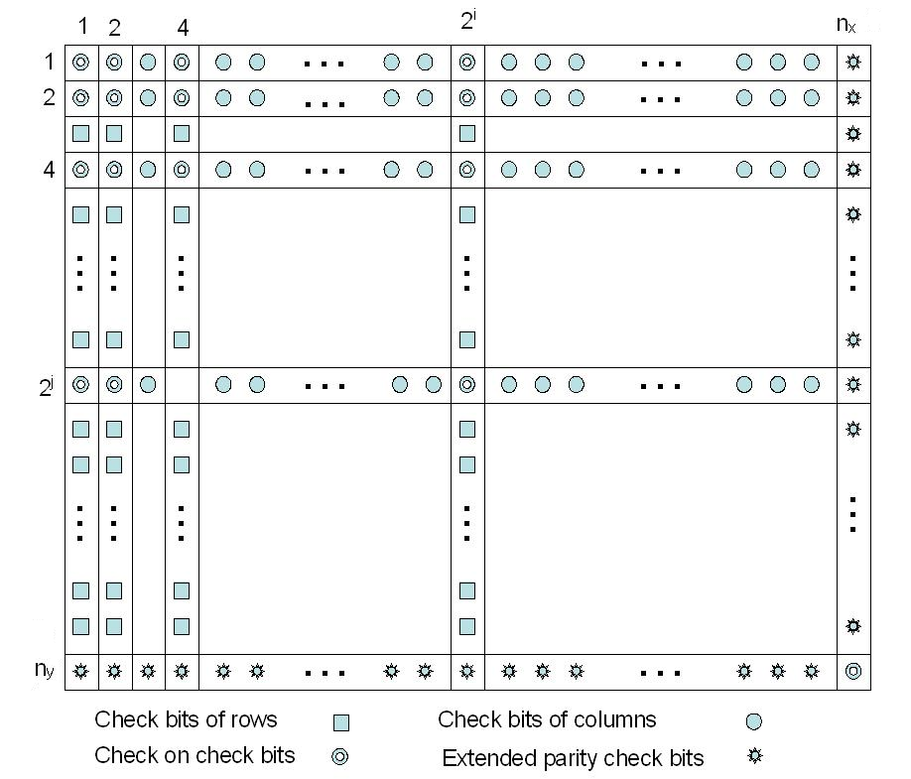
- — Block turbo code (BTC) structure

Transmission of the block over the channel shall occur in a linear fashion, with all bits of the first row transmitted left to right followed by the second row, etc. To match a required packet size, BTC may be shortened by removing symbols from the BTC array. In the two-dimensional case, rows, columns, or parts thereof can be removed until the appropriate size is reached. There are two steps in the process of shortening product codes:

- Step 1) Remove I_{x} rows and I_{y} columns from the two-dimensional code. This is equivalent to shortening the component codes that make up the BTC.
- Step 2) Use if the size of data field of SBTC specified from Step (1) of this sub-clause is larger than expected size. In this case, the D right LSBs are zero-filled by the encoder. After decoding at the receive end, the decoder shall strip off these unused bits and only the specified data payload is passed to the next higher level in the PHY. The same general method is used for shortening the last code word in a message where the available data bytes do not fill the available data bytes in a code block.

These two processes of code shortening are depicted in Figure 2Error: Reference source not found. The new coded block length of the code is (n_{x} – I_{x})(n_{y} – I_{y}). The corresponding information length is given as (k_{x} – I_{x})(k_{y} – I_{y}) – D. Consequently, the code rate is given by Equation
$R=\frac{(k_{x}−I_{x})(k_{y}−I_{y})−D}{(n_{x}−I_{x})(n_{y}−I_{y})}$
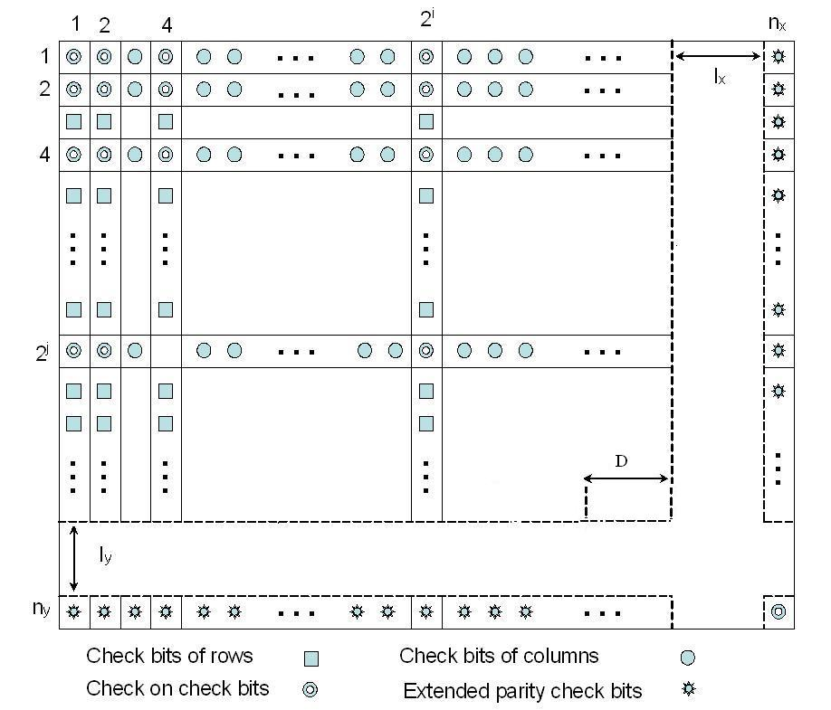
- — Shortened BTC (SBTC) structure

The basic sizes of the useful data payloads for different modulation type and encoding rate are displayed in Error: Reference source not foundError: Reference source not found. Table 3 gives the code parameters of SBTC for different data payload and coded block sizes.

Table 2—Useful data payload for one or multiple sub-channel
Modulation scheme | QPSK |  | 16QAM |  | 64QAM |  |  |  | Coded Bytes
Encoding Rae | 1/2 | 3/4 | 1/2 | 3/4 | 1/2 | 2/3 | ¾ | 5/6 | Coded Bytes
Allowed Data (Bytes) | 3 | - | - | - | - | - | - | - | 6
Allowed Data (Bytes) | 6 | 9 | 6 | 9 | - | - | - | - | 12
Allowed Data (Bytes) | 9 | - | - | - | 9 | 12 | - | 15 | 18
Allowed Data (Bytes) | 12 | 18 | 12 | 18 | - | - | - | - | 24
Allowed Data (Bytes) | 15 | - | - | - | - | - | - | - | 30
Allowed Data (Bytes) | 18 | 27 | 18 | 27 | 18 | 24 | 27 | 30 | 36
Allowed Data (Bytes) | 21 | - | - | - | - | - | - | - | 42
Allowed Data (Bytes) | 24 | 36 | 24 | 36 | - | - | - | - | 48
Allowed Data (Bytes) | 27 | - | - | - | 27 | 36 | - | 45 | 54
Allowed Data (Bytes) | 30 | 45 | 30 | 45 | - | - | - | - | 60
Allowed Data (Bytes) | 33 | - | - | - | - | - | - | - | 66
Allowed Data (Bytes) | 36 | 54 | 36 | 54 | 36 | 48 | 54 | 60 | 72

The encoding block size shall depend on the number of subchannels allocated and the modulation specified for the current transmission. Concatenation of a number of subchannels shall be performed in order to make larger blocks of coding where it is possible, with the limitation of not passing the largest block under the same coding rate. Table 4 specifies the concatenation of subchannels for different allocations and modulations. The parameters in Table 4 and 5 shall apply to the SBTC encoding scheme.
For any modulation and FEC rate, given an allocation of n subchannels, the following parameters are defined:
-j: parameter dependent on the modulation and FEC rates
-n: number of allocated subchannels
-k: floor (n/j)
-m: n modulo j
The rules used for subchannel concatenation are showed in Table 4.
Table 3 Code parameters for different data payload coded block sizes
Data Bytes | Coded Bytes | Constituent | Code parameters
Data Bytes | Coded Bytes | Constituent | Ix | Iy | D
3 | 6 | (15,11)(8,7) | 3 | 4 | 0
6 | 12 | (16,11) (8,7) | 4 | 0 | 1
9 | 12 | (16,15) (16,15) | 10 | 0 | 3
9 | 18 | (16,11) (16,15) | 4 | 4 | 5
12 | 18 | (8,7) (64,63) | 4 | 28 | 9
15 | 18 | (16,15) (16,15) | 7 | 0 | 0
12 | 24 | (16,11) (16,15) | 4 | 0 | 9
18 | 24 | (8,7) (32,31) | 2 | 0 | 11
15 | 30 | (15,11) (31,26) | 3 | 11 | 0
18 | 36 | (15,11) (31,26) | 3 | 7 | 8
24 | 36 | (16,15) (32,26) | 4 | 8 | 6
27 | 36 | (8,7) (64,63) | 2 | 16 | 19
30 | 36 | (16,15) (32,31) | 7 | 0 | 8
21 | 42 | (7,4) (63,57) | 0 | 15 | 0
24 | 48 | (16,11) (32,26) | 0 | 8 | 6
36 | 48 | (16,15) (63,57) | 8 | 15 | 6
27 | 54 | (32,26) (32,26) | 14 | 8 | 0
36 | 54 | (32,31) (31,26) | 8 | 13 | 11
45 | 54 | (8,7) (64,63) | 0 | 10 | 11
30 | 60 | (32,26) (32,26) | 2 | 16 | 0
45 | 60 | (16,15) (32,26) | 0 | 2 | 0
33 | 66 | (32,26) (32,26) | 8 | 10 | 24
36 | 72 | (32,26) (32,26) | 14 | 0 | 24
48 | 72 | (16,11) (64,63) | 0 | 28 | 1
54 | 72 | (16,15) (64,57) | 0 | 28 | 3
60 | 72 | (16,15) (64,63) | 7 | 0 | 24

Table 4- Subchannel concatenation rule
Number of suchannels | Subchannel concatenated
n <= j | One block of n subchannels
n > j | m = 0 | k blocks of j subchannels
n > j | m ≠ 0 | (k-l) blocks of j subchannels  One block of ceil ((m+j)/2 ) subchannels  One block of floor ((m+j)/2) subchannels
Table 5 - Encoding subchannel concatenation for different allocations and modulations
Modulation and rate | J
QPSK ½ | 12
QPSK ¾ | 6
16-QAM 1/2 | 6
16-QAM 3/4 | 6
64-QAM 1/2 | 4
64-QAM 2/3 | 4
64-QAM 3/4 | 2
64-QAM 5/6 | 4

