IEEE P802.22
Wireless RANs
Updated Figures for “Proposed Geolocation Text Additions to Section 6.15
Date: 2007-10-17
Author(s):
Name | Company | Address | Phone | email
Edward Au | Huawei & HKUST | Dept. of ECE, HKUST, Clear Water Bay, HK | 852-2358-8027 | eeedward@ust.hk
Winston Caldwell | Fox | 10201 W. Pico Blvd.  Los Angeles, CA 90064 | 310-369-4367 | Winston.caldwell@fox.com
Abstract
This submission contains updated figures for “Proposed Geolocation Text Additions to Section 6.15”.

Please refer to pages 2 and 4 for the latest figures of CPE and BS initialization procedures, respectively.

Notice: This document has been prepared to assist IEEE 802.22. It is offered as a basis for discussion and is not binding on the contributing individual(s) or organization(s). The material in this document is subject to change in form and content after further study. The contributor(s) reserve(s) the right to add, amend or withdraw material contained herein.

Release: The contributor grants a free, irrevocable license to the IEEE to incorporate material contained in this contribution, and any modifications thereof, in the creation of an IEEE Standards publication; to copyright in the IEEE’s name any IEEE Standards publication even though it may include portions of this contribution; and at the IEEE’s sole discretion to permit others to reproduce in whole or in part the resulting IEEE Standards publication. The contributor also acknowledges and accepts that this contribution may be made public by IEEE 802.22.

Patent Policy and Procedures: The contributor is familiar with the IEEE 802 Patent Policy and Procedures
<http://standards.ieee.org/guides/bylaws/sb-bylaws.pdf>, including the statement "IEEE standards may include the known use of patent(s), including patent applications, provided the IEEE receives assurance from the patent holder or applicant with respect to patents essential for compliance with both mandatory and optional portions of the standard." Early disclosure to the Working Group of patent information that might be relevant to the standard is essential to reduce the possibility for delays in the development process and increase the likelihood that the draft publication will be approved for publication. Please notify the Chair <Carl R. Stevenson> as early as possible, in written or electronic form, if patented technology (or technology under patent application) might be incorporated into a draft standard being developed within the IEEE 802.22 Working Group. If you have questions, contact the IEEE Patent Committee Administrator at <patcom@ieee.org>.
Replace Figure 2 “CPE network entry and initialization procedure” by the following figure.
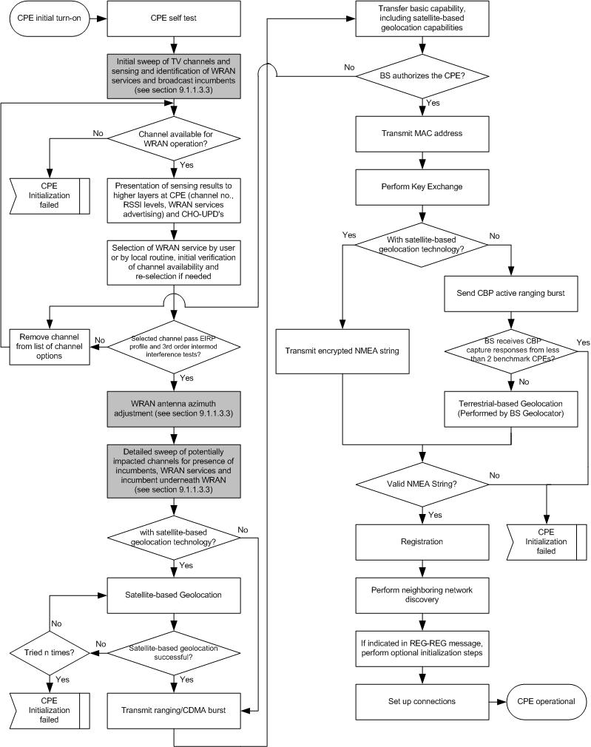
Replace Figure 3 “Obtaining downstream parameters” by the following figure.

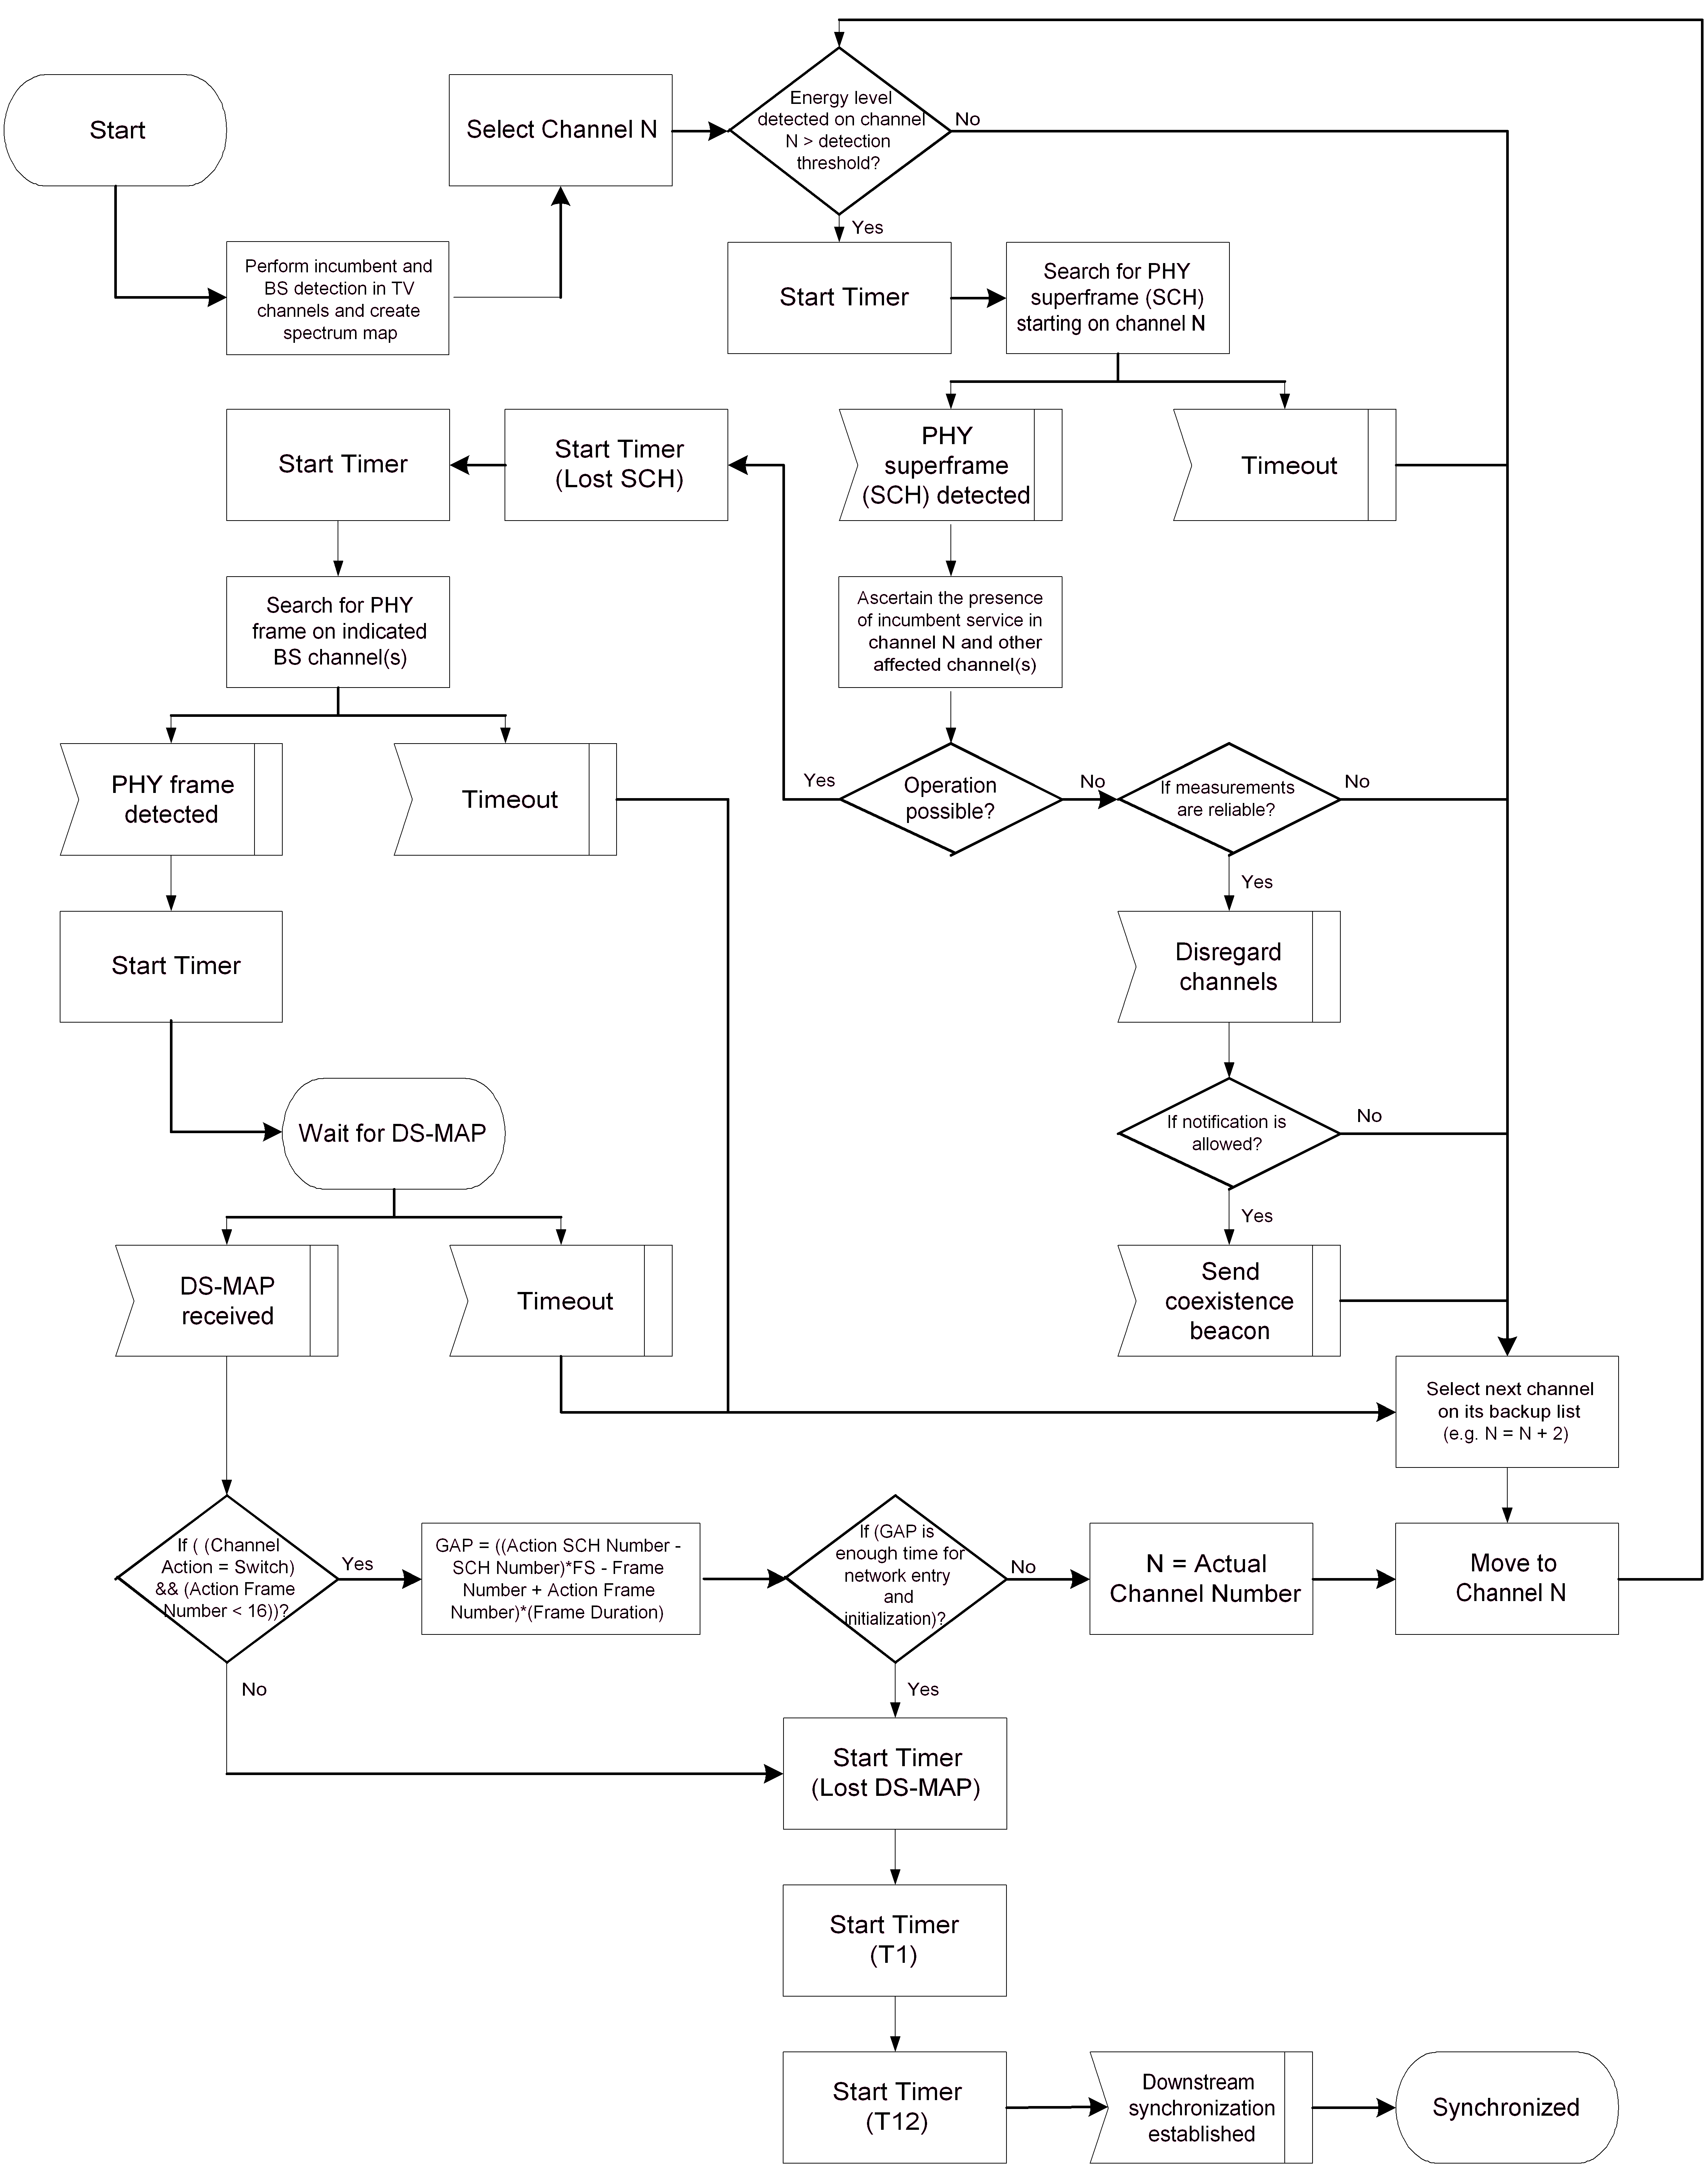

Replace Figure 1 “BS initialization procedure” of 07/0248r15 by the following figure, with the modifications summarized as follows.
- Removing all "Operation Completed" boxes;
- Rename the box "Build the list of available TV channels" to "Build the initial list of available TV channels using the geolocator and an incumbent database" to reflect the text in page 2 of 07/0248r15.
- Add a conditional box "Remove channel from list of available TV channels" and connect it in between the boxes "Perform incumbent detection" and "Perform Neighboring Network Discovery".

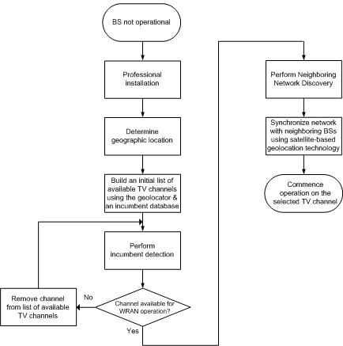
Replace Figure 7 by the following figure:

