IEEE P802.22
Wireless RANs
Wideband sensing
Date: 2007-07-10
Author(s):
Name | Company | Address | Phone | Email
Shridhar Mubaraq Mishra | UC Berkeley | 2108 Allston Way, Suite 200, Berkeley CA  94704 | +1-510-666-3135 | smm@eecs.berkeley.edu
Rahul Tandra | UC Berkeley | 267 Cory Hall  UC Berkeley  94720-1770 |  | tandra@eecs.berkeley.edu
Anant Sahai | UC Berkeley | 267 Cory Hall  UC Berkeley  94720-1770 |  | sahai@eecs.berkeley.edu

Abstract
This document builds the case for wideband sensing – in particular it proposes the use of shadowing correlation across frequencies to weed out unqualified users and enable cooperation between qualified users only. Such cooperation enables us to lower the system probability of harmful interference while also reducing the probability of missed opportunity.
Notice: This document has been prepared to assist IEEE 802.22. It is offered as a basis for discussion and is not binding on the contributing individual(s) or organization(s). The material in this document is subject to change in form and content after further study. The contributor(s) reserve(s) the right to add, amend or withdraw material contained herein.

Release: The contributor grants a free, irrevocable license to the IEEE to incorporate material contained in this contribution, and any modifications thereof, in the creation of an IEEE Standards publication; to copyright in the IEEE’s name any IEEE Standards publication even though it may include portions of this contribution; and at the IEEE’s sole discretion to permit others to reproduce in whole or in part the resulting IEEE Standards publication. The contributor also acknowledges and accepts that this contribution may be made public by IEEE 802.22.

Patent Policy and Procedures: The contributor is familiar with the IEEE 802 Patent Policy and Procedures
<http://standards.ieee.org/guides/bylaws/sb-bylaws.pdf>, including the statement "IEEE standards may include the known use of patent(s), including patent applications, provided the IEEE receives assurance from the patent holder or applicant with respect to patents essential for compliance with both mandatory and optional portions of the standard." Early disclosure to the Working Group of patent information that might be relevant to the standard is essential to reduce the possibility for delays in the development process and increase the likelihood that the draft publication will be approved for publication. Please notify the Chair <Carl R. Stevenson> as early as possible, in written or electronic form, if patented technology (or technology under patent application) might be incorporated into a draft standard being developed within the IEEE 802.22 Working Group. If you have questions, contact the IEEE Patent Committee Administrator at <patcom@ieee.org>.
1. Wideband Sensing

The initial motivation for wideband sensing came from the need to harvest many vacant channels in a short time. In this paper, we present a system level motivation for wideband sensing. A single radio cannot detect very low SNR signals due to uncertainty in noise+interference power – its sensitivity is limited by the SNR Wall [1], [2].

The goal is of course to simultaneously grab any available channel for our own system while avoiding harmful interference to primary receivers. A major conceptual challenge in engineering spectrum-sharing systems is to establish an appropriate reference for comparison against which to evaluate the performance of any proposed system. One approach is the "must detect at -116dbm" reference of [3] that is commonly used. The approach here is to instead use the "no-talk-zone" power-control rule baseline of [4] where the reference system has perfect access to both the position of the secondary user in question and the primary transmitter. The advantage of using this reference is that it better enables us to refine the model of the wireless environment and leverage this understanding to get significant performance gains.
Gains obtained even indirectly through better modeling of the environment are vulnerable to being mirages that depend inordinately on the detailed assumptions of the model. To be robust, it is important that the model be appropriately coarse. The underlying appeal of the 90%/10% spec on the -116dbm reference is that it seems robust in that it implicitly only depends on certain monotonicity assumptions of detector performance at higher signal strengths and an appeal to the certain rarity of such weak primary signals in situations where harmful interference is possible. In our case, the approach to coarse modeling is more explicit and allows us to robustly
prevent harmful interference while still allowing performance gains from cooperation.

Conservative cooperation among such sensitivity limited radios (using the “OR” rule) can further guarantees made to the primary while impacting the ability of the cognitive radio system to find vacant channels. A major reason that cooperation diminishes a system’s ability to find vacant channels is that there is no mechanism of distinguishing a ‘qualified’ radio from an ‘unqualified’ one. A ‘qualified’ radio is one that has a very good channel to the primary. The ‘unqualified’ radio on the other hand suffers from bad fades hence cannot reliably detect the primary (if such a radio declared a primary to be present, odds are that noise triggered the radio into falsely believing that a primary was present). Hence the natural question is: how can a radio determine its shadowing environment and hence be certain that it is a ‘qualified’ radio? To understand our approach in solving the problem, let’s visualize a very simple scenario. We have two sensing radios trying to detect a TV station -- the first radio is on the roof top while the second is in the basement. The radio in the basement is deeply shadowed and hence cannot reliably detect the primary. This is an example of an ‘unqualified’ radio. How do we distinguish between a radio on the roof versus a radio in the basement? The radio on the roof can probably see many more primary transmitters (for example it can detect cellular base station transmissions as well as other TV stations). In contrast, the radio in the basement cannot locate other primary users since all transmission are deeply shadowed in the basement. Hence, sensing other primary users (or transmitters we know to be always on -- called anchors in the rest of this document) can help us weed out ‘unqualified’ radios. Detecting a large number of primary transmitters/anchors requires a wideband sensor.

2. Preliminaries

We first define two metrics which we will use to characterize and compare the performance of various detection algorithms.
- Probability of Harmful Interference (P_{HI}): The probability that a cognitive radio system interferes with the primary user. For a network composed of a single radio with the primary signal at a given Signal-to-Noise ratio (SNR), this probability is the same as the probability of missed detection (P_{MD}) in classical detection theory (This definition assumes that a radio that mis-detects the primary will always interfere with its receivers). But, even for a single radio, the probability of harmful interference goes a step beyond the probability of missed detection in characterizing the guarantees made to the primary user -- it incorporates characteristics of the propagation environment into the guarantee.
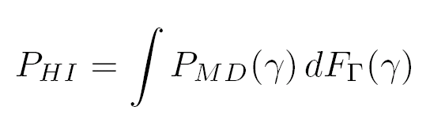

Here γ is the received Signal to noise ratio (SNR) of the primary signal written in dB scale. The received SNR is random and F_{Γ}(γ) is its cumulative density function (CDF).

- Probability of Missed Opportunity (P_{MO}): The probability that a cognitive radio system does not use a vacant channel. For a single radio, this probability is the same as the probability of false alarm (P_{FA}) in classical detection theory.

2. Single Radio

Having defined the two probability measures P_{HI} and P_{MO} we now compare the performance of various detection algorithms by plotting the optimal tradeoff curve between P_{HI} and P_{MO}. The optimal tradeoff curve can be obtained as follows: we first plot the set of possible achievable points (P_{HI}, P_{MO}) using a given detection algorithm. This constitutes the achievable region for that detection algorithm. The boundary of this achievable region will give us the optimal tradeoff. We call this optimal tradeoff curve the detection frontier. If the achievable region of ‘detection algorithm A’ is a subset of the achievable region for ‘detection algorithm B’, then we can claim that ‘detection algorithm B’ strictly out performs ‘detection algorithm B’.

We now give the base line detector – ‘random coin-tossing detector’. We toss a coin and if it turns Heads we declare that the primary is present, otherwise we declare that the primary is absent. Clearly, the set of achievable points (P_{HI}, P_{MO}) satisfy P_{HI} + P_{MO} = 1. The frontier for this detector is show in Figure 1(a). This gives us the baseline tradeoff between P_{HI} and P_{MO}.

The detection frontier for a single radio narrowband energy detector is shown in Figure 1. In Figure 1(b) we have plotted the P_{MO} versus P_{HI} curve assuming nominal noise energy of -96 dBm and an uncertainty of 1 dB. In this case we see that the performance at low P_{HI} is significantly worse as compared to completely known noise statistics. To achieve low P_{HI} we are forced to set the detector threshold within the noise uncertainty region. For this detector threshold the worst case P_{MO} is much higher. We can clearly see that for low P_{HI} this detector performs worse than the simple coin-tossing detector. This reiterates the fact that narrowband energy detection is non-robust to uncertainty in the noise distribution.

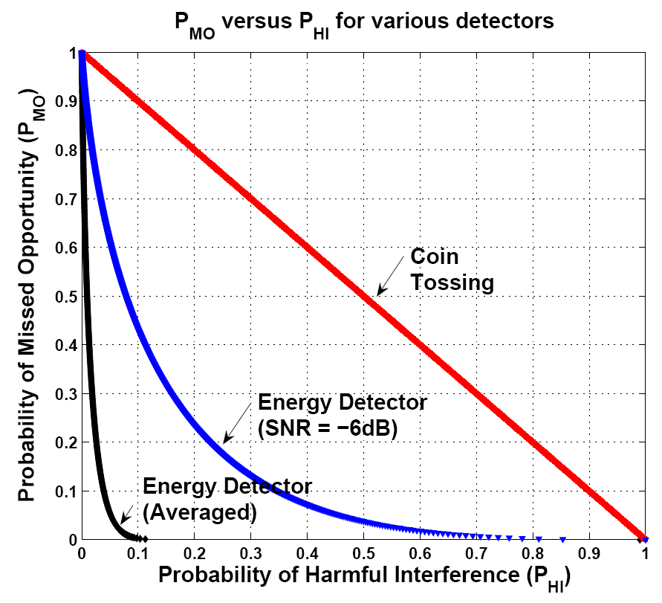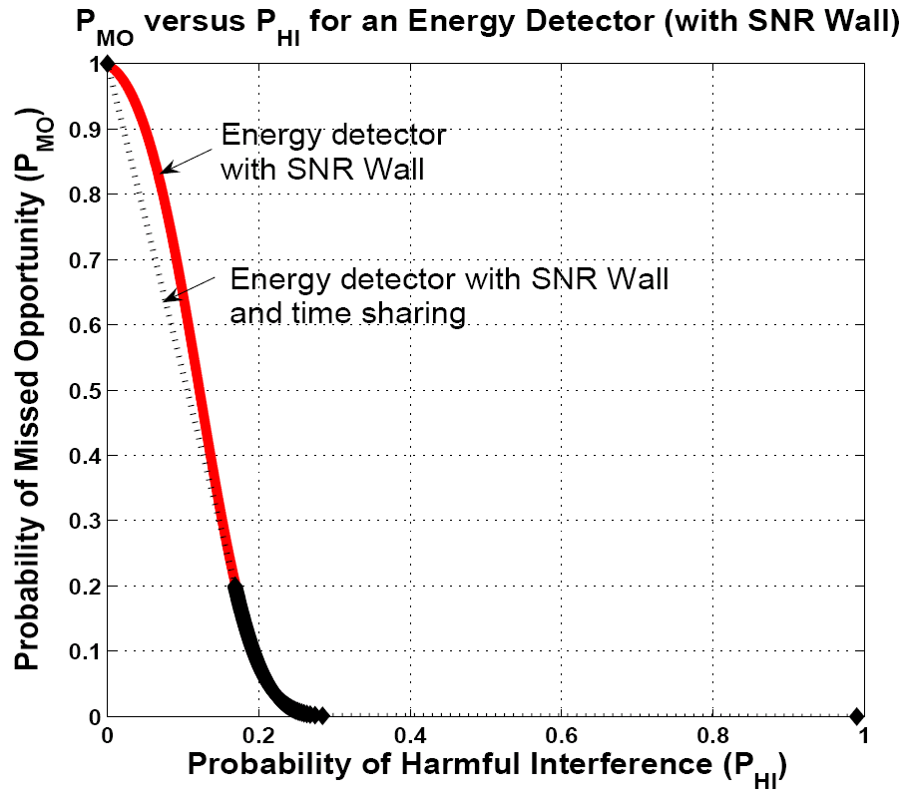
(a) (b)

Figure 1:(a) P_{MO} versus P_{HI} for various detectors with completely known noise characteristics (b) P_{MO} versus P_{HI} for an energy with 1dB noise uncertainty

3. Cooperation

In a multi-radio system, we are interested in the probability of harmful interference of the system (P_{HI}) and probability of missed opportunity of the system (P_{MO}). This quantity depends on the correlation between the received SNR of the different radios and the rule used to combine the results of the radios.

Figure 2 shows the effect of radios cooperating using the “OR” rule – system declares the primary to be present if any of the radios claims that the primary is present. P_{HI} decreases exponentially with the number of radios, while P_{MO} increases exponentially with the number of radios. Furthermore, when the assumption of independence between radios breaks down, P_{HI} reduces considerably while P_{MO} remains the same.

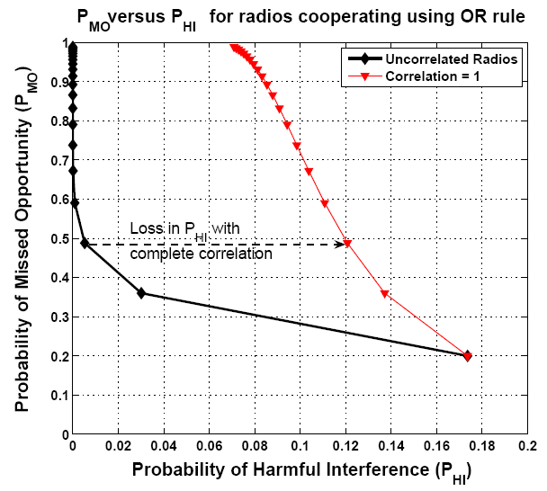

Figure 2: Performance characteristics of multiple cooperating radios using the OR rule

4.0 Shadowing correlation across frequency

Anchor: An anchor is a node that is always ‘on’ and is collocated with the primary of interest. While many TV transmitters are collocated (for example, the Sutro tower in San Francisco hosts 28 different TV stations [3]) the always ‘ON’ assumption is a simplification to facilitate analysis.

The relevant question is: what is the correlation between the shadowing in the frequency of interest to the shadowing in an adjacent band?

Results from UWB experiments: In order to study shadowing correlation among frequencies, we analyzed the measurement data from UWB channel characterization experiments performed by Kunish and Pamp [4]. In their experiments, the receiver was fixed while the transmitter was moved on a straight line track in steps of 1 cm with a total displacement of 150cm. For each location, the transmitter would transmit sinusoids on frequencies from 1GHz to 11GHz in steps of 62.5MHz. The received signal was stored for analysis. The measurements were repeated on 30 different parallel tracks spaced 1cm apart. Furthermore, the measurements were conducted for various configurations: Line-Of-Sight (LOS), where the transmitter and receiver had a line of sight for all measurements, Non-Line-Of-Sight (NLOS) where the receiver was always obstructed from the transmitter for all measurements, and partial Line-of-Sight ((N)LOS) where the transmitter would move from LOS to NLOS conditions. In Figure 3(a)-(c) the received power on two different frequencies (1 GHz and 1.0625 GHz) is plotted for the LOS, (N)LOS, NLOS configurations. The received power is also plotted after averaging out the multipath. Similarly, Figure3(d)-(f) show the received power on two frequencies that are further apart (1 GHz and 2 GHz) for LOS, (N)LOS and NLOS configurations.

There are a few things to note:

- The range of received power for the LOS configuration is a lot smaller than for other configurations (15dB versus 30dB). Furthermore, multipath effects are a lot reduced under LOS conditions (the multipath is Ricean rather than Rayleigh). Under these conditions, while the actual correlation between the received powers at the two frequencies is low, we can still make very strong statements about the received
- Power on the second frequency once we have observed the received power on the first frequency. For example, if we see received power (without multipath) on 1 GHz to be above -54dBm, then the chance of seeing the received power on 2 GHz to be below -58dBm is very small.
- The partial LOS ((N)LOS) configuration shows very high correlation as is evident by the nearly diagonal joint density (with the multipath removed). Initially, the transmitter and receiver are in line of sight of each other but that changes as the transmitted is moved. This shows up as increased variability in the multipath.
- Frequencies with are closer together are more correlated as opposed to frequencies that far apart (Compare the correlation between 1GHz and 1.0625GHz, and that between 1GHz and 2GHz).

The model:

For the sake of the analysis we assume that the received SNR for the anchor (γ_{A}) and the primary (γ_{P}) are as follows:

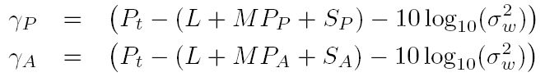

Where Pt is the transmit power in dBm, L is path loss in dB, MP_{A} and MP_{P} is the multipath for the anchor and primary respectively, S_{A} and S_{P} is the shadowing for the anchor and primary respectively, and σ²_{w} is the noise power in mW. We assume that S_{P} and S_{A} are log-normal. Furthermore we assume that they are correlated with correlation coefficientρ, where 0 ≤ ρ ≤ 1. Similarly, MP_{P} and MP_{A} are the shadowing seen by the primary and the anchor signals respectively. We also assume that these are independent and also log-normally distributed. Hence for our discussion, the received powers (in dB) have a normal distribution with mean 3.2 dB and standard deviation 5.5dB [5].

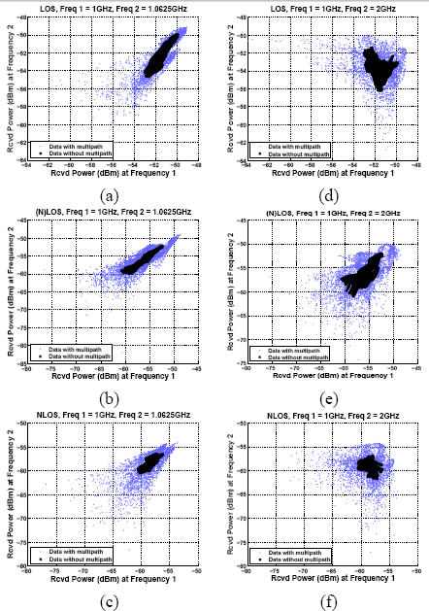

Figure 3: (a-c) Received power at 1GHz and 1.0625GHz in LOS, (N)LOS and NLOS configurations (d-f) Received power at 1GHz and 2GHz LOS, (N)LOS and NLOS configurations.

5.0 Performance of wideband sensing

We now describe our algorithm for wideband energy detection.

• Run an energy detector for each of the primary and anchor band.

– Let the number of time samples used for energy detection be M. Start with setting the energy detection thresholds for the primary and anchor bands. Call them λ_{P} and λ_{A} respectively.
– Compute the empirical estimate of the energy in each band. Let T(Y_{A}) denote this test-statistic for the anchor, and T(Y_{P}) be the corresponding test statistic for the primary band. Now compare these test-statistics to the corresponding thresholds.
– Let H_{P,1} denote the decision when the energy estimate in the primary band exceeds λ_{P}, and H_{P,0} otherwise. Similarly, declare H_{A,1} or H_{A,0} for the anchor band.

Given the individual decisions in each band, we make a global decision of whether the primary is present or absent. This decision is made as shown in Table I. Here H₁ denotes the global decision that the primary band is used and H₀ denotes the global decision that the primary band is empty.

Anchor band decision | H_{A,1} | H_{A,1} | H_{A,0} | H_{A,0}
Primary band decision | H_{P,1} | H_{P,1} | H_{P,0} | H_{P,0}
Global Decision | H₁ | H₀ | H₁ | H₁

Table 1: Wideband Detection Algorithm

Now P_{HI} and P_{MO} can be calculated as:

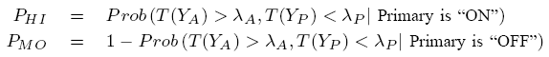

These expressions can be rewritten as:

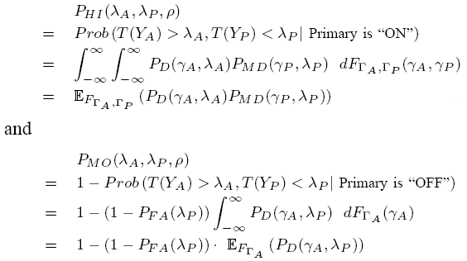

As we vary them λ_{P} and λ_{A}, we trace the wideband frontier which is compared with the narrowband frontier in Figure 4. The figure clearly shows that wideband energy detection is much better than its narrowband counterpart. In particular, the gains are significantly higher for low values of P_{HI}.

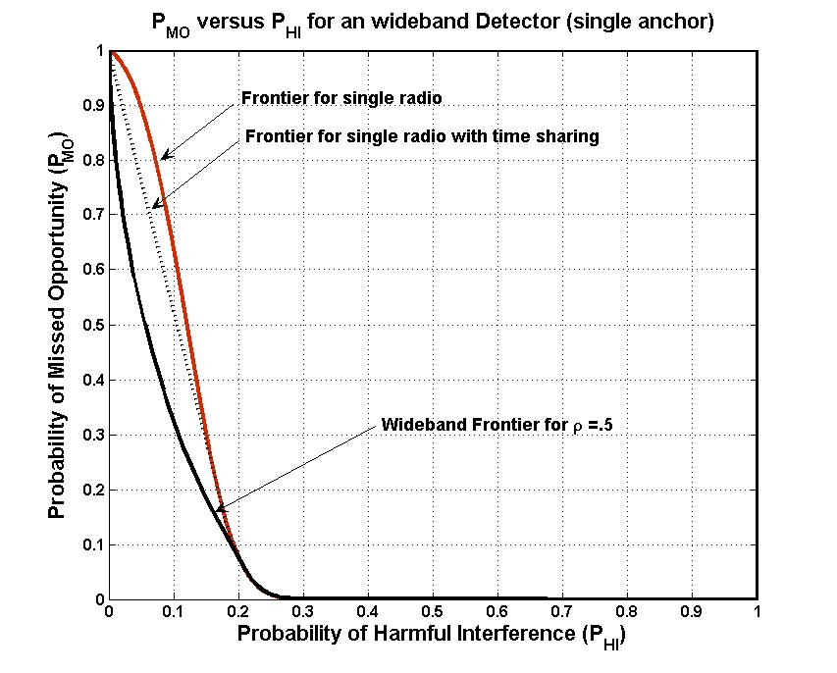
Figure 4: Performance characteristics of a single wideband radio with a single anchor. The wideband detector outperforms the narrowband energy detector. In particular, for low P_{HI} , the P_{MO} for the wideband detector is much lower than the P_{MO} for the narrowband detector. This can be seen from the slope of the frontiers at (0, 1).

6.0 Cooperation among wideband sensors

As with narrowband sensing we could use the simple “OR” rule for wideband sensors too. Since the wideband sensor exhibits better P_{MO} versus P_{HI} characteristics than a narrowband sensor, cooperation will start with a better point and hence perform better than cooperation among radios using narrowband energy detection.

However, this form of cooperation however ignores the fact that wideband detection can also allow us to weed out unqualified users. We now modify the wideband detection algorithm to give us additional cooperative gains. We introduce the notion of abstention (denoted by A in Table 2). If a radio doing wideband detection does not see the anchor node, then its detection results for the primary band are unreliable. Hence, in those cases the detector declares ‘abstain’. All the radios which abstain are considered ‘unqualified’ for voting during cooperation, i.e., we use the “OR” rule for detection only among radios which don’t abstain.

Anchor band decision | H_{A,1} | H_{A,1} | H_{A,0} | H_{A,0}
Primary band decision | H_{P,1} | H_{P,1} | H_{P,0} | H_{P,0}
Global Decision | H₁ | H₀ | A | A

Table 2: Wideband Detection Algorithm modified for cooperation

Assuming spatial independence and symmetry in the joint distributions, the system probability of harmful interference (P_{HI}^{WB}) and system probability of missed opportunity (P_{MO}^{WB}) can be specified as:
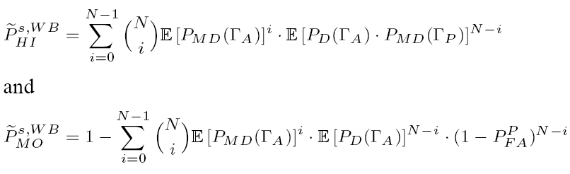

These are illustrated in Figure 5.

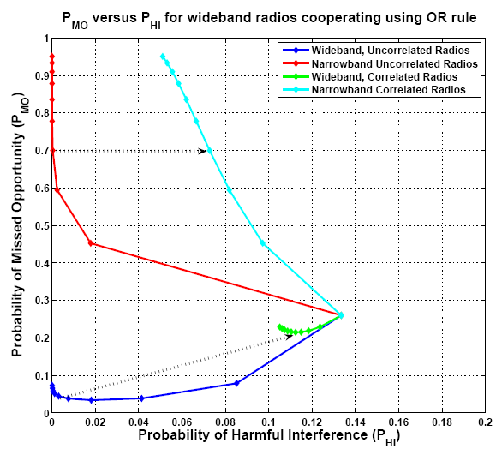

Figure 5: Impact of voting abstentions on cooperative gains. While the number of cooperating radios is limited, ternary voting provides gains in both P_{HI} and P_{MO} while using the OR rule. This is because ternary voting allows us to weed out `unqualified' radios from the decision process.

When the radios do wideband sensing without abstentions P_{HI} drops with cooperation, but at the cost of increased P_{MO}. On the other hand, with abstentions P_{HI} drops with increasing number of cooperating users as before. However, P_{MO} also drops with increase in the number of cooperating users (see Fig. 5). P_{MO} decreases as number of users increases, reaches a minimum for a critical number of cooperating users and then increases again after that critical number. This shows that with abstentions, we can get gains in P_{HI} without losing performance.

- Conclusions

The naive solution to the problem of sensitivity limited radios is to consider the decision of a variety of radios with the hope that all radios seeing a bad fade is an extremely rare event. Unfortunately, radios cooperating using the OR rule adversely effect their own ability to use opportunities. The main reason for this is the ‘every radio is alike’ philosophy which does not distinguish between ‘qualified’ radios (radio that have a good channel to the primary) from ‘unqualified’ ones.

In this paper we proposed wideband sensing as a mechanism to qualify radios. In the wideband regime, a radio is able to sense many primary transmitters. Taking co-located ‘anchor’ (transmitters that are always on) transmitters as an example, we have shown that a wideband radio detecting a single primary and a anchor can greatly increase its achievable region of operation (probability of harmful interference (P_{HI}) versus probability of missed opportunity (P_{MO}) curve). Such a wideband radio does strictly better than a narrowband radio.

Furthermore, this achievable region increases as the frequency correlation between the anchor transmitter and the actual primary is increased. Wideband sensing allows radio to cast their vote using a ternary system (primary present, primary absent, abstain). This enables the system to cooperate only between ‘qualified’ radios (radios that do not abstain). Under appropriate constraints, ternary voting can lead to better P_{HI} and P_{MO} of the system. Non-zero value of probability of false alarm (P_{FA}) of primary detection limits the number of radios that we can cooperate with, while still getting gains in both P_{HI} and P_{MO}.

- References

- R. Tandra and A. Sahai, ‘Fundamental limits on detection in low SNR under noise uncertainty’, In proceedings of the WirelessCom ‘05 Symposium on Signal Processing, 2005.
- D. Cabric, A. Tkachenko, and R. W. Brodersen, ‘Experimental study of spectrum sensing based on energy detection and network cooperation’, In proceedings of the ACM 1st International Workshop on Technology and Policy for Accessing Spectrum (TAPAS), 2006.
- G. Chouinard, D Cabric, M. Ghosh “Sensing Thresholds”, IEEE 802.22-06/0051r3, May 2006.
- N. Hoven and A. Sahai, "Power scaling for cognitive radio," WirelessCom 2005, June 2005.
- Digital Telivision/HDTV channel list: San Francisco Bay Area. http://www.choisser.com/channels.html
- J. Kunisch and J. Pamp, ‘Measurement results and modeling aspects for the UWB radio channel’, In Ultra Wideband Systems and Technologies, May 2002.
- Geralad Chouinard, ‘DTV signal stochastic behavior at the edge of the protected contour and resulting probability of detection from various sensing schemes’, IEEE 802.22 Meeting Documents, March 2007.

