IEEE P802.22
Wireless RANs
Improved RTS and ANP sequences to DQPSK symbols mapping
Date: 2007-07-16
Author(s):
Name | Company | Address | Phone | email
David Mazzarese | Samsung Electronics | Korea | +82 10 3279 5210 | d.mazzarese@samsung.com
Baowei Ji | Samsung Telecom. America | USA | +1-972-761-7167 | bji@sta.samsung.com
Jinxia Cheng | Samsung Electronics | China | +86 10 6439 0088 3133 | jinxia.cheng@samsung.com
Shan Cheng | Samsung Electronics | Korea | +82 31 279 7557 | cheng.shan@samsung.com
Euntaek Lim | Samsung Electronics | Korea | +82 31 279 5917 | et.lim@samsung.com

Abstract
[We present our arguments to change the convolutional code in 802.22.1 to a systematic recursive convolutional code.]
Notice: This document has been prepared to assist IEEE 802.22. It is offered as a basis for discussion and is not binding on the contributing individual(s) or organization(s). The material in this document is subject to change in form and content after further study. The contributor(s) reserve(s) the right to add, amend or withdraw material contained herein.

Release: The contributor grants a free, irrevocable license to the IEEE to incorporate material contained in this contribution, and any modifications thereof, in the creation of an IEEE Standards publication; to copyright in the IEEE’s name any IEEE Standards publication even though it may include portions of this contribution; and at the IEEE’s sole discretion to permit others to reproduce in whole or in part the resulting IEEE Standards publication. The contributor also acknowledges and accepts that this contribution may be made public by IEEE 802.22.

Patent Policy and Procedures: The contributor is familiar with the IEEE 802 Patent Policy and Procedures
<http://standards.ieee.org/guides/bylaws/sb-bylaws.pdf>, including the statement "IEEE standards may include the known use of patent(s), including patent applications, provided the IEEE receives assurance from the patent holder or applicant with respect to patents essential for compliance with both mandatory and optional portions of the standard." Early disclosure to the Working Group of patent information that might be relevant to the standard is essential to reduce the possibility for delays in the development process and increase the likelihood that the draft publication will be approved for publication. Please notify the Chair <Carl R. Stevenson> as early as possible, in written or electronic form, if patented technology (or technology under patent application) might be incorporated into a draft standard being developed within the IEEE 802.22 Working Group. If you have questions, contact the IEEE Patent Committee Administrator at <patcom@ieee.org>.

Introduction

In this section, we present the our motivations for recommending to change the convolutional code in the 802.22.1 draft [1] to a systematic recursive convolutional code. A systematic code has the property that the uncoded information bits are present in the codeword, whereas the uncoded information bits cannot be seen without decoding the codeword with non-systematic codes. As a consequence, the receiver of an 802.22.1 beacon must decode the MSF1 field to recover the beacon frame MSF1.

The code currently used in the 802.22.1 draft [1] is the same as currently specified in the 802.22 working document [2]. This is the reason why this code was chosen. It offers approximately a 6 dB gain at the SNR achieved by a beacon at the edge of the detection zone, which happens to be what is needed by 802.22.1. the 802.22 convolutional code has been chosen for the reason that it is already adopted in the 802.16 standard.

It is well known in the art of coding [3] that the best systematic recursive convolutional codes have about the same performance as the best non-systematic convolutional codes. Systematic codes slightly beat non-systematic codes at low SNR, while non-systematic codes lightly beat systematic codes at high SNR.

Benefits

Using a systematic convolutional code for the 802.22.1 beacon would offer the following advantages, that cannot be obtained with the current non-systematic convolutional code:

- The MSF1 bits can be recoved by a receiver without having to decode the encoded codeword. This will be possible in a limited area around the beacon. Note that other parts of the beacon frame (MSF2 and MSF3) are also uncoded, for the reason that they are mostly useful in inter-beacon communication. Therefore, for this types of communications, it is also acceptable to receive the MSF1 field without encoding.

- By sending the uncoded information bits in the first half of MSF1, the whole beacon information can be sent over the air in half the amount of time that is currently possible in [1]. If a CPE is closed enough to successfully receive an uncoded beacon frame without FEC, which is the case that will encountered most often in real deployments, it should be able to listen only for about 15 ms, instead of about 30 ms currently. The CPE can determine this fact beforehand, since it must have already detected the beacon sync burst, and obtained an estimate of the received SNR of the beacon.

It is known that 802.22.1 has features that can facilitate over-the-air planning of sub-channel frequencies assignements in wireless microphone systems, thanks to inter-beacon communications. These communications do not need encoding, since they are short range. If an 802.22.1 transmitter and receiver is embedded in a wireless microphone of future generation, it needs to be simple and economic. An FEC encoder and decoder for a 64 state convolutional code, although off-the-shelves nowadays, would still incur a complexity that is not necessary in these types of devices. First of all, the wireless microphones would not operate at the maximum power allowed by Part 74 rules, as it is the case today. Therefore, an 802.22.1 beacon embedded in a wireless microphone would not be there for the purpose of protecting the Part 74 wireless microphone, but solely for frequency coordination and inter-beacon communication. Therefore, it does not need to meet the PER requirements at the edge of the detection zone at low SNR, thus is does not need FEC. It would be typical that in a network of such devices, another independent higher power beacon would be the PPD and make sure that all the wireless microphones are being protected.

The convolutional code of [1] was chosen because it is the same as the one used in the 802.22 working document [2], with the argument that a single Viterbi decoder would be needed in the CPE and the BS. A systematic convolutional code can be chosen with the same number of states as the current convolutional code without any penalty in performance. Moreover, it may be appropriate to adopt the same systematic convolutional code in the 802.22 standard as in the 802.22.1 standard.

Therefore, we recommend to use a systematic convolutional code, for the reasons stated above, and to make it optional to allow for a cost reduction of certain devices that do not need the functionality of the FEC. It is understood that a beacon manufactured for the primary purpose of protection of Part 74 devices will need to include that option. To support the optional feature, we propose to add one bit in the PHR to signify whether the packet is using FEC or not on MSF1. If FEC is not being used on MSF1, since the FEC rate should 1/2, the information bits will simply be sent twice consecutively, which still allows for soft combining and improved detection (repetition coding).

While we give an example of performance of a systematic code vs. the non-systematic code currently specified in [1], we do not make an explicit proposal to use this precise code in 802.22.1. 802.22.1 may elect to choose this code, or another code, as appropriate. At this point, we would recommend the adoption of the feature that the convolutional code should be systematic and optional. If the WG accepts to include this feature in the standard, work will need to be done to exactly specify this code. This is mature technology and therefore it is feasible to find such a code.

Performance

We compare the non-systematic convolutional code of [1] with the systematic recursive convolutional code using the same generator polynomials (171 133), and where the feedback polynomial is equal to 171 (in octal). These two codes have the same code rate of 1/2, the same constraint length and the same number of states (64). Therefore, their Viterbi decoders have exactly the same complexity and structure. 100,000 packets of 136 bit-long codewords were sent for each point of the curves. A packet error rate of 1% would correspond approximately to a BER slightly higher than 10⁻⁵. This BER is achieved at about the same SNR for both codes. There would be no penalty to adopt a systematic convolutional code for 802.22.1.

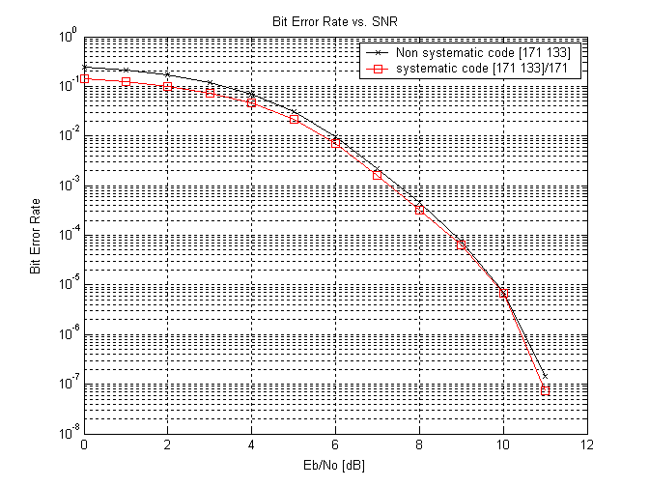

Proposed changes to [1]

The FEC section 6.8.2 would need to be modified with the description of the systematic convolutional code. An ad-hoc group should be tasked to provide this section, if the systematic code is adopted by the WG. If puncturing is needed to make the rate of the code 1/2, only parity bits should be punctured, but not the information bits.

Other changes to support this optional feature are:
- Add an FEC indication bit in the PHR, with repetition 3.
- Identify the FEC as optional in the text wherever appropriate.
- Add a paragraph in Annex B3 to recommended the use of FEC to offer the level of protection for which the standard has been designed, in any device that is intended not solely for inter-beacon communication.
- Send the information bits + CRC1 in the first half of MSF1.
- If FEC is present: set the FEC indication bit to 1 in the PHR, and send the parity bits in the second half of MSF1.
- If FEC is not present: set the FEC indication bit to 0 in the PHR, and send the information bits + CRC1 again in the second half of MSF1.

References

[1] Part 22.1: Enhanced Protection for Low-Power, Licensed Devices Operating in Television Broadcast Bands, P802.22.1-D1, May 2007.

[2] IEEE P802.22™/D0.3 Draft Standard for Wireless Regional Area Networks Part 22: Cognitive Wireless RAN Medium Access Control (MAC) and Physical Layer (PHY) specifications: Policies and procedures for operation in the TV Bands, May 2007.

[3] Sergio Benedetto and Ezio Biglieri, Principles of Digital Transmission with Wireless Applications, Kluwer Academic, 1999.

