IEEE P802.22
Wireless RANs
Text on Dual FPLL pilot sensing – For Informative Annex on Sensing Techniques
Last Updated - Date: 2007-06-15
Author(s):
Name | Company | Address | Phone | email
Gene Turkenich  Vasanth Gaddam | Philips Research North America | 345 Scarborough Road, Briarcliff Manor, NY 10510 | (914) 945-6370  (914) 945-6424 | gene.turkenich@philips.com  vasanth.gaddam@philips.com

Abstract

This document contains the text on the Dual FPLL pilot sensing techniques for the informative annex on sensing techniques.

Notice: This document has been prepared to assist IEEE 802.22. It is offered as a basis for discussion and is not binding on the contributing individual(s) or organization(s). The material in this document is subject to change in form and content after further study. The contributor(s) reserve(s) the right to add, amend or withdraw material contained herein.

Release: The contributor grants a free, irrevocable license to the IEEE to incorporate material contained in this contribution, and any modifications thereof, in the creation of an IEEE Standards publication; to copyright in the IEEE’s name any IEEE Standards publication even though it may include portions of this contribution; and at the IEEE’s sole discretion to permit others to reproduce in whole or in part the resulting IEEE Standards publication. The contributor also acknowledges and accepts that this contribution may be made public by IEEE 802.22.

Document Policy and Procedures: The contributor is familiar with the IEEE 802 Document Policy and Procedures
<http://standards.ieee.org/guides/bylaws/sb-bylaws.pdf>, including the statement "IEEE standards may include the known use of document(s), including document applications, provided the IEEE receives assurance from the document holder or applicant with respect to documents essential for compliance with both mandatory and optional portions of the standard." Early disclosure to the Working Group of document information that might be relevant to the standard is essential to reduce the possibility for delays in the development process and increase the likelihood that the draft publication will be approved for publication. Please notify the Chair <Carl R. Stevenson> as early as possible, in written or electronic form, if documented technology (or technology under document application) might be incorporated into a draft standard being developed within the IEEE 802.22 Working Group. If you have questions, contact the IEEE Document Committee Administrator at <patcom@ieee.org>.

- Dual FPLL pilot sensing algorithm

The Dual FPLL sensing techniques described in this section are non-blind (ATSC-specific) sensing techniques that meet the sensing sensitivity requirements of 802.22 and hence are classified as a fine sensing technique.
The sensor system, presented in Fig 1, employs two Frequency Tracking Blocks (FTBs). These blocks are

designed to track an a priori known frequency of the ATSC pilot, f_{pilot} , within a signal source, an Intermediate Frequency (IF) at the TV tuner output. The outputs, F₁ and F₂ , are frequencies, that FTBs are locked into at the given moment. In the absence of the pilot, or when the pilot energy is insufficient, the outputs, F₁ and F₂ , maintain their initial input preset values, F_{ini_1} and F_{ini_2,} respectively. These preset values are selected to be:

F_{ini_1 =} f_{pilot} + 30 kHz;
F_{ini_2 =} f_{pilot} - 30 kHz;

The FTBs are initially and thereafter periodically (period = t_{set}) preset to their respective F_{ini} values. The time period, t_{set} , is set to anywhere between 30 and 100 msec. The detection criterion is based upon a degree of convergence of these FTBs on the same spectral position of the ATSC pilot within preset time period. The detection is true, when at the end of period, t_{set} ,

|F₁ - F₂| < F_{thresh}, where F_{thresh} is typically set to 20~30 kHz.

The above equation shows that, though the described sensor system is architecturally synchronous, the actual detection criterion does not require a complete f_{pilot} acquisition.

Fig 2 outlines a possible architecture for each of the required two FTB blocks in Fig 1. A Frequency-Phase Locked Loop (FPLL) in Fig 2 is implemented as a version of the Costas Loop. In this implementation the input/output angular values, φ_{ini} / φ_{inc ,} are used as a convenient functional equivalents of the frequencies, F_{ini} / F_{x} , in Fig 1. The output, φ_{inc}, needs to be fed into the Decision Block (Fig 1) as one of two required inputs.

A signal from the ADC contains a pilot (tone) nominally located at f_{pilot}. This signal is converted into a complex form after being multiplied by two sine waves, shifted by 90 degrees, from a Numerically Controlled Oscillator (NCO). An NCO is, in essence, a sine/cosine lookup table that is fed by a modulo 2π accumulator. The NCO input receives a phase increment, φ_{inc} , that is added to the accumulator on each system clock. In the described implementation the system clock is at a constant frequency, F_{clk}. When FPLL is completely locked on the incoming tone, f_{pilot} , the NCO advances by an angle equal to 2π/( F_{clk} / f_{pilot}) in each system clock, F_{clk}, period.
The Real (Re) and Imaginary (Im) parts of the complex signal are fed into the phase detector. The phase detector contains two identical Low Pass Filters LPFa, and an LPFb, that is needed to achieve a phase shift. The LPFa filters define the lock-in range of the FPLL, which is set to +- 100 kHz to accommodate possible deviations of the ATSC pilot position. The output of the detector contains the phase error value, both a sign and a magnitude.
The Loop Filter integrates the phase error value to derive the frequency error in the Integrator branch. The frequency error is a difference between the initial preset frequency, set by , φ_{ini} , and the actual pilot frequency in the incoming signal. The Proportional branch adjusts the magnitude of the phase error. The combined phase/frequency error data are added to an initial phase increment, φ_{ini} , to arrive at φ_{inc} , a final phase increment value , that defines the NCO output frequency.

- Performance of the algorithms

Figure 1 and Figure 2 show the convergence behaviour of the two FTBs, each set to a different initial frequency, in the presence of an ATSC DTV signal with a low SNR and very low SNR respectively, while Figure 3 shows the FTB outputs in the absence of an ATSC DTV signal. It can be observed from the plots that the FTB outputs start converging within few milliseconds in the presence of DTV signal and depending on the threshold value a decision can be made as early as 10 ms from the beginning of sensing process.
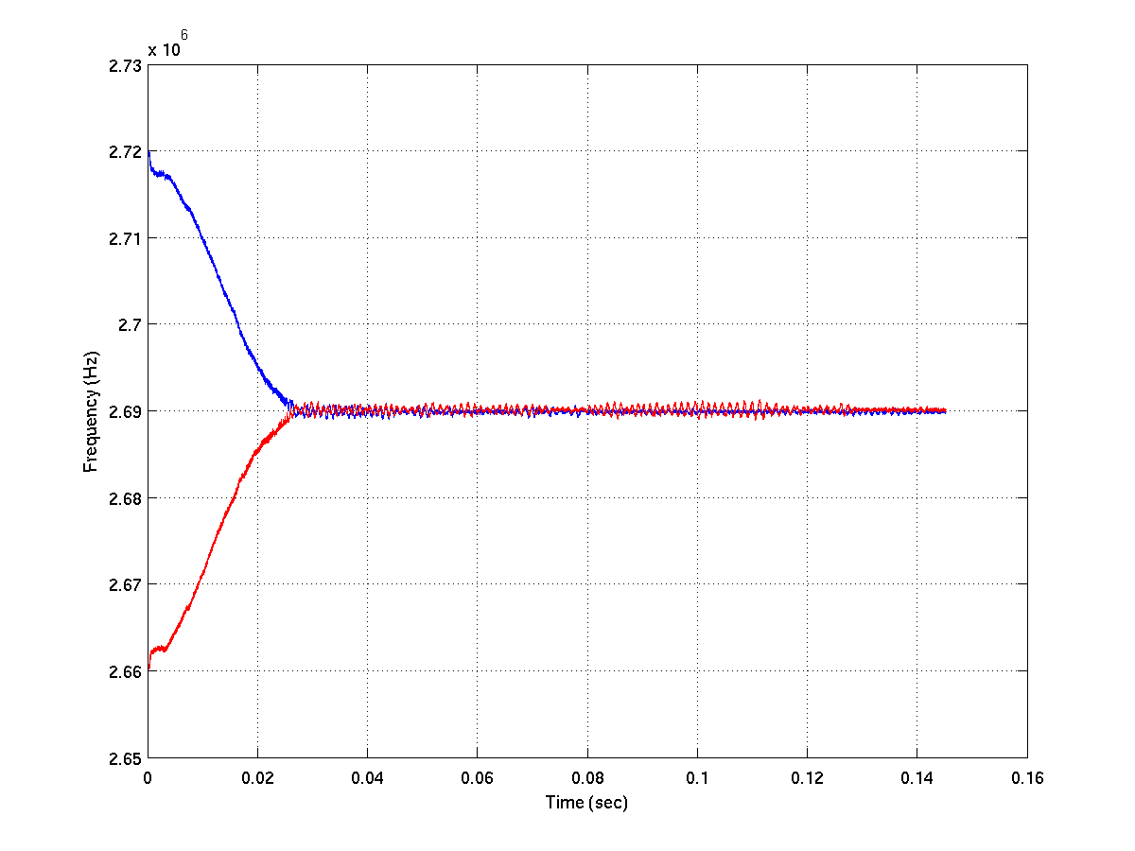
Figure 1 – Convergence behaviour of the two frequency tracking blocks (FTBs) each set to a different initial frequency in the presence of a low SNR ATSC DTV signal

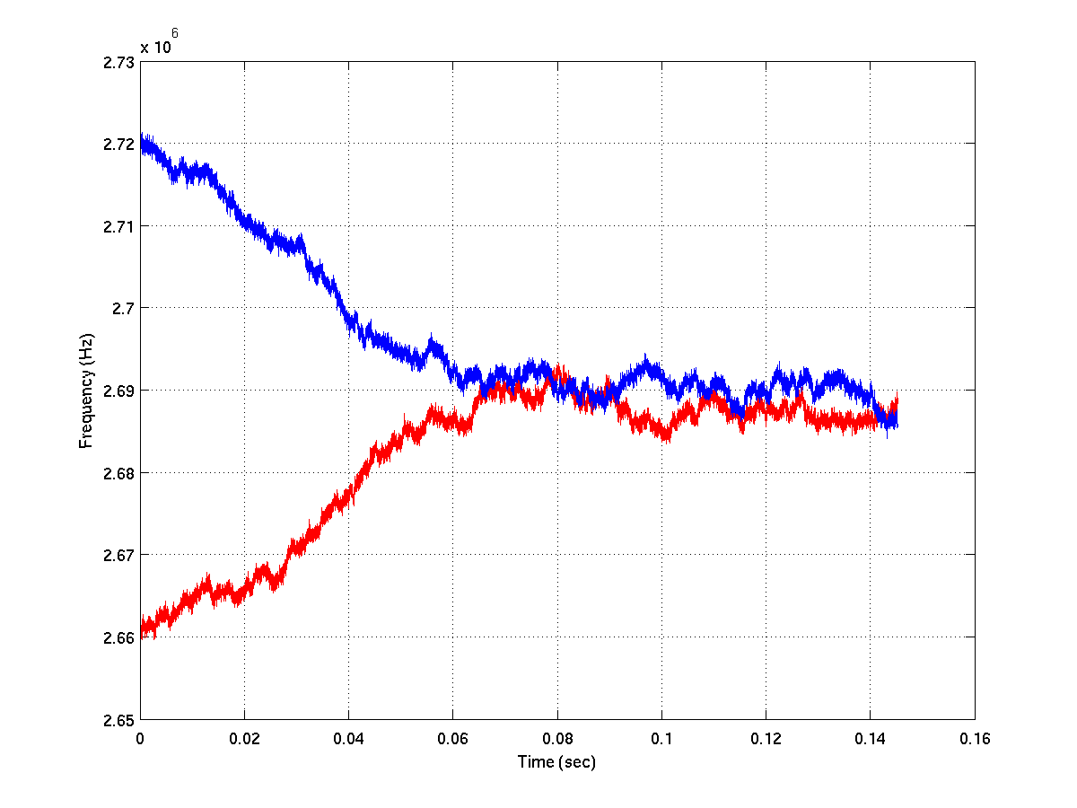
Figure 2 – Convergence behaviour of the two frequency tracking blocks (FTBs) each set to a different initial frequency in the presence of a very low SNR ATSC DTV signal
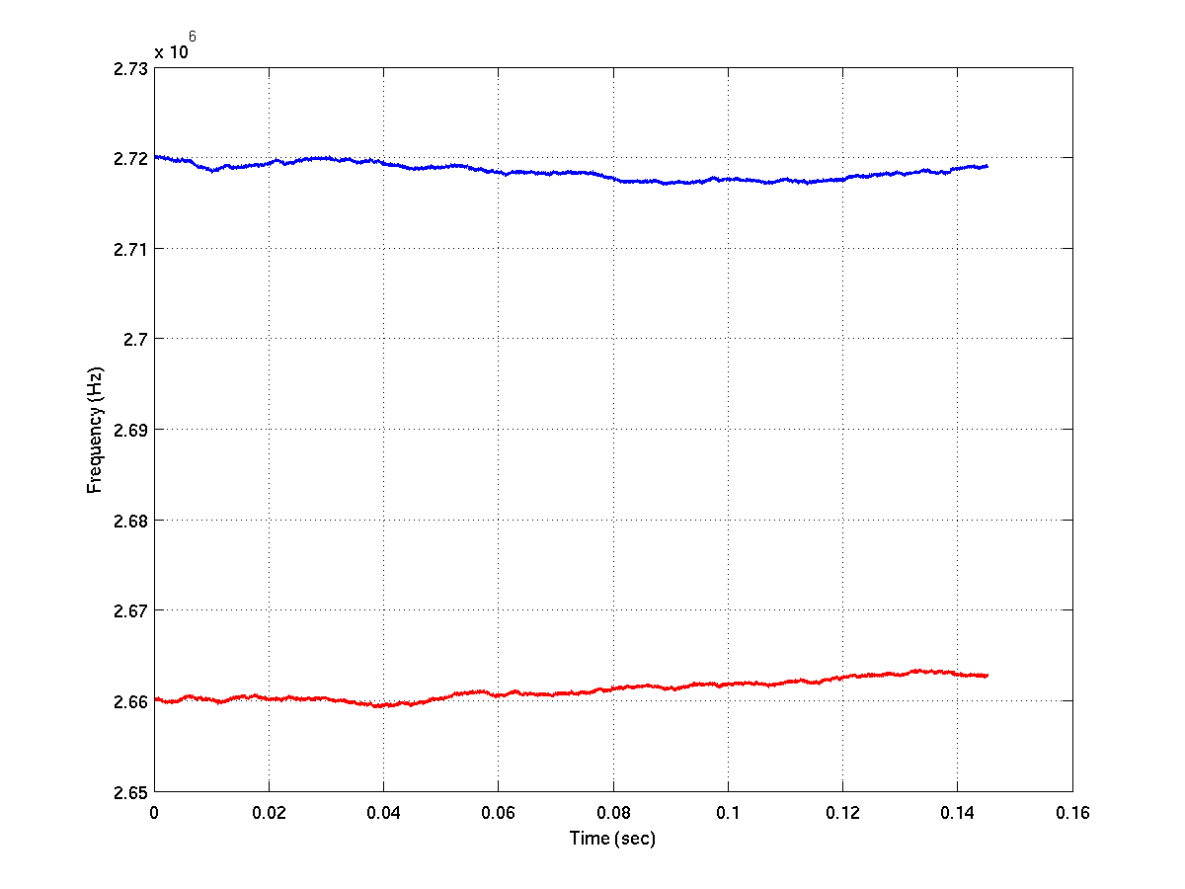
Figure 3 – Convergence behaviour of the two frequency tracking blocks (FTBs) each set to a different initial frequency in the absence of an ATSC DTV signal

The proposed FPLL based sensing algorithm was tested with the 12 DTV signals specified. Figure 4 shows the probability of misdetection curves for the 12 ATSC DTV capture signals with a sensing time of 75ms. The threshold value was set such that the probability of false alarm is less than 1%. Table 1 shows the average of required SNR for these 12 captured signals with P_{FA} << 0.01 and P_{MD} = 0.10.

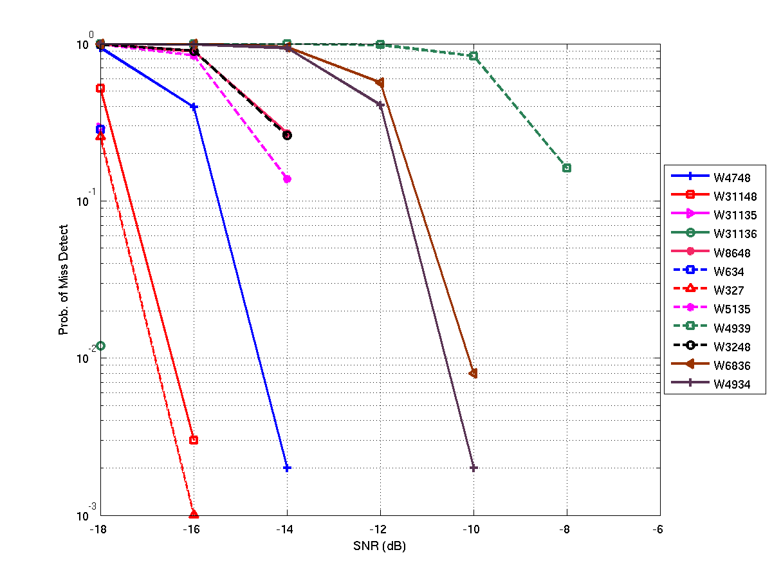
Figure 4 – Probability of misdetection curves for the different ATSC DTV signal captures with a sensing time of 75ms.

Table 1: Required SNR for DTV signal detection (Averaged over 12 signals)
Sensing Time | 50 ms | 75 ms
Required SNR | -12.42 dB | -14.88 dB

