IEEE P802.22
Wireless RANs
Proposed Geolocation Changes to Section 6.15 Network Entry and Initialization of the Working Document toward a Draft Standard v0.3
Date: 2007-08-03
Author(s):
Name | Company | Address | Phone | email
Winston Caldwell | Fox | 10201 W. Pico Blvd.  Los Angeles, CA 90035 | 310-369-4367 | Winston.caldwell@fox.com
Abstract
The purpose of this document is to propose additions to Section 6.15, Network Entry and Initialization, of the Working Document toward a Draft Standard, v0.3.7. The additions proposed describe the necessary geolocation steps in order to satisfy the requirements of the system.
Notice: This document has been prepared to assist IEEE 802.22. It is offered as a basis for discussion and is not binding on the contributing individual(s) or organization(s). The material in this document is subject to change in form and content after further study. The contributor(s) reserve(s) the right to add, amend or withdraw material contained herein.

Release: The contributor grants a free, irrevocable license to the IEEE to incorporate material contained in this contribution, and any modifications thereof, in the creation of an IEEE Standards publication; to copyright in the IEEE’s name any IEEE Standards publication even though it may include portions of this contribution; and at the IEEE’s sole discretion to permit others to reproduce in whole or in part the resulting IEEE Standards publication. The contributor also acknowledges and accepts that this contribution may be made public by IEEE 802.22.

Patent Policy and Procedures: The contributor is familiar with the IEEE 802 Patent Policy and Procedures
<http://standards.ieee.org/guides/bylaws/sb-bylaws.pdf>, including the statement "IEEE standards may include the known use of patent(s), including patent applications, provided the IEEE receives assurance from the patent holder or applicant with respect to patents essential for compliance with both mandatory and optional portions of the standard." Early disclosure to the Working Group of patent information that might be relevant to the standard is essential to reduce the possibility for delays in the development process and increase the likelihood that the draft publication will be approved for publication. Please notify the Chair <Carl R. Stevenson> as early as possible, in written or electronic form, if patented technology (or technology under patent application) might be incorporated into a draft standard being developed within the IEEE 802.22 Working Group. If you have questions, contact the IEEE Patent Committee Administrator at <patcom@ieee.org>.
  - 6.15 Network Entry and Initialization
    - BS Initialization
The WRAN BS initialization procedure shall consist of the following steps:

- BS is professionally installed.
- Determine the BS geographic location.
- BS accesses any available TV channel usage database to build list of available TV channels.
- Perform incumbent detection in all usable TV channels to detect other legitimate incumbent services that are not listed in the database.
- Perform neighboring network discovery on selected channel(s).
- BS synchronizes network with neighboring BSs using satellite-based geolocation technology.
- Commence operation on the selected operating channel(s).

      - Professional Installation
The operator shall professionally install the BS as per the Recommended Practice.
      - Determine Geographic Location
The geolocation requirement for the BS is that the WRAN system shall know the latitude and longitude of the BS transmitting antenna within a radius of 15 m and its altitude above mean sea level. The BS geographic location information shall be stored in the BS memory.
      - Access TV Channel Usage Database and Build List of Available TV Channels
The BS shall access a TV channel usage database. The geolocator will determine and tablulate the position of the CPEs. The spectrum manager will then compute the relative distances between the geographic location of the BS and the TV station protected contour geographic coordinates contained in the database. The BS spectrum manager shall construct an initial list of available TV channels on which the WRAN could potentially operate using the information output from the geolocator. The BS shall prohibit WRAN operation on any TV channel not on this initial list of available TV channels.
      - Perform Incumbent Detection
The BS shall perform incumbent detection in each of the TV channels listed on the available TV channel list to detect other legitimate incumbent services that do not exist in the TV channel usage database. The BS spectrum manager shall use the output from the BS spectrum sensing function to identify other occupied channels and remove those additional channels from the available TV channel list.

      - Perform Neighboring Network Discovery
The BS shall perform neighboring 802.22 network discovery on selected channels according to Section 6.21.2.1.3.
      - Synchronize Network with Neighboring Network Operation
The BS shall synchronize with neighboring BSs using its installed satellite-based geolocation technology.
      - Commence Operation
The BS may now commence operation on any one TV channel listed on the available TV channel list.

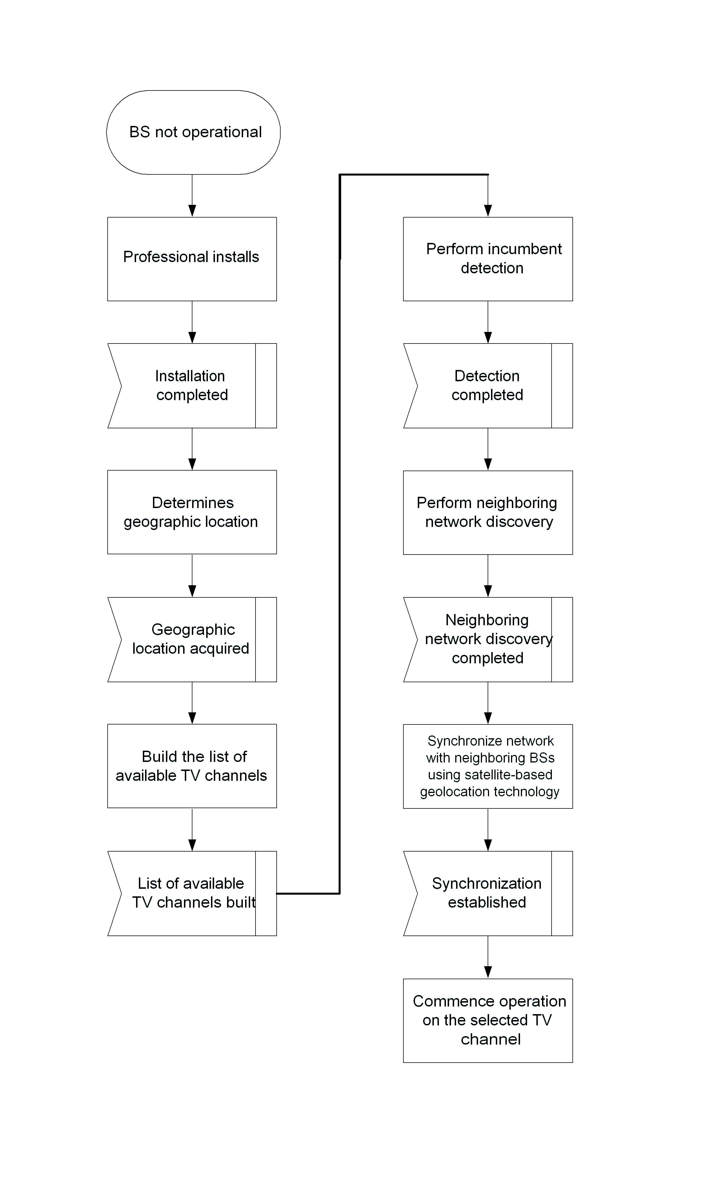

- –BS initialization procedure

    - CPE Initialization
Before a CPE can be serviced by a BS, it needs to enter the network and negotiate its capabilities with the BS. This may involve many tasks (e.g., geolocation and sensing channels) and frame exchanges between the CPE and the BS, and this whole procedure is hereby referred to as network entry and initialization. More importantly, during this process the BS needs to minimize the CPE communication so as not to cause harmful interference with incumbents. In other words, the network entry and initialization process is incumbent safe, which essentially means that incumbent system protection shall be maximized..

Figure 2 illustrates a scenario where the need for the definition of an incumbent safe CPE initialization can be easily seen. In this figure, consider that CPE 4 is powered down whereas the BS is transmitting in the cell which is under normal operation. Further, assume that the TV station in Figure 2 is powered up and starts transmitting in the same channel (i.e., channel #52 in this example) that is being used by the BS for its transmissions in the cell. CPE 4 should be capable of detecting that the BS is operating in a channel that is occupied by an incumbent service. The BS must be capable of determining if CPE 4 is located within interference range of the TV station protected contour (i.e., in the keep-out region). The purpose of the sensing and geolocation capabilities of the WRAN system is to prevent harmful interference to the primary TV service by providing the necessary information to the BS spectrum manager which generates the list of available channels. The definition of an incumbent safe CPE initialization phase is critical for cognitive radio systems. The MAC incorporates algorithms to address this need.

- –Scenario where a safe bootstrap operation is required to protect incumbents

First and foremost, The MAC does not presuppose any pre-assigned channel where a CPE is able to look for a BS given the time-varying and unpredictable nature of channel occupancy. Hence, the first task a CPE must perform in attempting to join a network is to scan the set of channels for BSs and incumbent services on which the transmissions of the CPE might interfere. The BS shall periodically send a SCH in its operating channel (see Error: Reference source not found) which may allow the CPE to recognize and, if appropriate, proceed with the CPE initialization procedure with the corresponding BS.

The procedure carried out by the BS and the CPE to perform CPE network entry and initialization is as follows:

- CPE performs detection of BS and incumbents in TV channels and tabulates spectrum measurements.
- CPE locates and synchronizes to the BS superframe and first frame preambles.
- CPE obtains the superframe and frame structure parameters from the BS.
- If the CPE is equipped with satellite-based geolocation technology, CPE acquires valid geolocation data from the satellites. If the data acquisition is unsuccessful, CPE initialization shall not continue.
- CPE transmits ranging/CDMA burst during the ranging window.
- BS acquires the burst and extracts CDMA code and ranging information.
- CPE transmits basic capabilities including satellite-based geolocation capability.
- If all required capabilities are present in the CPE, BS authorizes CPE, CPE transmits MAC address, and key exchange is performed.
- BS requests NMEA data from CPE.
- CPE transmits its encrypted response.
- If the CPE NMEA report indicates non-satellite-based data:
  - BS requests the CPE that is trying to associate to transmit CBP burst, and it also requests other associated CPEs to receive CBP burst in the operating channel.
  - CPE sends CBP active ranging burst.
  - The associated CPEs that were waiting for the CBP burst send the CBP active ranging burst received to the BS.
- BS performs and validates geolocation of CPE.
- If geolocation of CPE is ok, perform registration; otherwise, the CPE does not proceed to registration and the BS sends a denial of service to the CPE
- Perform neighboring network discovery.
- If indicated as desired by the CPE during registration (REG-REQ message), perform other optional initialization procedures such as establish IP connectivity, establish time of day, and transfer operational parameters.
- Set up connections.

Figure 3 summarizes the network entry of the CPE and its initialization procedure. Note that these steps taken by the CPE consist of a set of actions and error verification. In the following subsections, we provide a more detailed description of these steps and their individual responsibilities.

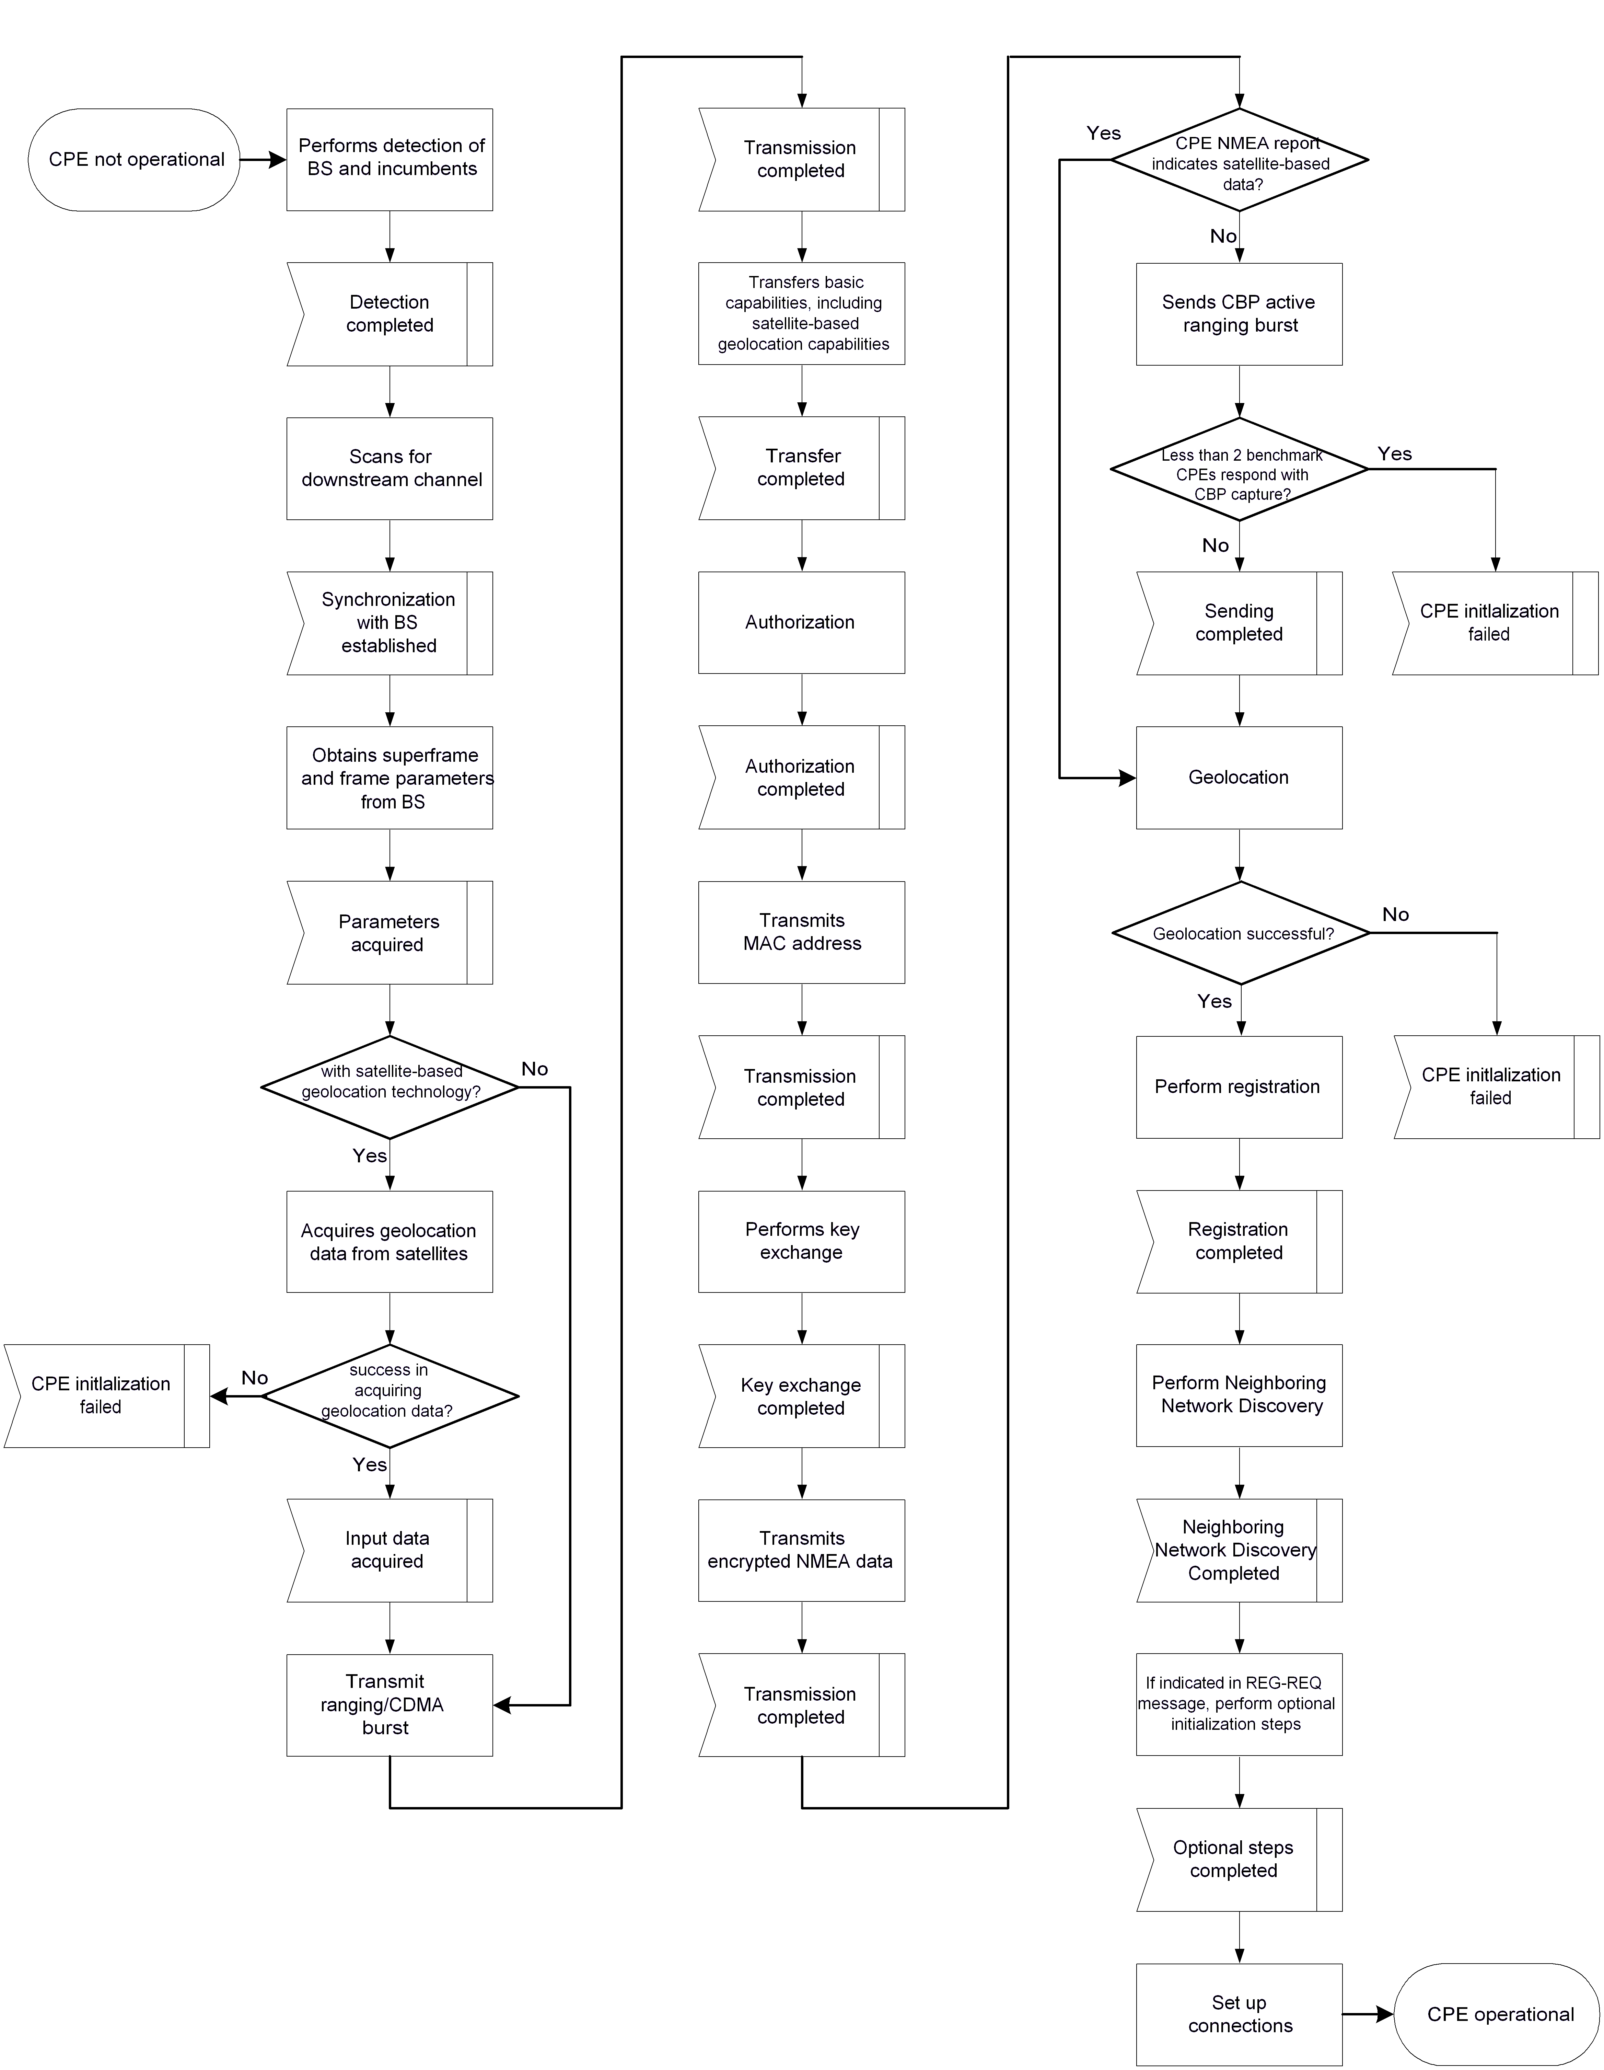
- –CPE initialization procedure

      - CPE Performs Detection of BS and Incumbents and Tabulates Spectrum Measurements
On initialization or after signal loss, the CPE shall perform spectrum sensing to detect the BS and legitimate incumbent services that are to be protected. The CPE shall tabulate its spectrum measurements as per (some Section). The MAC shall search for the SCH message from the BS, which indicates the beginning of the superframe. (Ivan asks if the BS should be alerted if the CPE detects an incumbent in the BS operating channel.) If the spectrum sensing function of the CPE detects a legitimate incumbent service on the BS operating channel or on either adjacent channel, the CPE shall not attempt to associate with a BS on the same channel.

      - CPE Locates and Synchronizes to the BS

The CPE acquires a downstream channel on which it detected BS by synchronizing to the BS superframe and frame preamble. If this fails, it shall select a BS on a different channel.

      - CPE Obtains Parameters from the BS

Once the PHY has achieved synchronization, the CPE shall obtain the superframe and frame structure parameters from the BS. As given by a PHY Indication, the MAC shall attempt to acquire the channel control parameters for the downstream and then the upstream.

Obtaining Downstream Parameters

After having received an SCH in a channel, the CPE shall perform sensing not only in the set of channels indicated in the SCH, but also in all other affected channels. During this sensing, the CPE shall attempt to identify incumbent operation. If incumbents are detected on the operating channel or either first adjacent channel, the MAC shall cause the CPE to cease transmitting application traffic on the channel and, at the first transmit opportunity send a short control message to the BS indicating that it is using a channel occupied by an incumbent. In case the BS receives such notification, it may take numerous actions as described in 6.21.1. The aggregate duration of the short control messages shall not exceed the Channel Closing Transmission Time (see Error: Reference source not found) of transmissions by the WRAN system before remedying the interference condition (i.e., changing channels, backing off transmit power, terminating transmissions, etc.).

Provided no incumbents are found, the CPE may proceed to the next step. Here, the MAC shall search for the DS-MAP MAC management messages. The CPE achieves MAC synchronization once it has received at least one DS-MAP message. A CPE MAC remains in synchronization as long as it continues to successfully receive the SCH, DS-MAP and DCD messages for its channel(s). If the Lost DS-MAP Interval (Error: Reference source not found) has elapsed without a valid DS-MAP message or the T1 interval (Error: Reference source not found) has elapsed without a valid DCD message or Lost SCH counts of SCH are missed, a CPE shall try to re-establish coarse and then fine synchronization. The process of acquiring synchronization is illustrated in Figure 4. The process of maintaining synchronization is illustrated in Figure 5.
        - Obtaining Upstream Parameters
After achieving fine synchronization, the CPE shall wait for a UCD message from the BS in order to retrieve a set of transmission parameters for a possible upstream channel. These messages are transmitted periodically from the BS for all available upstream channels and are addressed to the MAC broadcast address.

If no upstream channel can be found after a suitable timeout period, then the CPE shall continue scanning to find another downstream channel. The process of obtaining upstream parameters is illustrated in Figure 6.

The CPE shall determine from the channel description parameters whether it may use the upstream channel. If the channel is not suitable, then the CPE shall continue scanning to find another downstream channel. If the channel is suitable, the CPE shall extract the parameters for this upstream from the UCD. It then shall wait for the next DS-MAP message and extract the time synchronization from this message. Then, the CPE shall wait for a bandwidth allocation map for the selected channel. It may begin transmitting upstream in accordance with the MAC operation and the bandwidth allocation mechanism.

The CPE shall perform initial ranging at least once. If initial ranging is not successful, the procedure is restarted from scanning to find another downstream channel.

The CPE MAC is considered to have valid upstream parameters as long as it continues to successfully receive the SCH, US-MAP and UCD messages. If at least one of these messages is not received within the time intervals specified in Error: Reference source not found, the CPE shall not use the upstream. This is illustrated in Figure 7.

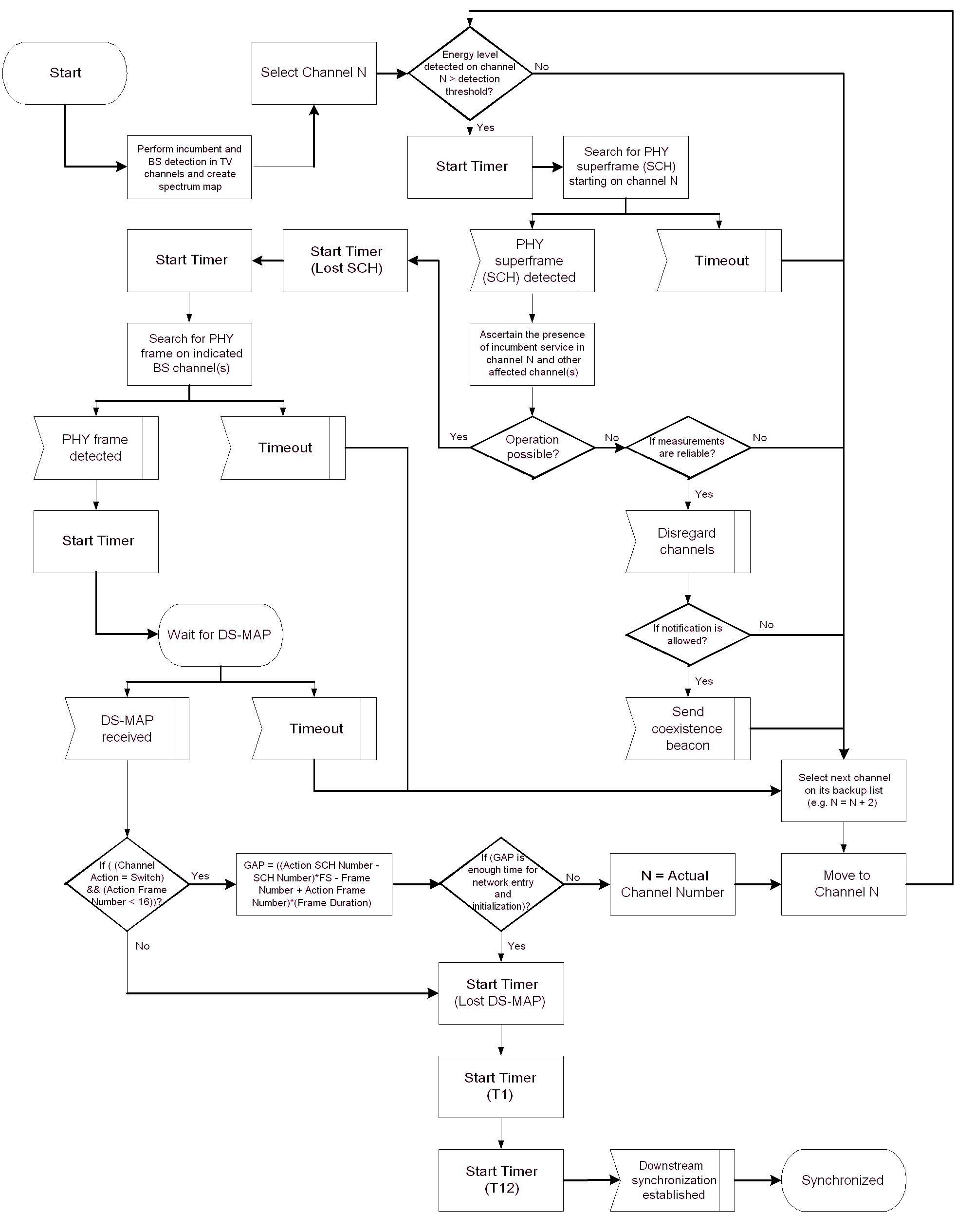
- –Obtaining downstream parameters

- –Maintaining downstream parameters

- –Obtaining upstream parameters

- –Maintaining upstream parameters

      - If Equipped with Satellite-Based Geolocation Technology, CPE Locks to Satellites and Acquires Valid Geolocation Data
If satellite-based geolocation technology is installed, the CPE shall establish lock with satellites. The CPE shall acquire valid geolocation data from the satellites. This CPE shall not progress to the next step of initialization until the satellite-based geolocation technology successfully establishes lock and acquires valid geolocation data from the satellites.

      - CPE transmits ranging/CDMA burst
Ranging is the process of acquiring the correct timing offset and power adjustments such that the CPE’s transmissions are aligned with the BS receive frame, and received within the appropriate reception thresholds. The timing delays through the PHY shall be constant..
        - Contention-based Initial Ranging and Automatic Adjustments
First, a CPE shall synchronize to the downstream and learn the upstream channel characteristics through the UCD MAC management message. At this point, the CPE shall scan the US-MAP message to find an Initial Ranging Interval. The BS may allocate an Initial Ranging Interval consisting of one or more transmission opportunities. The size of each transmission opportunity shall be as specified by the Ranging request opportunity size (see Error: Reference source not found).

The CPE may put together a RNG-REQ message to be sent in an Initial Ranging Interval. The CID field shall be set to the non-initialized CPE value (zero)(Ivan: Are we sure we want to use zero... ususally reserved for test traffic, like all ones is reserved for broadcast Furthermore, we want ot allow invited RNG-REQ, in which case the value would be non-zero). Alternatively, upon invitation, the initial ranging process shall begin by sending initial-ranging CDMA codes on the US allocation dedicated for that purpose, in addition to RNG-REQ messages sent on contention slots.

Ranging adjusts each CPE’s timing offset such that it appears to be co-located with the BS. The CPE shall set its initial timing offset to the amount of internal fixed delay equivalent to colocating the CPE next to the BS. This amount includes delays introduced through a particular implementation and shall include the downstream PHY interleaving latency, if any.

When the Initial Ranging transmission opportunity occurs, the CPE shall send the RNG-REQ (Ivan:???) message or a CDMA code. Thus, the CPE sends the message as if it were collocated with the BS.

The CPE shall calculate the maximum transmit signal strength for initial ranging, P_{TX_IR_MAX}, from the following equation:

P_{TX_IR_MAX} = EIR x P_{IR,max} + BS_EIRP – RSS

where the EIR x P_{IR,max} and BS_EIRP are obtained from the DCD, and RSS is the measured RSSI, by the CPE, as described in the PHY.

In the case that the receive and transmit gain of the CPE antennae are substantially different, the CPE shall use the following equation:

P_{TX_IR_MAX} = EIR x P_{IR,max} + BS_EIRP – RSS + (G_{RX_CPE} – G_{TX_CPE})

where G_{RX_CPE} is the CPE receive antenna gain and G_{Tx_CPE} is the CPE transmit antenna gain.

In the case that the EIR x P_{IR,max} and/or BS_EIRP are/is not known, the CPE shall start from the minimum transmit power level defined by the BS.

NOTE – The EIR x P_{IR,max} is the maximum equivalent isotropic received power, which is computed for a simple single antenna receiver as RSS_{IR,max} – GANT_BS_RX, where the RSS_{IR,max} is the received signal strength at antenna output and GANT_BS_RX is the receive antenna gain. The BS_EIRP is the equivalent isotropic radiated power of the base station, which is computed for a simple single-antenna transmitter as P_{TX} + GANT_BS_TX, where P_{TX} is the transmit power and GANT_BS_TX is the transmit antenna gain.

In the case that the CPE uses RNG-REQ messages, the CPE shall send the RNG-REQ at a power level below P_{TX_IR_MAX}, measured at the antenna connector. If the CPE does not receive a response, the CPE shall resend the RNG-REQ at the next appropriate Initial Ranging transmission opportunity at one step higher power level. If the CPE receives a response containing the frame number in which the RNG-REQ was transmitted, it shall consider the transmission attempt unsuccessful but implement the corrections specified in the RNG-RSP and issue another RNG-REQ message after the appropriate backoff delay. If the CPE receives a response containing its MAC Address, it shall consider the RNG_RSP reception successful.

When a BS detects a transmission in the ranging slot that it is unable to decode, it may respond by transmitting a RNG-RSP that includes transmission parameters, but identifies the frame number and frame opportunity when the transmission was received instead of the MAC Address of the transmitting CPE.

In the case that the CPE uses CDMA, the CPE shall send a CDMA code at a power level below P_{TX_IR_MAX}, measured at the antenna connector. If the CPE does not receive a response, the CPE shall send a new CDMA code at the next appropriate Initial Ranging transmission opportunity at one step higher power level. If the CPE receives a RNG-RSP message containing the parameters of the code it has transmitted and status continue, it shall consider the transmission attempt unsuccessful but implement the corrections specified in the RNG-RSP and issue another CDMA code after the appropriate backoff delay. If the CPE receives an US-MAP containing a CDMA allocation IE with the parameters of the code it has transmitted, it shall consider the RNG-RSP reception successful, and proceed to send a unicast RNG-REQ on the allocated BW.

Once the BS has successfully received the RNG-REQ message, it shall return a RNG-RSP message using the initial ranging CID. Within the RNG-RSP message shall be the Basic and Primary Management CIDs assigned to this CPE. The message shall also contain information on RF power level adjustment and offset frequency adjustment as well as any timing offset corrections. At this point the BS shall start using invited Initial Ranging Intervals addressed to the CPE’s Basic CID to complete the ranging process, unless the status of the RNG-RSP message is success, in which case the initial ranging procedure shall end.

If the status of the RNG-RSP message is continue, the CPE shall wait for an individual Initial Ranging interval assigned to its Basic CID. Using this interval, the CPE shall transmit another RNG-REQ message using the Basic CID along with any power level and timing offset corrections.

The BS shall return another RNG-RSP message to the CPE with any additional fine tuning required. The ranging request/response steps shall be repeated until the response contains a Ranging Successful notification or the BS aborts ranging. Once successfully ranged (RNG-REQ is within tolerance of the BS), the CPE shall join normal data traffic in the upstream. In particular, state machines and the applicability of retry counts and timer values for the ranging process are defined in Error: Reference source not found.

NOTE— The burst profile to use for any upstream transmission is defined by the Upstream Interval Usage Code (UIUC). Each UIUC is mapped to a burst profile in the UCD message.

NOTE—

- The BS shall allow the CPE sufficient time to have processed the previous RNG-RSP (i.e., to modify the transmitter parameters) before sending the CPE a specific ranging opportunity. This is defined as CPE Ranging Response Processing Time in Error: Reference source not found.

On receiving a RNG-RSP instruction to move to a new downstream frequency and/or upstream channel ID, the CPE shall consider any previously assigned Basic, Primary Management, and Secondary Management CIDs to be de-assigned, and shall obtain new Basic, Primary Management, and Secondary Management CIDs via initial ranging and registration.

It is possible that the RNG-RSP may be lost after transmission by the BS. The CPE shall recover by timing out and reissuing its Initial RNG-REQ. Since the CPE is uniquely identified by the source MAC address in the Ranging Request, the BS may immediately reuse the Basic, Primary Management, and Secondary Management CIDs previously assigned. If the BS assigns new Basic, Primary Management, and Secondary Management CIDs, it shall make some provision for aging out the old CIDs that went unused.
        - Ranging Parameter Adjustment
Adjustment of local parameters (e.g. transmit power) in a CPE as a result of the receipt or non-receipt of a RNG-RSP message is considered to be implementation-dependent with the following restrictions:

- All parameters shall be within the approved range at all times.
- Power adjustment shall start from the initial value selected with the algorithm described in subclause 6.15.5.1 unless a valid power setting is available from non-volatile storage, in which case this value may be used a the starting point.
- Power adjustment shall be capable of being reduced or increased by the specified amount in response to the RNG-RSP messages.
- If, during initialization, power in increased to the maximum value without a response from the BS, it shall wrap back to the minimum.

On receiving a RNG-RSP message, the CPE shall not transmit until the RF signal has been adjusted in accordance with the RNG-RSP and has stabilized.
      - BS Acquires Burst
The BS acquires the burst sent by the CPE and extracts the CDMA code and the ranging information.
      - CPE Transmits Basic Capabilities Including Satellite-Based Geolocation Capabilities
Right after the completion of initial ranging, the CPE informs the BS of its basic capabilities by transmitting a CBC-REQ message (see Error: Reference source not found) with its capabilities set to “on” (see Figure 8). The BS responds with a CBC-RSP message (see Error: Reference source not found) with the intersection of the CPE’s and BS’s capabilities set to “on” (see Figure 9 and Figure 10 respectively). Note that the CPE capability information is presented in Error: Reference source not found.

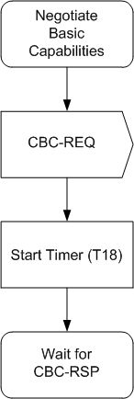
- Negotiate basic capabilities – CPE

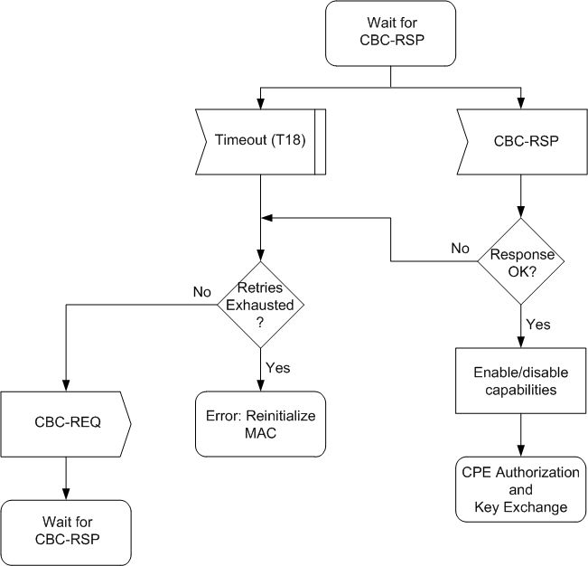
- Wait for CBC-RSP – CPE

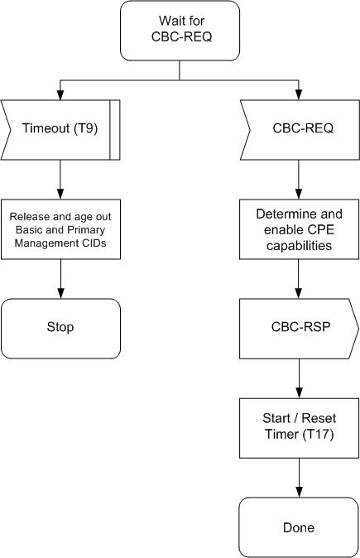
- Negotiate basic capabilities – BS
      - If all Required Capabilities Are Present in CPE, BS Authorizes CPE, CPE Transmits Its MAC Address, and BS and CPE Perform Key Exchange
If all of the required capabilities are present in the CPE, the BS and CPE continue with performing authorization, transmitting CPE MAC address to the BS, and exchanging keys, as described in Error: Reference source not found
      - BS Requests NMEA Data from CPE
If the CPE is equipped with satellite-based geolocation technology, the BS shall request the NMEA 0183 data from the CPE (as defined in Section …).
      - CPE Transmits NMEA Data to BS
The CPE shall securely send its NMEA data to the BS (as defined in Section …).
      - If the CPE NMEA Report Indicates a Non-Satellite Based Response, Use CBP for Geolocation of CPE
The BS arms its associated benchmark CPEs to receive the CBP burst from the CPE that is attempting to associate. The CPE sends a CBP active ranging burst. The BS queries its associated benchmark CPEs for CBP capture. At least two associated benchmark CPEs must respond with positive CBP capture.
      - BS Performs Geolocation of CPE
The BS geolocator uses either the received captured NMEA 0183 data from satellite-based geolocation technology or terrestrial triangulation and ranging through benchmark CPE capture of a CBP burst in order to geolocate the CPE. The BS geolocator shall determine the location of the transmitting antenna of each associated CPE within a radius of 100 m for 67% of the cases and 300 m for 95% of the cases.

The BS geolocator shall not only determine the location of the CPE but also determine the relative distance between the CPE location and each nearby incumbent protected contours. The BS shall refuse to serve the CPE if:
- the geographic location of the CPE has not been successfully determined by the BS geolocator or;
- the BS geolocator has determined that the CPE is located inside of the keep-out region of any incumbent service protected contour for the specific channel offset between the BS operating channel and the incumbent service (as described in Section …) or;
- Fewer than two benchmark CPEs have responded with CBP capture if terrestrial triangulation is used to determine the location of the CPE.
.
      - If Geolocation is Successful, BS Continues with Registration of the CPE
Registration is the process by which the CPE is allowed entry into the network and a managed CPE receives its Secondary Management CID and thus becomes manageable. To register with a BS, the CPE shall send a REG-REQ message to the BS. The BS shall respond with a REG-RSP message. For an CPE that has indicated being a managed CPE in the REG-REQ message, the REG-RSP message shall include the Secondary Management CID.

Figure 11 shows the procedure that shall be followed by the CPE.

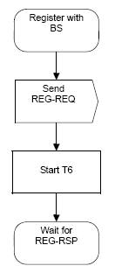
- CPE Registration

Once the CPE has sent a REG-REQ to the BS, it shall wait for a REG-RSP to authorize it to forward traffic to the network. Figure 12 shows the waiting procedure that shall be followed by the CPE.

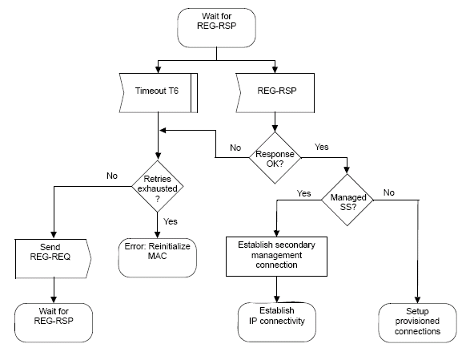
- Wait for REG-RSP—CPE

The BS shall perform the operations shown in Figure 13.

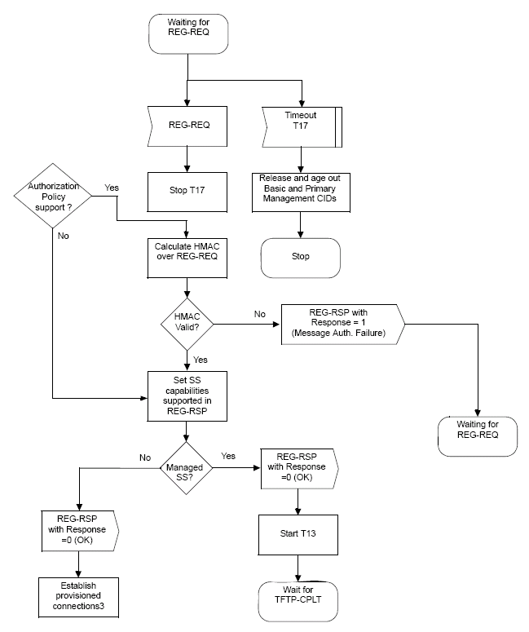
- Registration—BS

For managed CPE, upon sending a REG-RSP, the BS shall wait for a TFTP-CPLT. If timer T13 (defined in
Error: Reference source not found) expires, the BS shall both deassign the management CIDs from that CPE and make some provision for aging out those CIDs (see Figure 14 and Figure 15).
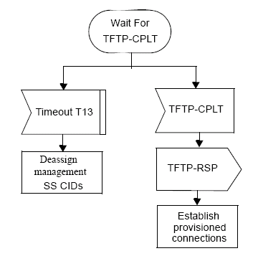
- Wait for TFTP-CPLT—BS

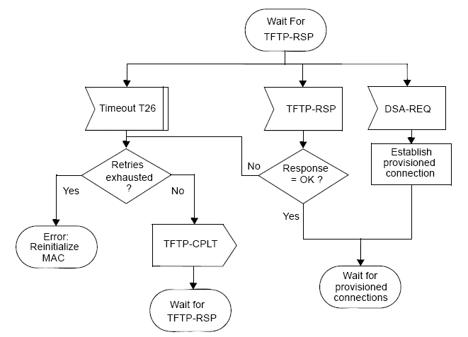
- Wait for TFTP-RSP—CPE

      - CPE Performs Neighboring Network Discovery
After a CPE has registered with a WRAN BS, it shall perform network discovery in order to identify neighboring WRANs and eneable efficient self-coexistence. The neighboring network discovery involves listening to the medium for CBP packets or BS SCH transmitted by other WRAN BSs. This network discovery mechanism is described in Section 6.21.2.1.3.
      - Optional Initialization Steps
If the CPE has indicated in the REG-REQ message that it is a managed CPE, the following three optional initialization steps should be performed after the neighboring network discovery

- Establish IP connectivity
- Establish time of day
- Transfer operational parameters
        - IP Version Negotiation
The CPE may include the IP version parameter (Error: Reference source not found) in the REG-REQ message to indicate which versions of IP it supports on the Secondary Management Connection. When present in the REG-REQ message, the BS shall include this IP version parameter in the REG-RSP message to command the CPE to use the indicated version of IP on the secondary management connection. The BS shall command the use of exactly one of the IP versions supported by the CPE.

The omission of the IP Version Parameter in the REG-REQ message shall be interpreted as IPv4 support only. Consequently, the omission of the IP Version Parameter in the REG-RSP message shall be interpreted as a command to use IPv4 on the secondary management connection.
        - Establish IP connectivity
The CPE shall invoke DHCP mechanism [IETF RFC 2131] in order to obtain an IP address and any other parameters needed to establish IP connectivity. If the CPE has a configuration file, the DHCP response shall contain the name of a file that contains further configuration parameters.

Establishment of IP connectivity shall be performed on the CPE’s secondary management connection as shown in Figure 16.

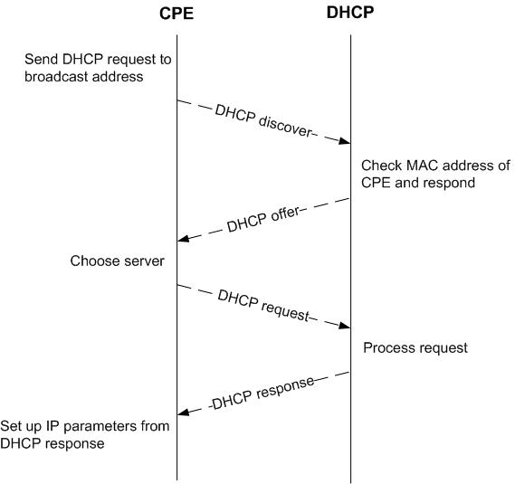
- Establishing IP connectivity
        - Establish Time of Day
The CPE and BS need to have the current date and time. This is required for time-stamping logged events for retrieval by the management system. This needs not be authenticated and needs to be accurate only to the nearest second.

The protocol by which the time of day shall be retrieved is defined in IETF RFC 868. Referring to Figure 17, the request and response shall be transferred using user datagram protocol (UDP). The time retrieved from the server [universal coordinated time (UTC)] shall be combined with the time offset received from the DHCP response to create the current local time. Establishment of time of day shall be performed on the CPE’s secondary management connection.

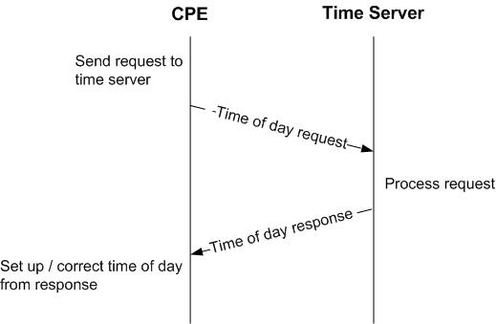
- Establishing time of day
Successfully acquiring the Time of Day is not mandatory for a successful registration, but is necessary for ongoing operation. The specific timeout for Time of Day Requests is implementation dependent.
        - Transfer Operational Parameters
After DHCP is successful, the CPE shall download the CPE’s configuration file using TFTP on its own secondary management connection as shown in Figure 18 when specified in the DHCP response. The CPE shall use an adaptive timeout for TFTP based on binary exponential backoff [IETF RFC 1123, IETF RFC 2349].

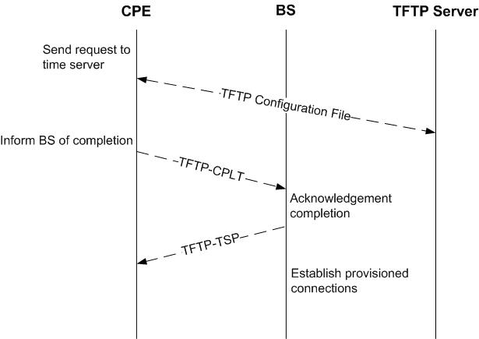
- Transferring operational parameters

When the configuration file download has completed successfully, the CPE shall notify the BS by transmitting the TFTP-CPLT message on the CPE’s primary management connection. Transmissions shall continue successfully until a TFTP-RSP message is received with response “OK” from the BS (see Figure 14 and Figure 15) or the CPE terminates retransmission due to retry exhaustion.
      - Set Up Connections
After the transfer of operational parameters for the managed CPE or after neighboring network discovery for unmanaged CPE, the BS shall send DSA-REQ messages (Error: Reference source not found) to the CPE to set up connections for preprovisioned service flows belonging to the CPE. The CPE responds with DSA-RSP messages. This is described further in subclause Error: Reference source not found.

References:

